# 

# REC TRANSPORT

A MINI-PROJECT REPORT

*Submitted by*

DANUSHNARAYAN S 221701012

*in partial fulfillment for the course*

**CD19606 - MOBILE APPLICATION DESIGN AND DEVELOPMENT**

*for the degree of*

# BACHELOR OF ENGINEERING

**in**

# COMPUTER SCIENCE AND DESIGN

RAJALAKSHMI ENGINEERING COLLEGE

RAJALAKSHMI NAGAR THANDALAM CHENNAI-602105

APRIL 2025

**BONAFIDE CERTIFICATE**

Certified that this project report **REC TRANSPORT** is the bonafide work of **DANUSHNARAYAN S (221701012)** who carried out the project work for the subject CD19651 – Mini Project under my supervision.

**SIGNATURE SIGNATURE**

# Prof. Uma Maheshwar Rao Mr. Vijay kumar. A. R

# Head of the Department Supervisor

Professor and Head Assistant Professor

Computer Science and Design Computer Science and Design Rajalakshmi Engineering College Rajalakshmi Engineering College Chennai - 602105 Chennai - 602105

Submitted to Project and Viva Voce Examination for the subject CD19651 – Mini Project held on .

Internal Examiner External Examiner

**ACKNOWLEDGEMENT**

Initially we thank the Almighty for being with us through every walk of our life and showering his blessings through the endeavour to put forth this report. Our sincere thanks to our Chairman **Mr. S. Meganathan, B.E, F.I.E.,** our Vice Chairman **Mr. Abhay Shankar Meganathan, B.E., M.S.,** and our respected Chairperson **Dr. (Mrs.) Thangam Meganathan, Ph.D.,** for providing us with the requisite infrastructure and sincere endeavoring in educating us in their premier institution.

Our sincere thanks to **Dr. S. N. Murugesan, M.E., Ph.D.,** our beloved Principal for his kind support and facilities provided to complete our work in time. We express our sincere thanks to our **Prof. UmaMaheshwar Rao** Associate Professor and Head of the Department of Computer Science and Design for his guidance and encouragement throughout the project work. We convey our sincere thanks to our internal guide and Project Coordinator**, Mr. Vijay kumar. A. R,** Department of Computer Science and Design, Rajalakshmi Engineering College for his valuable guidance throughout the course of the project.

DANUSHNARAYAN S (221701012)

**ABSTRACT**

This project focuses on the development of a real-time bus tracking system designed to improve the efficiency and convenience of college transportation services. Using GPS technology, the system allows students, faculty, and staff to track buses live via a mobile application, providing up-to-the-minute information on bus locations, estimated arrival times, and any delays. The app features easy access through the bus driver’s phone number, ensuring a secure and reliable experience. The system is designed to alleviate common issues faced by traditional transportation systems, such as unpredictable schedules, communication breakdowns, and long wait times. In addition to real-time tracking, the application will offer notifications and alerts for route changes, delays, and other important updates, ensuring users are always informed. This feature helps users better plan their journeys and avoid unnecessary waiting. The app’s user-friendly interface and intuitive design make it accessible to a wide range of users, ensuring that the system can be easily adopted across the college community. Overall, the goal of this project is to provide a smarter, more efficient transportation solution for the college, enhancing the experience for everyone who relies on the buses for daily commutes. By improving communication, reducing waiting times, and increasing the reliability of the service, this system aims to offer a more streamlined, stress-free alternative to traditional transport systems, making college transportation both more efficient and convenient for all users.

**TABLE OF CONTENTS**

| **S.No.** | **TITLE** | **PAGE No.** |
| --- | --- | --- |
| 1 | INTRODUCTION | 6 |
| 2 | LITERATURE REVIEW | 7 |
| 3 | SOFTWARE USED | 9 |
| 4 | LIMITATIONS | 11 |
| 5 | PROPOSED DESIGN | 12 |
| 6 | IMPLEMENTATION | 13 |
| 7 | OUTPUT | 14 |
| 8 | CONCLUSION | 19 |

**LIST OF FIGURES**

| **S.No.** | **TITLE** | **PAGE.No.** |
| --- | --- | --- |
| 1 | FRONT PAGE | 14 |
| 2 | SIGN UP PAGE | 15 |
| 3 | LOGIN PAGE | 16 |
| 4 | MAIN PAGE | 17 |
| 5 | LIVE TRACKING | 18 |

**CHAPTER 1**

**INTRODUCTION**

In many educational institutions, students and staff rely on college-provided transport services. However, the lack of real-time tracking, timely notifications, and an efficient complaint system often leads to inconvenience and uncertainty. This project aims to develop a College Transport Mobile Application that enhances the commuting experience by integrating live location tracking, instant route updates, and a complaint management system.  By leveraging Firebase for backend services, Google Maps API for tracking, and Flutter for cross-platform app development, this system will provide a user-friendly and efficient solution to improve the reliability and accessibility of college transport services. Efficient and well-managed transportation is essential for educational institutions, ensuring that students and faculty can commute safely and on time. However, traditional college transport systems often face challenges such as lack of real-time bus tracking, uncertain arrival times, poor communication regarding delays, and an inefficient complaint resolution system. These issues can cause inconvenience, confusion, and unnecessary delays for students and staff. To address these challenges, the REC Transport 2.0 - Bus Tracking App has been developed as a smart, real-time, and user-friendly transportation management system. The REC Transport 2.0 app aims to enhance the college transport experience by providing live bus tracking, route details, estimated arrival times, and instant notifications.. The following sections will provide a detailed analysis of the technology stack, system architecture, and implementation methodology of the REC Transport 2.0 app, demonstrating how it transforms college transportation into a smarter and more efficient system.

**CHAPTER 2**

**LITERATURE REVIEW**

**2.1. SSN College of Engineering**: SSN College implemented a real-time bus tracking system through a mobile app, allowing students to track bus locations and receive notifications for delays. A study on their system (2020) emphasized the need for real-time GPS tracking, which enhanced student satisfaction by 70%. However, it was noted that the app lacked advanced features like predictive analytics and user feedback systems, which could improve the overall user experience. Another research (2018) on the app's usability found that while the basic features were effective, user engagement could be improved with a more intuitive UI/UX design.

**2.2. SRM Institute of Science and Technology**: SRM’s transport system, through its SRM Bus Trackerapp, integrates real-time GPS tracking and notifications for bus schedules. A 2019 study on SRM’s system highlighted the app’s success in reducing waiting times by 30% and improving communication. The study also pointed out that SRM’s system is one of the most efficient, offering real-time location updates, route changes, and feedback management. However, it lacked predictive analytics and AI for traffic forecasting, which could optimize the system further.

**2.3. VIT University**: The VIT Bus Tracker app provides real-time tracking and estimated arrival times, benefiting both students and administrators. A study conducted in 2021 found that VIT’s system successfully implemented a web portal for administrators to manage routes and monitor bus performance. However, it was noted that while the system facilitated basic communication through notifications, there were challenges in scaling it for larger campuses, and it lacked predictive features for real-time traffic updates. Future enhancements were suggested, such as integrating AI-based features for better traffic management.

**2.4. Venkateshwara College of Engineering**: Venkateshwara College implemented a basic real-time tracking system using GPS, allowing students to track buses and receive notifications. A study in 2020 on their system revealed that while it was effective for smaller campuses, it had limited scalability and lacked advanced features such as route deviation alerts and predictive analytics. The research concluded that for better user engagement and efficiency, the system should incorporate user feedback and advanced analytics to improve overall service delivery.

**2.5. Saveetha University**: Saveetha University introduced a real-time bus tracking system through the Saveetha Bus Trackerapp, which allows students and staff to track buses in real-time, access route details, and receive notifications about delays and schedule changes. A study conducted in 2022 on the system highlighted its success in improving operational efficiency by reducing wait times and optimizing bus routes. The system uses GPS technology, and real-time updates are provided through push notifications. However, the study also noted that the system lacks predictive analytics and a complaint management feature. Saveetha's app was praised for its user-friendly interface but was seen as needing further enhancement in terms of scalability for a larger user base and the addition of more advanced features like predictive analytics to forecast bus arrivals based on traffic data.

**CHAPTER 3**

**SOFTWARE USED**

**FLUTTER**

**3.1 Tool Selection**  
During the initial phase of the development of the real-time bus tracking system, our team evaluated several technology stacks to determine the most appropriate one. Flutter emerged as the ideal choice for mobile application development due to its ability to create cross-platform apps with a single codebase. This allowed for seamless development for both iOS and Android platforms while maintaining a consistent user experience. Additionally, Flutter's rich set of pre-designed widgets and its fast rendering engine made it an ideal choice for building a responsive and visually appealing user interface. The Flutter framework’s flexibility, performance, and rapid development capabilities ensured the timely delivery of the application.

**3.2 Development Implementation with Flutter**  
Using Flutter, our team developed the front end of the real-time bus tracking system with an intuitive and responsive interface. Flutter’s widget-based architecture allowed us to create reusable components for different screens, which enhanced code maintainability and scalability. We utilized Flutter’s powerful framework to integrate live bus tracking, estimated arrival times, and push notifications in a smooth and visually engaging manner. The integration of Google Maps API within Flutter enabled real-time map-based tracking, allowing students, staff, and administrators to interact with live data easily. Furthermore, Flutter’s hot-reload feature helped streamline the development process by enabling rapid testing and iteration.

**3.3 Prototyping and Feedback**  
Prototyping and feedback were crucial in shaping the final product, and Flutter played an essential role in enabling quick iterations. By leveraging Flutter's rich UI toolkit, we were able to rapidly develop prototypes and test them with end-users. Feedback was gathered from students, faculty, and administrators to refine the user interface and enhance overall usability. Changes in the design, layout, or user flow were implemented swiftly due to the efficiency provided by Flutter’s real-time reload feature. This ensured that the app met the needs of the users while providing an optimal user experience.

**3.4 Collaboration and Real-Time Updates**  
Throughout the development process, Flutter allowed for easy collaboration between the front-end developers, backend team, and designers. The team utilized GitHub for version control, ensuring that the latest code was integrated seamlessly and that changes were tracked efficiently. The cross-platform nature of Flutter allowed developers to simultaneously work on both iOS and Android versions of the app, reducing the time required for development and testing. We also employed Firebase for real-time database integration and cloud-based updates, enabling the app to reflect live bus locations and updates on both platforms simultaneously.

**CHAPTER 4**

**LIMITATIONS**

### 4.1 Technical Limitations

Server Downtime Risks If the backend server crashes or undergoes maintenance, the app will stop updating bus locations. Requires constant monitoring and backups to prevent service interruptions. High Data Usage Continuous GPS updates consume mobile data, which could be a concern for users with limited data plans. Optimization techniques like location update intervals can reduce data consumption. Device Compatibility Issues Some older devices may not support real-time tracking features efficiently. The app may have performance issues on low-end smartphones.

### 4.2. User Experience Limitations

Notification Delays Push notifications may be delayed due to background restrictions on some devices. Users may miss critical updates about bus delays or route changes. User Adaptability Some students and faculty members may find the app complicated to use. Training or user guides may be needed for first-time users. Limited Offline Functionality The app might not work when offline, preventing users from accessing saved schedules or routes.

### 4.3. Operational Limitations

Dependency on Driver Cooperation If drivers forget to start tracking or turn off their devices, users won’t get real-time updates. Requires strict adherence to operational guidelines. Traffic and Unexpected Delays The app can’t predict real-time traffic jams, roadblocks, or accidents, leading to inaccurate ETAs. Integration with traffic APIs (like Google Maps) could help improve accuracy.

**CHAPTER 5**

**PROPOSED DESIGN**

### 5.1 Real Time Tracking

Students and faculty can track buses live and know exact arrival times, reducing uncertainty and long waiting times. Helps plan travel efficiently, avoiding missed buses..

### 5.2 Improved Safety & Security

Real-time bus tracking ensures student safety, especially during late hours. Emergency alerts can be integrated for quick response to incidents.

### 5.3 User-Friendly & Convenient.

A simple mobile app with an intuitive interface makes it easy for students, faculty, and staff to use. No need to physically check for bus arrival times—everything is available on the phone.

### 5.4. Helps in Efficient Route Planning

Admins can monitor bus routes and optimize them based on real-time data. Reduces unnecessary detours, improving efficiency and fuel consumption.

### 5.5 Environmentally Friendly

Reducing unnecessary waiting and optimizing routes can lead to lower fuel consumption. Helps in reducing the carbon footprint of the transport system.

**CHAPTER 6**

**IMPLEMENTATION DETAIL**

### 6.1. System Components

* Mobile App (Students & Faculty) – Displays bus locations and estimated arrival times.
* GPS on Buses – Enables real-time tracking of bus movement.
* Backend Server – Processes and manages tracking data.
* Admin Dashboard – Provides insights and monitoring capabilities.

### 6.2. Development Process

* GPS Integration: Equip buses with GPS tracking devices.
* Backend Development: Create APIs to process location data.
* Mobile App Development: Build the frontend for students and faculty.
* Admin Dashboard Creation: Provide a control panel for monitoring buses.
* Testing & Deployment: Ensure the system runs smoothly before launch.

### 6.3. Expected Outcome

* Accurate Live Tracking of college buses.
* Enhanced Communication between students, faculty, and drivers.
* Reduced Waiting Times with real-time updates and notifications

**CHAPTER 7**

**OUTPUT**

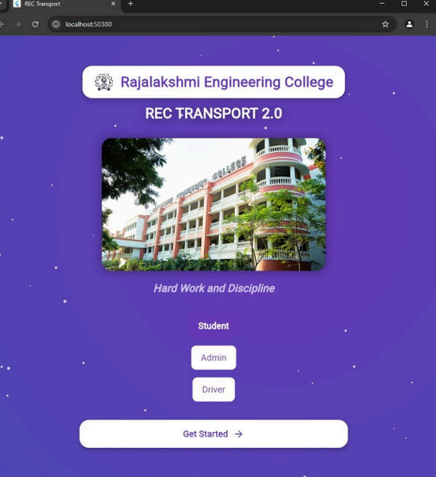

### 

***Fig 1:The Front Page***

The Home Page of the REC Transport 2.0 - Bus Tracking App serves as the initial screen where users select their role before proceeding further. The app supports three user categories: Student, Staff, and Admin, each with specific access to transport-related functionalities.

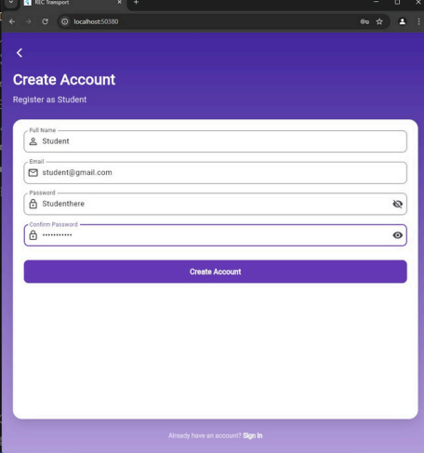

***Fig 2: The Signup page***

The Signup Page in the REC Transport 2.0 - Bus Tracking App allows users to create an account based on their role (Student, Staff, or Administrator) and securely access transport services. It is built using Flutter for a responsive user interface and Firebase Authentication for secure user registration

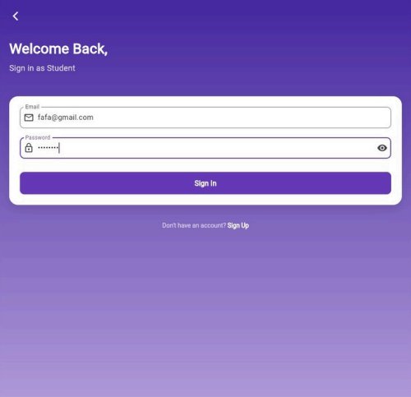

***Fig3: Login Page***

The login screen is the entry point of the REC Transport 2.0 - Bus Tracking App, designed to provide a seamless authentication experience for users. It ensures secure access to the app while maintaining a userfriendly interface.The login screen connects with Firebase Authentication, ensuring secure and encrypted user verification. When a user enters their credentials, the app communicates with Firebase to validate login details. If authentication is successful, the user is redirected to the dashboard, where they can access real-time bus tracking, schedules, and other features. To enhance usability, the app incorporates error handling, displaying messages for incorrect credentials, weak passwords, or network issues. Additionally, a loading indicator ensures users receive feedback during the authentication process.

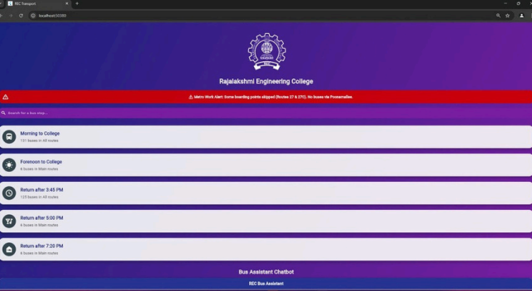

***Fig 4: Main Page***

The Main Page of the REC Transport 2.0 - Bus Tracking App serves as the central dashboard where users can view real-time bus tracking, route details, and schedules. This page is designed to provide a seamless user experience, ensuring stl available buses with details such as bus number, driver name, route, and stops. Users can filter routes based on their location or specific destinations.Search & Filters: A search bar allows users to find a specific bus or route quickly. Filters help refine results based on bus numbers, locations, or timings. Estimated Time of Arrival (ETA): Displays the expected arrival time of each bus at different stops, helping users plan their travel efficiently.Notifications & Alerts: Provides important updates, such as route changes, delays, or emergency notifications, using Firebase Cloud Messaging (FCM).Complaint & Feedback Button: Allows students and staff to report issues related to buses, routes, or schedules. Students, staff, and admins can easily access critical transport information.The main page follows a structured and visually appealing design with the following key elements: Live Bus Tracking Map: Displays the real-time location of all buses using the Google Maps API or Flutter Map. Users can select a bus to view its current position, estimated arrival time, and route.

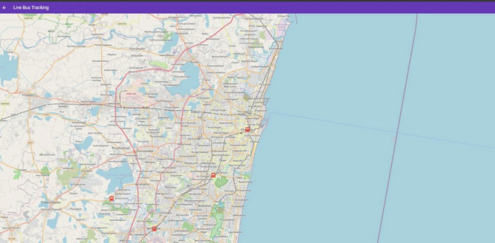

.

***Figure5:- Live Location***

The Live Location Tracking feature in the REC Transport 2.0 - Bus Tracking App provides real-time GPS updates of college buses, enabling students and staff to track their movement and estimated arrival times. This feature ensures efficient transport planning and reduces uncertainty regarding bus schedules .The Live Location Tracking system is powered by Firebase Realtime Database, which continuously updates the bus’s GPS coordinates. The app uses the Geolocator package to fetch the user’s live location and compare it with bus routes.Students can track the nearest bus and plan their arrival at the bus stop accordingly. Staff can monitor bus movement to ensure schedule adherence. Admins can oversee the entire fleet, detect delays, and optimize route efficiency. The Live Location Tracking feature is a crucial component of the REC Transport 2.0 app, providing students and staff with accurate, real-time bus information. By leveraging GPS, Firebase, and Maps API, the system ensures a seamless, efficient, and stress-free commuting experience, reducing waiting times and improving overall transport management***.***

**GITHUB LINK : https://github.com/Danushnarayan/TRANSPORT_APP/tree/master**

### CHAPTER 9

### CONCLUSION

The REC Transport 2.0 - Bus Tracking App is designed to enhance the efficiency and convenience of college transportation by providing a seamless, real-time tracking experience. By integrating Flutter for the frontend and Firebase for the backend, the app ensures a robust, scalable, and high-performance solution that caters to the needs of students and faculty. With live GPS tracking, users can monitor bus locations in real time, reducing uncertainty and wait times. The app’s ability to provide instant notifications about bus schedules, delays, and route changes ensures that students remain informed at all times. Additionally, features like a complaint and feedback system allow users to report issues and suggest improvements, contributing to a better transport experience. The combination of an intuitive user interface and a powerful backend infrastructure makes REC Transport 2.0 not just a tracking tool, but a comprehensive transport management solution. The use of Google Maps API, Firebase Authentication, and Cloud Firestore ensures that the app delivers accurate and secure data while maintaining a smooth user experience. Looking ahead, the app has the potential to evolve with features such as AI-powered chat support, predictive arrival times, and QR-based bus check-ins. These advancements will further optimize the efficiency of college transport and enhance user satisfaction. With its solid foundation and future-oriented approach, REC Transport 2.0 is set to redefine how students interact with their campus transportation system, making travel more reliable, accessible, and stress-free.

### REFERENCES

1. Chavan, A., Patil, A., Joshi, S., & Joshi, M. (2020). Smart College Bus Tracking System using Android Application. International Journal of Scientific Research in Computer Science, Engineering and Information Technology (IJSRCSEIT).
2. Amrutha, T., Pooja, A., Sneha, A., & Vishnu, P. (2019). GPS and GSM Based College Bus Tracking System. International Journal of Innovative Technology and Exploring Engineering (IJITEE)
3. Ghosh, S., Mukherjee, A., & Sharma, R. (2018). Real-time Bus Tracking System Using GPS. International Journal of Computer Applications (IJCA).
4. 4.Google Developers. (2024). Google Maps API for Transport Tracking. Google Cloud Documentation.
5. 5.Firebase. (2024). Real-Time Database for Live Location Tracking. Google Firebase Documentation.
6. 6.Moovit Inc. (2023). Moovit - Smart Public Transport Navigation App.
7. 8.Ridlr App. (2023). Public Transport Route Planning & Bus Live Tracking.