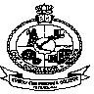
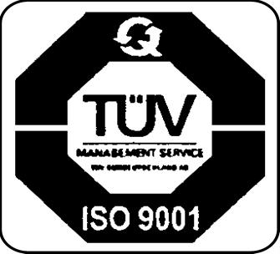
Kongu Engineering College

PERUNDURAI, ERODE– 638060

Phone: 04294-226581, 226583

Department of



Computer Applications

RESEARCH CLUB

Mail:hod_mca@kongu.ac.in Website: mca.kongu.edu

CIRCULAR
Ref: KEC/MCA/Research Club/CIR-03/2025-2026 Date: 12.03.2026
The Research Club of the Department of Computer Applications is pleased to organize a Session on “Effective Strategies for Converting Projects into Research Papers.” The purpose of this session is to help students understand how their academic or research projects can be systematically transformed into well-structured research papers.
This session will focus on identifying the core research contribution from a project, organizing the project work into standard research paper sections such as abstract, introduction, methodology, results, and conclusion, and presenting technical ideas in a clear and structured manner. This session will help students learn how to effectively document their project work in the format of a research paper and develop essential academic writing skills.

Details of the Programme:
📅 Date: 12.03.2026 ⏰ Time: 8.45 am – 11.00am
📍 Venue: MCA Block, Second Floor, MCA CC, KEC.
👤 Resource Person: Mrs. S. Nandhinidevi
Assistant Professor (Sr.G)
Department of Computer Technology
Kongu Engineering College, Perundurai

All the 1st year MCA students are informed to attend the session without fail. The session will be highly beneficial in motivating young minds to explore research opportunities and develop a deeper understanding of the publication process.

Secretary Faculty Coordinator HoD / CA (Mr.G.Nisanth) (Dr.P.Vijayakumar) (Dr.A.Tamilarasi)

