Министерство образования Республики Беларусь
Учреждение образования
«Белорусский государственный университет информатики и радиоэлектроники»

Факультет компьютерных систем и сетей

Кафедра электронных вычислительных машин

ОТЧЕТ
по лабораторной работе №2
по дисциплине КиДСВТ

Выполнил: Проверил:
студент гр. 750501 Золоторевич Л. А.
Гагуа Д. Р.

Минск 2021

NA2
&
NAO3

1

&
NAOA2

&
&
1

NOAO2

1

&
1

O2
1
&
NA3
NAO3

1

&
NAO3

1

&
N_
1
N_
1
NA2
&
N_
1
N_
1
N_
1
N_
1
N_
1
N_
1
X₁
X₄
X₃
X₂
Y₂
Y₄
Y₁

Y₃
1 Моделируемая структура

Система булевых функций:

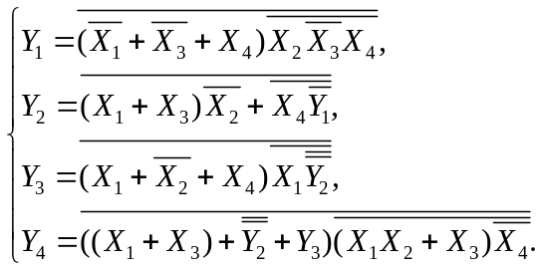

Таблица 1 - Логические элементы
Имя  элемента | Функция элемента | Задержка  (ns)
N_ | 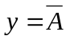 | 1
NA2 | 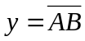 | 2
NA3 | 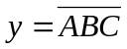 | 3
NAO3 | 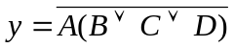 | 5
NAOA2 | 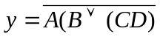 | 4
NOAO2 | 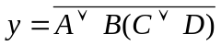 | 4
O2 | 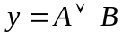 | 2

Класс устройства: последовательностное.

2 Описание и трансляция в системе VLSI_SIM

Описание логической схемы:

CIRCUIT SYSTEM;
INPUTS X1(1), X2(1), X3(1), X4(1);
OUTPUTS Y1(1), Y2(1), Y3(1), Y4(1);
GATES
N_X1 'N_' (1) X1(1);
N_X2 'N_' (1) X2(1);
N_X3 'N_' (1) X3(1);
N_X4 'N_' (1) X4(1);
NA3_2n34 'NA3' (1) X2(1), N_X3(1), X4(1);
Y1 'NAO3' (1) NA3_2n34(1), N_X1(1), N_X3(1), X4(1);
N_Y1 'N_' (1) Y1(1);
NA2_4ny1 'NA2' (1) X4(1), N_Y1(1);
Y2 'NOAO2' (1) NA2_4ny1(1), N_X2(1), X3(1), X1(1);
N_Y2 'N_' (1) Y2(1);
N_N_Y2 'N_' (1) N_Y2(1);
NA2_1nn_ 'NA2' (1) X1(1), N_N_Y2(1);
Y3 'NAO3' (1) NA2_1nn_(1), N_X2(1), X4(1), X1(1);
NAOA2_n_ 'NAOA2' (1) N_X4(1), X3(1), X2(1), X1(1);
O2_x3x1 'O2' (1) X3(1), X1(1);
Y4 'NAO3' (1) NAOA2_n_(1), O2_x3x1(1), Y3(1), N_N_Y2(1);
ENDGATES
END

Результаты трансляции схемы:

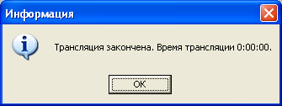

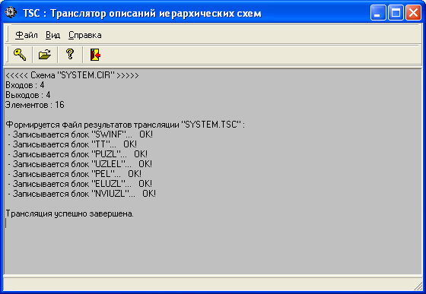

3 Построение теста

Для генерации тестов схемы использовалась полнота 100% и последовательное уменьшение покрытия одного набора: 50, 45, 40, 35, 30, 25, 20, 15, 10, 7, 5, 3, 1, 0.5.

Построение первого теста:

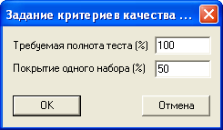

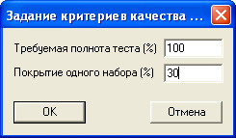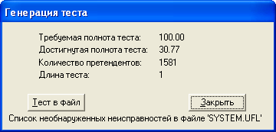

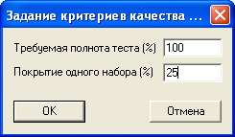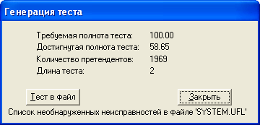

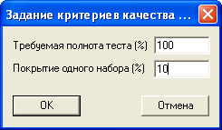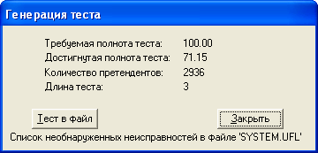

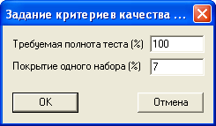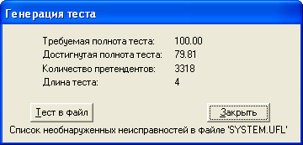

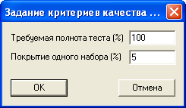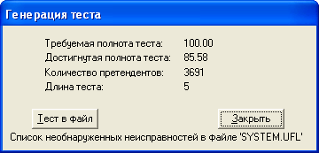

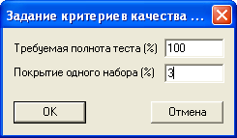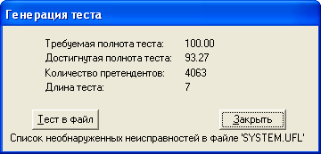

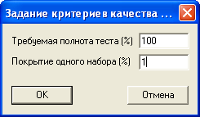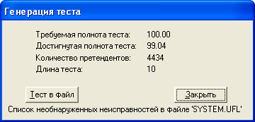

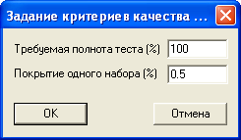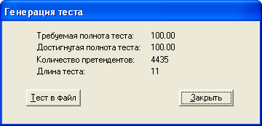

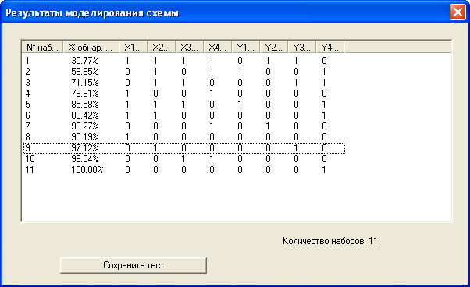

Полученное множество: 1111, 0101, 0110, 1001, 1110, 1100, 0001, 1000, 0100, 0011, 0000.

Построение второго теста:

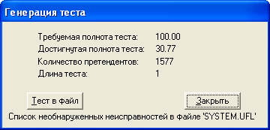

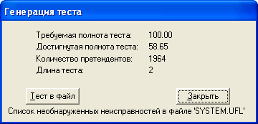

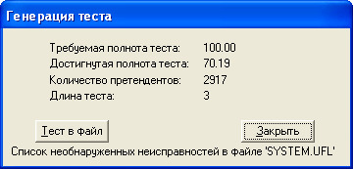

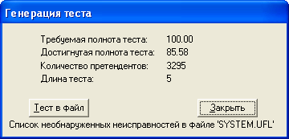

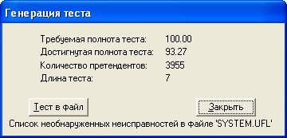

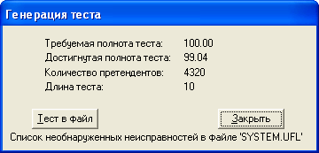

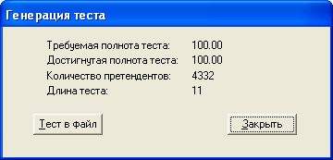

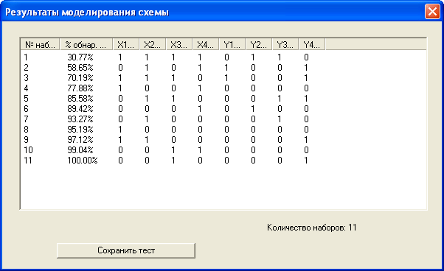

Полученное множество: 1111, 0101, 1110, 1001, 0110, 0001, 0100, 1000, 1100, 0011, 0010.

Построение третьего теста:

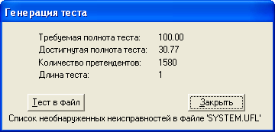

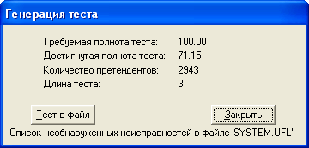

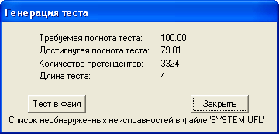

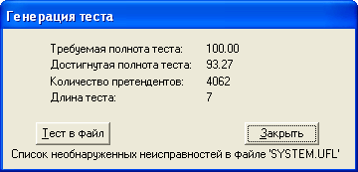

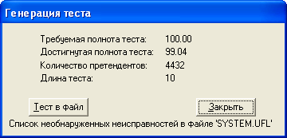

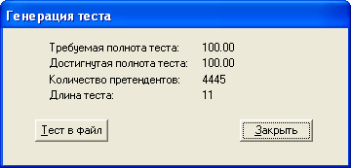

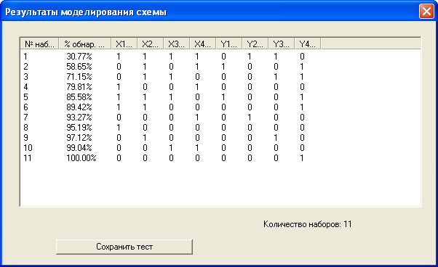

Полученное множество: 1111, 0101, 0110, 1001, 1110, 1100, 0001, 1000, 0100, 0011, 0000.

4 Моделирование на полученном тесте 2

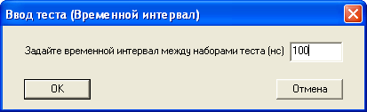

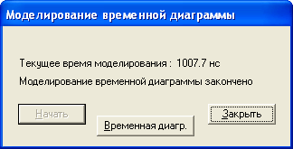

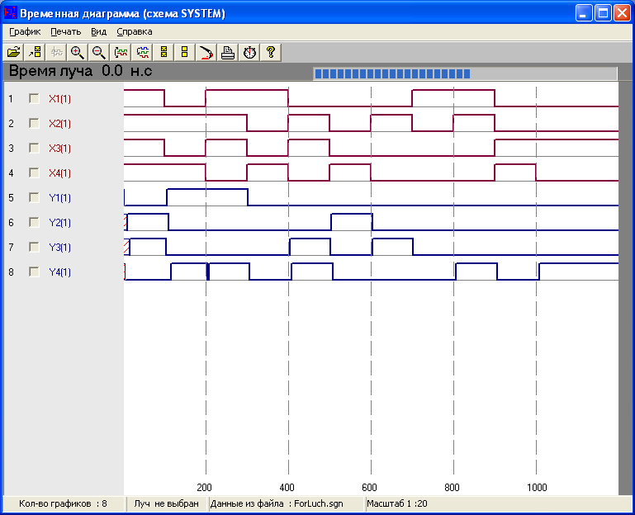

Результаты: с помощью теста был обнаружено импульсное переключение четвёртого выходного сигнала.

5 Описание устройства на языке VHDL

Описание потоковой модели устройства:

library IEEE;
use IEEE.STD_LOGIC_1164.ALL;

entity device is
Port ( X1 : in STD_LOGIC;
X2 : in STD_LOGIC;
X3 : in STD_LOGIC;
X4 : in STD_LOGIC;
Y1 : inout STD_LOGIC;
Y2 : inout STD_LOGIC;
Y3 : inout STD_LOGIC;
Y4 : out STD_LOGIC);
end device;

architecture Behavioral of device is
signal N_X1: STD_LOGIC;
signal N_X2: STD_LOGIC;
signal N_X3: STD_LOGIC;
signal N_X4: STD_LOGIC;
signal N_Y1: STD_LOGIC;
signal N_Y2: STD_LOGIC;
signal N_N_Y2: STD_LOGIC;
signal NA3_X2_NX3_X4: STD_LOGIC;
signal NA2_X4_NY1: STD_LOGIC;
signal NA2_X1_NNY2: STD_LOGIC;
signal NAOA2_x1_x2_x3_nx4: STD_LOGIC;
signal O2_X1_X3: STD_LOGIC;
begin
N_X1 <= not X1 after 1 ns;
N_X2 <= not X2 after 1 ns;
N_X3 <= not X3 after 1 ns;
N_X4 <= not X4 after 1 ns;

Y1 <= not ((N_X1 or N_X3 or X4) and NA3_X2_NX3_X4) after 5 ns;
Y2 <= not (((X1 or X3) and N_X2) or NA2_X4_NY1) after 4 ns;
Y3 <= not ((X1 or N_X2 or X4) and NA2_X1_NNY2) after 5 ns;
Y4 <= not ((O2_X1_X3 or N_N_Y2 or Y3) and NAOA2_x1_x2_x3_nx4) after 5 ns;

N_Y1 <= not Y1 after 1 ns;
N_Y2 <= not Y2 after 1 ns;
N_N_Y2 <= not N_Y2 after 1 ns;

NA3_X2_NX3_X4 <= not(X2 and N_X3 and X4) after 3 ns;
NA2_X4_NY1 <= X4 nand N_Y1 after 2 ns;
NA2_X1_NNY2 <= X1 nand N_N_Y2 after 2 ns;
NAOA2_x1_x2_x3_nx4 <= (((X1 and X2) or X3) nand N_X4) after 4 ns;
O2_X1_X3 <= X1 or X3 after 2 ns;
end Behavioral;

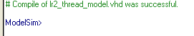

Описание структурной модели устройства:

library IEEE;
use IEEE.STD_LOGIC_1164.ALL;

-------------------------------------
-- N_

entity N is
Port ( X : in STD_LOGIC;
Y : out STD_LOGIC);
end N;

architecture Behavioral of N is
begin
Y <= not X after 1 ns;

end Behavioral;

-------------------------------------
-- NA2

entity NA2 is
Port ( X1 : in STD_LOGIC;
X2 : in STD_LOGIC;
Y : out STD_LOGIC);
end NA2;

architecture Behavioral of NA2 is
begin
Y <= X1 nand X2 after 2 ns;

end Behavioral;

-------------------------------------
-- NA3

entity NA3 is
Port ( X1 : in STD_LOGIC;
X2 : in STD_LOGIC;
X3 : in STD_LOGIC;
Y : out STD_LOGIC);
end NA3;

architecture Behavioral of NA3 is
begin
Y <= not(X1 and X2 and X3) after 3 ns;

end Behavioral;

-------------------------------------
-- NAO3

entity NAO3 is
Port ( X1 : in STD_LOGIC;
X2 : in STD_LOGIC;
X3 : in STD_LOGIC;
X4 : in STD_LOGIC;
Y : out STD_LOGIC);
end NAO3;

architecture Behavioral of NAO3 is
begin
Y <= X1 nand (X2 or X3 or X4) after 5 ns;

end Behavioral;

-------------------------------------
-- NAOA2

entity NAOA2 is
Port ( X1 : in STD_LOGIC;
X2 : in STD_LOGIC;
X3 : in STD_LOGIC;
X4 : in STD_LOGIC;
Y : out STD_LOGIC);
end NAOA2;

architecture Behavioral of NAOA2 is
begin
Y <= X1 nand (X2 or (X3 and X4)) after 4 ns;

end Behavioral;

-------------------------------------
-- NOAO2

entity NOAO2 is
Port ( X1 : in STD_LOGIC;
X2 : in STD_LOGIC;
X3 : in STD_LOGIC;
X4 : in STD_LOGIC;
Y : out STD_LOGIC);
end NOAO2;

architecture Behavioral of NOAO2 is
begin
Y <= X1 nor (X2 and (X3 or X4)) after 4 ns;

end Behavioral;

-------------------------------------
-- O2

entity O2 is
Port ( X1 : in STD_LOGIC;
X2 : in STD_LOGIC;
Y : out STD_LOGIC);
end O2;

architecture Behavioral of O2 is
begin
Y <= X1 or X2 after 2 ns;

end Behavioral;

-------------------------------------

entity device is
Port ( X1 : in STD_LOGIC;
X2 : in STD_LOGIC;
X3 : in STD_LOGIC;
X4 : in STD_LOGIC;
Y1 : inout STD_LOGIC;
Y2 : inout STD_LOGIC;
Y3 : inout STD_LOGIC;
Y4 : out STD_LOGIC);
end device;

architecture Behavioral of device is

component N
Port (
X: in STD_LOGIC;
Y: out STD_LOGIC
);
end component;

component NA2
Port (
X1: in STD_LOGIC;
X2: in STD_LOGIC;
Y: out STD_LOGIC
);
end component;

component NA3
Port (
X1: in STD_LOGIC;
X2: in STD_LOGIC;
X3: in STD_LOGIC;
Y: out STD_LOGIC
);
end component;

component NAO3
Port (
X1: in STD_LOGIC;
X2: in STD_LOGIC;
X3: in STD_LOGIC;
X4: in STD_LOGIC;
Y: out STD_LOGIC
);
end component;

component NAOA2
Port (
X1: in STD_LOGIC;
X2: in STD_LOGIC;
X3: in STD_LOGIC;
X4: in STD_LOGIC;
Y: out STD_LOGIC
);
end component;

component NOAO2
Port (
X1: in STD_LOGIC;
X2: in STD_LOGIC;
X3: in STD_LOGIC;
X4: in STD_LOGIC;
Y: out STD_LOGIC
);
end component;

component O2
Port (
X1: in STD_LOGIC;
X2: in STD_LOGIC;
Y: out STD_LOGIC
);
end component;

signal N_X1: STD_LOGIC;
signal N_X2: STD_LOGIC;
signal N_X3: STD_LOGIC;
signal N_X4: STD_LOGIC;
signal N_Y1: STD_LOGIC;
signal N_Y2: STD_LOGIC;
signal N_N_Y2: STD_LOGIC;
signal NA3_X2_NX3_X4: STD_LOGIC;
signal NA2_X4_NY1: STD_LOGIC;
signal NA2_X1_NNY2: STD_LOGIC;
signal NAOA2_x1_x2_x3_nx4: STD_LOGIC;
signal O2_X1_X3: STD_LOGIC;
begin
N_X1_inst: N
port map(
X => X1,
Y => N_X1
);

N_X2_inst: N
port map(
X => X2,
Y => N_X2
);

N_X3_inst: N
port map(
X => X3,
Y => N_X3
);

N_X4_inst: N
port map(
X => X4,
Y => N_X4
);

N_Y1_inst: N
port map(
X => Y1,
Y => N_Y1
);

N_Y2_inst: N
port map(
X => Y2,
Y => N_Y2
);

N_N_Y2_inst: N
port map(
X => N_Y2,
Y => N_N_Y2
);

NA3_inst: NA3
port map(
X1 => X2,
X2 => N_X3,
X3 => X4,
Y => NA3_X2_NX3_X4
);

NA2_X4_NY1_inst: NA2
port map(
X1 => X4,
X2 => N_Y1,
Y => NA2_X4_NY1
);

NA2_X1_NNY2_inst: NA2
port map(
X1 => X1,
X2 => N_N_Y2,
Y => NA2_X1_NNY2
);

NA0A2_inst: NAOA2
port map(
X1 => N_X4,
X2 => X3,
X3 => X1,
X4 => X2,
Y => NAOA2_x1_x2_x3_nx4
);

O2_inst: O2
port map(
X1 => X1,
X2 => X3,
Y => O2_X1_X3
);

NA03_Y1_inst: NAO3
port map(
X1 => NA3_X2_NX3_X4,
X2 => N_X1,
X3 => N_X3,
X4 => X4,
Y => Y1
);

NOA02_Y2_inst: NOAO2
port map(
X1 => NA2_X4_NY1,
X2 => N_X2,
X3 => X1,
X4 => X3,
Y => Y2
);

NA03_Y3_inst: NAO3
port map(
X1 => NA2_X1_NNY2,
X2 => X1,
X3 => N_X2,
X4 => X4,
Y => Y3
);

NA03_Y4_inst: NAO3
port map(
X1 => NAOA2_x1_x2_x3_nx4,
X2 => O2_X1_X3,
X3 => N_N_Y2,
X4 => Y3,
Y => Y4
);
end Behavioral;

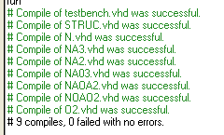

Описание поведенческой модели устройства:

library IEEE;
use IEEE.STD_LOGIC_1164.ALL;

entity device is
Port ( X1 : in STD_LOGIC;
X2 : in STD_LOGIC;
X3 : in STD_LOGIC;
X4 : in STD_LOGIC;
Y1 : inout STD_LOGIC;
Y2 : inout STD_LOGIC;
Y3 : inout STD_LOGIC;
Y4 : out STD_LOGIC);
end device;

architecture Behavioral of device is
begin

Y1 <= (not(X1) or not(X3) or X4) nand not(X2 and not(X3) and X4);
Y2 <= ((X1 or X3) and not(X2)) nor (X4 nand not(Y1));
Y3 <= (X1 or not(X2) or X4) nand (X1 nand not(not(Y2)));
Y4 <= ((X1 or X3) or not(not(Y2)) or Y3) nand (((X1 and X2) or X3) nand not(X4));

end Behavioral;

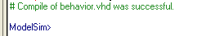

6 Разработка блока тестирования

Описание тестбенча с использованием теста 2:

library IEEE;
use IEEE.STD_LOGIC_1164.ALL;

entity device_tb is
end device_tb;

architecture Behavioral of device_tb is
component device
port (
X1 : in STD_LOGIC;
X2 : in STD_LOGIC;
X3 : in STD_LOGIC;
X4 : in STD_LOGIC;
Y1 : out STD_LOGIC;
Y2 : out STD_LOGIC;
Y3 : out STD_LOGIC;
Y4 : out STD_LOGIC
);
end component;

signal X1: STD_LOGIC := 'X';
signal X2: STD_LOGIC := 'X';
signal X3: STD_LOGIC := 'X';
signal X4: STD_LOGIC := 'X';
signal Y1: STD_LOGIC;
signal Y2: STD_LOGIC;
signal Y3: STD_LOGIC;
signal Y4: STD_LOGIC;
begin

device_inst: device
port map(
X1 => X1,
X2 => X2,
X3 => X3,
X4 => X4,
Y1 => Y1,
Y2 => Y2,
Y3 => Y3,
Y4 => Y4
);

process
begin
wait for 100 ns;
X1 <= '1';
X2 <= '1';
X3 <= '1';
X4 <= '1';
wait for 100 ns;

X1 <= '0';
X2 <= '1';
X3 <= '0';
X4 <= '1';
wait for 100 ns;

X1 <= '1';
X2 <= '1';
X3 <= '1';
X4 <= '0';
wait for 100 ns;

X1 <= '1';
X2 <= '0';
X3 <= '0';
X4 <= '1';
wait for 100 ns;

X1 <= '0';
X2 <= '1';
X3 <= '1';
X4 <= '0';
wait for 100 ns;

X1 <= '0';
X2 <= '0';
X3 <= '0';
X4 <= '1';
wait for 100 ns;

X1 <= '0';
X2 <= '1';
X3 <= '0';
X4 <= '0';
wait for 100 ns;

X1 <= '1';
X2 <= '0';
X3 <= '0';
X4 <= '0';
wait for 100 ns;

X1 <= '1';
X2 <= '1';
X3 <= '0';
X4 <= '0';
wait for 100 ns;

X1 <= '0';
X2 <= '0';
X3 <= '1';
X4 <= '1';
wait for 100 ns;

X1 <= '0';
X2 <= '0';
X3 <= '1';
X4 <= '0';
wait;
end process;

end Behavioral;

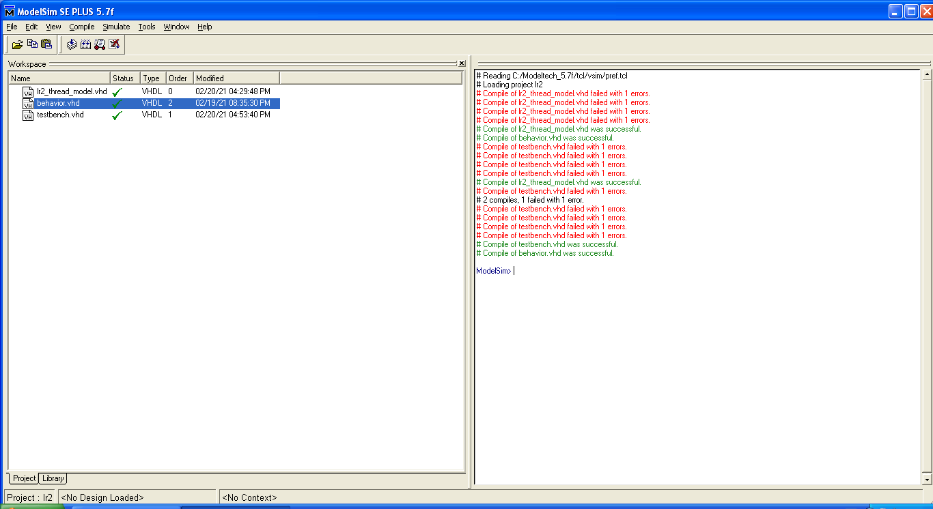

7 Моделирование в системе ModelSim

Моделирование потоковой модели:

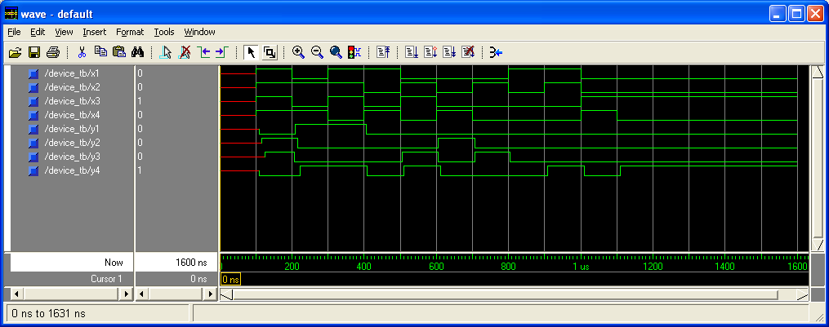

Моделирование структурной модели:

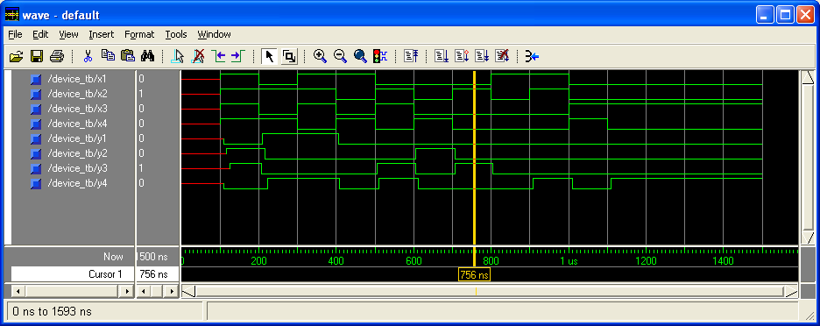

Моделирование поведенческой модели:

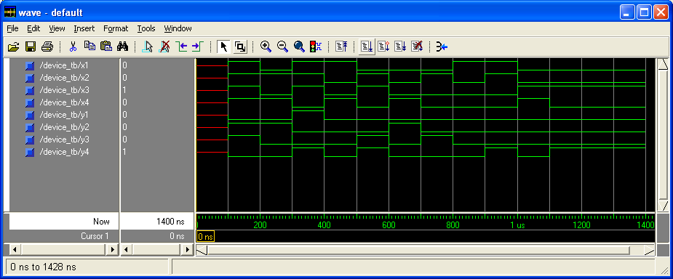

Моделирование в SCA_Time:

8 Анализ полученных результатов

Диаграммы 1, 2 и 4 похожи по значениям выходных сигналов. В четвёртой диаграмме есть импульсное переключение. Диаграмма 3 отличается от остальных различием выходных сигналов на втором тесте – там же, где на диаграмме 4 есть импульсное переключение.

