**Initial Rstudio setup**

When you first open Rstudio, it might not be able to automatically find where the R programming language is installed. If this happens, you will need to manually direct it to the folder in which R is found, as below:

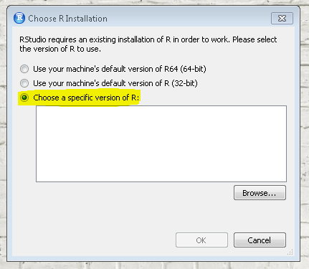

Select “Browse...” and navigate through the following folders to find where R is installed:

This PC > OS (C: ) > Users > Public > R-4.1.3

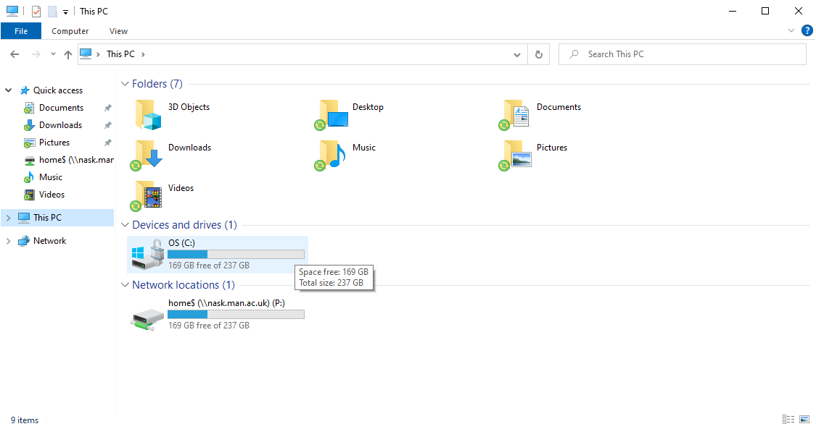

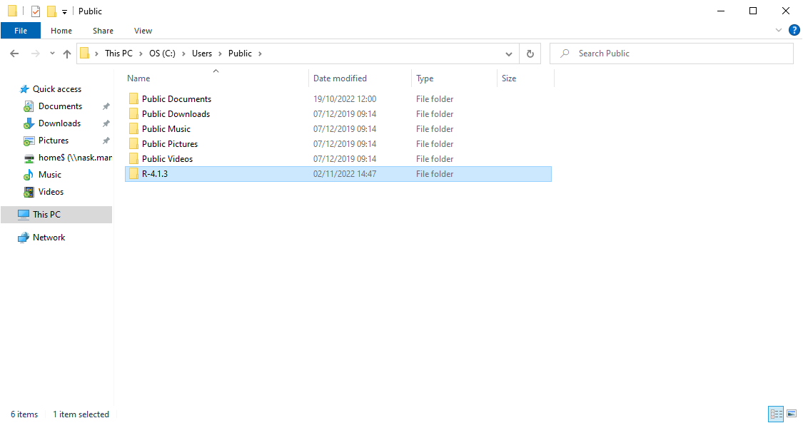

Select the “R-4.1.3” folder and set this as the location of R.

Click “OK” and now Rstudio should be all set up!