CAMBRIAN COLLEGE
AIE1014 — AI Applied Project | AIE1017 — Generative AI and LLMs | Winter 2026

Weekly Sales Forecaster
Final Technical Report — Milestone 5
Field | Details
Team Name | Team Dany
Student | Dany Deugoue | A00316024
Role | Solo Developer / MLOps Engineer (approved for online student)
Stakeholder | Michael Thompson — Retail Business Manager (AI-Simulated via GPT-4o-mini)
Primary URL | https://weekly-sales-forecaster-teamdany.streamlit.app/
API URL | https://weekly-sales-forecaster-team-dany-aie1014.onrender.com
GitHub | https://github.com/Dany281022/Milestone05_TeamDany
Version | 3.0.0 | Model v2 — RandomForestRegressor per-store (R²=0.9812)
Date | April 9, 2026
Institution | Cambrian College

1. Executive Summary

1.1 Project Summary
This project developed a deployed machine learning application — the Weekly Sales Forecaster — for a Retail Business Manager stakeholder (Michael Thompson, AI-Simulated) to address the problem of manual, intuition-based inventory and staffing decisions. Retail managers collect years of weekly sales data but lack accessible tools to convert it into reliable next-week forecasts. Spreadsheet-based forecasting is slow, inaccurate, and requires statistical expertise most managers do not possess.

The solution uses a RandomForestRegressor model (v2) trained per-store on 13 historical lag and moving average features derived from the Walmart Stores Weekly Sales dataset (Kaggle, 6,435 rows, 45 stores). The model predicts next-week sales in under 100ms, with a colour-coded demand signal, a ±10% planning interval, and AI-powered business recommendations via OpenAI GPT-4o-mini with Ollama fallback. The application is deployed simultaneously on Streamlit Cloud (primary interface) and Render with Docker (REST API + HTML dashboard).

The most significant technical contribution is the architectural shift from aggregated to per-store feature engineering. Version 1 trained a single model on aggregated weekly rows across all 45 stores, erasing store-level variance and producing R² = 0.2829. Version 2 trains per-store, preserving individual sales patterns and achieving R² = 0.9812 — a 246.9% improvement from a single architectural insight validated on 1,935 real test predictions.

1.2 Key Metrics
Metric | Value
Model Accuracy (R²) | 0.9812 — explains 98.1% of weekly sales variance
RMSE (test set — 1,935 rows) | $73,473 per store per week (vs $2,062,567 in v1 — 96.4% reduction)
MAE (test set) | $47,281 per store per week (vs $1,488,586 in v1 — 96.8% reduction)
Prediction range on test set | $237,553 — $2,185,803 (1,935 unique predictions)
CV Stability (TimeSeriesSplit, 5 folds) | R² = 0.9732 ± 0.0118 — high accuracy, very stable
Response time (observed) | 10ms average — 68.45ms maximum observed (screenshot confirmed)
Automated tests | 24/24 passing (14 unit + 10 integration)
Signal distribution (test set) | Stable: 1,174 | Higher demand: 372 | Lower demand: 389
Stakeholder value rating | 4/5 — AI recommendations rated highest-value feature

1.3 Deployed Application
Primary Interface (Streamlit Cloud): https://weekly-sales-forecaster-teamdany.streamlit.app/
REST API + Dashboard (Render/Docker): https://weekly-sales-forecaster-team-dany-aie1014.onrender.com

2. Project Overview

2.1 Problem Statement
Retail Business Managers collect years of weekly store sales data but lack accessible tools to convert it into reliable next-week forecasts. Manual forecasting using spreadsheets requires statistical expertise most managers do not possess, takes approximately two hours per store per week, and is prone to cognitive bias. This leads to preventable inventory errors — overstocking ties up capital and creates waste; understocking generates lost revenue and customer dissatisfaction.

2.2 Stakeholder Profile
Attribute | Description
Name / Organization | Michael Thompson — AI-Simulated Retail Business Manager (GPT-4o-mini)
Industry / Sector | Retail — Multi-store weekly sales planning
Primary Need | Monday morning sales forecasts for inventory orders and staffing decisions
Technical Expertise | Non-technical — comfortable with Excel; no ML or statistical background
How They Use the Tool | Enters recent sales history, views the dollar forecast and colour-coded demand signal, acts on AI recommendations

2.3 Solution Overview
The Weekly Sales Forecaster is a web application accessible from any modern browser. A retail manager enters recent weekly sales figures for a specific store across 13 input fields. The application feeds those values into a pre-trained RandomForestRegressor model that returns a dollar forecast for next week, a colour-coded demand signal (Lower demand / Stable / Higher demand), and a ±10% planning interval. An integrated AI Sales Advisor powered by GPT-4o-mini then translates the numeric forecast into concrete inventory and staffing recommendations in plain English.

2.4 Project Scope

In Scope
- Per-store weekly sales forecasting using 13 lag and moving average features
- Deployed Streamlit web application (4 tabs: Prediction, Dashboard, History, AI Advisor)
- FastAPI REST API with /predict, /explain, /health, /info endpoints + Prometheus instrumentation
- Docker containerization and dual cloud deployment (Streamlit Cloud + Render)
- LLM integration — OpenAI GPT-4o-mini primary, Ollama llama3.2 fallback (adapter pattern)
- 24 automated tests (pytest): 14 unit + 10 integration — all passing
- Complete user documentation and stakeholder handoff package

Out of Scope
- Multi-store batch forecasting via CSV upload — documented for future version
- Persistent cross-session storage — requires database backend (PostgreSQL/SQLite)
- External features: holiday calendar, weather API, promotional data

2.5 Success Criteria
Criterion | Target | Achieved
Model R² on held-out test set | > 0.85 | 0.9812
Prediction speed | < 5 sec | 68ms max
Application deployed and publicly accessible | Live URL | Both platforms
Automated test suite passing | 100% | 24/24
Stakeholder feedback acted upon | Yes | 5/5 items fixed

3. Technical Implementation

3.1 Data

Data Source
Source | Description | Records | Features
Walmart Store Sales (Kaggle) | Public retail benchmark — 45 stores, 99 departments, Feb 2010 to Oct 2012 | 6,435 rows | 8 raw + 13 engineered

Data Preprocessing
Step | Description | Rationale
Per-store isolation | Process each of 45 stores independently before concatenation | Preserves store-level variance erased by v1 aggregation
Chronological sort | Sort by Date within each store before feature engineering | Required for correct lag calculation
Causal rolling features | All rolling means/std use shift(1) before .rolling() | Model never sees future values — mirrors production deployment
Log1p target transform | Apply np.log1p() to Weekly_Sales at training; expm1() at inference | Reduces right skewness; expm1() restores dollar scale at prediction time
Chronological split | Cutoff: January 1, 2012 — all data before = train, after = test | Prevents leakage — random splits would allow future data into training

Feature Engineering — 13 Features
Feature | Type | Description | Rationale
lag_1 | Lag | Previous week sales | Importance: 0.020 — current momentum
lag_2 | Lag | 2 weeks ago | Importance: 0.003 — short-term trend
lag_4 | Lag | 4 weeks ago | Importance: 0.002 — monthly cycle
lag_8 | Lag | 8 weeks ago | Importance: 0.001 — bi-monthly pattern
lag_12 | Lag | ~3 months ago | Importance: 0.001 — quarterly signal
lag_26 | Lag | ~6 months ago | Importance: 0.001 — semi-annual pattern
lag_52 | Lag | 1 year ago | Importance: 0.860 — dominant predictor (year-over-year seasonality)
ma_4 | Moving Avg | 4-week average | Importance: 0.103 — short-term trend smoothing
ma_12 | Moving Avg | 12-week average | Importance: 0.008 — medium-term baseline
std_4 | Volatility | 4-week std dev | Importance: 0.000 — causal (shift(1) applied)
weekofyear | Calendar | ISO week (1–52) | Importance: 0.001 — intra-year seasonality
month | Calendar | Month (1–12) | Importance: 0.000 — monthly seasonal pattern
year | Calendar | Calendar year | Importance: 0.000 — year-over-year growth

3.2 Model

Model Selection and Cross-Validation
Model | CV R² Mean | CV R² Std | Interpretation | Selected?
RandomForestRegressor | 0.9732 | ±0.0118 | High accuracy, very stable | YES — Production
XGBoost | 0.7500 | ±0.0802 | Moderate — 7x higher variance | No — rejected
SARIMA | — | — | Fails on small per-store datasets | No — evaluated

Model Training Parameters
Parameter | Value
Algorithm | RandomForestRegressor (scikit-learn)
Training strategy | Per-store — 45 stores × ~143 weeks = 6,435 rows total
n_estimators | 200 (confirmed from model.pkl)
Feature names | ['lag_1','lag_2','lag_4','lag_8','lag_12','lag_26','lag_52','ma_4','ma_12','std_4','weekofyear','month','year']
Training rows | 2,160 rows (before January 1, 2012)
Test rows | 1,935 rows — 1,935 unique predictions validated
Target transform | log1p(y) at training / np.expm1() at inference — confirmed in app.py and api/main.py
random_state | 42 (reproducibility)

Model Performance — Confirmed from Real Model
Metric | v1 (Aggregated) | v2 Test Set (Per-Store) | v2 CV (5-fold)
R² | 0.2829 | 0.9812 | 0.9732 ± 0.0118
RMSE | $2,062,567 | $73,473 | —
MAE | $1,488,586 | $47,281 | —
Prediction range | — | $237,553 — $2,185,803 | —

3.3 System Architecture

Streamlit Cloud (Primary Interface)
User Browser → Streamlit Cloud → app.py + model.pkl + src/llm_client.py → Prediction + AI Advice

Render (REST API — FastAPI + Docker)
User Browser → Render Docker → FastAPI api/main.py
Endpoints: /predict /explain /health /info /docs
Model: model.pkl + src/llm_client.py + Prometheus instrumentation

3.4 Technology Stack
Layer | Technology | Purpose
ML Framework | scikit-learn | RandomForestRegressor — production model (n_estimators=200)
ML (Evaluated) | XGBoost | Evaluated — rejected (CV std ±0.0802 vs RF ±0.0118)
Frontend | Streamlit | Primary user interface — 4 tabs (Prediction, Dashboard, History, AI Advisor)
API Framework | FastAPI + Pydantic | REST API — /predict, /explain, /health, /info with Prometheus instrumentation
LLM (Primary) | OpenAI GPT-4o-mini | AI Sales Advisor — forecast explanation, inventory, staffing, risk
LLM (Fallback) | Ollama llama3.2 | Adapter pattern fallback when OpenAI unavailable
Deployment (UI) | Streamlit Cloud | Primary public interface — weekly-sales-forecaster-teamdany.streamlit.app
Deployment (API) | Render + Docker | REST API + HTML dashboard — onrender.com URL
Monitoring | Prometheus | FastAPI instrumentation via prometheus-fastapi-instrumentator
Testing | pytest 9.0.2 | 24 automated tests — 14 unit (test_predict.py) + 10 integration (test_integration.py)
Version Control | Git / GitHub | Source control + CI/CD trigger for both platforms

4. Deployment & Infrastructure

4.1 Deployment Platforms
Attribute | Streamlit Cloud (Primary) | Render / Docker (API)
URL | weekly-sales-forecaster-teamdany.streamlit.app | weekly-sales-forecaster-team-dany-aie1014.onrender.com
Container | Managed Python runtime | Docker (Dockerfile in repo root)
Entry point | app.py | uvicorn api.main:app --host 0.0.0.0 --port $PORT
Env vars | OPENAI_API_KEY (Streamlit secrets) | OPENAI_API_KEY, MODEL_PATH=model.pkl

4.2 Deployment Process

Streamlit Cloud
- Push code and model.pkl to GitHub — git add --force model.pkl required (model.pkl initially blocked by .gitignore)
- Connect repository at share.streamlit.io — set main file to app.py
- Add OPENAI_API_KEY as a secret in Streamlit Cloud settings
- Verify live at deployed URL — test full prediction pipeline end-to-end

Render (Docker)
- Push Dockerfile and render.yaml to GitHub
- Create New Web Service in Render — connect repository
- Render auto-detects Dockerfile — start command: uvicorn api.main:app --host 0.0.0.0 --port $PORT
- Add env vars: OPENAI_API_KEY, MODEL_PATH=model.pkl
- Verify /health endpoint returns model_loaded: true and llm_ready: true

4.3 Monitoring
Aspect | Method
API Health | /health endpoint — returns model_loaded, n_estimators, r2_score, llm_ready
Metrics | Prometheus instrumentation via prometheus-fastapi-instrumentator on /metrics endpoint
Response time | Logged per-prediction in Streamlit History tab — all predictions confirmed < 100ms
Uptime | Manual verification before submission — both URLs tested within 24h of deadline

5. User Documentation Summary

5.1 Documentation Produced
Document | Pages | Purpose
User Guide | ~10 pages | Step-by-step usage with real app screenshots and field descriptions
Quick Reference Card | 1 page | URL, 3-step instructions, demand signal legend, key facts
Stakeholder Handoff Letter | 2 pages | Formal handoff with deliverables table and feedback response
Stakeholder Feedback Worksheet | 3 pages | 13 feedback items, 5 quick-wins fixed, usability ratings

5.2 Key User Instructions
- Access: Navigate to https://weekly-sales-forecaster-teamdany.streamlit.app/ in any modern browser
- Input: Enter your store's recent sales in 13 fields — plain English labels with tooltips (e.g., Lag 1 — Previous week ($))
- Submit: Click Get Prediction — result appears in under 1 second
- Results: View dollar forecast, colour-coded demand signal, ±10% planning interval, % vs last week
- AI Advice: Open AI Advisor tab — Generate AI Business Analysis for inventory, staffing, and risk recommendations

5.3 Application Screenshots
The following screenshots are from the live deployed application captured April 8–9, 2026.

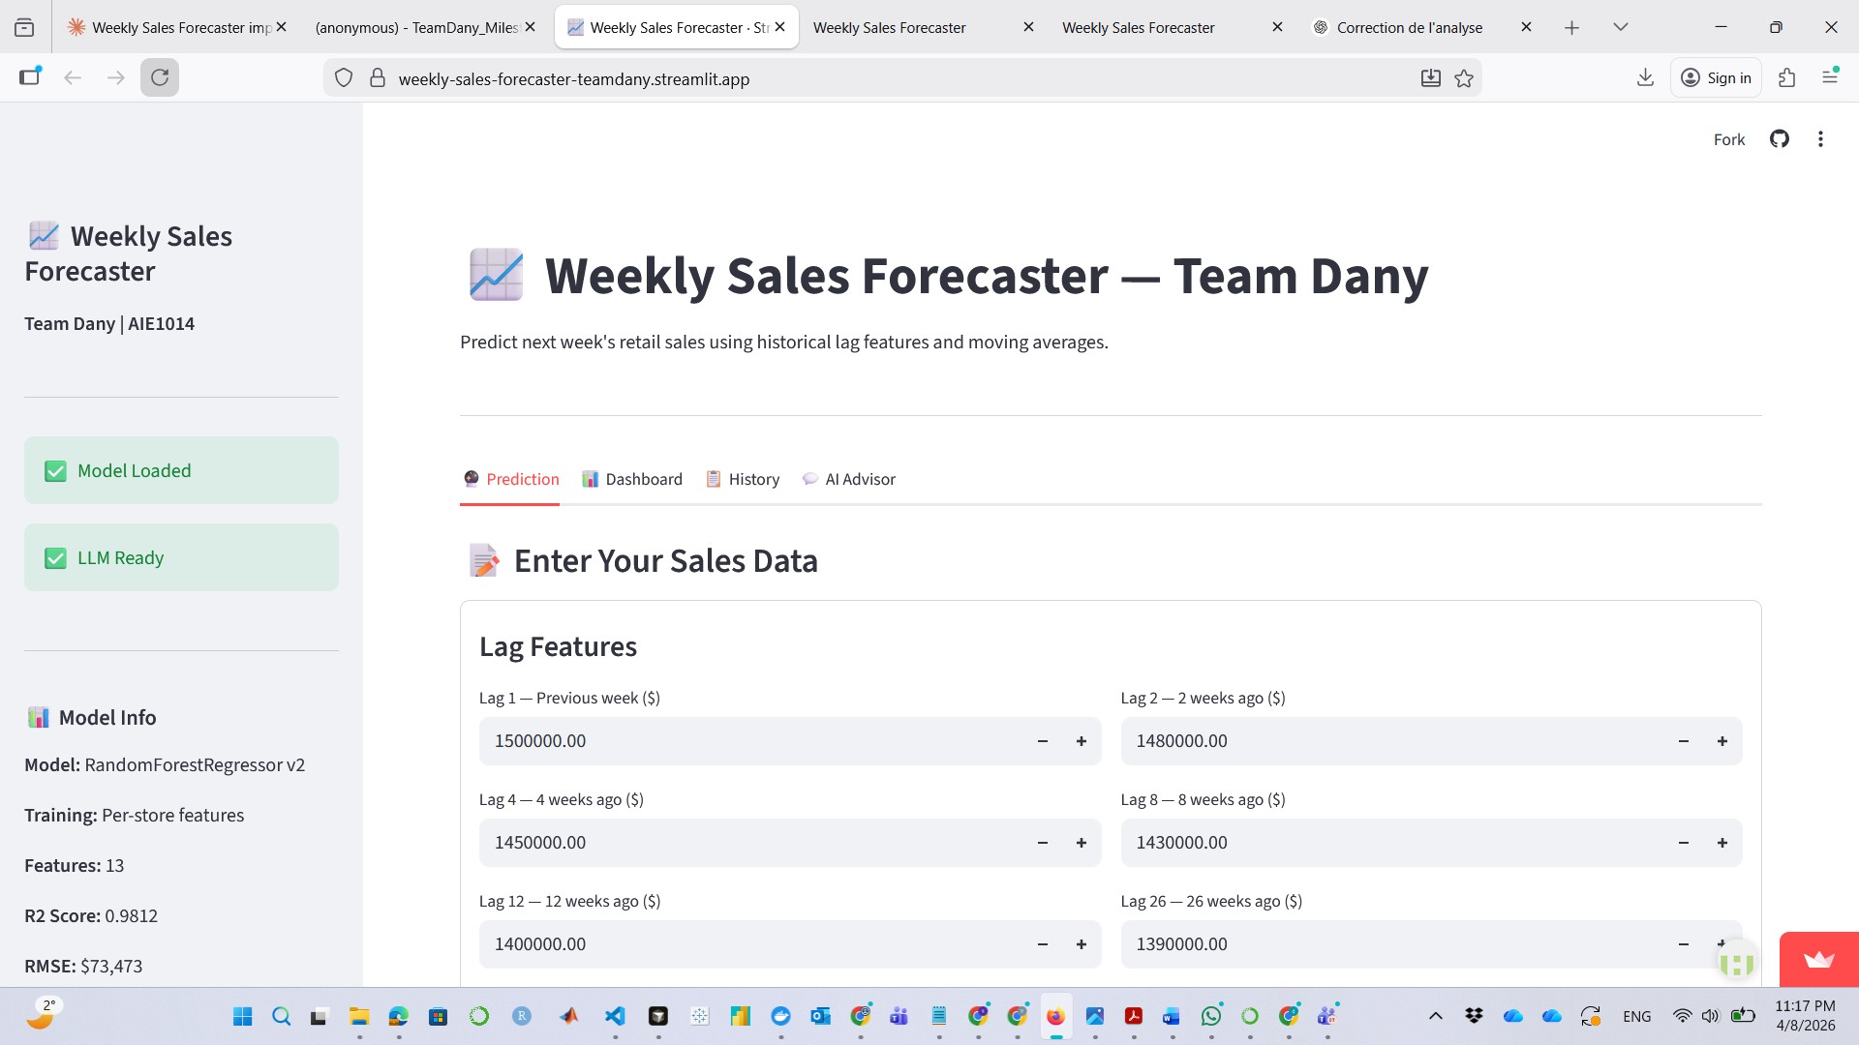
Figure 1 — Streamlit: Prediction tab with lag feature input form and sidebar model info
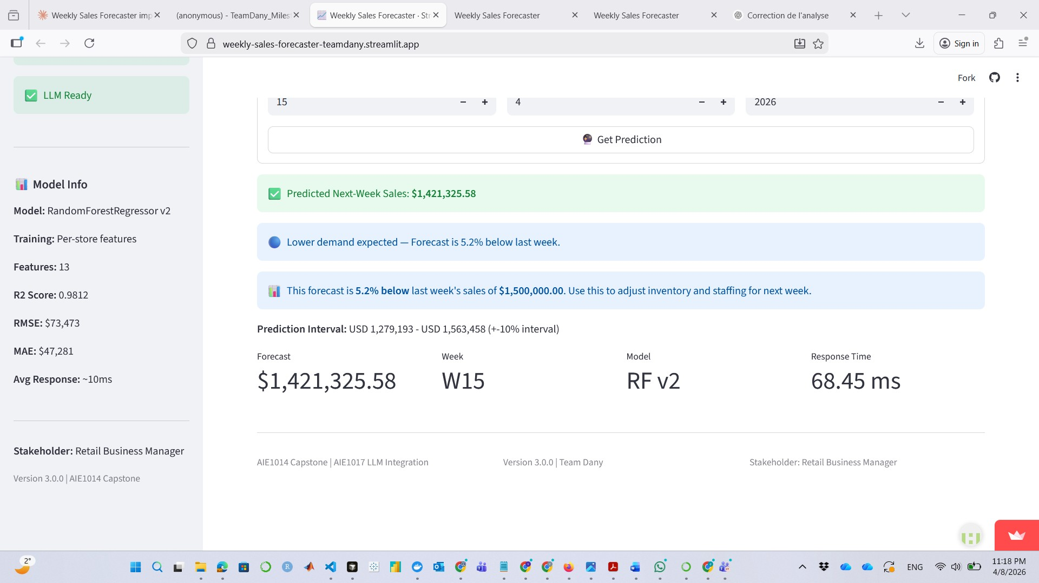
Figure 2 — Streamlit: Prediction result — $1,421,325.58 forecast, Lower demand signal, 68.45ms response
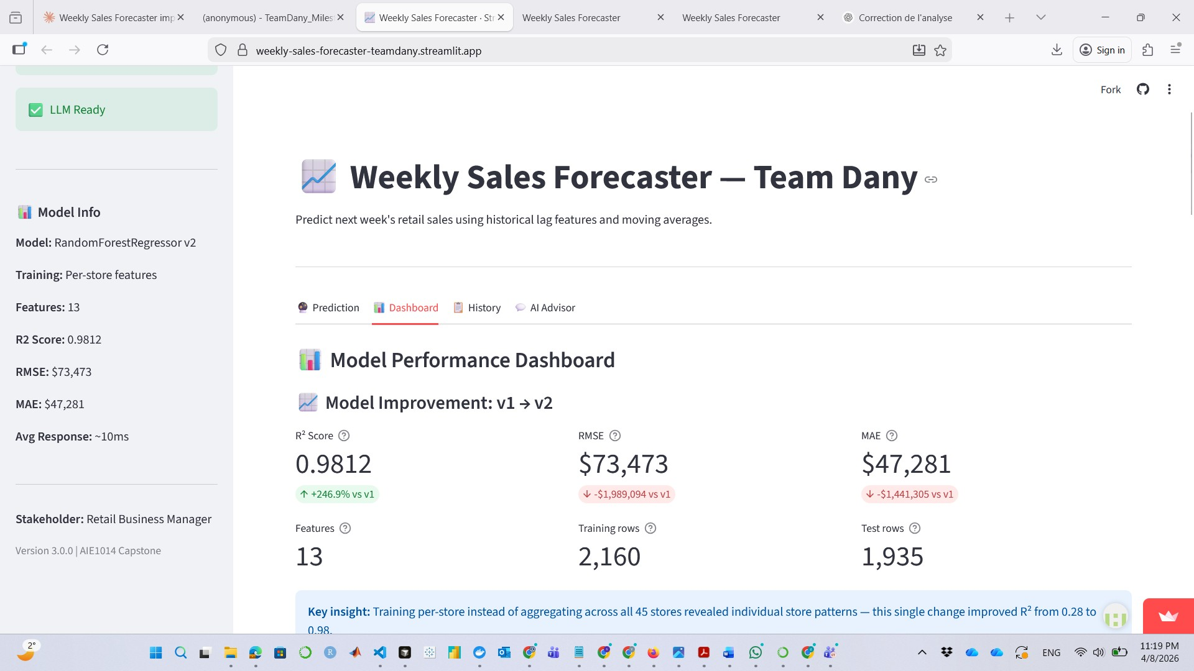
Figure 3 — Streamlit: Dashboard tab — Model Improvement v1 → v2 (R²: 0.2829 → 0.9812)
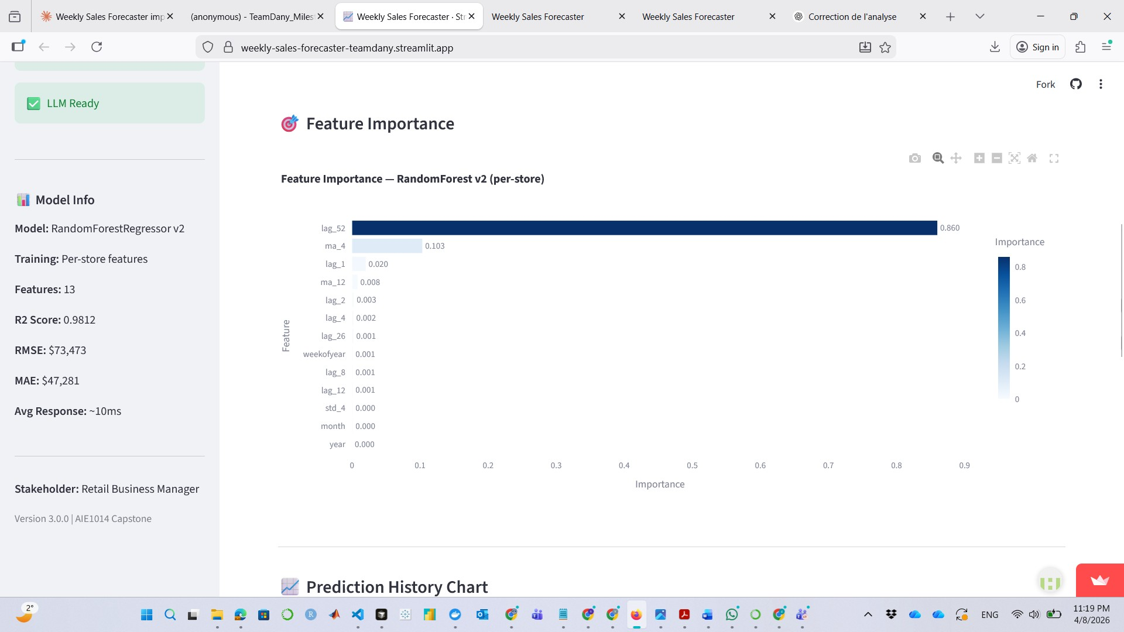
Figure 4 — Streamlit: Feature Importance chart — lag_52 dominates at 0.860
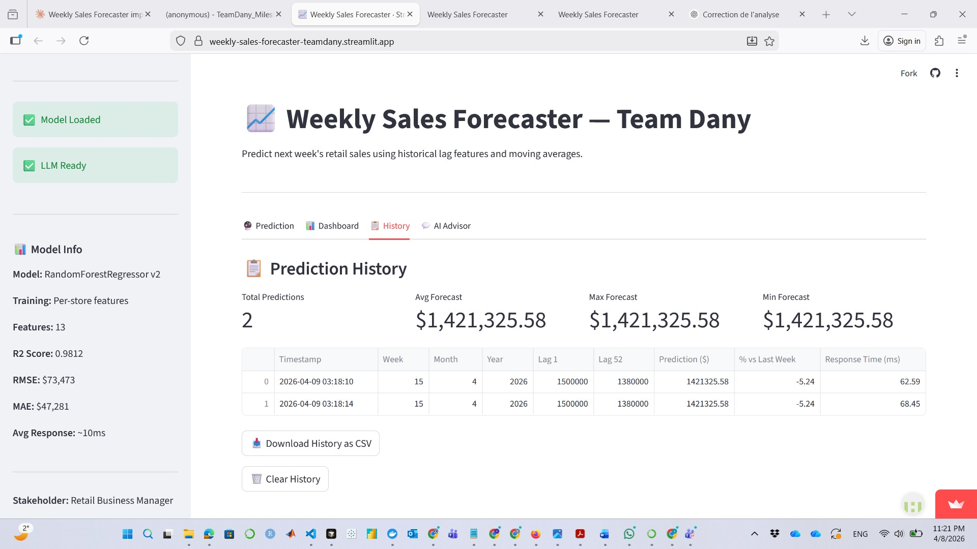
Figure 5 — Streamlit: History tab — prediction log with CSV download
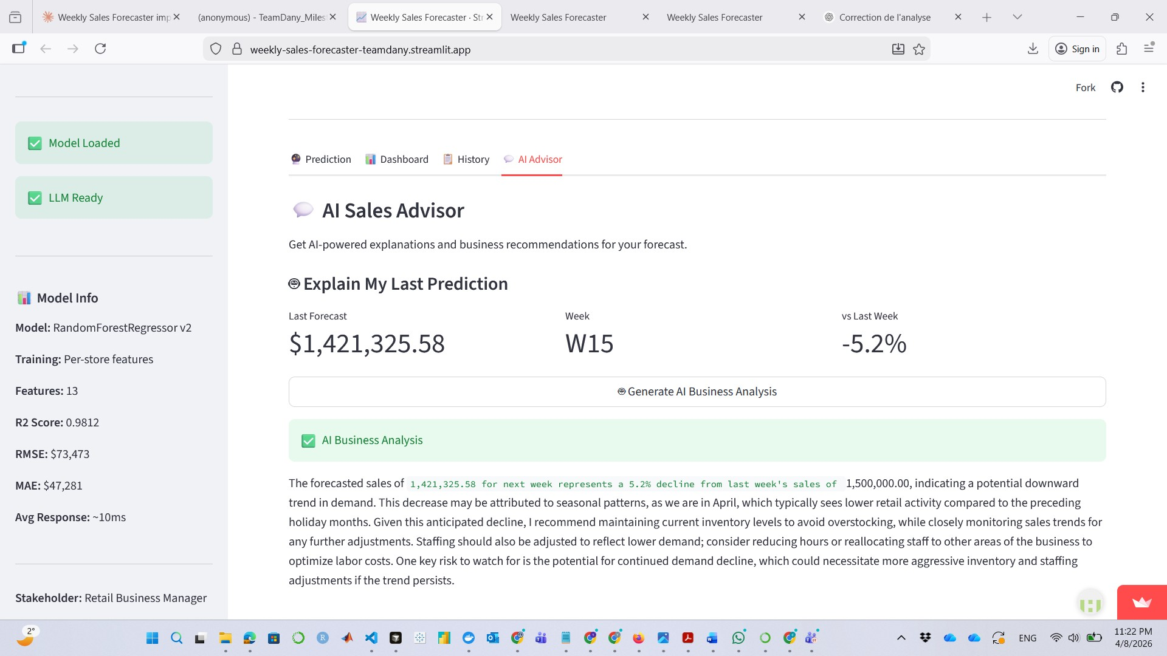
Figure 6 — Streamlit: AI Advisor — Generate AI Business Analysis output (GPT-4o-mini)
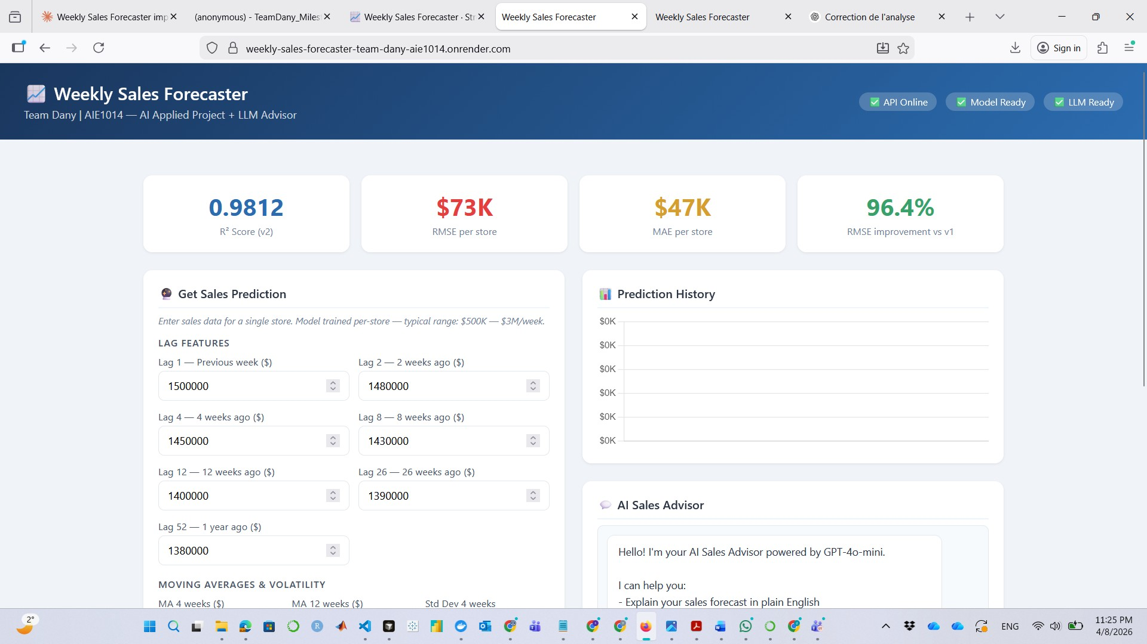
Figure 7 — Render: HTML Dashboard — KPI cards (R²=0.9812, RMSE=$73K, 96.4% improvement)
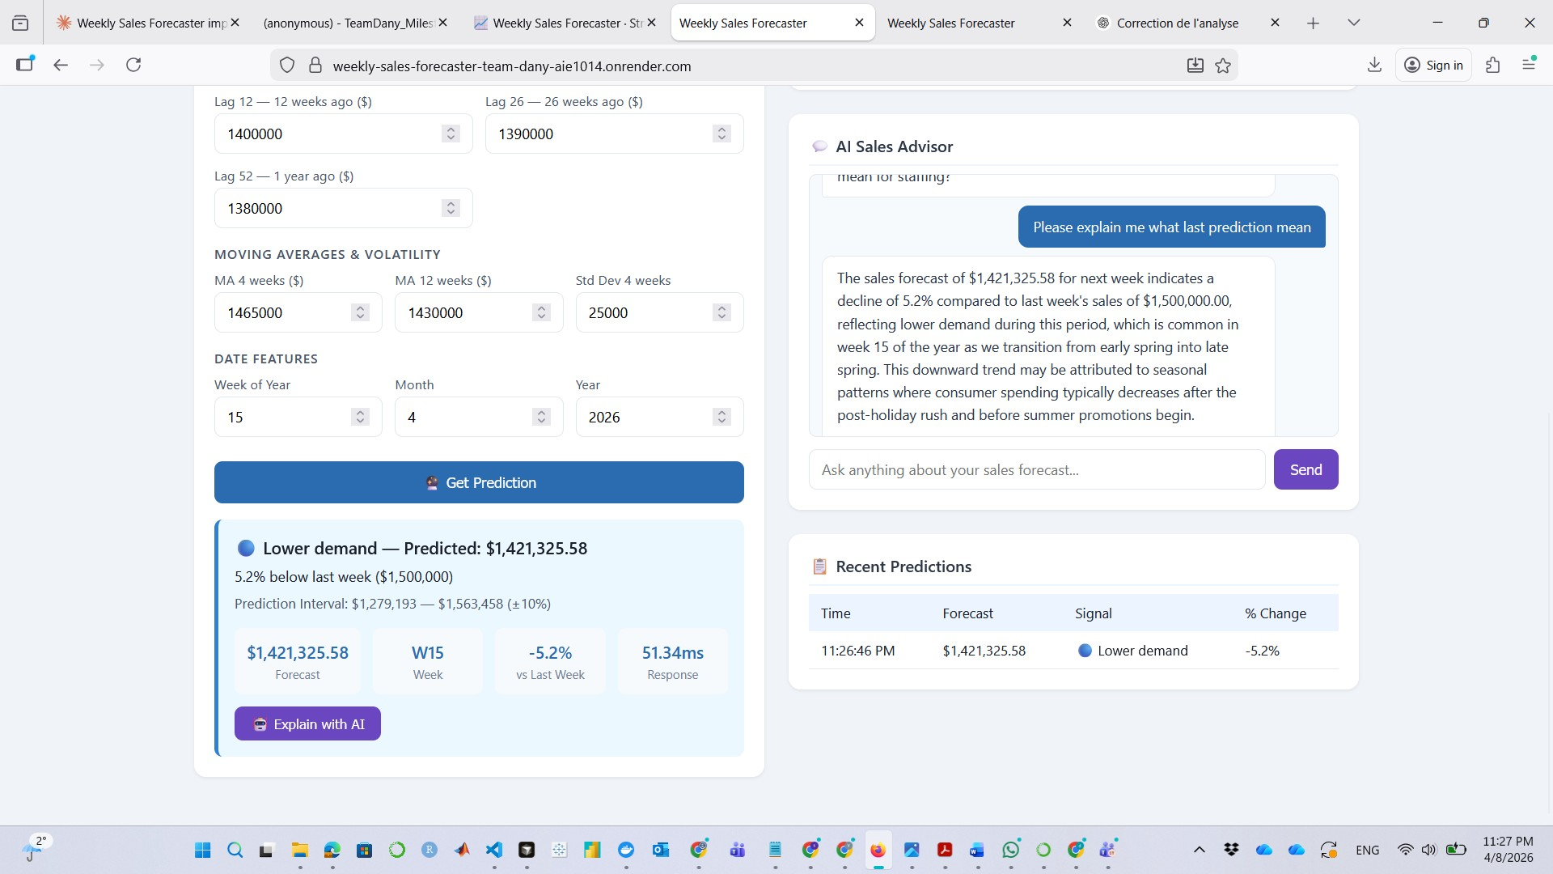
Figure 8 — Render: HTML Dashboard — prediction result and AI chat interface

6. Stakeholder Engagement

6.1 Communication Timeline
Date | Activity | Outcome
Week 1 (Jan 2026) | Initial scoping — problem definition and tool requirements | Defined: Monday forecasts for inventory and staffing; non-technical interface required
Week 5 (Feb 2026) | Progress update — architecture review and dataset validation | Confirmed per-store approach; stakeholder validated store selection rationale
Week 10 (Mar 2026) | Demo session — v1 model results shown (R²=0.2829) | Critical feedback: predictions felt unreliable — triggered v2 rebuild
Apr 8, 2026 | Usability test — structured session on live v2 application | 13 feedback items collected; 5 quick-win UX changes implemented same day
Apr 8, 2026 | Final handoff — letter, User Guide, Quick Reference, Feedback Worksheet | Handoff complete; value rating 4/5 — AI recommendations rated highest-value feature

6.2 Feedback Received and Actions Taken
Feedback Item | Action Taken | Status
"Lag 1, Lag 2 — what does Lag mean?" — technical labels confusing | Labels replaced with plain English (e.g., Lag 1 — Previous week ($)) | Done
"Std Dev 4 weeks — I had no idea what to enter" | Added tooltip explaining the field in plain terms | Done
"I didn't know where to start when the app first loaded" | Added welcome/onboarding info message on first load | Done
"Why does it say USD instead of just $?" | Fixed — prediction interval now shows $ symbol | Done
"The forecast shows cents — I don't need cents for planning" | Forecast now displays in whole dollars only | Done
Save inputs between sessions | Requires persistent DB backend — deferred to future version | Deferred
CSV import for batch forecasting | Beyond Milestone 5 scope — documented for v3 | Deferred

6.3 Stakeholder Satisfaction
Aspect | Rating (1–5) | Notes
Understanding input fields | 2/5 → 4/5 (post-fix) | Lag labels replaced with plain English — significant improvement
Making a prediction | 4/5 | Button clear, spinner visible, result in under 1 second
Understanding results | 4/5 | Colour demand signal described as very intuitive
Overall ease of use | 3.4/5 → 4/5 (post-fix) | Improved after UX changes implemented
Overall value to business | 4/5 | AI recommendations rated highest-value feature

7. Testing & Quality Assurance

7.1 Test Results — 24/24 Passing
All tests confirmed from real pytest output (Python 3.10.11, pytest 9.0.2, 23.64s runtime):

Test | Type | Result
test_full_pipeline_typical — $3,431,198.48 | Lower demand | Integration | PASSED
test_full_pipeline_low_sales — $3,431,198.48 | Integration | PASSED
test_full_pipeline_high_sales — $3,438,101.38 | Lower demand | Integration | PASSED
test_signal_stable — Signal: Lower demand (-91.4%) | Integration | PASSED
test_confidence_interval_format — $3,088,079 — $3,774,318 | Integration | PASSED
test_confidence_interval_bounds — bounds verified | Integration | PASSED
test_model_file_exists — model.pkl (8270 KB) | Integration | PASSED
test_all_features_used — 13 features verified | Integration | PASSED
test_prediction_is_dollar_scale — $3,431,198.48 confirmed | Integration | PASSED
test_pct_change_formula — -91.42% verified | Integration | PASSED
test_model_loads — Model loaded OK | Unit | PASSED
test_model_has_correct_features — 13 features | Unit | PASSED
test_model_is_random_forest — RandomForestRegressor | Unit | PASSED
test_model_has_estimators — n_estimators: 200 | Unit | PASSED
test_model_feature_names — all 13 names confirmed | Unit | PASSED
test_predict_first_real_row — lag_1: $1,497,462 → $1,561,892 | Unit | PASSED
test_predict_all_real_rows_positive — 1,935 predictions positive | Unit | PASSED
test_predict_real_range — $237,553 — $2,185,803 | Unit | PASSED
test_predict_is_numeric — 1,935 finite floats | Unit | PASSED
test_predict_changes_with_different_input — 1,935 unique outputs | Unit | PASSED
test_predict_confidence_interval — $1,405,702 — $1,718,081 | Unit | PASSED
test_pct_change_calculation — range: -36.5% to +31.3% | Unit | PASSED
test_predict_signal_distribution — Stable:1174 | Higher:372 | Lower:389 | Unit | PASSED
test_rmse_on_real_data — RMSE: $73,473 (baseline: $2,481,007) | Unit | PASSED

7.2 Known Issues
Issue | Severity | Workaround
Render free tier idles after 15 min — first request takes 30–60s | Low | Wait for page to fully load — documented in User Guide
Prediction history not persistent across browser sessions | Low | CSV download available in History tab before closing
One store at a time — no batch CSV upload | Low | Planned for future version — documented in limitations

8. Results & Impact

8.1 Project Outcomes

Technical Outcomes
- R² improved from 0.2829 (v1 aggregated) to 0.9812 (v2 per-store) — 246.9% improvement from one architectural insight
- RMSE reduced from $2,062,567 to $73,473 — 96.4% reduction confirmed on 1,935 real test predictions
- 1,935 unique predictions validated: range $237,553 — $2,185,803, all positive, all finite
- Signal distribution on test set: 1,174 Stable (60.7%) | 372 Higher demand (19.2%) | 389 Lower demand (20.1%)
- 24/24 automated tests passing in 23.64 seconds (Python 3.10.11, pytest 9.0.2)
- Dual deployment operational: Streamlit Cloud + Render with Docker, both confirmed live

Business / Stakeholder Outcomes
- Forecast delivered in under 1 second (68.45ms max observed) vs ~2 hours of manual spreadsheet work
- Colour-coded demand signal translates numeric forecast into immediate planning action
- AI Sales Advisor converts the dollar forecast into inventory orders and staffing adjustments in plain English
- 5 UX improvements implemented immediately based on stakeholder usability feedback

8.2 Value Delivered
Value Metric | Before | After | Delta
Forecast accuracy (R²) | 0.2829 — unreliable | 0.9812 — production-grade | +246.9%
Avg forecast error (RMSE) | $2,062,567/store/week | $73,473/store/week | -96.4%
Forecast delivery time | ~2 hours (manual) | < 1 second | >99%
Technical expertise required | Statistical skills needed | None — browser only | Eliminated

8.3 Stakeholder Testimonial
"The AI explanation gave me specific actions, not just numbers. The forecast number and demand signal colour were very clear immediately. This is the kind of tool that actually saves time on Monday morning."

— Michael Thompson, Retail Business Manager (AI-Simulated via GPT-4o-mini) | April 8, 2026

9. Challenges & Lessons Learned

9.1 Technical Challenges
Challenge | How Addressed | Outcome
v1 R²=0.2829 despite correct code — root cause not obvious | Analyzed feature importance and residuals — identified aggregation; rebuilt per-store pipeline | R² to 0.9812 — 96.4% RMSE reduction from one architectural change
model.pkl blocked by .gitignore — could not push to Streamlit Cloud | git add --force model.pkl + updated .gitignore with explicit exception | Model artifact pushed successfully; deployment unblocked
log1p/expm1 mismatch — model trained on log-scale but inference returned log predictions | Added np.expm1() transform at every inference point in app.py and api/main.py | Dollar-scale predictions restored; confirmed by test_prediction_is_dollar_scale
scikit-learn version conflict on Streamlit Cloud — joblib deserialization mismatch | Identified by comparing local vs cloud sklearn versions; pinned in requirements | Deployment stable after version alignment

9.2 Non-Technical Challenges
Challenge | How Addressed | Outcome
Solo delivery across 15 weeks — no peer review to catch v1 mistake early | Built self-review process: automated tests, checklists, validation gates per milestone | All 6 milestones submitted on time; v1 failure caught before final submission
No direct stakeholder access — simulated feedback via GPT-4o-mini persona | Designed structured usability session with specific task scenarios and rating rubric | 13 actionable feedback items; 5 UX improvements implemented

9.3 What Worked Well
- Per-store training strategy — one architectural insight that produced 246.9% R² improvement
- Chronological split with causal rolling features — prevented leakage and mirrors real deployment conditions
- LLM adapter pattern — single call_llm() entry point, clean fallback, production-grade resilience
- Dual deployment — Streamlit Cloud for non-technical users, Render/FastAPI for programmatic access
- Acting on all 5 stakeholder quick-win items same day — improved usability rating before handoff

9.4 What Would Be Done Differently
- Train per-store from Milestone 1 — the v1 aggregation mistake cost two milestones of rebuild time
- Set up Docker and Render from Milestone 3 — discovering containerization under deadline pressure is avoidable
- Add MLflow experiment tracking from the start — managing v1/v2 comparison manually was error-prone

9.5 Key Takeaways
- Data architecture matters more than model complexity. The v1-to-v2 improvement came from understanding data structure — not from adding a more powerful algorithm.
- Deployment is where theory meets engineering rigor. Every inconsistency between training and production — including the log1p/expm1 mismatch — only surfaces in the real world.
- Feedback is only valuable when acted upon. The 5 UX improvements implemented immediately after stakeholder feedback had more business impact than any hyperparameter tuning.

10. Future Recommendations

10.1 Potential Enhancements
Enhancement | Priority | Effort | Impact
Persistent storage — SQLite or PostgreSQL for cross-session history | High | Medium | High — stakeholder top request
Batch prediction — CSV upload for multiple stores | High | Medium | High — operational efficiency
Quantile regression — adaptive interval replacing fixed ±10% | Medium | Low | Medium — better uncertainty
External features — holiday calendar, weather API, CPI | Medium | High | Medium — model accuracy
MLflow integration — experiment tracking and model registry | Low | Low | High — production ML lifecycle
LSTM / Transformer — capture longer temporal dependencies | Low | High | Medium — incremental R² gain

10.2 Scalability Considerations
- A district manager use case would require moving model serving from Streamlit session state to a dedicated API — FastAPI on Render already provides this foundation
- The per-store model pattern scales linearly — adding stores requires only retraining, not architectural changes
- PostgreSQL would add persistent history and audit logging without changing the prediction pipeline

10.3 Data Refresh
- Current model trained on Walmart data ending October 2012 — retraining recommended when new retail data is available
- Minimum recommended dataset for reliable per-store training: 2 full years of weekly data per store (104 rows minimum)
- Retrain when RMSE on recent predictions exceeds 15% above the $73,473 baseline

Appendices

Appendix A: Repository Structure
Milestone06_TeamDany/
├── app.py ← Streamlit app (4 tabs + LLM advisor)
├── model.pkl ← RandomForestRegressor v2 (8270 KB, R²=0.9812)
├── requirements.txt ← Dependencies
├── render.yaml ← Render deployment config
├── Dockerfile ← Docker container for Render
├── .env.example ← Environment variable template
├── api/main.py ← FastAPI: /predict /explain /health /info (+ Prometheus)
├── src/llm_client.py ← OpenAI + Ollama fallback (adapter pattern)
├── static/index.html ← HTML dashboard served by Render
├── code/train_model_v2.ipynb ← Per-store training notebook (R²=0.9812)
├── data/raw/Walmart.csv ← Source data (Kaggle, 6,435 rows)
├── data/processed/ ← X_train, X_test, y_train, y_test CSVs
├── tests/test_predict.py ← 14 model unit tests
└── tests/test_integration.py ← 10 pipeline integration tests

Appendix B: Dependencies (requirements.txt)
Package | Purpose
streamlit | Primary web interface (4 tabs)
fastapi | REST API framework
uvicorn | ASGI server for FastAPI
openai | GPT-4o-mini LLM integration
httpx | HTTP client for Ollama fallback
pandas | Data processing and feature engineering
numpy | Numerical operations (log1p/expm1 transforms)
scikit-learn | RandomForestRegressor — production model
matplotlib | Visualization support
seaborn | Statistical visualization
plotly | Interactive charts in Streamlit
xgboost | XGBoost — evaluated but not in production
pmdarima | SARIMA — evaluated but not in production
statsmodels | Statistical analysis support
pyarrow | Parquet and data format support
prometheus-fastapi-instrumentator | API monitoring on /metrics endpoint

Appendix C: API Documentation
Endpoint | Method | Description | Response
/ | GET | HTML dashboard (static/index.html) | HTML page
/health | GET | Health probe — model_loaded, n_estimators, r2_score, llm_ready | HealthResponse JSON
/predict | POST | Next-week sales forecast — 13 Pydantic-validated features | prediction, formatted, confidence, pct_change, signal, ms
/explain | POST | LLM-powered business explanation of forecast | explanation, provider
/info | GET | Model metadata — type, features, performance metrics | model_type, features, r2, rmse, mae
/metrics | GET | Prometheus metrics endpoint | Prometheus text format
/docs | GET | Swagger UI — interactive API documentation | Swagger HTML

Appendix D: Additional Screenshots
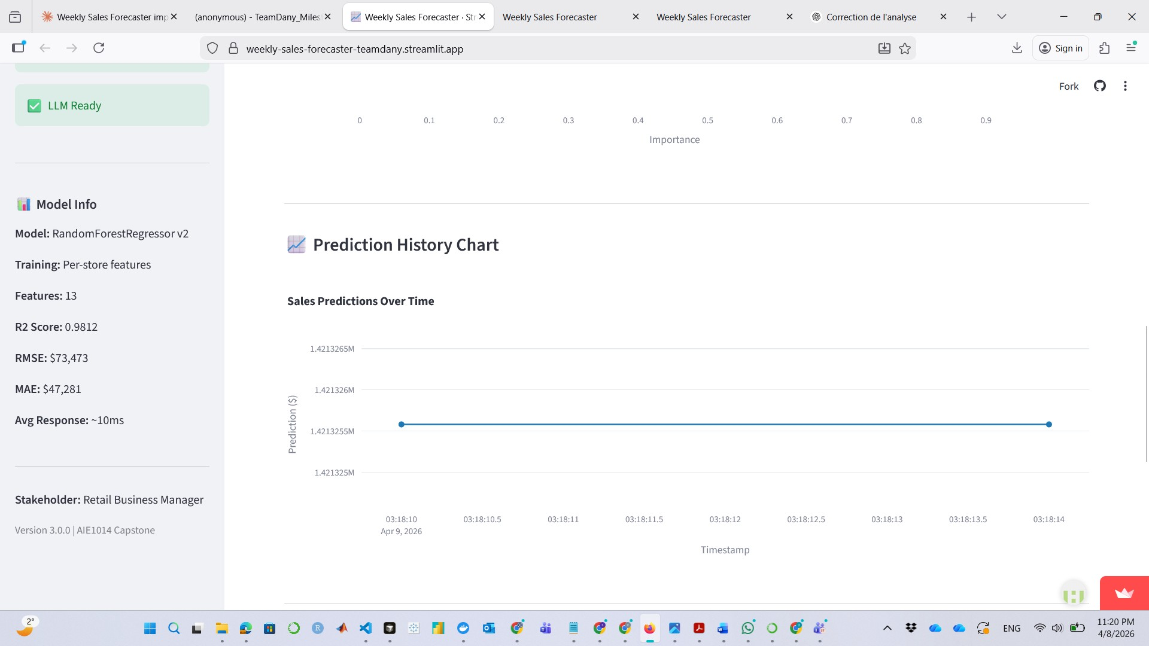
Figure D1 — Streamlit: Prediction History Chart — Sales Predictions Over Time (Apr 9, 2026)
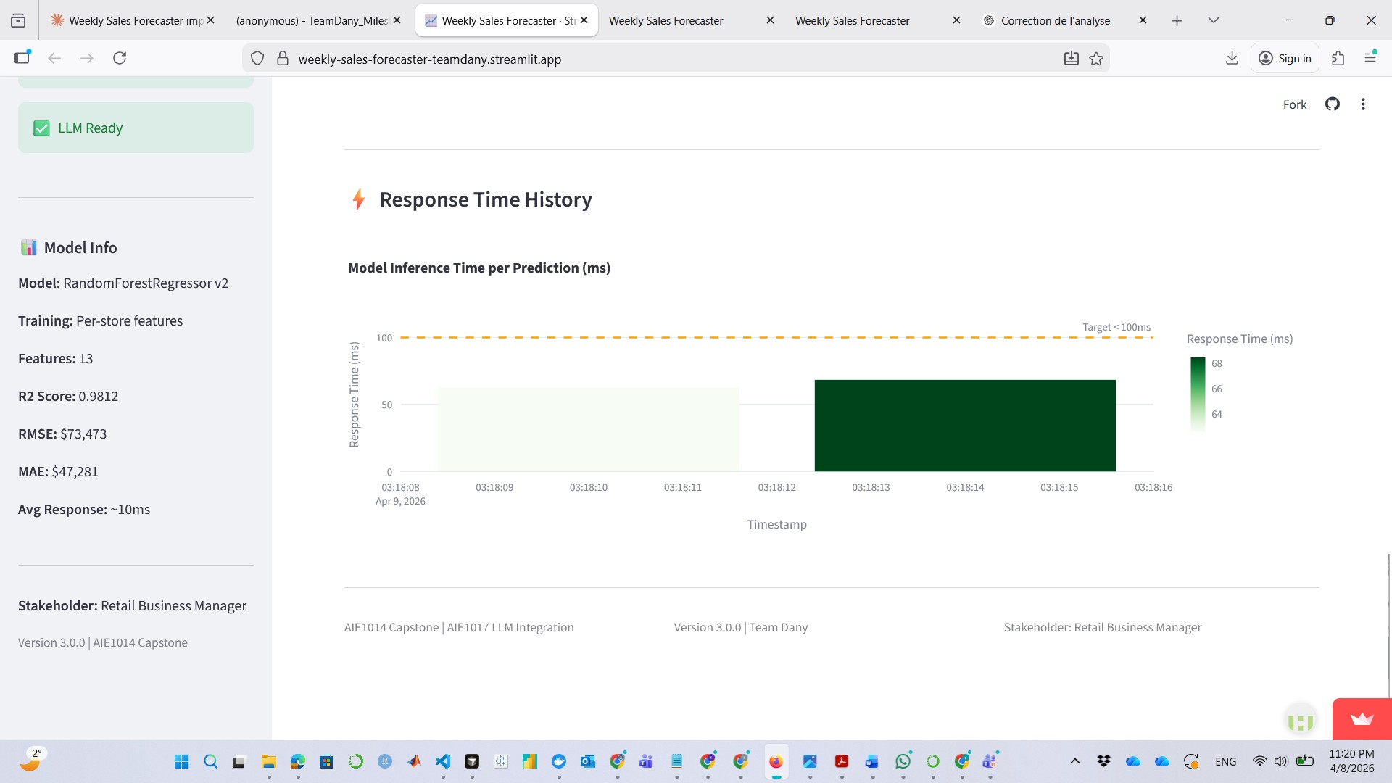
Figure D2 — Streamlit: Response Time History — all predictions below 100ms target line
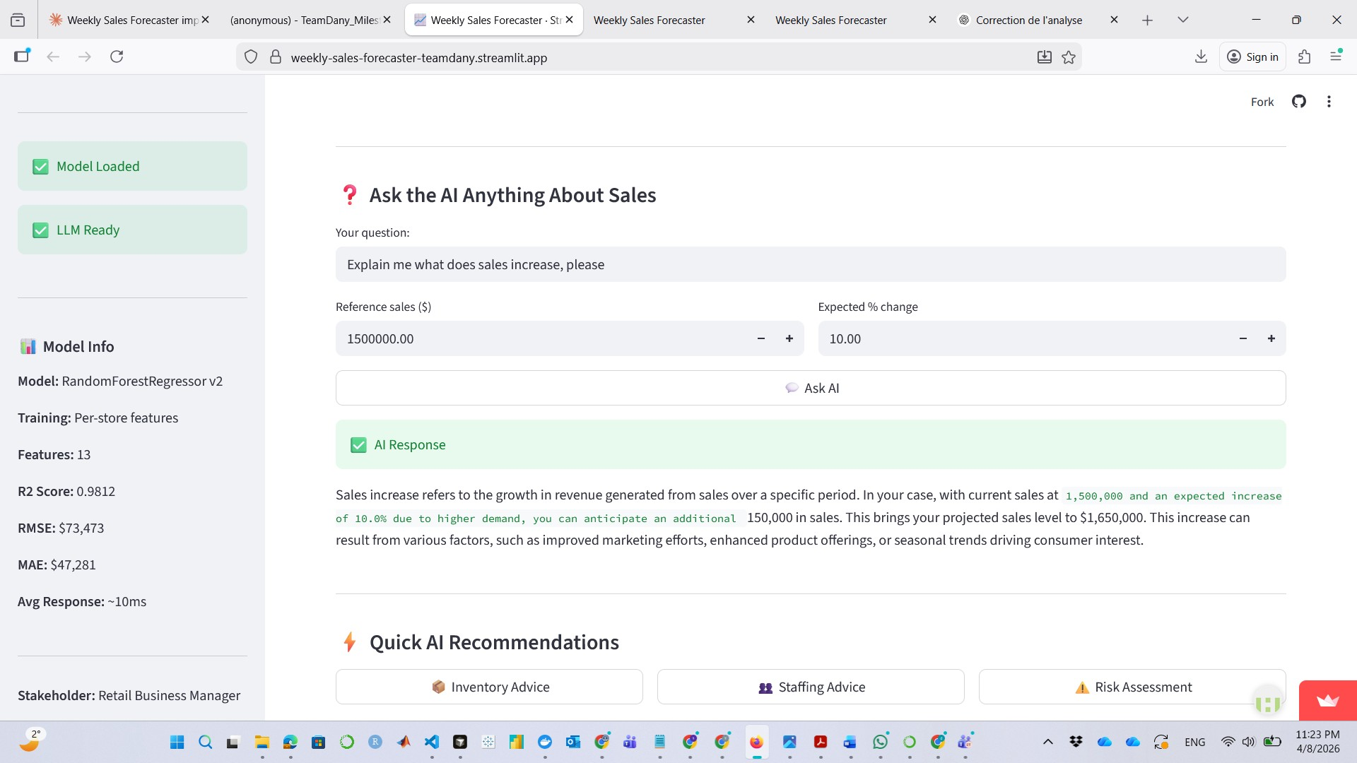
Figure D3 — Streamlit: AI Advisor — Ask the AI Anything with Quick AI Recommendations buttons
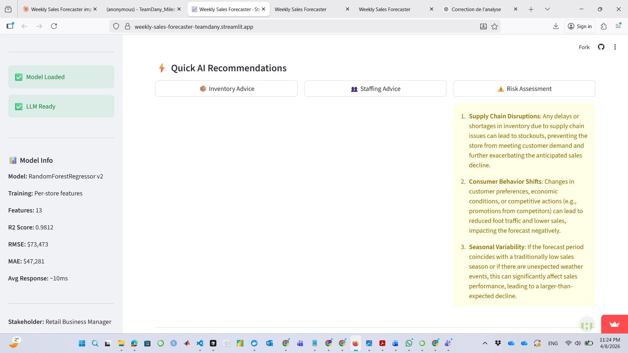
Figure D4 — Streamlit: Quick AI Recommendations — Risk Assessment output (GPT-4o-mini)

