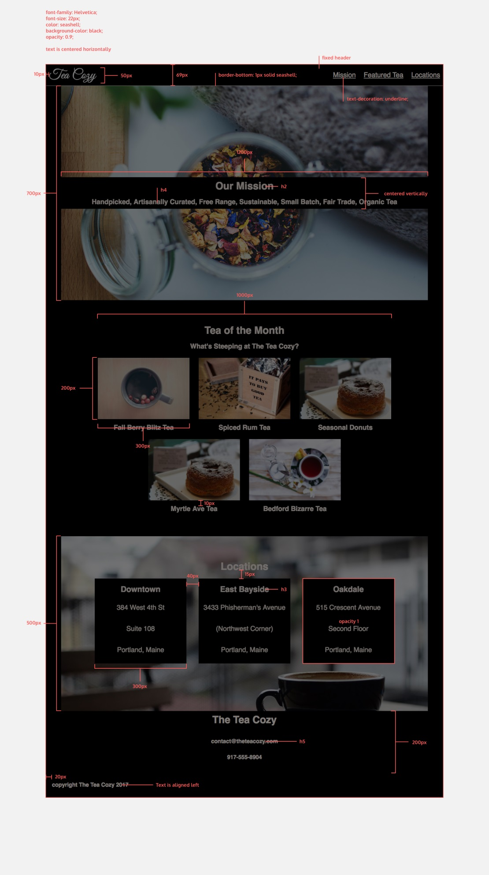logo

<div class="content"> display: flex;

<div class="mission"> display: flex;

<h2>

<h4>

<div class="tea-month">

<h2>

<h4>

<div class="row">

<div class="tea-image">

<h3>

<div class="row">

<div class="locations">

<h2>

<div class="row2">

<h3>

<p> ou <span>

<p> ou <span>

<p> ou <span>

<p> ou <span>

<header> display: flex;

<div class="logo">

<nav>

<span><a href="#"> </a></span>

<footer>

<h2>

<div class="contact">

<h2>

<h5>

<h5>