How to setup Grafana to view statistics:

1. Install Influxdb
2. Install grafana
3. Go to localhost:3000
4. Enter username = ‘admin’, password = ‘admin’ as password.
5. Select data source = ‘InfluxDB’.
6. Enter the following data in the form:

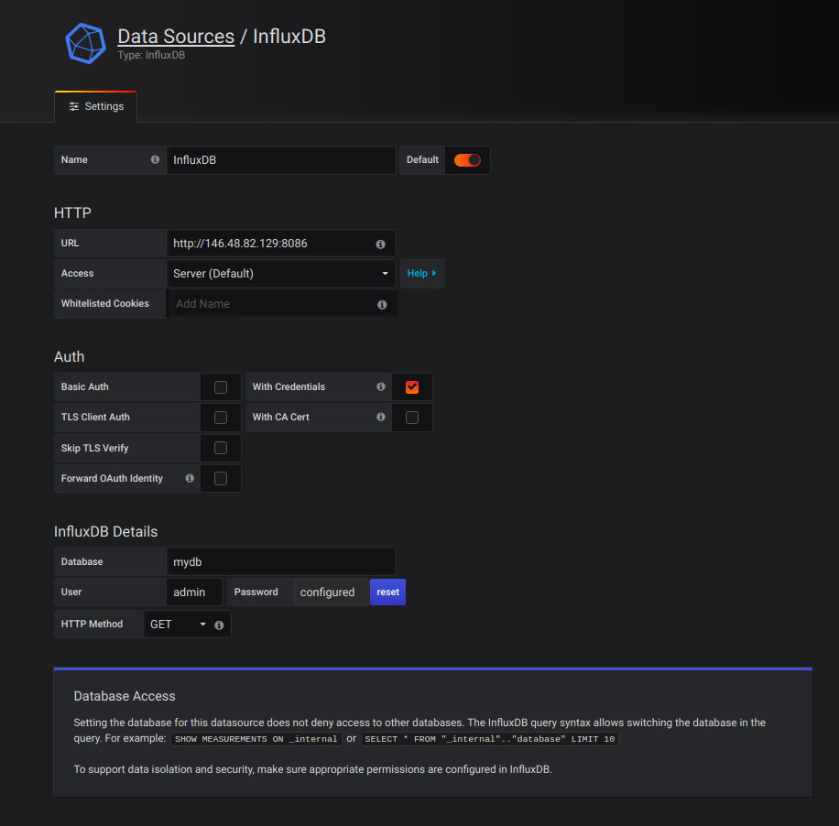
7. Go to http://localhost:3000/?orgId=1 and click on “New Dashboard”

--→ FRANCESCO!!

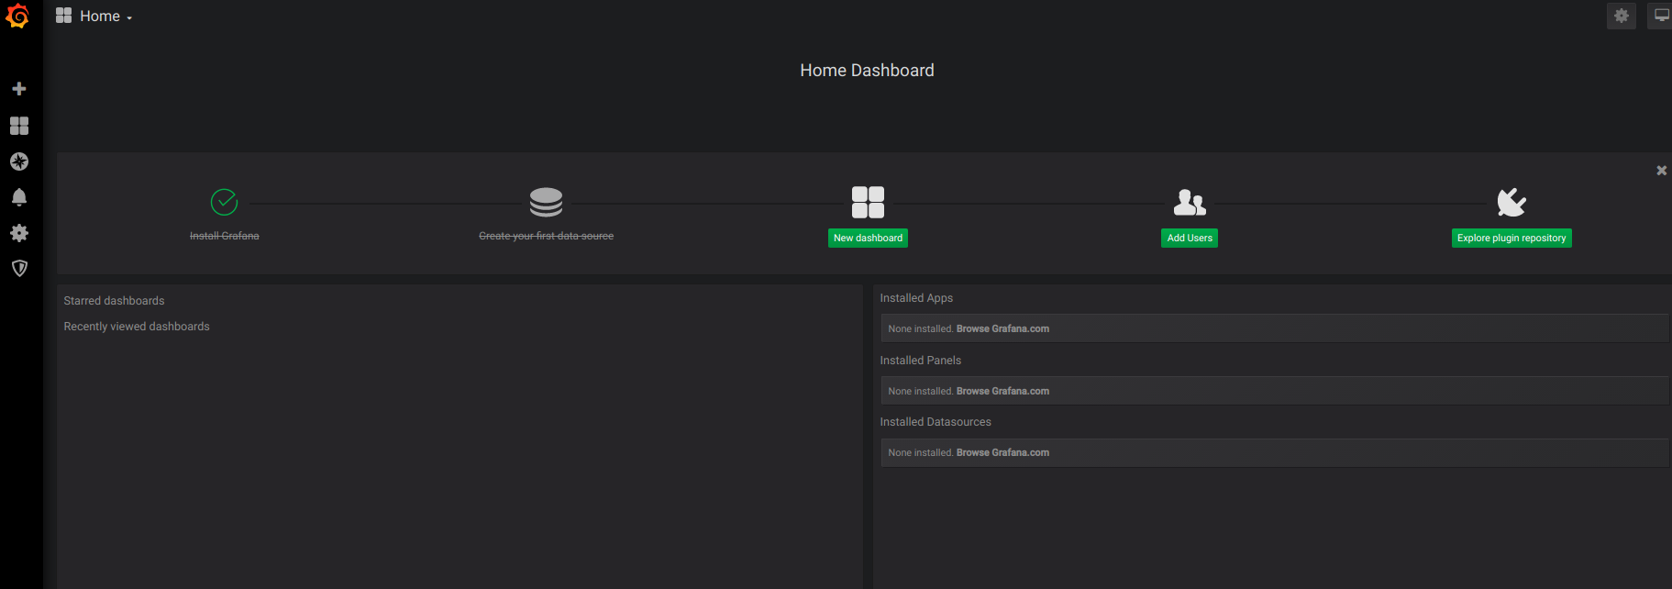
8. Add new dashboard and click on “Add Query”.

