Advanced Software Engineering
University of Pisa
Homework 1
Daniele Gadler
564198

- Link to the Github Repository:
https://github.com/DanyEle/ase-lab-18/tree/master/hw-1/doodle
- Screenshot of successful execution of myservice/tests/test_doodle.py
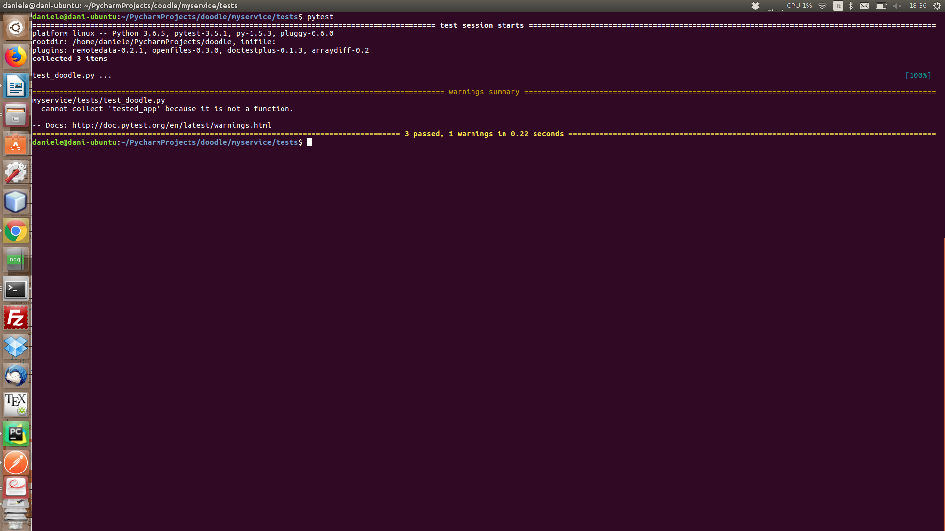
All tests have been passed, even though one warning has been generated.

Further details:
In my code, I added a few more exceptions, throwing (400) client errors in case the input provided does not fit the foreseen type (for example, if a string is excepted, but something different from a string is passed).

3. Screenshots of the tests performed with Postman for all above operations:

[Test 1 – Create Doodle test and get doodle]
1) Create doodle
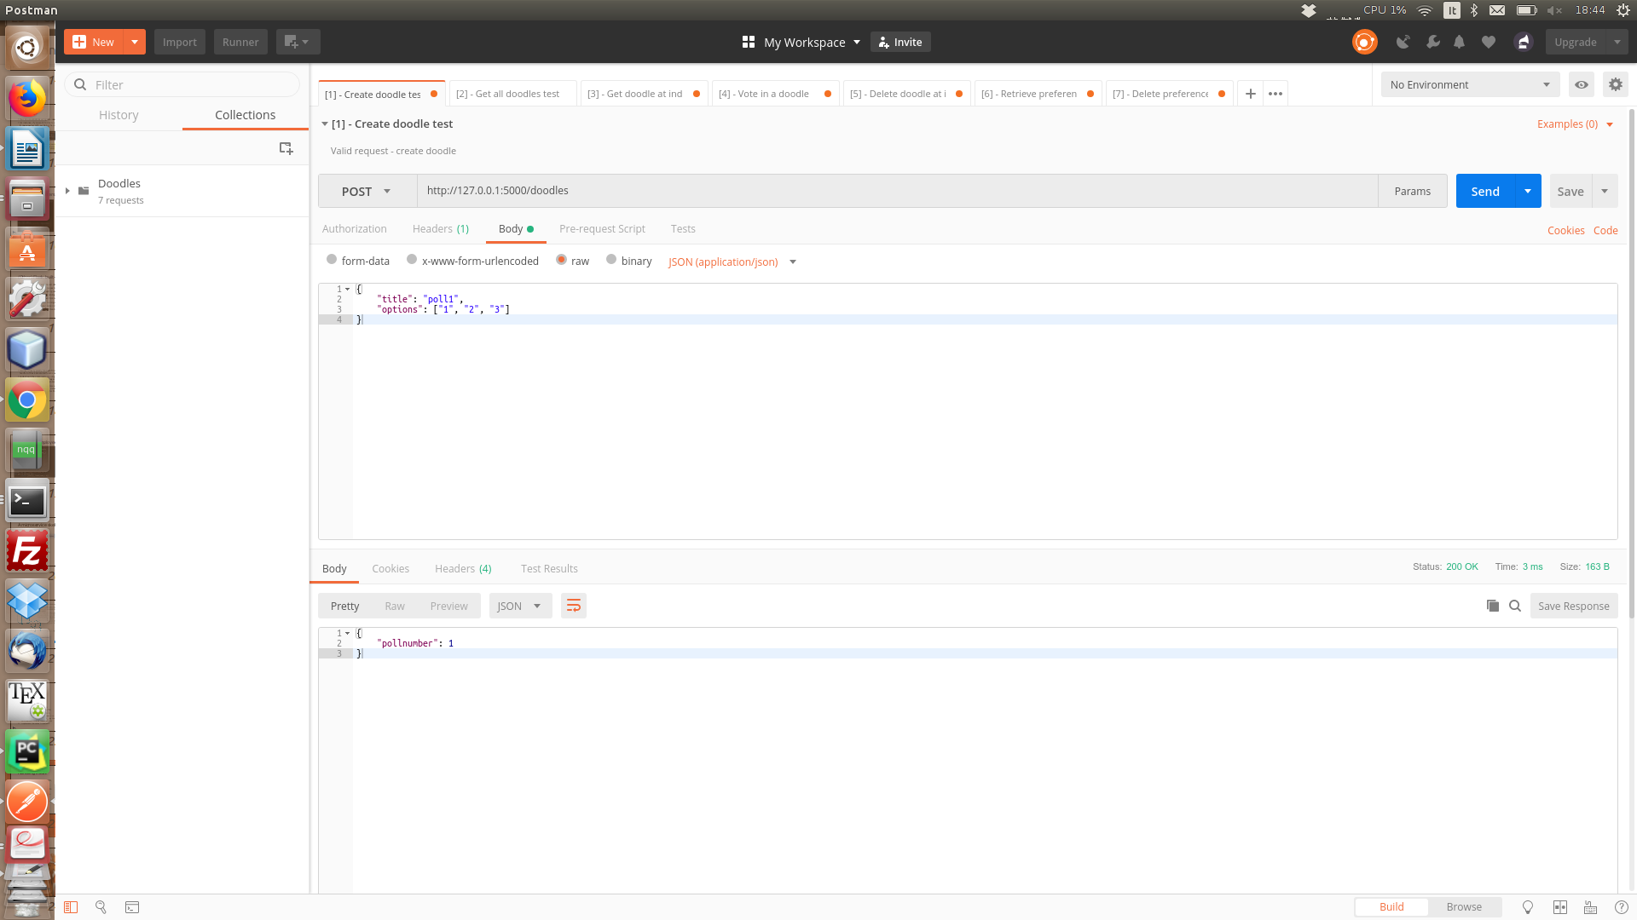

2)

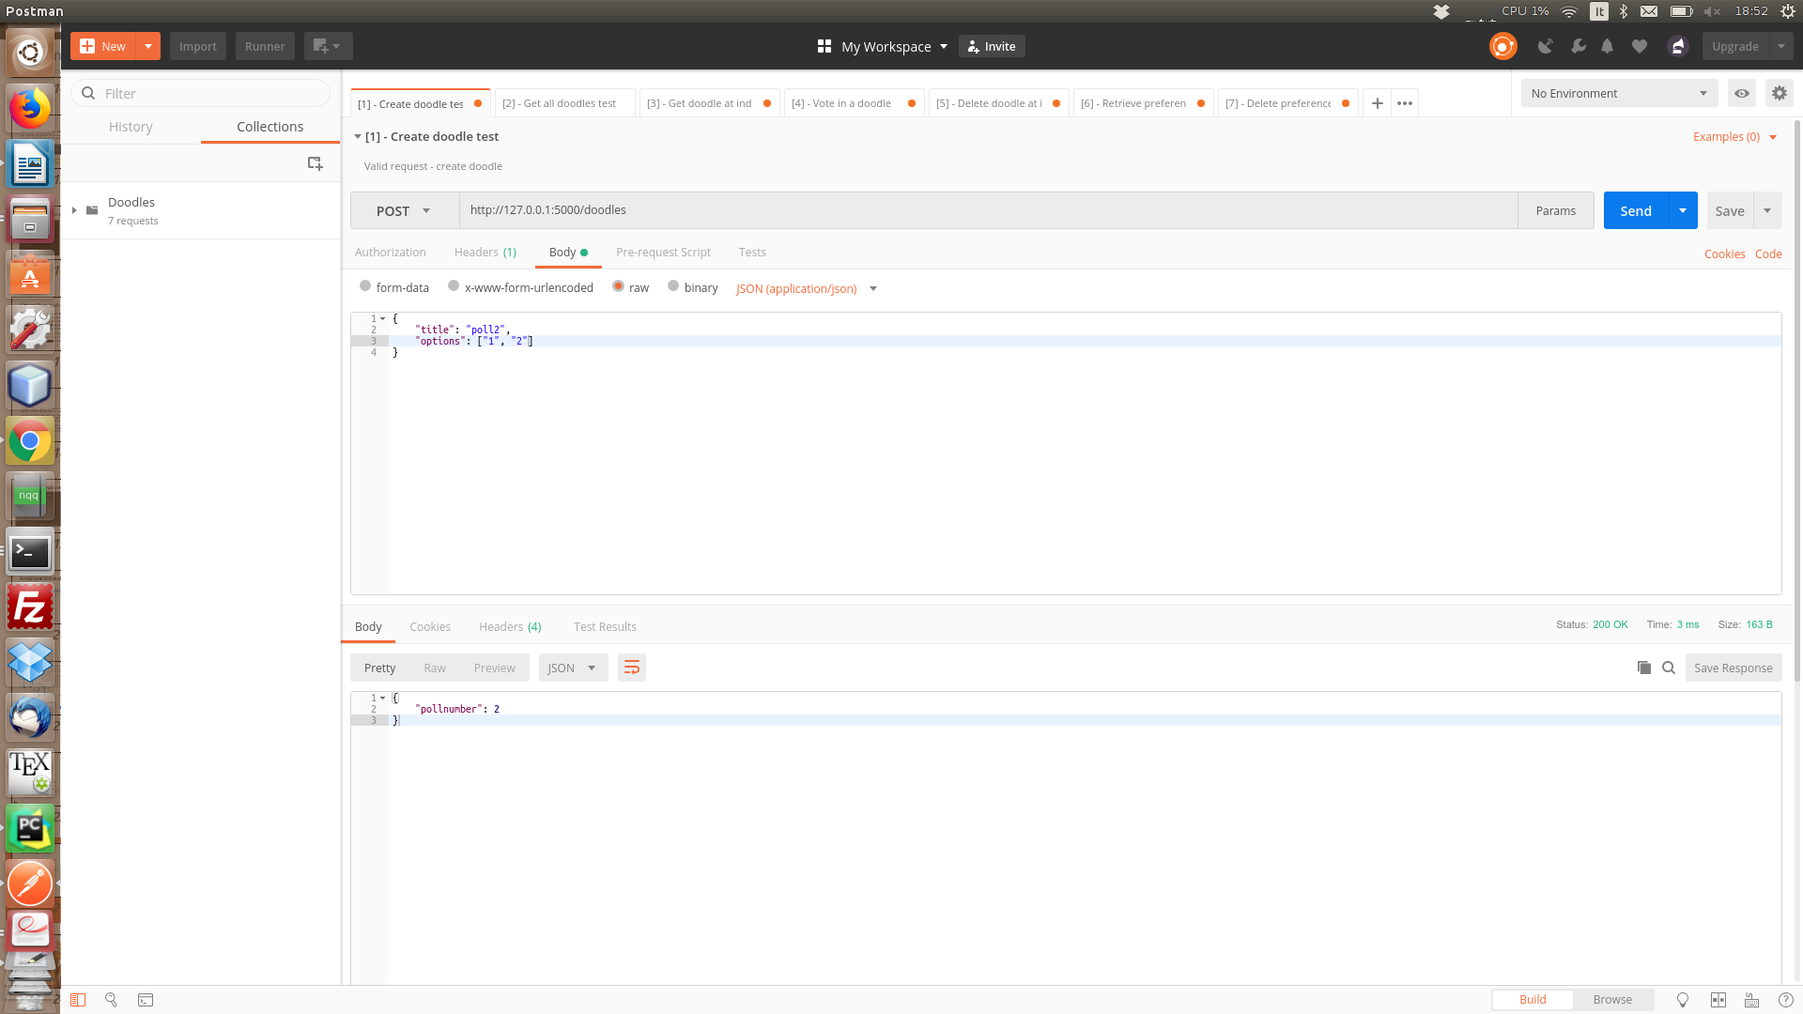

3)

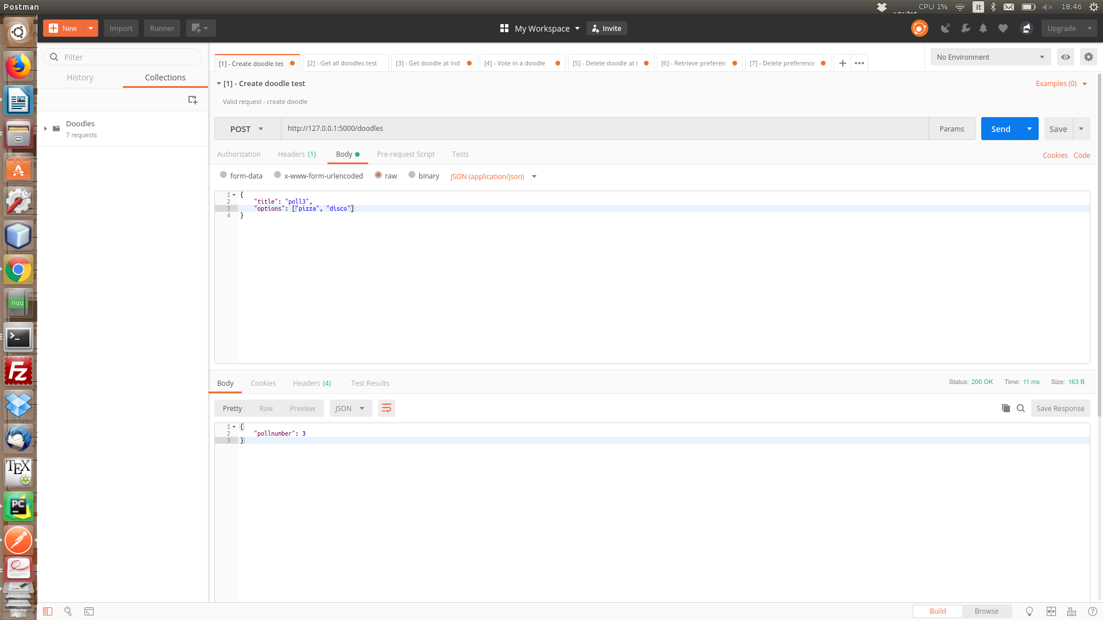

4) Get all doodles

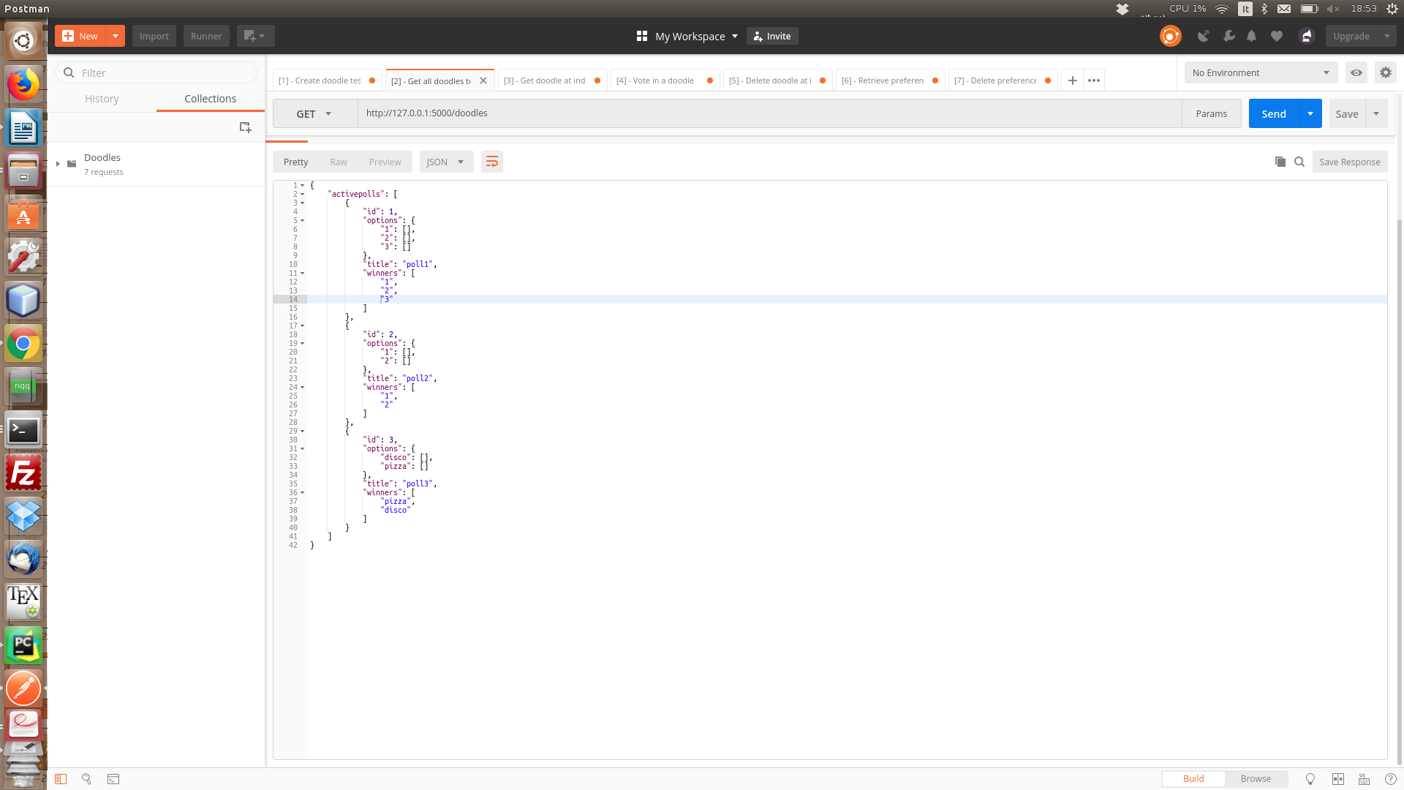

[Test 2 – retrieve single doodle]

5) Get a single doodle

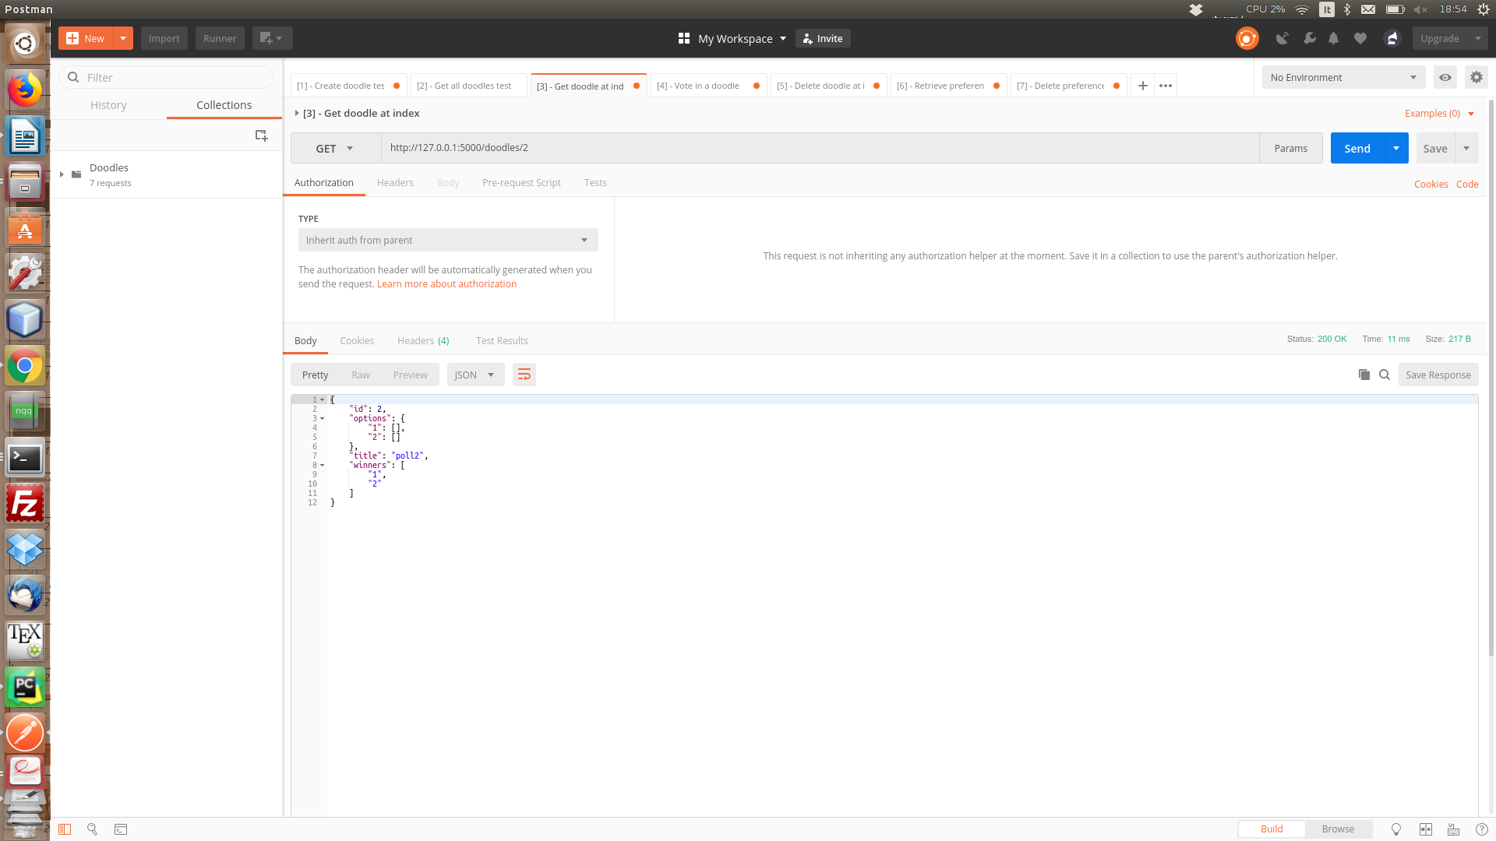

6)

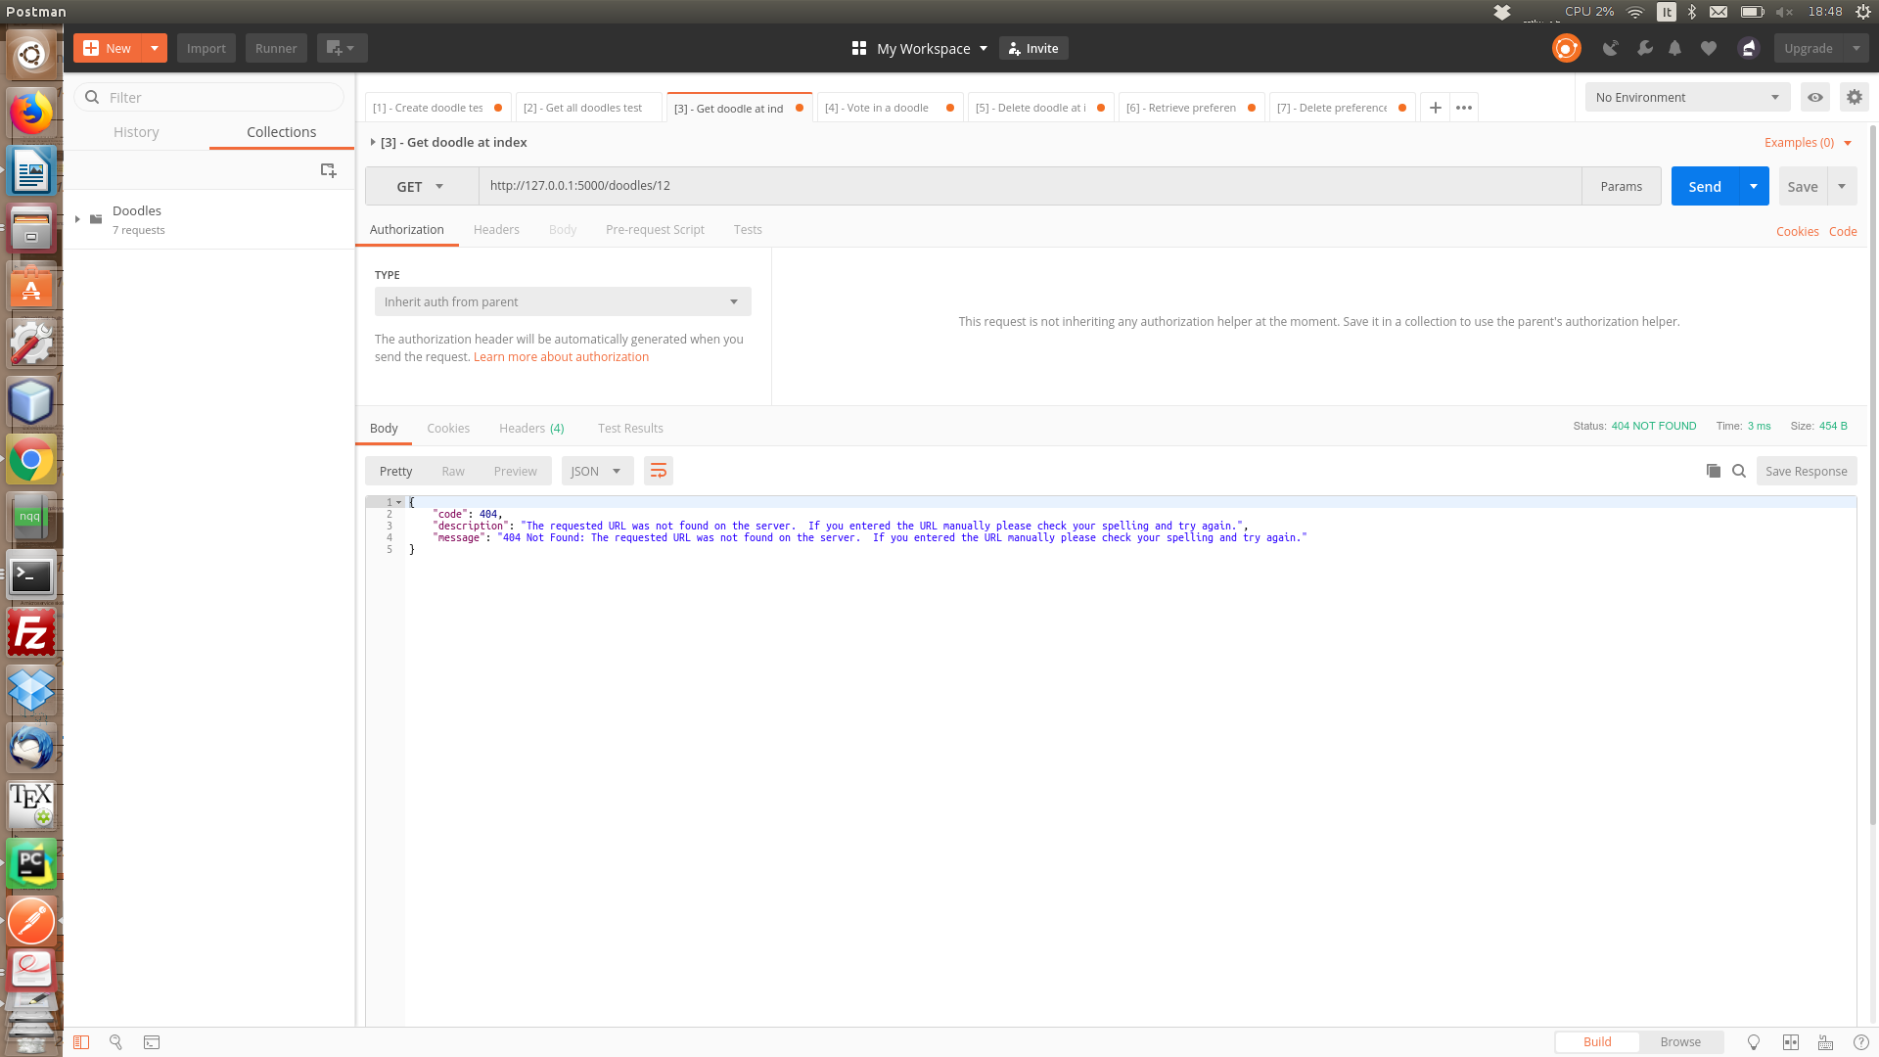

7) Test vote in a doodle

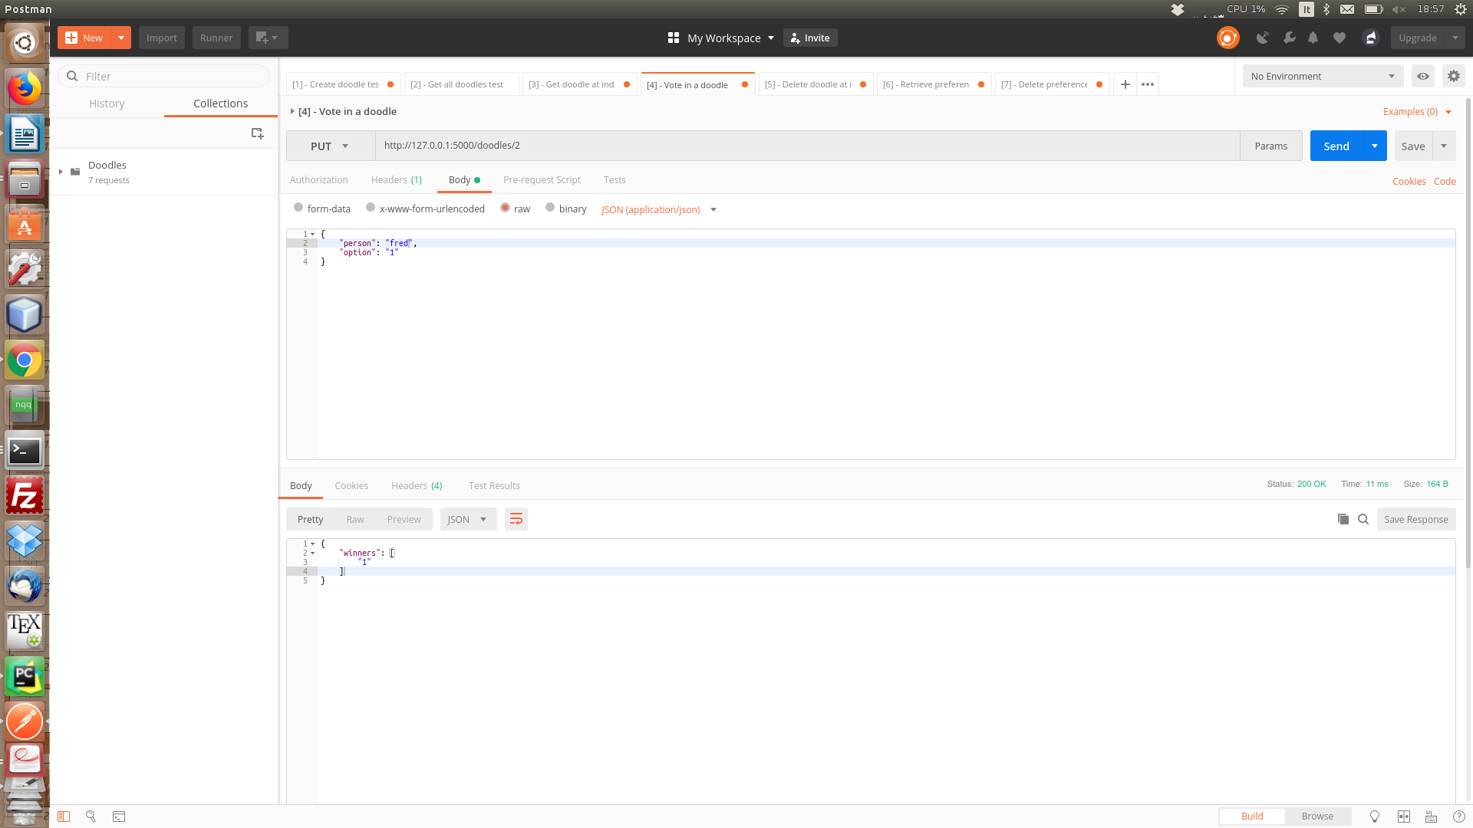

8)

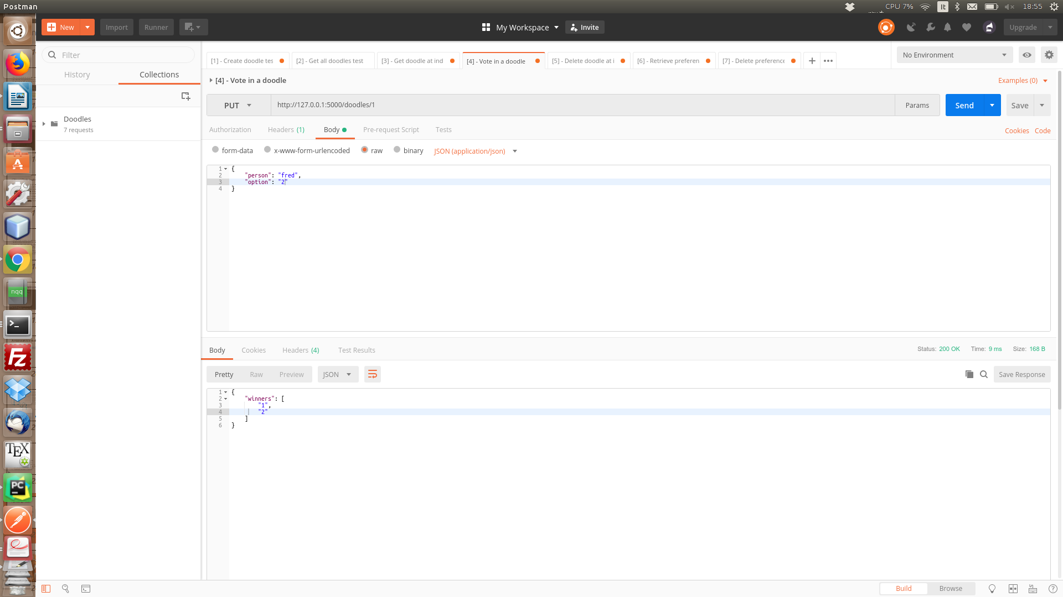
9)

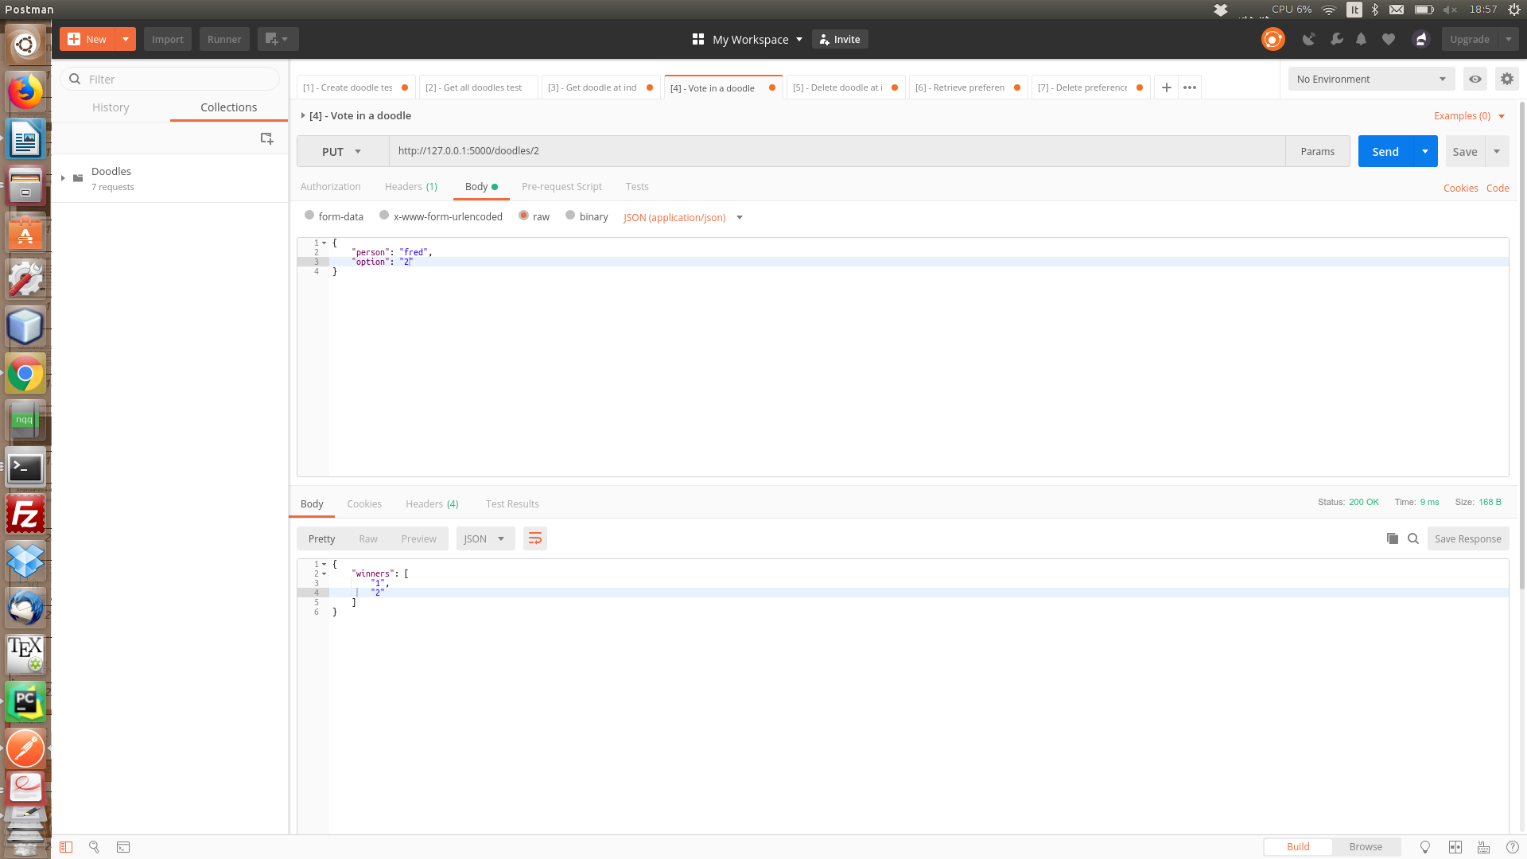
10)
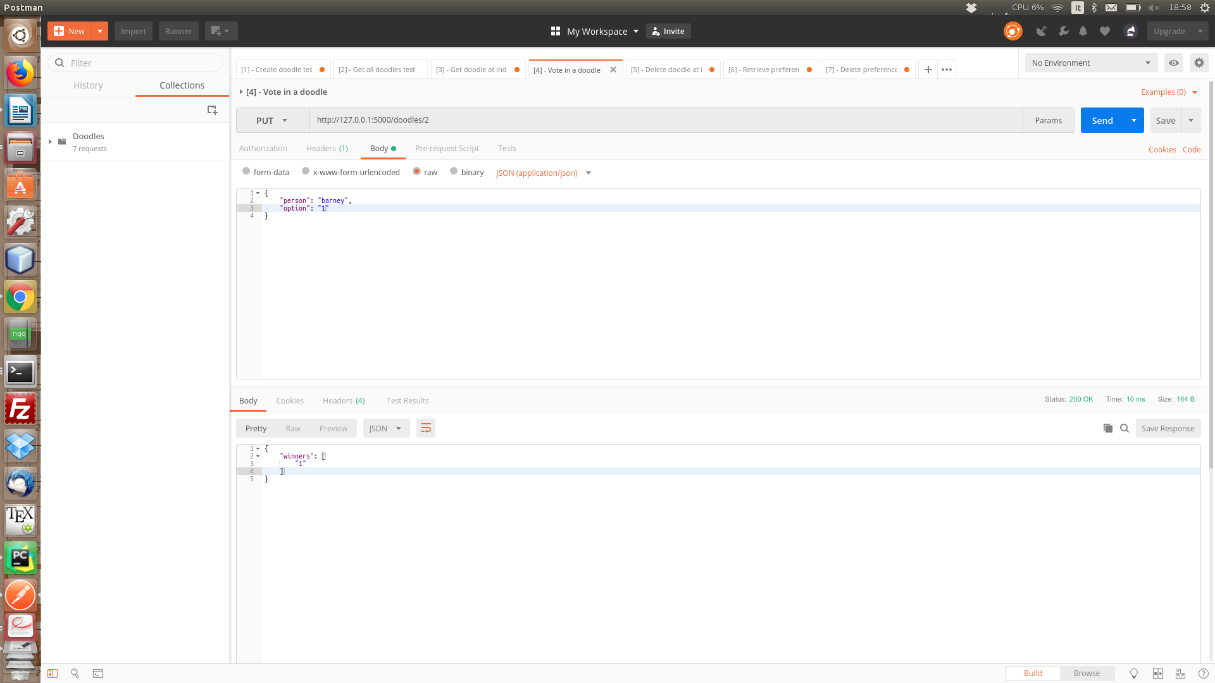
11) Same person voting already voted option from themselves
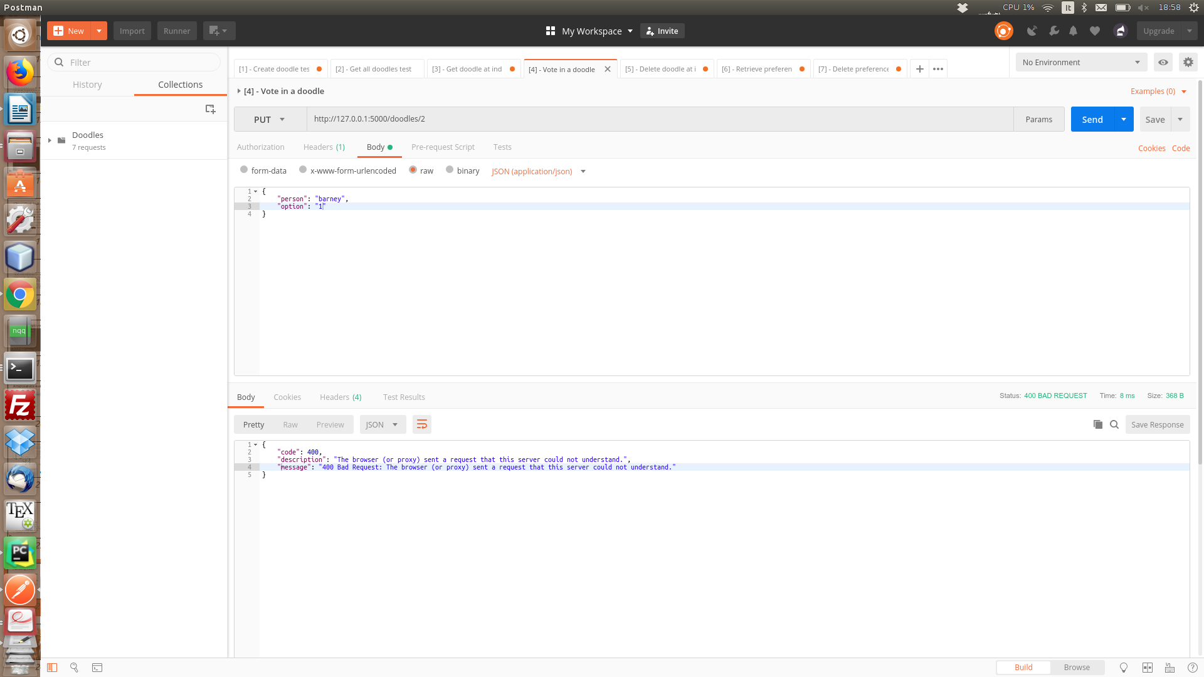
12) Vote non-existing option

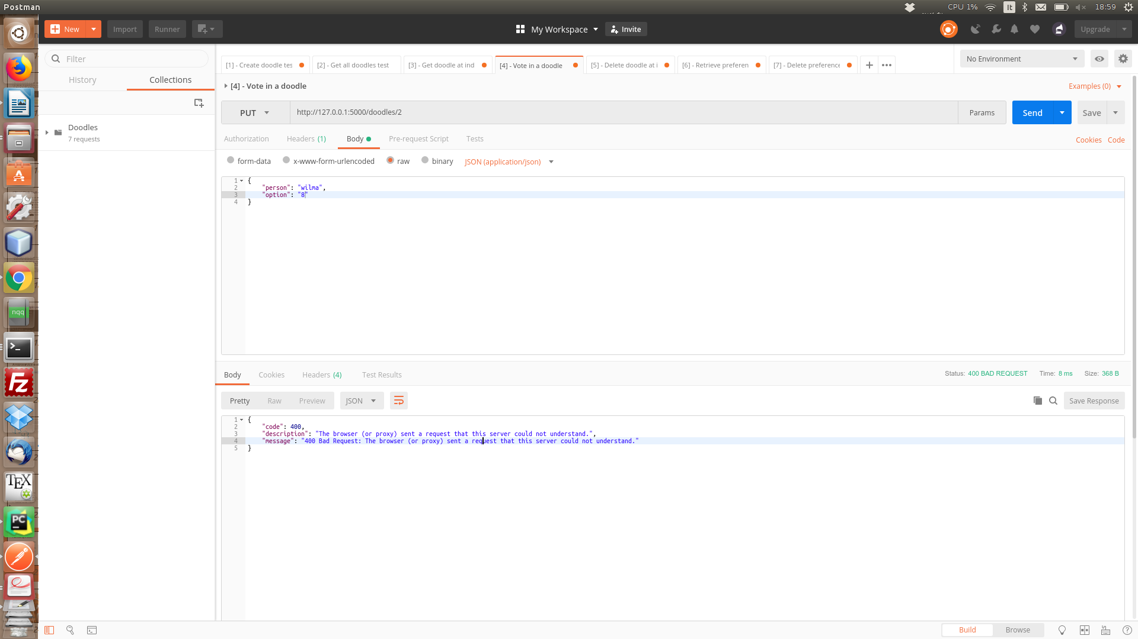
13) Delete a doodle

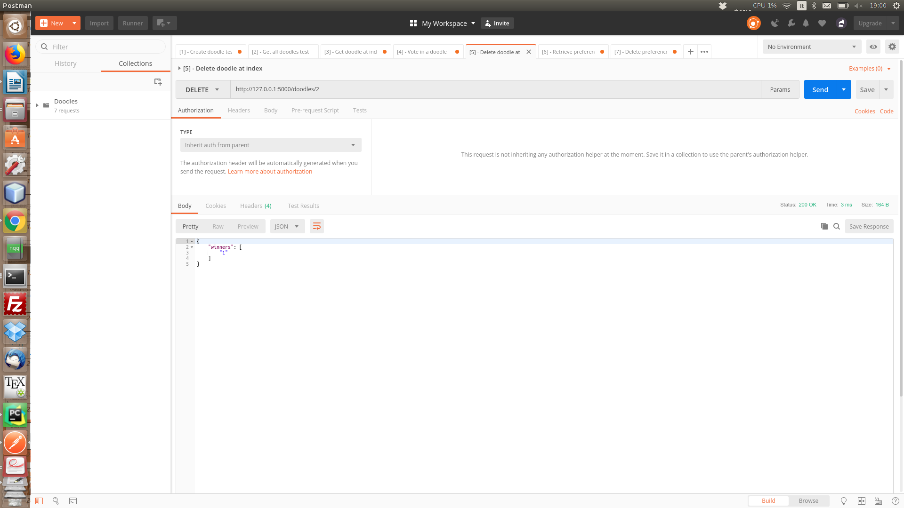
14) Get all existing doodles

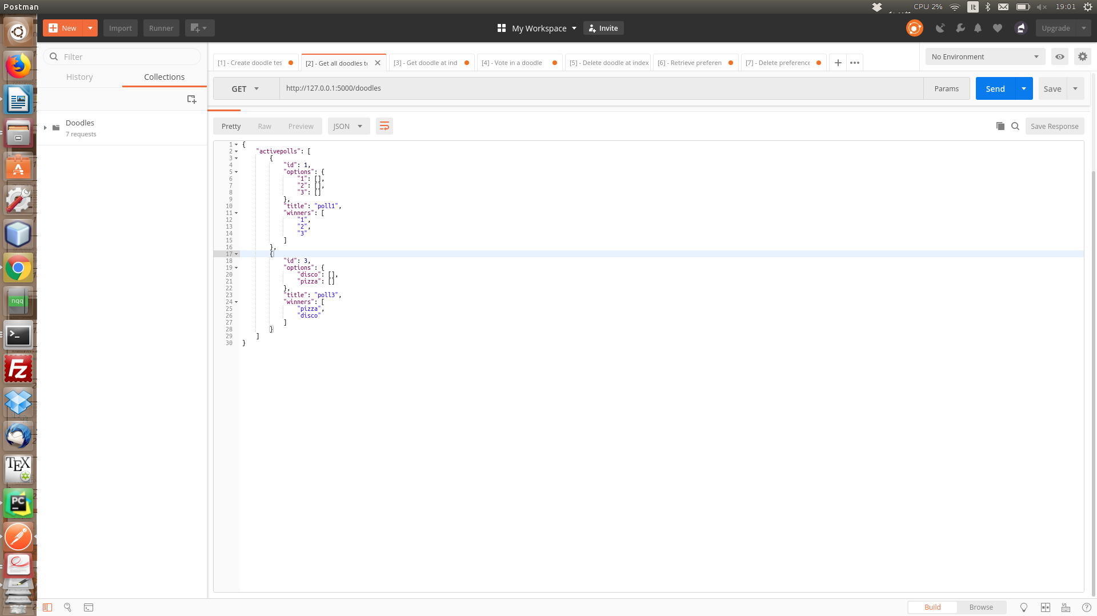
15) Delete previous doodle

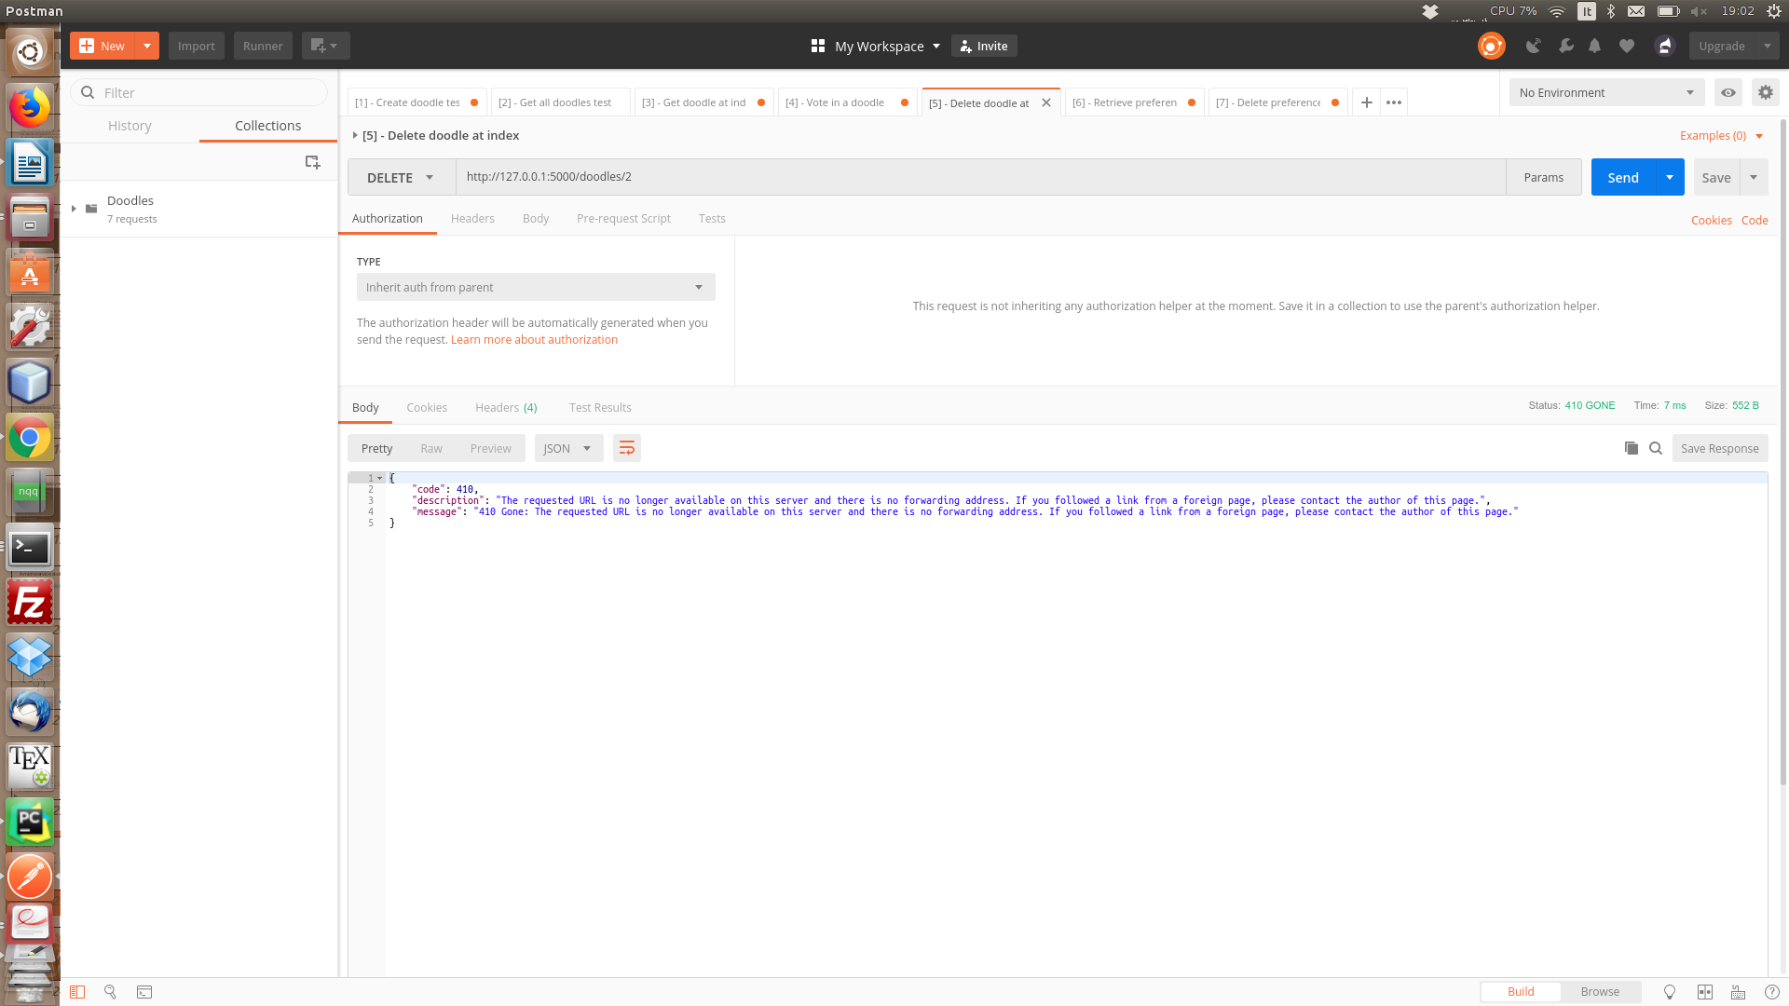
16) Delete non-existing doodle

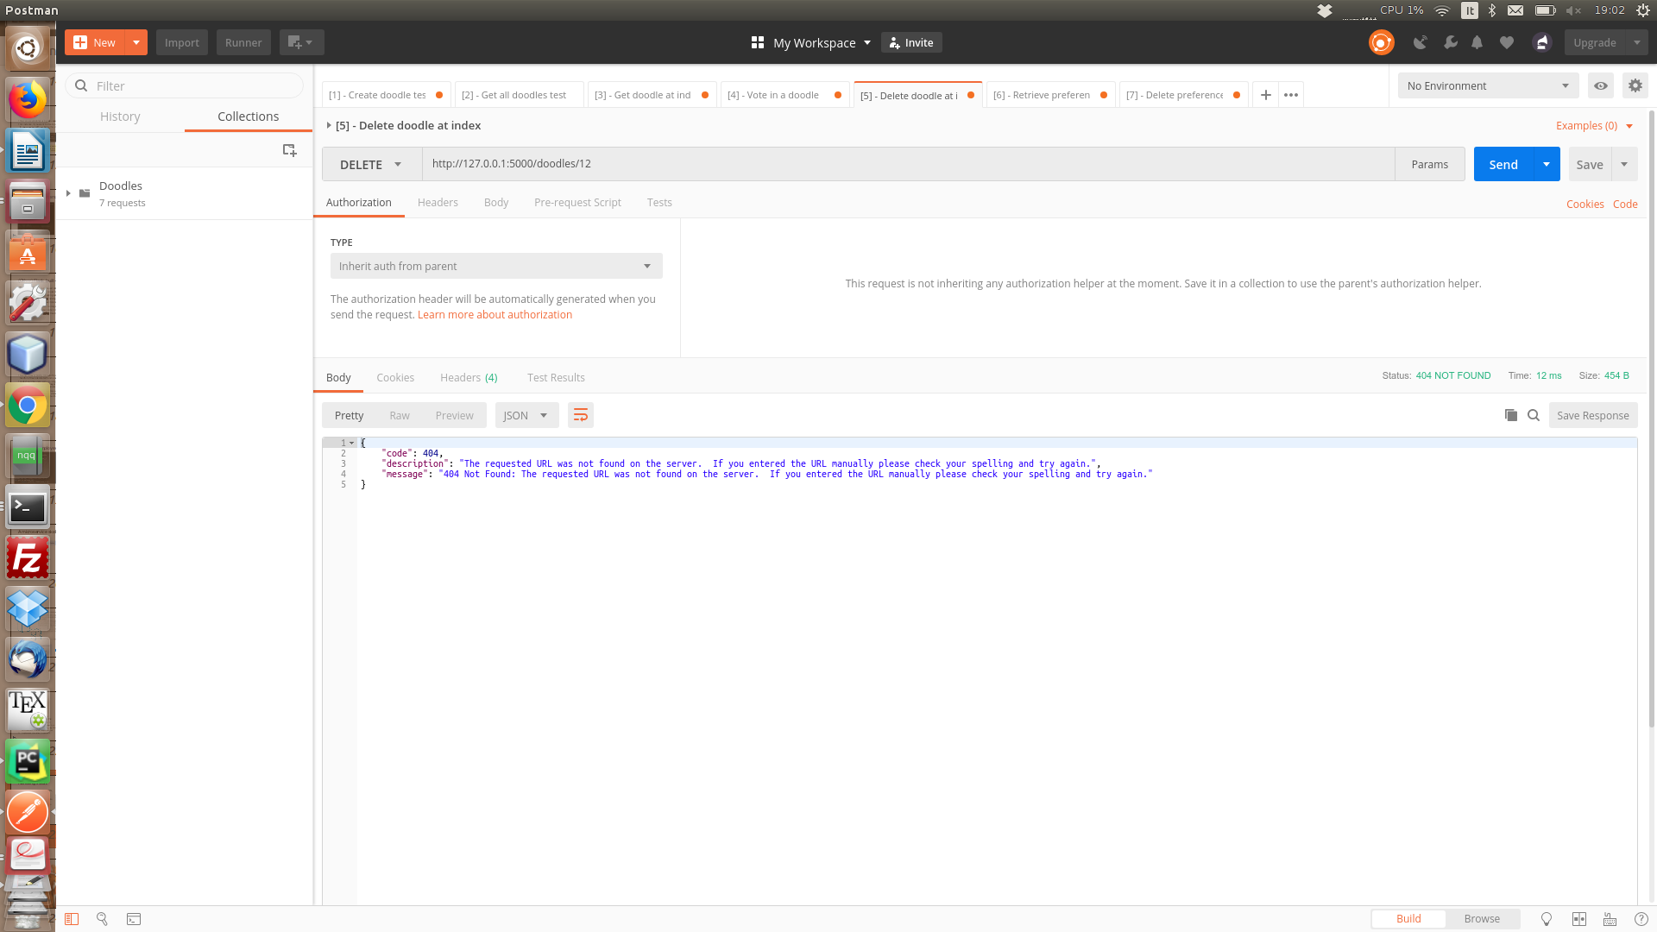
17) Get previously existing doodle

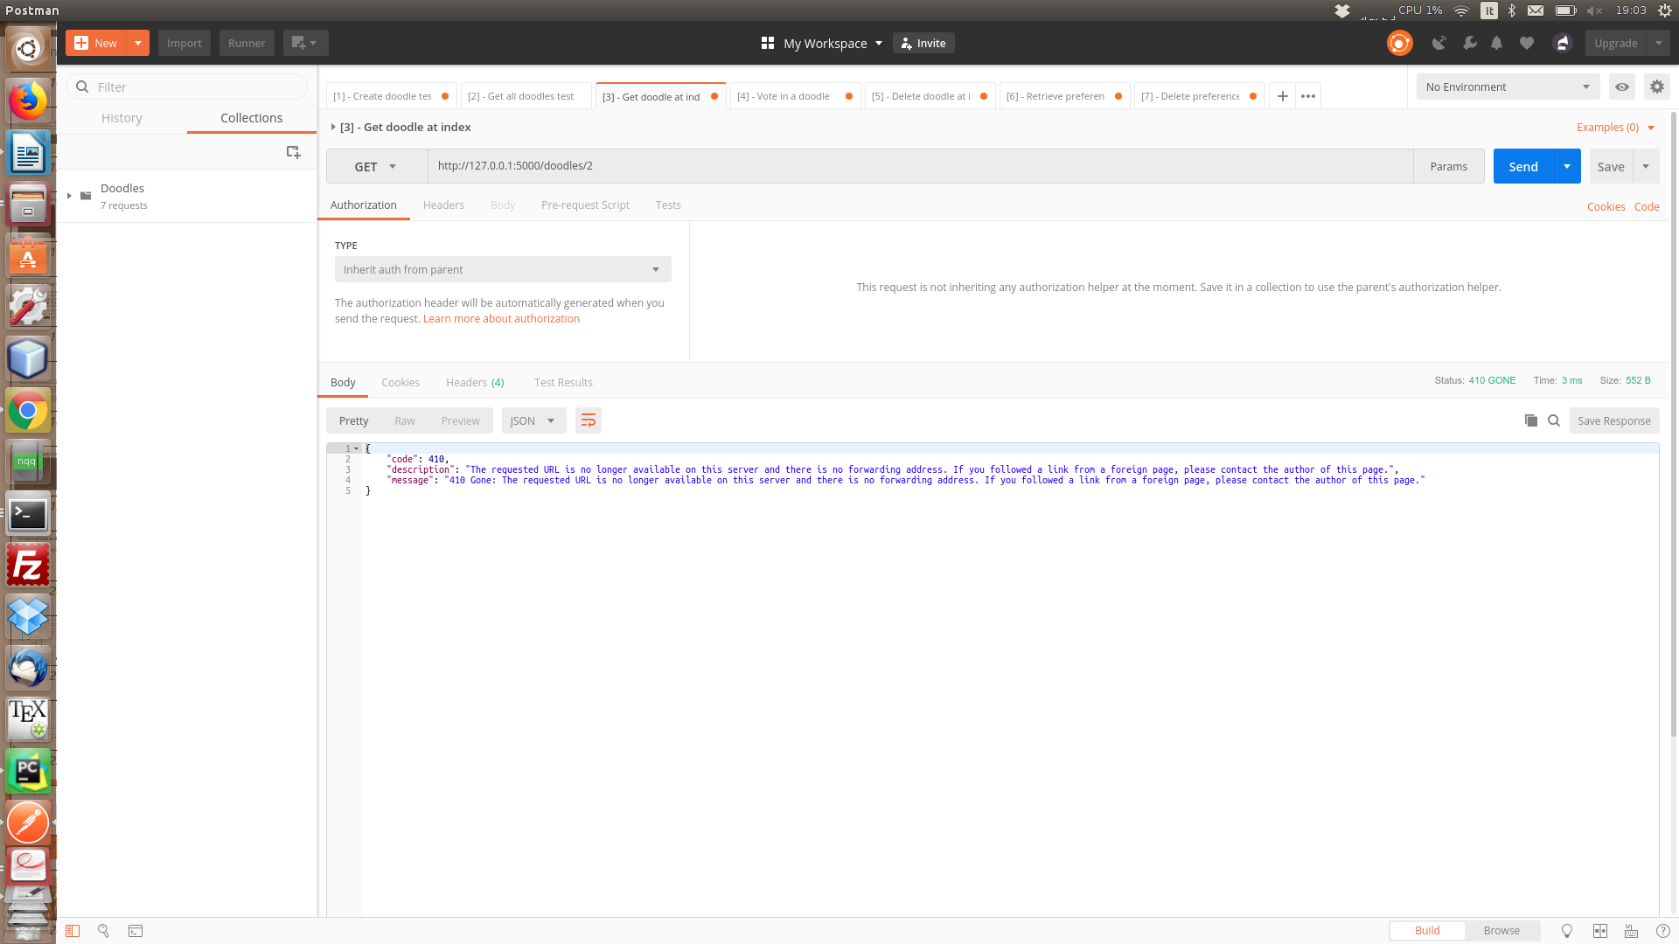
[Test 3 ]

18) Vote in a doodle
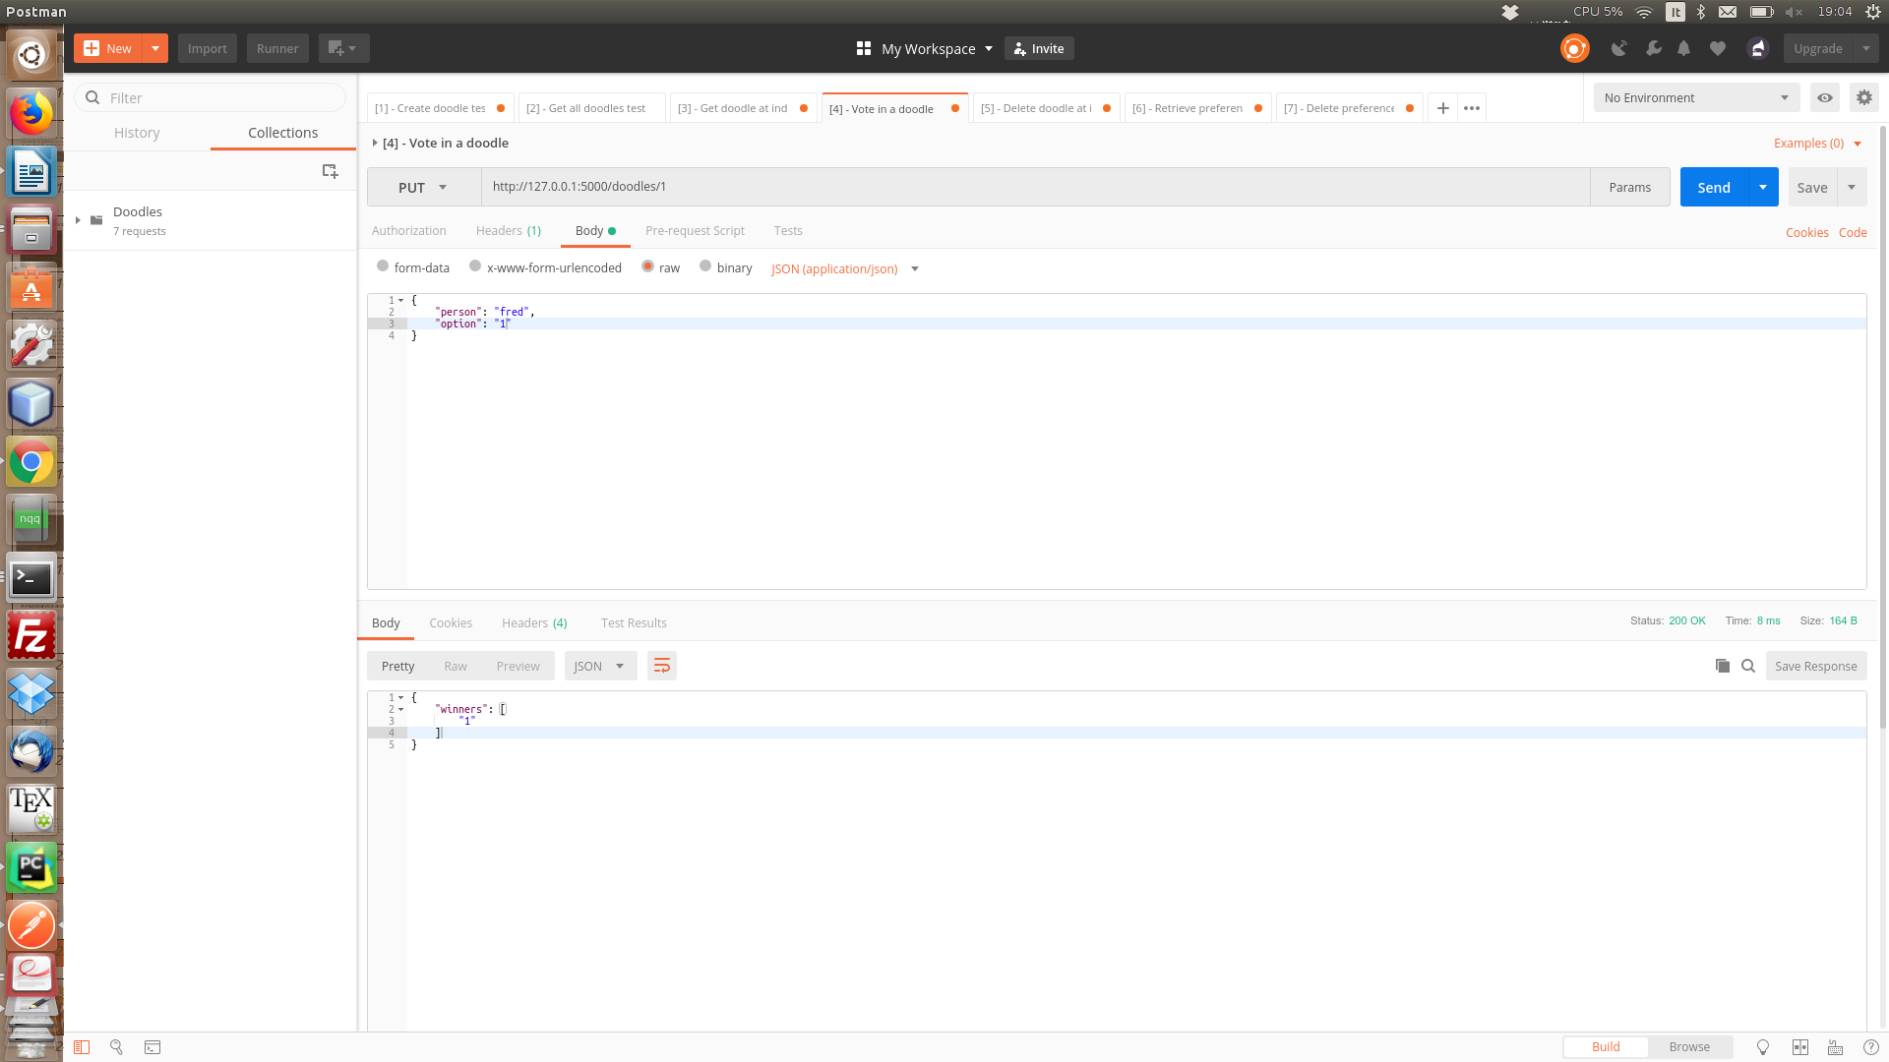
19)

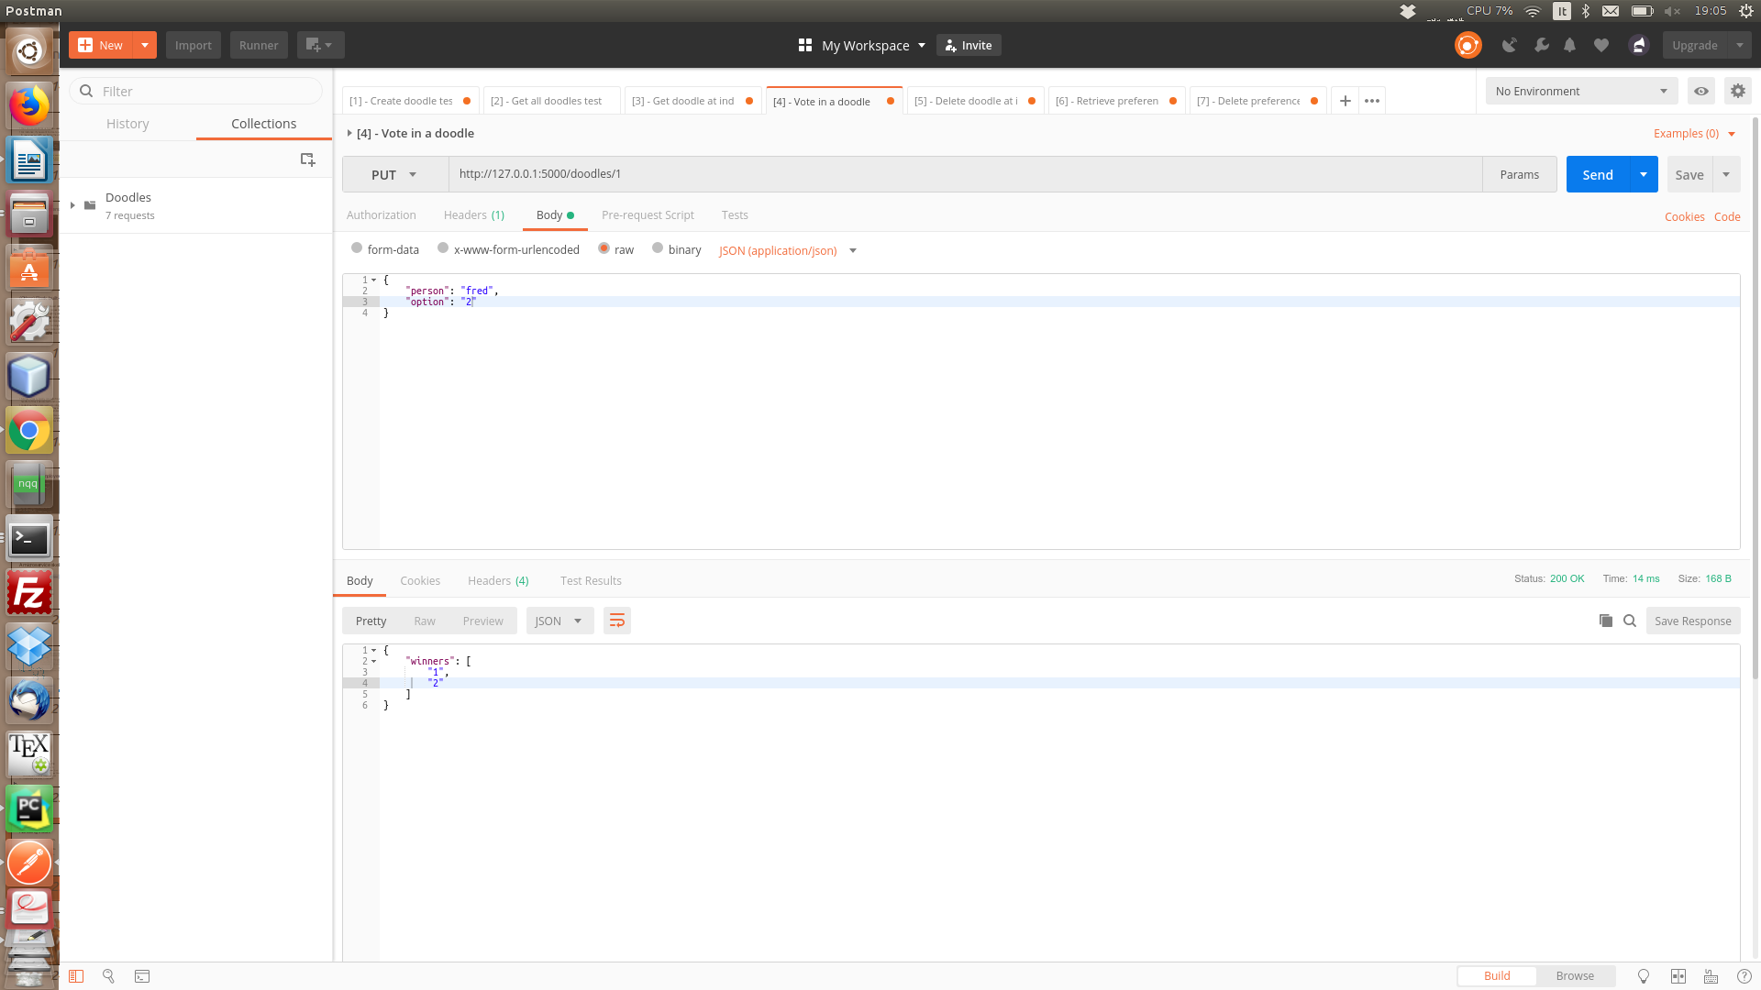

20)

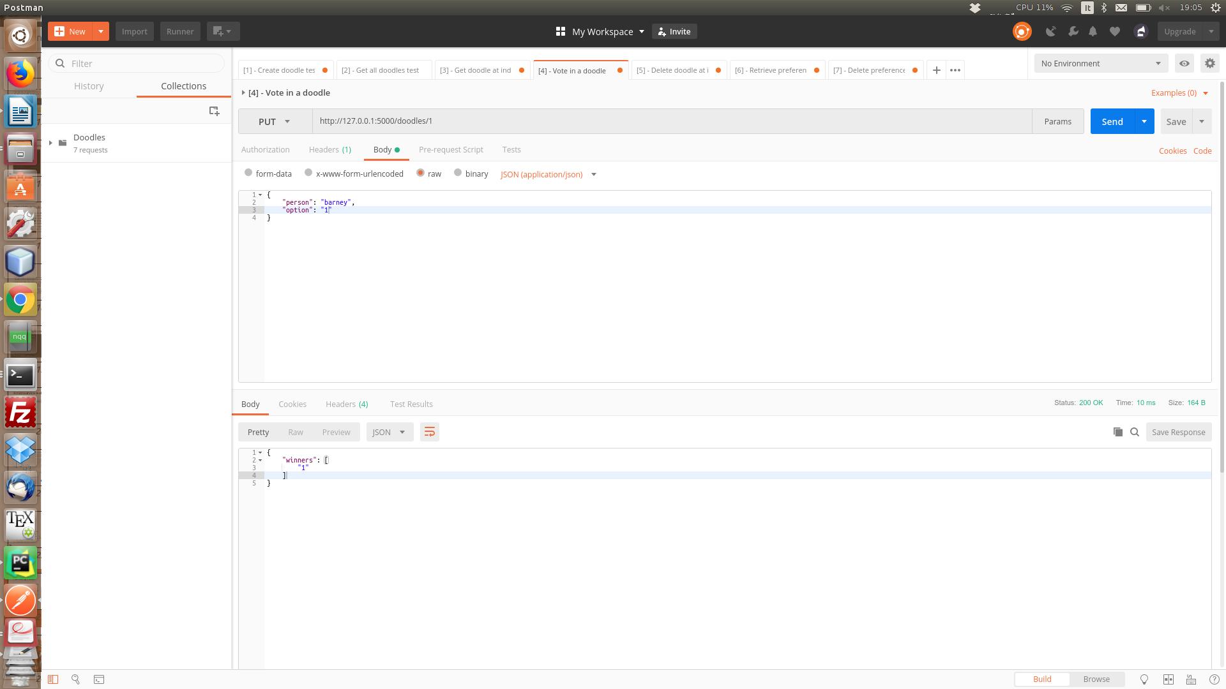
21)Get votes from a person that voted
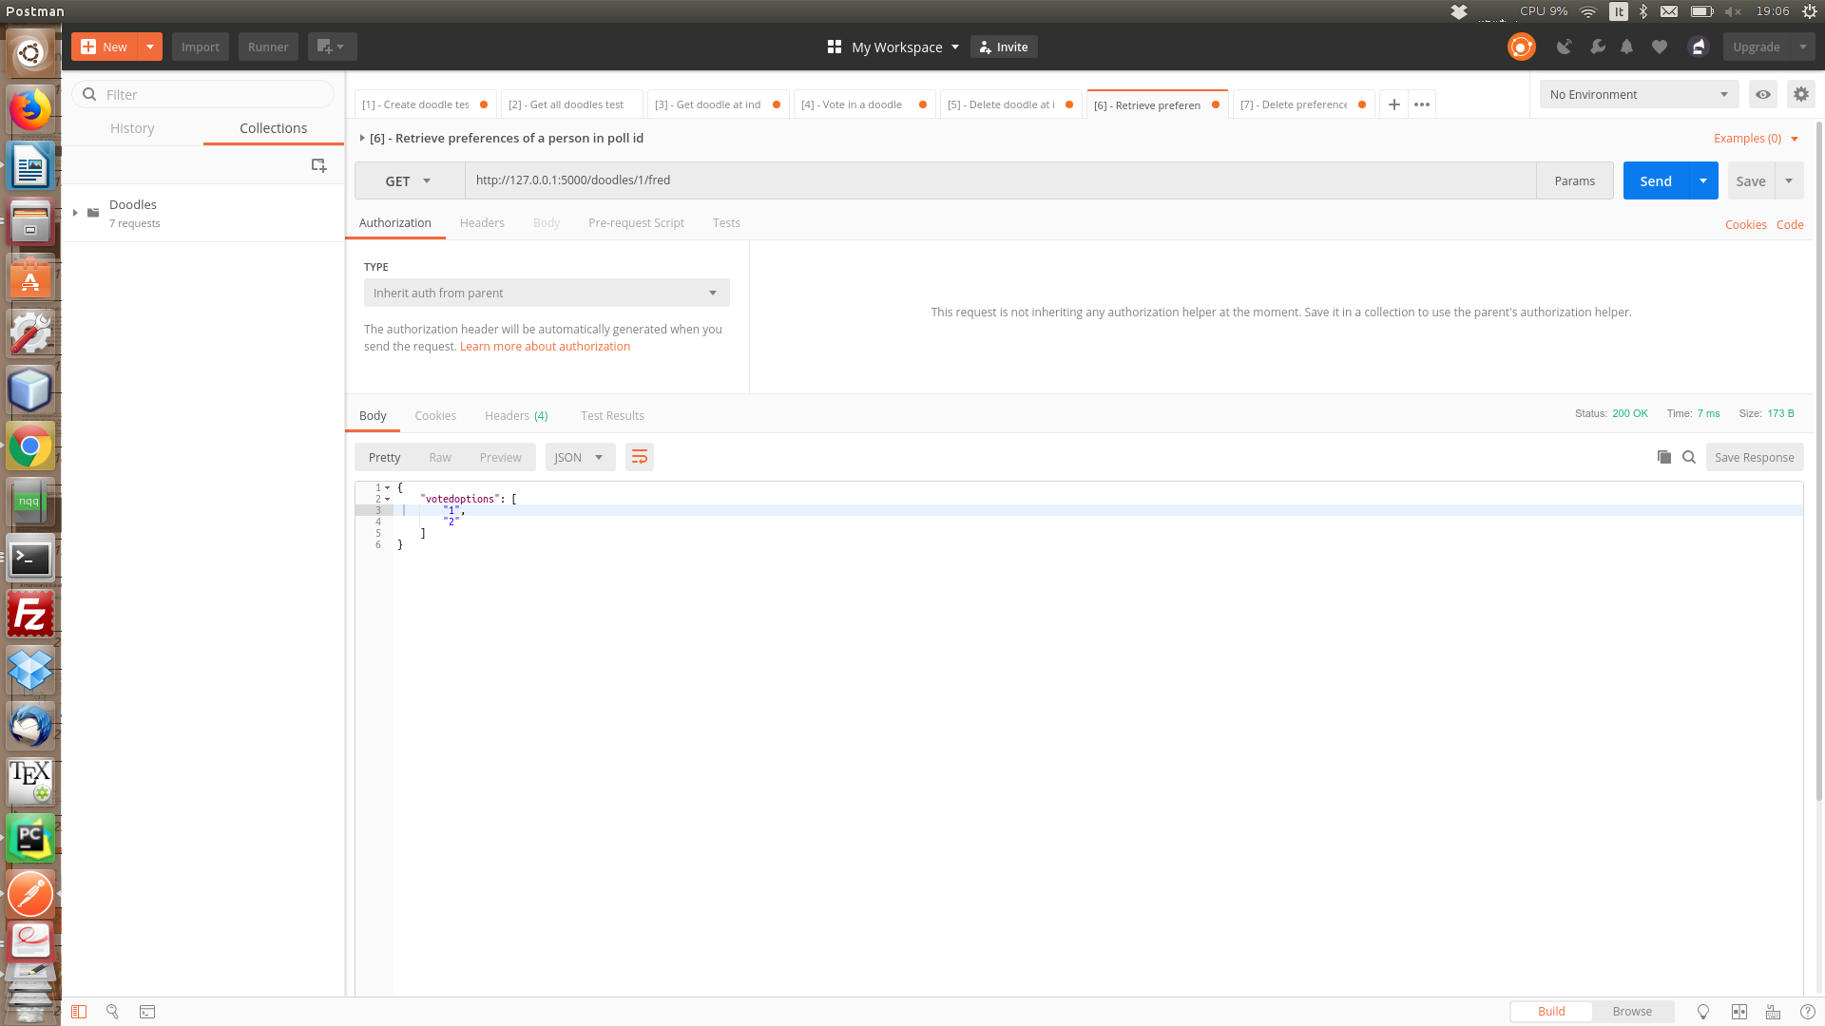

22) Get votes from a person that has not yet voted
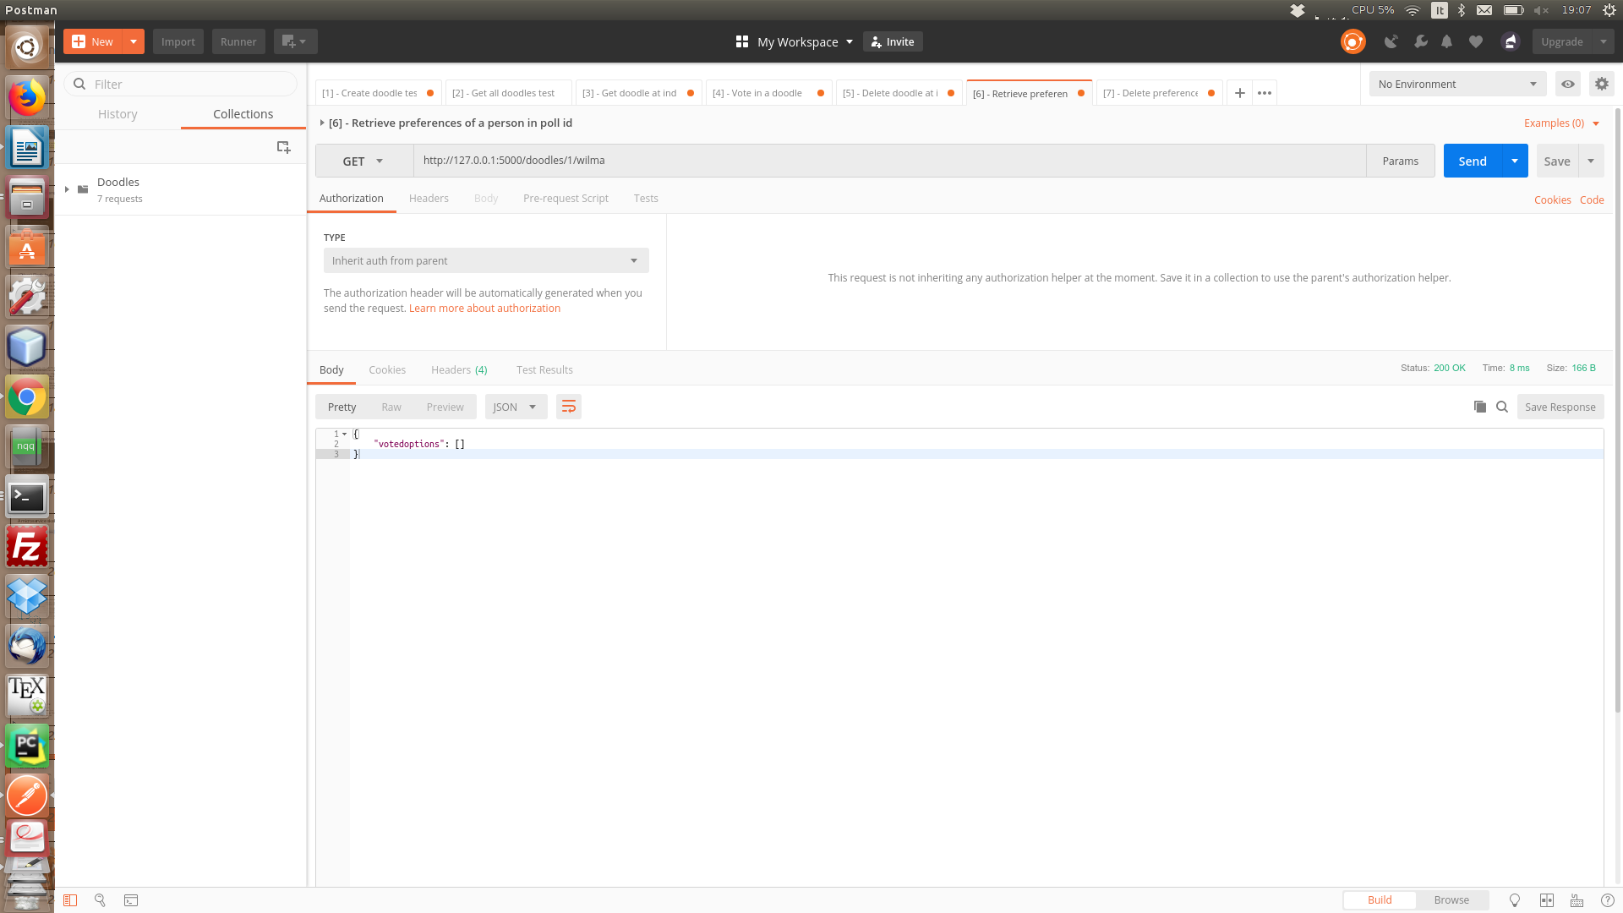
23) Delete votes from a person that voted

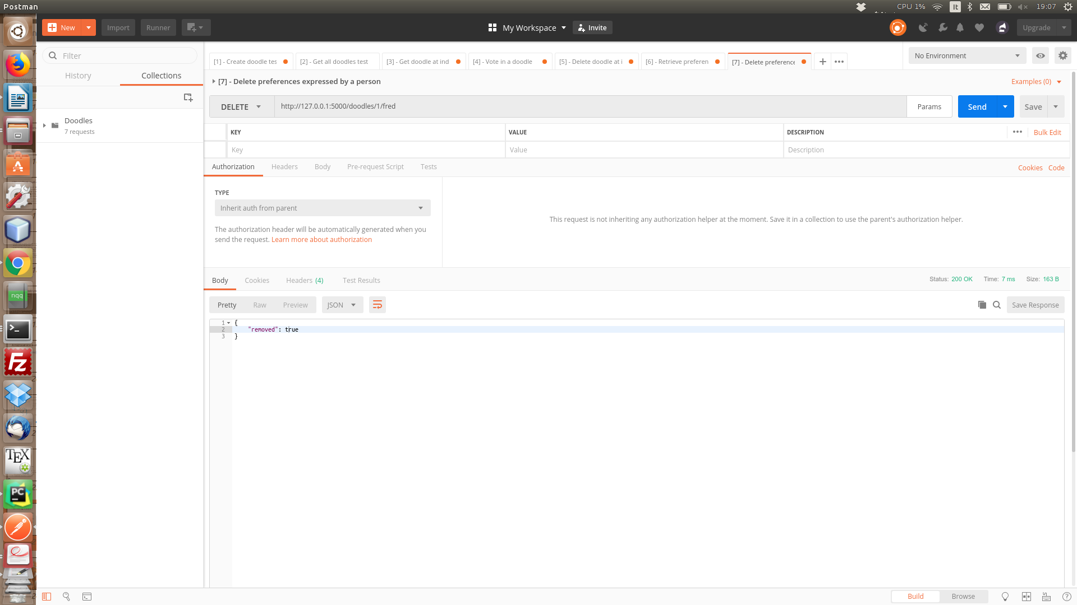
24) Get votes from a person that was deleted
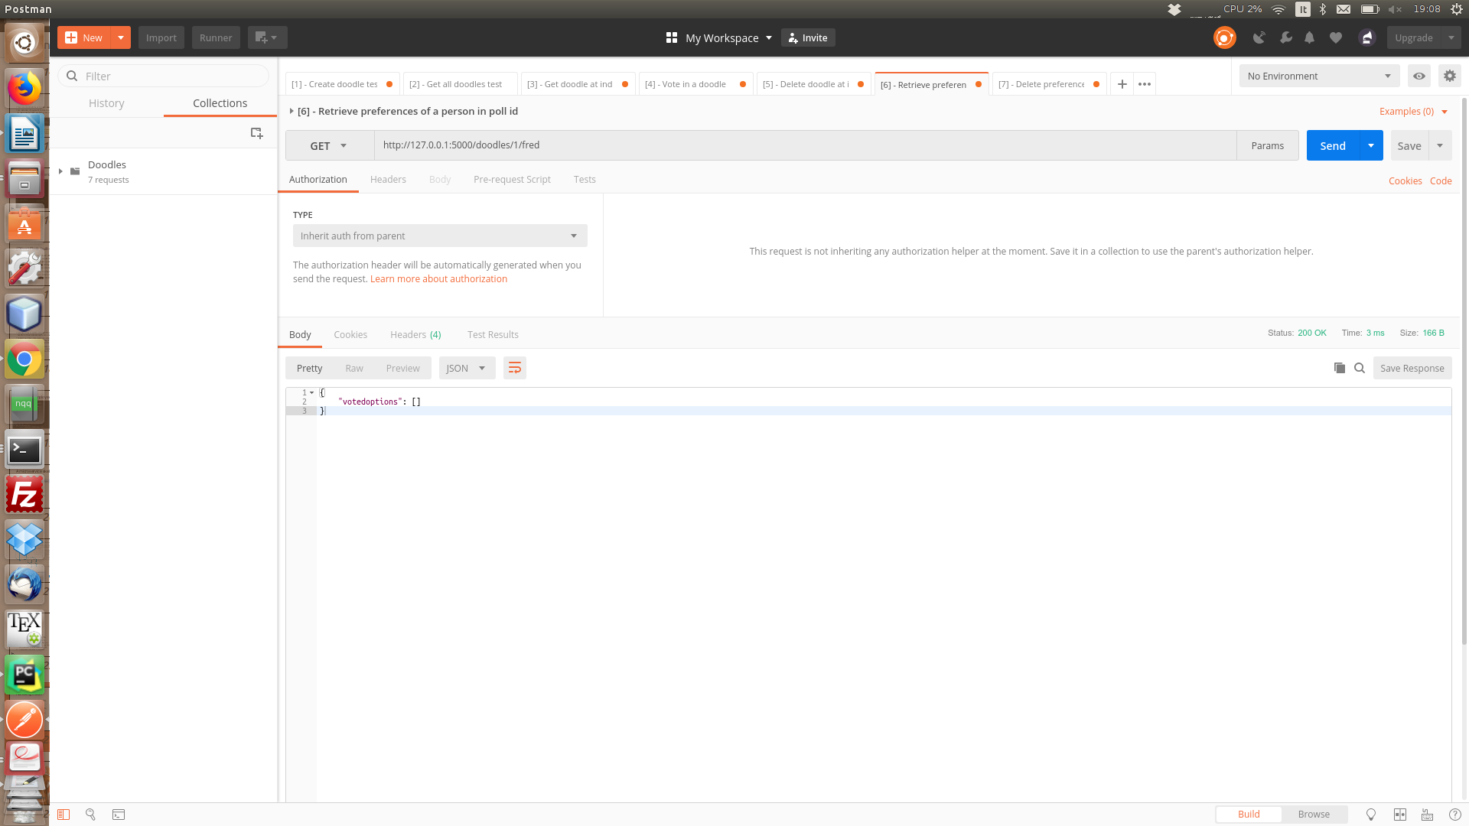
25) Delete votes from a person that did not vote
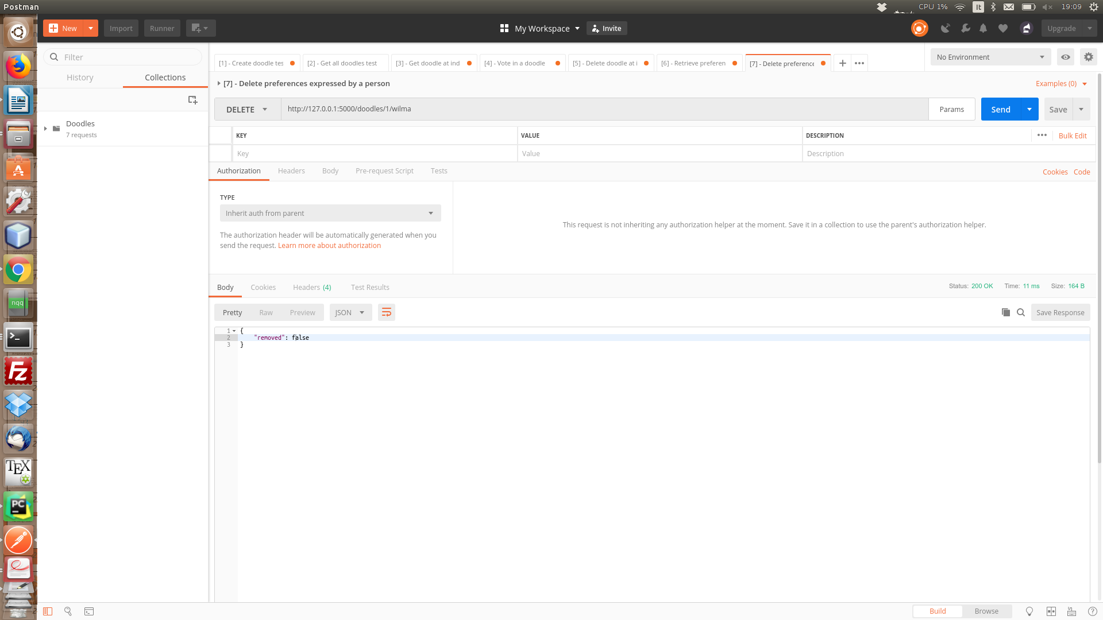

26) Retrieve votes from a non-existing poll
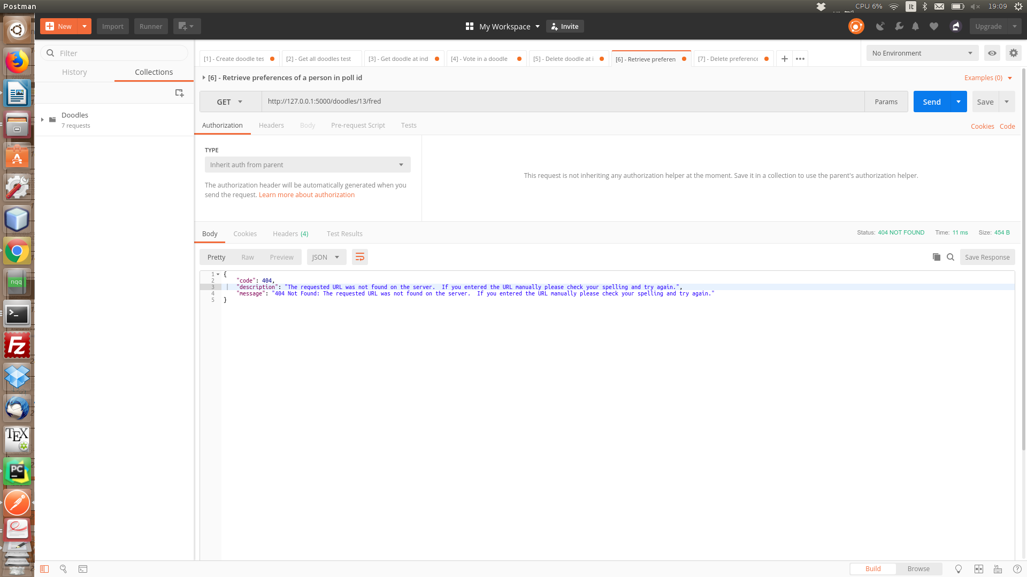

27) Get votes from a previously existing poll
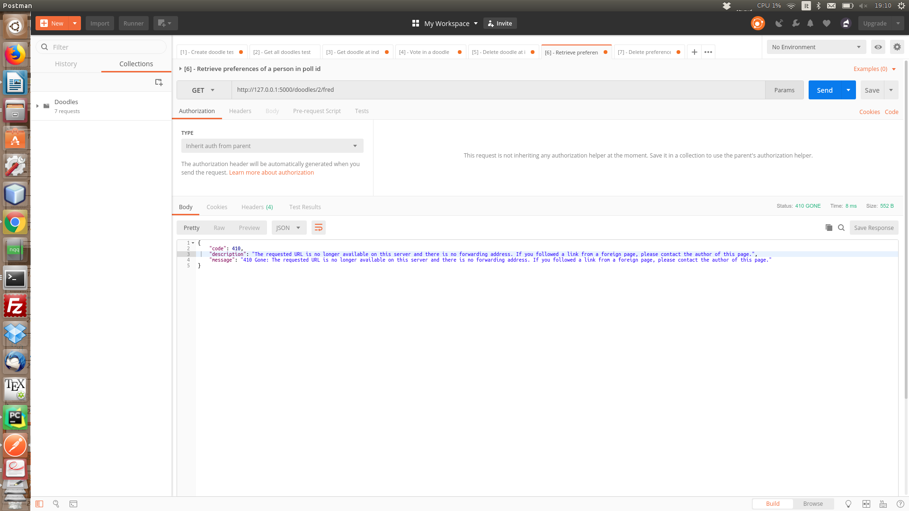

[4 – Extra tests]

28) Invalid data structure provided as ‘person’

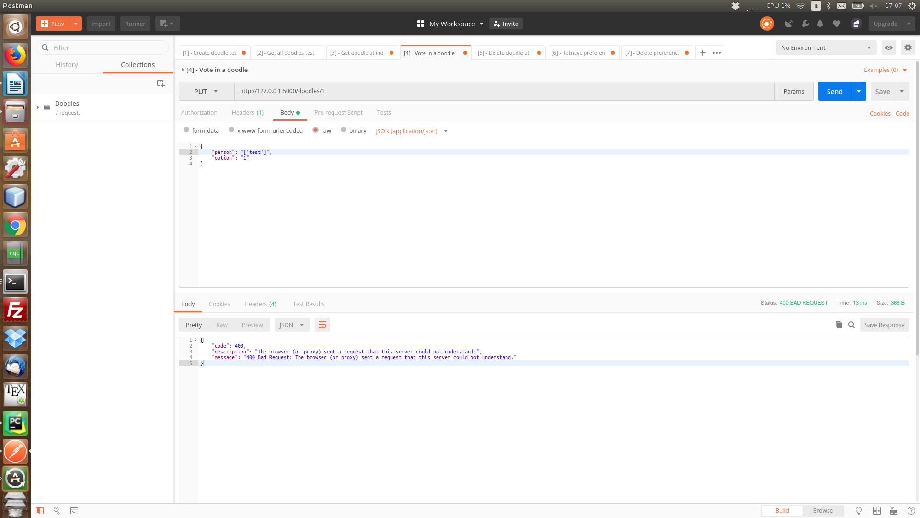
29) Invalid data structure provided while creating the doodle:


