ТУЕС към ТУ- София

Programming for Embedded Systems

2018-2019

**Задание за Курсов Проект**

**Тема: Автоматизирана количка с ултразвукови сензори**

Ученик:

1. Даниел Николаев Янев

**Технически параметри:**

HW платформа: Arduino Mega, HC-SR04 сензор

SW платформа: Arduino IDE

Функционални изисквания:

* Количката да се движи автономно и да избягва препятствия по пътя, като обработва данни от ултразвуковите сензори.

**Подпис Ученик: ………………**

**Подпис Учител: ………………**

# Hardware Design

## Principal Hardware Schema

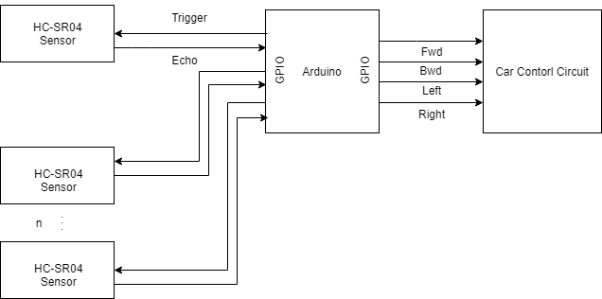

## Radio car schema

The cars schema originally controls the H-Bridge based on ultrasonic radio communication but for the purpose of the project the schema is taken out and the microcontroller controls the H-Bridge.

## HC-SR04 (4)

The HC-SR04 ultrasonic sensor uses sonar to determine distance to an object like bats do. It offers excellent non-contact range detection with high accuracy and stable readings in an easy-to-use package.

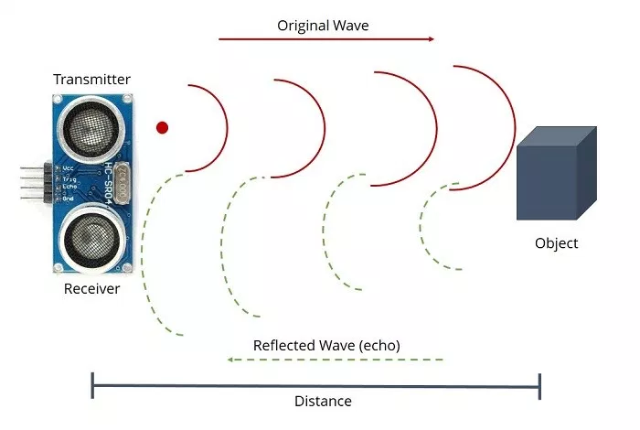

How it works:

1. The transmitter (trig pin) sends a signal: a high-frequency sound.
2. When the signal finds an object, it is reflected and…
3. … the transmitter (echo pin) receives it.

The time between the transmission and reception of the signal allows us to know the distance to an object. This is possible because we know the sounds velocity in the air.

## Sensor Placement

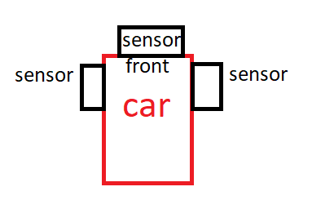

## Power Supply

The car rocks a 6V/2Ah Acid battery that serves both as a power source for the arduino and the motors and as a weight on over the rear wheel drive. Optional, the arduino could be powered from an USB Power Bank for adaptor convenience (requires **common ground** with the Acid battery).

# Software platform - Arduino

***Arduino*** *is an open-source hardware and software company, project and user community that designs and manufactures single-board microcontrollers and microcontroller kits for building digital devices and interactive objects that can sense and control both physically and digitally. Its products are licensed under the* ***GNU Lesser General Public License*** *(LGPL) or the* ***GNU General Public License*** *(GPL), permitting the manufacture of Arduino boards and software distribution by anyone. Arduino boards are available commercially in preassembled form or as do-it-yourself (DIY) kits.  
  
 Arduino board designs use a variety of microprocessors and controllers. The boards are equipped with sets of digital and analog input/output (I/O) pins that may be interfaced to various expansion boards or breadboards (shields) and other circuits. The boards feature serial communications interfaces, including Universal Serial Bus (USB) on some models, which are also used for loading programs from personal computers. The microcontrollers are typically programmed using a dialect of features from the programming languages C and C++. In addition to using traditional compiler toolchains, the Arduino project provides an integrated development environment (IDE) based on the Processing language project. (1)*

An Arduino board was chosen for this project for the soul purpose of simplicity. The project requires a few IO pins and with the help of external libraries for controlling the ultrasound sensors (Ref 1.3.1) a far more complicated microcontroller (like the Raspberry Pi) would be an overkill.

## IDE - Arduino IDE

*The Arduino integrated development environment (IDE) is a cross-platform application (for Windows, macOS, Linux) that is written in the programming language Java. It is used to write and upload programs to Arduino board.  
  
 The source code for the IDE is released under the* ***GNU General Public License****, version 2. The Arduino IDE supports the languages C and C++ using special rules of code structuring. The Arduino IDE supplies a software library from the Wiring project, which provides many common input and output procedures. User-written code only requires two basic functions, for starting the sketch and the main program loop, that are compiled and linked with a program stub main() into an executable cyclic executive program with the GNU toolchain, also included with the IDE distribution. The Arduino IDE employs the program avrdude to convert the executable code into a text file in hexadecimal encoding that is loaded into the Arduino board by a loader program in the board's firmware. (2)*

Arduino IDE also provides convenient way of installing libraries through the GUI either by downloading them from the IDE or from a zip file. It automatically adds them in the correct folder and links all the files properly, allowing user to use relative path instead of full path.

*Example of the ease from using relative paths compared to full paths*

## Language - C/C++

C/C++ was chosen for the project as its natively supported by Arduino IDE.

## Arduino Core Library - Arduino.h

Arduino.h(3) provides an API for operating with the microcontrollers I/O, handling interrupts, custom macros for every board and more.

# Software Detailed Design - Static View

Main algorithm

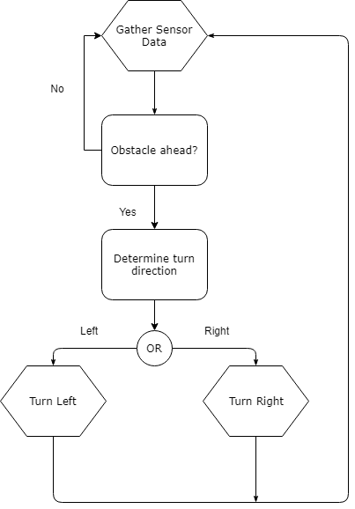

# 

# Software Detailed Design - Dynamic View

Sensors Arduino Car Hardware

| | |

| trigger pin | |

| <------------------------ | |

| | |

| echo pin | |

| ------------------------> | |

| | control signals |

| | ------------------------> |

| | |

References

* (1) - <https://en.wikipedia.org/wiki/Arduino>
* (2) - <https://en.wikipedia.org/wiki/Arduino_IDE>
* (3) - <https://github.com/arduino/ArduinoCore-avr/blob/master/cores/arduino/Arduino.h>
* (4) - <https://randomnerdtutorials.com/complete-guide-for-ultrasonic-sensor-hc-sr04/>