**Danyal Zahid**

**24k-0519**

**BCS 1-D**

**Q1:**

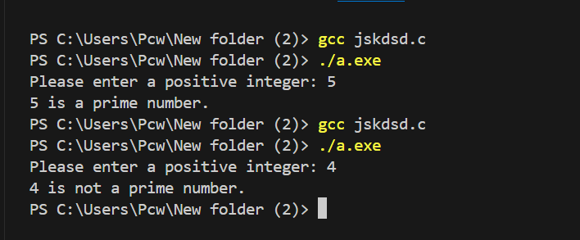

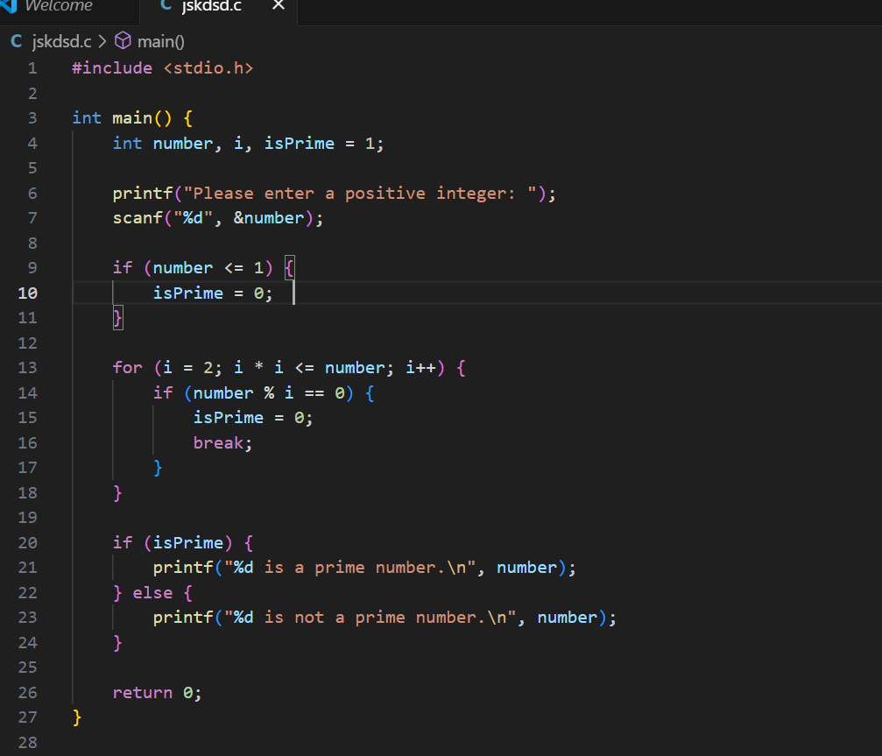

**Q2:**

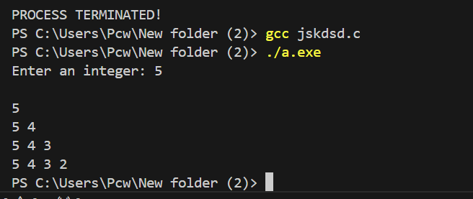

**Q3:**

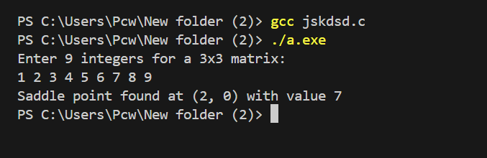

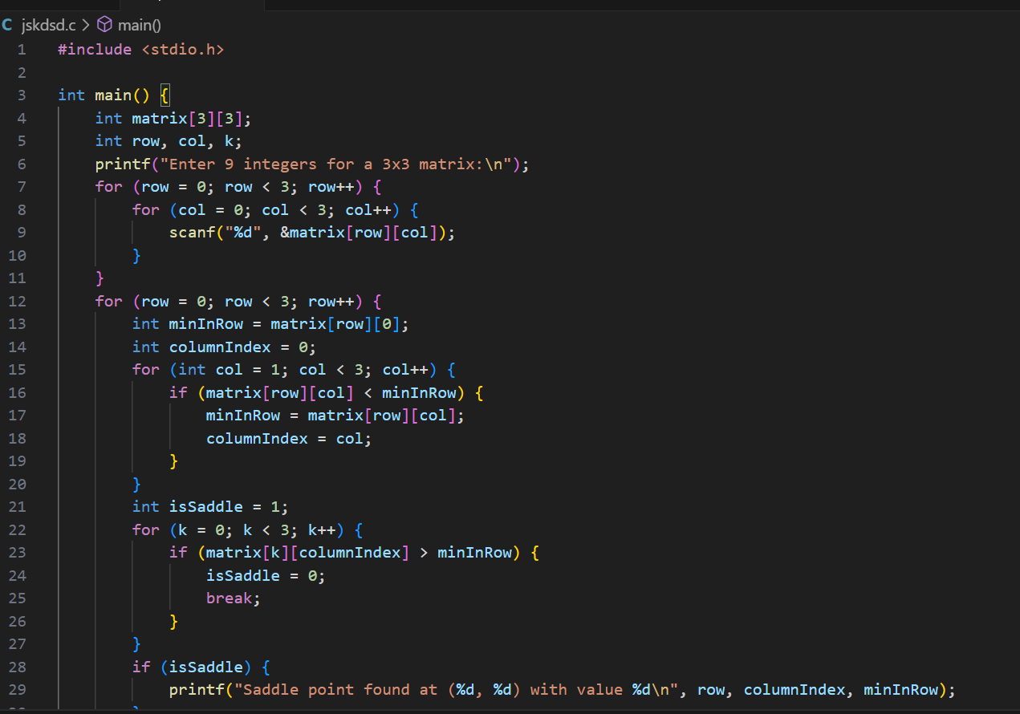

**Q4:**

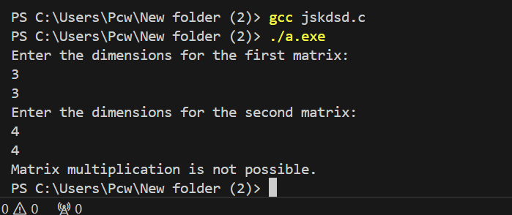

**Q5:**

