Task 1:
Declaration:
#include <iostream>
using namespace std;

int main(){
int sales[5];
int* p = sales;

return 0;
}
1:

int total = 0;

//input loop
for (int i = 0; i < 5; i++){
cout << "Enter a Non-negative Number: \n";
cin >> *(p + i);

while (*(p + i) < 0){
cout << "Invalid Number, Should be Non-negative\nTry Again: \n";
cin >> (*(p + i));
}
}

//output loop
cout << "Value of p Before: " << p << "\n";
cout << "Array: ";
for (int i = 0; i < 5; i++){
total += *(p + i);
cout << *(p + i) << " ";
}

cout << "\nTotal: " << total << "\n";
cout << "Value of p After: " << p << "\n";
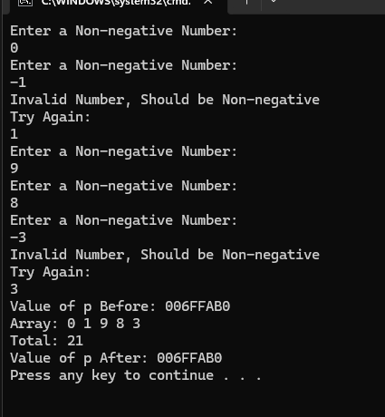
2:
cout << "After adding 2:\n";
*(p + 2) += 2; //third day's value is stored after 2 places
total += 2;

//output loop for updated values
for (int i = 0; i < 5; i++){
cout << *(p + i) << " ";
}

cout << "\nTotal: " << total << "\n";
Task and input | Expected result | Actual result | Pass or fail
Task: 1  Input: 0, 9, 1, 10, 3 | Array: 0 9 1 10 3  Total: 23  After adding 2: 0 9 3 10 3  New Total: 25 | Came same as Expected | Pass

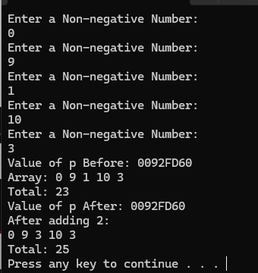
3:
- p is a the name (identifier) of the variable that is going to store the address of an integer in this scenario.
- int *p means that p is a pointer variable (stores address).
- &p gives the address of p (not the address INSIDE p but the address of p ITSELF)
- When using *p in any place after the declaration (after int *p;), it means go to the address inside p and give the value stored there. This is called DEFERENCING.
- In *(p+2), p is pointing to first integer address (in this scenario). When we add 2, we skip two integer addresses forward so we go one address forward (pointing to second integer address) then go another address forward so p + 2 gives address of 3rd integer in memory. Finally, we look at the value stored at this address by using the deference operator (*) explained above.
- Valid indices are 0, 1, 2, 3, 4 since it is an array of length 5.
- When we write p + 5, we are skipping 5 places forward. Since p is already at index 0, skipping 5 places forward means 1 then 2 then 3, 4, 5. However, 5 is not a valid index of the array and no value stored there so cannot do that as will return garbage value.

Task 2:
1:

#include <iostream>;
using namespace std;

int main(){
int numberOfStudents; //number of students = size of array

cout << "Enter the Total Number of Students: \n";
cin >> numberOfStudents;

//validation
while (numberOfStudents <= 0){
cout << "Invalid! Cannot be 0 or Less\nTry Again\n";
cin >> numberOfStudents;
}

int *marks = new int[numberOfStudents];

//input loop
for (int i = 0; i < numberOfStudents; i++){
cout << "Enter Marks: \n";
cin >> *(marks + i);

while (*(marks + i) < 0 || *(marks + i) > 100){
cout << "Invalid marks, Should be From 0 to 100\nTry Again: \n";
cin >> (*(marks + i));
}

}
return 0;
}

Task and input | Expected result | Actual result | Pass or fail
Task: 2.1  Input: 0, -1, 5, 10, 20, -1, 101, 0, 100, 70 | Should run with no issue, -1, 0, and 101 input should fail | Same as expected | Pass

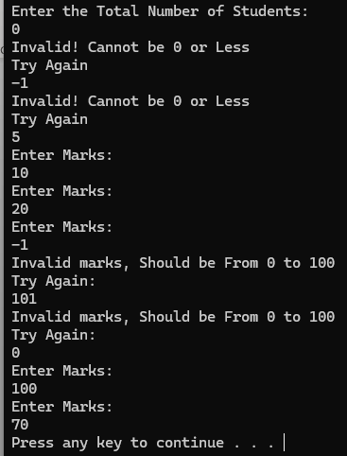

2:
int total = 0;
int count = 0;
cout << "\nMarks: ";
for (int i = 0; i < numberOfStudents; i++){
cout << *(marks + i) << " ";
total += *(marks + i);

if (*(marks + i) >= 50)
count++;
}

cout << "\nTotal Marks: " << total << "\n";
cout << "Average: " << (float) total / numberOfStudents;
cout << "\nNumber of Students with Marks >= 50: " << count << "\n";

Task and input | Expected result | Actual result | Pass or fail
Task: 2.2  Input: 5, 10, 20, 30, 50, 93 | Marks: 10 20 30 50 93  Total Marks: 203  Average: 40.6  >=50 count: 2 | Same as expected | Pass

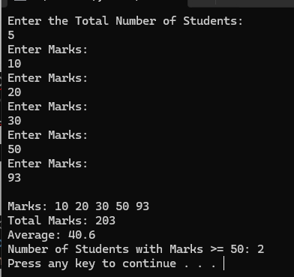
3:
delete[] marks;
marks = nullptr;
The pointer variable is created and allocated memory on the stack. The array is created using NEW keyword so stored on heap. The pointer variable points to the address of the first element in the heap. Since the pointer variable and the elements are on separate memory blocks (stack and heap) so they are different objects.
4:
int marks[n]; fails because it is created on stack. For this, the memory size required by marks is allocated at compile time. Since the compiler cannot allocate memory size as it is not known, it fails.
When using new int[n], the array is created on heap and memory size required is determined at runtime and not compile time so no issue occurs.
Test input | Expected result | Actual Result | Pass or Fail
n = 4; marks = 40 50 70 81 | Total 241; average 60.25; pass count 3 | Same as expected | Pass
n = 1; mark = 0 | Total 0; average 0; pass count 0 | Same as expected | Pass
n = 0 | Error; no allocation or mark input | Same as expected | Pass

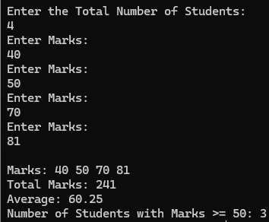
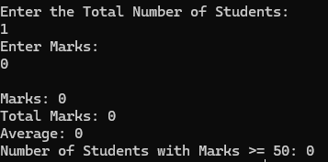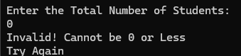

Task 3:
1:
#include <iostream>>
using namespace std;

int main(){
int sales[2][3];
int(*rowPtr)[3] = sales;

for (int r = 0; r < 2; r++){
cout << "Branch " << r + 1 << ":\n";
for (int c = 0; c < 3; c++){
cout << "Enter Day Sale: \n";
cin >> *(*(rowPtr + r) + c);
}
cout << "\n";
}

int branchTotal;
for (int r = 0; r < 2; r++){
cout << "Branch " << r + 1 << ": ";
branchTotal = 0; // reset to 0 for each branch

for (int c = 0; c < 3; c++){
cout << *(*(rowPtr + r) + c) << " ";
branchTotal += *(*(rowPtr + r) + c);
}
cout << "\n";
}

return 0;
}

Task and input | Expected result | Actual result | Pass or fail
Task: 3.1  Input: 2, 4, 6, 1, 3, 5 | Branch 1: 2 4 6  Branch 2: 1 3 5 | Same as expected | Pass

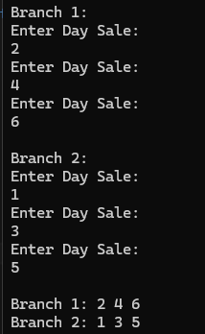

2:
#include <iostream>>
using namespace std;

int main(){
int sales[2][3];
int(*rowPtr)[3] = sales;

for (int r = 0; r < 2; r++){
cout << "Branch " << r + 1 << ":\n";
for (int c = 0; c < 3; c++){
cout << "Enter Day Sale: \n";
cin >> *(*(rowPtr + r) + c);
}
cout << "\n";
}

int branchTotal;
for (int r = 0; r < 2; r++){
cout << "Branch " << r + 1 << ": ";
branchTotal = 0; // reset to 0 for each branch

for (int c = 0; c < 3; c++){
cout << *(*(rowPtr + r) + c) << " ";
branchTotal += *(*(rowPtr + r) + c);
}
cout << "Branch Total: " << branchTotal << "\n";
}

int dayTotal;
for (int c = 0; c < 3; c++){
dayTotal = 0;
for (int r = 0; r < 2; r++){
dayTotal += *(*(rowPtr + r) + c);
}
cout << "Total for Day " << c + 1 << " :" << dayTotal << "\n";
}

return 0;
}
Task and input | Expected result | Actual result | Pass or fail
Task: 3.2  Input 1: 2, 4, 6, 1, 3, 5  Input 2: all 0 | Branch 1: 2 4 6 Total: 12  Branch 2: 1 3 5 Total: 9  Day Total: 3, 7, and11  Branch 1: 0 0 0 Total: 0  Branch 2: 0 0 0 Total: 0  Day Total: 0 | Same as expected | Pass

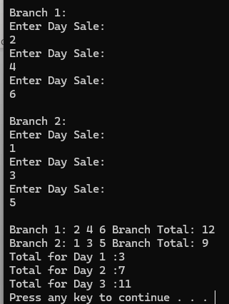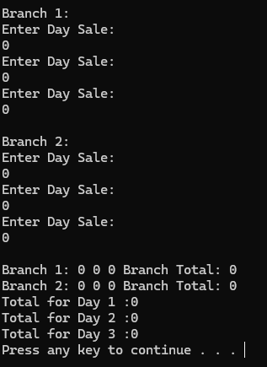
3:
rowPtr points to an entire row of 3 integers.
When we write rowPtr + 1, we move one row of 3 integers forward.
When this is done with int* pointing to one integer, we move forward by one integer but for rowPtr, we move forward by one row.
Int** mean pointer to a pointer. Sales is not a pointer to a pointer. It is a pointer to an array of 3 integers.

Task 4:
1:
#include <iostream>
using namespace std;

int main(){
int students, subjects;

}
2:
#include <iostream>
using namespace std;

int main(){
int students, subjects;

cout << "Enter the Total Number of Students: \n";
cin >> students;
while (students <= 0){
cout << "Invalid! Cannot be 0 or Less\nTry Again\n";
cin >> students;
}

cout << "Enter the Total Number of Subjects: \n";
cin >> subjects;
while (subjects <= 0){
cout << "Invalid! Cannot be 0 or Less\nTry Again\n";
cin >> subjects;
}

int** marks = new int*[students];

for(int i = 0; i < students; i++){
*(marks + i) = new int[subjects];
}
return 0;
}

3:
#include <iostream>
using namespace std;

int main(){
int students, subjects;

cout << "Enter the Total Number of Students: \n";
cin >> students;
while (students <= 0){
cout << "Invalid! Cannot be 0 or Less\nTry Again\n";
cin >> students;
}

cout << "Enter the Total Number of Subjects: \n";
cin >> subjects;
while (subjects <= 0){
cout << "Invalid! Cannot be 0 or Less\nTry Again\n";
cin >> subjects;
}

int** marks = new int*[students];

for(int i = 0; i < students; i++){
*(marks + i) = new int[subjects];
}

for (int i = 0; i < students; i++){
for(int j = 0; j < subjects; j++){
cout << "Enter Marks for Student " << i + 1 << " Subject " << j + 1 << ": \n";
cin >> *(*(marks + i) + j);
}
}

for (int i = 0; i < students; i++){
cout << "Student " << i + 1 << ": ";
for(int j = 0; j < subjects; j++){
cout << marks[i][j] << " ";
}
cout << "\n";
}
return 0;
}

4:
int total;
int highestTotal = -1;
int highestStudent;
for (int i = 0; i < students; i++){
total = 0;
cout << "Student " << i + 1 << ": ";
for(int j = 0; j < subjects; j++){
cout << marks[i][j] << " ";
total += marks[i][j];
}
cout << "Total Marks: " << total;
cout << "\n";

if (total > highestTotal){
highestTotal = total;
highestStudent = i + 1;
}
}
cout << "Student " << highestStudent << " has the highest total marks: " << highestTotal << "\n";

Task and input | Expected result | Actual result | Pass or fail
Task: 4.4  Input: 2, 3, 50, 60, 70, 80, 40, 90 | Student 1: 50 60 70 Total: | ___ | ___

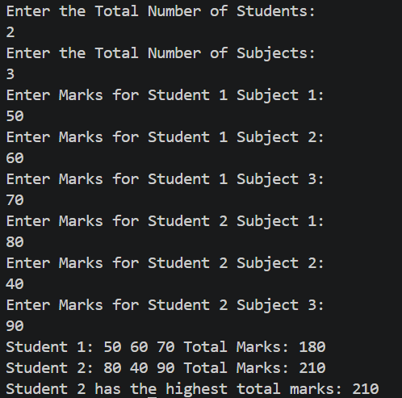
5:

for(int i = 0; i < students; i++){
delete[] marks[i];
}
delete[] marks;
marks = nullptr;

if only delete[] marks was executed, only the row pointer array would be deleted but the subjects (coloumns) arrays would remain allocated.

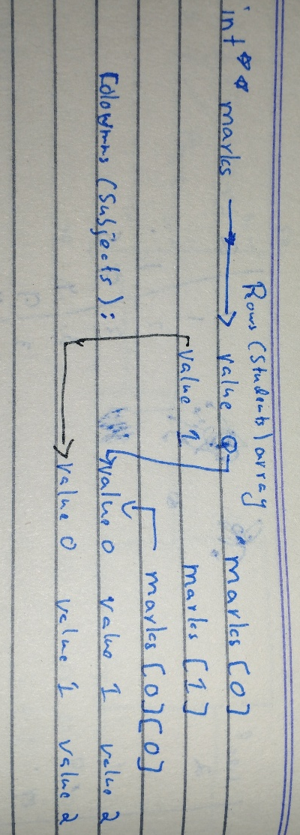
6:

Input by Row | Expected result | Actual Result
2 × 3: 50 60 70 / 80 40 90 | Totals: 180, 210; top student: 2 | Totals: 180, 210  Top Student: 2
2 × 2: 40 60 / 50 50 | Totals: 100, 100; top student: 1 | Totals: 100, 100  Top Student: 1
1 × 1: 75 | Total: 75; top student: 1 | Total: 75 Top Student: 1

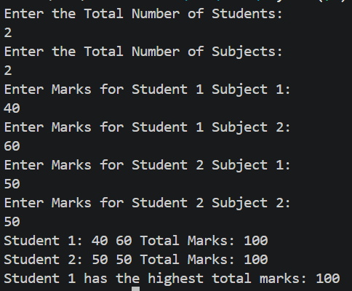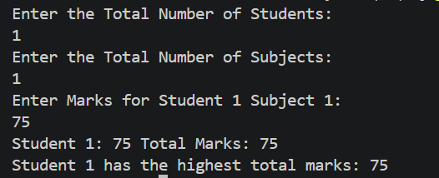

Task 5:
1:
#include <iostream>
using namespace std;

int main(){
int n;
cout << "Enter number of students:\n";
cin >> n;

while (n < 1 || n > 10){
cout << "Invalid! Cannot be 0 or Less or Greater than 10\nTry Again\n";
cin >> n;
}

int *marks = new int[n];

//input loop
for (int i = 0; i < n; i++){
cout << "Enter Marks for Student " << i + 1 << ":\n";
cin >> *(marks + i);

//validation
while (*(marks + i) < 0 || *(marks + i) > 100){
cout << "Invalid marks, Should be From 0 to 100\nTry Again: \n";
cin >> (*(marks + i));
}
}

int *extendedMarks = new int[n + 1];
for (int i = 0; i < n; i++){
*(extendedMarks + i) = *(marks + i);
}

cout << "Enter Marks for New Student:\n";
cin >> *(extendedMarks + n);

while (*(extendedMarks + n) < 0 || *(extendedMarks + n) > 100){
cout << "Invalid marks, Should be From 0 to 100\nTry Again: \n";
cin >> (*(extendedMarks + n));
}

return 0;
}

2:
delete[] marks;
marks = extendedMarks;
n += 1;

for (int i = 0; i < n; i++){
cout << "Marks for Student " << i + 1 << ": " << *(marks + i) << "\n";
}

3:
delete[] marks;

Changing n alone doesn’t change anything because the array has already been created and memory already allocated on the heap, changing n later doesn’t effect anything on that array, it only changes the value of n on the stack.
Final Program:
#include <iostream>
using namespace std;

int main(){
int n;
cout << "Enter number of students:\n";
cin >> n;

while (n < 1 || n > 10){
cout << "Invalid! Cannot be 0 or Less or Greater than 10\nTry Again\n";
cin >> n;
}

int *marks = new int[n];

//input loop
for (int i = 0; i < n; i++){
cout << "Enter Marks for Student " << i + 1 << ":\n";
cin >> *(marks + i);

//validation
while (*(marks + i) < 0 || *(marks + i) > 100){
cout << "Invalid marks, Should be From 0 to 100\nTry Again: \n";
cin >> (*(marks + i));
}
}

int *extendedMarks = new int[n + 1];
for (int i = 0; i < n; i++){
*(extendedMarks + i) = *(marks + i);
}

cout << "Enter Marks for New Student:\n";
cin >> *(extendedMarks + n);

while (*(extendedMarks + n) < 0 || *(extendedMarks + n) > 100){
cout << "Invalid marks, Should be From 0 to 100\nTry Again: \n";
cin >> (*(extendedMarks + n));
}

delete[] marks;
marks = extendedMarks;
n += 1;

for (int i = 0; i < n; i++){
cout << "Marks for Student " << i + 1 << ": " << *(marks + i) << "\n";
}

delete[] marks;
return 0;
}

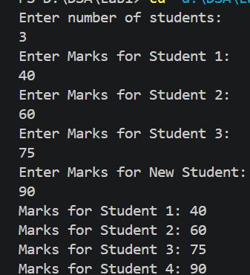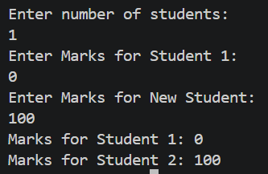

Task 6:
1:
- Out of Bounds Access: the loop runs when i = 3 but the indices in the array on the heap go from 0 till 2 only. Consequence is that undefined behavior may occur, adjacent heap data may also get corrupted
- Incorrect code (delete values): the correct syntax is delete[] values. Consequence is that undefined behaviour may occur since it may or may not correctly free the heap memory.
- Accessing a value on the heap after it has been deleted:
  - We used cout << values[0] after values[] had been deleted. Consequence: we may read garbage data and again: undefined behaviour may occur
2:
#include <iostream>
using namespace std;

int main(){
int n = 3;
int* values = new int[n];
for (int i = 0; i <n; i++)
cin >> values[i];

for (int i = 0; i < n; i++)
cout << values[i] << " ";

delete[] values;
values = nullptr;
return 0;
}

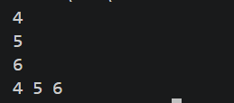
3:
- Out-of-Bounds Access:
  - Reading or writing to memory outside the allocated space or index range
- Dangling Pointer:
  - A pointer that points to a memory address that has already been deleted (deallocated)
- Memory Leak:
  - Allocating heap memory and then losing all references to it (no pointer is pointing to that memory address) without freeing/deallocating that memory. This memory is now constantly occupied till the program terminates.
Why a program appearing to run successfully does not prove its memory accesses are valid?
In relation to the errors above, reading a memory address that has been deleted still gives correct data but it is only because that data was not overwritten by any other program. Similarly, going past the allocated space in heap also did’t cause the program to crash but it does lead to undefined behaviour since you accessed potentially another program’s memory.
If later in time, that deleted memory had been overwritten, you would be reading false data or someone else’s data.

