Markdown → PDF & DOCX Converter
A professional offline Chrome extension that transforms Markdown into polished PDF and editable DOCX documents. No backend, fully offline, premium via Chrome Web Store.
Features • Installation • Usage • Examples • Contributing

Features
- GitHub Flavored Markdown – headings, lists, tables, blockquotes, code blocks
- Live math rendering with KaTeX – inline $E=mc^{2}$ and display-mode $\int_{0}^{∞}{ }$
- Mermaid diagrams – flowcharts, sequence diagrams, graphs – rendered as sharp SVGs
- Syntax highlighting for code blocks (Python, JavaScript, Java, C++, Bash, etc.)
- 10 professional fonts – Inter, Roboto, JetBrains Mono, and more
- PDF export – uses browser print engine for vector‑quality output (A4 / Letter)
- DOCX export – fully editable Word documents with embedded SVGs and tables
- 100% offline – all processing happens locally, no data leaves your machine
- Clean, icon‑driven UI – minimal text, easy to use for non‑technical audiences
- Premium via Chrome Web Store – one‑time purchase, verified by Google sign‑in, no ads ever

Installation

Quick start (for users)
- [Install]
- Pin the extension to your toolbar.
- Paste Markdown → choose a font → click Export PDF or DOCX.

Build from source (for developers)
bash
git clone https://github.com/Danyalkhattak/markdown-converter.git
cd markdown-converter
npm install
node setup.js # downloads all required libraries into extension/libs/

Then load the extension folder as an unpacked extension in Chrome:
- Go to chrome://extensions
- Enable Developer mode
- Click Load unpacked and select the extension folder

Usage
- Click the extension icon in the toolbar.
- Paste your Markdown (or click the selection button to grab text from the current page).
- Choose a font from the dropdown.
- Click PDF to export a document that opens in a new tab and auto‑triggers print.
- Click DOCX to download a fully editable .docx file.
Settings (gear icon) allow you to:
- Change the default font and export format
- Switch code theme (light/dark)
- Toggle Mermaid diagram and KaTeX math rendering

Supported Markdown Features
Feature | PDF | DOCX
Headings | ✓ | ✓
Bold / Italic | ✓ | ✓
Lists | ✓ | ✓
Tables | ✓ | ✓ (native Word tables)
Code blocks | ✓ (highlighted) | ✓ (monospaced)
Blockquotes | ✓ | ✓
Inline math $...$ | ✓ (KaTeX) | fallback text
Block math $\$...\$$ | ✓ (KaTeX) | fallback text
Mermaid diagrams | ✓ (SVG) | ✓ (embedded SVG)

Examples

Mermaid Flowchart
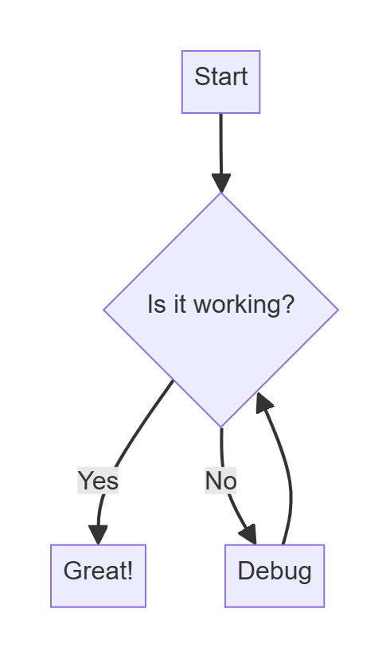
Renders as a sharp vector graphic in both PDF and DOCX.

LaTeX / KaTeX
Inline: The mass–energy equivalence formula is $E=mc^{2}$.
Display:
$$\int_{-∞}^{∞}{ }e^{-x^{2}}dx=\sqrt{π}$$
All math is rendered using KaTeX – no server required.

Markdown Table
Language | Speed | Popularity
Python | Fast | Very high
Rust | Fast | Growing
JavaScript | Fast | Very high

Tables become real Word tables in DOCX, not images.

Contributing
We welcome improvements, bug fixes, and new feature ideas.
Here’s how to contribute:
- Fork the repository.
- Create a new branch: git checkout -b feature/amazing-feature
- Make your changes (keep the code clean and well‑commented).
- Test locally: load the extension folder as an unpacked extension.
- Commit and push: git commit -m "Add amazing feature"
- Open a Pull Request describing what you’ve done and why.

Development guidelines
- The extension is written in plain JavaScript, HTML, and CSS – no build step.
- All third‑party libraries are downloaded via setup.js into extension/libs/ (do not commit them).
- The "key" field in manifest.json should only be used for local development and never committed to the public repository (we maintain a separate manifest.dev.json for that).
- UI changes must remain icon‑based and minimal; avoid adding emojis or long text.

License
This project is licensed under the MIT License.
Premium features are unlocked via a legitimate Chrome Web Store purchase.

Made with ❤️ for students, developers, and technical writers worldwide by Danyal Khattak.

