**Programming languages (TC-2006)**

**Homework 02**

1.- Golang (Go)

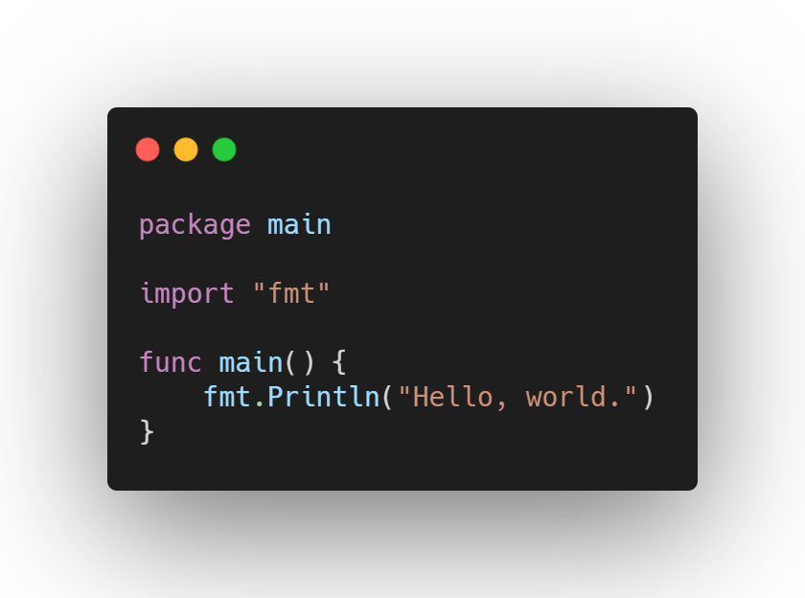<https://golang.org/doc/code.html>

Based on its way of expressing solutions, Go is an imperative programming language because it clearly states each command to execute, it focuses more on the how rather than on the what.

Based on its paradigm, Go is also an imperative programming language, because the commands show step by step how the computation should occur.

2.- Prolog

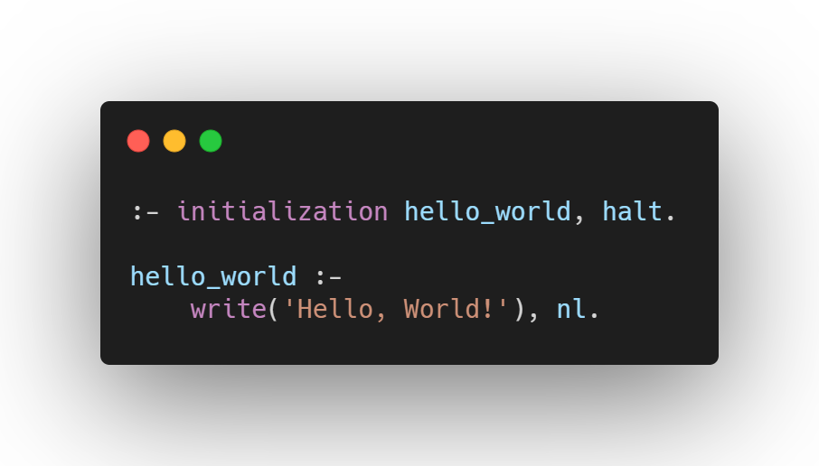<https://www.swi-prolog.org/pldoc/doc_for?object=manual>

Based on its way of expressing solutions Prolog is a declarative programming language, because it cares more about the what the computer should do and not on how.

Based on its paradigm, Prolog is a logic-oriented programming language because its statements are written in a logical form, following rules.

3.- Ruby

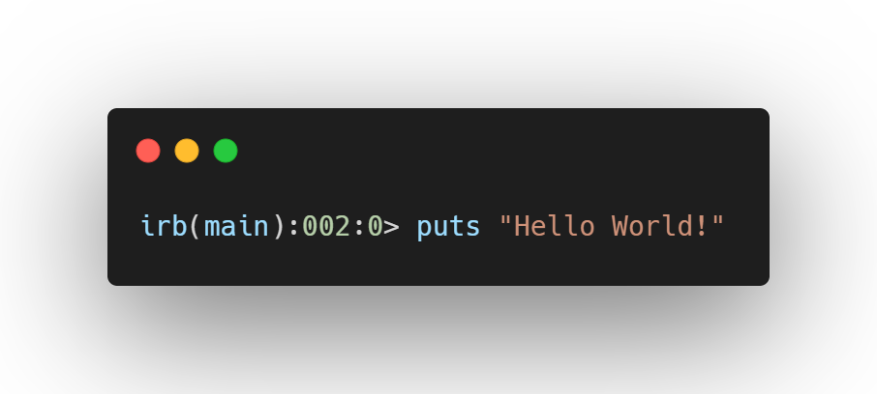<https://www.ruby-lang.org/es/documentation/>

Based on its way of expressing solutions, Ruby is an imperative programming language because it cares more about how the computer should behave.

Based on its paradigm, Ruby is an object-oriented programming language because all its components are objects of a class.

**I promise to apply my knowledge, strive for its development, and not use unauthorized or illegal means to complete this activity, following the Tecnológico de Monterrey Student Code of Honor.**