**Project 01**

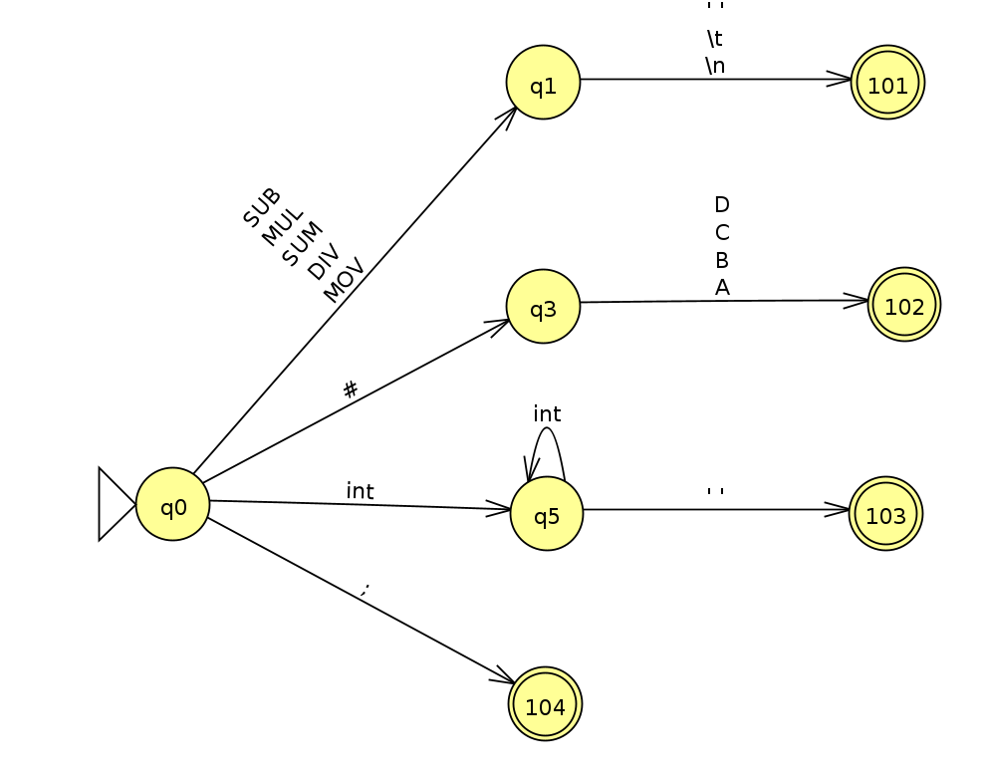**Lexical Analysis (DFA)**

**Syntactic Analysis (Grammar)**

$$S →OPERATION REGISTER REGISTER S$$

$$S →ASSIGNMENT INTEGER REGISTER S$$

$$S →ASSIGNMENT REGISTER REGISTER S$$

$$S → ;$$