Lab 6 - Implementing Intrusion Prevention System (IPS) Using Cisco IOS
Topology
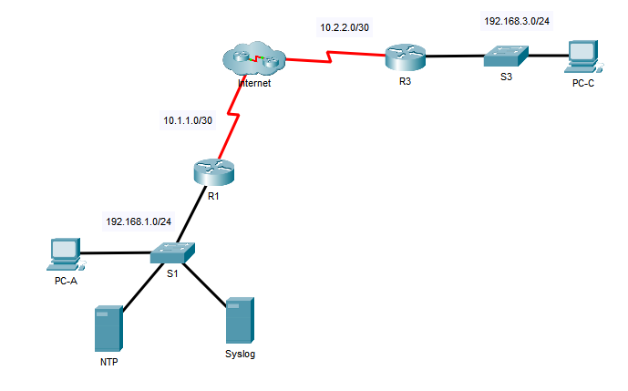
Addressing Table
Device | Interface | IP Address | Subnet Mask | Default Gateway | Switch Port
R1 | G0/1 | 192.168.1.1 | 255.255.255.0 | N/A | S1 F0/1
R1 | S0/0/0 | 10.1.1.1 | 255.255.255.252 | N/A | N/A
R3 | G0/1 | 192.168.3.1 | 255.255.255.0 | N/A | S3 F0/1
R3 | S0/0/1 | 10.2.2.1 | 255.255.255.252 | N/A | N/A
Syslog | NIC | 192.168.1.100 | 255.255.255.0 | 192.168.1.1 | S1 F0/2
NTP | NIC | 192.168.1.101 | 255.255.255.0 | 192.168.1.1 | S1 F0/4
PC-A | NIC | 192.168.1.2 | 255.255.255.0 | 192.168.1.1 | S1 F0/3
PC-C | NIC | 192.168.3.2 | 255.255.255.0 | 192.168.3.1 | S3 F0/2
Objectives
- Enable IOS IPS.
- Configure logging.
- Modify an IPS signature.
- Verify IPS.
Background / Scenario
Your task is to enable IPS on R1 to scan traffic entering the 192.168.1.0 network.
The server labeled Syslog is used to log IPS messages. You must configure the router to identify the syslog server to receive logging messages. Displaying the correct time and date in syslog messages is vital when using syslog to monitor the network. Set the clock and configure the timestamp service for logging on the routers. Finally, enable IPS to produce an alert and drop ICMP echo reply packets inline.
The server and PCs have been preconfigured. The routers have also been preconfigured with the following:
- Enable password: ciscoenpa55
- Console password: ciscoconpa55
- SSH username and password: SSHadmin / ciscosshpa55
- OSPF 101
- Enable IOS IPS
    - Verify the IPS signature file is already loaded on R1.
The routers in Packet Tracer already have signature files imported and in place. They are the default xml files in flash. For this reason, it is not necessary to configure the public crypto key and complete a manual import of the signature files.
On R1, issue the dir command to verify the signature file is already present.
QUESTION 1 Is the master signature file (sigdef-default.xml) present on the device currently?
Before proceeding, go to the “Lab 6 - Implementing Intrusion Prevention System (IPS) Using Cisco IOS - QUESTIONS” quiz on the Brightspace page and enter your answer for question 1. Leave the quiz open while you complete the rest of the lab sheet.

    - Enable the Security Technology package.
      - On R1, issue the show version command to view the Technology Package license information.
      - If the Security Technology package has not been enabled, use the following command to enable the package.
R1(config)# license boot module c1900 technology-package securityk9
      - Accept the end user license agreement.
      - Save the running-config and reload the router to enable the security license.
      - Verify that the Security Technology package has been enabled by using the show version command.
    - Check current IPS signature status.
On R1, use the show ip ips all and show ip ips configuration commands to check if there are any signatures currently active on the device.
QUESTION 2 How many signatures are currently active on the device?
Before proceeding, return to the quiz and enter your answer for question 2. Leave the quiz open while you complete the rest of the lab sheet.

    - Verify network connectivity.
      - Ping from PC-C to PC-A. The ping should be successful.
      - Ping from PC-A to PC-C. The ping should be successful.
    - Create an IOS IPS configuration directory in flash.
On R1, create a directory in flash using the mkdir command. Name the directory dir_ips.
    - Configure the IPS signature storage location.
On R1, configure the IPS signature storage location to be the directory you just created.
    - Create an IPS rule.
On R1, create an IPS rule name using the ip ips name name command in global configuration mode. Name the IPS rule ipsios.
    - Enable logging.
IOS IPS supports the use of syslog to send event notification. Syslog notification is enabled by default. If logging console is enabled, IPS syslog messages display.
      - Enable the syslog service on the Syslog server if it is not enabled.
      - Enable the NTP service on the NTP server if it is not enabled.
      - Configure R1 to obtain its system time information from the NTP server at IP address 192.168.1.101.
      - Verify that the timestamp service for logging is enabled on the router using the show run command. Enable the timestamp service if it is not enabled.
      - Send log messages to the syslog server at IP address 192.168.1.100.
    - Configure IOS IPS to use the signature categories.
Retire the all signature category with the retired true command (all signatures within the signature release). Unretire the IOS_IPS Basic category with the retired false command.
    - Apply the IPS rule to an interface.
Apply the IPS rule to an interface with the ip ips name direction command in interface configuration mode. Apply the rule outbound on the G0/1 interface of R1. After you enable IPS, some log messages will be sent to the console line indicating that the IPS engines are being initialised.
Note: The direction in means that IPS inspects only traffic going into the interface. Similarly, out means that IPS inspects only traffic going out of the interface.
- Modify the Signature
    - Change the event-action of a signature.
Un-retire and enable the echo request signature (signature 2004, subsig ID 0), enable it, and change the signature action to alert and drop.
    - Use show commands to verify IPS.
Use the show ip ips all command to view the IPS configuration status summary.
QUESTION 3 To which interfaces and in which direction is the ipsios rule applied?
Before proceeding, return to the quiz and enter your answer for question 3. Leave the quiz open while you complete the rest of the lab sheet.
    - Verify that IPS is working properly.
      - From PC-C, attempt to ping PC-A.
QUESTION 4 Was PC-C able to successfully ping PC-A? Why was it able/not able to?
      - From PC-A, attempt to ping PC-C.
QUESTION 5 Was PC-A able to successfully ping PC-C? Why was it able/not able to?
Before proceeding, return to the quiz and enter your answers for questions 4 & 5. Leave the quiz open while you complete the rest of the lab sheet.
    - View the syslog messages.
      - Click the Syslog server.
      - Select the Services tab.
      - In the left navigation menu, select SYSLOG to view the log file.
QUESTION 6 Are there any log messages visible from the IPS process and, if so, what is the “risk rating” showing on them?
Before proceeding, return to the quiz and enter your answer for question 6.

If you have correctly configured all parts of the lab your activity score should now be showing as 100%. If so, click on “check results” in the activity window. Return to the Brightspace quiz one last time and enter the code into the appropriate question box (Q7) of the quiz.
You have completed the lab – please submit the Brightspace quiz.

