Lab 7 - Configure a Site-to-Site VPN

Topology
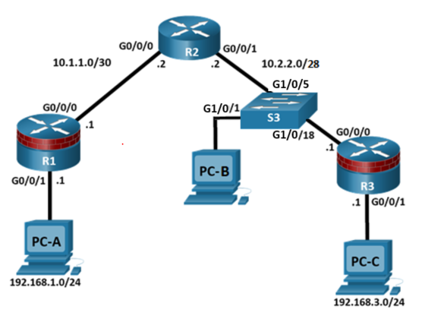

Addressing Table
Device | Interface | IP Address | Subnet Mask | Default Gateway | Switch Port
R1 | G0/0/1 | 192.168.1.1 | 255.255.255.0 | N/A | N/A
R1 | G0/0/0 | 10.1.1.1 | 255.255.255.252 | N/A | N/A
R2 | G0/0/0 | 10.1.1.2 | 255.255.255.252 | N/A | N/A
R2 | G0/0/1 | 10.2.2.2 | 255.255.255.240 | N/A | S3 G1/0/5
R3 | G0/0/1 | 192.168.3.1 | 255.255.255.0 | N/A | N/A
R3 | G0/0/0 | 10.2.2.1 | 255.255.255.240 | N/A | S3 G1/0/18
PC-A | NIC | 192.168.1.3 | 255.255.255.0 | 192.168.1.1 | N/A
PC-B | NIC | N/A | N/A | N/A | S3 G1/0/1
PC-C | NIC | 192.168.3.3 | 255.255.255.0 | 192.168.3.1 | N/A

Objectives
Part 1: Configure Basic Device Settings
- Configure hostnames, interface IP addresses, and access passwords.
- Configure the OSPF dynamic routing protocol.
Part 2: Configure Local SPAN and Capture Copied Traffic in Wireshark
- Configure Local SPAN on S3.
- Capture and view copied Telnet traffic crossing between the two LANs.
Part 3: Configure a Site-to-Site VPN Using Cisco IOS
- Configure IPsec VPN settings on R1 and R3.
- Verify site-to-site IPsec VPN configuration.
- Test IPsec VPN operation.
- Attempt to capture and traffic going through the IPsec VPN tunnel.

Background / Scenario
In this scenario, R2 is essentially acting as the ISP so the connections between R1 and R2 and between R3 and R2 (via S3) are WAN connections.
VPNs can provide a secure method of transmitting data over a public network, such as the Internet. VPN connections can help reduce the costs associated with leased lines. Site-to-Site VPNs typically provide a secure (IPsec or other) tunnel between a branch office and a central office. Another common implementation of VPN technology is remote access to a corporate office from a telecommuter location, such as a small office or home office.
In this lab, you will build and configure a multi-router network, use Cisco IOS to configure a site-to-site IPsec VPN, and then test the VPN. The IPsec VPN tunnel is from R1 to R3 via R2 and S3. R2 and S3 act as pass-throughs and have no knowledge of the VPN. IPsec provides secure transmission of sensitive information over unprotected networks, such as the Internet. IPsec acts at the network layer and protecting and authenticating IP packets between participating IPsec devices (peers), such as Cisco routers.
To demonstrate the potential vulnerabilites of sending sensitive information over unprocted networks, PC-B is going to act as a threat actor that is going to eavesdrop on all traffic going between R1’s LAN and R3’s LAN. This will be achievied by configuring port mirroring on S3 and sending a copy of the traffic going between the LAN’s to PC-B where it can be analysed using Wireshark.
To set up port mirroring, you will use the Switched Port Analyzer (SPAN) feature on the Cisco switch. SPAN is a type of port mirroring that sends copies of a frame entering a port, out another port on the same switch. Wireshark is a software protocol analyser, or "packet sniffer" application, used for network troubleshooting, analysis, software and protocol development, and education.
ISAKMP Phase 1 Policy Parameters
Parameters |  | R1 | R3
Key Distribution Method | Manual or ISAKMP | ISAKMP | ISAKMP
Encryption Algorithm | DES, 3DES, or AES | AES-256 | AES-256
Hash Algorithm | MD5, SHA-1, or SHA-2 | SHA-256 | SHA-256
Authentication Method | Pre-shared keys or RSA | pre-share | pre-share
Key Exchange | DH Group | DH 24 | DH 24
IKE SA Lifetime | 86400 seconds or less | 1800 | 1800
ISAKMP Key |  | cisco123 | cisco123
Note: Bolded parameters are defaults. Only unbolded parameters have to be explicitly configured.
IPsec Phase 2 Policy Parameters
Parameters | R1 | R3
Transform Set Name | R1-R3 | R1-R3
ESP Transform Encryption | AES-256 | AES-256
ESP Transform Authentication | SHA-256 | SHA-256
Peer IP Address | 10.2.2.1 | 10.1.1.1
Traffic to be Encrypted | access-list 101 (source 192.168.1.0 dest 192.168.3.0) | access-list 101 (source 192.168.3.0 dest 192.168.1.0)
Crypto Map Name | CMAP | CMAP
SA Establishment | ipsec-isakmp | ipsec-isakmp

Note: Before you begin, ensure that the routers and the switches have been erased and have no startup configurations.

Required Resources
- 3 Routers (Cisco 4221 with Cisco XE Release 16.9.6 universal image or comparable with a Security Technology Package license)
- 1 Switch (Cisco 2960+ with Cisco IOS Release 15.2(7) lanbasek9 image or comparable)
- 3 PCs (Windows OS with a terminal emulation program, such as PuTTY or Tera Term and Wireshark installed)
- Console cables to configure Cisco networking devices
- Ethernet cables as shown in the topology

Configure Basic Device Settings
In Part 1, you will set up the network topology and configure basic settings, such as the interface IP addresses, dynamic routing, device access, and passwords.

Cable the network as shown in the topology.
Attach the devices as shown in the topology diagram and cable as necessary.

Configure basic settings for each router.
Note: All tasks should be performed on R1, R2, and R3. The procedure for R1 is shown here as an example.
      - Configure hostnames, as shown in the topology.
Router(config)# hostname R1
      - Configure the interface IP addresses, as shown in the Addressing Table.
R1(config)# interface g0/0/1
R1(config-if)# ip address 192.168.1.1 255.255.255.0
R1(config-if)# no shutdown
R1(config-if)# exit
R1(config)# int g0/0/0
R1(config-if)# ip address 10.1.1.1 255.255.255.252
R1(config-if)# no shutdown

Disable DNS lookup.
Disable DNS lookup to prevent the router from attempting to translate incorrectly entered commands.
R1(config)# no ip domain lookup

Configure the OSPF routing protocol on R1, R2, and R3.
      - On R1, use the following commands:
R1(config)# router ospf 101
R1(config-router)# network 192.168.1.0 0.0.0.255 area 0
R1(config-router)# network 10.1.1.0 0.0.0.3 area 0
      - On R2, use the following commands:
R2(config)# router ospf 101
R2(config-router)# network 10.1.1.0 0.0.0.3 area 0
R2(config-router)# network 10.2.2.0 0.0.0.15 area 0
      - On R3, use the following commands:
R3(config)# router ospf 101
R3(config-router)# network 192.168.3.0 0.0.0.255 area 0
R3(config-router)# network 10.2.2.0 0.0.0.15 area 0

Configure PC host IP settings.
      - Configure a static IP address, subnet mask, and default gateway for PC-A, as shown in the IP Addressing Table.
      - Configure a static IP address, subnet mask, and default gateway for PC-C, as shown in the IP Addressing Table.

Verify basic network connectivity.
      - Ping from R1 to the R3 G0/0/1 interface at IP address 192.168.3.1.
If the pings are unsuccessful, troubleshoot the basic device configurations before continuing.
      - Ping from PC-A on the R1 LAN to PC-C on the R3 LAN.
If the pings are unsuccessful, troubleshoot the basic device configurations before continuing.
Note: If you can ping from PC-A to PC-C, you have demonstrated that the OSPF routing protocol is configured and functioning correctly. If you cannot ping, but the device interfaces are up and IP addresses are correct, use the show run and show ip route commands to help identify routing protocol-related problems.

Configure and encrypt passwords.
Note: Passwords in this task are set to a minimum of 10 characters but are relatively simple for the benefit of performing the lab. More complex passwords are recommended in a production network.
**Configure the same settings for R1 and R3. The procedure for R1 is shown here as an example.**
      - Configure a minimum password length.
Use the security passwords command to set a minimum password length of 10 characters.
R1(config)# security passwords min-length 10
      - Configure the enable secret password on both routers with a password of cisco12345. Use the type 9 (SCRYPT) hashing algorithm.
R1(config)# enable algorithm-type scrypt secret cisco12345
      - Create a local admin01 account using admin01pass for the password. Use the type 9 (SCRYPT) hashing algorithm.
R1(config)# username admin01 algorithm-type scrypt secret admin01pass

Configure the console line.
Configure the console on R1 and R3 to use the local database for login. For additional security, configure the line to log out after five minutes of inactivity. Issue the logging synchronous command to prevent console messages from interrupting command entry.
R1(config)# line console 0
R1(config-line)# login local
R1(config-line)# exec-timeout 5 0
R1(config-line)# logging synchronous

Configure the vty lines to allow Telnet connections.
Note: Telnet sends data in plaintext so SSH should always be used instead for remote connections where possible. Telnet is only being used in this instance so the traffic can be examined by Wireshark.
Configure the vty lines on R1 and R3 to use the local database for login. Remote access to the routers should only be allowed using Telnet. Configure the vty lines to logout after five minutes of inactivity.
R1(config)# line vty 0 97
R1(config-line)# login local
R1(config-line)# exec-timeout 5 0
R1(config-line)# transport input telnet

Configure Local SPAN and Capture Copied Traffic in Wireshark
To configure Local SPAN, you need to configure one or more source ports called monitored ports and a single destination port also called a monitored port for copied or mirrored traffic to be sent out from. SPAN source ports can be configured to monitor traffic in either ingress or egress, or both directions (default).
The SPAN source port will need to be configured on the port that connects to R2 on S3 switch port G1/0/5. This way all traffic going between R2 and R3 will be monitored. The SPAN destination port will be configured on S3 switch port G1/0/1 which is connected to PC-B which will be running Wireshark. In this scenario, PC-B is assuming the role of a threat actor which is attempting to eavesdrop on any communications between PC-A and PC-C.

Configure SPAN on S3.
      - Access S3 and configure its hostname.
      - Configure the source and destination monitor ports on S3. Now all traffic entering or leaving G1/0/5 will be copied and forwarded out of G1/0/1.
Open configuration window
S3(config)# monitor session 1 source interface g1/0/5
S3(config)# monitor session 1 destination interface g1/0/1
      - Verify SPAN configuration for session 1.
S3# show monitor session 1
Session 1
---------
Type : Local Session
Source Ports :
Both : Gi1/0/5
Destination Ports : Gi1/0/1
Encapsulation : Native
Ingress : Disabled

Capture data with Wireshark.
      - Start Wireshark on PC-B.
      - Start a Wireshark capture on the Ethernet interface.
Note: If several interface options are listed, it may be necessary to check which is the correct physical adapater on the PC. There are several ways to check this but one way is to issue the ipconfig /all command from the PC’s command line. The physical adapter will likely be an Intel NIC (rather than a loopback adapter or virtual adapter).
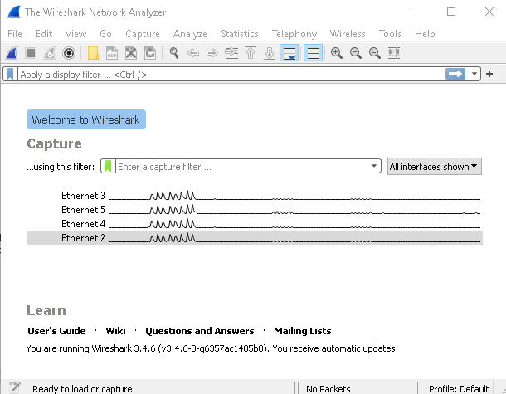

Telnet into R3.
      - Open a new Putty window and Telnet from PC-A to the R3 G0/0/0 interface IP address 10.2.2.1. The username is admin01 and the password is admin01pass as configured on the router in Part 1.
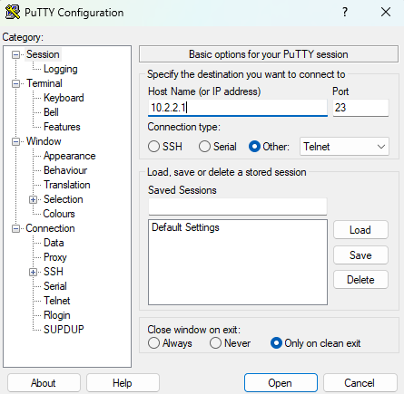

      - Enter privileged EXEC mode.
R3> enable
Password:
R3#
      - Exit the Telnet session.

Examine the Telnet session.
      - Return to Wireshark on PC-B and apply a filter that only displays Telnet-related traffic. Enter telnet in the filter field and click Apply.
      - Right-click one of the Telnet lines in the Packet list section of Wireshark, and from the drop-down list, select Follow > TCP Stream.
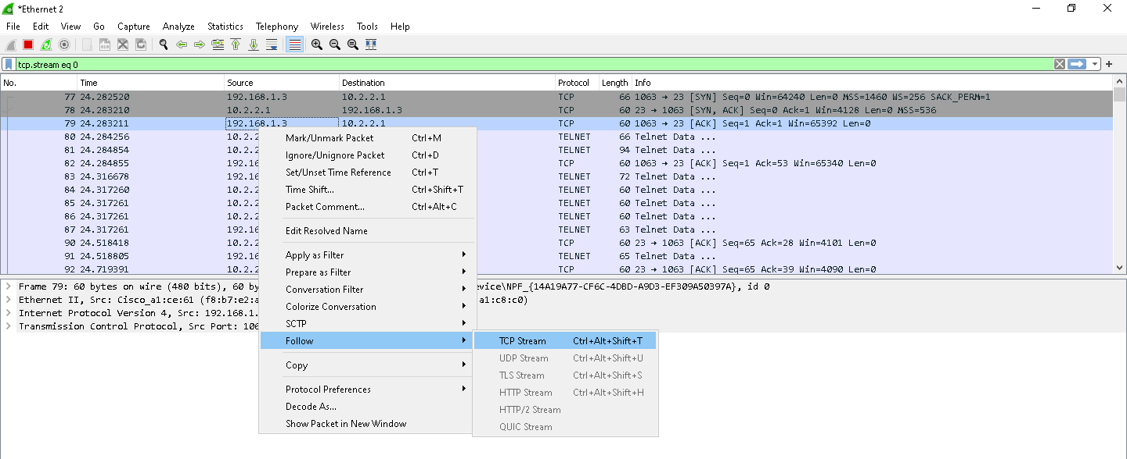
      - The Follow TCP Stream window displays the data for the Telnet session between PC-A and R3. The entire session is displayed in plaintext, including the passwords. Notice that the username that you entered is displayed with duplicate characters. This is caused by the echo setting in Telnet to allow you to view the characters that you type on the screen.
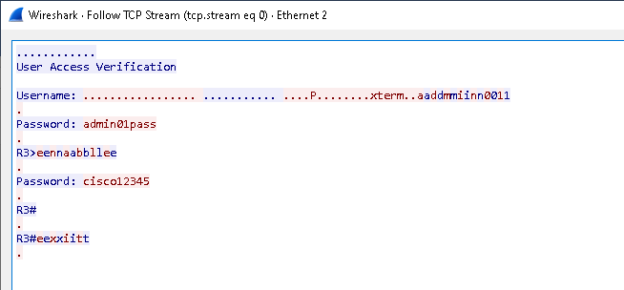
      - After you have finished reviewing your Telnet session in the Follow TCP Stream window, click Close.
      - Close Wireshark.

Configure a Site-to-Site VPN with Cisco IOS
In Part 3 of this lab, you will configure an IPsec VPN tunnel between R1 and R3 that passes through R2 and S3. You will configure R1 and R3 using the Cisco IOS CLI. You will then review and test the resulting configuration.
Note: Because no tunnel is yet in place, PC-A should still be able to ping PC-C. If not, troubleshoot the basic device configurations before continuing.
  - Configure IPsec VPN Settings on R1 and R3.

Enable IKE policies on R1 and R3.
IPsec is an open framework that allows for the exchange of security protocols as new technologies, and encryption algorithms as they are developed.
There are two central configuration elements in the implementation of an IPsec VPN:
- Implement Internet Key Exchange (IKE) parameters
- Implement IPsec parameters
IKE Phase 1 defines the key exchange method used to pass and validate IKE policies between peers. In IKE Phase 2, the peers exchange and match IPsec policies for the authentication and encryption of data traffic.
      - Establish an ISAKMP policy and view the available options.
To allow IKE Phase 1 negotiation, you must create an ISAKMP policy and configure a peer association for that ISAKMP policy. An ISAKMP policy defines the authentication and encryption algorithms and the hash function used to send control traffic between the two VPN endpoints. When an ISAKMP security association has been accepted by the IKE peers, IKE Phase 1 has been completed. IKE Phase 2 parameters will be configured later.
Issue the show crypto isakmp default policy command in order to view the pre-configured default policies that exist on the routers.
R1# show crypto isakmp default policy
QUESTION 1 How many default policies exist on each of the devices?
QUESTION 2 What is the policy priority number of the first listed policy?
QUESTION 3 What are the differences between the first listed policy and the last listed policy?
Before proceeding, go to the “Lab 7 - Configure a Site-to-Site VPN - QUESTIONS” quiz on the Brightspace page and enter your answers for questions 1-3. Leave the quiz open while you complete the rest of the lab sheet.

      - In this lab, we will creat our own ISAKMP policy. Issue the crypto isakmp policy number global configuration mode command on R1 for policy 10. Do the same on R3.
R1(config)# crypto isakmp policy 10
      - View the various IKE parameters available using Cisco IOS help by typing a question mark (?).
R1(config-isakmp)# ?
ISAKMP commands:
authentication Set authentication method for protection suite
default Set a command to its defaults
encryption Set encryption algorithm for protection suite
exit Exit from ISAKMP protection suite configuration mode
group Set the Diffie-Hellman group
hash Set hash algorithm for protection suite
lifetime Set lifetime for ISAKMP security association
no Negate a command or set its defaults

Configure the IKE Phase 1 ISAKMP policy on R1 and R3.
Your choice of an encryption algorithm determines how confidential the control channel between the endpoints is. The hash algorithm controls data integrity, ensuring that the data received from a peer has not been tampered with in transit. The authentication type ensures that the packet was sent and signed by the remote peer. The Diffie-Hellman group is used to create a secret key shared by the peers that has not been sent across the network.
      - Configure an ISAKMP policy with a priority of 10. Refer to the ISAKMP Phase 1 table for the specific parameters to configure.
Note: Use the mnemonic HAGLE to remember the 5 SAs to configure:
- Hash: SHA-256
- Authentication: pre-shared key
- Group: 24
- Lifetime: 1800 seconds (Half an hour)
- Encryption: AES 256
R1(config)# crypto isakmp policy 10
R1(config-isakmp)# hash sha256
R1(config-isakmp)# authentication pre-share
R1(config-isakmp)# group 24
R1(config-isakmp)# lifetime 1800
R1(config-isakmp)# encryption aes 256
R1(config-isakmp)# end
      - Configure the same policy on R3.
R3(config)# crypto isakmp policy 10
R3(config-isakmp)# hash sha256
R3(config-isakmp)# authentication pre-share
R3(config-isakmp)# group 24
R3(config-isakmp)# lifetime 1800
R3(config-isakmp)# encryption aes 256
R3(config-isakmp)# end

QUESTION 4 What is the significance of using a policy priority of 10 here?
Before proceeding, return to the quiz and enter your answer for question 4. Leave the quiz open while you complete the rest of the lab sheet.

      - Verify the IKE policy with the show crypto isakmp policy command.
R1# show crypto isakmp policy

Global IKE policy
Protection suite of priority 10
encryption algorithm: AES - Advanced Encryption Standard (256 bit keys).
hash algorithm: Secure Hash Standard 2 (256 bit)
authentication method: Pre-Shared Key
Diffie-Hellman group: #24 (2048 bit, 256 bit subgroup)
lifetime: 1800 seconds, no volume limit

Configure pre-shared keys.
Because pre-shared keys are used as the authentication method in the IKE policy, a key must be configured on each router that points to the other VPN endpoint. These keys must match for authentication to be successful. The global configuration mode crypto isakmp key key-string address ip-address command is used to enter a pre-shared key. Use the IP address of the remote peer, which is the remote interface that the peer would use to route traffic to the local router.
      - Each IP address that is used to configure the IKE peers is also referred to as the IP address of the remote VPN endpoint. Configure the pre-shared key of cisco123 on router R1. Production networks should use a complex key. This command points to the remote peer R3 G0/0/0 IP address.
R1(config)# crypto isakmp key cisco123 address 10.2.2.1

QUESTION 5 & 6 What does IP address 10.2.2.1 correspond to and why is it being used here on R1?

      - Configure the pre-shared key cisco123 on router R3. The command for R3 points to the R1 G0/0/0 IP address.
R3(config)# crypto isakmp key cisco123 address 10.1.1.1

QUESTION 7 & 8 What does IP address 10.1.1.1 correspond to and why is it being used here on R3?
Before proceeding, return to the quiz and enter your answers for questions 5-8. Leave the quiz open while you complete the rest of the lab sheet.

Configure the IPsec transform set and lifetime.
      - The IPsec transform set is another crypto configuration parameter that routers negotiate to form a security association. To create an IPsec transform set, use the crypto ipsec transform-set tag command where tag is a name configured by the administrator. Use ? to see which parameters are available.
R1(config)# crypto ipsec transform-set R1-R3 ?
ah-md5-hmac AH-HMAC-MD5 transform
ah-sha-hmac AH-HMAC-SHA transform
ah-sha256-hmac AH-HMAC-SHA256 transform
ah-sha384-hmac AH-HMAC-SHA384 transform
ah-sha512-hmac AH-HMAC-SHA512 transform
esp-192-aes ESP transform using AES cipher (192 bits)
esp-256-aes ESP transform using AES cipher (256 bits)
esp-3des ESP transform using 3DES(EDE) cipher (168 bits)
esp-aes ESP transform using AES cipher
esp-des ESP transform using DES cipher (56 bits)
esp-gcm ESP transform using GCM cipher
esp-gmac ESP transform using GMAC cipher
esp-md5-hmac ESP transform using HMAC-MD5 auth
esp-null ESP transform w/o cipher
esp-seal ESP transform using SEAL cipher (160 bits)
esp-sha-hmac ESP transform using HMAC-SHA auth
esp-sha256-hmac ESP transform using HMAC-SHA256 auth
esp-sha384-hmac ESP transform using HMAC-SHA384 auth
esp-sha512-hmac ESP transform using HMAC-SHA512 auth
      - On R1 and R3, create a transform set with tag R1-R3 and use an ESP transform with an AES 256 cipher with ESP and the SHA-256 hash function. The transform sets must match on both ends of the VPN.
R1(config)# crypto ipsec transform-set R1-R3 esp-aes 256 esp-sha256-hmac
R1(cfg-crypto-trans)# exit

R3(config)# crypto ipsec transform-set R1-R3 esp-aes 256 esp-sha256-hmac
R3(cfg-crypto-trans)# exit

Define interesting traffic.
To make use of the IPsec encryption with the VPN, it is necessary to define extended access lists to tell the router which traffic to encrypt. A packet that is permitted by an access list used for defining IPsec traffic is encrypted if the IPsec session is configured correctly. A packet that is denied by the IPsec access list is not dropped. It is sent unencrypted. Also, like any other access list, there is an implicit deny at the end, which means the default action is to not encrypt traffic. If there is no IPsec security association correctly configured, no traffic is encrypted and traffic is forwarded unencrypted.
In this scenario, from the perspective of R1, the traffic you want to encrypt is traffic going from R1’s Ethernet LAN to R3’s Ethernet LAN or vice versa from the perspective of R3. These access lists are used outbound on the VPN endpoint interfaces and must mirror each other.
Note: IPsec evaluates whether access lists are mirrored and does not form a security association if the peers do not have mirrored access lists to select interesting traffic.
      - Configure the IPsec VPN interesting traffic ACL on R1.
R1(config)# access-list 101 permit ip 192.168.1.0 0.0.0.255 192.168.3.0 0.0.0.255
QUESTION 9 What do each part of the ACL statement correspond to?
Before proceeding, return to the quiz and enter your answer for question 9. Leave the quiz open while you complete the rest of the lab sheet.

      - Configure the IPsec VPN interesting traffic ACL on R3.
R3(config)# access-list 101 permit ip 192.168.3.0 0.0.0.255 192.168.1.0 0.0.0.255

Create and apply a crypto map.
A crypto map associates traffic that matches an access list to a peer and various IKE and IPsec settings. After the crypto map is created, it can be applied to one or more interfaces. The interfaces that it is applied to should be the ones facing the IPsec peer.
To create a crypto map, use crypto map <name> <sequence-num> <type> command in global configuration mode to enter crypto map configuration mode for that sequence number. Multiple crypto map statements can belong to the same crypto map and are evaluated in ascending numerical order. Enter crypto map configuration mode on R1. Use a type of ipsec-isakmp, which means IKE is used to establish IPsec security associations.
      - Create the crypto map on R1, name it CMAP, and use 10 as the sequence number. A message displays after the command is issued.
R1(config)# crypto map CMAP 10 ipsec-isakmp
% NOTE: This new crypto map will remain disabled until a peer
and a valid access list have been configured.
      - Use the match address <access-list> command to specify which access list defines which traffic to encrypt.
R1(config-crypto-map)# match address 101
      - To view the list of possible set commands that you can do with a crypto map, use the help function.
R1(config-crypto-map)# set ?
identity Identity restriction.
ip Interface Internet Protocol config commands
isakmp-profile Specify isakmp Profile
nat Set NAT translation
peer Allowed Encryption/Decryption peer.
pfs Specify pfs settings
reverse-route Reverse Route Injection.
security-association Security association parameters
transform-set Specify list of transform sets in priority order
      - Setting a peer IP or hostname is required. Set it to R3’s remote VPN endpoint interface using the following command.
R1(config-crypto-map)# set peer 10.2.2.1
      - Use the set transform-set tag command to hard code the transform set to be used with this peer. Set the perfect forwarding secrecy type using the set pfs type command, and modify the default IPsec security association life time with the set security-association lifetime seconds seconds command.
R1(config-crypto-map)# set pfs group24
R1(config-crypto-map)# set transform-set R1-R3
R1(config-crypto-map)# set security-association lifetime seconds 900
R1(config-crypto-map)# exit
      - Create a mirrored matching crypto map on R3.
R3(config)# crypto map CMAP 10 ipsec-isakmp
R3(config-crypto-map)# match address 101
R3(config-crypto-map)# set peer 10.1.1.1
R3(config-crypto-map)# set pfs group24
R3(config-crypto-map)# set transform-set R1-R3
R3(config-crypto-map)# set security-association lifetime seconds 900
R3(config-crypto-map)# exit
      - Apply the crypto maps to the appropriate interfaces on R1 and R3.
Note: The router generates a notification that crypto is now on. However, the SAs are not established until the crypto map has been activated by interesting traffic
R1(config)# interface G0/0/0
R1(config-if)# crypto map CMAP
*Jan 28 04:09:09.150: %CRYPTO-6-ISAKMP_ON_OFF: ISAKMP is ON
R1(config)# end

R3(config)# interface G0/0/0
R3(config-if)# crypto map CMAP
*Jan 28 04:10:54.138: %CRYPTO-6-ISAKMP_ON_OFF: ISAKMP is ON
R3(config)# end
  - Verify the Site-to-Site IPsec VPN Configuration.

Verify the IPsec configuration on R1 and R3.
      - Use the show crypto map command to display the crypto maps that will be applied to the router. This also displays the associated transform sets.
R1# show crypto map
Crypto Map IPv4 "CMAP" 10 ipsec-isakmp
Peer = 10.2.2.1
Extended IP access list 101
access-list 101 permit ip 192.168.1.0 0.0.0.255 192.168.3.0 0.0.0.255
Current peer: 10.2.2.1
Security association lifetime: 4608000 kilobytes/900 seconds
Responder-Only (Y/N): N
PFS (Y/N): Y
DH group: group24
Mixed-mode : Disabled
Transform sets={
R1-R3: { esp-256-aes esp-sha256-hmac } ,
}
Interfaces using crypto map CMAP:
GigabitEthernet0/0/0

R3# show crypto map
Crypto Map IPv4 "CMAP" 10 ipsec-isakmp
Peer = 10.1.1.1
Extended IP access list 101
access-list 101 permit ip 192.168.3.0 0.0.0.255 192.168.1.0 0.0.0.255
Current peer: 10.1.1.1
Security association lifetime: 4608000 kilobytes/900 seconds
Responder-Only (Y/N): N
PFS (Y/N): Y
DH group: group24
Mixed-mode : Disabled
Transform sets={
R1-R3: { esp-256-aes esp-sha256-hmac } ,
}
Interfaces using crypto map CMAP:
GigabitEthernet0/0/0

Note: The output of these show commands does not change if interesting traffic goes across the connection. You test various types of traffic in the next task.
  - Verify the IPsec VPN Operation.

Display ISAKMP security associations.
The show crypto isakmp sa command reveals that no IKE SAs exist yet. When interesting traffic is sent, this command output will change.
R1# show crypto isakmp sa
IPv4 Crypto ISAKMP SA
dst src state conn-id status

IPv6 Crypto ISAKMP SA

Display IPsec security associations.
The show crypto ipsec sa command shows the unused SA between R1 and R3.
Note: The number of packets sent across is zero (i.e. the number of packets encapsulated, encrypted, decapsulated, and decrypted are all set to 0), and there is a lack of any security associations listed toward the bottom of the output. The output for R1 is shown here.
R1# show crypto ipsec sa

interface: GigabitEthernet0/0/0
Crypto map tag: CMAP, local addr 10.1.1.1

protected vrf: (none)
local ident (addr/mask/prot/port): (192.168.1.0/255.255.255.0/0/0)
remote ident (addr/mask/prot/port): (192.168.3.0/255.255.255.0/0/0)
current_peer 10.2.2.1 port 500
PERMIT, flags={origin_is_acl,}
#pkts encaps: 0, #pkts encrypt: 0, #pkts digest: 0
#pkts decaps: 0, #pkts decrypt: 0, #pkts verify: 0
#pkts compressed: 0, #pkts decompressed: 0
#pkts not compressed: 0, #pkts compr. failed: 0
#pkts not decompressed: 0, #pkts decompress failed: 0
#send errors 0, #recv errors 0

local crypto endpt.: 10.1.1.1, remote crypto endpt.: 10.2.2.1
plaintext mtu 1500, path mtu 1500, ip mtu 1500, ip mtu idb GigabitEthernet0/0/0
current outbound spi: 0x0(0)
PFS (Y/N): N, DH group: none

inbound esp sas:

inbound ah sas:

inbound pcp sas:

outbound esp sas:

outbound ah sas:

outbound pcp sas:

Generate some uninteresting test traffic and observe the results.
      - Ping from R1 to the R3 G0/0/0 interface IP address 10.2.2.1. These pings should be successful.
      - Issue the show crypto isakmp sa command.
      - Ping from R1 to PC-C. These pings should be successful.
      - Issue the show crypto isakmp sa command again.
QUESTION 10 Was an SA formed after this ping from R1 to PC-C? Why was this the case?
Before proceeding, return to the quiz and enter your answer for question 10. Leave the quiz open while you complete the rest of the lab sheet.

Generate some interesting test traffic and observe the results.
      - Ping from PC-A to PC-C.
      - Re-issue the show crypto isakmp sa command.
R1# show crypto isakmp sa
IPv4 Crypto ISAKMP SA
dst src state conn-id status
10.2.2.1 10.1.1.1 QM_IDLE 1001 ACTIVE

IPv6 Crypto ISAKMP SA
      - Re-issue the show crypto ipsec sa command.
QUESTION 11 Has the number of encrypted packets on the output changed from what it was before?
Before proceeding, return to the quiz and enter your answer for question 11. Leave the quiz open while you complete the rest of the lab sheet.

R1# show crypto ipsec sa

interface: GigabitEthernet0/0/0
Crypto map tag: CMAP, local addr 10.1.1.1

protected vrf: (none)
local ident (addr/mask/prot/port): (192.168.1.0/255.255.255.0/0/0)
remote ident (addr/mask/prot/port): (192.168.3.0/255.255.255.0/0/0)
current_peer 10.2.2.1 port 500
PERMIT, flags={origin_is_acl,}
#pkts encaps: 3, #pkts encrypt: 3, #pkts digest: 3
#pkts decaps: 3, #pkts decrypt: 3, #pkts verify: 3
#pkts compressed: 0, #pkts decompressed: 0
#pkts not compressed: 0, #pkts compr. failed: 0
#pkts not decompressed: 0, #pkts decompress failed: 0
#send errors 0, #recv errors 0

local crypto endpt.: 10.1.1.1, remote crypto endpt.: 10.2.2.1
plaintext mtu 1438, path mtu 1500, ip mtu 1500, ip mtu idb GigabitEthernet0/0/0
current outbound spi: 0x95B6C7B5(2511783861)
PFS (Y/N): Y, DH group: group24

inbound esp sas:
spi: 0x1EBD4016(515719190)
transform: esp-256-aes esp-sha256-hmac ,
in use settings ={Tunnel, }
conn id: 2001, flow_id: ESG:1, sibling_flags FFFFFFFF80004048, crypto map: CMAP
sa timing: remaining key lifetime (k/sec): (4607999/671)
IV size: 16 bytes
replay detection support: Y
Status: ACTIVE(ACTIVE)

inbound ah sas:

inbound pcp sas:

outbound esp sas:
spi: 0x95B6C7B5(2511783861)
transform: esp-256-aes esp-sha256-hmac ,
in use settings ={Tunnel, }
conn id: 2002, flow_id: ESG:2, sibling_flags FFFFFFFF80004048, crypto map: CMAP
sa timing: remaining key lifetime (k/sec): (4607999/671)
IV size: 16 bytes
replay detection support: Y
Status: ACTIVE(ACTIVE)

outbound ah sas:

outbound pcp sas:
  - Attempt to Capture VPN Traffic with Wireshark.

Telnet into R3’s WAN Interface from PC-A.
      - Start another Wireshark capture on PC-B on the Ethernet interface.
      - Telnet from PC-A to the R3 G0/0/0 interface IP address 10.2.2.1 again.
      - Return to Wireshark on PC-B and attempt to find view the Telnet session by filtering for telnet traffic and following the TCP stream as you did previously.
QUESTION 12 Is it still possible to see this recent Telnet session in Wireshark?
Before proceeding, return to the quiz and enter your answer for question 12. Leave the quiz open while you complete the rest of the lab sheet.

Telnet into R3’s LAN Interface from PC-A.
      - Exit the Telnet session on PC-A. Close the Follow TCP Stream window on PC-B and stop the current packet capture on Wireshark.
      - Repeat Step 12 but this time use R3 G0/0/1 interface IP address 192.168.3.1 when doing the Telnet from PC-A.
QUESTION 13 Is it still possible to see this recent Telnet session in Wireshark? Why is this the case?
Before proceeding, return to the quiz and enter your answer for question 13. Leave the quiz open while you complete the rest of the lab sheet.

      - Change the filter in Wireshark from telnet to ESP. Examine the displayed packets.
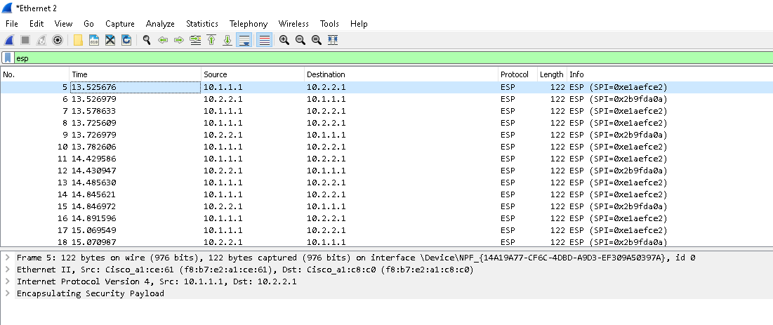
QUESTION 14 Do the source and destination IP addresses correspond to the actual IP addresses of PC-A and R3 G0/0/1? If not, what addresses do they correspond to?
Before proceeding, return to the quiz and enter your answer for question 14.

You have completed the lab – get your lab supervisor to correct your work and submit the Brightspace quiz.

