Lab 7 - Configure a Site-to-Site VPN

Topology
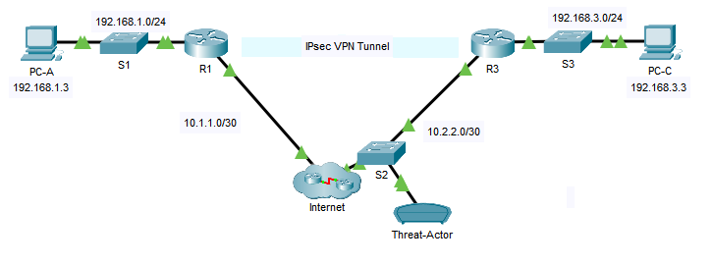

Addressing Table
Device | Interface | IP Address | Subnet Mask | Default Gateway | Switch Port
R1 | G0/1 | 192.168.1.1 | 255.255.255.0 | N/A | N/A
R1 | G0/0 | 10.1.1.1 | 255.255.255.252 | N/A | N/A
R3 | G0/1 | 192.168.3.1 | 255.255.255.0 | N/A | N/A
R3 | G0/0 | 10.2.2.1 | 255.255.255.252 | N/A | S2 F0/18
PC-A | NIC | 192.168.1.3 | 255.255.255.0 | 192.168.1.1 | N/A
Threat-Actor | NIC | N/A | N/A | N/A | S2 F0/1
PC-C | NIC | 192.168.3.3 | 255.255.255.0 | 192.168.3.1 | N/A

Objectives
Part 1: Configure Basic Security Settings
- Configure access passwords.
Part 2: Configure Local SPAN and Capture Copied Traffic in the Sniffer
- Configure Local SPAN on S2.
- Capture and view copied Telnet traffic crossing between the two LANs.
Part 3: Configure a Site-to-Site VPN Using Cisco IOS
- Configure IPsec VPN settings on R1 and R3.
- Verify site-to-site IPsec VPN configuration.
- Test IPsec VPN operation.
- Attempt to capture and traffic going through the IPsec VPN tunnel.

Background / Scenario
VPNs can provide a secure method of transmitting data over a public network, such as the Internet. VPN connections can help reduce the costs associated with leased lines. Site-to-Site VPNs typically provide a secure (IPsec or other) tunnel between a branch office and a central office. Another common implementation of VPN technology is remote access to a corporate office from a telecommuter location, such as a small office or home office.
In this lab, you will configure a multi-router network, use Cisco IOS to configure a site-to-site IPsec VPN, and then test the VPN. The IPsec VPN tunnel is from R1 to R3 via the Internet cloud. Any intermediate in the Internet cloud act as a pass-through and have no knowledge of the VPN. IPsec provides secure transmission of sensitive information over unprotected networks, such as the Internet. IPsec acts at the network layer and protecting and authenticating IP packets between participating IPsec devices (peers), such as Cisco routers.
To demonstrate the potential vulnerabilites of sending sensitive information over unprocted networks, Threat-Actor is going to eavesdrop on all traffic going between R1’s LAN and R3’s LAN. This will be achievied by configuring port mirroring on S2 and sending a copy of the traffic going between the LAN’s to Threat-Actor where it can be analysed by the sniffer device.
To set up port mirroring, you will use the Switched Port Analyzer (SPAN) feature on the Cisco switch. SPAN is a type of port mirroring that sends copies of a frame entering a port, out another port on the same switch.
ISAKMP Phase 1 Policy Parameters
Parameters |  | R1 | R3
Key Distribution Method | Manual or ISAKMP | ISAKMP | ISAKMP
Encryption Algorithm | DES, 3DES, or AES | AES-256 | AES-256
Hash Algorithm | MD5, SHA-1, or SHA-2 | SHA-1 | SHA-1
Authentication Method | Pre-shared keys or RSA | pre-share | pre-share
Key Exchange | DH Group | DH 5 | DH 5
IKE SA Lifetime | 86400 seconds or less | 1800 | 1800
ISAKMP Key |  | cisco123 | cisco123
Note: Bolded parameters are defaults. Only unbolded parameters have to be explicitly configured.
IPsec Phase 2 Policy Parameters
Parameters | R1 | R3
Transform Set Name | R1-R3 | R1-R3
ESP Transform Encryption | AES-256 | AES-256
ESP Transform Authentication | SHA-1 | SHA-1
Peer IP Address | 10.2.2.1 | 10.1.1.1
Traffic to be Encrypted | access-list 101 (source 192.168.1.0 dest 192.168.3.0) | access-list 101 (source 192.168.3.0 dest 192.168.1.0)
Crypto Map Name | CMAP | CMAP
SA Establishment | ipsec-isakmp | ipsec-isakmp

Configure Basic Security Settings
In Part 1, you will test conectivity and configure basic security settings, such as passwords.

Verify basic network connectivity.
      - Ping from PC-A on the R1 LAN to PC-C on the R3 LAN.
Note: If you can ping from PC-A to PC-C, you have demonstrated that the static routes are configured and functioning correctly.

Configure and encrypt passwords.
Note: Passwords in this task are set to a minimum of 10 characters but are relatively simple for the benefit of performing the lab. More complex passwords are recommended in a production network.
Note: All tasks should be performed on R1 and R3. The procedure for R1 is shown here as an example.
      - Configure a minimum password length.
Use the security passwords command to set a minimum password length of 10 characters.
R1(config)# security passwords min-length 10
      - Configure the enable secret password on both routers with a password of cisco12345.
R1(config)# enable secret cisco12345
      - Create a local admin01 account using admin01pass for the password.
R1(config)# username admin01 secret admin01pass

Configure the console line.
Configure the console to use the local database for login. For additional security, configure the line to log out after five minutes of inactivity. Issue the logging synchronous command to prevent console messages from interrupting command entry.
R1(config)# line console 0
R1(config-line)# login local
R1(config-line)# exec-timeout 5 0
R1(config-line)# logging synchronous

Configure the vty lines to allow Telnet connections.
Note: Telnet sends data in plaintext so SSH should always be used instead for remote connections where possible. Telnet is only being used in this instance so the traffic can be examined by the sniffer.
      - Configure the vty lines on R1 and R3 to use the local database for login. Remote access to the routers should only be allowed using Telnet. Configure the vty lines to logout after five minutes of inactivity.
R1(config)# line vty 0 15
R1(config-line)# login local
R1(config-line)# exec-timeout 5 0
R1(config-line)# transport input telnet

Save the basic running configuration for all three routers.
Save the running configuration to the startup configuration from the privileged EXEC mode prompt on R1 and R3.
R1# copy running-config startup-config

Configure Local SPAN and Capture Copied Traffic in the Sniffer
To configure Local SPAN, you need to configure one or more source ports called monitored ports and a single destination port also called a monitored port for copied or mirrored traffic to be sent out from. SPAN source ports can be configured to monitor traffic in either ingress or egress, or both directions (default).
The SPAN source port will need to be configured on the port that connects to the Internet cloud on S2 switch port F0/5. This way all traffic going between the Internet cloud and R3 will be monitored. The SPAN destination port will be configured on S2 switch port F0/1 which is connected to Threat-Actor which is actually a Sniffer device. In this scenario, Threat-Actor is attempting to eavesdrop on any communications between PC-A and PC-C.

Configure SPAN on S2.
      - Access S2 and configure its hostname.
      - Configure the source and destination monitor ports on S2. Now all traffic entering or leaving F0/5 will be copied and forwarded out of F0/1.
Open configuration window
S2(config)# monitor session 1 source interface f0/5
S2(config)# monitor session 1 destination interface f0/1
      - Verify SPAN configuration for session 1.
S2# show monitor session 1
Session 1
---------
Type : Local Session
Description : -
Source Ports :
Both : Fa0/5
Destination Ports : Fa0/1
Encapsulation : Native
Ingress : Disabled

Capture data with the Sniffer.
      - Open up the Threat-Actor device and go to the GUI tab.
      - Enable the sniffer service by setting the radio button to On.
      - Click Show All/None to toggle off all the event list filter options. Click on Edit Filters and click the tick box beside Telnet.
      - Close the edit filters window and verify the sniffer is now configured to capture Telnet traffic only. Click Clear if there are already captured packets.
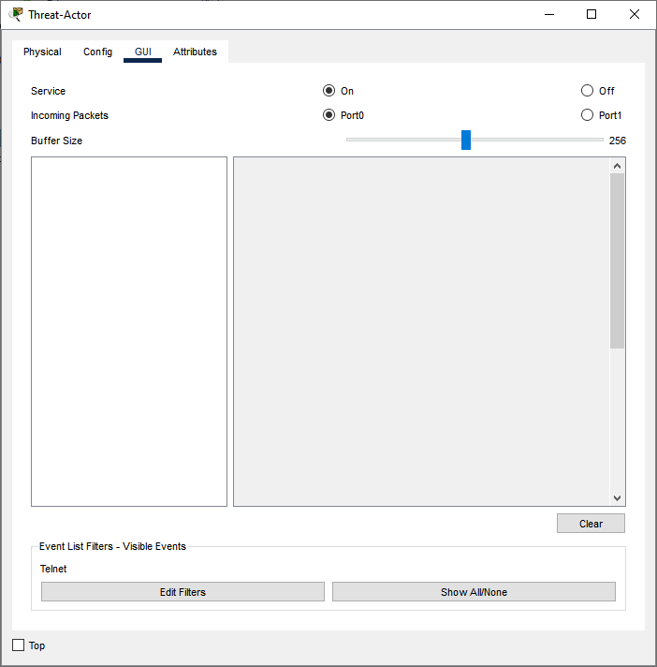

Telnet into R3.
      - Open up the Desktop tab on PC-A and click on the Telnet / SSH Client app. Telnet to the R3 G0/0 interface IP address 10.2.2.1. The username is admin01 and the password is admin01pass as configured on the router in Part 1.
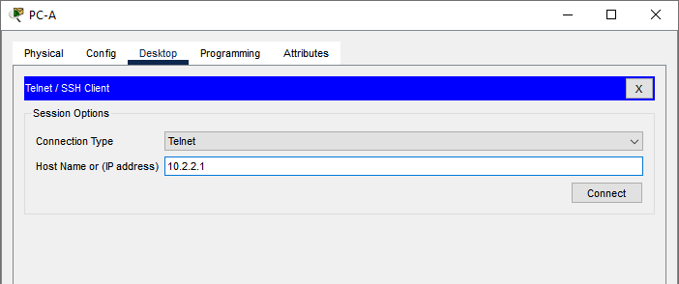
      - Enter privileged EXEC mode.
R3> enable
Password: <cisco12345>
R3#
      - Exit the Telnet session.

Examine the Telnet session.
Return to the Threat-Actor sniffer device and open the GUI tab. Click on several of the Telnet packets that have been captured and view the Telnet data field in the central window.
The captured packets display the data for the Telnet session between PC-A and R3. The entire session is displayed in plaintext, including the passwords. Try to locate the captured packets that relate to each character of the username and passwords entered. See below for example.
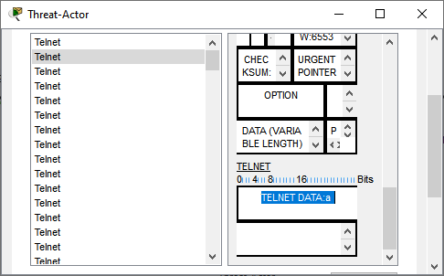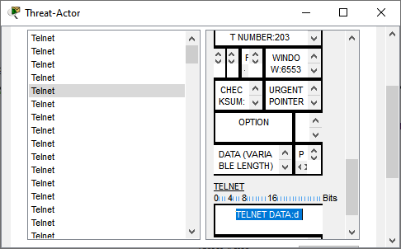

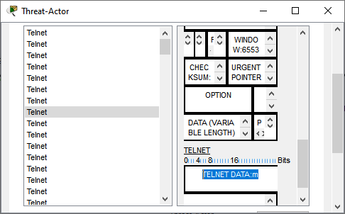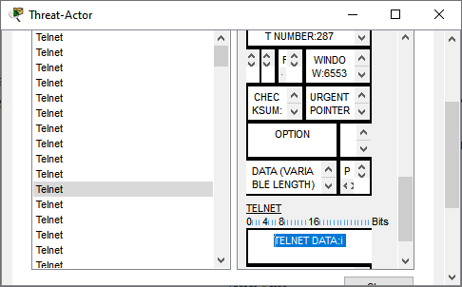
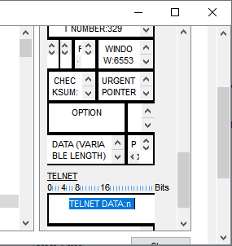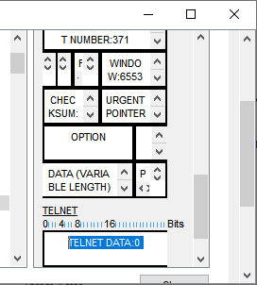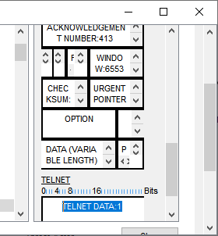

Configure a Site-to-Site VPN with Cisco IOS
In Part 3 of this lab, you will configure an IPsec VPN tunnel between R1 and R3 that passes through the Internet cloud and S2. You will configure R1 and R3 using the Cisco IOS CLI. You will then review and test the resulting configuration.
Note: Because no tunnel is yet in place, PC-A should still be able to ping PC-C. If not, troubleshoot the basic device configurations before continuing.
  - Configure IPsec VPN Settings on R1 and R3.

Enable IKE policies on R1 and R3.
IPsec is an open framework that allows for the exchange of security protocols as new technologies, and encryption algorithms as they are developed.
There are two central configuration elements in the implementation of an IPsec VPN:
- Implement Internet Key Exchange (IKE) parameters
- Implement IPsec parameters
IKE Phase 1 defines the key exchange method used to pass and validate IKE policies between peers. In IKE Phase 2, the peers exchange and match IPsec policies for the authentication and encryption of data traffic.
To allow IKE Phase 1 negotiation, you must create an ISAKMP policy and configure a peer association for that ISAKMP policy. An ISAKMP policy defines the authentication and encryption algorithms and the hash function used to send control traffic between the two VPN endpoints. When an ISAKMP security association has been accepted by the IKE peers, IKE Phase 1 has been completed. IKE Phase 2 parameters will be configured later.
      - In this lab, we will create our own ISAKMP policy with a priority of 10. Issue the crypto isakmp policy number global configuration mode command on R1 for policy 10.
R1(config)# crypto isakmp policy 10
      - View the various IKE parameters available using Cisco IOS help by typing a question mark (?).
R1(config-isakmp)# ?
ISAKMP commands:
authentication Set authentication method for protection suite
default Set a command to its defaults
encryption Set encryption algorithm for protection suite
exit Exit from ISAKMP protection suite configuration mode
group Set the Diffie-Hellman group
hash Set hash algorithm for protection suite
lifetime Set lifetime for ISAKMP security association
no Negate a command or set its defaults

Configure the IKE Phase 1 ISAKMP policy on R1 and R3.
Your choice of an encryption algorithm determines how confidential the control channel between the endpoints is. The hash algorithm controls data integrity, ensuring that the data received from a peer has not been tampered with in transit. The authentication type ensures that the packet was sent and signed by the remote peer. The Diffie-Hellman group is used to create a secret key shared by the peers that has not been sent across the network.
      - Configure the ISAKMP policy. Refer to the ISAKMP Phase 1 table for the specific parameters to configure.
Note: Use the mnemonic HAGLE to remember the 5 SAs to configure:
- Hash: SHA-256
- Authentication: pre-shared key
- Group: 24
- Lifetime: 1800 seconds (Half an hour)
- Encryption: AES 256
R1(config-isakmp)# hash sha
R1(config-isakmp)# authentication pre-share
R1(config-isakmp)# group 5
R1(config-isakmp)# lifetime 1800
R1(config-isakmp)# encryption aes 256
R1(config-isakmp)# end
      - Configure the same policy on R3.
R3(config)# crypto isakmp policy 10
R3(config-isakmp)# hash sha
R3(config-isakmp)# authentication pre-share
R3(config-isakmp)# group 5
R3(config-isakmp)# lifetime 1800
R3(config-isakmp)# encryption aes 256
R3(config-isakmp)# end
      - Verify the IKE policy with the show crypto isakmp policy command.
R1# show crypto isakmp policy

Global IKE policy
Protection suite of priority 10
encryption algorithm: AES - Advanced Encryption Standard (256 bit keys).
hash algorithm: Secure Hash Standard
authentication method: Pre-Shared Key
Diffie-Hellman group: #5 (1536 bit)
lifetime: 1800 seconds, no volume limit

Configure pre-shared keys.
Because pre-shared keys are used as the authentication method in the IKE policy, a key must be configured on each router that points to the other VPN endpoint. These keys must match for authentication to be successful. The global configuration mode crypto isakmp key key-string address ip-address command is used to enter a pre-shared key. Use the IP address of the remote peer, which is the remote interface that the peer would use to route traffic to the local router.
      - Each IP address that is used to configure the IKE peers is also referred to as the IP address of the remote VPN endpoint. Configure the pre-shared key of cisco123 on router R1. Production networks should use a complex key. This command points to the remote peer R3 G0/0 IP address.
R1(config)# crypto isakmp key cisco123 address 10.2.2.1

QUESTION 1 & 2 What does IP address 10.2.2.1 correspond to and why is it being used here on R1?

      - Configure the pre-shared key cisco123 on router R3. The command for R3 points to the R1 S0/0/0 IP address.
R3(config)# crypto isakmp key cisco123 address 10.1.1.1
QUESTION 3 & 4 What does IP address 10.1.1.1 correspond to and why is it being used here on R3?

Configure the IPsec transform set and lifetime.
      - The IPsec transform set is another crypto configuration parameter that routers negotiate to form a security association. To create an IPsec transform set, use the crypto ipsec transform-set tag command where tag is a name configured by the administrator. Use ? to see which parameters are available.
R1(config)# crypto ipsec transform-set R1-R3 ?
ah-md5-hmac AH-HMAC-MD5 transform
ah-sha-hmac AH-HMAC-SHA transform
esp-3des ESP transform using 3DES(EDE) cipher (168 bits)
esp-aes ESP transform using AES cipher
esp-des ESP transform using DES cipher (56 bits)
esp-md5-hmac ESP transform using HMAC-MD5 auth
esp-sha-hmac ESP transform using HMAC-SHA auth
      - On R1 and R3, create a transform set with tag R1-R3 and use an ESP transform with an AES 256 cipher with ESP and the SHA-256 hash function. The transform sets must match on both ends of the VPN.
R1(config)# crypto ipsec transform-set R1-R3 esp-aes 256 esp-sha-hmac
R1(cfg-crypto-trans)# exit

R3(config)# crypto ipsec transform-set R1-R3 esp-aes 256 esp-sha-hmac
R3(cfg-crypto-trans)# exit

Define interesting traffic.
To make use of the IPsec encryption with the VPN, it is necessary to define extended access lists to tell the router which traffic to encrypt. A packet that is permitted by an access list used for defining IPsec traffic is encrypted if the IPsec session is configured correctly. A packet that is denied by the IPsec access list is not dropped. It is sent unencrypted. Also, like any other access list, there is an implicit deny at the end, which means the default action is to not encrypt traffic. If there is no IPsec security association correctly configured, no traffic is encrypted and traffic is forwarded unencrypted.
In this scenario, from the perspective of R1, the traffic you want to encrypt is traffic going from R1’s Ethernet LAN to R3’s Ethernet LAN or vice versa from the perspective of R3. These access lists are used outbound on the VPN endpoint interfaces and must mirror each other.
Note: IPsec evaluates whether access lists are mirrored and does not form a security association if the peers do not have mirrored access lists to select interesting traffic.
      - Configure the IPsec VPN interesting traffic ACL on R1.
R1(config)# access-list 101 permit ip 192.168.1.0 0.0.0.255 192.168.3.0 0.0.0.255
QUESTION 5 What do each part of the ACL statement correspond to?
      - Configure the IPsec VPN interesting traffic ACL on R3.
R3(config)# access-list 101 permit ip 192.168.3.0 0.0.0.255 192.168.1.0 0.0.0.255

Create and apply a crypto map.
A crypto map associates traffic that matches an access list to a peer and various IKE and IPsec settings. After the crypto map is created, it can be applied to one or more interfaces. The interfaces that it is applied to should be the ones facing the IPsec peer.
To create a crypto map, use crypto map <name> <sequence-num> <type> command in global configuration mode to enter crypto map configuration mode for that sequence number. Multiple crypto map statements can belong to the same crypto map and are evaluated in ascending numerical order. Enter crypto map configuration mode on R1. Use a type of ipsec-isakmp, which means IKE is used to establish IPsec security associations.
      - Create the crypto map on R1, name it CMAP, and use 10 as the sequence number. A message displays after the command is issued.
R1(config)# crypto map CMAP 10 ipsec-isakmp
% NOTE: This new crypto map will remain disabled until a peer
and a valid access list have been configured.
      - Use the match address <access-list> command to specify which access list defines which traffic to encrypt.
R1(config-crypto-map)# match address 101
      - To view the list of possible set commands that you can do with a crypto map, use the help function.
R1(config-crypto-map)# set ?
peer Allowed Encryption/Decryption peer.
pfs Specify pfs settings
security-association Security association parameters
transform-set Specify list of transform sets in priority order
      - Setting a peer IP or hostname is required. Set it to R3’s remote VPN endpoint interface using the following command.
R1(config-crypto-map)# set peer 10.2.2.1
      - Use the set transform-set tag command to hard code the transform set to be used with this peer. Set the perfect forwarding secrecy type using the set pfs type command, and modify the default IPsec security association life time with the set security-association lifetime seconds seconds command.
R1(config-crypto-map)# set pfs group5
R1(config-crypto-map)# set transform-set R1-R3
R1(config-crypto-map)# set security-association lifetime seconds 900
R1(config-crypto-map)# exit
      - Create a mirrored matching crypto map on R3.
R3(config)# crypto map CMAP 10 ipsec-isakmp
R3(config-crypto-map)# match address 101
R3(config-crypto-map)# set peer 10.1.1.1
R3(config-crypto-map)# set pfs group5
R3(config-crypto-map)# set transform-set R1-R3
R3(config-crypto-map)# set security-association lifetime seconds 900
R3(config-crypto-map)# exit
      - Apply the crypto maps to the appropriate interfaces on R1 and R3.
Note: The router generates a notification that crypto is now on. However, the SAs are not established until the crypto map has been activated by interesting traffic
R1(config)# interface G0/0
R1(config-if)# crypto map CMAP
*Jan 28 04:09:09.150: %CRYPTO-6-ISAKMP_ON_OFF: ISAKMP is ON
R1(config)# end

R3(config)# interface G0/0
R3(config-if)# crypto map CMAP
*Jan 28 04:10:54.138: %CRYPTO-6-ISAKMP_ON_OFF: ISAKMP is ON
R3(config)# end
  - Verify the Site-to-Site IPsec VPN Configuration.

Verify the IPsec configuration on R1 and R3.
      - Use the show crypto map command to display the crypto maps that will be applied to the router. This also displays the associated transform sets.
R1# show crypto map
Crypto Map IPv4 "CMAP" 10 ipsec-isakmp
Peer = 10.2.2.1
Extended IP access list 101
access-list 101 permit ip 192.168.1.0 0.0.0.255 192.168.3.0 0.0.0.255
Current peer: 10.2.2.1
Security association lifetime: 4608000 kilobytes/900 seconds
PFS (Y/N): Y
Transform sets={
R1-R3,
}
Interfaces using crypto map CMAP:
GigabitEthernet0/0

R3# show crypto map
Crypto Map IPv4 "CMAP" 10 ipsec-isakmp
Peer = 10.1.1.1
Extended IP access list 101
access-list 101 permit ip 192.168.3.0 0.0.0.255 192.168.1.0 0.0.0.255
Current peer: 10.1.1.1
Security association lifetime: 4608000 kilobytes/900 seconds
PFS (Y/N): Y
Transform sets={
R1-R3,
}
Interfaces using crypto map CMAP:
GigabitEthernet0/0

Note: The output of these show commands does not change if interesting traffic goes across the connection. You test various types of traffic in the next task.
  - Verify the IPsec VPN Operation.

Display ISAKMP security associations.
The show crypto isakmp sa command reveals that no IKE SAs exist yet. When interesting traffic is sent, this command output will change.
R1# show crypto isakmp sa
IPv4 Crypto ISAKMP SA
dst src state conn-id status

IPv6 Crypto ISAKMP SA

Display IPsec security associations.
The show crypto ipsec sa command shows the unused SA between R1 and R3.
Note: The number of packets sent across is zero (i.e. the number of packets encapsulated, encrypted, decapsulated, and decrypted are all set to 0), and there is a lack of any security associations listed toward the bottom of the output. The output for R1 is shown here.
R1# show crypto ipsec sa

interface: GigabitEthernet0/0
Crypto map tag: CMAP, local addr 10.1.1.1

protected vrf: (none)
local ident (addr/mask/prot/port): (192.168.1.0/255.255.255.0/0/0)
remote ident (addr/mask/prot/port): (192.168.3.0/255.255.255.0/0/0)
current_peer 10.2.2.1 port 500
PERMIT, flags={origin_is_acl,}
#pkts encaps: 0, #pkts encrypt: 0, #pkts digest: 0
#pkts decaps: 0, #pkts decrypt: 0, #pkts verify: 0
#pkts compressed: 0, #pkts decompressed: 0
#pkts not compressed: 0, #pkts compr. failed: 0
#pkts not decompressed: 0, #pkts decompress failed: 0
#send errors 0, #recv errors 0

local crypto endpt.: 10.1.1.1, remote crypto endpt.: 10.2.2.1
plaintext mtu 1500, path mtu 1500, ip mtu 1500, ip mtu idb GigabitEthernet0/0
current outbound spi: 0x0(0)
PFS (Y/N): N, DH group: none

inbound esp sas:

inbound ah sas:

inbound pcp sas:

outbound esp sas:

outbound ah sas:

outbound pcp sas:

Generate some uninteresting test traffic and observe the results.
      - Ping from R1 to the R3 G0/0 interface IP address 10.2.2.1. These pings should be successful.
      - Issue the show crypto isakmp sa command.
      - Ping from R1 to PC-C. These pings should be successful.
      - Issue the show crypto isakmp sa command again.
QUESTION 6 Was an SA formed after this ping from R1 to PC-C? Why was this the case?

Generate some interesting test traffic and observe the results.
      - Ping from PC-A to PC-C.
      - Re-issue the show crypto isakmp sa command.
R1# show crypto isakmp sa
IPv4 Crypto ISAKMP SA
dst src state conn-id status
10.2.2.1 10.1.1.1 QM_IDLE 1001 ACTIVE

IPv6 Crypto ISAKMP SA
      - Re-issue the show crypto ipsec sa command.
QUESTION 7 Has the number of encrypted packets on the output changed from what it was before?

R1# show crypto ipsec sa

interface: GigabitEthernet0/0
Crypto map tag: CMAP, local addr 10.1.1.1

protected vrf: (none)
local ident (addr/mask/prot/port): (192.168.1.0/255.255.255.0/0/0)
remote ident (addr/mask/prot/port): (192.168.3.0/255.255.255.0/0/0)
current_peer 10.2.2.1 port 500
PERMIT, flags={origin_is_acl,}
#pkts encaps: 3, #pkts encrypt: 3, #pkts digest: 3
#pkts decaps: 3, #pkts decrypt: 3, #pkts verify: 3
#pkts compressed: 0, #pkts decompressed: 0
#pkts not compressed: 0, #pkts compr. failed: 0
#pkts not decompressed: 0, #pkts decompress failed: 0
#send errors 0, #recv errors 0

local crypto endpt.: 10.1.1.1, remote crypto endpt.:10.2.2.1
path mtu 1500, ip mtu 1500, ip mtu idb GigabitEthernet0/0
current outbound spi: 0x049F72E6(77558502)

inbound esp sas:
spi: 0x554D149B(1431114907)
transform: esp-aes 256 esp-sha-hmac ,
in use settings ={Tunnel, }
conn id: 2002, flow_id: FPGA:1, crypto map: CMAP
sa timing: remaining key lifetime (k/sec): (4525504/784)
IV size: 16 bytes
replay detection support: N
Status: ACTIVE

inbound ah sas:

inbound pcp sas:

outbound esp sas:
spi: 0x049F72E6(77558502)
transform: esp-aes 256 esp-sha-hmac ,
in use settings ={Tunnel, }
conn id: 2003, flow_id: FPGA:1, crypto map: CMAP
sa timing: remaining key lifetime (k/sec): (4525504/784)
IV size: 16 bytes
replay detection support: N
Status: ACTIVE

outbound ah sas:

outbound pcp sas:
  - Attempt to Capture VPN Traffic with the Sniffer.

Telnet into R3’s WAN Interface from PC-A.
      - Open up the Sniffer (i.e. Threat-Actor) device and clear the previously captured Telnet packets by clicking the Clear button on the GUI tab.
      - Telnet from PC-A to the R3 G0/0 interface IP address 10.2.2.1 again.
      - Return to the Sniffer on Threat-Actor and attempt to find view the Telnet session as you did previously.
QUESTION 8 Is it still possible to see this recent Telnet session in Wireshark?

Telnet into R3’s LAN Interface from PC-A.
      - Exit the Telnet session on PC-A. Clear any Telnet packets in the GUI on the Sniffer.
      - Repeat Step 1 but this time use R3 G0/1 interface IP address 192.168.3.1 when doing the Telnet from PC-A.
QUESTION 9 Is it still possible to see this recent Telnet session in Wireshark? Why is this the case?

      - Change the filter in the Sniffer from telnet to IPSec. Start a new Telnet session from PC-A to R3’s G0/1 interface and examine the displayed packets in the Sniffer.
Note: The telnet data is still visible in the packets in the Sniffer. This is simply because the Packet Tracer simulation is programmed to display them. A real sniffer/packet analyser (such as WireShark) would be unable to see the data though.
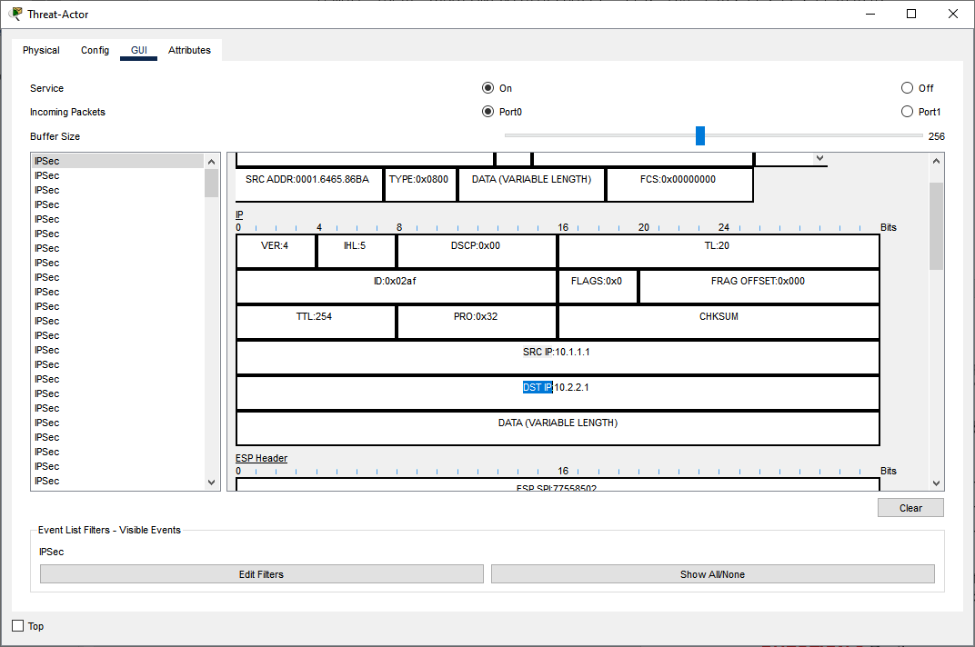
QUESTION 10 Do the source and destination IP addresses correspond to the actual IP addresses of PC-A and R3 G0/0/1? If not, what addresses do they correspond to?

