Diagrams

Nume : Dieaconu Danut Nicusor

Grupa : CEN 3.1B

1. : High level architecture diagram

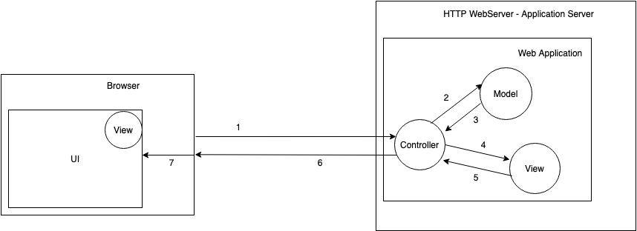

When the application is executed, the following happen :

1. The browser calls the required methods of the controllers
2. The controllers request all the database information from the models
3. The models return the database structure to the controller
4. The GUI is requested from the views
5. The views return the GUI to the controller
6. After getting all the required data, the controllers return the received information to the web browser
7. As the information is received, the browser assembles the data thus creating the GUI and displays it to the user
8. : In order to provide a better understanding of the distribution of the system, we need a deployment view of the system, whitch is composed of the following diagrams :

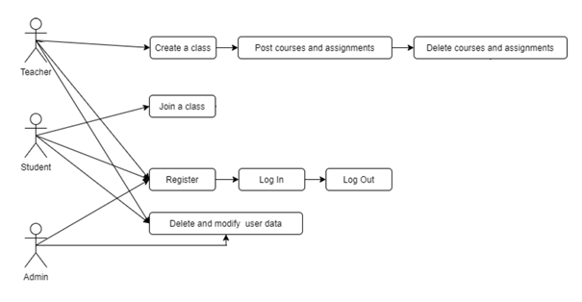

This is the use case diagram and describes the way the user interacts with the application. Each user is able to register, Log In and Log Out using the email and password.

The teacher can create a class and is able to post courses and assignments within that class. He is also able to delete these. He can add/remove users to the classroom and post a grade for each student on an assignment.   
 The student can join or request access to a class, submit work for a specific assignment, view his grade as well as the courses and assignments within the class.

The admin can delete and modify user data.

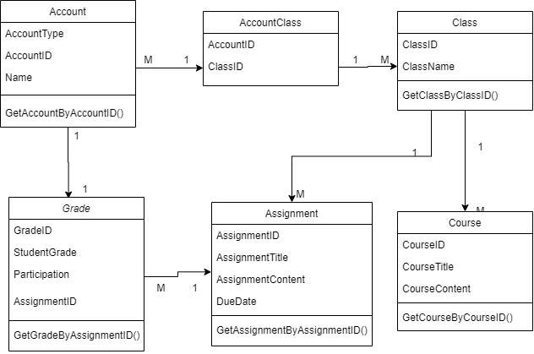

This one is the class diagram which represents each model with it’s variables and the corresponding methods. The class and account classes are connected with an additional class (AccountClass) whitch is required for the many to many relation between these classes. A class contains courses and assignments and each assignment has a grade.

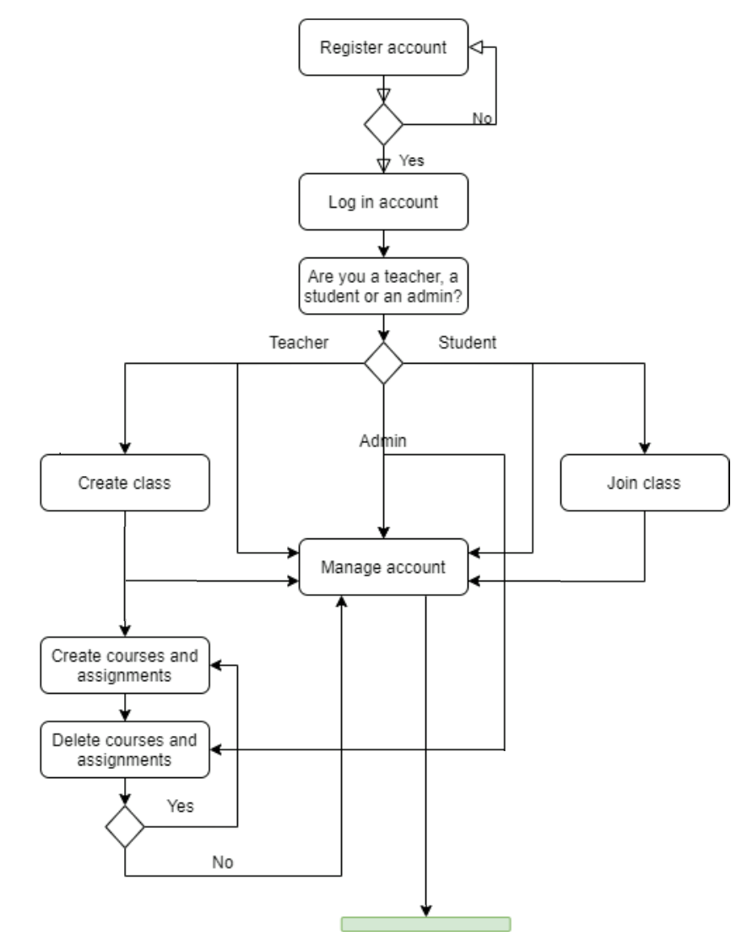

This one is the activity diagram. It describes the way a user uses the application. As the user registers, he is asked if he is a teacher or a student. The admin role is given only by an already existing admin. As the user logs in, he is brought to the main dashboard where he can manage the classes he is attending or create/join a new class depending on his role. The teacher is also able to create or delete courses and assignments and add grade for his students. The admin can delete and modify the user data.