SAGE VS SLIME

Materials List
- 18 unit cards (9 per team)
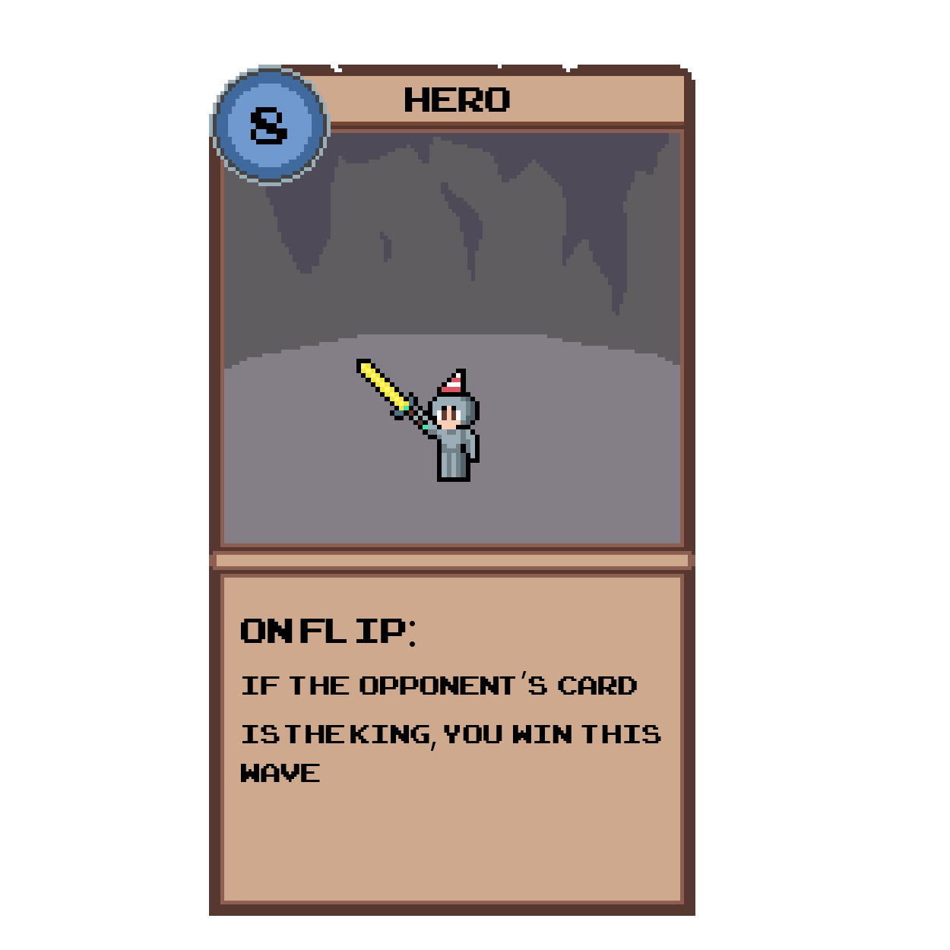
- 6 power up cards (Fireball, Smoke Bomb, Damage Potion) (3 per team)
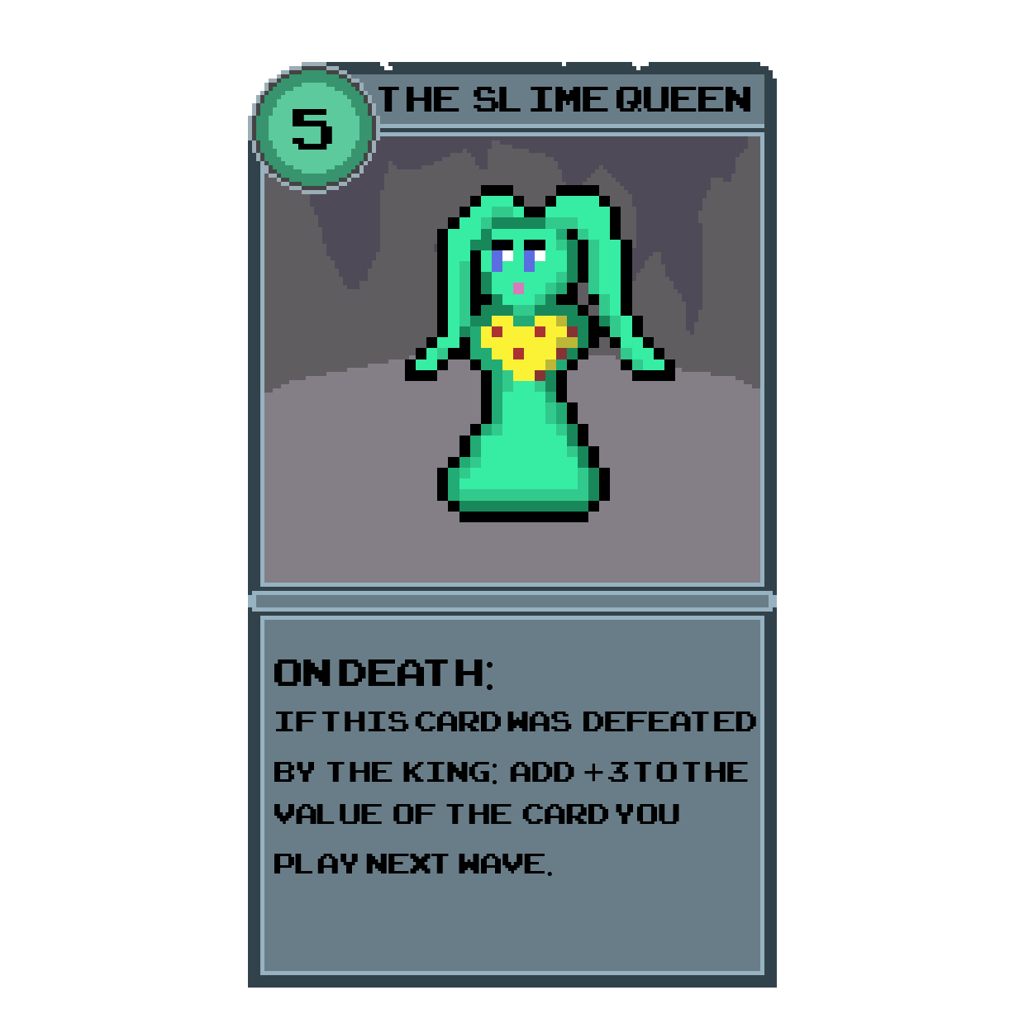
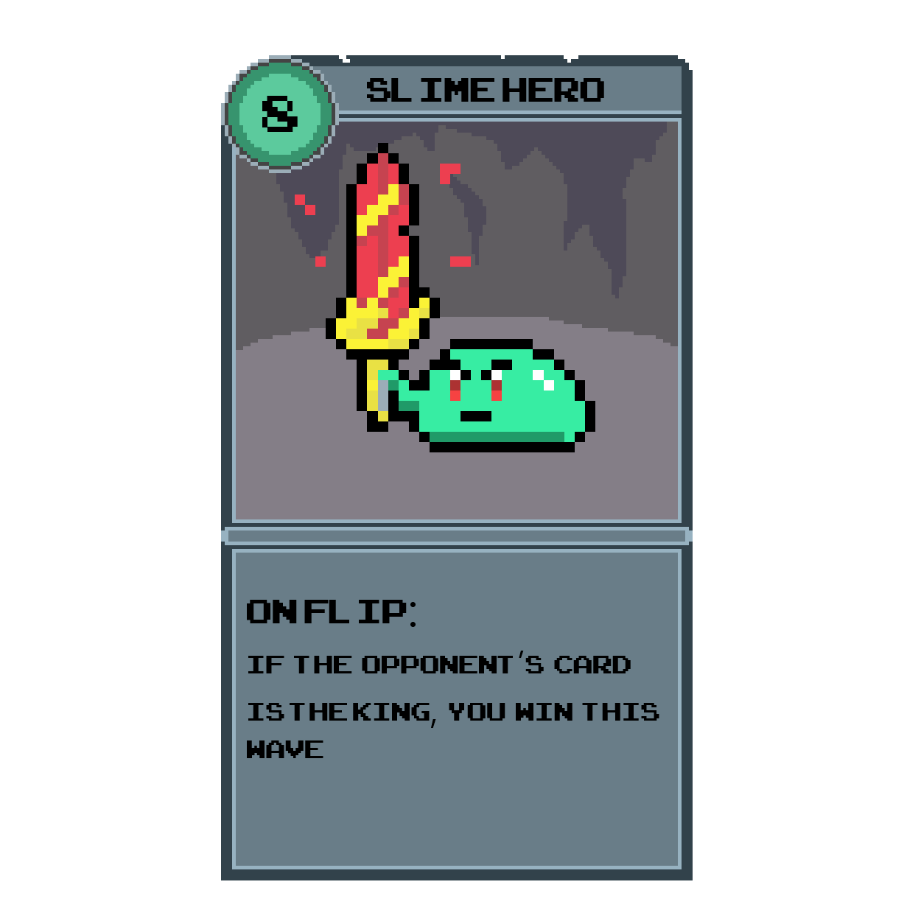

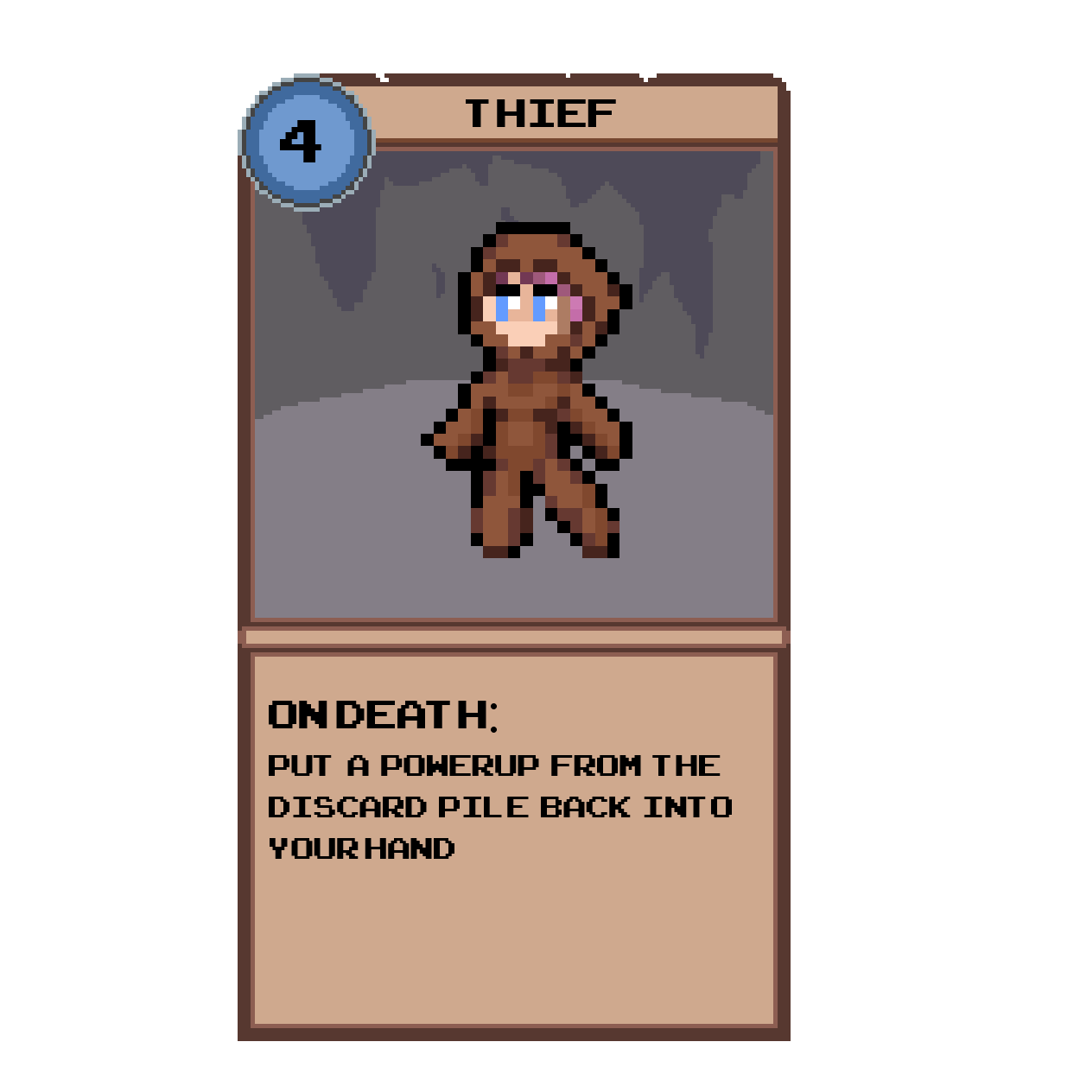
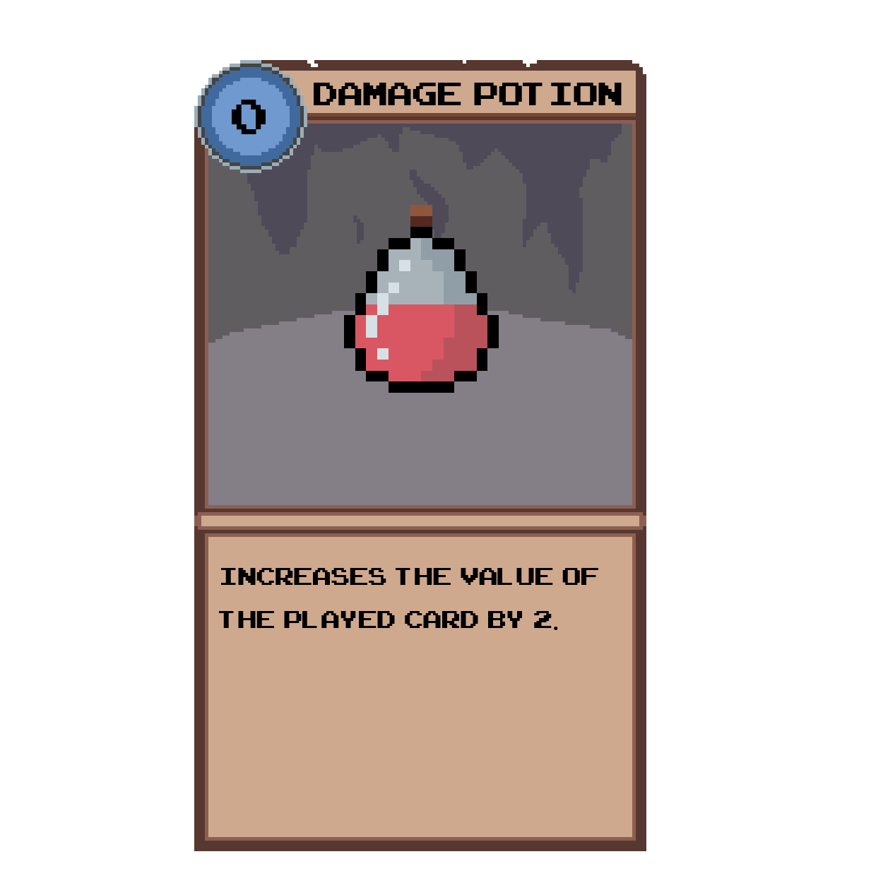
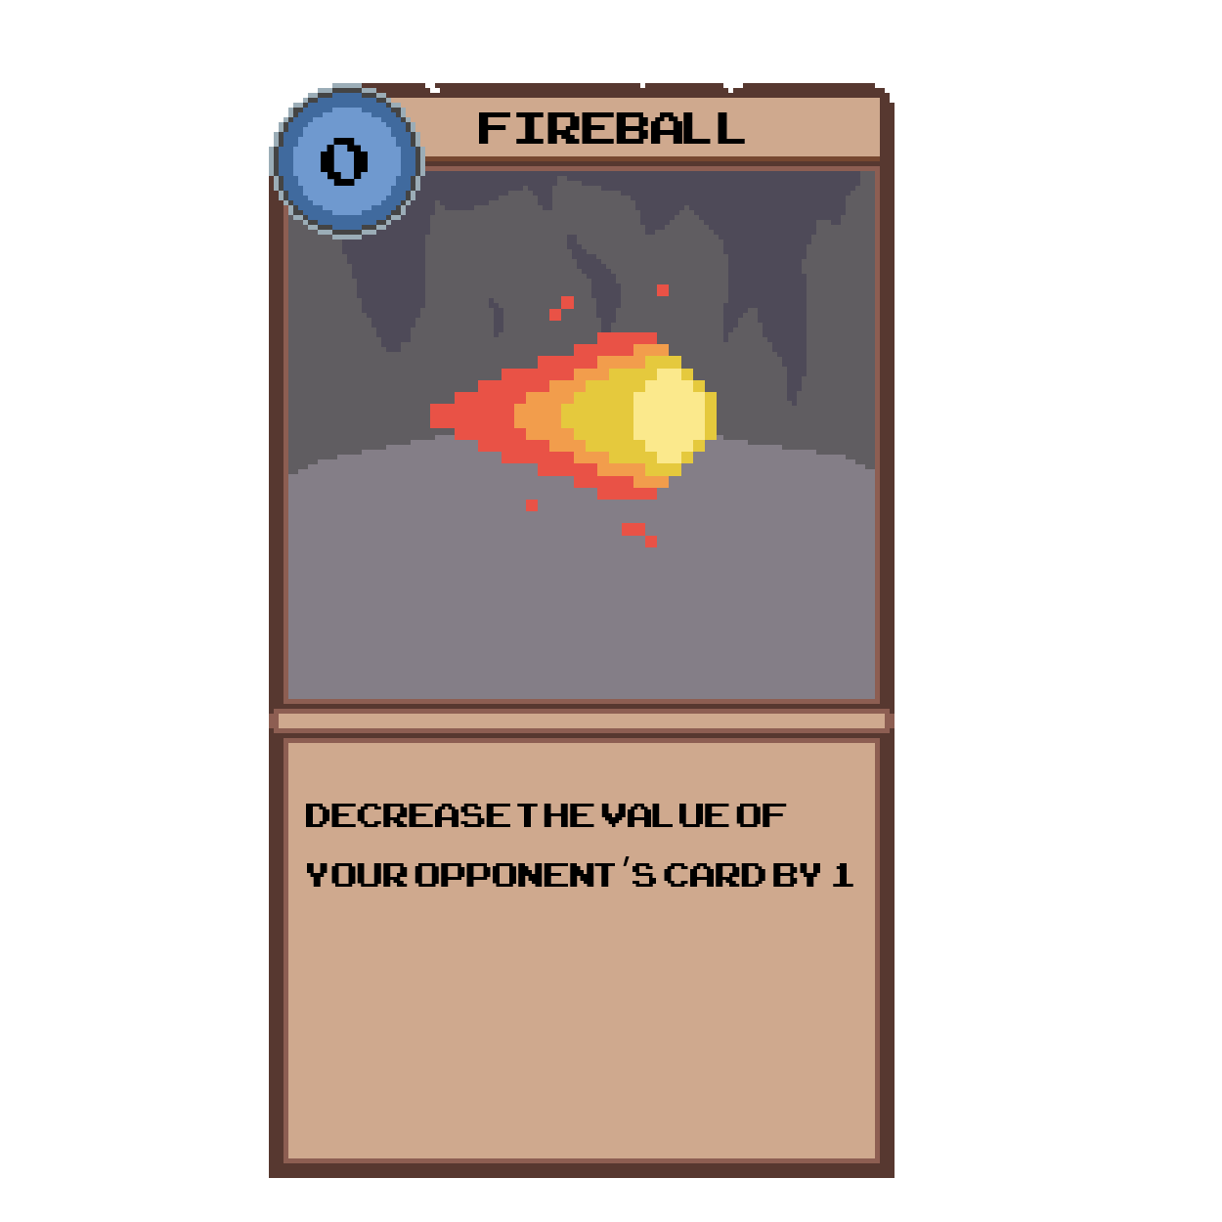
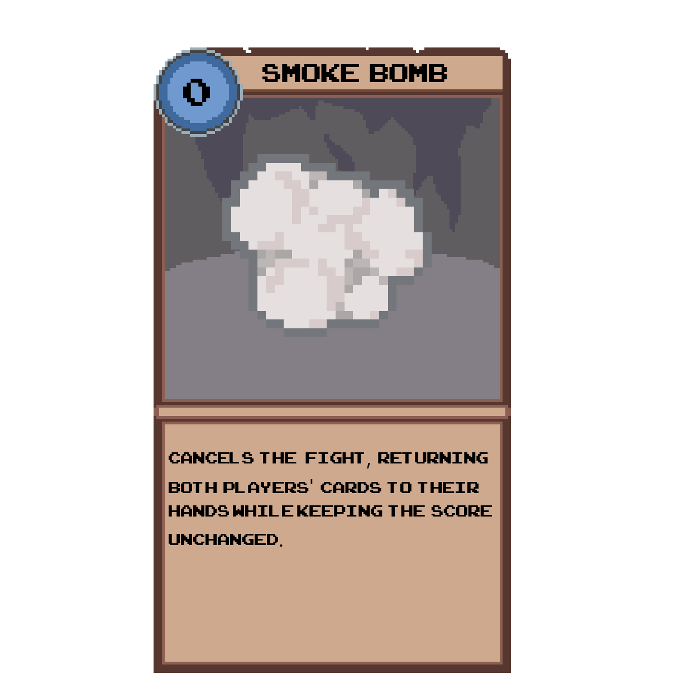
PRINTABLE CARDS

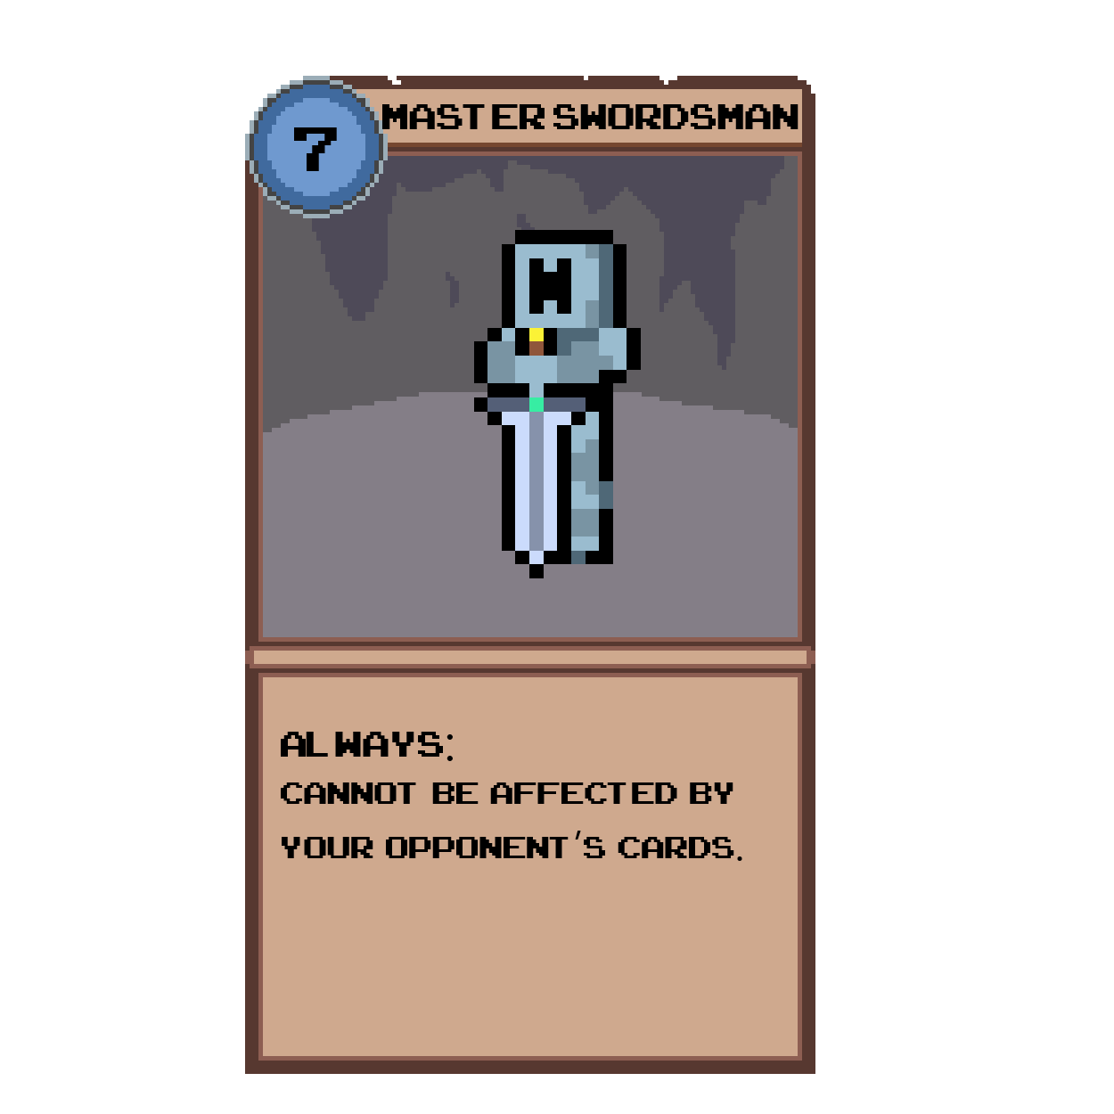
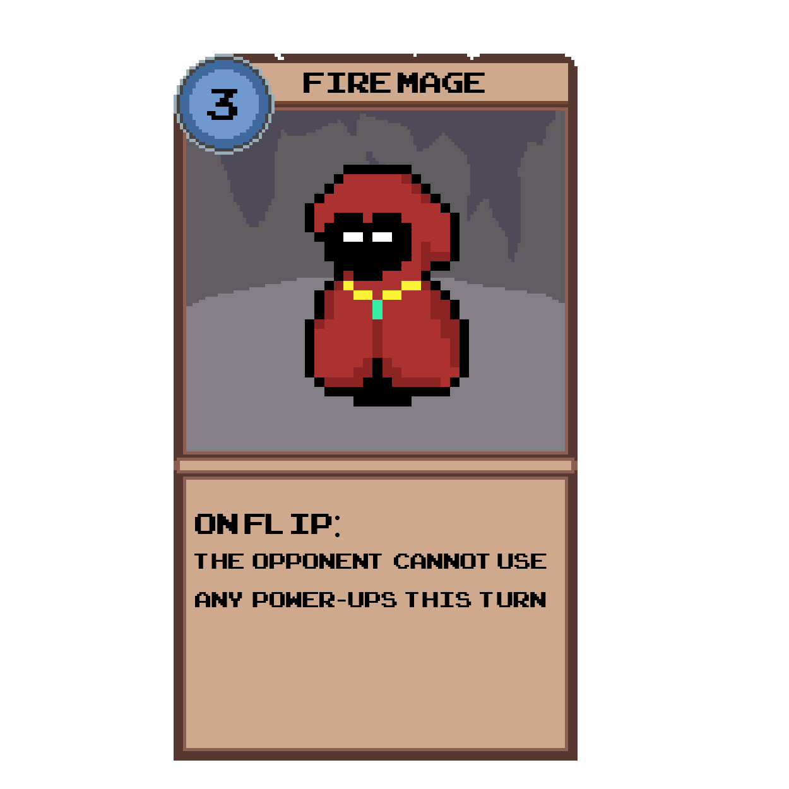
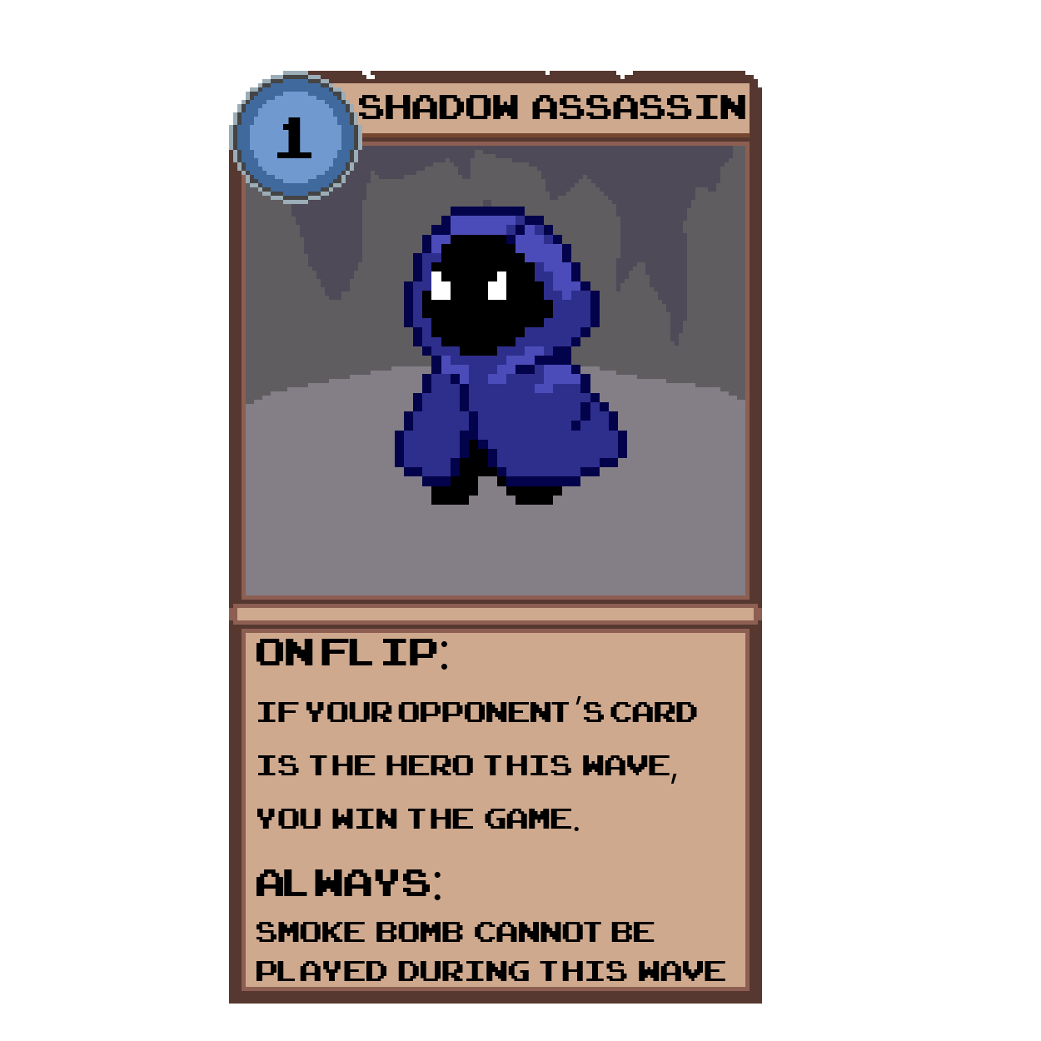

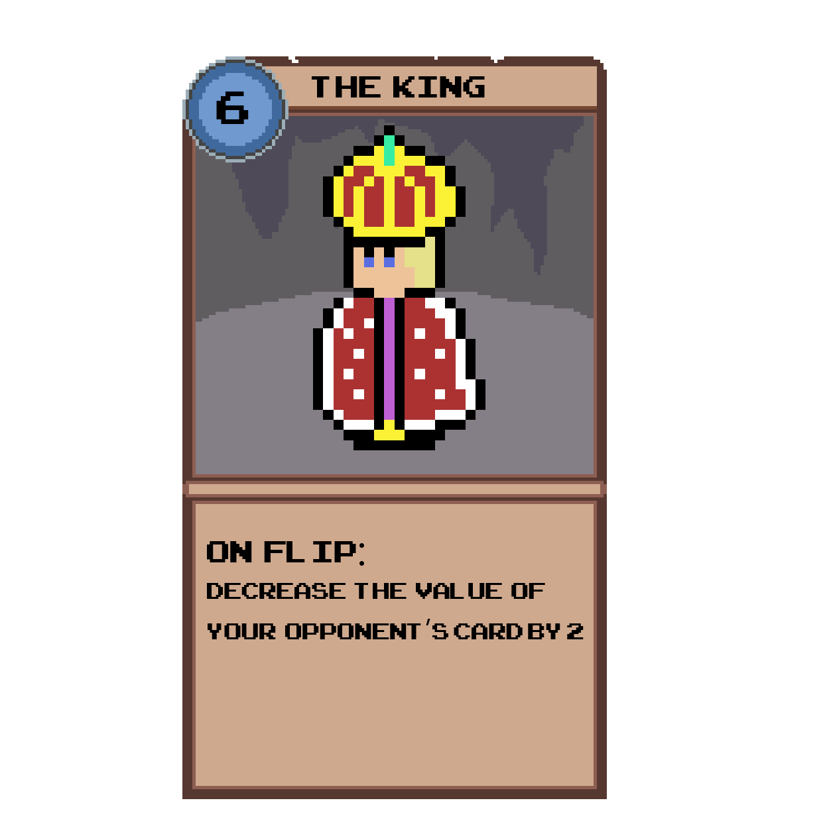
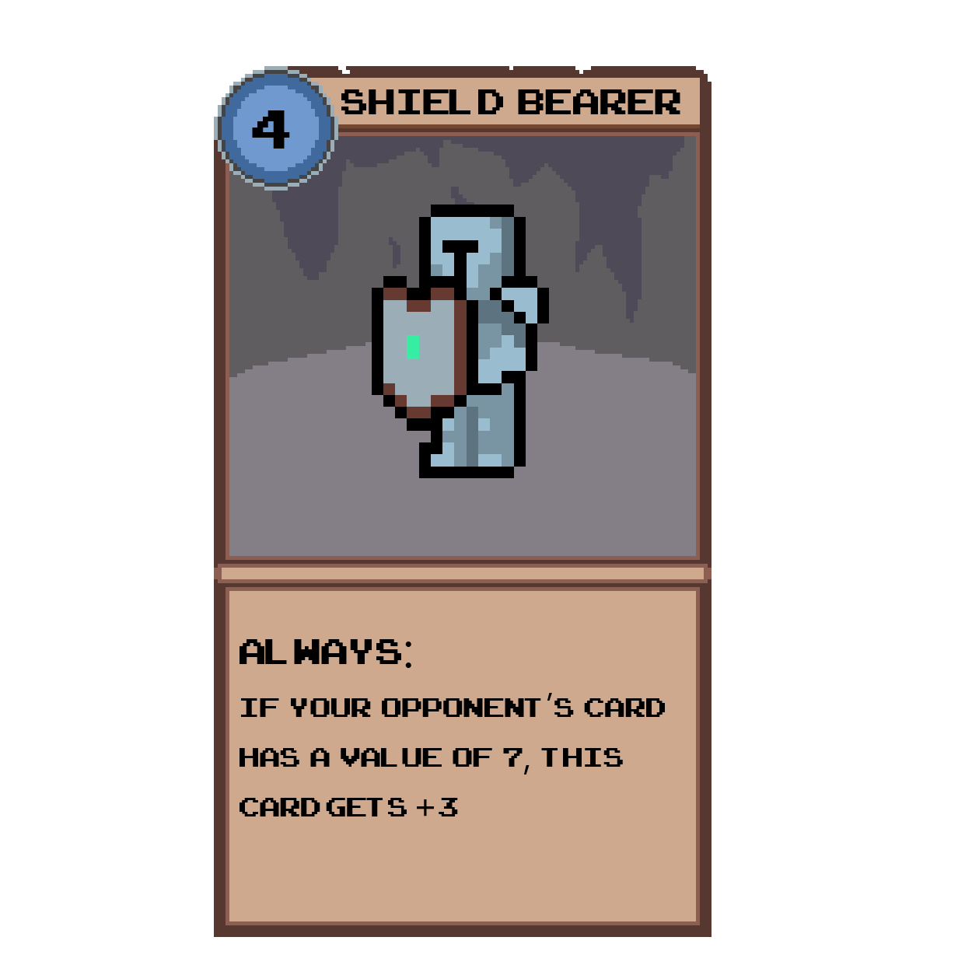

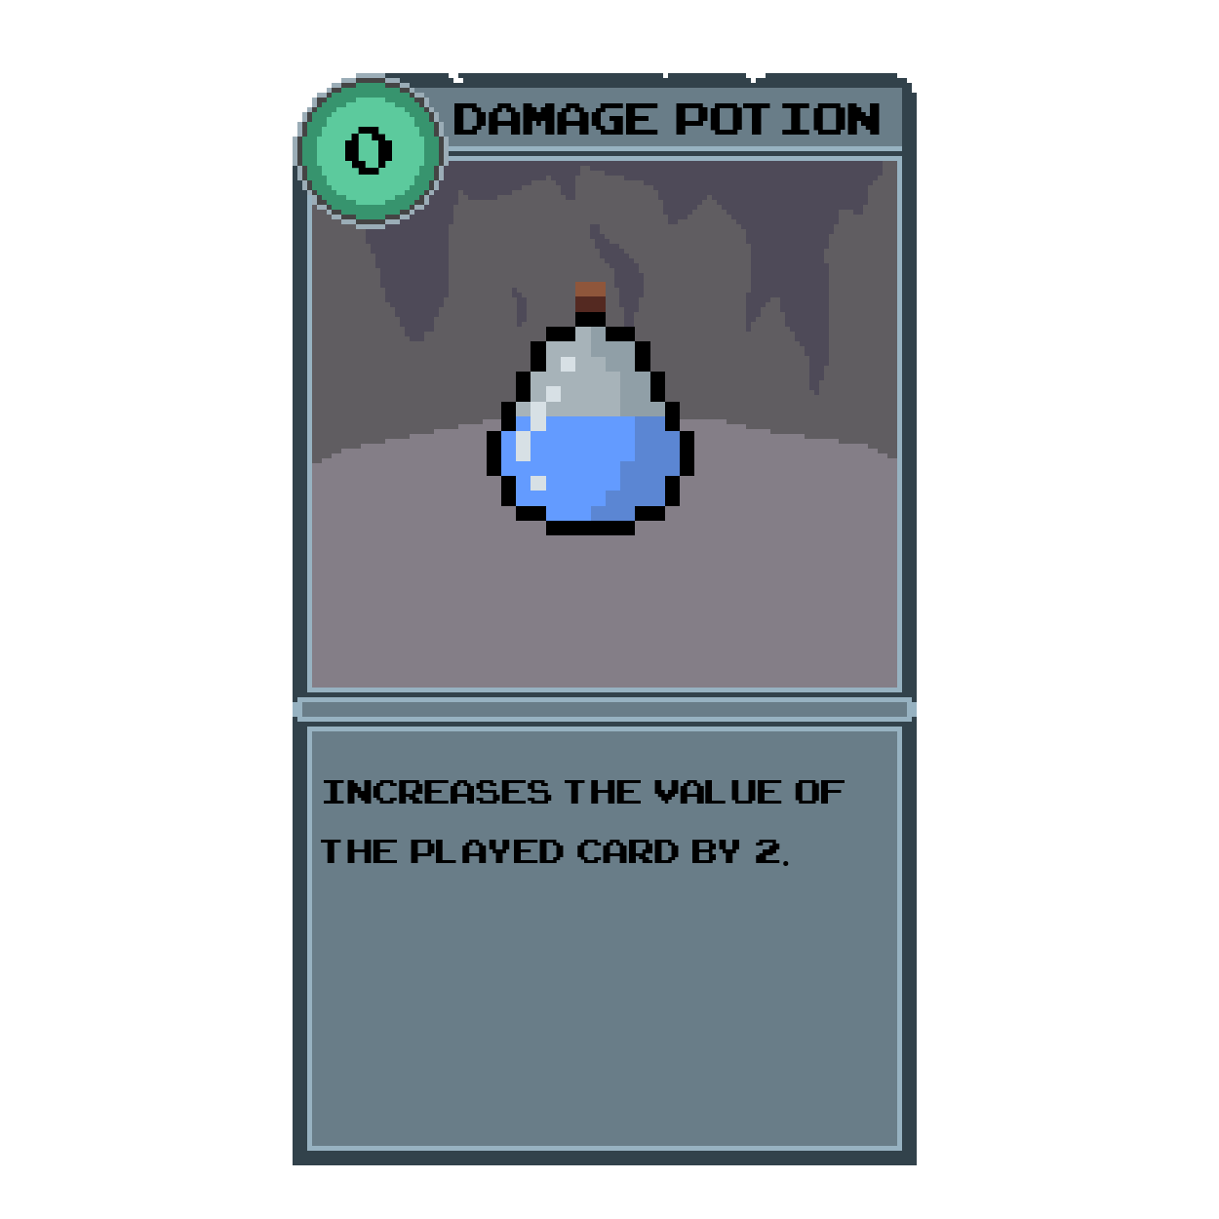
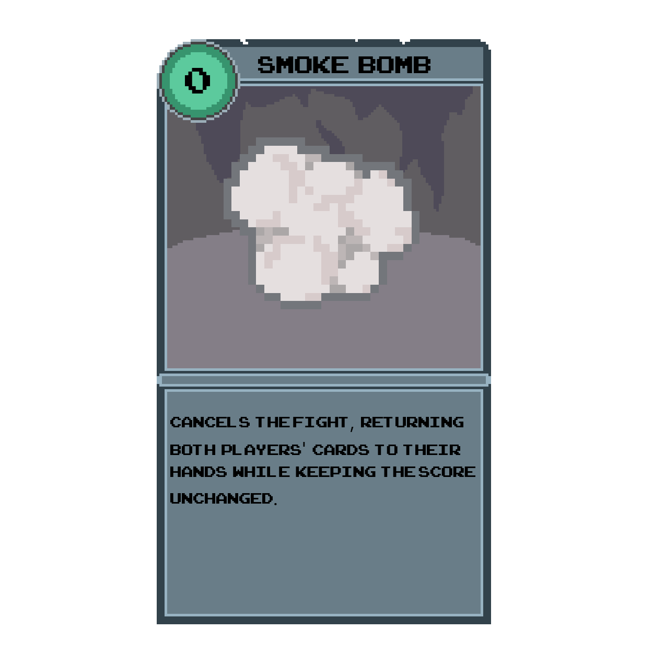
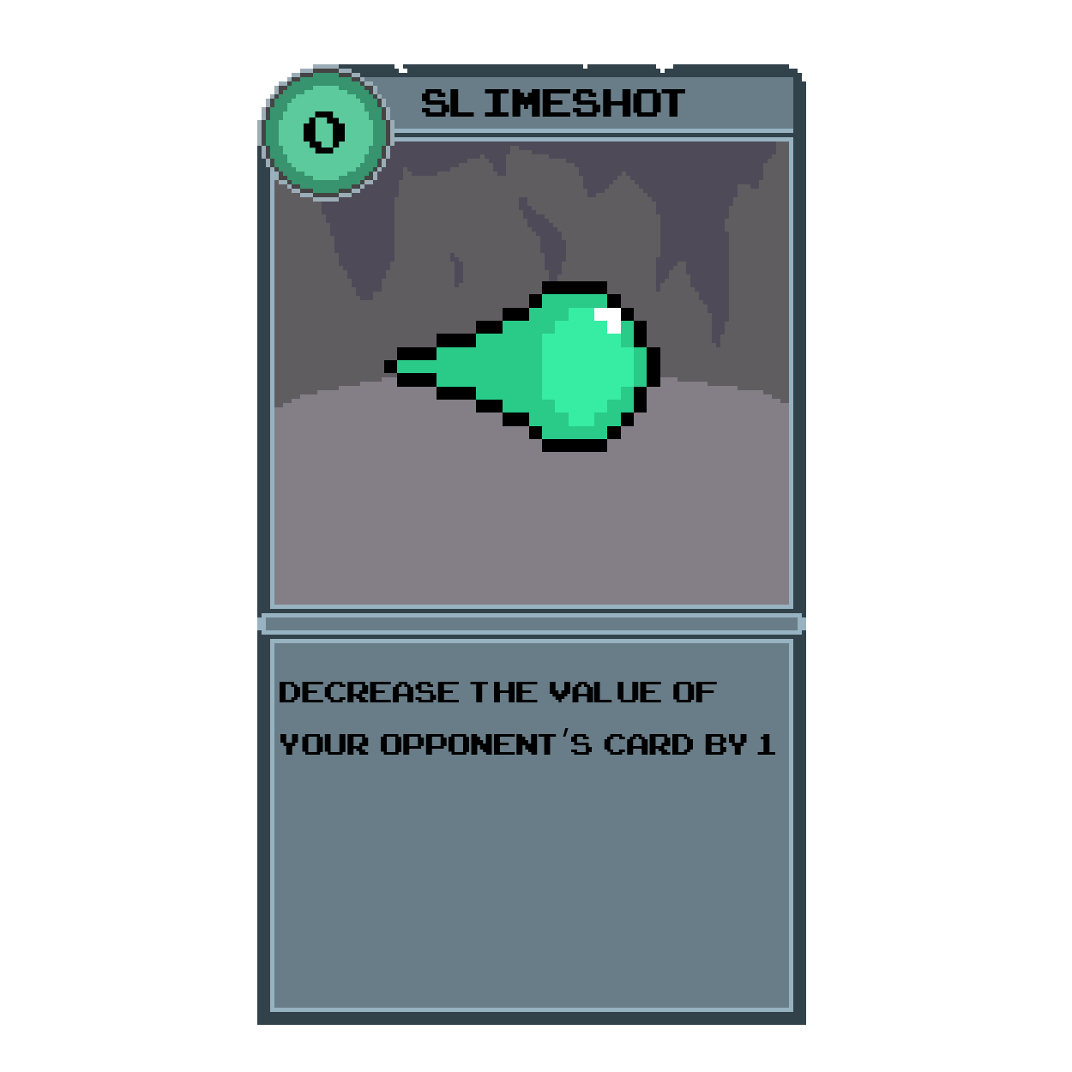

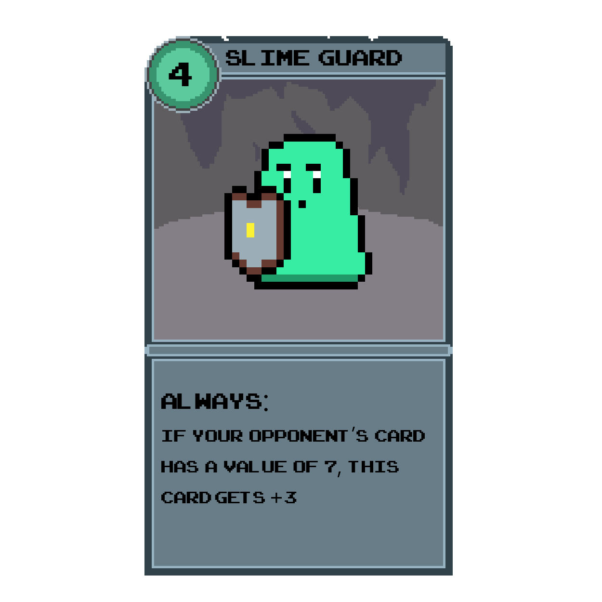

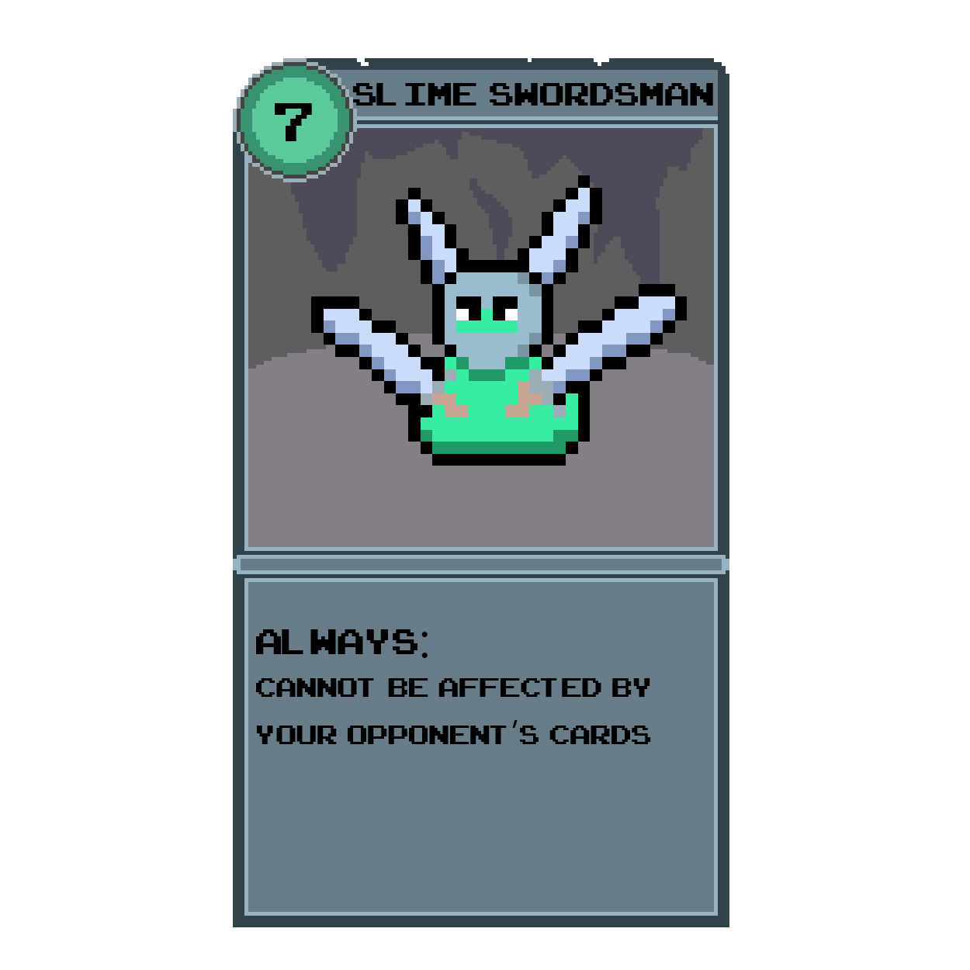
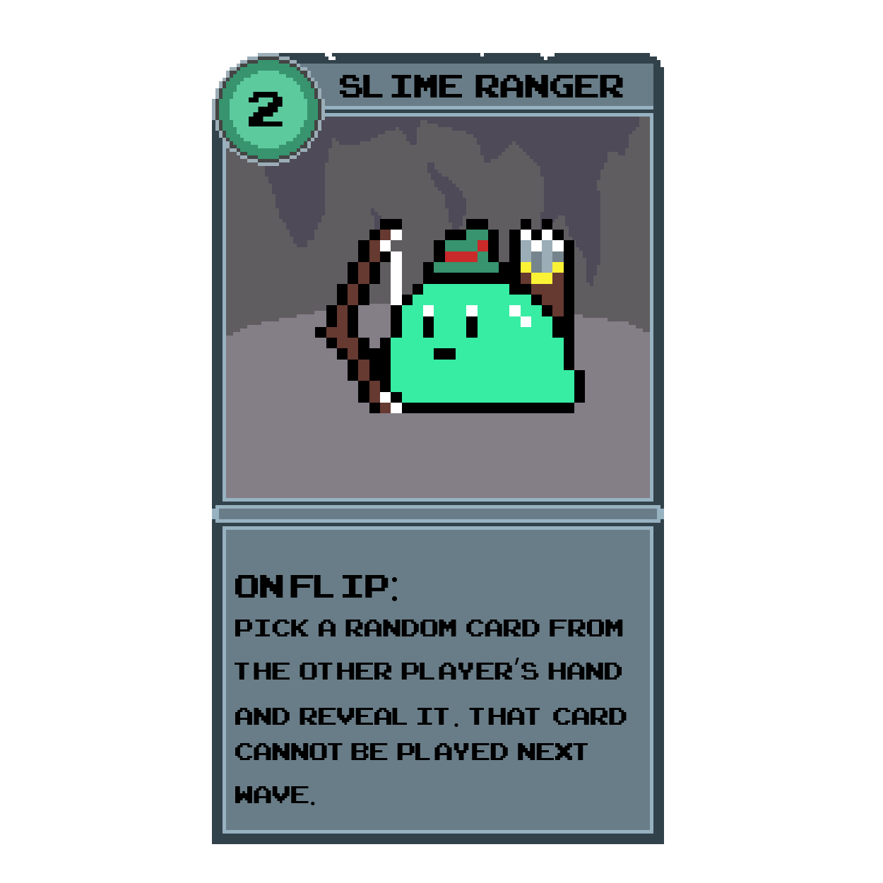
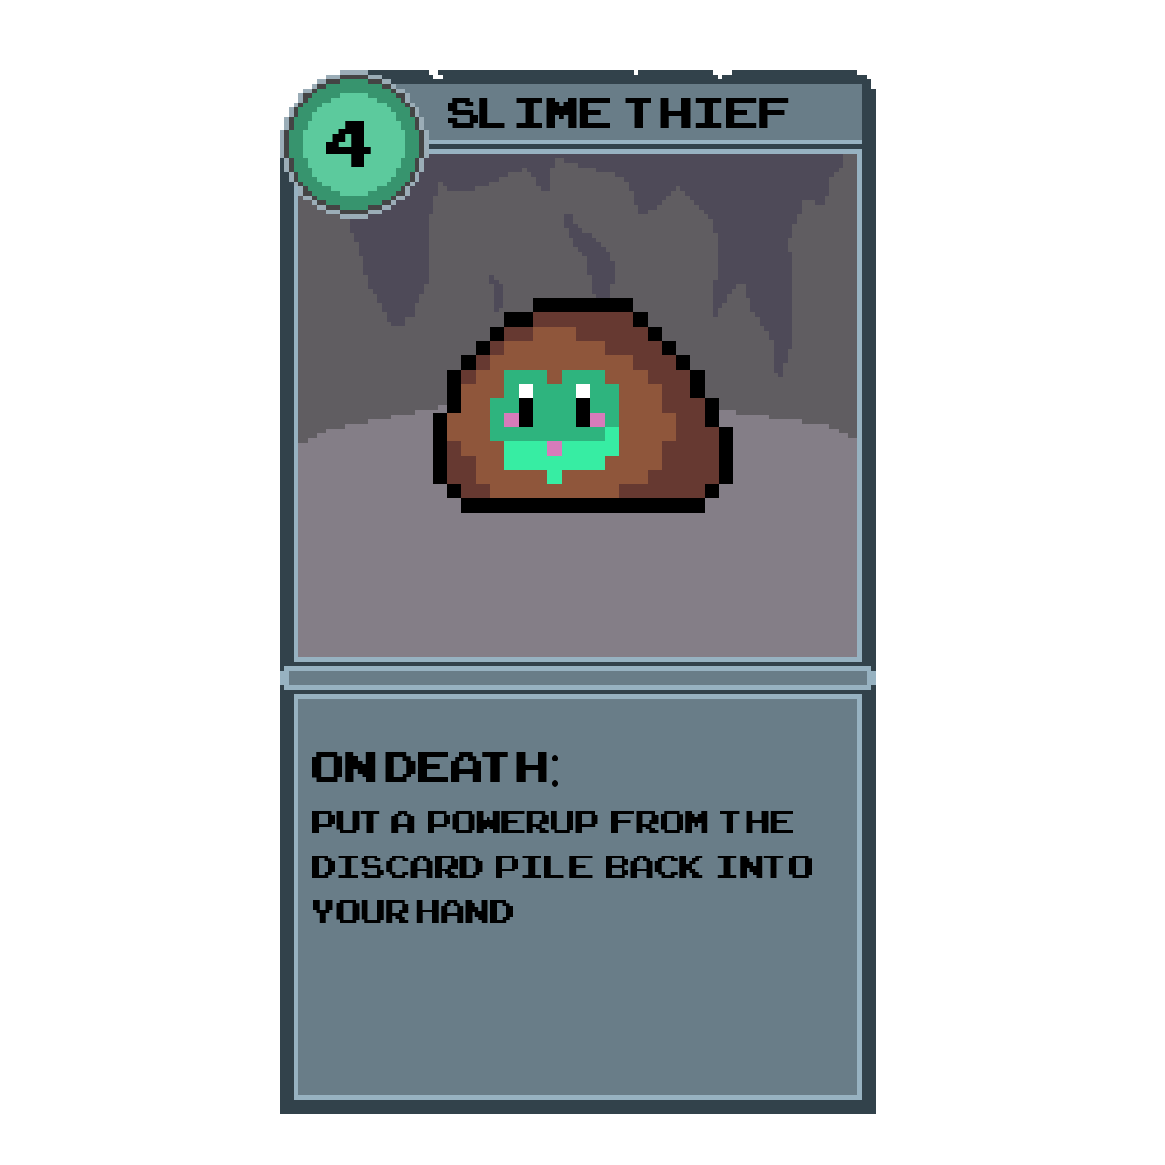

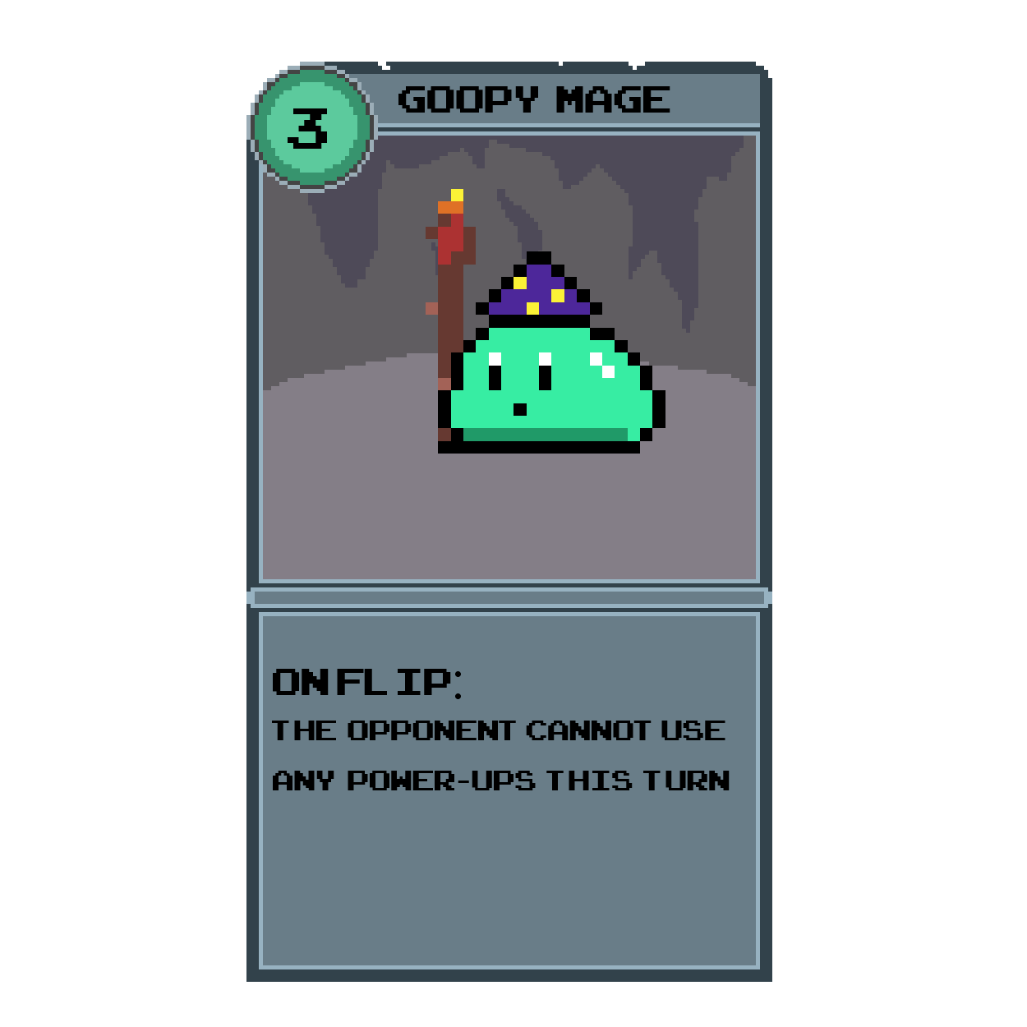
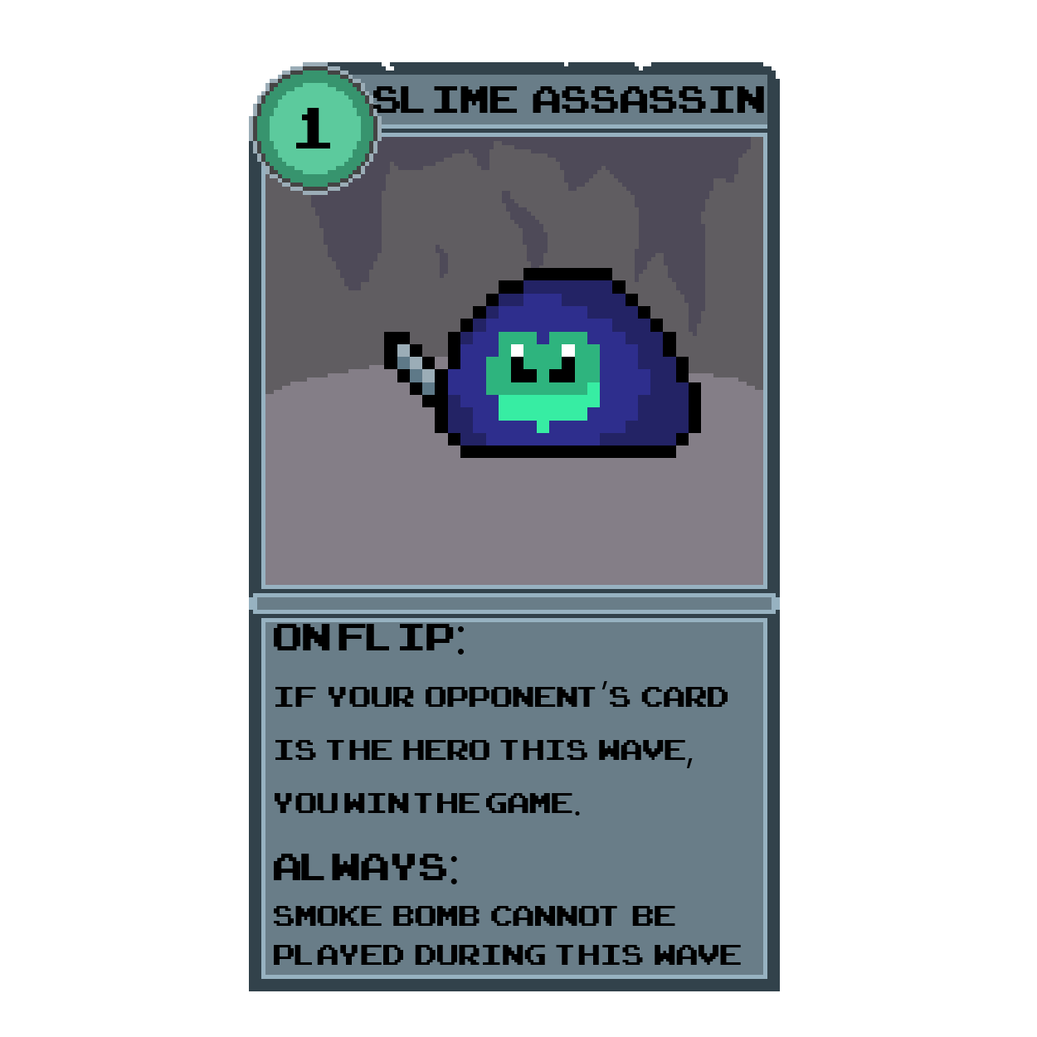

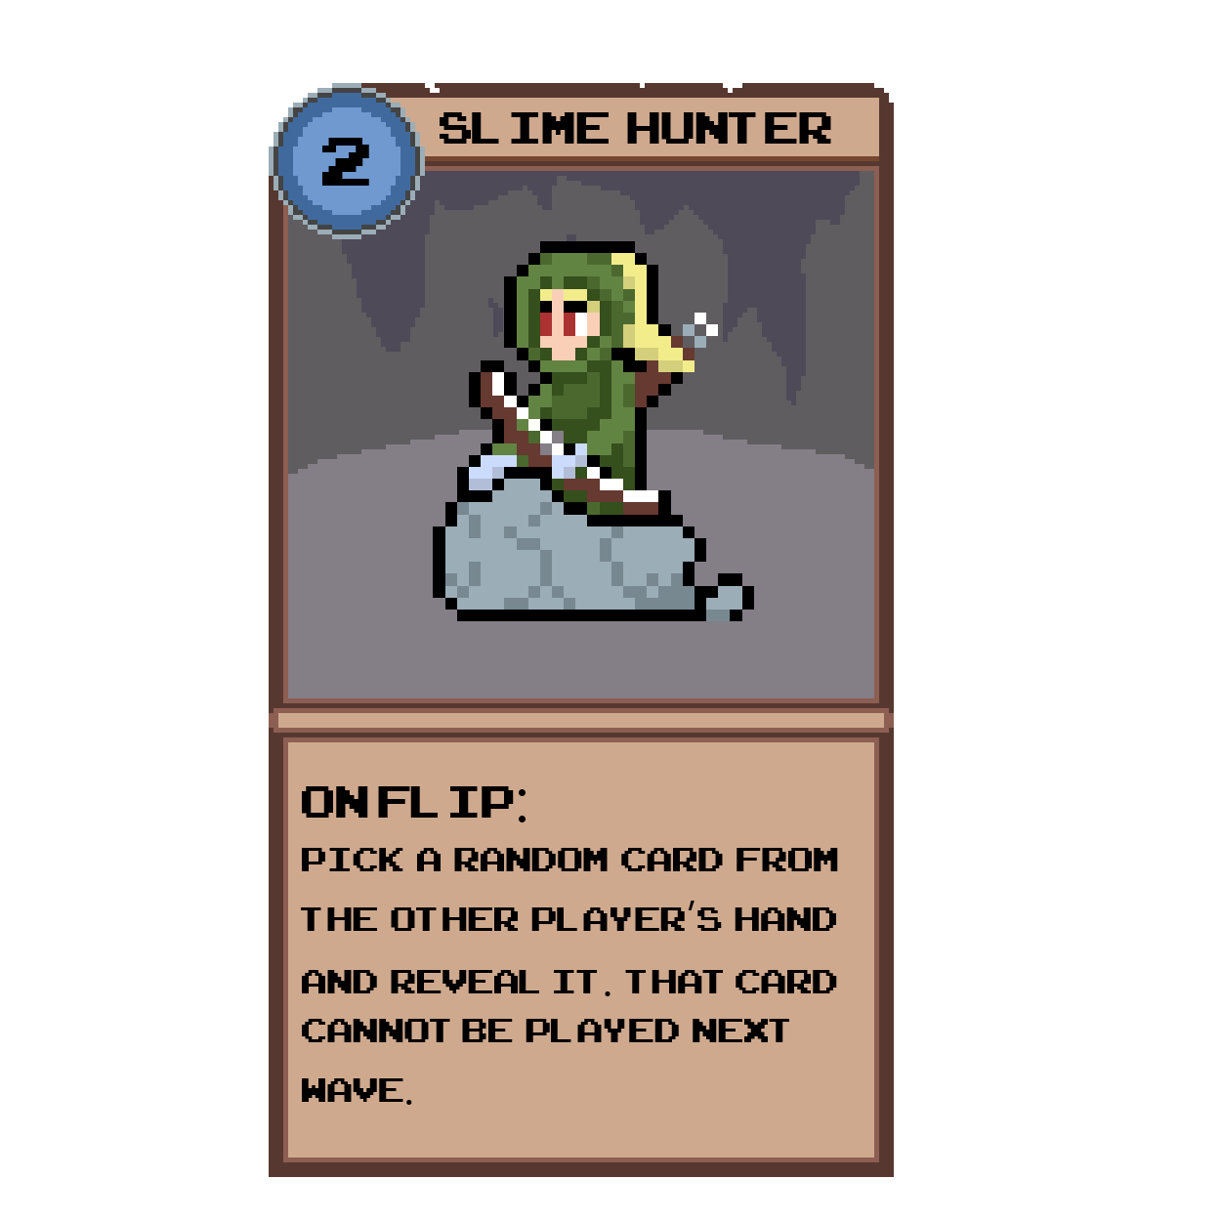
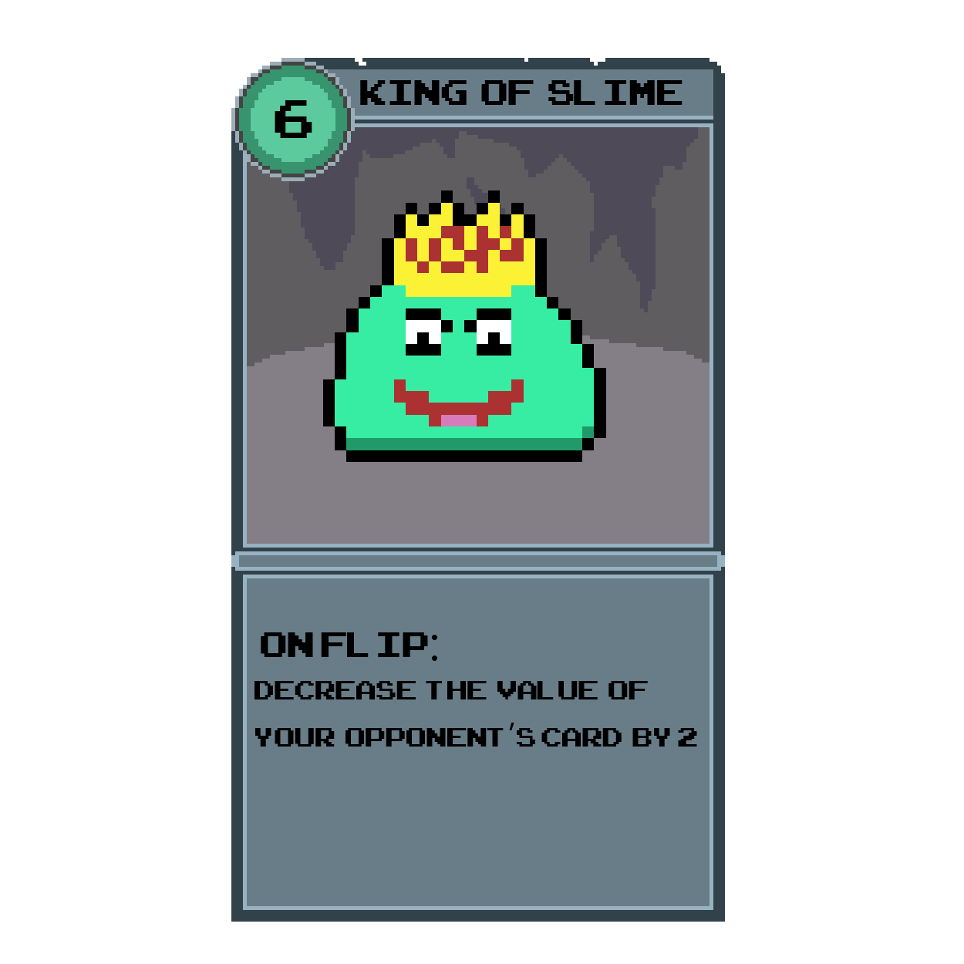
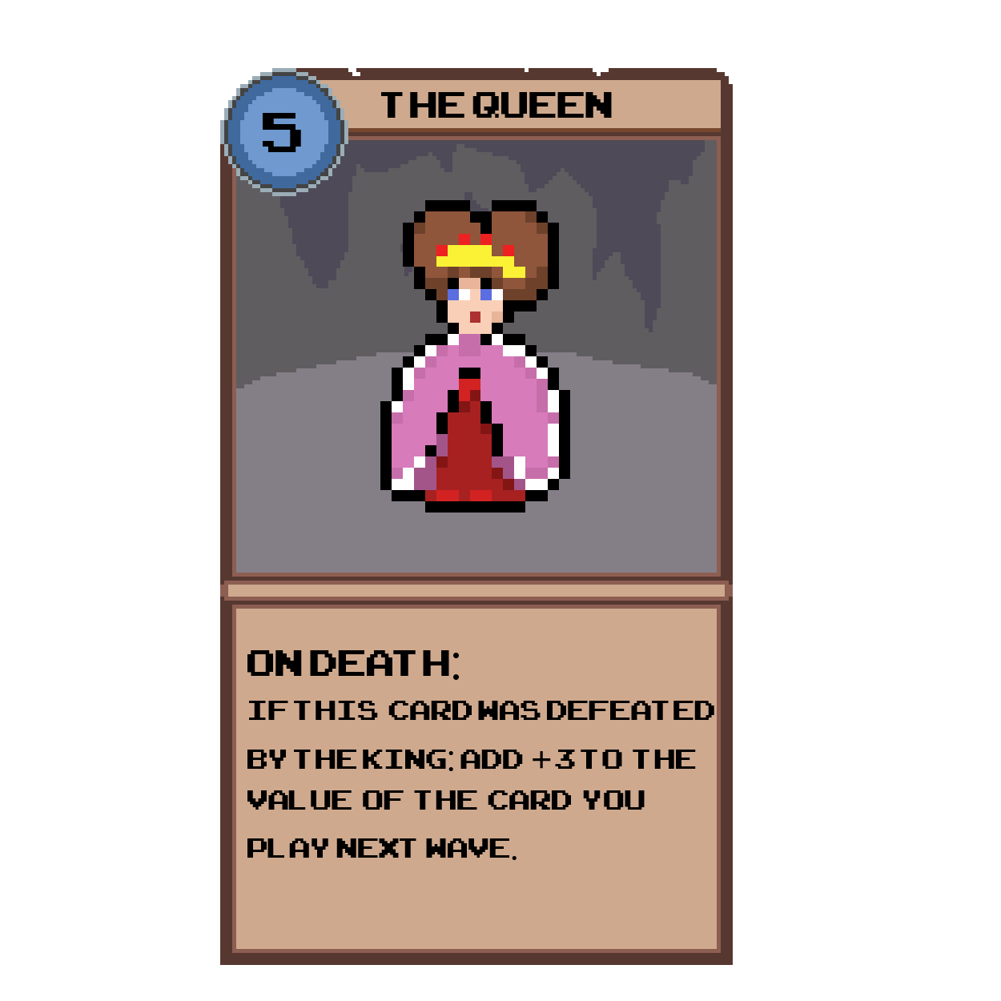

Rules
Setup:
- Each player starts with a deck of 12 cards, including 9 unit cards and 3 power-ups.
- All cards are drawn into the players' hands at the beginning of the game.
- Used power-ups and defeated unit cards will be placed into a discard pile during gameplay.

Game Phases:
1. Play Phase
- Both players select one unit card from their hands and place it face down on the table.
2. Reveal Phase
- Players simultaneously flip their unit cards face-up.
- Any On Flip effects activate immediately.
- Cards with an Always effect remain active for the entire wave.
3. Power-Up Phase
- After both unit cards are revealed, players may play power-ups from their hands.
- Players can play as many power-ups as they have available during this phase.
4. Resolution Phase
- The unit card with the higher value wins the wave unless a special effect or power-up modifies the outcome.
- If both unit cards have the same value, the wave ends in a tie.
- On Death: This effect activates only if the card loses the battle during the wave.
- If the Smoke Bomb is used, both players return their unit cards to their hands. All used power-up cards are placed into the discard pile. The score remains unchanged.
5. Discard Phase
- Used power-ups and unit cards played during the wave are placed into their respective discard piles.
6. End Phase
- Check if any player has achieved 5 wins. If yes, they are declared the winner.
- If no player has reached 5 wins, return to the Play Phase for the next wave.
Edge Case: Last Unit Card
- If a card effect requires you to pick a random card from your opponent's hand and reveal it, and the revealed card is the last remaining unit card in their hand, the effect does not apply. The revealed card is returned to the opponent’s hand, and the wave proceeds as normal.
- If a card has a on death effect and is used in a wave that results in a tie, that effect does not happen.

