Remote Work Health Impact Analysis

Danylo Karaulanov

2025-08

## Survey_Date Age Gender Region Industry Job_Role Work_Arrangement  
## <date> <dbl> <chr> <chr> <chr> <chr> <chr>   
## 1 2025-06-01 27 Female Asia Professional… Data An… Onsite   
## 2 2025-06-01 37 Female Asia Professional… Data An… Onsite   
## 3 2025-06-01 32 Female Africa Education Busines… Onsite   
## 4 2025-06-01 40 Female Europe Education Data An… Onsite   
## 5 2025-06-01 30 Male South America Manufacturing DevOps … Hybrid   
## 6 2025-06-01 52 Male Oceania Customer Ser… Busines… Onsite   
## # ℹ 7 more variables: Hours_Per_Week <dbl>, Mental_Health_Status <chr>,  
## # Burnout_Level <chr>, Work_Life_Balance_Score <dbl>,  
## # Physical_Health_Issues <chr>, Social_Isolation_Score <dbl>,  
## # Salary_Range <chr>

# **Introduction**

This report analyzes how different work arrangements (remote, hybrid, and onsite) affect employee health and burnout based on survey data from over 3,000 participants.

The analysis focuses on the following research questions:

* Does work arrangement influence burnout levels? - How do gender, age, and mental health status correlate with burnout? - What practical steps can organizations take to address identified risks?

# **Key Findings**

## **1. Burnout by Gender**

Analysis shows variation in burnout levels across genders. For example, female employees reported slightly higher ‘High Burnout’ percentages in remote and onsite settings compared to males. Charts from R analysis provide visual confirmation.

burnout_by_gender <- data %>%  
 count(Gender, Work_Arrangement, Burnout_Level) %>%  
 group_by(Gender, Work_Arrangement) %>%  
 mutate(Percentage = n / sum(n) * 100) %>%  
 ungroup()  
head(burnout_by_gender)

## # A tibble: 6 × 5  
## Gender Work_Arrangement Burnout_Level n Percentage  
## <chr> <chr> <chr> <int> <dbl>  
## 1 Female Hybrid High 170 37.4  
## 2 Female Hybrid Low 79 17.4  
## 3 Female Hybrid Medium 205 45.2  
## 4 Female Onsite High 212 27.5  
## 5 Female Onsite Low 230 29.8  
## 6 Female Onsite Medium 330 42.7

ggplot(burnout_by_gender, aes(x = Work_Arrangement, y = Percentage, fill = Burnout_Level)) +  
 geom_col(position = "dodge") +   
 facet_wrap(~Gender) +   
 labs(title = "Burnout Levels by Work Arrangement and Gender", x = "Work Arrangement", y = "Percentage (%)", fill = "Burnout Level") +   
 theme_minimal() +   
 scale_fill_brewer(palette = "RdYlGn", direction = -1) +   
 theme(axis.text.x = element_text(angle = 45, hjust = 1))

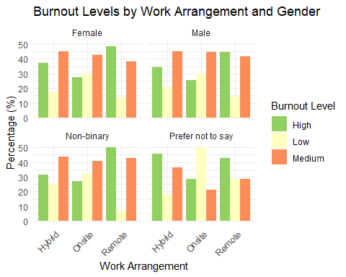

## **2. Burnout by Work Arrangement**

Remote workers consistently reported higher burnout than hybrid and onsite employees. Hybrid workers had the lowest proportion of high-burnout cases.

burnout_by_arrangement <- data %>%  
 group_by(Work_Arrangement, Burnout_Level) %>%  
 summarise(Count = n()) %>%  
 mutate(Percentage = (Count / sum(Count)) * 100)  
head(burnout_by_arrangement)

## # Groups: Work_Arrangement [2]  
## Work_Arrangement Burnout_Level Count Percentage  
## <chr> <chr> <int> <dbl>  
## 1 Hybrid High 360 35.7  
## 2 Hybrid Low 193 19.2  
## 3 Hybrid Medium 454 45.1  
## 4 Onsite High 413 26.4  
## 5 Onsite Low 471 30.2  
## 6 Onsite Medium 678 43.4

ggplot(burnout_by_arrangement,  
 aes(x = Work_Arrangement, y = Percentage, fill = Burnout_Level)) + geom_col(width = 0.6) +   
 scale_fill_manual(values = c("Low" = "#A6D8A0", "Medium" = "#F9CB8F", "High" = "#F38D8D")) +   
 labs(x = "Work Type", y = "Percentage of Employees", fill = "Burnout Level") +   
 theme_minimal() +   
 theme(panel.grid = element_blank(), axis.text = element_text(size = 11), legend.position = "top")

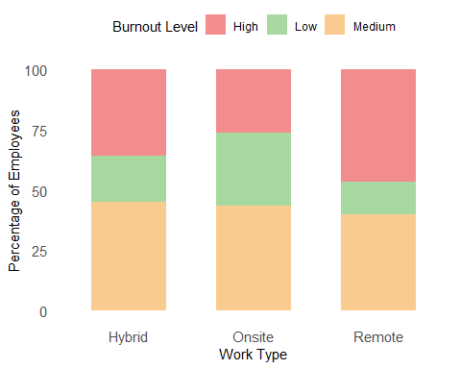

## **3. Mental Health and Burnout**

Employees with pre-existing mental health conditions (such as anxiety, ADHD, or stress disorders) showed a much higher likelihood of reporting ‘High Burnout.’ Visualization confirms the strong overlap between mental health challenges and burnout.

## # Groups: Mental_Health_Status [2]  
## Mental_Health_Status Burnout_Level Count Percentage  
## <chr> <chr> <int> <dbl>  
## 1 ADHD High 119 30.9  
## 2 ADHD Low 109 28.3  
## 3 ADHD Medium 157 40.8  
## 4 Anxiety High 136 34.5  
## 5 Anxiety Low 92 23.4  
## 6 Anxiety Medium 166 42.1

ggplot(mental_health_burnout, aes(x = Mental_Health_Status, y = Percentage, fill = Burnout_Level)) +   
 geom_bar(stat = "identity", position = "dodge") +   
 labs(title = "Burnout Levels by Mental Health Status", x = "Mental Health Condition", y = "Percentage (%)") +  
 theme_minimal() +  
 theme(axis.text.x = element_text(angle = 45, hjust = 1))

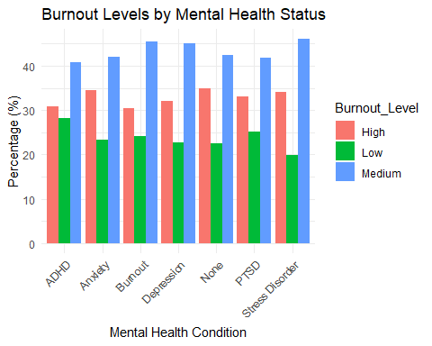

## **4. Age and Burnout**

Burnout levels varied by age group. Younger employees (under 30) had the highest proportion of burnout, while workers aged 40+ were less likely to report severe burnout. Age bands were grouped as Under 30, 30–39, 40–49, and 50+ for clarity.

## # Groups: Age_Group [2]  
## Age_Group Burnout_Level Count Percentage  
## <chr> <chr> <int> <dbl>  
## 1 30-39 High 256 36.7  
## 2 30-39 Low 149 21.4  
## 3 30-39 Medium 292 41.9  
## 4 40-49 High 230 31.1  
## 5 40-49 Low 180 24.4  
## 6 40-49 Medium 329 44.5

ggplot(burnout_by_age,   
 aes(x = Age_Group, y = Percentage, fill = Burnout_Level)) +  
 geom_col(width = 0.6, color = "white", linewidth = 0.3) +   
 scale_fill_manual(values = c("Low" = "#7bc8a4", "Medium" = "#ffb347", "High" = "#ff6b6b")) +  
 labs(x = "Age Group", y = "Percentage (%)", fill = "Burnout Level") +  
 theme_minimal(base_size = 12) +  
 theme(legend.position = "top", panel.grid.major.x = element_blank(), plot.title = element_text(hjust = 0.5, face = "bold")) +  
 geom_text(aes(label = paste0(round(Percentage), "%")), position = position_stack(vjust = 0.5), color = "white", size = 3.8)

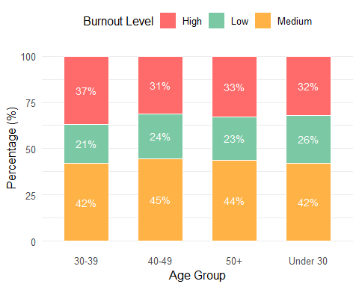

# **Conclusion**

The analysis highlights that remote workers and younger employees are more at risk of high burnout. Additionally, mental health conditions strongly correlate with increased burnout.

# **Recommendations:

Based on the findings, organizations should consider the following actions:

* Implement targeted wellness programs for remote employees, focusing on reducing screen fatigue.
* Provide age-specific support initiatives, such as mentorship for younger staff.
* Encourage flexible work arrangements for high-burnout groups.
* Offer mental health resources, such as counseling and stress management workshops.
* Monitor workload and ensure employees maintain work-life balance.