My application takes a Microsoft Access database file (.mdb) of a specific format and allows the user to select a variety of options displayed in **Figure 1**. This calculates the students’ grades in the database file.

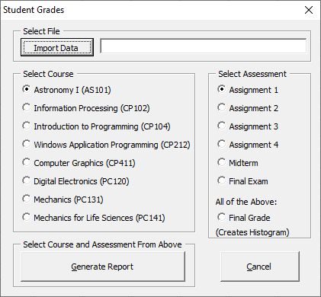

**Figure 1.**

There is error-checking if the user does not select a file. The default first options are automatically checked and the user may choose one of each as specified. The data is extracted and organized. In addition, the average and standard deviation will be calculated. The table generated includes the student’s first and last name, student ID, and which assignment is being looked at.

There is a special option called “Final Grade”. If the user selects this option, then all of the assessments are put on the table along with a histogram, then a Microsoft Word document which exports the data along with the histogram. Note that the histogram exported is linked to the Microsoft word document, so deleting the histogram in any way will prompt an error message indicating an error with the references.

Provided are examples of a generated data (worksheet and document) below.

Example of Word Output

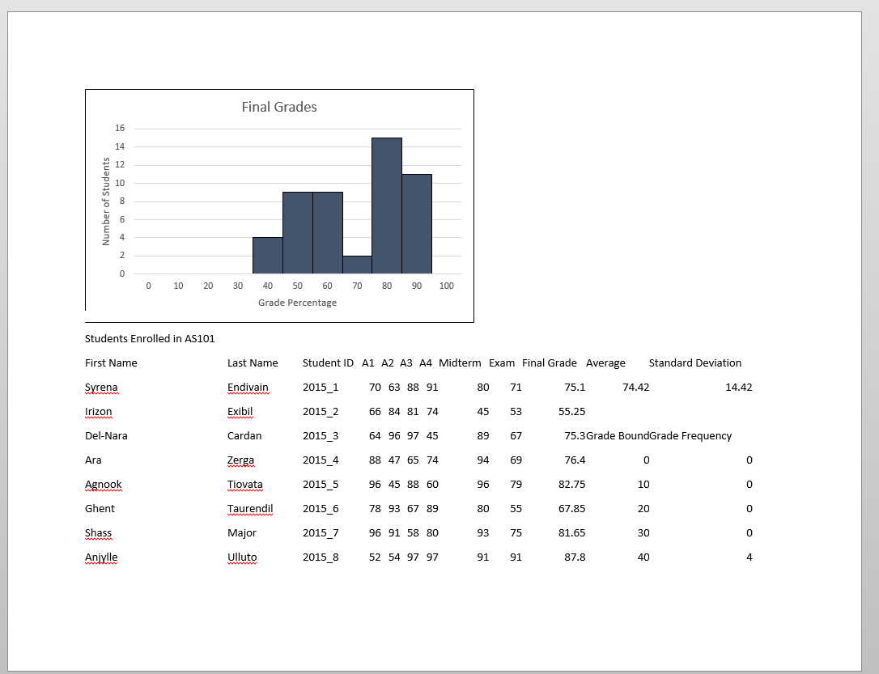

Example of Excel Output

