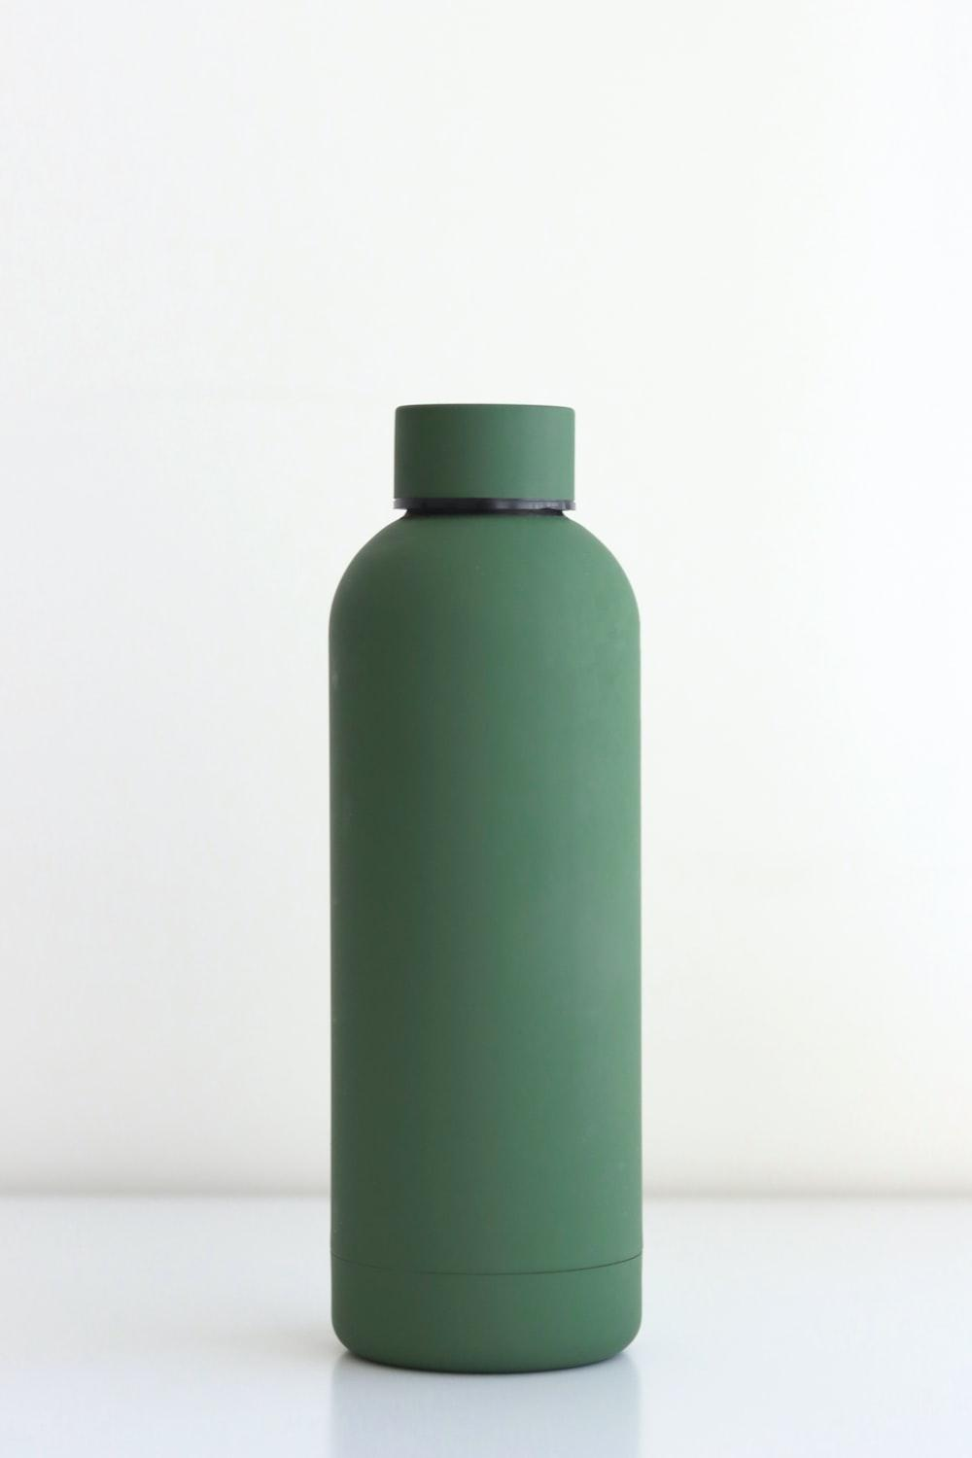

**Hydrobottle**

**Project Documentatation**

Avi Pradhan

Daniel Krasnov

Ross Cooper

Keiran Malott

# 1 Introduction

#### 1.1 Mission Statement

Hydrobottle's mission is to provide anyone who needs a bottle, or container with a companion that will last them their whole life, at an affordable price. We do this by using high quality materials and an ingenious design.

#### 1.2 Executive Summary

Bottles are a product that is used daily by millions of people in the world. To tap into that market that led us to designing a high quality e-commerce website, we finally arrived at Hydrobottle(<http://127.0.0.1/shop/shop.html>).

We used HTML to create a high quality website design that is both pleasing to the eye and easy to navigate. We coded using Java, allowing customers to access our website through JSPs. The website is designed in a way that lets potential customers create accounts, allowing them to order Hydrobottle products and leave reviews. Through our account system our customers can see all the orders they have made in the past together, making it convenient to plan new purchases.

Hydrobottle uses all the major card manufacturers (VISA, Master, AMEX), allowing customers a peace of mind when ordering. We also have technology in place that makes sure customers can only order items that are in stock by cross checking each item in the order with the warehouse, we then let the customer know if the item is in stock by completing the order or by telling them the item is not in stock

# 2 System Features

| **Final Overall System Features** | **Category** | **Possible Points** | **Points** |
| --- | --- | --- | --- |
| **Documentation (10 Total Points)** | | | |
| Executive Summary (up to 1 page) | Core | 2 | 2 |
| System Features (2 Pages) | Core | 2 | 2 |
| Walkthrough with screenshots (up to 15 pages) | Core | 6 | 6 |
|  | | | |
| **Main/Home Page (up to 14 total points)** | | | |
| Search for a product by name | Core | 1 | 1 |
| Browse products by category | Core | 1 | 1 |
| List products (by search/browse) | Core | 1 | 1 |
| List products with image | Core | 1 | 1 |
| Page header with menu | Basic | 1 | 1 |
| Page header shows current logged in user | Basic | 1 | 1 |
| Improved UI (user-firendly, images, etc.) | Basic | 2 | 2 |
| Product recommendation based on user | Advanced | 4 | 4 |
|  | | | |
| **Shopping cart (up to 8 total points)** | | | |
| Add to shopping cart | Core | 1 | 1 |
| View shopping cart | Core | 1 | 1 |
|  | | | |
| **Checkout (up to 9 total points)** | | | |
| Checkout with customer id | Core | 1 | 1 |
| Checkout with data validation | Basic | 2 | 2 |
|  | | | |
| **Product Detail Page (up to 2 total points)** | | | |
| Product Detail Page (up to 2 total points) | Core | 1 | 1 |
| Product detail has an image from database | Core | 1 | 1 |
|  | | | |
| **User Accounts/Login (up to 12 total points)** | | | |
| Create user account page | Basic | 2 | 2 |
| Create account with data validation | Basic | 2 | 2 |
| Edit user account info (address, password) | Basic | 2 | 2 |
| Login/Logout | Core | 1 | 1 |
| Page listing all orders for user | Core | 1 | 1 |
|  | | | |
| **Product Reviews (up to 5 total points)** | | | |
| Ability to enter a review on a product | Basic | 2 | 2 |
| Display product review on product detail page | Basic | 1 | 1 |
| Restrict to one review per user on item purchased | Advanced | 2 | 2 |
|  | | | |
| **Warehouse/Inventory (up to 5 total points)** | | | |
| Display item inventory by store/warehouse | Basic | 2 | 2 |
| Edit item inventory by store/warehouse | Advanced | 3 | 3 |
|  | | | |
| **Adminstrator Portal (up to 19 total points)** | | | |
| Secured by login | Core | 1 | 1 |
| List report showing total sales/orders | Core | 1 | 1 |
| Database restore with SQL script | Basic | 2 | 2 |
|  | | | |
| **Total: (out of 50 with maximum of 10 bonus marks)** | 51 | | |

# 3 Walkthrough

For the walkthrough access the website at:<http://127.0.0.1/shop/shop.html>

Admin Username and Password:

Avi Pradhan: Username: avi Password:pw

Non Admin Username and Password:

Arnold Anderson: Username:arnold Password:test

#### 3.1 Non Admin Walkthrough

| 1 | Welcome to the Hydrobottle website. On the homepage there are many tabs that lead to different functions. Here customers can start by clicking the “Create Account” tab to start shopping with us. Existing customers can click on the “Login” tab and get back to shopping. |  |
| --- | --- | --- |
| 2 | Once a user clicks on the “Login” tab they are brought to this page where they can gain access by entering the username and password they created before. |  |
| 3 | If the username and password is correct they are brought back to the home page with 1 new additional tab telling the user who is currently logged in, and the “User Account” tab where they can view their account information and also look at any previous orders they had placed. Is also now activated. The user can also click on the “Edit Your Account” button to change any of the information they may have mistakenly entered. |  |
| 4 | For a new user who does not have an existing account, they must click on the “Create Account” tab in the homepage. They are then redirected to this page where they must follow the prompts and fill out their: Desired username, desired password, first name, last name, email, phone number, address, city, state, postal code, and country. Once a user finishes filling in all the fields they will be met with a “Your account has been created!” message notifying them that the account creating process was a success. Users can now use their username and password to access the features of Hydrobottle. |  |
| 5 | If a user wants to start shopping they must click on the “Begin Shopping” tab. On this page the user is shown a list of all the available products that they can purchase. To make shopping easier for the user we have listed the category and price of the product beside the name of the product. The customer can also press the “View Cart” button on the left of the screen to view the items currently in the cart.  The customer can also quickly add items by clicking on the “Add to Cart” button. |  |
| 6 | On this page the user can also type in the product they are searching for in the search bar to narrow the list of displayed products. The user can also filter the results they get by choosing a category in the drop down menu on the left of the search bar. Currently Hydrobottle provides products in the Sports, Life Style, Coffee, Cups, Accessories, Food Jars, Bags, and Beer/Wine categories. |  |
| 7 | The customer can also click on the name of the product they want to view to breing up additional information. Here they can also leave a review. This depends on if they have bought the item before or not.  For the purposes of the walkthrough, let's click on the “Everyday Flask” product. Here we can see a picture of the product, a description, product id, and price. We are also given the option to either add the product to the cart or continue shopping if the product does not sound appealing. |  |
| 8 | By clicking on the “Add to Cart” button the user is brought to the shopping cart page. Here you can see all the products you have added to the cart. The user is also shown the product id, product name, quantity, price and subtotal. The user is also shown the order total which adds up the price of all the products together. For the purpose of the walkthrough 3 Everday Flasks (to demonstrate subtotal ) and a Kids Flask is added to the cart.  If the user wants to keep on shopping, they can click on the “Continue Shopping” button to return to the shopping page. If a user is happy with the products they can click on the “Check Out” button. |  |
| 9 | If “Check Out” is clicked, a login screen will show up where the user must log in again to authenticate their purchase.  Once an order is successfully made, the user is greeted with this screen where the order summary, Shipping to which customer, and the order Id is shown. |  |
| 10 | Back on the home page if the customer clicks on the “User Account” tab they can then see their current order under the List all orders: heading. |  |
| 11 | If the user goes back to the product they just purchased, they will be able to leave a rating and a review.  By pressing the submit button the user is greeted with a page thanking them for the review. Once the review is made, the review shows up under the Reviews heading with the Date it was written, rating out of 5 and the review itself. Trying to submit another review is not allowed so the user will get a “You have reviewed this before message”. If the user has not bought the item before they get a message telling them they have not bought it before. |  |

#### 3.2 Admin Walkthrough

This walkthrough displays the features the admin has access to.

| 1 | Welcome to the Hydrobottle website. On the homepage there are many tabs that lead to different functions. To login click on the “Login” tab. |  |
| --- | --- | --- |
| 2 | After pressing the button, the user will be prompted to enter their login details. |  |
| 3 | Once logged in the “Admin” and “List All Order” tabs become activated.  First, the order list displays all the orders that have currently been placed on the website. The admin is able to see the order id, when it was placed, which customer placed it, what products were sold (with their quantity and product id), and the total amount of money the customer spent. |  |
| 4 | The “Admin” tab leads us to a page where a table shows us the sales report of each day a sale took place. Here we can also reload the database if need be. There is a “View Warehouse” button at the bottom that leads us to a different page. |  |
| 5 | In the warehouse page, the admin can view the current inventory of each warehouse. Every warehouse has a name, an associated warehouse id, the product id and how much of it they have. The admin can also update the amount of a particular item at any warehouse by entering the warehouse id and product id under the “Update Inventory” table.  For this walkthrough we will be changing the product with the id 1 in the Bottler.INC warehouse from 500 to 200. The attached image reflects the changes made by the admin. |  |