Java Script Arrays

An array in java script is a global object and can contain any data type, it can be interpreted as a collection of elements. An array is used to store a collection of data into a single object. In javascript, neither the length nor the types of its elements are fixed.

Creating an Array



Getting an Array’s length

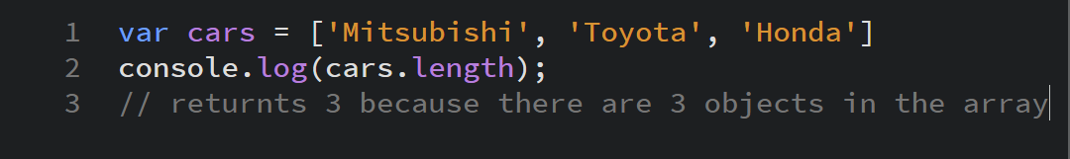

Accessing an Index in the Array

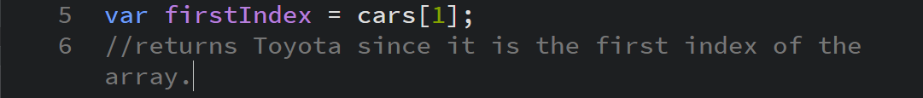

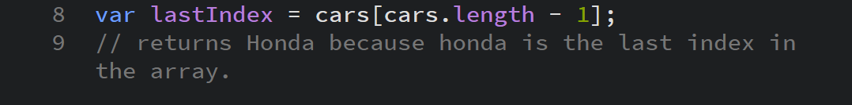

Add to the end of an Array

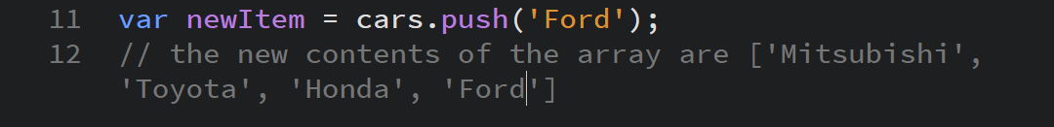

Remove an item from the end of an Array



Remove an item from the front of the Array



Add an item to the front of the Array



Find an index of the item in an Array

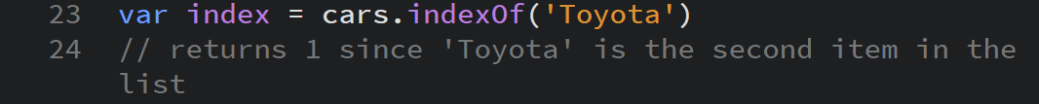

Remove an item by its index Position



Copy an Array



Accessing Elements in an Array

Elements in a javascript array start at index 0.

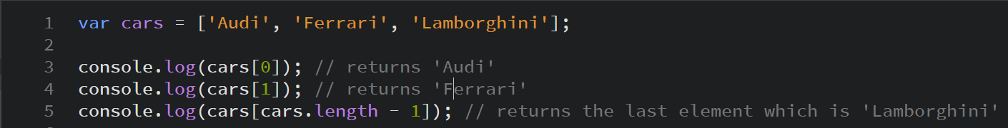

Increase the length of an Array



Decrease the length of an Array (some elements may be deleted)

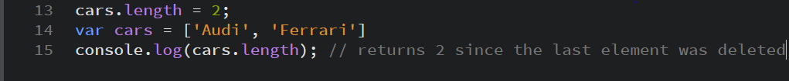

Array Methods

All array instances are inherited from Array.prototype

Methods

Array.prototype.length – returns the number of elements in an Array

Mutator Methods

Changes/Modifies the contents of the Array

Array.prototype.copyWithin() – Copies a sequence of Array elements inside the Array

Array.prototype.fill() – Fills all array elements with a static value

Array.prototype.pop() – removes the last element of the array and returns it

Array.prototype.reverse() – reverses the order of the elements in the Array

Array.prototype.shift() – removes the first element of the array and returns it

Array.prototype.sort() – Sorts the elements in the Array and returns it

Array.prototype.splice() – Adds and or removes an element/s from the Array

Array.prototype.unshift() – Adds an element to the front of the array and returns it

Accessor Methods

Does not modify anything but returns something from the Array

Array.prototype.concat() – Returns a new array joined with another Array

Array.prototype.indexOf() – Returns an index of a specified element in the Array

Array.prototype.join() – Joins all elements of the Array into a string

Array.prototype.lastIndexOf() – returns the last index of the Array

Array.prototype.slice() – Extracts a section from the Array and makes it into a new one

Array.prototype.toString() – returns a string with the Array elements inside of it

Array.prototype.toLocaleString() – returns a localized string of the Array and its Elements

Iteration Methods

Processes all elements of an array in a loop

Array.prototype.entries() – returns an iterator object which contains a key value pair for each object in the Array

Array.prototype.entry() – returns true if an element in the array satisfies a certain condition

Array.prototype.filter() – creates a new array with the elements that satisfy a certain function

Array.prototype.find() – Returns the found value on the Array

Array.prototype.findIndex – Returns the found index of an element in the Array

Array.prototype.forEach() – Calls a function for every element in the Array

Array.prototype.keys() – Returns an iterator which contains the keys of each index in the Array

Array.prototype.map() – Creates a new Array with it satisfying a condition within the Array

Array.prototype.reduce() – Reduce the Array into a single value

Array.prototype.reduceRight() – Reduce the Array into a single value starting from right to left

Array.prototype.some() – Returns true if atleast one element in the Array satisfies a single function

Array.prototype.values() – Returns a new Iterator Object that contains the values for each Array index