HTML (Hypertext Markup Language)

Index of Elements

O - element that has both start and end tag

F - element that has no ending tag

E - empty element

D - if element is deprecated

L - loose or deprecated (DTD)

- frameset (DTD)

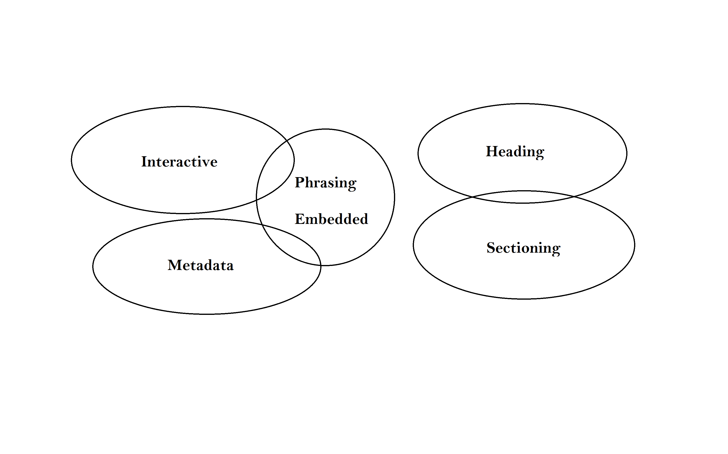

Content attributes:

> Global attributes - defined in all elements

>ARIA role attribute - accessibility

DOM (Document Model Interface)

interface HTMLParagtaph Element: HTML Element{ };

| | |

base interface subinterface generic interface

<p> - represents a paragraph; thematic collection of items

Chrome vox - accessibility tool; web reader

html - parent

head:

title, base, link, meta, style

body:

article,aside,nav,section

header,footer

main

address

div

h1,h2,h3,h4,h5,h6

p

hr - horixzontal

pre - preformatted text

blockquote - larger blocks; inline

ol,ul

li

dt,dd

figure

figcaption

e (emphasis), strong (strong emphasis), s (obsoleted), q

dfr, abbr

kanji - rt, ruby, rb,rtc,rp

hiragana - data, time

code,var,samp,kbd

sup, sub

i,b,u,mark

bdi,bdo

span

br,wbr

ins,del

table

caption

colgroup

td,tr