Java Script Basics

Java script uses mostly java syntax but alos uses Awk, Perl and Python. Java script is case-sensitive and uses Unicode character set.

Instructions are called statements and are separated by semicolons.

Spaces, tabes and blank lines called whitespaces.

ECMAScript defines keywordsand adds semicolons automatically to ends of statements.However it is recommended that you always add semicolons to the end of your script to avoid bugs.

Comments

Java script comments are just the same as comments in java or any other language



Declarations

There are three kinds of declarations in Java Script

var – describes a variable and optionally gives it a value



let – describes a block variable and optionally gives it a value



const – declares a read only constant



Data Types

Six data types that are primitives:

Boolean – true or false

null – Special keyword that denotes a null value

undefined – A property whose value is undefined

Number – can be an Integer or a Double

String – ‘Galo’

Symbol – (ECMAScript 2015) data type whose instances are unique and immutable

Operators

|  |  |  |
| --- | --- | --- |
| + | Add/ concatenate | Used to add 2 integers together or two strings together |
| -, *, / | Subtract, multiply, divide | Basic math operators |
| = | Assignment operator | Assigns a value to a variable |
| === | Identify operator | Checks if two values are the same |
| !,!== | Negation | Returns an opposite value of what it precedes |

Conditionals

Allow you to test whether a piece of code is true or not

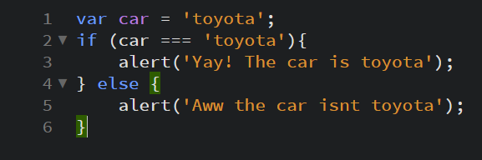

Functions

Functions package a functionality you wish to reuse. This saves a lot of time since you need to do the logic only once and then you can just call the value it returns

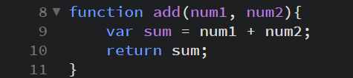

Events

Events are code structures that wait for an event to happen and once it does, it executes a certain piece of code

