LEC1
Transmitting data: 1. Circuit switching(connection-oriented, fixed but guaranteed bandwidth, end-to-end, no sharing, idle闲置 if unused)
FDM:用不同的频率把频谱分割开，每个用户占用一个频率段。
TDM:用时间把资源分割开，每个用户轮流使用同一个频率。
4G and 5G do not support circuit switching
- Packet switching(dynamic, efficient bandwidth utilization, congestion拥塞, queuing delays or packet loss may happen)
CSFB-Example:X0= (bandwidth - circuit)/arrival rate 求P(X<=X0)
5G:high speed,low latency(delay),high density comparison(2G4Gonlyspeed)
Access network: 5G New Radio / Core network: 5G Core
5G Use cases
eMBB:Data rates up to 10 Gbps (uplink), 20 Gbps (downlink); Spectral efficiency up to 15 bps/Hz, 30 bps/Hz; Data rate at cell level is shared(User experienced data rate: 50 Mbps, 100 Mbps); Support high mobility: up to 500 Kmph; Efficient energy consumption; Low cost per bit; Examples: Smart phones, home/enterprise 5G, Extended reality
mMTC:Connection density: 1 million devices per kmsq; Battery life ~ 10 years; Low data rate: 1-100 kbps; Enhanced coverage; Examples: Smart meters in buildings factories, logistics, healthcare sensors
URLLC:Low user plane latency: 1 ms; Low control plane latency: 10 ms; Reliability: 99.999% success rate; Mobility interruption time: 0 ms; Examples: Traffic safety and control, V2X, Industrial IoT, Remote surgery
5G Use Cases – Extended Reality
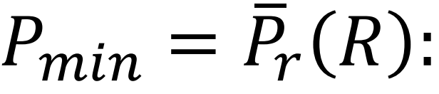
• Augmented Reality (AR): e.g., Pokemon Go(Virtual information and objects are overlaid onto the real world)• Virtual Reality (VR): e.g., Oculus Quest(Fully immersed in a simulated digital environment)• Mixed Reality (MR): e.g., Apple Vision Pro(Digital and real-world objects co-exist and interact)• Extended Reality (XR):Umbrella term used in the 5G context for AR, VR, MR
5G Use Cases – Other Examples
• Monitoring & Surveillance(Cameras, sensors, robots, data sent to command center)• Fixed Wireless Access(Wi-Fi router that connects to 5G base station instead of fiber broadband)• Industrial Networks
• Vehicle to Everything (V2X) Communications(5G Autonomous Driving: Platooning; In Vehicle Infotainment)
5G System
Separation enables scaling based on the demand(Flexible deployment)
gNodeB:Base station that supports NR; If it supports both LTE and NR, it is called Ng-eNB; Provides wireless connectivity to wireless devices.
User Plane Function (UPF): Mobility anchor point; Policy enforcement;Lawful interception; Marks QFI for IP packets
Session Management Function (SMF):Establish and release session; Provide device with an IP
Access and Mobility Function (AMF):Manages handovers between base stations; Authentication and key agreement
Authentication Server Function (AUSF):Supports AMF with authentication related functions
User Subscription Data (UDM):Front end for user subscription data; Supports AMF with access authorization
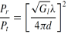
Policy Control Function (PCF):Session management policies; Non-session management policies
LEC2
Free-Space Path Loss
Received power in dB:
Large Scale Fading
• In free space, the received power attenuates (减弱) proportional(比例) to the square of the distance from the transmitter
• With reflections, absorptions吸收, scattering散射, refractions折射, and diffractions衍射the power can attenuate much more rapidly with distance
• More important for cell site planning基站规划更重要, less for communication system design对通信系统设计影响较小
• Frequency dependent but usually modeled as frequency independent. Why?
Small-scale Multipath Fading
• More pronounced at higher carrier frequency高频载波下更明显
• Multipath fading occurs due to constructive and destructive interference of the transmitted waves多径衰落由相长干涉相消干涉引起
• Channel varies significantly when receiver moves a distance of the order of the carrier wavelength ~30 cm for 900 MHz, just ~1 cm for 25 GHz!
当接收器移动与载波波长相当的距离时，信道会发生显著变化
• Primary driver behind wireless/cellular communication system design
Fourier Transform
A mathematical transform to transform a non-periodic function in time domain into a function in the frequency domain.
$$X(ω)=ℱ\{x(t)\}=\int_{−∞}^{∞}{x}(t)e^{−jωt} dt,$$

$$x(t)=ℱ^{−1}\{X(ω)\}=\frac{1}{2π}\int_{−∞}^{∞}{X}(ω)e^{jωt} dω$$

$$X(f)=\int_{−∞}^{∞}{x}(t)e^{−j2πft} dt,x(t)=\int_{−∞}^{∞}{X}(f)e^{j2πft} df$$
x(t)=1当 -T/2<= t<= T/2 时, X(f)=T·sinc(fT)=T·sin(pi fT)/pi fT
Channel Impulse Response
• Wireless channel modeled as linear time-varying system:线性时变
$$y(t)=\sum_{i}{α_{i}}(t)x(t−τ_{i}(t))$$
where the channel changes amplitude and delay of each path.
• Time-varying impulse response:时变冲激响应
$$h(τ,t)=\sum_{i}{a_{i}}(t)δ(τ−τ_{i}(t))$$
• Effect of moving users, environment, and all of the complexities in the channel finally reduce to an input/output relation between transmit and receive antennas!
• Frequency response is a slowly varying function of t with a frequency response H(f;t) at each fixed time t
$$H(f;t):=\int_{−∞}^{∞}{h}(τ,t)e^{−j2πfτ}dτ=\sum_{i}{α_{i}}(t)e^{−j2πfτ_{i}(t)}$$
Baseband Equivalent Model
通信在通带[fc-W/2, fc+W/2]，在基带处理[-W/2, W/2]
Baseband Equivalent Impulse Response
$$h_{b}(τ,t)=\sum_{i}{a_{i}^{b}}(t)δ(τ−τ_{i}(t))$$
$$where a_{i}^{b}(t)=a_{i}(t)e^{−j2πf_{c}τ_{i}(t)}πf_{c}τ_{i}(t)\}$$
The phase changes by π/2 when the delay on the path changes by 1/(4fc)
路径的物理距离仅变化λ/4时，接收到的信号相位就会剧烈地变化π/2。
Two-ray Model

$$\frac{P_{r}}{P_{t}}={\left[\frac{λ}{4π}\right]}^{2}{\left|\frac{\sqrt{G_{t}G_{r}}}{d}+\frac{R_{v}\sqrt{G_{t}G_{r}}}{l+l'}e^{−jΔϕ}\right|}^{2}$$
$$where Δϕ=\frac{2π(l+l'−d)}{λ}$$
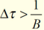
Pr Fluctuate波动:Interference Fading干涉衰落; Δφ=2nπ, Constructive Interference; Δφ=(2n+1)π，Destructive Interference
after dc: change the distance doesn’t change the phase considerably
Multipath resolvability：minimum time separation between two multipath components such that they can be resolved at the receiver( Rx Filter,带宽B）
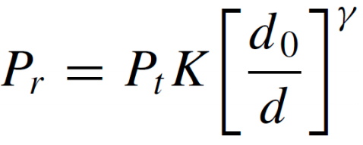
Empirical Models – Hata Model 只能用在特定地区
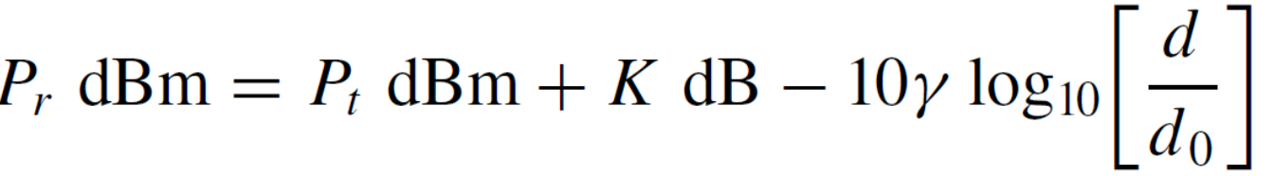
Simplified Path Loss Model
Shadowing: 被大的障碍物阻挡
Cell Coverage Area：path loss and average shadowing 的圈子
Tradeoff: increase transmit power, higher coverage, but interference other
$$C=Q(a)+\exp\left[\frac{2−2ab}{b^{2}}\right]Q\left(\frac{2−ab}{b}\right)$$

$$a=\frac{P_{min}−{\bar{P}}_{r}(R)}{σ_{Ψ_{dB}}}, b=\frac{10γ{\log_{10}}_{10}{(}e)}{σ_{Ψ_{dB}}}$$
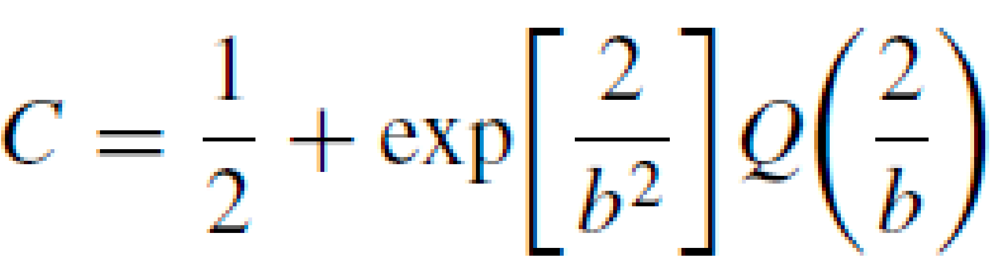
Simplified when
Sampling and Symbols
• Sampling is the process of measuring the instantaneous values of continuous-time signal in a discrete form.• A bandlimited signal can be exactly reproduced if sampled at, at least twice the bandwidth.• One or more samples represent a symbol. Depends on modulation, error-correcting code.
Flat and Frequency-Selective Fading
衰落是由于不同路径信号在接收端发生相消干涉导致的。
Coherence Bandwidth相干带宽:
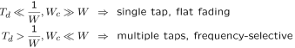

Average Fade Duration
• If average fade duration >> symbol duration(Slow fading, Error correction codes may fail纠错码, Interleaving交织 is needed: longer decoding delay)
• If average fade duration is roughly equal to or less than symbol duration(Fast fading, Error correction codes work
• Average fade duration is an important design parameter
Diversity分集
• Fading impairs the reliability of transmission降低传输可靠性• Reliability can be increased by providing more signal paths, that fade independently
• Ways to provide diversity,(Time, frequency, and space)
• Macro-diversity: To combat对抗 shadowing (dual connectivity双连接 in cellular networks)• Micro-diversity: To combat fading (e.g., multiple antennas多天线, carrier aggregation载波聚合)
Time Diversity
• Send the same symbol in multiple time intervals多个时间发送相同符号
• Time diversity can also be obtained by interleaving and coding over symbols across independent time periods独立时间段内交织和编码
• Amount of time diversity is limited by delay constraint and how fast channel varies时间分集的大小受延迟约束和信道变化速度的限制
• For voice, delay constraint is ~40 ms in cellular networks
• Not an option for 5G’s URLLC
Frequency Diversity
• Transmit same narrowband signal at different carrier frequencies
• Inefficient, like repetition coding for time diversity• Increased power
Spatial Diversity SIMO, MISO, MIMO
Receiver Diversity
• Multiple diversity branches for linear combining线性合并
• Co-phasing: coherent detection and removal of phase for each branch(Avoids destructive combining)相干检测并消除相位差
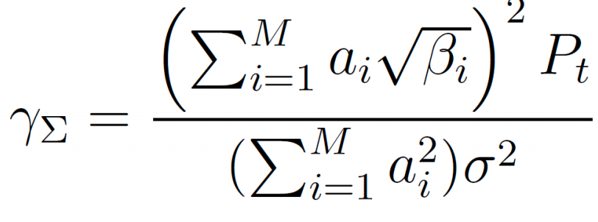
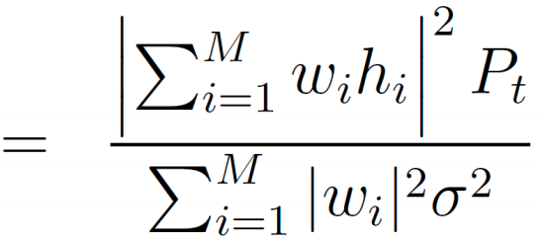
Combiner output SNR:
Combining Techniques
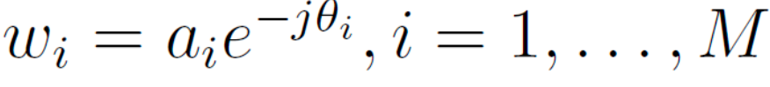
• Coherent combining:
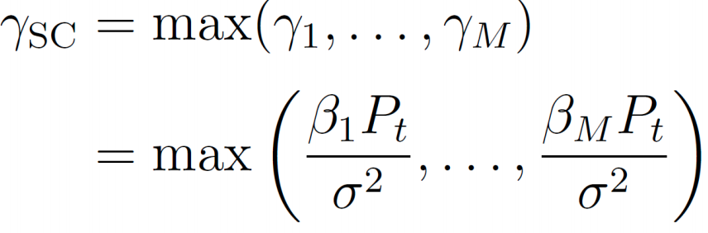
• Diversity combining techniques: Selection combining, Equal-gain combining, Maximal-Ratio Combining
Selection Combining
• SC selects signal from branch with the largest SNR as the combiner output
Equal-Gain Combining 和SC比较的话没有绝对的大于小于关系
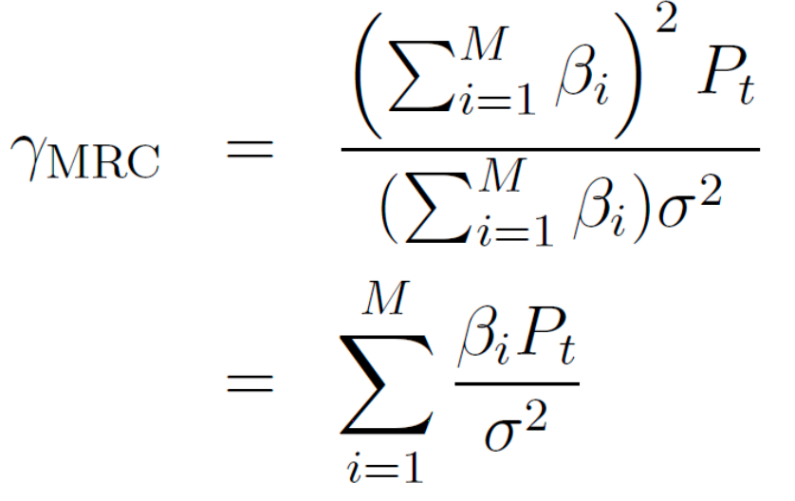
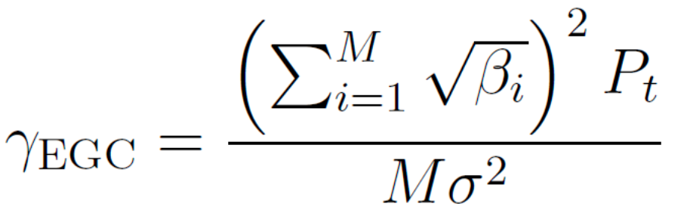
• SC: only one branch is used at a given time, thus the signal powers from other branches are not utilized• For EGC, signals from all branches are combined with equal weight
Maximal Ratio Combining
• Combining weights are chosen to maximize the SNR
• The output SNR is the sum of SNRs of all individual branches!
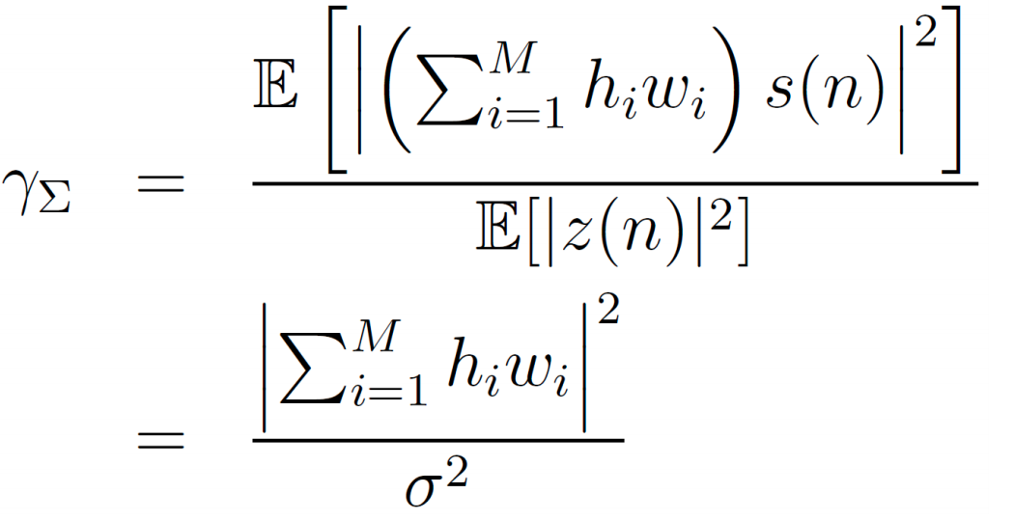
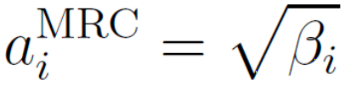
• Is it always true that • MRC SNR > SC SNR• MRC SNR > EGC SNR
• ‘s maximize the SNR over all possible ai‘s
Transmit Diversity
• If channel is known at the transmitter: Transmit Beamforming
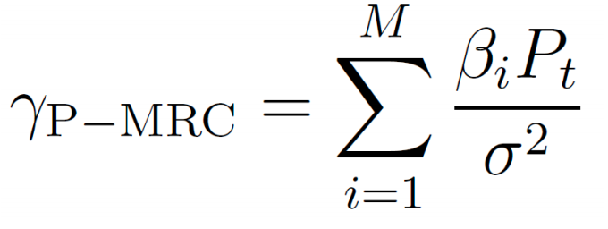
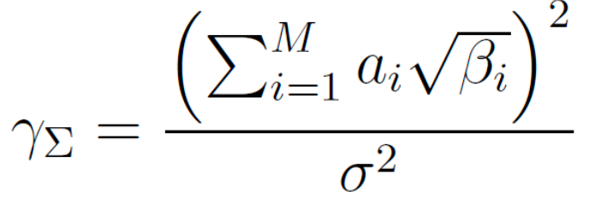
• If channel is unknown: Space-time codes:Alamouti Scheme
Coherent Beamforming
Pre-Maximal-Ratio-Combining
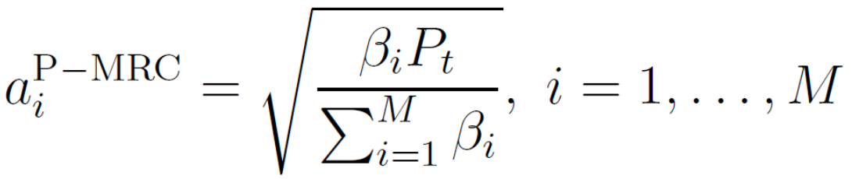
MISO-SIMO Channel Duality性能和MRC相同
LEC3
5G New Radio (5G-NR) to UE用户not restricted with backwards
compatibility. Reuses many of the structures and features of LTE.
5G Core Network (5GCN) mobility management, subscription management, security management.provide connectivity for the evolution of LTE
5G Deployment Options
Standalone: eNB(LTE)---EPC; gNB(NR)---5GC, ng-eNB(LTE)---5GC
Not SA: en-gNB(NR)---eNB(LTE assist)---EPC; ng-eNB(LTE)---gNB(NR assist)---5GC, gNB(NR)---ng-eNB(LTE assist)---5GC
Why a New Access Network?
LTE:
- The always on transmission(• BS detection via synchronization signals, broadcast of system info, reference signals for channel estimation, long handshake procedures• Reduces energy performance• Causes interference to other UE, and other cells)
- largely fixed and irresponsible use of physical resources
- Not designed for low-latency applications(• Time-domain interleaving: needs buffering before decoding)
NR:
- Ultra-lean design for energy performance and reduced interference(• Re-designed the cell-search procedures • NR relies on reference signals only when data is transmitted)
- Forward compatibility (• Radio-interface design that allows for substantial future evolution • Introducing new technologies, enabling new services and use cases • Maximize the time/frequency resources that can be flexibly utilized)
- Low latency support(• Front-loaded reference and control signals•Overall tightened processing times E.g., Faster MAC header processing)
Frequency Bands for NR
• Operating in different f bands is a basic aspect of global mobile services
• The physical layer specifications of NR don’t assume any specific frequency band物理层规范没有指定频域
• Require for different frequency ranges• Maximum transmit power • Out of band emission limits •Use of MIMO(more widespread above 24GHz)
• The differences between bands are more pronounced for NR due to the very wide range of frequency bands
Traffic Types in 5G
Voice:Low data rate,steady flow/Broadband:High data rate,burst traffic /URLLC:High reliability,low latency/Massive MTC:Low datarate, many dev
Use QoS Flow Identifier: QFI to identify the traffic to achieve the desired
performance or QoS (quality-of-service)
(•Guaranteed bit-rate (GBR) • Non-GBR • Delay critical)
QoS Handling
• Handling of different QoS requirements OK in LTE, and NR builds upon it
• IP packets are mapped to QFI basedon requirements in the CoreNet (UPF)
• The mapping of QFI to data radio bearers is done in access network(SDAP
Radio Bearer<=SDAP=>QoS Flow Identifier<=UPF=>QoS Requirements
• QoS-QFI-radio bearer mapping is not necessarily oneto-one
• Multiple QoS flows can be mapped to the same data radio bearer
- Layer Internet Protocol Stack
• Application, Transport, Network, Link, Physical Layers of Internet.
• Each layer passes data to a layer below
• Data unit passed down is called Service Data Unit (SDU) not encapsulated
• After encapsulation封装, it is called Protocol Data Unit (PDU)
SDAP：Maps QFI to radio bearers in downlink；Marks QFI in in uplink
PDCP: Packet Data Convergence Protocol
• Header compression(Reduce header length 减少报头长度for wireless transmission; Decompress at the receiving side 接收端解压before handing to IP networks; Robust Header Compression (ROHC) Protocol协议
• Confidentiality 保密性and integrity protection消息完整性
发方加密消息收方解密消息；发和接确保在传输中或传输后无篡改
• Routing and duplication[NR supports dual connectivity; PDCP routes data flows to multiple cells to enable dual connectivity(Higher data rates); Sometimes, data is duplicated( Higher reliability by selection diversity )]
RLC: Radio Link Control
RLC Segmentation (Segmentation of RLC SDUs from the PDCP into suitably sized RLC PDUs)
RLC Retransmissions重传• Handles retransmission of erroneously received PDUs, as well as removal of duplicate PDUs • Unlike LTE, RLC in NR does not ensure in sequence delivery of SDUs to upper layers. (Advantage: 1.immediately pass the data up 2.buffer can be smaller)
MAC: Medium Access Control
MAC Logical/Transport Channels
• The MAC provides services to the RLC in the form of logical channels
• A logical channel is defined by the type of information it carries (• Control channel: transmission of control and configuration information • Traffic channel: transmission of user data)
• From the physical layer, the MAC layer uses services in the form of transport channels
• Transport channel is defined by how and with what characteristics the information is transmitted over the radio interface
MAC Logical Channel Multiplexing
mapping of logical channels to the appropriate transport channels
MAC CE (MAC Control Elementsand) Header Insertion
• Used for in-band control signaling, scheduling, random access
Carrier Aggregation Increase data rate per user by assigning multiple frequency blocks to the same user
• A feature of LTE, became more flexible in further releases
• MAC is responsible for distributing data from each flow across the different component carriers, or cells
• Independent processing of the component carriers in the physical layer
• Carrier aggregation is invisible above the MAC layer
• Logical channels are multiplexed to form transport blocks per component carrier • Each component carrier has its own hybrid-ARQ entity
Carrier Aggregation(MAC) vs Dual Connectivity(PDCP)
• Both result in device connecting to more than one cell
• Difference is the degree of coordination and whether cells reside in the same or different gNBs
Carrier Aggregation | Dual Connectivity
Tight coordination | Loose coordination
Scheduling decisions are taken jointly between all cells | May be hybrid radio access technologies混合无线接入技术, eg. NR-LTE dual connectivity
Cells in the same gNB | Cells may be in different gNBs
Invisible above MAC level | Done at PDCP level
Hybrid ARQ – Stop and Wait(Hybrid Automatic Repeat Request)
Hybrid because it supports: [• error correction (in PHY layer)
• retransmission if error cannot be corrected (in MAC layer)]
• NR MAC layer parallel processing of transport blocks(异步,LTE是同步)
MAC Scheduling
Scheduling inputs:(• Channel conditions of users • Buffer status • Data flow priorities)
Scheduling outputs(• Choose UEs to communicate• Assign resource blocks • Transport format: modulation and coding scheme调制和编码方案, antenna (beamforming), transport block size)
PHY: Physical Layer
Mapping of Transport and Physical Channels
• MAC: maps Logical channels to Transport channels
• PHY: maps Transport channels to Physical channels
Cyclic Redundancy Check
• To detect errors at the Transport block level • Cannot correct errors, but detects them • Requests retransmission through MAC or RLC
Error Correction
• LDPC codes for data channels • Polar codes for control channels (new in 5G) • Invented by Prof. Erdal Arikanin 2008
Modulation and Mapping functions
• QPSK Modulation• Assign modulated waveforms to MIMO antenna
• Convert into analog waveforms in carrier frequency
OFDM
• Recall FDM (Frequency Division Multiplexing) • In OFDM, there is no
guardband between frequencies • Further, the frequency bands overlap!
• OFDM is closely spaced FDM • In FDM a simple band-pass filter isolates individual carriers • In frequency domain, each subcarrier results in a sinc function • OFDM has subcarrier interference except at orthogonally spaced frequencies • At orthogonal frequencies, the individual peaks of subcarriers
line up with the nulls of the other subcarriers
Centralized/Cloud RAN
• Traditionally, each remote radio unit (RRU) is connected to a single baseband unit (BBU)
• Transmit receive signal processing for a large number of base stations is centralized at a single server
• Requires base stations to be connected to the BBU Pool a.k.a the “super base station”
This architecture allows,(• joint processing and demodulation of multiple users’ signals,• enhanced intercell interference management • coordination, and joint resource allocation across multiple BSs • Energy efficient
• Economies of scale • New business models)
LEC4
Virtual Network Functions in 5G
• Core network functions in 5G are Virtual Network Functions
• Functions use service-based architecture for communicating w. each other
NFV Benefits
• Eliminated reliance on specific, proprietary hardware(• Which had long product cycles• Slow pace of development)
• Less Capex/Opex for operators when scaling network infrastructure
• Agility: rapidly develop, test, and launch to respond to demand
How Do 5G Network Functions Communicate?
HTTP: hypertext transfer protocol • Web’s application layer protocol
• client: browser that requests, receives, (using HTTP protocol) and “displays” Web objects
• server: Web server sends (using HTTP protocol) objects in response to requests
• Consumer-producer as opposed to client-server of web
• Request-response similar to HTTP in web
• Subscribe-notify: notify if subscription criteria is met
HTTP REST (Representational State Transfer)
• GET: to get data from server/producer• POST: sends data to server/producer• PUT: sends and overwrites data at the server/producer• DELETE: removes data from server/producer
Service Discovery
• Network Repository Function (NRF)• Keeps track of all network functions• Known to all network functions
Service Registration=>Service Discovery=>Service Request
Network Slicing
• Network slicing overlays multiple virtual networks on top of a shared network domain • Each slice of a network can have its own logical
topology, security rules and performance characteristics
5G Network Slicing Features
• Customization: end-to-end custom performance
• Isolation: logical isolation of the network slice
• Quality assurance: unique quality assurances for each slice
• Unified platform: all slices share the same physical infrastructure
LEC5
Cellular Concepts
• Cluster: group of adjacent cells without frequency reuse
• Sub-band: the frequency spectrum is divided into subbands and each sub-band is used within one cell of the cluster
• Cell size: smaller for heavy traffic and larger for low traffic
• Types of cells:
• Macrocell: large coverage (aprox. 6 miles in diameter); used in remote areas, high-power transmitters and receivers are used
• Microcell: small coverage (half a mile in diameter); used in urban zones; low-powered transmitters and receivers are used
• Picocell: covers areas such as building or a tunnel
• Handover: moving a call from one cell to another
• Roaming: allowing mobiles to send/receive calls outside the service provider’s coverage area
Cellular Network Components
Cell <=antennas=<Base Transceiver Station (BTS)<=cable or microwave=<
Basic Station Controller (BSC)<=PSTN=<Mobile Switching Center (MSC)
Setting Up a Call
powered on, the phone not have a frequency/ time slot/code assigned to it; it scans for the control channel of the BTS and picks the strongest signal. then sends a message (including its id number) to the BTS. BTS sends an acknowledgement message back to the cell phone. The phone then registers with the BTS. After registered, the BTS assigns a channel to phone, ready.
Making a Call
• The subscriber dials the receiver’s number and sends it to the BTS
• The BTS sends ID, location and number of the caller and also the number of the receiver to its BSC • BSC forwards this information to its MSC
• MSC routes the call to the receiver’s MSC which is then sent to the receiver’s BSC and then to its BTS• Communication is established
Receiving a Call
When the receiver phone is in an idle state it listens for the control channel of its BTS. If there is an incoming call, the BSC and BTS sends a message to the cells in the area where the receiver’s phone is located. The phone monitors message and compares the number from the message with its own. If numbers matches, the cell phone sends acknowledgement to the BTS. After authentication, the communication is established.
Cellular Network Planning
Radio Network Planning(should offer sufficient capacity and coverage.)
Process:collection of parameters; Pre-planning theoretical coverage and capacity plans; Site selection; Frequency allocation
Dimensioning Inputs: area; estimated traffic in cell; minimum power and blocking criteria; path loss; frequency band to be used and frequency re-use.
Link Budget Calculation(定义了cell ranges; the coverage thresholds.)
• Done for both uplink(more critical手机信号到BTS更关键) and downlink
• Factors to consider: (sensitivity of the base station in the uplink direction; transmitted power and the gains of the antennas for downlink direction; combiner loss for downlink calculations; cable loss for both directions.)
Uplink calculations
PLu (Path Loss in uplink) = EIRPm (Peak EIRP of Mobile) - Prb
EIRPm = Ptm (Power tx from the MS) - Losses + Gm
Losses = Lcm (cable loss at mobile) + Lom (any other loss)
Prb = -Gb (antenna gain) + Losses + Bs (BTS sensitivity)
Losses = Lcb (cable loss at BTS) + Lob (any other loss)此处不带combiner
Downlink calculations
PLd (Path Loss in downlink) = EIRPb - Prm(Power received by the MS)
EIRPb = Ptb (Power tx by BTS) + Gib (antennas gain) -Losses
Losses = Lcb (cable loss at BTS) + Lccb (combiner loss at BTS)带combiner
Prm = Ms (Mobile sensitivity) + Losses - Gm (mobile antenna Gain)
Losses = Lcm (cable loss) + Lom (any other loss)
Implications
• obvious difference in the results of the uplink and downlink power budget,
• Thus, BTS antenna radiations’ coverage is more than MS antenna, thereby giving more coverage in the downlink direction.• Reducing the power in the downlink direction can reduce this difference but lead to a loss of coverage.
• Other ways (introduce diversity at the BTS; introduce low-noise amplifiers (LNA) at the BTS)
Cell and Network Coverage 因素、衡量、需求、做法
• coverage depend mainly on natural factors such as geographical aspect/propagation conditions, and on human factors such as the landscape (urban, suburban, rural), subscriber behaviour etc. • measure: defined as the probability of the field strength being above the sensitivity level in the target area.• For that, the radio propagation conditions have to be predicted as accurately as possible for the region.• radio planners can create their own or use existing standard models
Radio Channel 传播途径、作用与影响、运动影响信号强度
• Radio waves propagate from transmitter to receiver via(Line-of-sight path视距路径, Reflection, Diffractions衍射在障碍物后, Scattering)
• Interaction of these waves causes multipath fading, shadowing • Relative motion of transmitter and receiver causes timevariation of signal strengths
Radio Wave Propagation
• Two basic goals of propagation modeling:
1. Average received signal strength for given Tx/Rx separation
2. Magnitude and rate of fluctuations in received signal strength over short distances/time durations → typically a few λ or seconds
Channel Impairments 信道损伤
plane waves with random amplitudes, phases, and angles of arrival interfering with each other and producing a varying field strength pattern
(Path loss: attenuation with distance; Shadowing: long-term variation of signal caused by obstructions; hills, buildings, mountain, foliage, for outdoor; walls, furniture, etc., for indoor; slow fading; Multipath: short-term signal variations; fast fading; Caused by multiple reflections from buildings, walls and ground, and scattering from local scatterers)
Two Ray Model
• Good for systems that use tall towers (over 50 m tall)
• Good for line-of-sight microcell systems in urban environments
Macro Cell Propagation Model
• Most widely used model: Okumura-Hata
• Used for 150-1000 MHz and 1500-2000 MHz, and 1 to 20 km, where f is the frequency (MHz), hbts is the BTS antenna height (m), a(hm) is a function of the MS antenna height, d is the distance between the BS and MS (km), Lother is the attenuation due to land usage classes.需要给公式a, A, B
• Most widely used model: Walfish-Ikegami
• Used for 800-2000 MHz, heights up to 50m and up to 5 km
• Path loss for LOS: P=42.6+26 log d+20 log f
• Path loss for non-LOS: P=32.4+20log f+20log d+L rds+L ms
Capacity Planning(定义number of BTS required and respective capacities.)
• The frequency re-use factor: number of BTSs that can be implemented before the frequency can be re-used.
• Three essential parameters for capacity planning: estimated traffic, antenna height and frequency reuse.
Traffic Estimation
•1 Erl is the amount of traffic generated by the user uses 1 channel for 1 hour
• Mobility: initially static users / dynamic users = 0.7, but now 1.0
• Blocking: not able to reach a dialled subscriber owing to lack of resources.
Parameter Planning
• two types: fixed and measured. • include those related to signalling, radio resource management (RRM), power control, neighbor cells, etc.• Signalling: Additional information required to help data reach its destination
Radio Network Optimization
• Optimisation involves monitoring监控, verifying验证 and improving the performance of the radio network. • lots of parameters are variable and have to be continuously monitored and corrected. • The network is always growing• Once a radio network is designed and operational, its performance is monitored. • The performance is compared against chosen key performance indicators (KPIs). • After fine-tuning, the results (parameters) are then applied to the network to get the desired performance.
LEC6
Multiple Access Schemes 多址接入
Frequency Division Multiple Access when a mobile enters another cell a unique frequency is assigned to it; used in analog systems
Time Division Multiple Access each subscriber is assigned a time slot to send/receive a data burst; is used in digital systems
Code Division Multiple Access each subscriber is assigned a code which is used to multiply the signal sent or received by the subscriber
Cellular FDM-TDMA Systems
• Basis for the GSM standards • FDM: duplexing mechanism双工机制
• TDMA: multiplexing mechanism复用机制 • Guard band占用不算
• System bandwidth is partitioned into several nonoverlapping FDM channels系统带宽被划分为多个互不重叠的FDM信道
• Time is slotted on each channel and each slot is assigned to a different user每个时隙分配给不同的用户
Traffic Usage Parameters
• Calling rate or call intensity: number of calls per hour
• Call holding time: average duration of occupancy of a call.
Traffic intensity以 Erlang 为单位
单个user 的: Ai = number calls per hour × each call time lasts per hour
总traffic: A = number of users × Ai, Example:5 × 1/5[erl] = 1[erl]
Meaning: in average, there is 1 active call; but the actual number of active calls varies from 0 (no active user) to 5 (all users active),with probability.
$P[k active calls]=\left(\frac{5}{k}\right)A_{i}^{k}(1−A_{i})^{−k}$ 当m数量较大时根据p来reserve
Infinite users

$$P[k,M]=\left(\frac{M}{k}\right)A_{i}^{k}(1−A_{i})^{M−k}=\frac{M!}{(M−k)!k!}{\left(\frac{A}{M}\right)}^{k}\frac{{\left(1−\frac{A}{M}\right)}^{M}}{{\left(1−\frac{A}{M}\right)}^{k}}$$

user无限的时候可以成为泊松分布
P[block] = P[C accepted calls]${ P}_{k}(A)=e^{−A}\frac{A^{k}}{k!}$
Call Capacity (defined with respect to a view of the switch or MSC)
• Two approaches to view the system: global view and component view
• Global view: MSC is a single unit. Each request is counted as an attempt.
• The call volume : the sum of the originating and incoming (O+I) calls
O: • Partial dial calls: partial time-outs and abandons • Intra-office calls: originate from and terminate to the same switch • Outgoing calls: originate from a line on the switch but terminate to a line on a different switch
I: • Incoming-terminating calls: terminate to a line on the MSC but originate from a different switch• Tandem calls: trunk-to-trunk calls that are routed through the switch • Direct inward dialing (DID): calls to a PBX system
• Component view: The component of interest is considered a subsystem.
• Each request to the component for service is counted as an attempt.
• This view applies to principal processors involved in call processing.
• the call volume of interest:the sum of originating and terminating half-calls
O half-calls: • One originating half-call is for each originating call, because two peripheral equipment外围设备 connections are required for a completed call. • If the component serves both lines and trunks, incoming and outgoing half-calls are added to the total half-call volume.
T half-calls: • One terminating half-call is for each incoming/terminating call and each inter-office call
Environment--(O+I) calls/line
Metro大都市 3.5–4.0; Suburban郊区2.0–2.5; Rural乡村 1.2–1.5
Call Quality
• Number of calls attempted: The total number of calls attempted (also called number of bids) is the best measure of unconstrained customer demand.
• Number of calls completed: The number of calls completed in a network sense (calls reaching ringing tone or being answered), when compared with number of calls attempted, provides a measure of the state of network congestion.网络意义上的已完成呼叫次数，与呼叫尝试次数的比较
• Grade of Service (GoS): (No. of busy hour call attempts - No. of busy hour call completed)/(No. of busy hour call attempts).
• Answer-seizure ratio 接听率(ASR): The ratio between the number of successful calls (answered) and the total number of call attempts (seizure)
• Answer-busy ratio 忙线率(ABR): Ratio of the number of successful calls (answered) and the total number of busy calls.
• both measured over short periods of time (5 to 15 mins)• Both indicators of instantaneous network congestion. • remain unanswered due to other reasons
Quality of Service
• factors:Transmission quality (level电平, crosstalk串扰, echo回声); Dial-tone delay, and post dial delay拨号音延迟和拨号后延迟; Grade of service; Fault incidence and service deficiency故障发生率和服务缺陷
• Approaches: • Design for the maximum permitted impairments in the most unfavorable condition 对最大损伤进行设计• Design for a certain range of impairments occurring as a result of a chance combination of elements (also known as statistical design methodology)对特定范围损伤进行设计
Engineering Considerations
• MSCs are engineered and administered based on the traffic load during the average busy hour of the busy season.
• Dial-tone speed delay is recorded whenever a test call does not receive a dial tone within 3 seconds.
• Terminating blockage is recorded whenever a terminating call is unable to complete because of a lack of an available path to the called line.
• Traffic data is collected for one or two weeks by half-hour during all parts of the day that may produce high loads (e.g., 8 A.M. to 11 P.M.).
Find the Average Busy Season per Busy Hour (ABS/BH)
Components of a Basic Queuing Process
• The calling population: from which customers/jobs originate; The size finite or infinite (most common); homogeneous (1type) or heterogeneous
• The Arrival Process: Determines how, when and where customer/jobs arrive to the system; Important characteristic is the customers/“jobs” inter-arrival times到达间隔时间; To correctly specify the arrival process requires data collection of interarrival times and statistical analysis.
• The queue configuration:(Specifies the number of queues; Their location; Their effect on customer behavior-Balking拒绝 and reneging放弃; Their maximum size-Distinction between infinite and finite capacity)
• The Service Mechanism:(one or several service facilities with one or several parallel service channels (servers); The service provided by a server is characterized by its service time; Specification is required and typically data gathering and statistical analysis; Most analytical queuing models are based on the assumption of exponentially distributed service times, with some generalizations.)
• The queue discipline(Specifies the order--Most used FIFO; Other LIFO, SPT, EDD…; Can entail prioritization based on customer type.)
Common Queuing Model
• Service times, interarrival times: independent and identically distributed(If not otherwise specified)服务时间和到达间隔时间独立同分布
• notation principle符号原则: A/S/c(A=The interarrival time distribution; S=The service time distribution; c=The number of parallel servers)
• Commonly used distributions(M = Markovian (exponential) - Memoryless; D = Deterministic distribution确定性分布; G = General distribution
• Example: M/M/c(Queuing system with exponentially distributed service and inter-arrival times and c servers服从指数分布且有 c 个服务器)
The Exponential Distribution and Queuing:Lack of Memory;
$f_{T}(t)=\left\{\begin{matrix}αe^{−αt} & when t≥0 \\ 0 & when t<0\end{matrix}\right.$, $F_{T}(t)=1−e^{−αt}$, $E[T]=1/α$, $var[T]=1/α^{2}$
Terminology and Notation M/M/1: ρ=λ/μ M/M/c: ρ=λ/(μ*c)
• The state = the number of customers in the system
• Queue length = (The state ) – (number of customers being served)
• N(t) = Number of customers/jobs in the system at time t
• Pn(t) = The probability that at time t, there are n customers/jobs
•λn= Average arrivals per time unit when there are n customers/jobs
•μn= Average service intensity when there are n customers/jobs in it.
• ρ= The utilization factor for the service facility (= The expected fraction
of the time that the service facility is being used)被使用的预期时间比例
Birth-and-Death Processes
Birth - arrival of a customer/job; Death - departure of a served customer/job
How Many Channels?
• Birth-death process$μp_{n}=λp_{n−1}⇒p_{n}=ρ^{n}p_{0}$
• Normalization constant $\sum_{n=0}^{∞}{p_{n}}=1⟺p_{0}=1−ρ , if ρ<1$
• Stationary distribution $p_{n}=ρ^{n}(1−ρ), n=0,1,…$
M/M/1 with finite waiting room:$p_{n}=ρ^{n}p_{0}, n=1,2,…,K$
$$p_{0}=\frac{1−ρ}{1−ρ^{K+1}}$$
• Stability condition: always stable – even if ρ≥1
• Probability of loss – using PASTA theorem:
$$P\{loss\}=P\{N(t)=K\}=\frac{ρ^{K}(1−ρ)}{1−ρ^{K+1}}$$
PASTA Theorem(Poisson Arrivals See Time Averages)
• Doesn’t PASTA apply for all arrival processes?
• Deterministic arrivals every 10 sec • Deterministic service times 9 sec
• Upon arrival: system is always empty a1=0
• Average time with one customer in system: p1=0.9
• “Customer” averages need not be time averages
• Randomization does not help, unless Poisson!
M/M/c Queue
$$1≤n≤c: p_{n}=\frac{λ}{nμ}p_{n−1}=\frac{1}{n!}{\left(\frac{λ}{μ}\right)}^{n}p_{0}=\frac{(cρ)^{n}}{n!}p_{0}, ρ≡\frac{λ}{cμ}$$

$$n>c: p_{n}={\left(\frac{λ}{cμ}\right)}^{n−c}p_{c}=\frac{1}{c!}{\left(\frac{λ}{μ}\right)}^{c}{\left(\frac{λ}{cμ}\right)}^{n−c}p_{0}=\frac{c^{c}ρ^{n}}{c!}p_{0}$$

M/M/c/c Queue: c-Server Loss System
• Stationary distribution:
$$p_{n}=\frac{(λ/μ)^{n}}{n!}{\left[\sum_{k=0}^{c}{\frac{(λ/μ)^{k}}{k!}}\right]}^{−1}, n=0,1,…,c$$

• Probability of blocking (using PASTA):
$$p_{c}=\frac{(λ/μ)^{c}}{c!}{\left[\sum_{k=0}^{c}{\frac{(λ/μ)^{k}}{k!}}\right]}^{−1}$$
Industry Considerations
(three models for handling or dispensing lost calls.)
• Blocked Call Held (BCH): Poisson formula: (User will immediately reattempt the call on receipt of a congestion signal and will continue to redial; Used in North America)塞信号后会立即重拨，并持续重拨
• Blocked Call Cleared (BCC): Erlang B formula:(User hangs up and waits for some interval before reattempting the call; Used in Europe, Asia, and Africa)挂断电话，等待一段时间后再重拨
• Blocked Call Delayed (BCD): Erlang C formula: (User is automatically put in a queue and is served when the connection equipment becomes available)
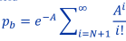
自动进入队列，并在连接设备可用时接听
Blocked Call Held
• pb: blocking probability
一个新到达的呼叫发现所有信道都忙碌，必须进入队列等待的概率。
• A: offered load以 Erlang 为单位， A = λ/μ
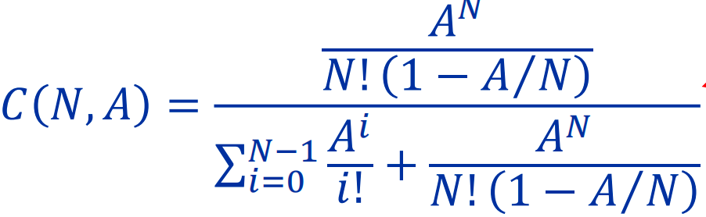
• N: number of trunks or channels
Blocked Call Delayed
LEC7
SIR Analysis
A large D/R ratio is required to keep the co-channel interference small
Worst case analysis: SINR at receiver
$$Ψ_{dB}=10η\log_{10}{\frac{D−R}{R}}−10\log_{10}{N_{I}}$$
Observations
• For equal transmit powers, D/R doesn’t depend on value of transmit power
• We determine the ratio D/R and not the values of D and R: cell sizes can be shrunk while keeping the ratio • Small cell sizes increase the system call handling capacity (since we are serving a small area with a group)
• Drawback: more inter-cell handoffs切换次数增加
Channel Reuse Analysis Hexagonal tessellation六边形镶嵌
FDM carriers partitioned into disjoint sets; Service area tessellated with cells; Carriers assigned to cells such that D/R ratio is satisfied; Hexagonal cell assumption makes analysis easy 对边间距C=√3R, Area=3√3R²/2
Channel Assignment
* Cell (i, j): i units along u axis(向右上方) and j units along v axis(正上方)
* The distance between cell 0 and cell (i, j)
$\text{D}\text{(}\text{i}\text{,}\text{j}\text{)=}\sqrt{{\text{i}}^{\text{2}}\text{+}\text{ij}\text{+}{\text{j}}^{\text{2}}}$
* starting from any cell in this set will give the same set of cells
* Starting from any other cell gives a different set
* Each of these sets is a co-channel group
* For (i, j) = (3, 2) there are 19 such groups (1,3,4,7,9,12,13,16,19,21,28)
$N_{reuse}=D^{2}=i^{2}+ij+j^{2}$ $D(i,j)/R=\sqrt{3N_{reuse}}$
Design Process
SIR analysis to determine D/R; determine N; layout the cells
D/R Ratio: Sectorization Analysis
Consider only first tier interferers; Only path loss, equal transmit power, worst case scenario
$$Ψ=\frac{R^{−η}}{\sum_{i=1}^{N_{I}}{D_{i}^{−η}}}=\frac{1}{{\sum_{i=1}^{N_{I}}{\left(\frac{D_{i}}{R}\right)}}^{−η}}$$
Spectrum Efficiency
• W: total spectrum • C: channels • s: TDM slots per channel
• K: number of sectors • C carriers partitioned into Nreuse subsets
• Each subset partitioned into K sets • Assume no mobility and handovers
一个cell的 Erlang capacity: 具体看查表n
$$g_{ϵ}\left(\frac{sC}{N_{reuse}K}\right)\frac{sC}{N_{reuse}K}K$$
System Erlang capacity:(total area A; cell area a)
$$Λ=\frac{A}{a}g_{ϵ}\left(\frac{sC}{N_{reuse}K}\right)\frac{sC}{N_{reuse}}$$
Spectrum Efficiency:(increase by decreasing cell area)
Erlang capacity per unit area per Hz of spectrum bandwidth
$$ν\overset{∧}{=}\frac{Λ}{AW}$$
sC/W is fixed; cell的 Erlang capacity decreases with increasing K,Nreuse
• Decreasing cell size(Increased handover: impacts Erlang capacity; Signaling load increases due to higher handoffs; Requires more BTS)
Cell Splitting
A cell with heavy traffic is split into smaller cells. Increasing amount of channel reuse and, hence, increasing system capacity. The value of the reuse factor, N, is important with respect to the type of split.
• N=3, use 4:1; • N=4, use 3:1; • N=7, use 3:1 or 4:1; • N=9, use 4:1
• 4:1 cell splitting: new cell is located on the border R=>R/2; A=>A/4
• 3:1 cell splitting: new cell is located on the corner R=>R/√3; A=>A/3
Channel Allocation
• Fixed channel assignment(FCA:each cell is allocated a predetermined set of voice channel; any new call attempt can only be served by the unused channels; the call will be blocked if all channels in that cell are occupied)
• Dynamic channel assignment(DCA: channels are not allocated to cells permanently; allocate channels based on request; reduce the likelihood of blocking, increase capacity)非永久分配;以请求分配;降低阻塞;提高容量
Simple Channel Borrowing (CB) Schemes
Simple Borrowing (SB)=> Borrow from the Richest (SBR)=>Basic Algorithm (BA):channel locking, minimize blocking probability=>Basic Algorithm with Reassignment (BAR)公用信道=>Borrow First Available
Dynamic Channel Allocation
all channels are kept in a central pool; After call complete, channel return;
different cost functions used for selecting candidate channels for assignment.
• The centralized DCA: single controller selecting a channel for each cell;
• The distributed DCA : controllers scattered across the network (MSCs).
集中式更好；但是计算和通信成本高；导致系统延迟过高；不实际
Centralized DCA
First Available (FA): minimizes the system computational time=>Locally Optimized Dynamic Assignment (LODA): based on future block probability =>Selection with Maximum Usage on the Reuse Ring(RING)选使用率最高=>Mean Square (MSQ)=>1-clique:(uses a set of graphs)
1-Clique Channel Assignment
• Uses a set of graphs, one for each channel, expressing the non-co-channel interference structure over the whole service area for that channel.
• In each graph: each cell is a vertex, and cells without cochannel interference are connected with edges.
• Thus, each graph reflects the results of a possible channel assignment.
• A channel is assigned from the several possibilities such that as many vertices as possible still remain available after the assignment.
• Low blocking probability, but high computational time.
Comparison of FCA and DCA
Performs better under heavy traffic  Low flexibility  Maximum channel reusability  Sensitive time and spatial changes  Not stable GOS per cell  High forced call termination prob  Suitable for large cell environment  covers all channels assigned to cell  Independent channel control  Low computational effort  Low call set up delay  Low implementation complexity  Complex labor intensive f planning  Low signaling load  Centralized control | Performs better under light traffic  Flexible channel allocation  Not always maximum  Insensitive to time and spatial  Stable GOS per cell in interference  Low forced call termination prob  Suitable in microcellular env  covers the temporary channel  control dependent on the scheme  High computational effort  Moderate to high call set up delay  缓和high implement complexity  No frequency planning  Moderate to high signaling load  control depending on the scheme
Hybrid Channel Allocation (HCA):divided into fixed and dynamic sets
• 3:1 (fixed to dynamic), provides better than fixed scheme for 50% traffic.
• Beyond 50% fixed scheme perform better.• For dynamic, with traffic load of 15% to 40%, better results are found with HCA.
Flexible Channel Allocation (FCA)
• Two types: Scheduled(Prior estimate) and Predictive(monitor every time)
Overlapped Cells-based Allocation
• For fast moving MS, if channels are assigned from micro cell, number of handoffs will increase. • Therefore highly mobile cells are assigned channels from the cell.• MS with low mobility are assigned to micro or pico cells.
LEC8
Handoffs • Requirements:(No degradation in call quality; No call dropping; Usually done based on signal strength measurements)
• Call blocking probability: 新呼叫被阻塞 • Call dropping probability: 由于切换而导致呼叫终止• Call completion probability:已接通的呼叫在终止前未被掉线• Handoff probability: 呼叫终止前发生切换• Rate of handoff: 单位时间内发生的切换次数• Interruption duration: 切换期间移动设备未连接到任何基站的持续时间• Handoff delay: 移动设备从应发生切换的位置移动到实际发生切换的位置所需的时间(距离)
Two main categories:
• Hard: “break before make”(Intra-cell handoffs; Inter-cell handoffs)
• Soft: “make before break”(Multiway soft handoffs;Softer handoffs)
• Horizontal vs vertical handoffs • Microcellular vs multilayer handoffs
Handoff Initiation
• Handoff initiation: process of deciding when to request a handoff.
• Handoff decision is based on the received signal strengths (RSS) from the current BS and neighboring BSs.
• Four main handoff initiation techniques:• Relative signal strength(with threshold, with hysteresis,with hysteresis and threshold)
Handoff initiation: Analysis
S_i(x): received signal strength from BS $i$ when MS is at distance $x$ from BS 0 Using path loss and shadowing model
Handoff initiation schemes
切换 (Handoff, HO) 判决的四种主要策略
Relative Signal Strength:新基站S1强于当前基站S0，切换
Threshold:要求S0(x) 低于某一最小门限 Sth
Hysteresis: 强 H dB 以上 或者两种同时
Handoff Schemes(Non-priority ,Priority ,Queuing handoff)
Non-priority scheme
• all S channels are shared by both originating and handoff request calls.
• BS handles a handoff request in the same way as an originating call.
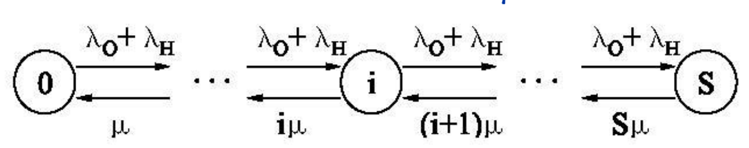
• Both kinds of requests are blocked if no free channel is available.
M/M/c/c: pi=(λH+λO)/iμ·pi-1
Priority scheme
Balance equations:
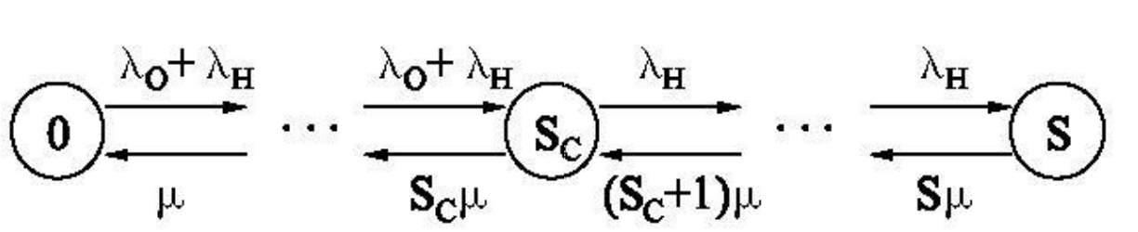
pi=(λH+λO)/iμ·pi-1 I<=Sc
Pi=λH/iμ·pi-1 Sc<=I<=S
Steady state prob.:

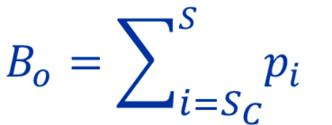
$$p_{i}=\left\{\begin{matrix}\frac{(λ_{O}+λ_{H})^{i}}{i!μ^{i}}p_{0} & 0≤i≤S_{C} \\ \frac{(λ_{O}+λ_{H})^{S_{C}}(λ_{H})^{i−S_{C}}}{i!μ^{i}}p_{0} & S_{C}≤i≤S\end{matrix}\right.$$

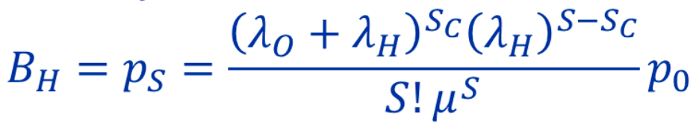
Blocking prob of an originating call
Blocking prob of an handover call
LEC9
Location and Handoff Management
▪ maintain continuous communication between 2 parties in the presence of mobility: Handoff
▪ maintain continuous communication between 2 parties in the presence of mobility: Roaming
▪ locate of a mobile unit in the entire coverage area:Location management
Location Management
Two basic operations in location management:
▪ Registration (Location update): the process of informing the presence or arrival of a MU to a cell.
▪ Location tracking/lookup: the process of locating the desired MU.
▪ Paging: the process of contacting the desired MU
▪ In location update, which is initiated by the mobile unit, the current location of the unit is recorded in HLR and VLR databases.
▪ Location lookup is essentially a database search to obtain the current location of the MS ▪ These tasks are initiated by the MSC
Registration (Location Update)
▪ There are six types of registration:(Power-down registration; Power-up registration; Deregistration; New system/Location area registration; Periodic registration; Forced registration)
Challenges with Location Management
▪ The cost(update and paging)⬆as cell size⬇, significant-micro cell cluster
▪ frequent cell crossing, common in highly commuting zones, cost⬆.
Solution:
▪ creates registration/location areas and paging areas to ⬇cost.
▪ neighboring cells are grouped together to form a registration/location area, and the paging area is constructed in a similar way.
Tradeoff in Location Management
▪ Network may only know approximate location
▪ location update/registration: Net know the location of a mobile user
▪ location search/terminal paging: Network find the location of a mobile user
▪ tradeoff between location update and search(▪ When the user is not called often, resources are wasted with frequent updates ▪ If updates are not done and a call comes, bandwidth or time is wasted in searching)
Basic Scheme ▪ Two Tiers:
▪ HLR: Home Location Register(stores user profile and the geographical location of each moving object at a pre-specified location)
▪ VLR: Visitor Location Register(stores user profile and the current location who is a visitor to a different cell than its home cell.)
▪ Registration Steps:
MS1 moves to cell 2. The MSC of cell 2 launches a registration query to its VLR 2.=>VLR2 sends a registration message containing MU’s identity, which can be translated to HLR address.=>After registration, HLR sends an acknowledgment back to VLR2.=>HLR sends a deregistration message to VLR1 (of cell 1) to delete the record of MS1 (obsolete). =>VLR1 acknowledges the cancellation.
Location Updates:(: Time Based, Movement Based, Distance Based)
Advanced Schemes ▪ Forwarding pointers:
▪ Update (upon crossing a RA boundary):(When the length of forwarding pointers < K: Set up a pointer between the two involving VLRs; When the length of forwarding pointers = K: Update information to the HLR)
▪ Search (HLR -> VLR0 -> …. -> VLRi -> cell ->paging)

