LAB 3: Inheritance

Learning Outcomes:

Upon successful completion of this workshop, you will have demonstrated the abilities to:

- Design and implement classes in the “is-a” relationship.
- Practice casting
- Describe to your instructor what you have learned in completing this workshop.

Requirements:

Part 1:

To complete this task you should read and study the lecture Inheritance

Step 1: Create a new project named “ItemManager”.

Step 2: Create a package named “DTO”, it contains some files: Item.java, Vase.java, Statue.java, and Painting.java

Step 3: Create another package named “GUI”, it contains the AntiqueShop.java file

Implement the class diagram as follows:

Item
#value: int
#creator: String
+Item()
+Item(int, String)
+getters/setters
+output():void
+input():void

Vase
-height: int
-material: String
+Vase()
+Vase(int, String, int, String)
+getters/setters
+outputVase():void
+InputVase(): void

AntiqueShop
+main():void

The AntiqueShop class is making use of Vase, Statue, and Painting, in the sense that it has declared references to them, and thus there is a dependency.
Painting
Statue
-height: int
-width: int
-isWatercolour: boolean
-isFramed: boolean
+Painting()
+Painting(int, String, int, int, boolean, boolean )
+getters/setters
+outputPaiting():void
+inputPainting():void
-weight: int
-colour: String
+Statue()
+Statue(int, String, int, String)
+getters/setters
+outputStatue():void
+inputStatue():void

Requirement:
  - In the file Item.java,

    - The method input(): Using Scanner class to input all fields of the Item class. Verify: value>0, creator is not empty

    - The method output(): print out all fields

  - In the file Vase.java,
    - The method inputVase(): Using Scanner class to input all fields of the Vase class.
    - The method outputVase(): print out all fields of the Vase class

Hint:
public class Vase{
…
//this method is used to input all fileds of a vase object public void inputVase(){
input(); // call the inherited method to input two fields: value, creator

//TODO: you is required to add more your code to input two fields : height, material
// use try..catch/throws to handle exceptions
}

//this method displays information of a vase object public void outputVase(){
output(); // call the inherited method to print two fields out: value, creator System.out.println(“Height:” + height);
System.out.println(“Material:”+ material);
}
…
}

  - You do the same for Statue class, Painting class
  - In the file “AntiqueShop.java”. you type like as follow:

3
public class AntiqueShop {
public static void main(String[] args){ Item item=null;
int choice=0; Scanner sc=…. do{
System.out.println(“1. Create a Vase:”); System.out.println(“2. Create a Statue:”); System.out.println(“3. Create a Painting:”); System.out.println(“4. Display the Item:”); System.out.println(“Input a choice:”); Choice=sc.nextInt();
switch(choice){
case 1:
item=new Vase();
((Vase)item).inputVase(); break;
case 2:
item =new Statue();
((Statue) item).inputStatue(); break;
case 3:
item =new Painting(); ((Painting) item).inputPainting();
break; case 4:
if(item!=null){
if(item instanceof Vase)
((Vase) item).outputVase(); else if(item instanceof Statue)
((Statue) item).outputStatue (); else if(item instanceof Painting)
((Painting) item).outputPainting ();
}
else System.out.println(“ you need to create an object”); break;
}
}while(choice<=4); }

  - (Optional) Now, you is required to update the above program. You should create a new class named Menu. This class contains one static method

//use this method to show pre-defined options
//input: an array contains the list of options
//output: return a user’s choice that is inputted from the keyboard.
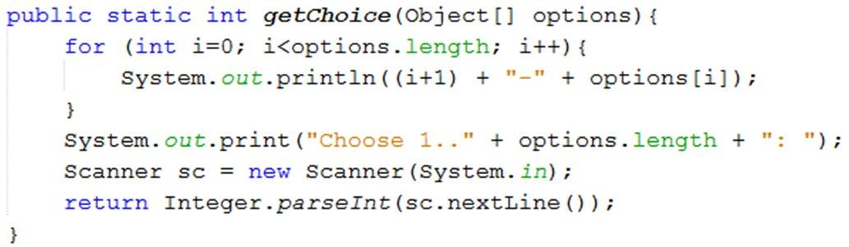

⇨ Update the main method to use the Menu class.


public class AntiqueShop {
public static void main(String[] args){
String[] options={“ Create a Vase “,”Create a Statue”,” Create a Statue”,” display the item”}; Item item=null;
int choice=0; do{
choice=Menu.getChoice(options); switch(choice){
case 1:
item=new Vase(); ((Vase)item).inputVase(); break;
….
}while(…);
}

4

