WSL1

Check your firewall settings:

Win-Key > Windows Defender Firewall > Advanced Settings > Inbound Rules

Win-Key + r > wf.msc > OK > Inbound Rules

WSL2

add the –ac flag. We will add a firewall rule after to

https://www.xfree86.org/current/Xserver.1.html

**-ac**

disables host-based access control mechanisms. Enables access by any host, and permits any host to modify the access control list. Use with extreme caution. This option exists primarily for running test suites remotely.

Check your firewall settings:

Win-Key > Windows Defender Firewall > Advanced Settings > Inbound Rules

Win-Key + r > wf.msc > OK > Inbound Rules

Look for VcXsrv rules and disable all

Then use the powershell script to create a rule. It will get the IP from wsl to make the rule as the IP changes. The rule created will be named WSL 2 Firewall Unlock and will look like this:

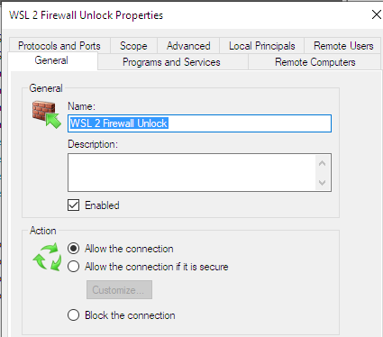

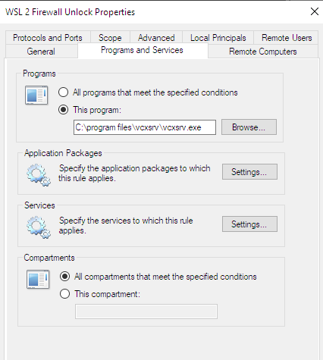

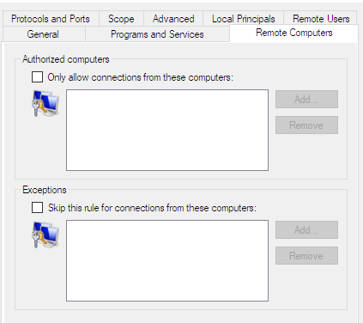

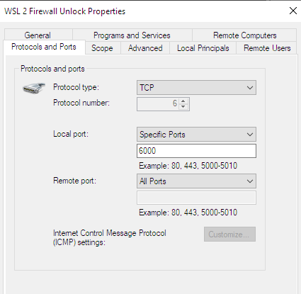

This is the IP the powershell script gets from wsl and sets for the rule

