DIGITAL SIGNAL PROCESSING

Lecturer Trần Hoàng Tùng

LABWORK 1

FREQUENCY & TIME REPRESENTATION

Student name: Đặng Thái Sơn

ID: BA9-053

INTRODUCTION

This labwork deals with the changing between time domain and frequency domain of several signals and systems.

Time domain and frequency domain refer to two different ways of looking at a signal. In the time domain, a signal is a wave that varies in amplitude (y-axis) over time (x-axis) while in the frequency domain, a signal is represented as a series of frequencies (x-axis) that each has an associated power (y-axis)

This is essential for students to imagine what would it be when applying knowledge, formulas in lecture time into pratical coding sessions.

TASK

-Given a signal Input_1kHz_15kHz, an impulse response and ECG.

+ Signals:

Plot the signal Input_1kHz_15kHz (in time domain)

Convert into frequency, plot real/imaginary/magnitude/phase

Using Inverse-FFT to get back to time domain

Comment?

+ Systems:

Plot the Impulse_response

Convert into frequency, plot real/imaginary/magnitude/phase

Calculate the output using time convolution/frequency multiplication

Comment?

+ EGC:

Plot the signal in time and frequency domain

Calculate the output using time convolution/frequency multiplication

Comments?

I/ Signals

1. Task 1

-In time domain, the given signal can be plot out like the following:

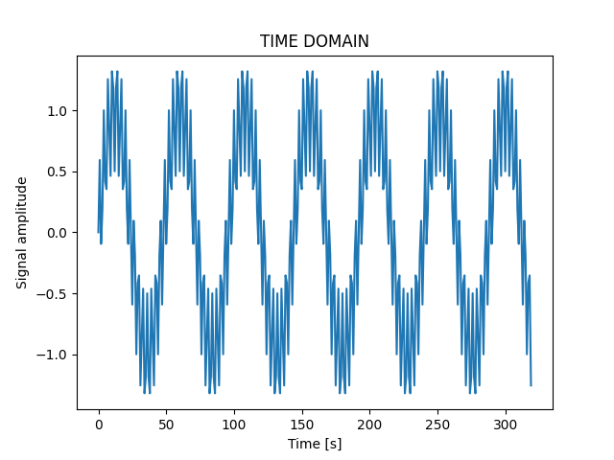

2. Task 2

a) Frequency domain

-To convert a signal in time domain to frequency domain, we should use the fast Fourier transform algorithm for computing the discrete Fourier transform. By using this, the signal in frequency domain becomes discrete

-Since the output of the signal in frequency domain is periodic, we just need to consider 1 period of it:

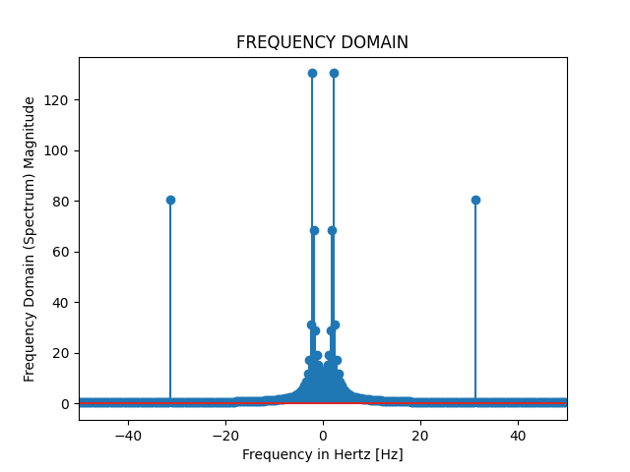

-In fact, the signal is complex so it should be represented in 3D. Therefore, it has three main components: real part, imaginary part and magnitude

b) Real part

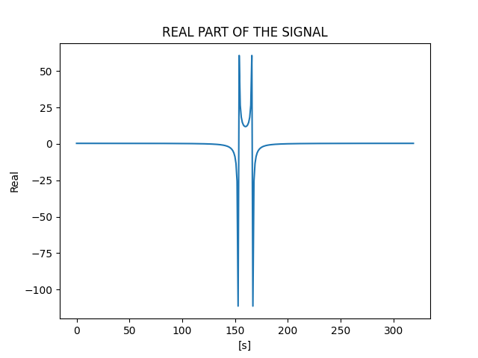

c) Imaginary part

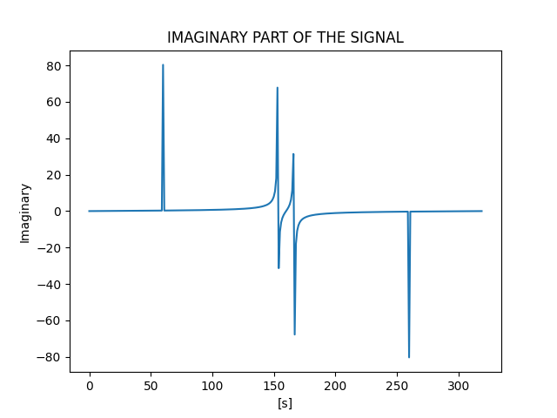

d) Magnitude

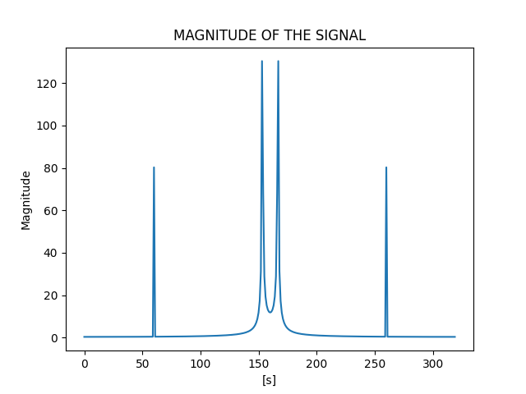

e) Phase

-The phase of the signal:

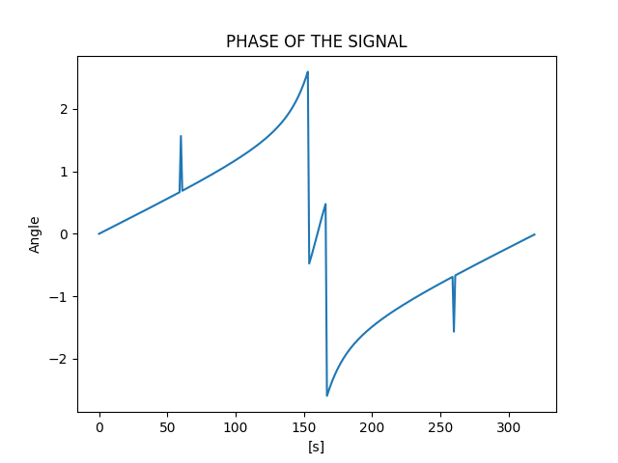

3. Task 3

-Using inverse fast Fourier transform, we can implement the signal in time domain thanks to the result we get in frequency domain. Now, casting complex values to real will discard the imaginary part:

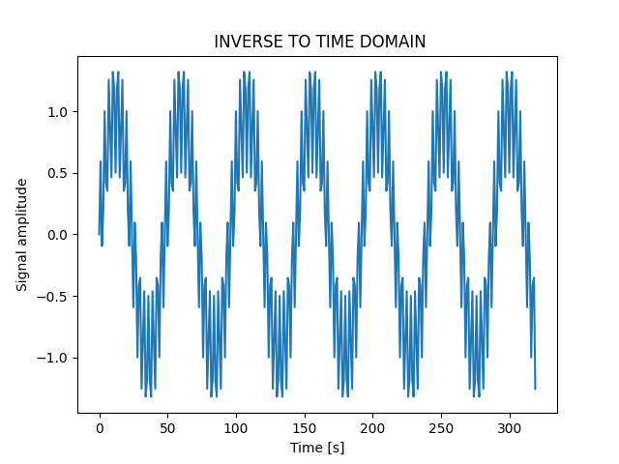

II/ Systems

1. Task 1

-To represent an LTI system in time domain, we must need an impulse response. Plot the given impulse response, we get:

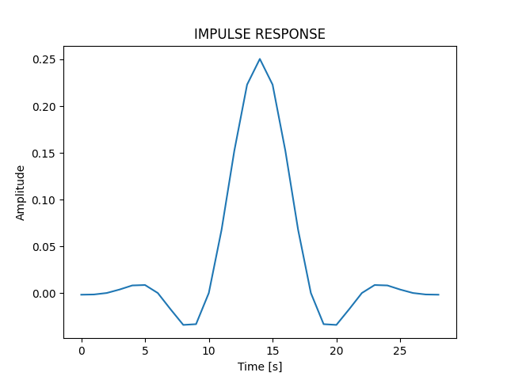

2. Task 2

a) Frequency response

-To represent an LTI system in frequency domain, we must need to transform impulse response into frequency response. Again, using fast Fourier transform, we get the following frequency response:

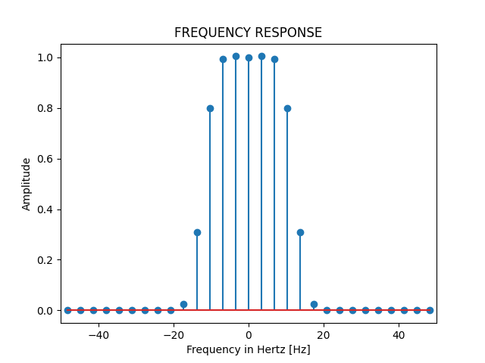

-The frequency response is periodic so we just need to show one period of it

-The frequency response is a complex value, so it contains three main parts: real part, imaginary part and magnitude as the following:

b) Real part

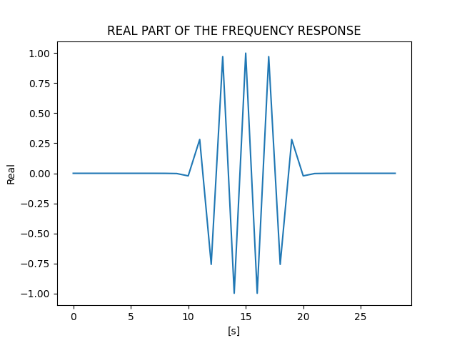

c) Imaginary part

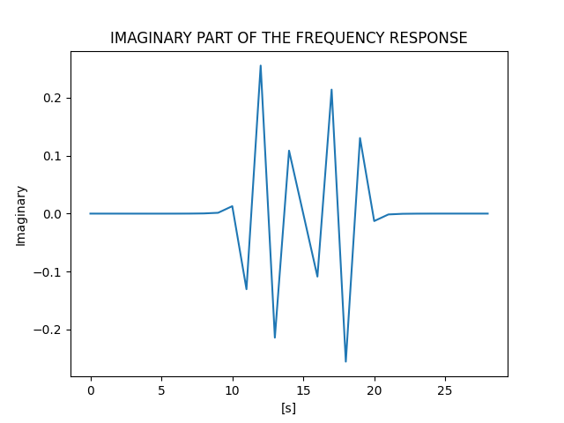

d) Magnitude

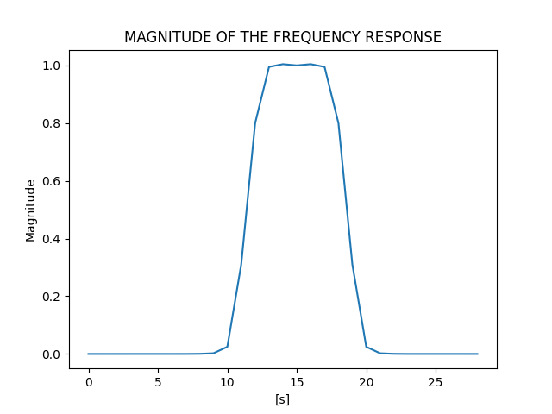

e) Phase

-Phase of the frequency response is:

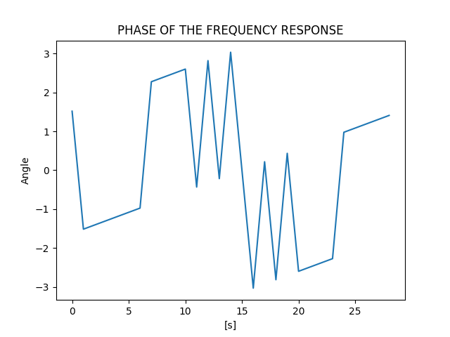

f) Inverse FFT

-Using inverse fast Fourier transform, we can implement the impulse response thanks to the frequency response. Now, casting complex values to real will discard the imaginary part:

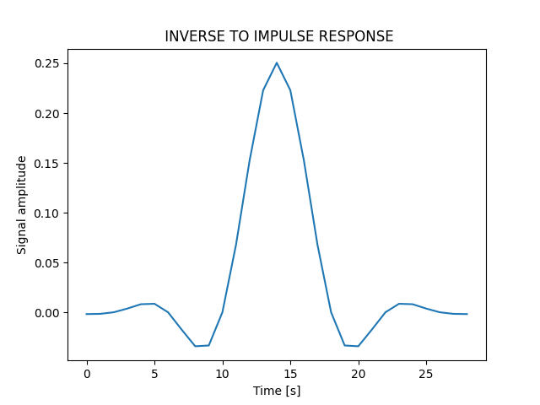

3. Task 3

a) Time convolution

-Since we already have the signal in time domain and impulse response, we can find out the output using time convolution: y(s) = x(s) * h(s)

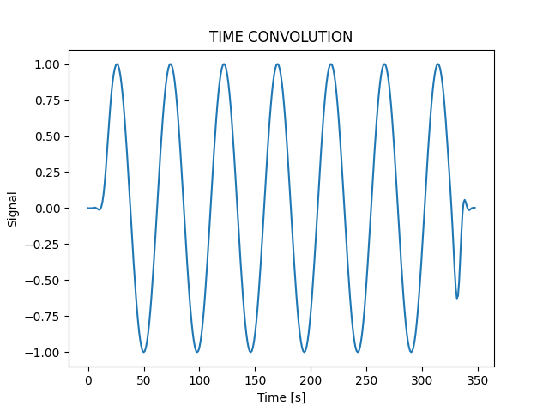

b) Frequency multiplication

-To find out the result using frequency multiplication, we must transform the signal in time domain to frequency domain and the impulse response to frequency response. Then multiply them together, we get:

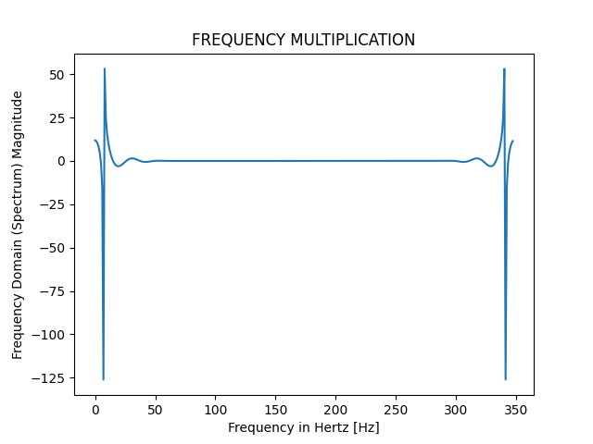

=>> CONCLUSION: by checking, we can see that if using fast Fourier transform, we can turn the result of time convolution into the output of frequency multiplication, vice versa.

III/ECG

ECG is known as electrocardiogram (a test that detects and records the strength and timing of the electrical activity in your heart). This information is recorded on a graph that shows each phase of the electrical signal as it travels through your heart.

1. Task 1

-Plot the given ECG signal in time domain, we get:

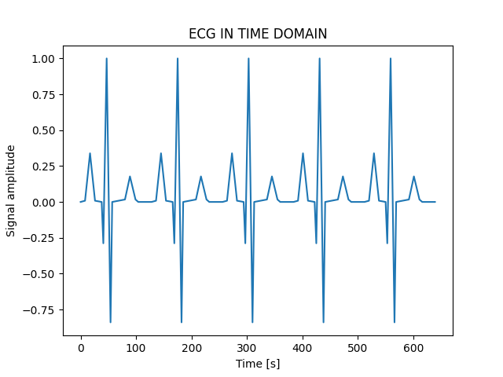

-Again, using fast Fourier transform, we get the signal in frequency domain (the signal is periodic so we just need to display one period only):

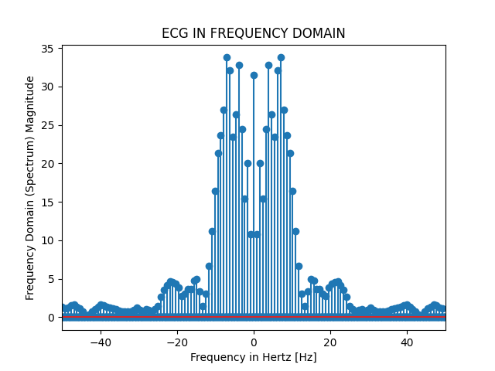

2. Task 2

-Having already the impulse response, frequency response and ECG in time domain and frequency domain, we can show the output of time convolution and frequency multiplication as following:

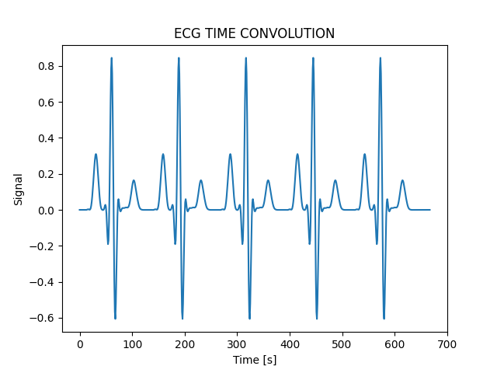

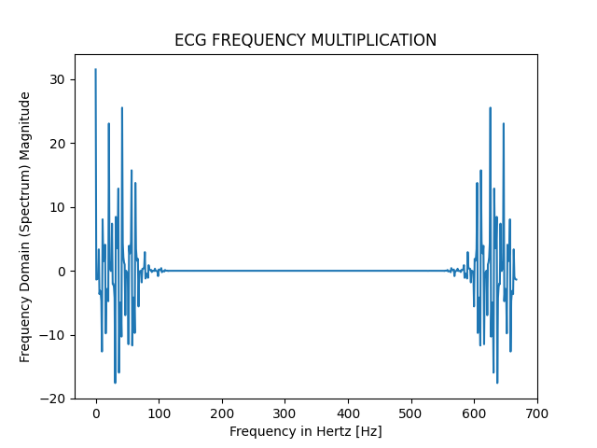

=>> We already stated that these two outputs can be transformed into each other using fast Fourier transform and inverse fast Fourier transform