**Digital Signal Processing**

Labwork 1

**Frequency & Time Representation**



Name: Đào Hải Long

ID: BA9-041

University of Science and Technology of Hanoi

1 Signal and System

1. **Time domain**

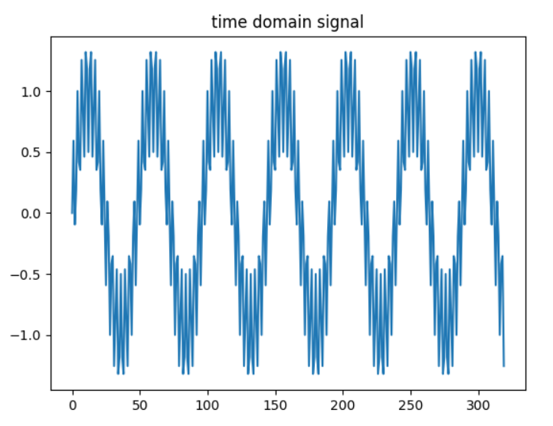

- This picture is discrete-time signal: n=320, x(n)= Input_1kHz_15kHz

-The x axis is transferred to the domain from 0 to 2pi

-A time-domain graph shows how a signal changes over time.

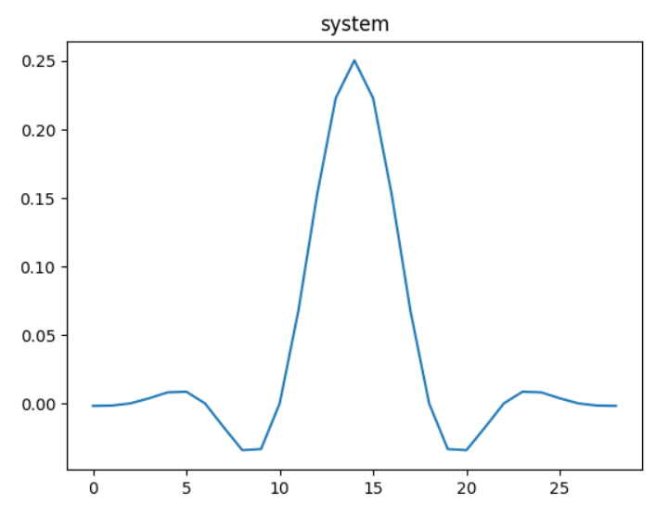

-This picture is discrete-time system:n=29, h(n) = Impulse_response

-The x axis is transferred to the domain from 0 to 2pi

**b) Frequency**

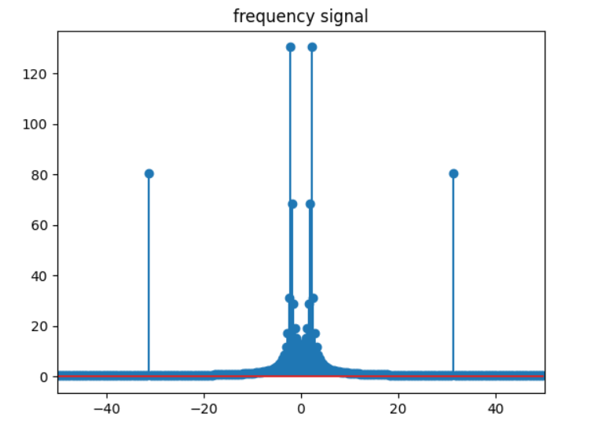

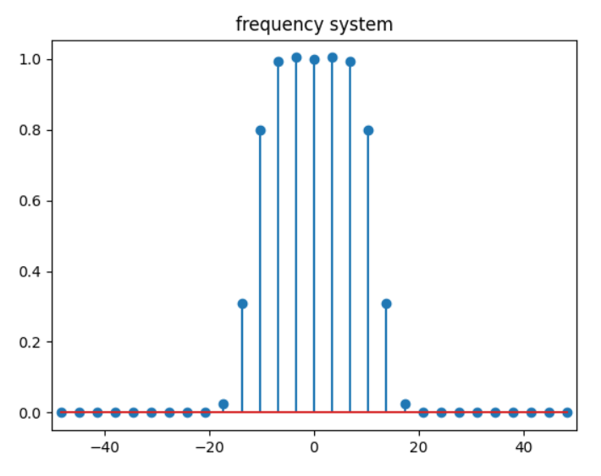

-The x axis is transferred to the domain from -pi to pi.(-40 to 40)

-Sampling rate, or number of measurements per second are: 100

-The Fourier transform takes us from the time to the frequency domain, and this turns out to have a massive number of applications. The fast Fourier transform (FFT) is an algorithm for computing the DFT. FFT depend on the fact that

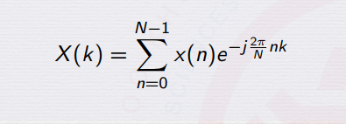

-The DTFT of an impulse response with LTI system

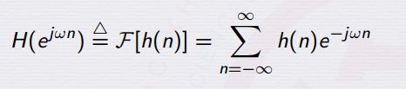

**c) Real**

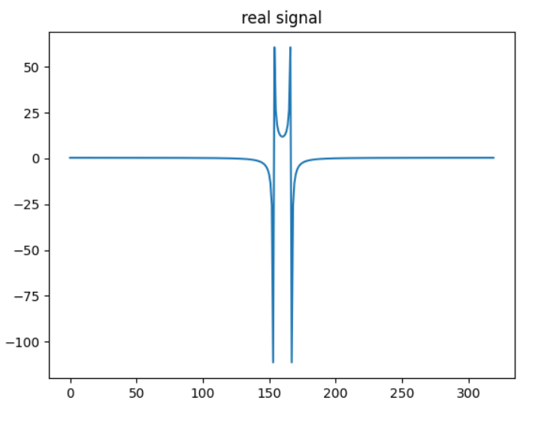

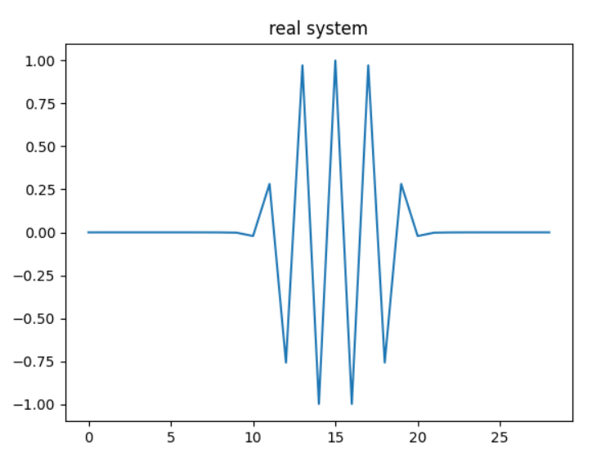

- The real DTFT and DFT transforms an N point time domain signal into two (N/2 + 1) point frequency domain signals/system. Points 0 through N/2 in the complex DTFT and DFT are the same as in the real DTFT and DFT . Even though the real DTFT and DFT uses only real numbers.

- The x axis is transferred to the domain from 0 to 2pi

**=**

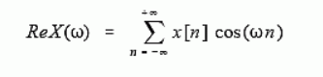 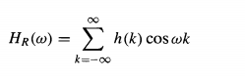

**e) imaginary**

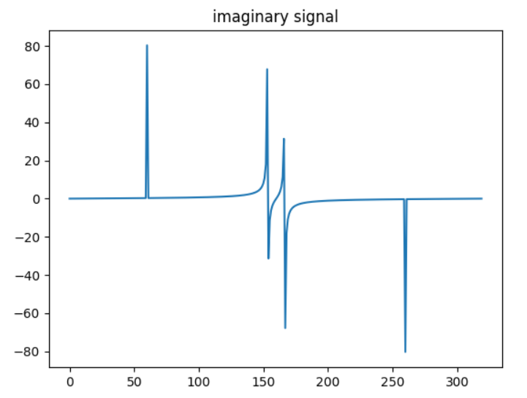

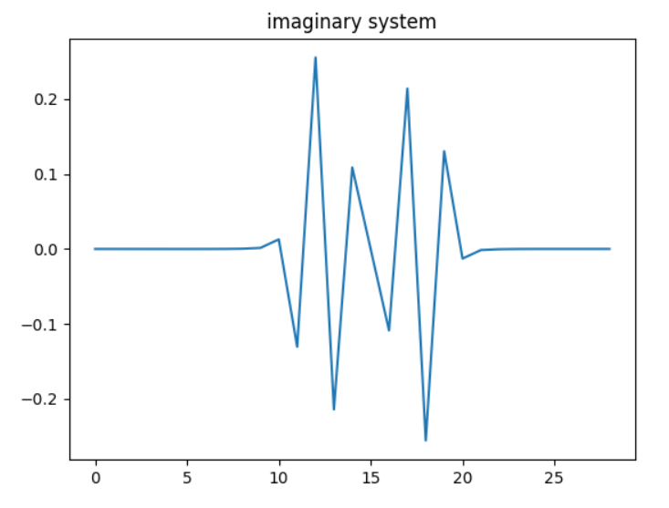

-The imaginaryDTFT and DFT transforms an N point time domain signal into two (N/2 + 1) point frequency domain signals.

- Points N/2 through N-1 in the complex DTFT and DFT are the same as in the imaginary DTFT and DFT

**=**

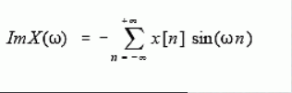 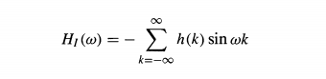

**e) Magnitude**

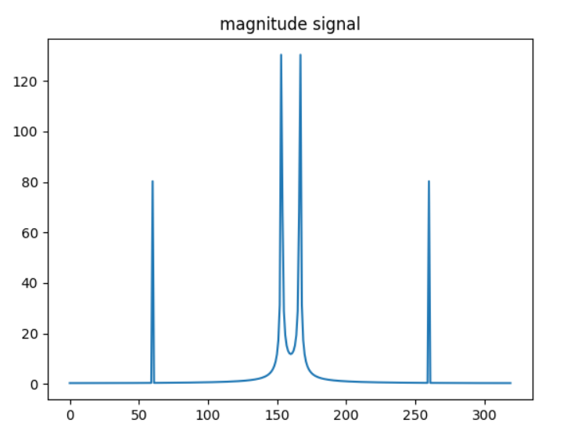

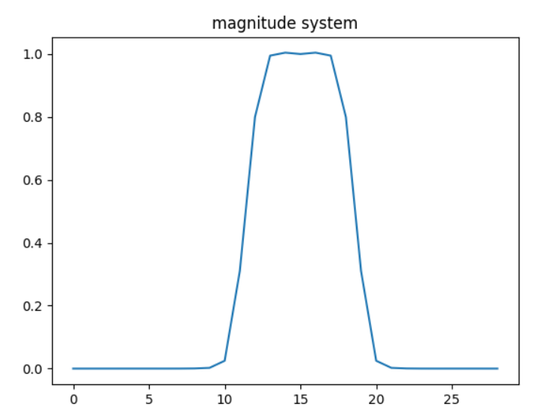

-With DFT as Linear Transformation

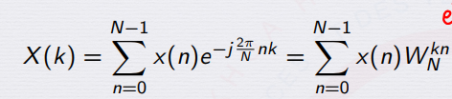

we defined WN = .

-Its magnitude is always maintained at uniform frequency domain.

**f) Phase**

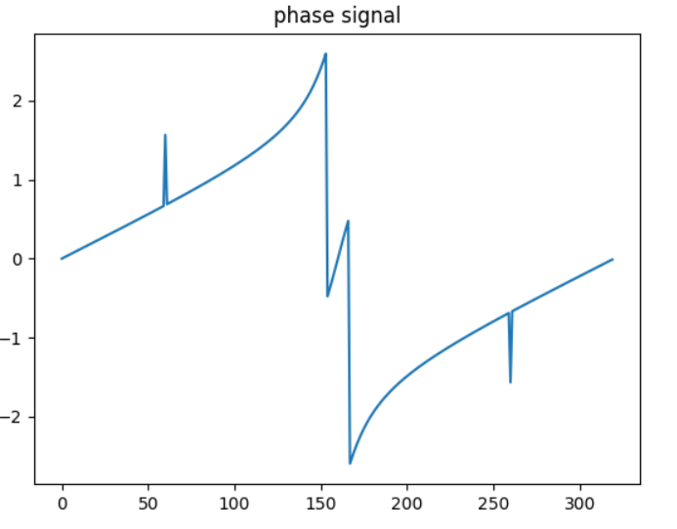

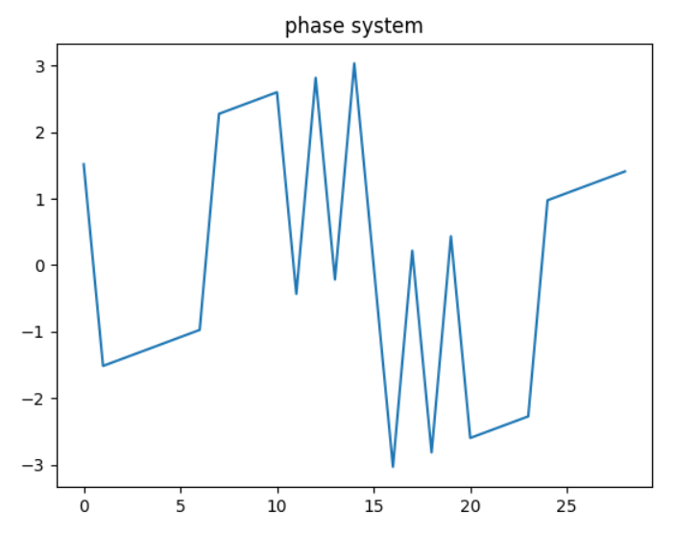

- Phase is an angle-like quantity representing the number of periods spanned by that variable.

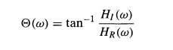

**g) Inverse-FFT**

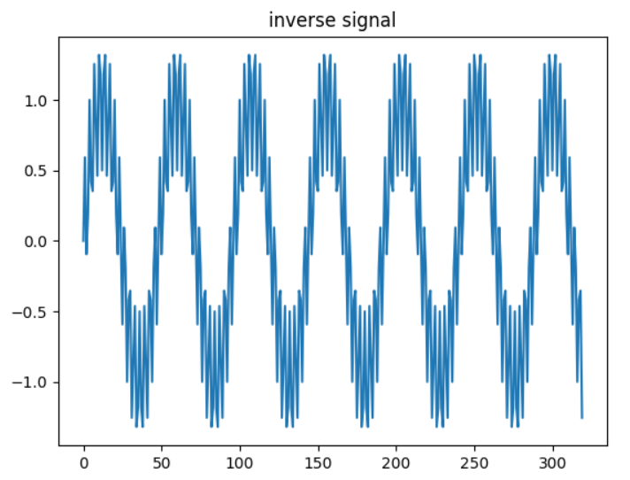

-The inverse transform is the same as the forward transform with the real and imaginary parts swapped for both input and output, up to a normalization

=> Inverse same input time domain

**h) Convolution and Multiplicaition Frequency**

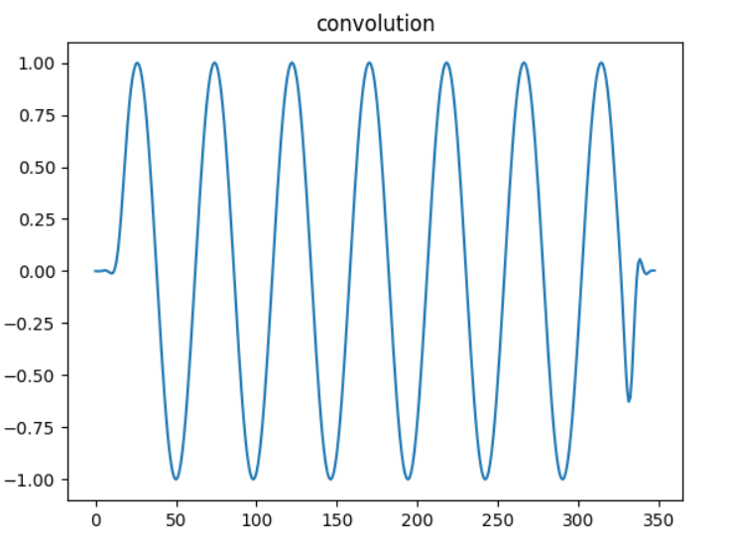

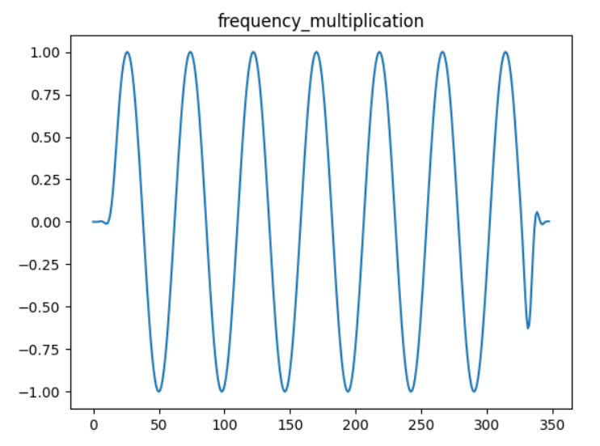

- Convolution in time domain equals multiplication in frequency domain

**F{x(t)*y(t)}(f)=F{x(t)}(f) . F{y(t)}(f)**

where F{x(t)}(f)F{x(t)}(f) denotes the Fourier transform of x(t)x(t), evaluated at the frequency

- The convolution theorem can be used to perform convolution via multiplication in the time domain.

**2.ECG**

**+ ECG in time** 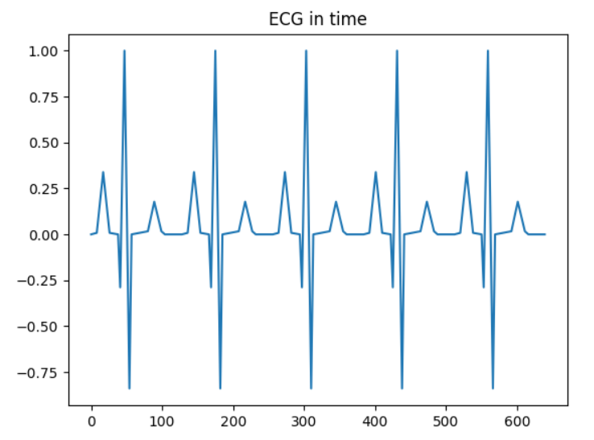

**-**x(n)=ECG ,n=640

**+ Frequency domain**

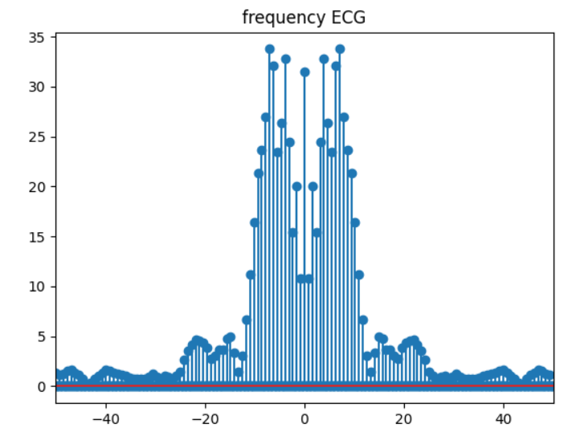

**+ Concolution and Multipication frequency**

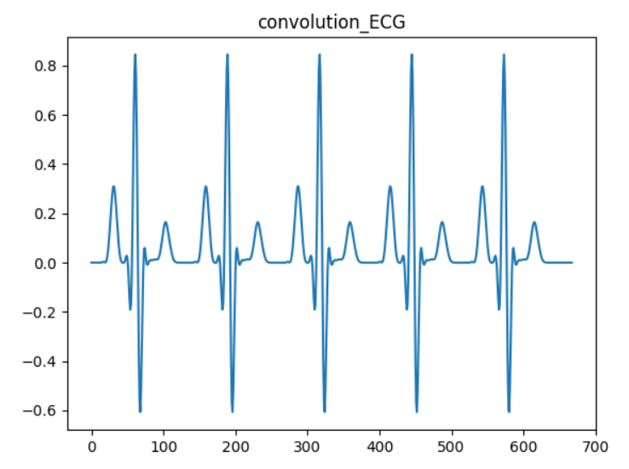

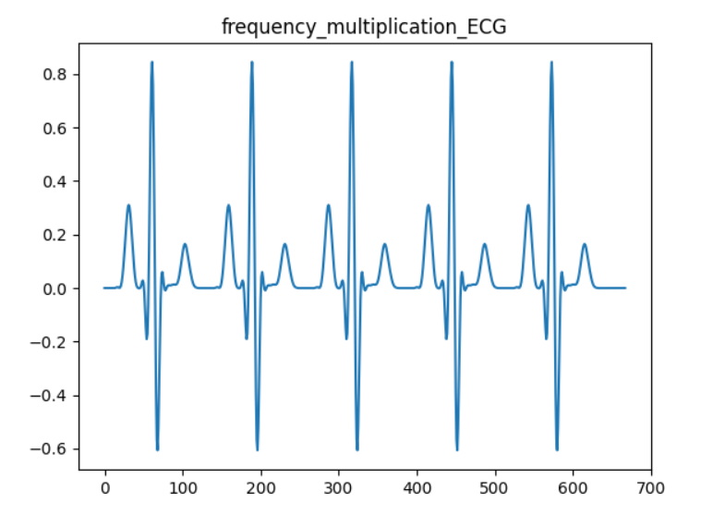

* Convolution in time domain equals multiplication in frequency domain

- The convolution theorem can be used to perform convolution via multiplication in the time domain.