|  |
| --- |
| Close-up image showing the leaf-sides of two oversized books side-by-side on a bookshelf, with additional books in soft focus background |
| User Manual  Automating Coffee Drewing |
| |  |  |  | | --- | --- | --- | | Thang Dao | 3/18/24 | [EN] UserManual | |

**Directory**

***SAFETY PRECAUTIONS 2***

***FOR INSTALLATION 2***

***FOR OPERATION 3***

***PRODUCT SPECIFICATIONS 5***

***CHECKING THE COFFEE MACHINE 5***

***Main Body. 5***

***USING THE COFFEE MACHINE 6***

***Turning the power on/off 6***

***Desktop App User Manual 7***

***Introduction(Text) 7***

***Introduction(Image) 8***

***Phone App User Manual 10***

***Introduction (Text) 10***

***Introduction (Image) 11***

|  |
| --- |
| **Correct Disposal of This Product**  **(Waste Electrical & Electronic Equipment)**  **(Applicable in countries with separate collection systems)**  This marking on the product, accessories or literature indicates that the product and its electronic accessories  (e.g. charger, headset, USB cable) should not be disposed of with other household waste at the end of their working life. To prevent possible harm to the environment or human health from uncontrolled waste disposal, please separate these items from other types of waste and recycle them responsibly to promote the sustainable reuse of material resources.  Household users should contact either the retailer where they purchased this product, or their local government office, for details of where and how they can take these items for environmentally safe recycling. Business users should contact their supplier and check the terms and conditions of the purchase contract. This product and its electronic accessories should not be mixed with other commercial wastes for disposal. |

*Any inquiries or issues regarding the product, please contact us via email at: thang.techcareers@gmail.com.*

# SAFETY PRECAUTIONS

***These safety precautions are for owner’s safety and preventions of property damage. Therefore, please read this manual thoroughly before using your product.***

WARNING

Hazards or unsafe practices that may result in severe personal injury or death.

CAUTION

Hazards or unsafe practices that may result in minor personal injury or property damage.

Follow directions.

Do NOT attempt.

Unplug the power plug from the wall socket.

Do NOT disassemble.

# FOR INSTALLATION

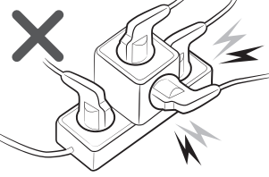WARNING

**Plug the power cord into a wall socket with the power specifications of the product or higher and use the socket for this appliance only. Also, do not extend the power cord on**

**your own.**

* Sharing a wall socket with other appliances using a multi outlet power strip or extending the power cord may result in electric shock or fire.
* Do not use an electric transformer. It may result in electric shock or fire.
* If the voltage/frequency/rated current/condition is different, it may cause electric shock or fire.
* Do not install this appliance near a heater, inflammable material.

**Do not install this appliance in a humid, oily or dusty location, in a location exposed to direct sunlight and water (rain drops). Do not install this appliance in a location where gas may leak.**

* Failure to do so may result in electric shock or fire.

**Plug the power plug into the wall socket firmly. Do not use a damaged power plug, damaged power cord or loose wall socket.**

* Failure to do so may result in electric shock or fire.

**When unplugging the product, do not pull the power cord. Grip the power plug, and then pull the power plug.**

* 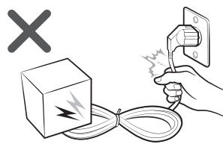Failure to do so may result in electric shock or fire.

**Do not pull or excessively bend the power cord. Do not twist or tie the power cord.**

**Do not hook the power line over a metal object, place a heavy object on the power cord, insert the power line between objects, or push the power cord into the space behind the appliance.**

* This may result in electric shock or fire.

**CAUTION**

**When the product will not be used for a long period of time or during a thunder or lightning storm, disconnect the power supply.**

* Failure to do so may result in electric shock or fire.

**It is dangerous when the power cable gets damaged, therefore contact us via email or qualified experts for the repair. Before cleaning or repairing the appliance, unplug the appliance.**

# FOR OPERATION

**WARNING**

**If the appliance is flooded, turn off the appliance and contact us via email.**

* Failure to do so may result in electric shock or fire.

**If the appliance generates a strange noise, a burning smell or smoke, disconnect the power supply immediately and contact us via email.**

* Failure to do so may result in electric shock or fire.

**In the event of a gas leak (such as propane gas, LP gas, etc.), ventilate immediately without touching the appliance or power cord and contact us via email or a qualified technician.**

* Do not use a ventilating fan.
* If there is a spark, explosion or fire may occur.

**Do not unplug the appliance during operation.**

* When plugging the appliance in again, flame may occur and it may result
* 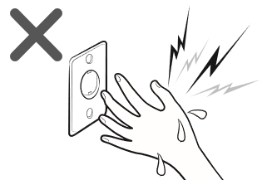Failure to do so may result in a product malfunction, water leakage,

**Do not touch the power plug with wet hands.**

* After unpacking the product, keep all packaging materials out of the reach of children.
* If a child places a bag over its head, it may suffocate.

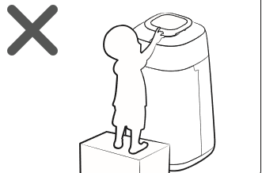**Do not insert your fingers or a foreign substances into the air outlet while product is operating.**

* Take special care that children do not injure themselves by inserting their fingers into the product. Do not place an object near the product that makes it possible for children to climb onto the machine.
* The child could fall and injure themselves or the product may fall over and injure the child.

**If water has entered the power supply module, unplug the power cable and dry the product completely before use.**

* Failure to do so may result in electric shock or fire.

# PRODUCT SPECIFICATIONS

Dimension of the product is based on maximum value of the measurement.

Measurement may vary depending on the side.

For product improvement purposes, design and specifications of the product are

subject to change without prior notice

|  |  |
| --- | --- |
| Model & Name | Automating Coffee Machine |
| Product dimension (W*H*D) | 370mm*700mm*370mm |

# CHECKING THE COFFEE MACHINE

## Main Body.

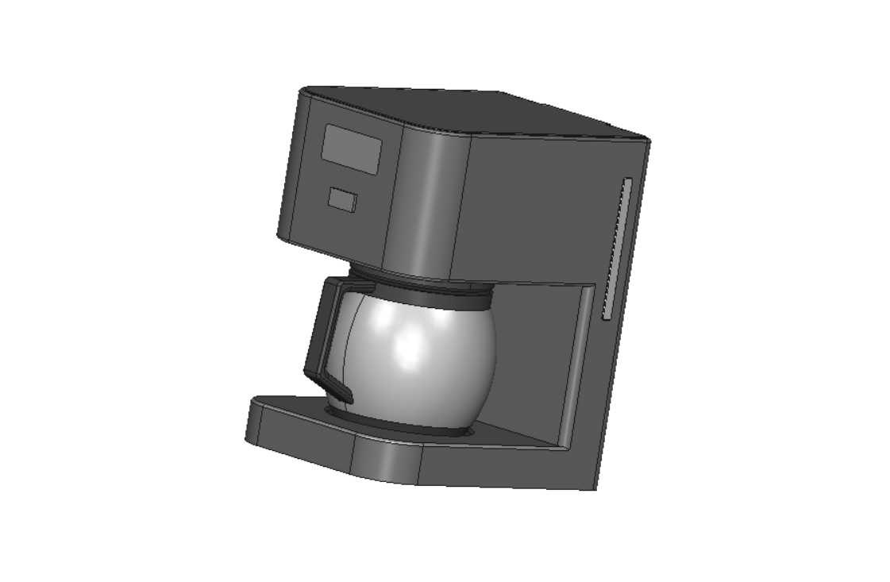

* **Image Annotation.**

1. Display: Shows brewing settings and status.
2. Power Button: Controls the machine's on/off function.
3. Coffee Pot: Holds brewed coffee.
4. The Lid: Covers the brewing chamber or reservoir.
5. Handle (at the rear side): Provides a grip for easy maneuvering.

# USING THE COFFEE MACHINE

## Turning the power on/off

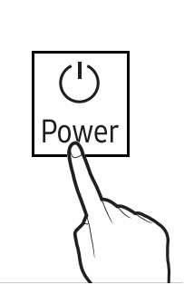

Once activated, the coffee maker will sound a bell and begin the connection check process.

When the coffee maker is powered on, the sensor will check the inventory and will be displayed for 5 seconds.

If the inventory is low, a notification will be displayed with a bell.

**Warning: When turning on the power, please ensure that the coffee machine is placed on a stable and level surface to prevent spillage or tipping.**

# Desktop App User Manual

## Introduction(Text)

* Welcome to Automating Coffee Drewing! This user manual will guide you through the steps required to use the desktop version of our software.

**Step 1: Download Software**

1. Visit the download link provided: [coming soon].
2. Follow the on-screen instructions to download the software to your computer.

**Step 2: Install Software**

1. Locate the downloaded software file on your computer.
2. Double-click the file to begin the installation process.
3. Follow the installation wizard prompts to complete the installation.
4. Once installation is complete, you're ready to use Automating Coffee Drewing.

**Step 3: Logging In**

1. Launch the installed software on your desktop.
2. You will be prompted to log in.
3. Enter the following credentials:

* Username: admin
* Password: admin

1. Click "Login" to access the software.

**Step 4: Using the Software**

1. After logging in, you will be presented with the main interface.
2. Choose any option or feature you want to utilize.
3. Follow the on-screen instructions to proceed with your chosen action.

**Additional Tips**

If you wish to view your order history:

1. Look for the "Order History" option.
2. Click on it to view your past orders.

For assistance or inquiries, click on the help icon (?) or contact our support team.

Remember to log out of the software when you're done to ensure security.

**Conclusion**

Congratulations! You have successfully learned how to download, install, and use Automating Coffee Drewing on your desktop. If you have any further questions or require assistance, don't hesitate to reach out to us.

## Introduction(Image)

* Welcome to Automating Coffee Drewing! This user manual will guide you through the steps required to use the desktop version of our software.

**Step 1: Download Software**

1. Visit the download link provided: [coming soon].
2. Follow the on-screen instructions to download the software to your computer.

**Step 2: Install Software**

1. Locate the downloaded software file on your computer.
2. Double-click the file to begin the installation process.
3. Follow the installation wizard prompts to complete the installation.
4. Once installation is complete, you're ready to use Automating Coffee Drewing.

**Step 3: Logging In**

1. Launch the installed software on your desktop.
2. You will be prompted to log in.
3. Enter the following credentials:
   * Username: admin
   * Password: admin
4. Click "Login" to access the software.

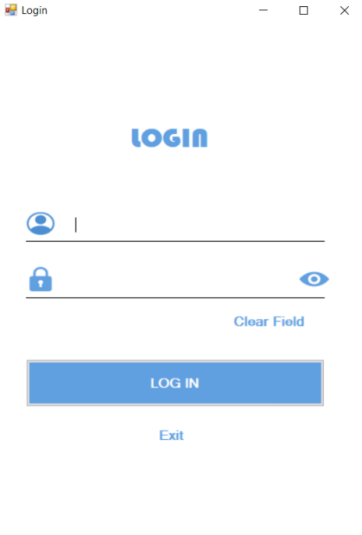

*Step 3: Logging into Automating Coffee Drewing*

**Step 4: Using the Software**

1. After logging in, you will be presented with the main interface.
2. Choose any option or feature you want to utilize.
3. Follow the on-screen instructions to proceed with your chosen action.
4. If you wish to view your order history:
5. Look for the option.
6. Click on it to view your past orders.

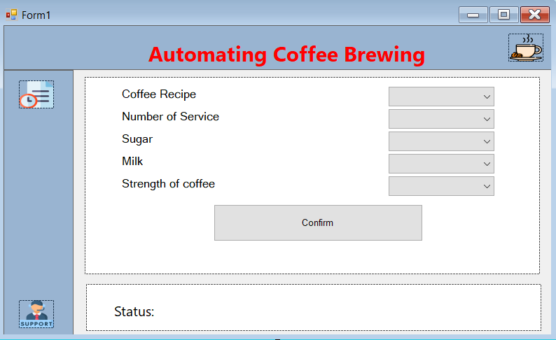

*Step 4: Main Interface of Automating Coffee Drewing*

* **Image Annotation.**

1. Coffee Recipe: Settings for brewing various types of coffee.
2. Number of Service: Determines the quantity of coffee servings to be brewed.
3. Sugar: Allowing users to adjust the sweetness of their beverages to their preference.
4. Milk: Stores and dispenses milk for adding to coffee.
5. Strength of Coffee: Adjusts the concentration or potency of the brewed coffee.

**Additional Tips**

For assistance or inquiries, click on to contact our support team.

Remember to log out of the software when you're done to ensure security.

**Conclusion**

Congratulations! You have successfully learned how to download, install, and use Automating Coffee Drewing on your desktop. If you have any further questions or require assistance, don't hesitate to reach out to us.

# Phone App User Manual

## Introduction (Text)

Welcome to Automating Coffee Drewing This user manual will guide you through the steps required to use the mobile app version of our software.

**Step 1: Download App**

1. Visit the App Store (iOS) or Google Play Store (Android) on your mobile device.
2. Search for “Automating Coffee Drewing “.
3. Tap on the app icon to download and install it on your device.

**Step 2: Install App**

1. Once the app is downloaded, tap on the app icon to launch it.
2. Follow the on-screen instructions to complete the installation process.
3. Once installation is complete, you're ready to use Automating Coffee Drewing on your mobile device.

**Step 3: Logging In**

1. After installing, launch the app on your mobile device.
2. You will be prompted to log in.
3. Enter the following credentials:

* Username: admin
* Password: admin

1. Tap "Login" to access the app.

**Step 4: Using the App**

1. After logging in, you will be presented with the main interface of the app.
2. Navigate through the options or features you want to use.
3. Follow the on-screen instructions to proceed with your chosen action.

**If you want to view your order history:**

1. Look for the "Order History" option.
2. Tap on it to view your past orders.

**Additional Tips**

1. For assistance or inquiries, tap on the help icon (?) or contact our support team.
2. Ensure that you have a stable internet connection for optimal app performance.

**Conclusion**

Congratulations! You have successfully learned how to download, install, and use Automating Coffee Drewing on your mobile device. If you have any further questions or require assistance, feel free to reach out to us.

## Introduction (Image)

Welcome to Automating Coffee Drewing This user manual will guide you through the steps required to use the mobile app version of our software.

**Step 1: Download App**

1. Visit the App Store (iOS) or Google Play Store (Android) on your mobile device.
2. Search for “Automating Coffee Drewing “.
3. Tap on the app icon to download and install it on your device.

**Step 2: Install App**

1. Once the app is downloaded, tap on the app icon to launch it.
2. Follow the on-screen instructions to complete the installation process.
3. Once installation is complete, you're ready to use Automating Coffee Drewing on your mobile device.

**Step 3: Logging In**

1. After installing, launch the app on your mobile device.
2. You will be prompted to log in.
3. Enter the following credentials:

* Username: admin
* Password: admin

1. Tap "Login" to access the app.

**Step 4: Using the App**

1. After logging in, you will be presented with the main interface of the app.
2. Navigate through the options or features you want to use.
3. Follow the on-screen instructions to proceed with your chosen action.

**If you want to view your order history:**

1. Look for the "Order History" option.
2. Tap on it to view your past orders.

**Additional Tips**

1. For assistance or inquiries, tap on the help icon (?) or contact our support team.
2. Ensure that you have a stable internet connection for optimal app performance.

**Conclusion**

Congratulations! You have successfully learned how to download, install, and use Automating Coffee Drewing on your mobile device. If you have any further questions or require assistance, feel free to reach out to us.