Document Version History (unchanged, not included)

Overview

Effective Date (unchanged, not included)

Purpose (unchanged, not included)

Audience (unchanged, not included)

Scope (unchanged, not included)

References (unchanged, not included)

System Environment
OVMT runs entirely in AWS (ca-central-1) on a hub-and-spoke model. Three kinds of account are involved:
- ADLH centralized account (hub): holds the OVMT source data in a hub bronze Glue database, and the SMUS / Amazon DataZone domain where data products are published.
- PDP spoke accounts (one per environment): hold every resource deployed for OVMT: the spoke Glue database and its tables, the Glue job, the orchestration, notifications and access controls.
- CMD Operations account (480007295562): holds the shared bucket from which every PDP Glue job reads its script.

Naming placeholders used in this section and throughout the document:
- {env}: the environment name stamped into each deployment: dev1, dev, test or prod (see 3.2.1).
- {ver}: the OVMT source version: 4 in DEV and TEST, 1 in PROD.
- {hubEnv} / {e}: the matching hub environment name and letter: dev/u (for both dev and dev1), test/a, prod/p.

The environment matrix below is the single reference for values that differ by environment. Everything not listed is identical across environments.

Table 3: OVMT environment matrix

Attribute | DEV | TEST | PROD
PDP spoke account | 941377137261 | 428904953989 | 539524424690
Environment name(s) {env} | dev (main pipeline)  dev1 (development pipeline) | test (main pipeline)  test1 (development pipeline; not supported, see 3.1.1) | prod (both pipelines)
Source version {ver} | 4 | 4 | 1
Spoke Glue database | dev_kg01_bronze_ovmt4_gluedb / dev1_kg01_bronze_ovmt4_gluedb | test_kg01_bronze_ovmt4_gluedb | prod_kg01_bronze_ovmt1_gluedb
Spoke S3 prefix | bronze/ovmt4/ | bronze/ovmt4/ | bronze/ovmt1/
Hub source database | dev_lh00_bronze_sbovmtut04_gluedb_<hubProjectId> | test_lh00_bronze_sbovmtat04_gluedb_<hubProjectId> | prod_lh00_bronze_sbovmtpt01_gluedb_<hubProjectId>
PDP SMUS project | 4pr26gw3hlzpxm | cvgrx0os90i8wa | 5mhhylgitccj2i
Data Engineer SSO role | ADLH-DataEngineer-Dev | ADLH-DataEngineer-Test (role ID differs from template; confirm) | ADLH-DataEngineer-Prod (role ID differs from template; confirm)
Landing Zone network | Dev VPC, application subnets | Test VPC, application subnets | Prod VPC, application subnets
SMUS publication functions | Deployed | Not deployed | Not deployed
Load schedule | One-off, 2026-10-16 18:00 UTC, enabled | Same (hard-coded) | Same (hard-coded)

Cloud Environment
Named resources and locations for OVMT in each PDP spoke account. Values that differ by environment are in the matrix above. How these resources are deployed and connected is described in 3.2.

Table 4: Cloud Environment

DataLake Bucket Name and Location: | PDP datalake unibucket, resolved from the ADLH parameter /ADLH/datalake-unibucket/pdp/s3/gpbucket/name. Actual bucket name per environment to be confirmed.  - Bronze tables: s3://<unibucket>/bronze/ovmt{ver}/<table>/ (44 folders)  - Load audit table: s3://<unibucket>/bronze/ovmt{ver}/table_load_status/  - Run summaries: s3://<unibucket>/bronze/ovmt{ver}/summary/  - Silver / gold: not used
Data Publishing Project (for DataZone) Name and Location: | PDP SMUS project in the ADLH SMUS domain (project IDs in the environment matrix). Domain ID and project display names to be confirmed.
ADLH Bucket Name and Location: | Hub source database {hubEnv}_lh00_bronze_sbovmt{e}t0{ver}_gluedb_<hubProjectId>, read through Lake Formation. Underlying ADLH bucket to be confirmed.
Source Bucket Other Than ADLH Name and Location: | N/A
Registry Name and Location: | N/A
BI Tools: | AWS Glue 5.0 (Spark, Apache Iceberg), AWS Glue Data Catalog, AWS Lake Formation, AWS Step Functions, Amazon EventBridge, AWS Lambda, Amazon SNS, Amazon S3, AWS KMS, AWS IAM, Amazon SageMaker Unified Studio / Amazon DataZone, AWS CloudFormation, AWS CodePipeline, AWS CodeBuild, Azure DevOps Repos. Athena: not used.
Roles: | Created for OVMT:  - {env}-kg01-pdp-ovmt-glue-execution-role  - {env}-kg01-pdp-ovmt-rowcount-lambda-execution-role  - {env}-kg01-pdp-ovmt-Eventbridge-execution-role  - {env}-kg01-pdp-ovmt-Stepfunction-execution-role  Existing roles used: ADLH Data Engineer SSO role; PDP SMUS project user role; shared SMUS publishing role dev1-kg01-pdp-hgmt-smus-publish-role (DEV only).
Glue Jobs and Location: | Job {env}-kg01-ovmt{ver}-active-view-entire-db-multi-threads-cfn-generated. Script in s3://ops-kg99-cmd-operations-glue-scripts/{env}/pdp/ovmt/ (CMD Operations account); audit helper library in the account’s Glue assets bucket.
Athena Jobs and Location: | N/A
Lambda Code Location: | Packaged by the deployment pipeline into the pipeline artifact bucket (name to be confirmed). Functions:  - {env}-kg01-ovmt{ver}-lambda-post-execution-row-counts-cfn (all environments)  - {env}-kg01-ovmt{ver}-create-smus-data-source, …-create-update-data-product, …-publish-data-product (DEV only)
Glue Database: | {env}_kg01_bronze_ovmt{ver}_gluedb
Step Functions State Machine: | {env}-kg01-ovmt{ver}-active-view-state-machine
EventBridge Rule: | {env}-kg01-ovmt{ver}-adhoc-schedule (default event bus)
SNS Topic: | {env}-kg01-ovmt-topic, email subscription to the PDP distribution list
CloudFormation Stack: | One main stack with eight nested stacks per environment. Stack name to be confirmed.
Log Locations: | CloudWatch Logs: Glue job logs and Spark UI event logs; one log group per Lambda function.

Detailed Design Flow

Notable Features
OVMT is built from the PDP template repository, which is the baseline for every PDP source. Most of its design is therefore standard PDP template behaviour; what makes OVMT distinct is its configuration and a small number of changes, summarized in 3.1.1.

The job materializes active records into physical Iceberg tables. The term “active view” in resource names does not mean that the targets are SQL views. The job discovers source tables dynamically but loads only tables already present in the target catalogue. CloudFormation defines 44 business tables; the job separately creates table_load_status.

There are three distinct control paths: infrastructure deployment, data loading and SMUS metadata publication. The load state machine does not invoke the SMUS functions. No S3 bucket creation, Glue crawler, direct source-database extraction or Athena execution is defined.

Design characteristics (marked “template” where the behaviour is standard for all PDP sources, or “OVMT” where it is specific to this source):
- Hub-to-spoke bronze copy (template). The source is the ADLH hub bronze database, which holds OVMT change records. PDP reads it through Lake Formation and writes to its own spoke bronze database.
- Active view reduction of change data (template). For each keyed table, the latest version of every record is kept and records whose latest change is not an insert or add are dropped. Keys are discovered from the hub catalog, not hard-coded.
- Metadata-driven, whole-database load (template). One generic job processes every hub table but loads only those defined in the spoke catalog; others are skipped and reported.
- Full refresh on every run (template). Each target table is replaced in a single commit; there is no incremental logic.
- Parallel table processing (template). Tables are loaded concurrently up to a configured parallelism.
- Built-in audit and notification (template). Every run writes a load audit table and a run summary, and emails start, completion (with row counts) or failure.
- Infrastructure as code with two branch pipelines (template). All resources are deployed by CloudFormation; one pipeline serves dev/test/prod and another dev1/test1/prod.
- Cross-account script hosting (template). The Glue script lives in the shared CMD Operations bucket, not in the PDP account.
- 44-table OVMT schema (OVMT). The spoke catalog defines the full OVMT bronze model (Appendix B).
- Exact row counts and larger job sizing (OVMT). OVMT counts rows by scanning each table instead of reading Iceberg metadata, and runs on 20 workers instead of 3.
- Fixed load schedule (OVMT). The schedule is written into the template rather than set per environment.

Differences from the PDP Template Repository
Every file in the OVMT repository was compared with the PDP template repository, ignoring formatting. Apart from the expected source-specific values, OVMT differs in the areas below. All other templates (IAM, Lake Formation, Lambda, SNS and the state machine) and the SMUS functions are identical to the template.

Table 5: OVMT differences from the PDP template repository

Category | Area | Template | OVMT | Impact
Expected customization | Source identity | Placeholders for source identifier, version and project name | ovmt; version 4 (DEV, TEST) and 1 (PROD); ovmt-repo | Drives every resource, database and S3 name.
Expected customization | Table definitions | One placeholder table pattern | 44 Iceberg tables, 585 columns | Defines the OVMT spoke schema.
Configuration | Load schedule | Schedule time and on/off state set per environment; off by default | Parameters removed; a one-off date is written into the template and enabled | The same schedule applies in every environment, including PROD. Changing it needs a template edit.
Configuration | Glue job capacity | 3 workers | 20 workers | About 6.7 times the compute per run. Rationale to be confirmed.
Configuration | Default parallelism | 10 (matches the scheduled run input) | 5 | Scheduled runs still use 10; only manually started runs use 5.
Configuration | Data Engineer SSO role (TEST, PROD) | One role ID per account | Different role IDs | Only one can be valid in each account. Confirm in IAM.
Processing logic | Row counting | Reads counts from Iceberg file metadata (no data scan) | Caches and scans each table to count | Exact counts at higher cost and memory. Metadata counts can overstate rows when delete files exist, which may be the reason. Confirm.
Defect introduced | Data product update function | Valid | Syntax error | The function cannot load. Correct by restoring the template version.
Cosmetic | Naming and build settings | Nested templates named for “events” and “stepfunctions”; DEV parameter default dev1; Python pinned in the script copy build | Renamed to “eventbridge” and “statemachine”; DEV default dev; Python pin removed | No functional effect (the build overwrites the environment name).

Inherited from the template (unchanged in OVMT). The following apply to every repository built from the template and should be raised with the template owners rather than fixed only in OVMT:
- The development pipeline targets test1, which the templates do not accept, so TEST cannot be deployed from that pipeline.
- SMUS publication functions are deployed in DEV only and run under a shared publishing role hard-coded to the DEV account. One of the four functions (run data source) is never deployed.
- When the Glue job fails, the state machine sends the failure email and then ends as “Succeeded”, which hides failures from monitoring.
- The main build pins Python 3.8, which is no longer supported.
- Some permissions are broader than needed (all SNS topics, unused SQS rights, Lake Formation ALL with grant option).
- The template README lists files that no longer exist under those names.

Architecture
OVMT has two pipelines. The deployment pipeline turns a change in the repository into deployed resources in each environment. The execution pipeline runs in each environment to load the bronze tables and, in DEV, publish them to SMUS. They share no runtime connection: deployment creates the resources that execution then uses.

Deployment Pipeline and Configuration
A push to the OVMT repository in Azure DevOps Repos starts one of two AWS CodePipeline pipelines. The main pipeline deploys to dev, test and prod; the development pipeline deploys to dev1, test1 and prod. Each pipeline runs the same stages (Figure 1):
- Build: package infrastructure (AWS CodeBuild). Identifies the three target environments for the pipeline, stamps the environment name into each environment’s parameter set, and packages the CloudFormation templates and Lambda code into the pipeline artifact bucket (KMS-encrypted).
- Build: distribute Glue script (AWS CodeBuild). Copies the active view script to the shared CMD Operations scripts bucket under each environment’s folder.
- Deploy (AWS CloudFormation). Creates or updates the OVMT stack in each environment from the packaged template and that environment’s parameter set. The main stack creates eight nested stacks in three dependency tiers; each can be switched off with a Deploy flag. Approval gates and stack names to be confirmed.
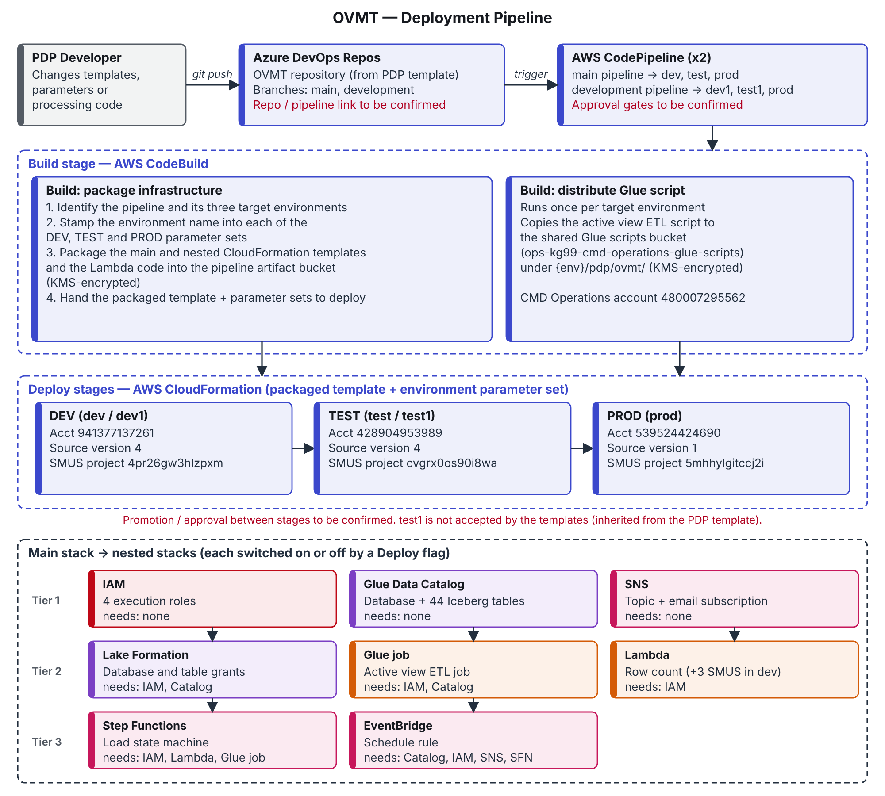
Figure 1: OVMT deployment pipeline

Configuration model. Every deployment parameter falls into one of four classes. The template defines the classes: anything that is a placeholder in the template is source-specific, and anything that varies between the three parameter sets is environment-specific.

Table 6: Deployment parameter classes

Class | Parameters | Set in | OVMT values
Fixed (platform) | Organization, eApplication ID, owner, cost centre, medallion layer, CMD Operations account / scripts bucket / KMS key, unibucket parameter path, Deploy flags | Main template defaults | cra, kg01, pdp, 609110600, bronze, 480007295562, all Deploy flags on
Source-specific | Source identifier, source version, project name, build data source name, spoke table definitions | Parameter sets, build settings, catalog template | ovmt; 4 / 4 / 1; ovmt-repo; 44 tables
Environment-specific | Environment name, Data Engineer role, SMUS project and project role, Glue assets location; resolved at deploy time: hub environment name and letter, network subnets, unibucket, hub project ID, Glue connection and security configuration | Parameter sets, environment mappings, ADLH and Landing Zone parameters | See the environment matrix (2.6)
Pipeline-supplied | Artifact bucket, artifact KMS key, pipeline name, scripts bucket, target environment | CodeBuild project settings (outside the repository) | To be confirmed

Source version differences. The source version (4 in DEV and TEST, 1 in PROD) selects which OVMT version is read from the hub and is part of the name of the spoke database, the S3 prefix and the job, state machine, schedule and function names. It does not change the table definitions, the processing logic or the permissions: the same 44 tables are deployed for both versions. Role and topic names do not include the version, so only one OVMT version can be deployed per environment. Confirm that hub OVMT versions 4 and 1 have the same schema; a difference would cause PROD table loads to fail.

Environment differences. Environments differ only in the values in the environment matrix (2.6). The one structural difference is that the SMUS publication functions are deployed in DEV only.

Execution Pipeline and Configuration
In each environment, an Amazon EventBridge rule starts the AWS Step Functions load state machine with the run input (Figure 2). The state machine:
- emails a start notice through Amazon SNS;
- runs the AWS Glue job and waits for it to finish. The job reads each hub table through Lake Formation, builds the active view and overwrites the matching spoke Iceberg table, then writes the load audit table and a run summary;
- invokes the row-count Lambda function, which turns the run summary into a row-count table;
- emails the completion notice with that table. If the Glue job fails, it emails a failure notice with the error and console links instead.

Publication path (DEV only, manual). Separately from the load, the SMUS publication functions register the spoke database as a SMUS data source and publish a data product of its assets. After that, SMUS refreshes the asset metadata daily. Data stays in S3 and is accessed under the Lake Formation grants.
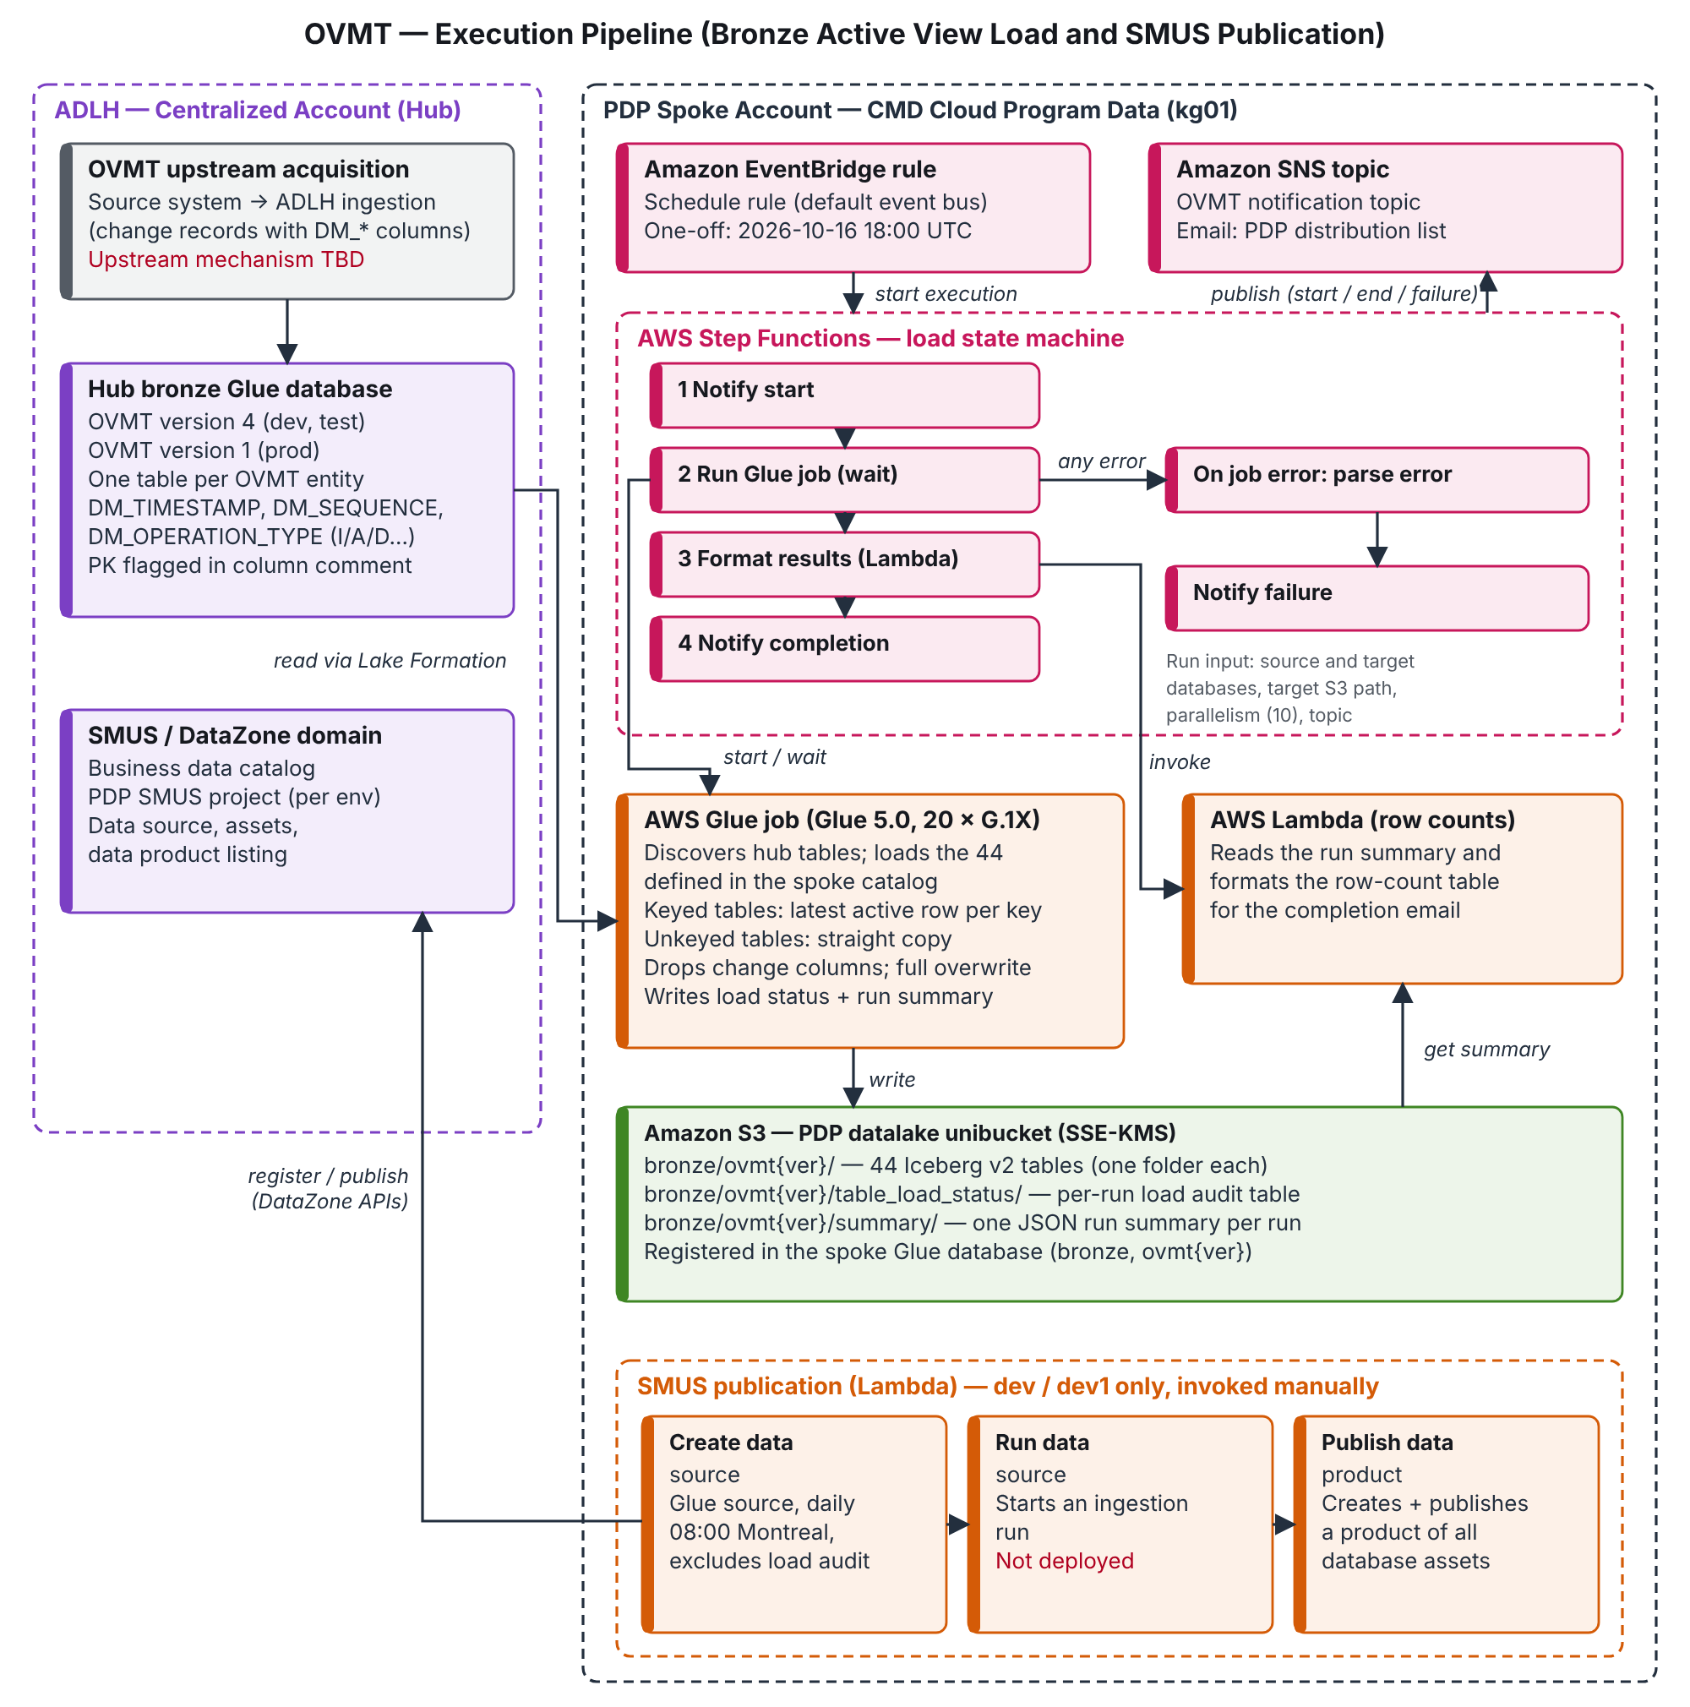
Figure 2: OVMT execution pipeline

Table 7: Execution configuration

Setting | Value | Varies by environment?
Trigger | EventBridge rule on the default event bus; one-off cron for 2026-10-16 18:00 UTC (14:00 EDT); enabled | No (hard-coded). Target frequency to be confirmed.
Run input | Hub source database, spoke target database, spoke S3 path, parallelism 10, SNS topic | Names only (environment and version)
Glue job | Glue 5.0, 20 × G.1X workers, 8-hour timeout, no retries, one concurrent run, bookmarks off | No
Parallelism | 10 tables at a time on scheduled runs; job default 5 if started directly | No
Row-count function | 128 MB, 2-minute timeout, runs in the Landing Zone application subnets | Subnets only
Notifications | One SNS topic; email to the PDP distribution list (start, completion or failure) | No
SMUS publication | Manual; data source refresh daily at 08:00 America/Montreal | DEV only

The run input fields and the load audit and run summary formats are detailed in Appendix C.

Component Information
Components are grouped by function. Each component is named for the AWS and Azure services it contains; a service can appear in more than one component when it plays different roles (AWS Lambda is used for both row counting and SMUS publication).

Component 1 Name: Azure DevOps Repos, AWS CodePipeline, AWS CodeBuild and AWS CloudFormation

Description:
These services are grouped because together they form the deployment path: they hold the OVMT design as code and turn it into running resources. None of them touches OVMT data.
- Azure DevOps Repos holds the OVMT repository: infrastructure templates, environment parameter sets, the Glue script and the Lambda code.
- AWS CodePipeline detects a push and runs the build and deploy stages for the three environments served by that branch.
- AWS CodeBuild prepares each environment’s parameter set, packages the templates and Lambda code, and distributes the Glue script to the shared scripts bucket.
- AWS CloudFormation creates or updates the OVMT main stack and its nested stacks in each environment, in dependency order, and rolls back on failure.

Developers change OVMT only through the repository; console changes would be overwritten on the next deployment. 3.2.1 describes the flow and the configuration model.

Frequency:
On each push to the main or development branch. Release and approval process for PROD to be confirmed.

Internal Dependencies:
- Packaging must finish before deployment; the Glue script must be distributed before the first load runs.
- Nested stacks deploy in three tiers (IAM, catalog and SNS first; then grants, Glue job and Lambda; then state machine and schedule).

External Dependencies:
- Pipeline and CodeBuild project settings, which are outside the repository.
- ADLH and Landing Zone parameters resolved at deployment, and the CMD Operations scripts bucket.

Constraints:
- The development pipeline cannot deploy test1 (inherited from the template).
- Fixed resource names allow only one OVMT stack per environment and account.

Security:
- Templates, Lambda code and the Glue script are stored KMS-encrypted.
- No credentials are kept in the repository; deployments run under the pipeline role (to be confirmed).

Exception/Reject Files:
- A failed build stops the pipeline; a failed deployment rolls the stack back to its previous state. No reject files.

Technologies Used:
Cloud: Azure DevOps Repos, AWS CodePipeline, AWS CodeBuild, AWS CloudFormation, Amazon S3, AWS KMS.

Volume Estimation:
One main and eight nested stacks per environment, about 64 resources in DEV and 61 in TEST and PROD.

Component 2 Name: Amazon S3, AWS Glue Data Catalog, AWS Lake Formation, AWS IAM and AWS KMS

Description:
These services are grouped because together they define where OVMT data lives and who can reach it. They are the persistent foundation that every other component reads from or writes to.
- Amazon S3 stores the spoke bronze data in the PDP datalake unibucket: one folder per table, the load audit table and the run summaries.
- AWS Glue Data Catalog registers the spoke bronze database and its 44 Apache Iceberg tables with explicit schemas. The load audit table is added by the Glue job on its first run.
- AWS Lake Formation controls access to the spoke database and tables: full access for the Glue role and the Data Engineer role, read-only access for the PDP SMUS project. It also governs PDP’s read access to the hub source database.
- AWS IAM provides the four execution roles used by the Glue job, the row-count function, the schedule and the state machine.
- AWS KMS encrypts data and catalog metadata with the ADLH-managed lake and catalog keys.

Spoke tables carry no change-tracking columns and are not partitioned. Each holds only the current active records.

Frequency:
Defined at deployment; data refreshed on each load run (Component 4).

Internal Dependencies:
- Created before the Glue job, state machine and schedule.
- Components 4 and 5 depend on the tables and grants existing.

External Dependencies:
- The ADLH unibucket, its Lake Formation registration and the KMS keys.
- ADLH granting PDP read access to the hub OVMT database. Mechanism to be confirmed.
- The Data Model for the 44 table schemas.

Constraints:
- Schemas are static: a hub schema change requires a matching catalog change, otherwise that table fails to load.
- Table descriptions are placeholders and flow into SMUS asset metadata.

Security:
- Access is enforced by Lake Formation; SMUS consumers are read-only.
- Grants carry the grant option, which is broader than needed (inherited from the template).
- Data classification: to be confirmed.

Exception/Reject Files:
- None. Catalog or grant failures surface as deployment failures (Component 1).

Technologies Used:
Cloud: Amazon S3, AWS Glue Data Catalog, Apache Iceberg v2, AWS Lake Formation, AWS IAM, AWS KMS.

Volume Estimation:
1 database; 44 business tables (585 columns) plus 1 audit table; 7 Lake Formation grants; 4 IAM roles. Row counts and storage: to be captured from the first full run.

Component 3 Name: Amazon EventBridge, AWS Step Functions, AWS Lambda (row count) and Amazon SNS

Description:
These services are grouped because together they run, sequence and report on each load. They decide when a load happens and tell people how it went, but do not transform data themselves.
- Amazon EventBridge holds the schedule rule that starts a load and passes the run input.
- AWS Step Functions sequences the run: start notice, Glue job (waiting for it to finish), row-count summary, completion notice. A job failure is routed to a failure notice.
- AWS Lambda (row count) reads the run summary written by the Glue job and formats a row-count table, with lists of skipped and failed tables, for the completion email.
- Amazon SNS delivers the start, completion and failure emails to the PDP distribution list.

Tables that fail inside a run that otherwise completes are reported in the completion email, not as a failed run.

Frequency:
Currently a one-off run (2026-10-16 18:00 UTC). Target frequency to be confirmed. Runs can also be started manually.

Internal Dependencies:
- The Glue job (Component 4) and the run summary it writes.
- The IAM roles (Component 2).

External Dependencies:
- Confirmation of the SNS email subscription by the distribution list.
- Completion of the ADLH hub load before each run; there is no automatic check.

Constraints:
- The schedule is hard-coded in UTC and identical across environments.
- Only one load can run at a time; a second start fails at the Glue step.

Security:
- Emails contain table names, counts and error messages, but no record-level data.
- The state machine role has broader SNS and SQS rights than needed (inherited).

Exception/Reject Files:
- Glue job failure: failure email, but the run still ends as “Succeeded” (inherited).
- Row-count function or email failure: the run fails with no email; check the Step Functions console.

Technologies Used:
Cloud: Amazon EventBridge, AWS Step Functions, AWS Lambda (Python), Amazon SNS, Amazon CloudWatch Logs.

Volume Estimation:
One state machine run and two emails per load.

Component 4 Name: AWS Glue (Spark ETL with Apache Iceberg)

Description:
This component is the only one that reads and writes OVMT data, so it stands alone. It is a single generic Glue job, shared in design with all PDP sources, that copies the OVMT hub bronze database into the PDP spoke bronze database as current-state tables.
For each hub table, processed up to ten at a time:
- Tables with no spoke definition are skipped.
- Tables with a primary key (identified from the hub catalog) are reduced to their latest version per key, ordered by change timestamp and sequence, keeping only records whose latest change is an insert or add.
- Tables without a primary key are copied as they are.
- Change-tracking columns are removed and the spoke table is fully replaced. An empty result leaves the previous contents in place.
- Source and target row counts are captured; OVMT counts them by scanning the tables (see 3.1.1).

At the end of the run, the job records successful tables in the load audit table and writes a run summary listing successful, skipped and failed tables.

Frequency:
Once per load run (Component 3).

Internal Dependencies:
- Spoke tables and grants (Component 2); the script distributed by the deployment pipeline (Component 1).
- Started and monitored by the state machine (Component 3).

External Dependencies:
- A current hub OVMT database whose tables carry the change-tracking columns and primary key comments.
- The ADLH Glue network connection and security configuration, and the audit helper library.

Constraints:
- Full refresh: run time grows with the total size of the hub change history, not with daily change volume.
- Only insert and add codes count as active; confirm whether the source also uses an update code.
- A failed table does not fail the job; tables commit independently, so a run can be partially refreshed.

Security:
- Runs under the Glue execution role with Lake Formation enforcement; writes are limited to the OVMT bronze area.
- No data leaves the account.

Exception/Reject Files:
- No reject files. Each table ends as success, skipped (no spoke definition, no access, missing change columns, empty result) or failed, and is listed in the run summary and the completion email.

Technologies Used:
Cloud: AWS Glue 5.0 (Apache Spark, Python), Apache Iceberg, Spark SQL.

Volume Estimation:
44 tables per run; 20 G.1X workers for up to 8 hours (at most 160 DPU-hours). Row volumes: to be captured from the first full run.

Component 5 Name: Amazon SageMaker Unified Studio (Amazon DataZone) and AWS Lambda (publication)

Description:
These services are grouped because together they make the loaded tables discoverable to consumers. This component publishes metadata only; it does not move data.
- AWS Lambda (publication) provides functions that call the DataZone APIs: create the SMUS data source for the spoke database, run it, and create and publish the data product. A fourth function looks up an existing data product.
- Amazon SageMaker Unified Studio / Amazon DataZone catalogs the 44 tables as assets in the PDP SMUS project (the load audit table is excluded), refreshes them daily at 08:00 Montreal time, and lists the data product for subscription.

The functions are invoked manually, once per environment, after the first load. They are not part of the load state machine.

Frequency:
One-time manual setup; daily metadata refresh at 08:00 America/Montreal.

Internal Dependencies:
- Loaded spoke tables and read-only Lake Formation grants for the SMUS project (Components 2 and 4).
- The data product can only be published after the data source has created the assets.

External Dependencies:
- The ADLH SMUS domain and PDP project.
- The shared SMUS publishing role, which is not created by OVMT.

Constraints:
- Deployed in DEV only; the approach for TEST and PROD is to be confirmed (inherited).
- The run function is never deployed (inherited); the update function cannot load (OVMT defect, see 3.1.1).
- Publishing is one-time: tables added later are not added to an existing data product.

Security:
- Runs under a shared publishing role hard-coded to the DEV account (inherited).
- Consumers gain access only through SMUS subscription and the read-only grants.

Exception/Reject Files:
- Errors fail the function invocation and are logged in CloudWatch; no notification is sent.

Technologies Used:
Cloud: Amazon SageMaker Unified Studio, Amazon DataZone, AWS Lambda (Python).

Volume Estimation:
One data source, 44 assets and one data product per environment.

