Program Data Provider

<Document Title>

Version Number: 1.0
Version Date: October 3, 2025
Draft

Business Intelligence Program Data Provider (PDP)
Strategic Services Compliance Data Division (SSCD)
Compliance Management Directorate (CMD)
Information Technology Branch (ITB)
Canada Revenue Agency

Services du programme d’intelligence d’affaires (SPIA)
Division des services stratégiques et des données d’observation (SSDO)
Direction de la gestion de l'observation (DGO)
Direction générale de l'informatique (DGI)
Agence du revenu du Canada

Document Version History
Table 1: Document Version History
Version # | Version Date | Author | Revision Notes
1.0 | October 3, 2026 | Jason Ryan | Initial draft

Table of Contents
1 Document Version History 1
2 Document Overview 3
2.1 Effective Date 4
2.2 Purpose 4
2.3 Audience 4
2.4 References 4
2.5 Heading 2.5 5
3 Heading 3 5
3.1 Heading 3.1 6
3.1.1 Heading 3.1.1 6
3.1.2 Heading 3.1.2 6
3.1.3 Heading 3.1.3 6
4 Heading 4 6
4.1 Heading 4.1 6
4.1.1 Heading 4.1.1 6
5 Appendix A 6
5.1 Glossary of Terms 7
6 Appendix B 7
6.1 Appendix B Sub-heading 8
7 Document Element Templates 9
7.1 Tables 10
7.2 Figures 10

Document Overview

Effective Date
The <Document Title> came into effect on Month DD, YYYY.

Purpose
<text for Heading 2.2>

Audience
The audience for this document is:
- <group 1>
- <group 2>
- <group 3>

References
Related documents and information:
- <item 1>
- <item 2>
- <item 3>

Heading 2.5
<text for Heading 2.5>

Amazon EventBridge

The steps to navigate to Scheduled rules in Amazon EventBridge
- Log in to the AWS Management Console.
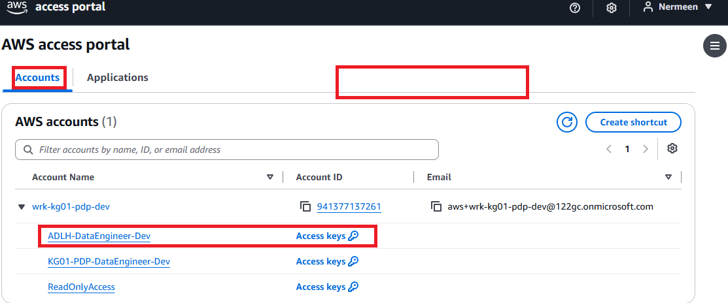
- In the search bar at the top, search for Amazon EventBridge.
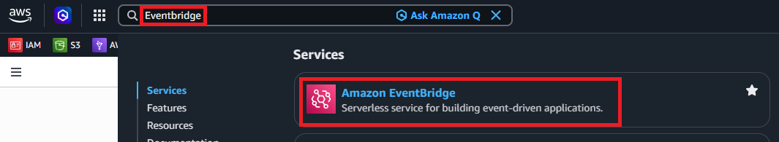
- Select Amazon EventBridge from the results.
- From the left navigation menu, select Scheduler, Scheduled rules legacy.
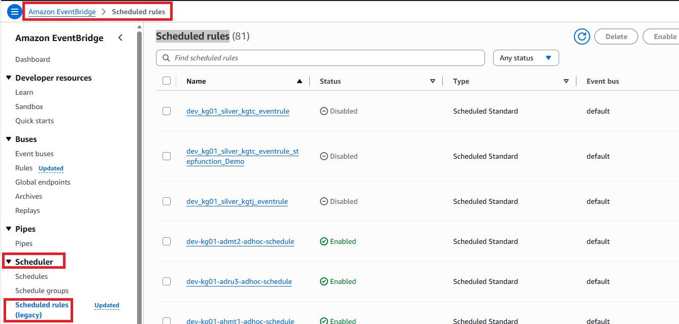
- To view existing EventBridge scheduled rules, in search bar writ AVMT
You see 2 schedules
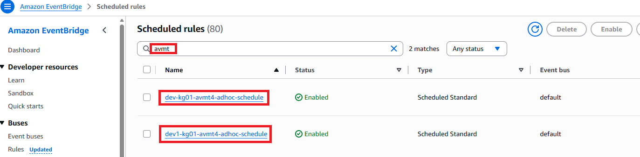
- In Dev Environment, each source DBID has 2 schedules
- Main branch dev-kg01-avmt4-adhoc-schedule.
- Development branch dev1-kg01-avmt4-adhoc-schedule.

EventBridge dev1-kg01-avmt4-adhoc-schedule

Rule details

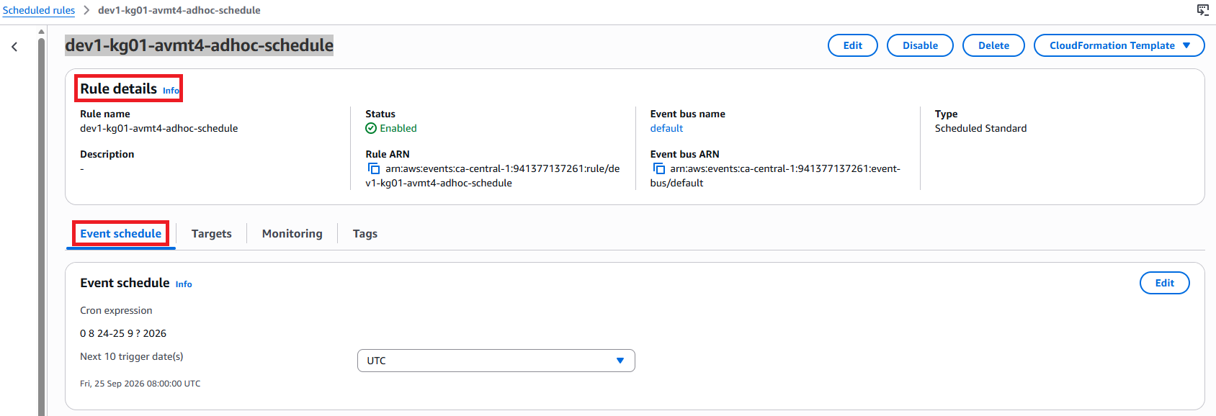
- Rule name: dev1-kg01-avmt4-adhoc-schedule
- Status: Enabled. The scheduled rule is active and can trigger at the configured time.
- Event bus: default
- Type: Scheduled Standard
- Rule ARN: The unique AWS identifier for this EventBridge rule.

Event schedule
The important part is the Cron expression.
AWS EventBridge cron expressions use the following format:
Minutes Hours Day-of-month Month Day-of-week Year
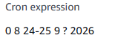
So this expression means:
- 0 → At minute 00
- 8 → At 08:00 UTC
- 24-25 → On September 24 and 25
- 9 → September
- ? → No specific day of the week
- 2026 → Year 2026
Therefore, the rule is scheduled to run at:
- September 24, 2026 at 08:00 UTC
- September 25, 2026 at 08:00 UTC

Targets
The Targets tab identifies what EventBridge invokes when this schedule fires.

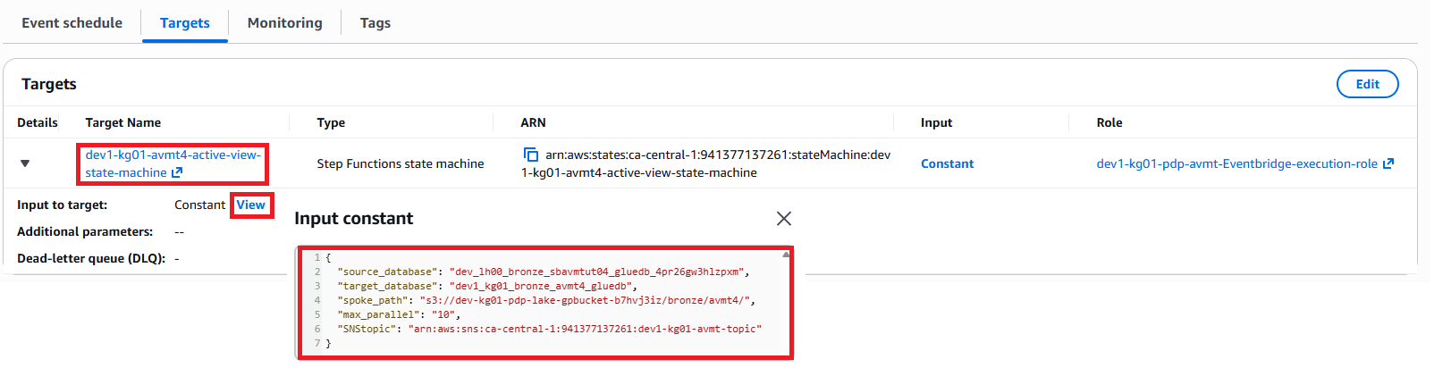
- Target Name: dev1-kg01-avmt4-active-view-state-machine.
- Type: Step Functions state machine.
- Target ARN: Points to the dev1-kg01-avmt4-active-view-state-machine in the ca-central-1 region.
- Input: Constant
EventBridge sends predefined input to the Step Functions state machine each time the rule is triggered.
- Click View beside Constant to see the actual input being passed.
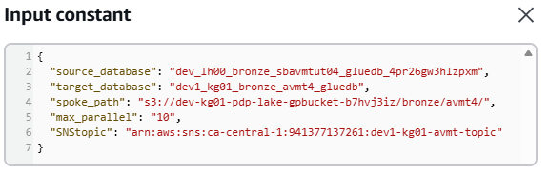
- Role: dev1-kg01-pdp-avmt-Eventbridge-execution-role
This is the IAM role EventBridge uses to get permission to start the Step Functions state machine.
Targets: The Targets tab identifies the AWS resource that is triggered by the scheduled EventBridge rule. In this example, the target is the Step Functions state machine dev1-kg01-avmt4-active-view-state-machine. When the scheduled time is reached, EventBridge uses the configured IAM execution role to invoke the state machine. Select View under Input to review the constant input parameters passed to the state machine.

AWS Stepfunction (State machines)

The steps to navigate Stepfunction.
- Sign in to the AWS Management Console.
- In the search bar at the top of the AWS Console, search for Step Functions.
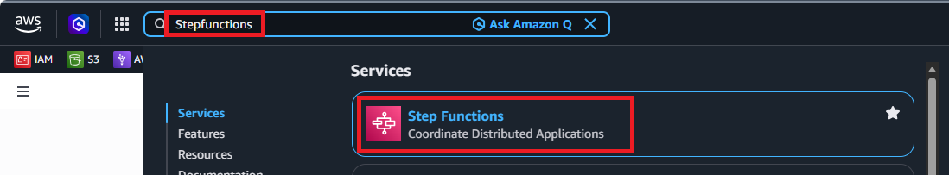
- Select Step Functions from the search results.
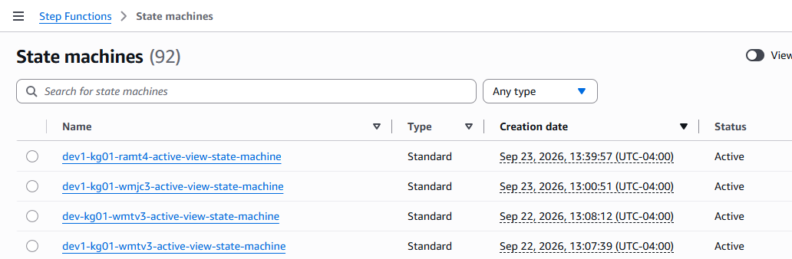

- From the left navigation menu, select State machines. A list of available state machines will be displayed.
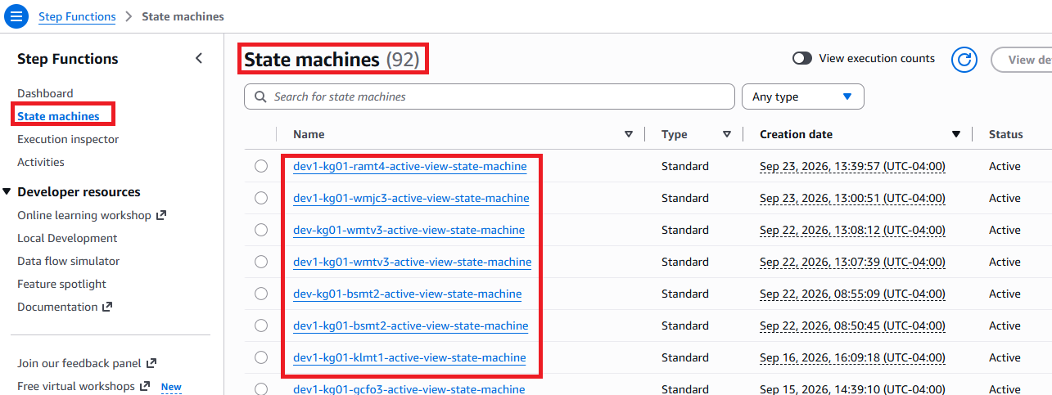

- Search for or select the AVMT4 state machine.
In Dev Environment, each source DBID has 2 state machines.
- Main branch dev-kg01-avmt4-active-view-state-machine.
- Development branch dev1-kg01-avmt4-active-view-state-machine.
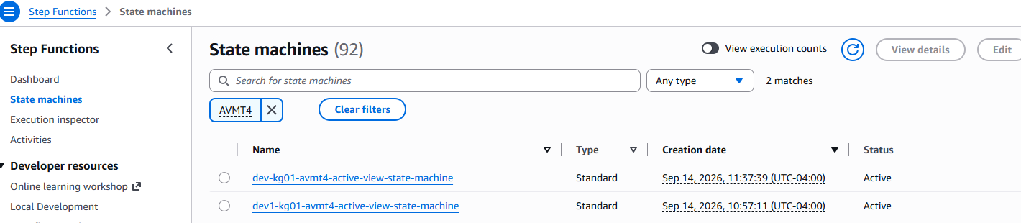
- Select dev1-kg01-avmt4-active-view-state-machine State machine details page will open.
- Arn: arn:aws:states:ca-central-1:941377137261:stateMachine:dev1-kg01-avmt4-active-view-state-machine.
- IAM execution role: dev1-kg01-pdp-avmt-Stepfunction-execution-role
- This is the IAM role that the Step Functions workflow uses when accessing or invoking other AWS resources.
- Type: Standard.
- Status: Active, meaning the state machine is available to run.
- Creation date: September 14, 2026 at 10:57:11, shown in UTC-04:00.
- Region: ca-central-1, based on the ARN.

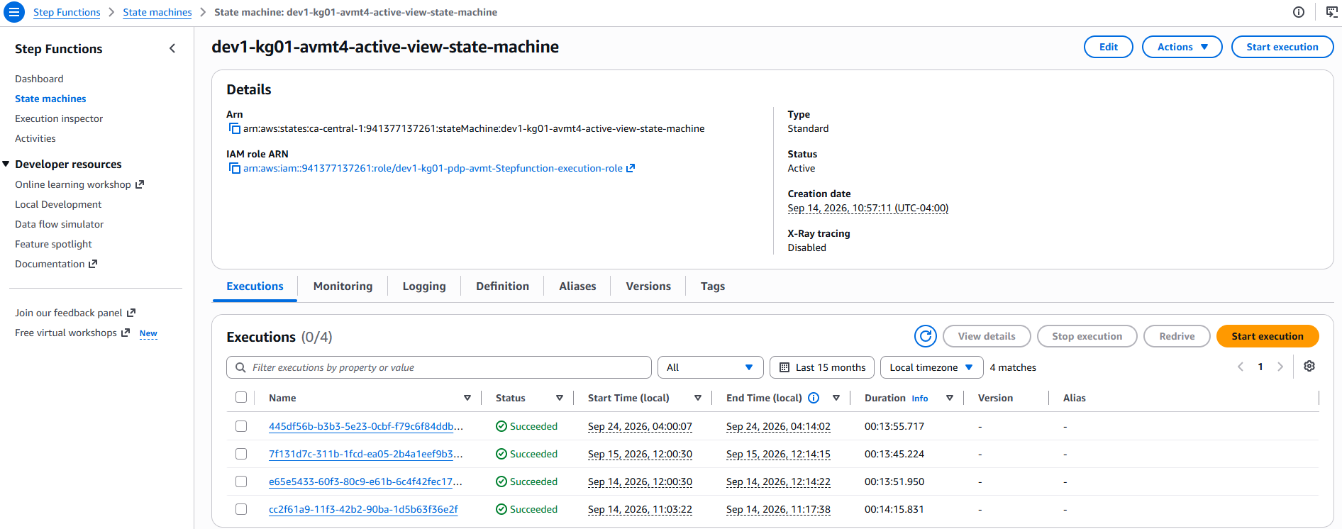

- Select the Executions tab to view previous executions and their status, such as Succeeded, Failed, or Running.
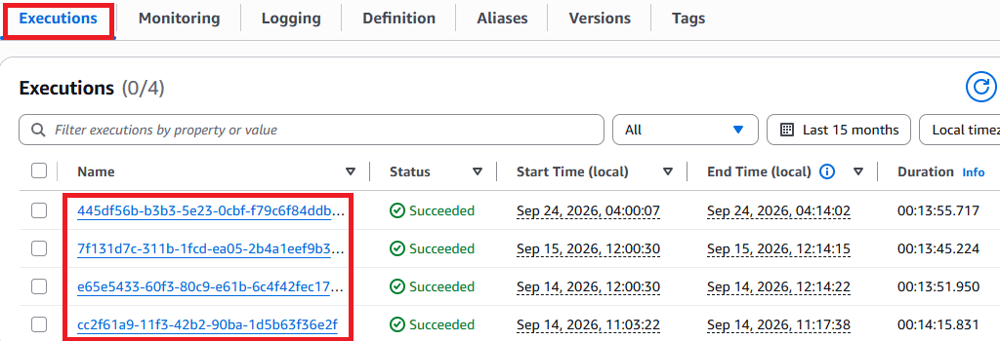

- Select an execution name to viewthe execution details and individual workflow steps.
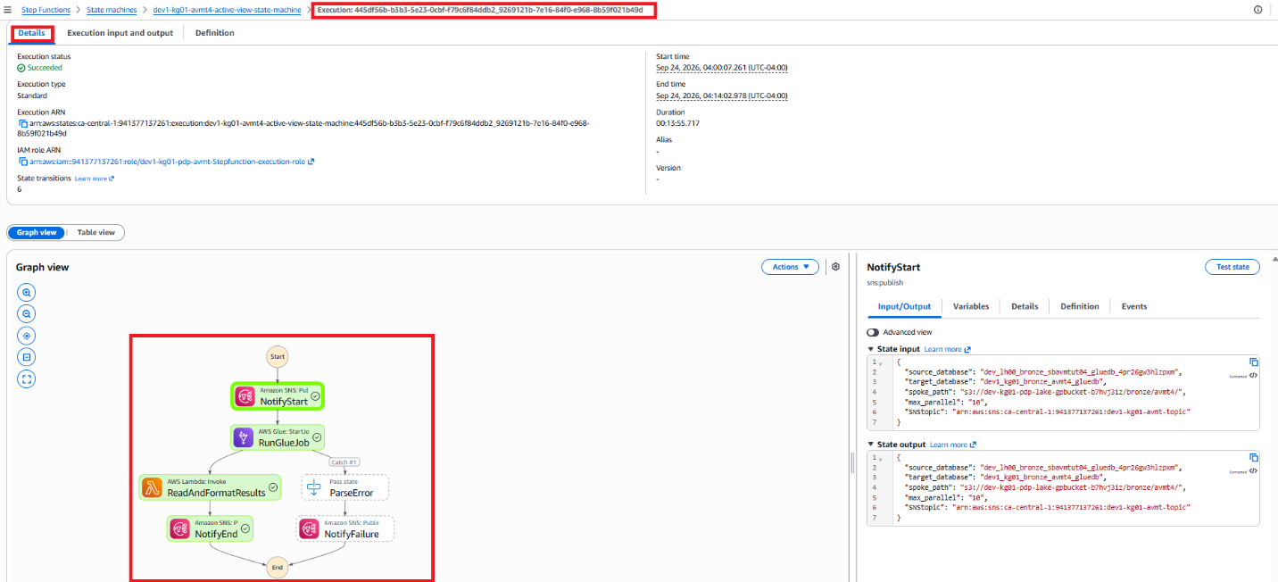
- Execution input and output
Select the Execution input and output tab to review the parameters provided to the Step Functions execution and the results returned during processing. The State input shows values such as the source database, target database, S3 path, maximum parallel processing value, and SNS topic. The State output contains the processing results, including the AWS Glue job details and execution status. This information can be used to verify the execution parameters and troubleshoot processing issues.
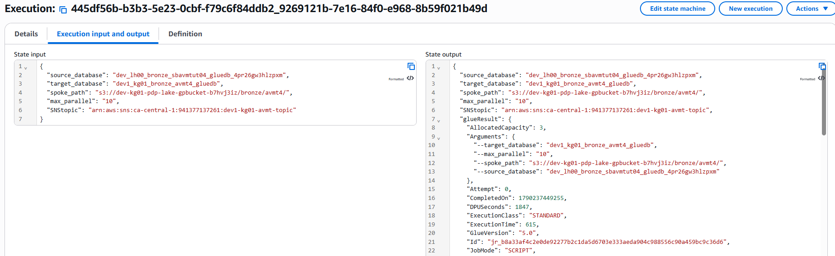
- Select the Definition tab to view the state machine workflow and understand the AWS services and processing steps configured in the state machine.
{
"StartAt": "NotifyStart",
"States": {
"NotifyStart": {
"Type": "Task",
"Resource": "arn:aws:states:::sns:publish",
"ResultPath": null,
"Parameters": {
"TopicArn.$": "$.SNStopic",
"Subject.$": "States.Format('Loading Database {} - Start Notification', $.target_database)",
"Message.$": "States.Format('********************\nStarting\n********************\nDatabase: {}\nStatus: Starting\nTime: {}\n********************', $.target_database, $$.State.EnteredTime)"
},
"Next": "RunGlueJob"
},
"RunGlueJob": {
"Type": "Task",
"Resource": "arn:aws:states:::glue:startJobRun.sync",
"ResultPath": "$.glueResult",
"Parameters": {
"JobName": "dev1-kg01-avmt4-active-view-entire-db-multi-threads-cfn-generated",
"Arguments": {
"--source_database.$": "$.source_database",
"--target_database.$": "$.target_database",
"--spoke_path.$": "$.spoke_path",
"--max_parallel.$": "$.max_parallel"
}
},
"Catch": [
{
"ErrorEquals": [
"States.ALL"
],
"Next": "ParseError",
"ResultPath": "$.glueResult"
}
],
"Next": "ReadAndFormatResults"
},
"ParseError": {
"Type": "Pass",
"Next": "NotifyFailure",
"ResultPath": "$.glueResult",
"Parameters": {
"ParsedCause.$": "States.StringToJson($.glueResult.Cause)",
"ParsedError.$": "$.glueResult.Error"
}
},
"ReadAndFormatResults": {
"Type": "Task",
"Resource": "arn:aws:states:::lambda:invoke",
"ResultPath": "$.lambdaResult",
"Parameters": {
"FunctionName": "arn:aws:lambda:ca-central-1:941377137261:function:dev1-kg01-avmt4-lambda-post-execution-row-counts-cfn",
"Payload": {
"run_id.$": "$.glueResult.Id",
"target_database.$": "$.glueResult.Arguments.--target_database",
"spoke_path.$": "$.glueResult.Arguments.--spoke_path"
}
},
"Retry": [
{
"ErrorEquals": [
"Lambda.ServiceException",
"Lambda.AWSLambdaException",
"Lambda.SdkClientException",
"Lambda.TooManyRequestsException"
],
"IntervalSeconds": 1,
"MaxAttempts": 3,
"BackoffRate": 2,
"JitterStrategy": "FULL"
}
],
"Next": "NotifyEnd"
},
"NotifyEnd": {
"Type": "Task",
"Resource": "arn:aws:states:::sns:publish",
"ResultPath": null,
"Parameters": {
"TopicArn.$": "$.SNStopic",
"Subject": "Glue Job Completed",
"MessageStructure": "json",
"Message": {
"default.$": "$.lambdaResult.Payload.message",
"email.$": "$.lambdaResult.Payload.message"
}
},
"End": true
},
"NotifyFailure": {
"Type": "Task",
"Resource": "arn:aws:states:::sns:publish",
"Parameters": {
"TopicArn.$": "$.SNStopic",
"Subject.$": "States.Format('Glue Job FAILED Database {} - Failure Notification', $.target_database)",
"Message.$": "States.Format('************** GLUE JOB FAILED **************\n\nStatus:\t\t\t{}\nTime:\t\t\t{}\n\n****************** DETAILS *****************\n\n{}\n\nView Glue Job:\nhttps://ca-central-1.console.aws.amazon.com/gluestudio/home?region=ca-central-1#/job/{}/run/{}\n\nView State Machine Execution: \nhttps://ca-central-1.console.aws.amazon.com/states/home?region=ca-central-1#/v2/executions/details/{}\n\n******************************************\n', $.glueResult.ParsedError, $$.State.EnteredTime, $.glueResult.ParsedCause.ErrorMessage, $.glueResult.ParsedCause.JobName, $.glueResult.ParsedCause.Id, $$.Execution.Id)"
},
"End": true,
"ResultPath": null
}
}
}

AWS Step Functions state machine Definition
When the state machine starts, an SNS notification is sent to indicate that processing has begun. The state machine then starts the AWS Glue job and waits for the job to complete. If the Glue job succeeds, a Lambda function processes and formats the post-execution results, including row-count information, and an SNS completion notification is sent. If the Glue job fails, the state machine captures and parses the error information and sends an SNS failure notification containing troubleshooting details and links to the Glue job and Step Functions execution.

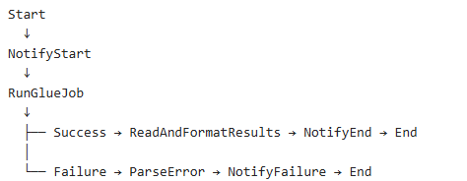

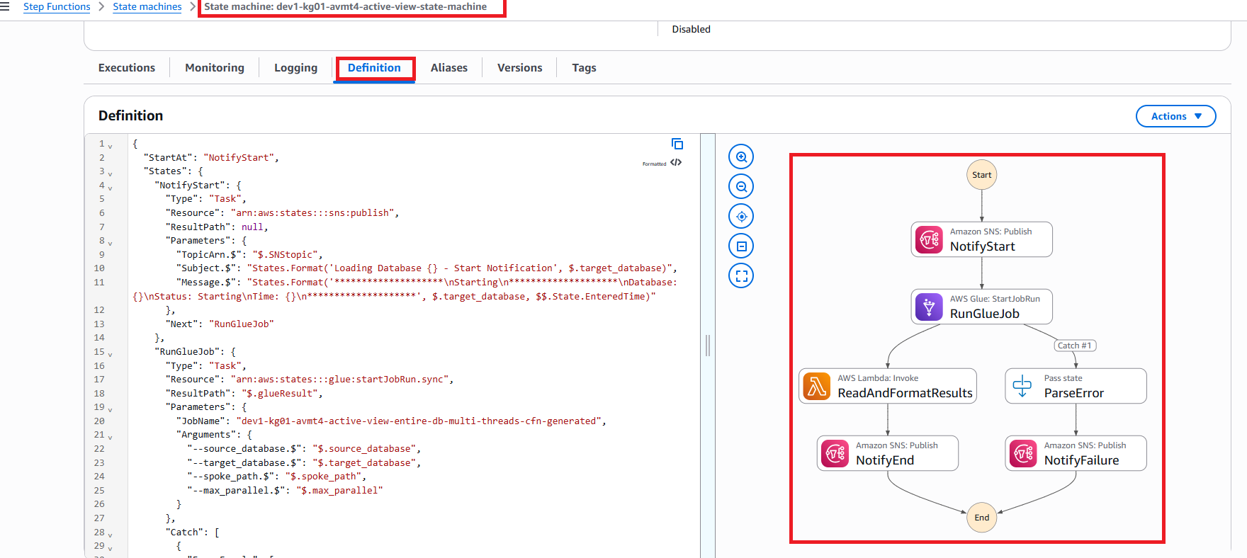

Start at NotifyStart
"StartAt": "NotifyStart"
This tells Step Functions that the first step of the workflow is NotifyStart.

NotifyStart - Send a starting notification
The first task publishes a message to Amazon SNS.
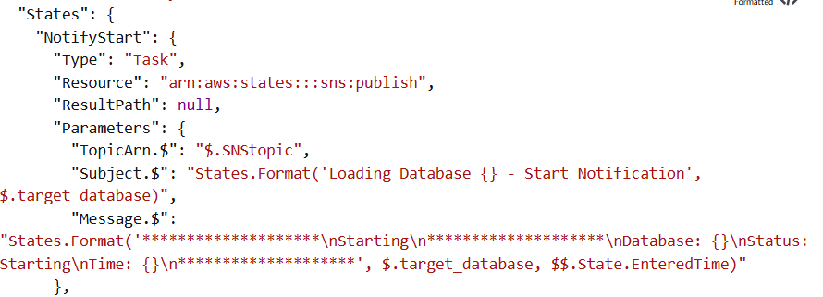
The SNS topic is obtained from: $.SNStopic
The notification subject contains the target database name:
Loading Database <target_database> - Start Notification
The message includes:
- Database name
- Status: Starting
- Time when the Step Functions state was entered
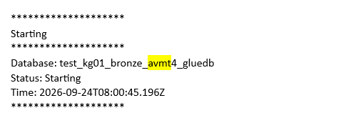
Figure 1: Example Starting email

RunGlueJob - Start the Glue job
The next step starts this AWS Glue job
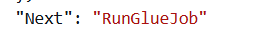
dev1-kg01-avmt4-active-view-entire-db-multi-threads-cfn-generated
The following parameters are passed to the Glue job from the Step Functions input:
- source_database
- target_database
- spoke_path
- max_parallel
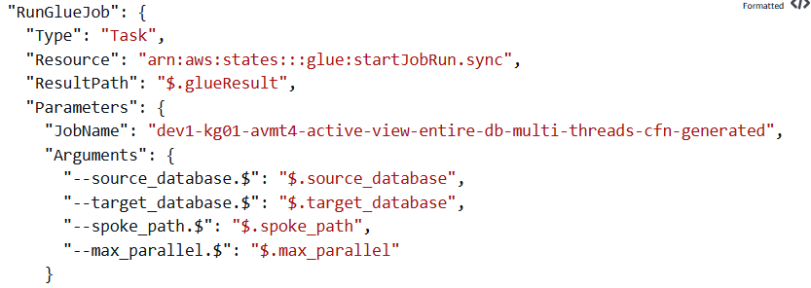
Note: .sync mean
The .sync means Step Functions waits for the Glue job to finish before continuing to the next step.
The Glue job output is stored in: $.glueResult
There are now two possible paths:
Path 1: Glue job succeeds.

ReadAndFormatResults - Run Lambda
After the Glue job succeeds, Step Functions invokes this Lambda function:
dev1-kg01-avmt4-lambda-post-execution-row-counts-cfn
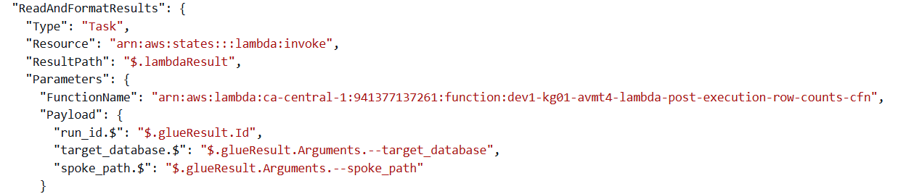The Lambda receives:
- Glue run_id
- target_database
- spoke_path
The purpose is to process the results after the Glue execution, including the post-execution row-count information indicated by the Lambda name.
The Lambda result is saved in: $.lambdaResult

Lambda retry
If the Lambda invocation encounters a temporary AWS service, SDK, or throttling error, Step Functions automatically retries the task. The retry interval starts at 1 second and increases using a backoff rate of 2. A full jitter strategy adds randomness to the retry delay to help reduce repeated throttling. The task can be retried up to three times before the execution proceeds according to its failure handling configuration.

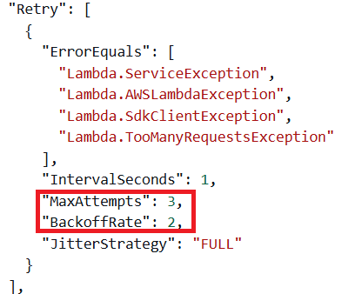
If Lambda temporarily fails because of certain AWS service errors, Step Functions automatically retries. It can retry up to 3 attempts

ErrorEquals
This specifies which errors should trigger a retry:
- Lambda.ServiceException - A Lambda service-side error occurred.
- Lambda.AWSLambdaException - An error occurred while Step Functions was communicating with Lambda.
- Lambda.SdkClientException - The AWS SDK encountered a client/communication problem.
- Lambda.TooManyRequestsException - Lambda is being throttled because too many requests are being made.

IntervalSeconds
The first retry starts with a 1-second retry interval. "IntervalSeconds": 1

MaxAttempts
Step Functions can retry the failed Lambda task up to 3 times under this retry policy.

BackoffRate
The wait time increases by a factor of 2 after each retry.
Conceptually, the retry delays grow like: "BackoffRate": 2
First retry → approximately 1 second
Second retry → approximately 2 seconds
Third retry → approximately 4 seconds
This helps handle temporary Lambda/AWS service issues.

JitterStrategy
Because JitterStrategy is enabled, the actual delays can vary rather than always being exactly 1, 2, and 4 seconds. This adds randomness to the retry delay.
The purpose is to prevent many requests from retrying at exactly the same time, which can be especially useful when Lambda is being throttled.

NotifyEnd - Send successful completion notification
After Lambda completes, Step Functions sends another SNS notification.
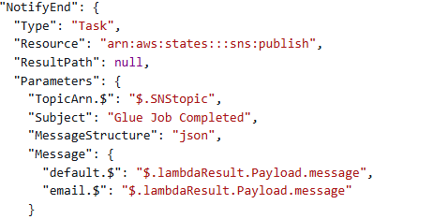
The subject is: Glue Job Completed
The message comes from: $.lambdaResult.Payload.message
So the Lambda function prepares the final message, and SNS sends that message to the configured recipients.
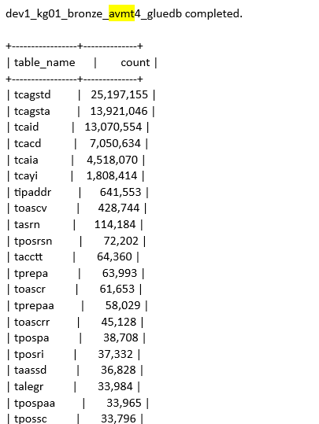
After this: "End": true

Path 2: Glue job fails
The workflow also has error handling. Inside RunGlueJob, there is:
Instead of immediately ending the state machine, Step Functions goes to: ParseError
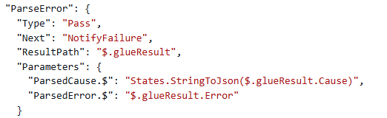

ParseError - Extract error information
ParseError processes the error returned from the failed Glue job.
It extracts:
- The error type
- Error cause
- Error message
- Glue job information
The parsed information is put back into: $.glueResult
This makes the failure information easier for the next step to use.

NotifyFailure - Send failure notification
Finally, Step Functions publishes an SNS failure notification.
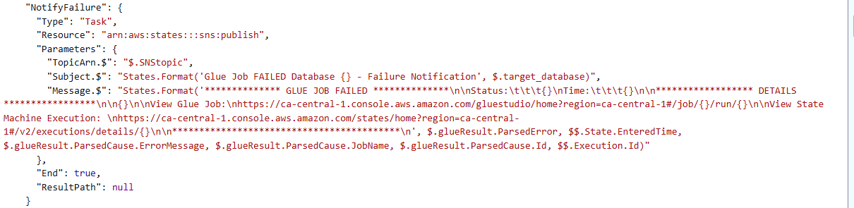The subject looks like: Glue Job FAILED Database <target_database> - Failure Notification
The message contains useful troubleshooting information, including:
- Failure status
- Failure time
- Error message
- Glue job name
- Glue job run ID
- Link to the Glue job execution
- Link to the Step Functions execution
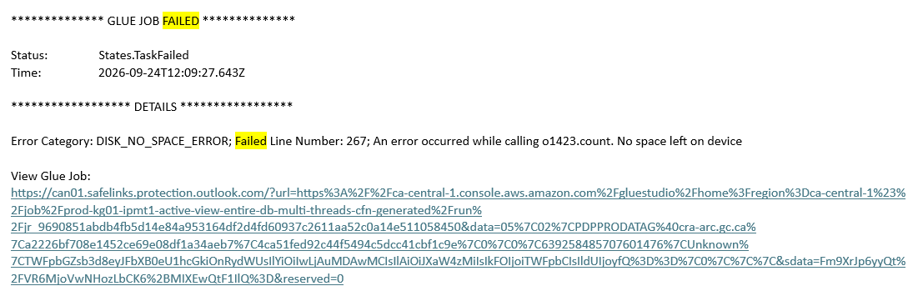After the notification is sent: "End": true. The workflow finishes.

S3 Bucket

The steps to navigate to an S3 bucket
- Sign in to the AWS Management Console.
- In the search bar at the top of the AWS Console, search for S3.
- Select S3 from the search results.
- From the left navigation menu, select General purpose buckets. A list of buckets available to your account will be displayed.
The AVMT templates reference an existing PDP data lake bucket. They do not create the bucket. In infra/templates/main-cfn.yaml, DatalakeUnibucketName is retrieved from this Systems Manager Parameter Store parameter:
/ADLH/datalake-unibucket/pdp/s3/gpbucket/name
<GO TO SYSTEMS MANAGER, PARAMETER STORE, IN THE DEV ENVIRONMENT ACCOUNT. FIND /ADLH/datalake-unibucket/pdp/s3/gpbucket/name AND RECORD ITS VALUE. COMPARE IT WITH THE BUCKET NAME IN spoke_path FROM A RECENT AVMT4 STATE MACHINE EXECUTION.>
- Search for or select the bucket identified by that parameter.
<SCREENSHOT showing the S3 bucket list and the PDP data lake bucket selected>
- S3 bucket name: <INSERT THE VALUE RESOLVED FROM /ADLH/datalake-unibucket/pdp/s3/gpbucket/name>
- S3 bucket region: <CHECK THE BUCKET DETAILS AND INSERT THE REGION>
An S3 bucket stores objects. Each object has a key, which identifies its location within the bucket. The folders displayed in the console are based on prefixes in object keys.
- Select the Objects tab and open bronze, then avmt4.
<SCREENSHOT showing the bronze/avmt4/ prefix and its contents>
The AVMT4 target path is:
s3://<resolved-data-lake-bucket-name>/bronze/avmt4/
This is the spoke_path configured in infra/templates/nested/events-cfn.yaml and passed to the Glue job through Step Functions. The Glue job also has the same path configured as a default argument in infra/templates/nested/glue-job-cfn.yaml.
The script uses spoke_path as the target Iceberg warehouse location. The source data is read through tables in source_database; spoke_path identifies the target location.
The following locations are used beneath this prefix:
- Table locations, such as bronze/avmt4/taaor/: Store the target Iceberg table’s data and metadata.
- bronze/avmt4/table_load_status: Stores the Iceberg status table created by the Glue script.
- bronze/avmt4/summary/: Stores JSON processing summaries that the post-execution Lambda reads.
<SCREENSHOT showing an example table prefix, table_load_status, and summary beneath bronze/avmt4/>
The dev and dev1 database names are different, but the S3 path generated by these templates does not include Environment. If both deployments resolve the same data lake bucket, they use the same bronze/avmt4/ prefix.
<COMPARE THE spoke_path VALUES FOR THE dev AND dev1 AVMT4 DEPLOYMENTS AND THE LOCATION OF THE SAME TABLE IN BOTH DATABASES. CONFIRM WHETHER THE DEPLOYMENTS CURRENTLY SHARE THE TARGET S3 LOCATION.>

Object details
- Select an object within the relevant prefix to open its details page.
- Review the object name, S3 URI, size, last modified time, and storage class. The S3 URI identifies the specific object, whereas spoke_path identifies the broader AVMT4 warehouse prefix.
<SCREENSHOT showing an AVMT4 object details page with its S3 URI, size, and last modified time>
The last modified time can help determine whether an object was created or updated around the time of a Glue job run. Compare it with the job run time and processing summary before drawing a conclusion. An Iceberg table can retain files from previous snapshots, so the presence of files alone does not establish which records are currently visible through the table.
The Glue script is intended to write each processing summary to:
s3://<resolved-data-lake-bucket-name>/bronze/avmt4/summary/<Glue-job-run-ID>.json
scripts/lambda/table_summary_end_of_load.py reads the summary for the run ID passed by Step Functions and formats its successful, skipped, and failed table information into a notification message.
<GO TO THE summary PREFIX AND COMPARE A SUMMARY OBJECT NAME WITH THE ACTUAL GLUE JOB RUN ID. THE SUPPLIED GLUE SCRIPT READS JOB_RUN_ID FROM args BUT DOES NOT INCLUDE IT IN THE getResolvedOptions LIST. CHECK THE DEPLOYED SCRIPT AND CONFIRM THAT THE SUMMARY USES THE ACTUAL RUN ID RATHER THAN None.json.>
- Select the Properties tab on the bucket page to review settings such as versioning and default encryption.
<SCREENSHOT showing the bucket Properties tab and the relevant settings>
- Select the Permissions tab to review the bucket’s access settings, including the bucket policy if one is present. The Glue job must have the required permissions to use the S3 locations configured for its processing.
<SCREENSHOT showing the bucket Permissions tab>
The job uses additional S3 locations outside the target warehouse:
- Glue script: The template’s default script location is s3://ops-kg99-cmd-operations-glue-scripts/dev1/pdp/avmt/kg01-pdp-bronze-active-view-entire-db-multithreads.py. This bucket is in the cmd-operations account.
- Temporary files: s3://aws-glue-assets-941377137261-ca-central-1/temporary/
- Spark event logs: s3://aws-glue-assets-941377137261-ca-central-1/sparkHistoryLogs/
- Additional Python dependency: s3://aws-glue-assets-941377137261-ca-central-1/scripts/spark_audit.py
The Glue assets locations above come from infra/params/pipeline-config-dev.json and the default arguments in glue-job-cfn.yaml. The script bucket name is a parent-template parameter and can be overridden during deployment.
<GO TO THE DEPLOYED GLUE JOB DETAILS AND CONFIRM ScriptLocation, --TempDir, --spark-event-logs-path, AND --extra-py-files. IF ACCESSING THE SCRIPT BUCKET IN S3, USE THE AUTHORIZED cmd-operations ACCOUNT ACCESS. CONFIRM THE PIPELINE'S SCRIPT-COPY DESTINATION MATCHES THE JOB'S ScriptLocation.>

AWS Athena

The steps to navigate to AWS Athena
- Sign in to the AWS Management Console.
- Check that you are in the AWS account and region containing the AVMT4 resources.
- In the search bar at the top of the AWS Console, search for Athena.
- Select Amazon Athena from the search results.
- Select Query editor.
<SCREENSHOT showing the Athena Query editor>
- At the top of the query editor, review the selected workgroup. A workgroup controls settings for the queries run through it, which may include the S3 location for query results.
The AVMT repository does not create an Athena workgroup or configure its query-result location.
<GO TO ATHENA AND CONFIRM THE WORKGROUP THAT PDP DEVELOPERS USE FOR AVMT4 IN THE DEV ENVIRONMENT. INSERT ITS EXACT NAME.>
- Workgroup: <INSERT THE VERIFIED WORKGROUP NAME>
- In the query editor, select the data source, catalog, and database that contain the table you need to inspect.
For the AVMT4 tables defined in this repository, use the AWS Glue Data Catalog data source, AwsDataCatalog. Confirm the Catalog selection displayed in the PDP account.
<SCREENSHOT showing the selected workgroup, AwsDataCatalog data source, Catalog field, and dev1_kg01_bronze_avmt4_gluedb database>
- Data source: AwsDataCatalog
- Catalog: <CHECK AND INSERT THE CATALOG SELECTION DISPLAYED IN THE CONSOLE, INCLUDING None IF THAT IS THE DISPLAYED VALUE>
- Database: dev1_kg01_bronze_avmt4_gluedb
The database name is generated by infra/templates/nested/glue-cfn.yaml. With Environment set to dev1, Eapplid set to kg01, Medallion set to bronze, and source set to avmt version 4, the generated name is dev1_kg01_bronze_avmt4_gluedb.
For the main-branch Dev deployment, the same naming convention produces dev_kg01_bronze_avmt4_gluedb.
Athena uses table definitions from the selected catalog to query data. A Glue database groups table definitions, and each table definition contains information such as column names, data types, and the data location. The database and table definitions are metadata; the underlying AVMT4 Iceberg data and metadata files are stored in S3.
The AVMT template defines tables such as taaor, taascri, and taass. Use taaor as the example table for this section.
- Table: taaor
- Expand the database in the query editor and select the table to review its columns and data types.
<SCREENSHOT showing taaor and its column list in dev1_kg01_bronze_avmt4_gluedb>
The taaor table is defined as an Iceberg version 2 table in glue-cfn.yaml. Its configured location is:
s3://<resolved-data-lake-bucket-name>/bronze/avmt4/taaor/
<CODE BLOCK FROM infra/templates/nested/glue-cfn.yaml showing GlueTableTAAOR, its Iceberg configuration, table name, S3 location, and a representative selection of columns>

The steps to run a query
- Enter a SELECT query in the query editor using the AVMT4 database and table.
<CODE BLOCK FROM THE ATHENA QUERY EDITOR showing SELECT * FROM "dev1_kg01_bronze_avmt4_gluedb"."taaor" LIMIT 10;>
- Select Run to execute the query.
- Review the query status and the Results tab. If the query succeeds, the Results tab displays the returned rows. A successful query shows that Athena was able to use the selected catalog definition and access the underlying data for that query.
<SCREENSHOT showing the query, its Succeeded status, and the Results tab>
- Select Query history to review previous queries and their status. Select a query to review its details when investigating a failed or unexpected result.
<SCREENSHOT showing Athena Query history and the details of a selected query>
Review the workgroup settings or query editor settings to identify how query results are stored. When the workgroup uses a customer S3 result location, that location is separate from the S3 location of the data being queried. A workgroup setting can override the query editor’s client-side setting.
<GO TO THE VERIFIED ATHENA WORKGROUP SETTINGS. RECORD THE QUERY-RESULT STORAGE CONFIGURATION AND, WHERE A CUSTOMER S3 LOCATION IS USED, ITS EXACT URI. CHECK WHETHER THE WORKGROUP OVERRIDES QUERY EDITOR SETTINGS.>
- Query result location: <INSERT THE VERIFIED S3 URI, OR INDICATE THAT THE WORKGROUP USES ATHENA-MANAGED QUERY RESULTS IF APPLICABLE>
Athena is useful for checking data after a Glue job has completed. For example, a developer can review the table schema, inspect a small sample of rows, or compare a table count with the processing summary reported by the workflow.
The Glue script also creates table_load_status in the target database. It stores source and target counts for tables reported as successfully processed, together with runtime identifiers and a timestamp.
<GO TO dev1_kg01_bronze_avmt4_gluedb AND CHECK WHETHER table_load_status EXISTS. IF USED FOR VALIDATION, COMPARE ITS RECORDS WITH THE SELECTED RUN'S JSON SUMMARY AND CHECK WHETHER run_id IS POPULATED CORRECTLY.>

AWS Glue Job and Database

The steps to navigate to an AWS Glue job
- Sign in to the AWS Management Console.
- Check that you are in the Dev Environment account and the ca-central-1 region.
- In the search bar at the top of the AWS Console, search for AWS Glue.
- Select AWS Glue from the search results.
- From the left navigation menu, select ETL jobs.
<SCREENSHOT showing the AWS Glue ETL jobs page>
- Search for this AVMT4 job:
dev1-kg01-avmt4-active-view-entire-db-multi-threads-cfn-generated
- Select the job to open its details.
<SCREENSHOT showing the selected AVMT4 Glue job and its details page>
This is the job referenced by the RunGlueJob task in dev1-kg01-avmt4-active-view-state-machine. Its name is generated in infra/templates/nested/glue-job-cfn.yaml and passed to the state machine through main-cfn.yaml.
The state machine passes four arguments to the job:
- source_database
- target_database
- spoke_path
- max_parallel
The values come from the state machine execution input. infra/templates/nested/events-cfn.yaml defines the constant input used by the scheduled rule.
For the dev1 AVMT4 example, the configured values are:
- source_database: dev_lh00_bronze_sbavmtut04_gluedb_<SSM-resolved-project-ID>
- target_database: dev1_kg01_bronze_avmt4_gluedb
- spoke_path: s3://<resolved-data-lake-bucket-name>/bronze/avmt4/
- max_parallel: "10"
The source database suffix is resolved from /ADLH/datazone/dev-kg01-pdp-project/project_id. The data lake bucket name is resolved from /ADLH/datalake-unibucket/pdp/s3/gpbucket/name.
<GO TO A RECENT AVMT4 EXECUTION AND RECORD THE FULL source_database AND spoke_path VALUES. COMPARE THEM WITH THE RESOLVED PARAMETERS AND CONSTANT INPUT OF THE DEPLOYED EVENTBRIDGE RULE.>
<CODE BLOCK FROM infra/templates/nested/events-cfn.yaml showing the constant execution input and the EnvMap values used to generate the source database name>
<CODE BLOCK FROM infra/templates/nested/stepfunctions-cfn.yaml showing RunGlueJob, the supplied GlueJobName, the four Arguments, and the .sync integration>
The .sync integration means Step Functions waits for the Glue job run to finish before moving to the next state. If the Glue job succeeds, the workflow proceeds to ReadAndFormatResults. If the Glue job fails, the workflow proceeds to ParseError and then NotifyFailure.

Job details
- Select the Job details tab to review the job configuration.
<SCREENSHOT showing the AVMT4 Glue Job details tab>
The repository configures the dev1 job with these settings:
- Job name: dev1-kg01-avmt4-active-view-entire-db-multi-threads-cfn-generated
- IAM role: dev1-kg01-pdp-avmt-glue-execution-role
- Job mode: SCRIPT
- Job command: glueetl
- Glue version: 5.0
- Job language: Python
- Worker type: G.1X
- Number of workers: 3
- Execution class: STANDARD
- Timeout: 480 minutes
- Maximum retries: 0
- Maximum concurrent job runs: 1
<COMPARE THESE REPOSITORY SETTINGS WITH THE DEPLOYED JOB DETAILS. RECORD ANY DIFFERENCES BEFORE FINALIZING THE SOP.>
The IAM role is created by infra/templates/nested/iam-cfn.yaml and passed to the job through main-cfn.yaml. It provides the job’s AWS permissions. The associated Lake Formation permissions are configured separately in lakeformation-cfn.yaml.
- Review the job parameters and default arguments shown in the job configuration.
<SCREENSHOT showing the Glue job parameters and default arguments>
The default arguments include the source database, target database, spoke_path, and max_parallel. Step Functions supplies those arguments again when starting a run. Review the specific run’s arguments to confirm the values used for that execution.
max_parallel is configured as "10". The script converts this value to an integer and uses it as the maximum number of threads in its table-processing thread pool.
This is different from NumberOfWorkers, which configures Glue compute capacity, and MaxConcurrentRuns, which controls how many runs of this job may execute simultaneously.
- Select the Script tab to inspect the processing code used by the job.
<SCREENSHOT showing the AVMT4 Glue job script>
The repository source file is:
scripts/glue/kg01-pdp-bronze-active-view-entire-db-multithreads.py
The job’s ScriptLocation points to the copy stored in the operations S3 bucket.
The script reads tables from source_database and loads corresponding existing tables in target_database. Where primary-key information is present in source column comments, it selects the latest record for each key and retains operation types I and A. Where no primary-key information is found, it performs a direct load. It excludes columns whose names begin with DM_.
The script records processing counts in table_load_status and writes a JSON summary containing successful, skipped, and failed tables. The post-execution Lambda reads that summary and prepares the notification message.
<CODE BLOCK FROM scripts/glue/kg01-pdp-bronze-active-view-entire-db-multithreads.py showing getResolvedOptions and the assignment of source_database, target_database, spoke_path, and max_parallel>

Job runs
- Select the Runs tab to view previous runs of the job.
<SCREENSHOT showing the AVMT4 Glue job Runs tab with run status, start time, and run ID>
- Select a run to review its status, start and end time, run ID, arguments, and available logs.
<SCREENSHOT showing the details of a selected AVMT4 Glue job run>
To match a Glue job run to a Step Functions execution, open the state machine execution and inspect its RunGlueJob step. Compare the Glue job run ID with the run ID shown in AWS Glue. This is useful when the job has run multiple times with different arguments.
If a run failed, review its error details and CloudWatch logs. Compare the error with the arguments passed by Step Functions and the paths and database names used by the script.
<SCREENSHOT showing where to open the selected job run's error details and logs>
A Succeeded job status does not necessarily mean that every source table loaded successfully. The script records several table-level failures and skipped conditions in its results without raising an exception for those conditions. Review the JSON summary and logs to determine the outcome for individual tables.
<OPEN THE SUMMARY FOR THE SELECTED RUN AND REVIEW ITS success, skipped, AND failed ARRAYS. COMPARE THE SUMMARY WITH THE GLUE LOGS AND THE POST-EXECUTION NOTIFICATION.>

The steps to navigate to an AWS Glue database
- In the AWS Glue left navigation menu, expand Data Catalog and select Databases.
<SCREENSHOT showing the AWS Glue Data Catalog Databases page>
- Search for the AVMT4 target database:
dev1_kg01_bronze_avmt4_gluedb
This database is created by infra/templates/nested/glue-cfn.yaml. Its name follows this pattern:
${Environment}${Eapplid}${Medallion}_${SourceIdentifier}${SourceIdentifierVersion}_gluedb
- Source database: dev_lh00_bronze_sbavmtut04_gluedb_<SSM-resolved-project-ID>
- Target database: dev1_kg01_bronze_avmt4_gluedb
The source database is referenced by the job and scheduled execution input. It is not created by the AVMT Glue database template.
<INSERT THE FULL SOURCE DATABASE NAME FROM THE SELECTED EXECUTION. CONFIRM THAT YOU ARE REVIEWING THE dev1 TARGET DATABASE RATHER THAN THE dev DATABASE OR THE SOURCE DATABASE.>
- Select the relevant database to view its details and tables.
<SCREENSHOT showing dev1_kg01_bronze_avmt4_gluedb and its table list>
A Glue database is a grouping of table definitions in the Data Catalog. It does not itself store the table’s data files.
The supplied glue-cfn.yaml defines 83 AVMT Iceberg tables. The Glue script additionally creates table_load_status if it does not already exist.
Select taaor to review its columns, data types, and location.
<SCREENSHOT showing the taaor schema, Iceberg table properties, and location in the Glue Data Catalog>
- Table name: taaor
- Table location: s3://<resolved-data-lake-bucket-name>/bronze/avmt4/taaor/
Compare the table location with the objects shown in S3. Athena can use the cataloged Iceberg table to query the records represented by its current table metadata.
The resources in this example work together as follows: EventBridge invokes the Step Functions state machine at its scheduled time. Step Functions passes execution values to the Glue job and waits for the run to finish. The job reads the source database and loads the target Iceberg tables. S3 stores the target table files and processing summaries. The Glue Data Catalog holds the database and table definitions, and Athena can query those tables for inspection. The post-execution Lambda reads the JSON summary and prepares the SNS completion message.
<SCREENSHOT showing the same AVMT4 example across the Step Functions execution input, Glue job run arguments, Glue table location, and S3 prefix>

Infrastructure as code
The AVMT repository defines the Glue database, tables, and job through CloudFormation templates. main-cfn.yaml connects the nested stacks and passes resource outputs between them.
The main files are:
- infra/templates/main-cfn.yaml
- infra/templates/nested/glue-cfn.yaml
- infra/templates/nested/glue-job-cfn.yaml
The processing code is stored separately in scripts/glue/kg01-pdp-bronze-active-view-entire-db-multithreads.py.

main-cfn.yaml — Parent stack
- Parameters
The parent template supplies shared values such as Environment, Eapplid, Medallion, SourceIdentifier, and SourceIdentifierVersion.
For the development-branch example, the configuration resolves to:
- Environment: dev1
- Eapplid: kg01
- Medallion: bronze
- SourceIdentifier: avmt
- SourceIdentifierVersion: 4
buildspec.yaml updates the environment configuration according to the CodeBuild initiator’s name. For an initiator ending in -development, the Dev configuration uses dev1. For one ending in -main, it uses dev.
DatalakeUnibucketName is retrieved from Parameter Store. GlueAssetLocation is supplied by the environment configuration file. The operations script bucket is supplied through CmdOpsGlueScriptsBucketName, whose default is ops-kg99-cmd-operations-glue-scripts.
<CODE BLOCK FROM infra/templates/main-cfn.yaml showing the shared parameters, DatalakeUnibucketName SSM reference, and CmdOpsGlueScriptsBucketName default>
- Resources and dependencies
GlueStack references nested/glue-cfn.yaml. It creates the target database and its predefined tables.
IamStack creates the Glue execution role. GlueJobStack references nested/glue-job-cfn.yaml and depends on GlueStack and IamStack.
The parent stack passes these outputs to GlueJobStack:
- GlueExecutionRoleArn: !GetAtt IamStack.Outputs.GlueExecutionRole
- SpokeDatabase: !GetAtt GlueStack.Outputs.GlueDatabase
This connects the job to the role and database created by the other nested stacks without hardcoding their deployed names.
LakeFormationPermissionStack receives the database name and Glue role ARN to configure target database, table, and data-location permissions.
StateMachineStack receives GlueJobStack.Outputs.GlueJobName so that RunGlueJob invokes the job created by the pipeline.
<CODE BLOCK FROM infra/templates/main-cfn.yaml showing GlueStack, GlueJobStack, their dependencies and parameter references, and the GlueJobName reference in StateMachineStack>
- Conditions
DeployGlueDB and DeployGlueJob control the deployment of the database and job nested stacks through IsDeployGlueDB and IsDeployGlueJob.
Both are set to "true" in the supplied Dev configuration.
<CODE BLOCK FROM infra/templates/main-cfn.yaml showing IsDeployGlueDB and IsDeployGlueJob, with the corresponding values from infra/params/pipeline-config-dev.json>

glue-cfn.yaml — Database and table infrastructure
- Parameters
The database template receives:
- Environment
- Eapplid
- Medallion
- SourceIdentifier
- SourceIdentifierVersion
- DatalakeUnibucketName
These values generate the database name and the S3 locations for its tables.
- Resources
GlueDatabase is an AWS::Glue::Database resource. CatalogId uses AWS::AccountId, so the database belongs to the Glue Data Catalog of the account where the stack is deployed.
DatabaseInput defines the description and name. For the dev1 AVMT4 example, the name becomes dev1_kg01_bronze_avmt4_gluedb.
<CODE BLOCK FROM infra/templates/nested/glue-cfn.yaml showing the Parameters section and GlueDatabase resource>
The template also defines 83 AWS::Glue::Table resources. Each references GlueDatabase and supplies its table name, column schema, and S3 location.
For example, GlueTableTAAOR defines:
- Table name: taaor
- Table type: EXTERNAL_TABLE
- Classification: iceberg
- Iceberg version: 2
- Metadata operation: CREATE
- Location: s3://${DatalakeUnibucketName}/${Medallion}/${SourceIdentifier}${SourceIdentifierVersion}/taaor/
The Columns section specifies the names and types expected by the table.
These resources create the database and table definitions. The Glue job subsequently loads records into the target tables. table_load_status is created by the processing script rather than by this template.
<CODE BLOCK FROM infra/templates/nested/glue-cfn.yaml showing GlueTableTAAOR, DatabaseName, OpenTableFormatInput, TableInput, Location, and representative Columns>
- Output
The template returns the created database name:
GlueDatabase: Value: !Ref GlueDatabase
main-cfn.yaml retrieves this output and supplies it to the Glue job as SpokeDatabase and to the Lake Formation stack as GlueDatabase.
<CODE BLOCK FROM infra/templates/nested/glue-cfn.yaml showing the GlueDatabase output, and from main-cfn.yaml showing where that output is passed to the other nested stacks>

glue-job-cfn.yaml — Job infrastructure
- Parameters
The job template receives the shared naming parameters, the Glue execution role ARN, the target database name, the data lake bucket name, and the operations script bucket name.
GlueMaxParallel has a default of "10". main-cfn.yaml does not pass an override for that parameter in the supplied repository.
GlueAssetLocation identifies the S3 base location used for temporary files, Spark event logs, and the additional Python dependency.
- Resources
GlueJob is an AWS::Glue::Job resource.
Its name is generated from Environment, Eapplid, SourceIdentifier, and SourceIdentifierVersion:
${Environment}-${Eapplid}-${SourceIdentifier}${SourceIdentifierVersion}-active-view-entire-db-multi-threads-cfn-generated
Role references GlueExecutionRoleArn. Command specifies glueetl and the S3 location of the Python script.
<CODE BLOCK FROM infra/templates/nested/glue-job-cfn.yaml showing GlueJob, Name, Role, ExecutionProperty, and Command>
The job uses Glue version 5.0, three G.1X workers, and STANDARD execution class. It allows one concurrent run, has no automatic job retries, and has a timeout of 480 minutes.
DefaultArguments configure the job’s source and target databases, spoke_path, max_parallel, temporary directory, logging options, and additional Python dependency. Job bookmarks are disabled.
The source database name is constructed using EnvMap and a project ID retrieved from Parameter Store. Both dev and dev1 map to the dev hub source naming pattern.
<CODE BLOCK FROM infra/templates/nested/glue-job-cfn.yaml showing EnvMap, the relevant DefaultArguments, GlueVersion, WorkerType, NumberOfWorkers, MaxRetries, and Timeout>
- Connection and security configuration
The job references an existing Glue connection through:
/ADLH/dataeng-security/glue/app_network_connection/name
Its security configuration is retrieved through:
/ADLH/datacatalog/glue/security-config/id
These references allow the job to use centrally configured connection and security resources. This template references those resources; it does not create them.
<GO TO THE DEPLOYED GLUE JOB AND CONFIRM THE RESOLVED CONNECTION AND SECURITY CONFIGURATION. REVIEW THEIR DETAILS TO IDENTIFY THE ACTUAL NETWORK AND ENCRYPTION SETTINGS.>
- Output
The template returns the created job name:
GlueJobName: Value: !Ref GlueJob
main-cfn.yaml passes this output to StateMachineStack. The state machine template substitutes it into the RunGlueJob task.
<CODE BLOCK FROM infra/templates/nested/glue-job-cfn.yaml showing GlueJobName, and from main-cfn.yaml showing its reference in StateMachineStack>
- Glue script and deployment
kg01-pdp-bronze-active-view-entire-db-multithreads.py contains the processing logic executed by the job. At a high level, it discovers source tables, processes them in parallel, loads corresponding target Iceberg tables, and writes counts and a processing summary.
buildspec.yaml packages main-cfn.yaml and its referenced deployment assets using aws cloudformation package. It produces template-export.yml and environment configuration files for subsequent pipeline actions.
buildspec-script-copy.yaml separately copies the Glue script to an environment-specific location in S3 using KMS encryption. The Glue job’s ScriptLocation must point to that copied object.
<CODE BLOCK FROM buildspec.yaml showing the CloudFormation package command and output artifacts> <CODE BLOCK FROM buildspec-script-copy.yaml showing the environment selection and aws s3 cp command for the Glue script>
<GO TO CODEPIPELINE AND THE ASSOCIATED CODEBUILD PROJECTS. CONFIRM WHICH ACTION USES EACH BUILDSPEC, THE VALUES OF ENV AND GLUE_SCRIPTS_BUCKET FOR THE SCRIPT-COPY ACTION, AND THAT ITS DESTINATION MATCHES THE DEPLOYED GLUE JOB'S ScriptLocation. ALSO CONFIRM WHICH DEPLOYMENT ACTION USES template-export.yml AND pipeline-config-dev.json.>

Heading 3
<text for Heading 3>

Heading 3.1
<text for Heading 3.1>

Heading 3.1.1
<text for Heading 3.1.1.>

Heading 3.1.2
<text for Heading 3.1.3>

Heading 3.1.3
<text for Heading 3.1.3>

Heading 3
<text for Heading 3>

Heading 3.1
<text for Heading 3.1>

Heading 3.1.1
<text for Heading 3.1.1.>

Heading 3.1.2
<text for Heading 3.1.3>

Heading 3.1.3
<text for Heading 3.1.3>

Heading 4
<text for Heading 4>

Heading 4.1
<text for Heading 4.1>

Heading 4.1.1
<text for Heading 4.1.1>

Appendix A

Glossary of Terms
This glossary contains definitions of the acronyms and abbreviations used in this document.
Table 2: Glossary
Acronym/Abbreviation | Description
ADW | Agency Data Warehouse
AWS | Amazon Web Services
BI | Business Intelligence
BPM | Business Performance Measurement
CRA | Canada Revenue Agency
eBCI | e-Business Computing Infrastructure
ETL | Extract Transform and Load
ITB | Information Technology Branch
OM&R | Operational Monitoring and Reporting
PDP | Program Data Provider
PSABA | Persistent Staging Area - Business Analytical
PSABO | Persistent Staging Area - Business Operations

Appendix B
<text for Appendix B>

Appendix B Sub-heading
<text for Appendix B Sub-heading>

Document Element Templates
This section can be removed from the document once the draft is completed.
This section contains document elements that can be copied to use elsewhere in the document to maintain consistency.

Tables
Table header row should repeat across pages.
Each table should have an associated caption, including table number and description. Caption should be placed above the table.
Table 3: Description of Table
Column 1 | Column 2 | Column 3 | Column 4 | Column 5
<value> | <value> | <value> | <value> | <value>
<value> | <value> | <value> | <value> | <value>
<value> | <value> | <value> | <value> | <value>
<value> | <value> | <value> | <value> | <value>
<value> | <value> | <value> | <value> | <value>
<value> | <value> | <value> | <value> | <value>
<value> | <value> | <value> | <value> | <value>
<value> | <value> | <value> | <value> | <value>
<value> | <value> | <value> | <value> | <value>
<value> | <value> | <value> | <value> | <value>

Figures
Each figure should have an associated caption, include figure number and description. Caption should be placed below the figure.
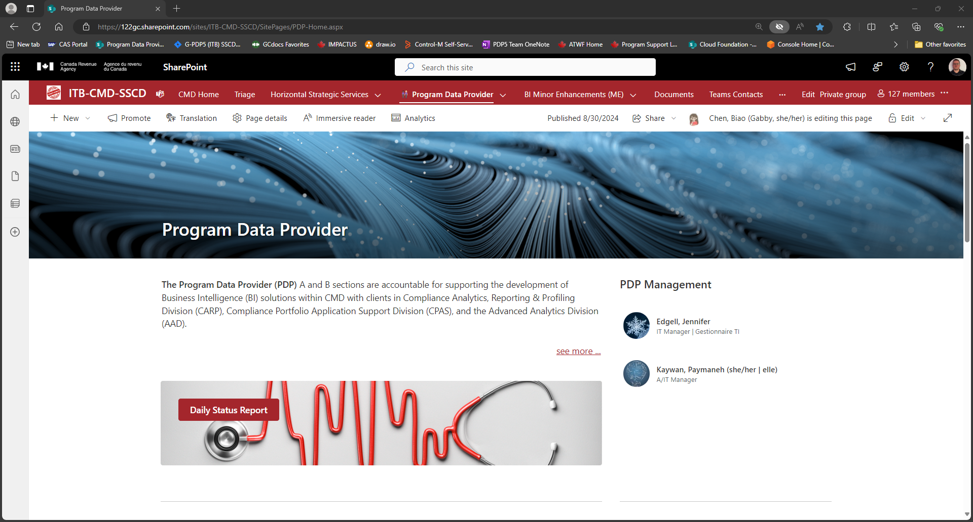
Figure 1: Description of Figure

