Program Data Provider

<Youssuf AWS Services Deep Dive>

Version Number: 1.0
Version Date: September 28, 2026
Draft

Business Intelligence Program Data Provider (PDP)
Strategic Services Compliance Data Division (SSCD)
Compliance Management Directorate (CMD)
Information Technology Branch (ITB)
Canada Revenue Agency

Services du programme d’intelligence d’affaires (SPIA)
Division des services stratégiques et des données d’observation (SSDO)
Direction de la gestion de l'observation (DGO)
Direction générale de l'informatique (DGI)
Agence du revenu du Canada

Document Version History
Table 1: Document Version History
Version # | Version Date | Author | Revision Notes
1.0 | September 28, 2026 | Youssuf Hichri | Initial draft

Table of Contents
1 Document Version History 2
Document Overview 4
1.1 Purpose 4
1.2 Audience 4
1.3 References 4
2 AWS SNS 5
2.1 What is AWS SNS? 6
2.2 Why is it used? 6
2.3 How does PDP use SNS? 6
2.4 Infrastructure as Code Example 7
2.4.1 Parameters 8
2.4.2 Resources 8
2.4.3 Output 9
2.5 Screenshots from console 9
2.6 Key observations and Architecture notes. 9
3 AWS Lambda 10
3.1 What is AWS Lambda? 11
3.2 Why is it used? 11
3.3 How does PDP use Lambda? 11
3.4 Infrastructure as Code Example 11
3.4.1 Parameters 16
3.4.2 Mappings 16
3.4.3 Conditions 16
3.4.4 Resources 16
3.4.5 Outputs 16
3.5 Screenshots from console. 16
3.6 Key observations and Architecture notes. 16
4 AWS LakeFormation 16
4.1 What is AWS LakeFormation? 17
4.2 Why is it used? 17
4.3 How does PDP use LakeFormation? 17
4.4 Infrastructure as Code Example 17
4.5 Screenshots from console. 18
4.6 Key observations and Architecture notes. 18
5 IAM Roles 18
5.1 What are IAM Roles? 19
5.2 Why are they used? 19
5.3 How does PDP use IAM Roles? 19
5.4 Infrastructure as Code Example 19
5.5 Screenshots from console. 20
5.6 Key observations and Architecture notes. 20
6 Service Interaction Summary 22
7 Appendix A 22
7.1 Glossary of Terms 22
8 Summary / Conclusion 23

Document Overview

Purpose
First piece of work assigned to coop students to gauge understanding of PDP’s workflow, deliverables, and usage of AWS Services to achieve those deliverables.

Audience
The audience for this document are the mentors assigned to onboarding new coop students:
- New PDP developers who are onboarding
- Co-op students joining the PDP development team
- Team members who are new to the AWS services and tools used within the PDP
- Developers who need a reference to better understand the PDP AWS environment, services, and development processes

References
Below is my main reference for researching the pipeline / flow of the application, and should be used as the main diagram in the context of understanding what PDP’s deliverables are:
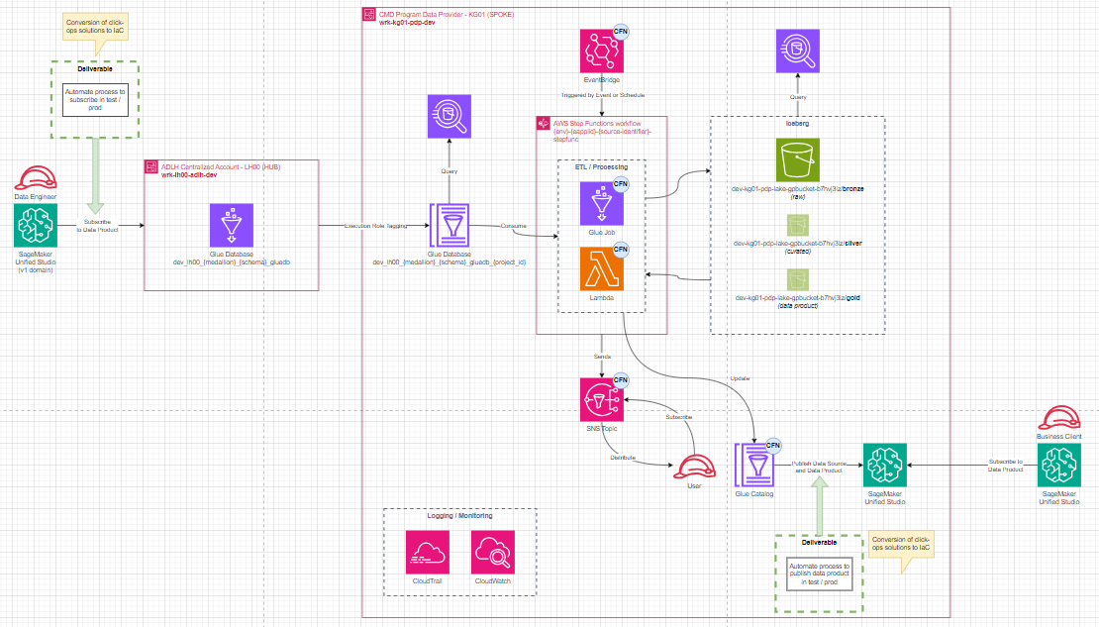
You can also find the diagram on the teams OneDrive: CPSS PDP Cloud DLD.drawio
The main data source used as the reference point was nrmt5.

AWS SNS

What is AWS SNS?
AWS SNS is a managed pub/sub messaging service used to send notifications between systems.
Some of the services SNS can integrate with are:
- Lambda subscribers
- Email
- SMS
- SQS Queries
- HTTP Endpoints
Other features SNS provide are:
- Encryption:
  - SNS encrypts data in-transit (as its being sent) by default.
  - SNS can also (optionally) encrypt data at-rest.
- Message Filtering:
  - Uses filter policies to configure the topic to publish specific messages to multiple Amazon SQS queues based on its message type.
- Message Fanout:
  - Messages are pushed to multiple subscribers at the same time.
- Message Durability:
  - Uses a DLQ (Dead Letter Queue) to capture messages that failed to send to the subscriber.
  - Needs a Redrive policy to be assigned.
- Message Archiving:
  - Allows you to store a single copy of all messages published to a topic for a specified period of time.
- Access Policy:
  - SNS uses access policies to define the users, roles, and systems that can access a topic.

Why is it used?
Assume you work on an enterprise application with live users and the application goes down for whatever reason. You would need some way for your IT team to be notified of the outage, otherwise it will go undetected, causing huge potential loss both in monetary earnings and in customers trust.
Other more technical reasons you would want to use SNS include but are not limited to:
- Decouples the application.
- Simplifying the creation of full Event-Driven applications, or simplifying the addition of event driven architecture into an application.

How does PDP use SNS?
Within PDP, SNS is used as the notification layer between components of the data-product pipeline. After ETL processing and data-product lifecycle activities occur, SNS topics are used to publish events that notify downstream services and subscribers. These notifications may indicate workflow completion, publication status changes, validation outcomes, or other operational events.
SNS helps decouple the different components of the architecture by allowing producers and consumers of events to remain independent of one another. Rather than directly invoking downstream systems, services publish messages to SNS topics, allowing subscribers such as Lambda functions and data-publication components to react to events asynchronously.

Infrastructure as Code Example
AWSTemplateFormatVersion: '2010-09-09'
Description: "This nested stack deploys Simple Notification Service (SNS) Topics"
Parameters:
Environment:
Type: String
Eapplid:
Type: String
SourceIdentifier:
Type: String
CostCentre:
Type: String
Owner:
Type: String

Resources:
SNSTopic:
Type: AWS::SNS::Topic
Properties:
TopicName: !Sub "${Environment}-${Eapplid}-${SourceIdentifier}-topic"
Subscription:
- Protocol: email
Endpoint: PDPPRODATAG@cra-arc.gc.ca
Tags:
- Key: eapplid
Value: !Ref Eapplid
- Key: owner
Value: !Ref Owner
- Key: environment
Value: !Ref Environment
- Key: costCentre
Value: !Ref CostCentre

Outputs:
SNSTopic:
Value: !Ref SNSTopic

Parameters
The parameters section is what allows the CloudFormation templates to be reusable. Instead of hardcoding values onto the template, you instead let AWS inject them at deploy time. In this case, the parameters needed for this resource to be fully deployed are the Environment (dev, dev1, test, prod), Eapplid (kg01 for pdp), SourceIdentifier (4 letter source DBID, such as nrmt), CostCentre (where the bill goes to), and finally Owner (who ownes this service).

Resources
The resources indicate everything that gets created when this template is ran. In the case of this sns template, the only thing created is an SNS Topic. Type indicates it is an AWS:SNS:Topic, then under properties we define the topics name, which follows the naming convention defined by the team. Also, under properties we define the subscription protocol, which basically dictates what type of messaging service we are opting into; in our case we want the SNS Service to send our PDPPRODATAG email address a notification email.
Then lastly, we define the tags, which are metadata attached to the resource. Tags are a key/value pair, where the key points/references the value data.

Output
Finally, outputs are just the values returned after the deployment. In this case, the returned value would be the SNS Topics ARN or the identifier.

Screenshots from console
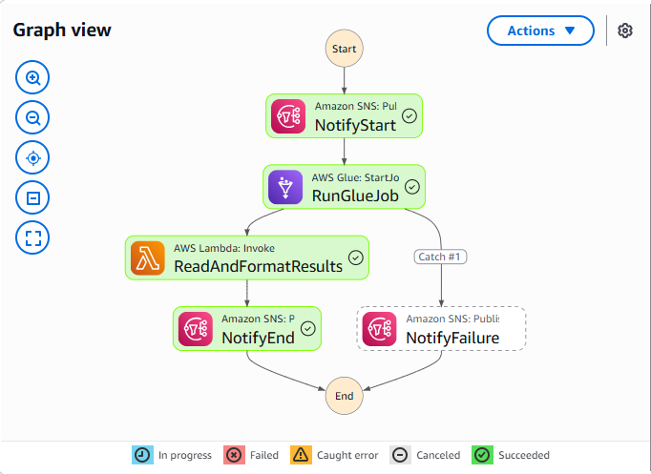

Key observations and Architecture notes.
- SNS appears to be used primarily for workflow and publication events rather than data processing.
- SNS helps integrate Glue Jobs, Lambda functions, and data product publication services.
- SNS provides a loosely coupled architecture where new subscribers can be added without modifying existing producers.
- SNS contributes to the event-driven design of the PDP platform.

Architecture Notes:
Glue job / Lambda -> SNS Topic -> Subscribers -> Publication / Validation / Monitoring

AWS Lambda

What is AWS Lambda?
AWS Lambda is a serverless compute service that allows code to run in response to events without managing servers. It runs code without needing to manage any servers and can be triggered by other services like: SNS, S3, EventBridge, API Gateway, SQS, and Scheduled events.

Why is it used?
Some reasons as to why a team would use Lambda are:
- Automatic scalability (no need to worry about resource allocation).
- Pay per use model. You only pay for when the service is being used, making this a very affordable service to use.
- Simplifies event driven architecture.

How does PDP use Lambda?
Lambda functions are primarily used to manage the data-product lifecycle rather than large-scale data transformations. Functions such as create-smus-data-source, create-update-data-product, and publish-data-product automate registration, maintenance, and publication of NRMT5 data products within the SMUS ecosystem. Additional Lambda functions perform operational tasks such as post-execution validation and row-count processing.
For a given data source, there exists a set of lambda functions that each do something different. In general, Lambda seems to be used as operational functions around the data product lifecycle, not core business transformations.

Infrastructure as Code Example
AWSTemplateFormatVersion: '2010-09-09'
Description: "This nested stack deploys lambda functions"

Parameters:
Environment:
Type: String
Eapplid:
Type: String
SourceIdentifier:
Type: String
SourceIdentifierVersion:
Type: String
LambdaRowcountExecutionRole:
Type: String

Mappings:
EnvMap:
dev1:
Name: Dev
dev:
Name: Dev
test:
Name: Test
prod:
Name: Prod
Conditions:
isDevEnv: !Or
- !Equals [!Ref Environment, "dev"]
- !Equals [!Ref Environment, "dev1"]
Resources:

LambdaFunction:
Type: AWS::Lambda::Function
Properties:
FunctionName: !Sub "${Environment}-${Eapplid}-${SourceIdentifier}${SourceIdentifierVersion}-lambda-post-execution-row-counts-cfn"
Architectures:
- x86_64
Code: ../../../scripts/lambda/
Description: pipeline generated lambda function to process format post execution role counts
EphemeralStorage:
Size: 512
Handler: table_summary_end_of_load.lambda_handler
LoggingConfig:
LogFormat: Text
LogGroup: !Sub "/aws/lambda/${SourceIdentifier}-post-execution-row-counts-cfn"
MemorySize: 128
Runtime: python3.14
RuntimeManagementConfig:
UpdateRuntimeOn: Auto
SnapStart:
ApplyOn: None
Timeout: 120
TracingConfig:
Mode: PassThrough
VpcConfig:
SecurityGroupIds:
- '{{resolve:ssm:/ADLH/dataeng-security/lambda/default-security-group/id}}'
SubnetIds:
- !Sub
- '{{resolve:ssm:/PBMMAccel/network/vpc/${EnvName}_vpc/subnet/App_${EnvName}_azd_net/id}}'
- EnvName: !FindInMap [EnvMap, !Ref Environment, Name]
- !Sub
- '{{resolve:ssm:/PBMMAccel/network/vpc/${EnvName}_vpc/subnet/App_${EnvName}_azb_net/id}}'
- EnvName: !FindInMap [EnvMap, !Ref Environment, Name]
- !Sub
- '{{resolve:ssm:/PBMMAccel/network/vpc/${EnvName}_vpc/subnet/App_${EnvName}_aza_net/id}}'
- EnvName: !FindInMap [EnvMap, !Ref Environment, Name]
Role: !Ref LambdaRowcountExecutionRole

LambdaFunctionCreateDataSource:
Type: AWS::Lambda::Function
Condition: isDevEnv
Properties:
FunctionName: !Sub "${Environment}-${Eapplid}-${SourceIdentifier}${SourceIdentifierVersion}-create-smus-data-source"
Architectures:
- x86_64
Code: ../../../scripts/lambda/
Description: Creates data source within SMUS
EphemeralStorage:
Size: 512
Handler: create_smus_data_source.lambda_handler
LoggingConfig:
LogFormat: Text
LogGroup: !Sub "/aws/lambda/${SourceIdentifier}-create-smus-data-source"
MemorySize: 128
Runtime: python3.14
RuntimeManagementConfig:
UpdateRuntimeOn: Auto
SnapStart:
ApplyOn: None
Timeout: 120
TracingConfig:
Mode: PassThrough
VpcConfig:
SecurityGroupIds:
- '{{resolve:ssm:/ADLH/dataeng-security/lambda/default-security-group/id}}'
SubnetIds:
- !Sub
- '{{resolve:ssm:/PBMMAccel/network/vpc/${EnvName}_vpc/subnet/App_${EnvName}_azd_net/id}}'
- EnvName: !FindInMap [EnvMap, !Ref Environment, Name]
- !Sub
- '{{resolve:ssm:/PBMMAccel/network/vpc/${EnvName}_vpc/subnet/App_${EnvName}_azb_net/id}}'
- EnvName: !FindInMap [EnvMap, !Ref Environment, Name]
- !Sub
- '{{resolve:ssm:/PBMMAccel/network/vpc/${EnvName}_vpc/subnet/App_${EnvName}_aza_net/id}}'
- EnvName: !FindInMap [EnvMap, !Ref Environment, Name]
Role: arn:aws:iam::941377137261:role/dev1-kg01-pdp-hgmt-smus-publish-role

LambdaFunctionCreateOrUpdateDataProduct:
Type: AWS::Lambda::Function
Condition: isDevEnv
Properties:
FunctionName: !Sub "${Environment}-${Eapplid}-${SourceIdentifier}${SourceIdentifierVersion}-create-update-data-product"
Architectures:
- x86_64
Code: ../../../scripts/lambda/
Description: Updates data product in SMUS
EphemeralStorage:
Size: 512
Handler: update_data_product.lambda_handler
LoggingConfig:
LogFormat: Text
LogGroup: !Sub "/aws/lambda/${SourceIdentifier}-create-update-data-product"
MemorySize: 128
Runtime: python3.14
RuntimeManagementConfig:
UpdateRuntimeOn: Auto
SnapStart:
ApplyOn: None
Timeout: 120
TracingConfig:
Mode: PassThrough
VpcConfig:
SecurityGroupIds:
- '{{resolve:ssm:/ADLH/dataeng-security/lambda/default-security-group/id}}'
SubnetIds:
- !Sub
- '{{resolve:ssm:/PBMMAccel/network/vpc/${EnvName}_vpc/subnet/App_${EnvName}_azd_net/id}}'
- EnvName: !FindInMap [EnvMap, !Ref Environment, Name]
- !Sub
- '{{resolve:ssm:/PBMMAccel/network/vpc/${EnvName}_vpc/subnet/App_${EnvName}_azb_net/id}}'
- EnvName: !FindInMap [EnvMap, !Ref Environment, Name]
- !Sub
- '{{resolve:ssm:/PBMMAccel/network/vpc/${EnvName}_vpc/subnet/App_${EnvName}_aza_net/id}}'
- EnvName: !FindInMap [EnvMap, !Ref Environment, Name]
Role: arn:aws:iam::941377137261:role/dev1-kg01-pdp-hgmt-smus-publish-role

LambdaFunctionPublishDataProduct:
Type: AWS::Lambda::Function
Condition: isDevEnv
Properties:
FunctionName: !Sub "${Environment}-${Eapplid}-${SourceIdentifier}${SourceIdentifierVersion}-publish-data-product"
Architectures:
- x86_64
Code: ../../../scripts/lambda/
Description: Publishes Data product in SMUS
EphemeralStorage:
Size: 512
Handler: publish_data_product.lambda_handler
LoggingConfig:
LogFormat: Text
LogGroup: !Sub "/aws/lambda/${SourceIdentifier}-publish-data-product"
MemorySize: 128
Runtime: python3.14
RuntimeManagementConfig:
UpdateRuntimeOn: Auto
SnapStart:
ApplyOn: None
Timeout: 120
TracingConfig:
Mode: PassThrough
VpcConfig:
SecurityGroupIds:
- '{{resolve:ssm:/ADLH/dataeng-security/lambda/default-security-group/id}}'
SubnetIds:
- !Sub
- '{{resolve:ssm:/PBMMAccel/network/vpc/${EnvName}_vpc/subnet/App_${EnvName}_azd_net/id}}'
- EnvName: !FindInMap [EnvMap, !Ref Environment, Name]
- !Sub
- '{{resolve:ssm:/PBMMAccel/network/vpc/${EnvName}_vpc/subnet/App_${EnvName}_azb_net/id}}'
- EnvName: !FindInMap [EnvMap, !Ref Environment, Name]
- !Sub
- '{{resolve:ssm:/PBMMAccel/network/vpc/${EnvName}_vpc/subnet/App_${EnvName}_aza_net/id}}'
- EnvName: !FindInMap [EnvMap, !Ref Environment, Name]
Role: arn:aws:iam::941377137261:role/dev1-kg01-pdp-hgmt-smus-publish-role

Outputs:
LambdaArn:
Value: !GetAtt LambdaFunction.Arn
LambdaName:
Value: !Ref LambdaFunction

Parameters
The parameters section is what allows the CloudFormation templates to be reusable. Instead of hardcoding values onto the template, you instead let AWS inject them at deploy time. In this case, the parameters needed for this resource to be fully deployed are the Environment (dev, dev1, test, prod), Eapplid (kg01 for pdp), SourceIdentifier (4 letter source DBID, such as nrmt), SourceIdentifierVersion, and finally LambdaRowcountExecutionRole.

Mappings

Conditions

Resources

LambdaFunction

LambdaFunctionCreateDataSource

LambdaFunctionCreateOrUpdateDataProduct

LambdaFunctionPublishDataProduct

Outputs

Screenshots from console.
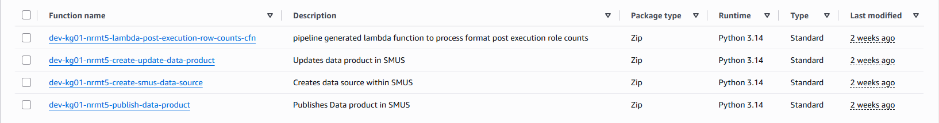

Key observations and Architecture notes.
- Lambda is used primarily for operational and orchestration activities rather than large-scale ETL processing.
- Lambda functions support metadata management, publication workflows, validation activities, and automation.
- Lambda functions appear closely integrated with the data-product publication process in SMUS.
- ETL transformations are primarily performed by Glue Jobs, while Lambda manages supporting workflow actions.
Architecture notes:
Glue Processing -> Lambda Functions: Create Data source, Create/update Data Product, Publish Data Product, Validation Tasks -> SMUS Publication.

AWS LakeFormation

What is AWS LakeFormation?
AWS Lake Formation is a managed service that simplifies the creation, governance, and security of data lakes. It provides centralized access control for data stored in Amazon S3 and metadata stored within the AWS Glue Data Catalog.
Rather than granting permissions directly to individual storage locations, administrators define permissions on databases, tables, and columns. Lake Formation then enforces those permissions across the data lake environment.

Why is it used?
Organizations use Lake Formation to:
- Centralize data governance.
- Control access to data at the database, table, and column level.
- Simplify permission management for large numbers of datasets.
- Enforce security and compliance requirements.
- Provide a single location for managing who can access trusted datasets.
Without Lake Formation, permissions would need to be managed separately across multiple services and storage locations.

How does PDP use LakeFormation?
Within PDP, Lake Formation is used as the governance layer for a data source’s datasets. Glue databases and tables are registered in Lake Formation, and access is granted through IAM roles. The dev-kg01-pdp-nrmt-glue-execution-role is authorized to access all tables in the data source’s Glue database, allowing Glue ETL jobs to process data. Additional permissions are granted to Data Engineers and Data Product publishing roles, enabling controlled access to trusted datasets while maintaining centralized security controls.

Infrastructure as Code Example
Take the following code snippet found in: lakeformation-cnf.yaml
LakeFormationDBTablePermissionToGlue:
Type: AWS::LakeFormation::Permissions
Properties:
DataLakePrincipal:
DataLakePrincipalIdentifier: !Ref GlueExecutionRoleArn
Resource:
TableResource:
DatabaseName: !Ref GlueDatabase
TableWildcard: {}
Permissions:
- ALL
This configuration grants the Glue execution role access to all tables within the NRMT Glue database. These permissions allow ETL jobs to create, update, and process tables while Lake Formation continues to enforce centralized governance controls. Consumer roles, however, are limited to reading and discovering datasets instead of modifying them.
Permissions:
- DESCRIBE
- SELECT

Screenshots from console.
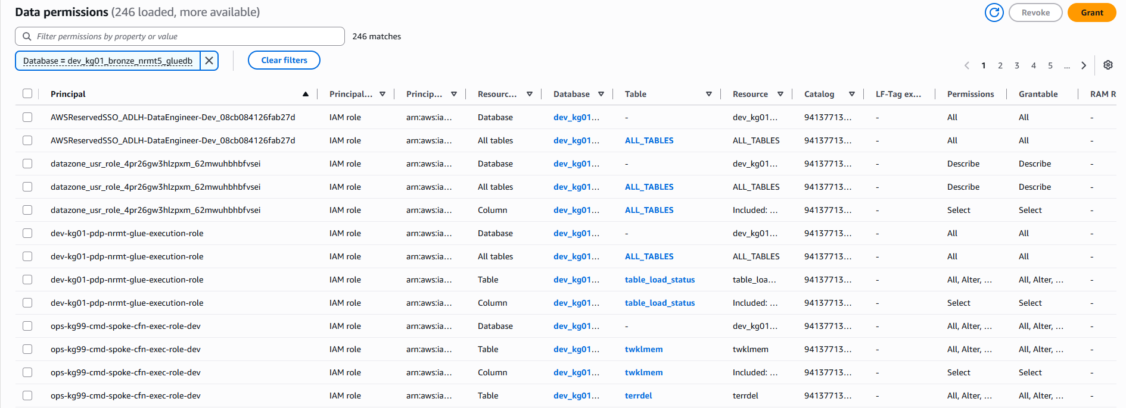

Key observations and Architecture notes.
- Lake Formation acts as the governance layer for PDP data products.
- Glue databases are registered in Lake Formation.
- Data access is granted primarily through IAM roles.
- Permissions are assigned to data engineers, ETL jobs, and publishing services.
- Lake Formation helps enforce the "single version of truth" concept by ensuring only authorized users and services can access the curated datasets.
Architecture notes:
S3 Data -> Glue Catalog -> Lake Formation -> IAM-based Permissions -> Authorized Consumers

IAM Roles

What are IAM Roles?
IAM Roles are AWS identities that provide temporary permissions to users, applications, and AWS services. Unlike IAM users, roles do not have permanent credentials. Instead, they are assumed by trusted entities when access is required.
IAM roles are commonly used by services such as Lambda, Glue, Step Functions, and EventBridge to securely access AWS resources.

Why are they used?
IAM roles are used because they:
- Eliminate the need to store long-term credentials.
- Support the principle of least privilege.
- Provide temporary, automatically rotated credentials.
- Enable secure service-to-service communication.
- Improve auditing and security management.
IAM roles are considered the standard method for granting AWS services access to other AWS resources.

How does PDP use IAM Roles?
IAM roles enforce least-privilege access throughout the pipeline. The dev-kg01-pdp-nrmt-glue-execution-role enables Glue jobs to access S3 storage, Data Catalog resources, Lake Formation permissions, CloudWatch logs, and SMUS publishing services. IAM roles serve as the primary mechanism for controlling service-to-service access.

Infrastructure as Code Example
Take the following code snippet found in: iam-cnf.yaml
GlueExecutionRole:
Type: AWS::IAM::Role
Properties:
RoleName: !Sub ${Environment}-${Eapplid}-${Owner}-${SourceIdentifier}-glue-execution-role
AssumeRolePolicyDocument:
Version: "2012-10-17"
Statement:
- Effect: Allow
Principal:
Service:
- glue.amazonaws.com
- databrew.amazonaws.com
Action: sts:AssumeRole
ManagedPolicyArns:
- arn:aws:iam::aws:policy/service-role/AWSGlueServiceRole
- arn:aws:iam::aws:policy/service-role/AWSGlueDataBrewServiceRole

This role allows AWS Glue jobs to assume the role, access S3 storage, update Glue Catalog resources, interact with Lake Formation, invoke downstream services, and publish operational events. The role follows the principle of least privilege by granting only the permissions required by the ETL workflow.

Screenshots from console.
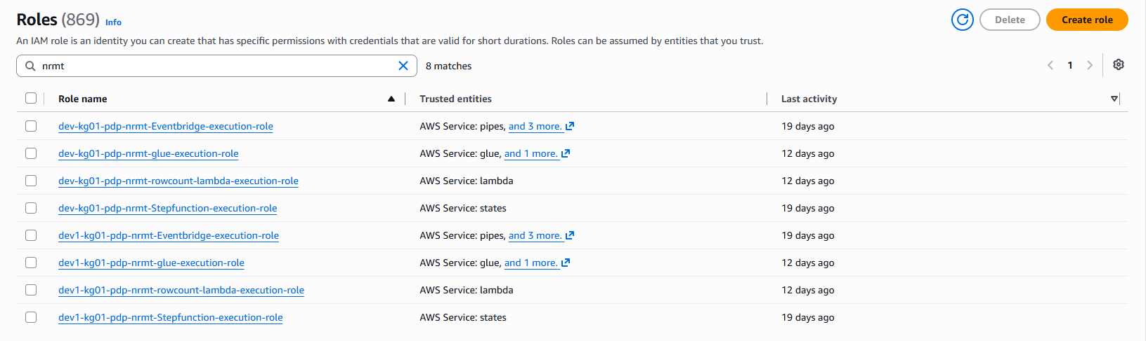
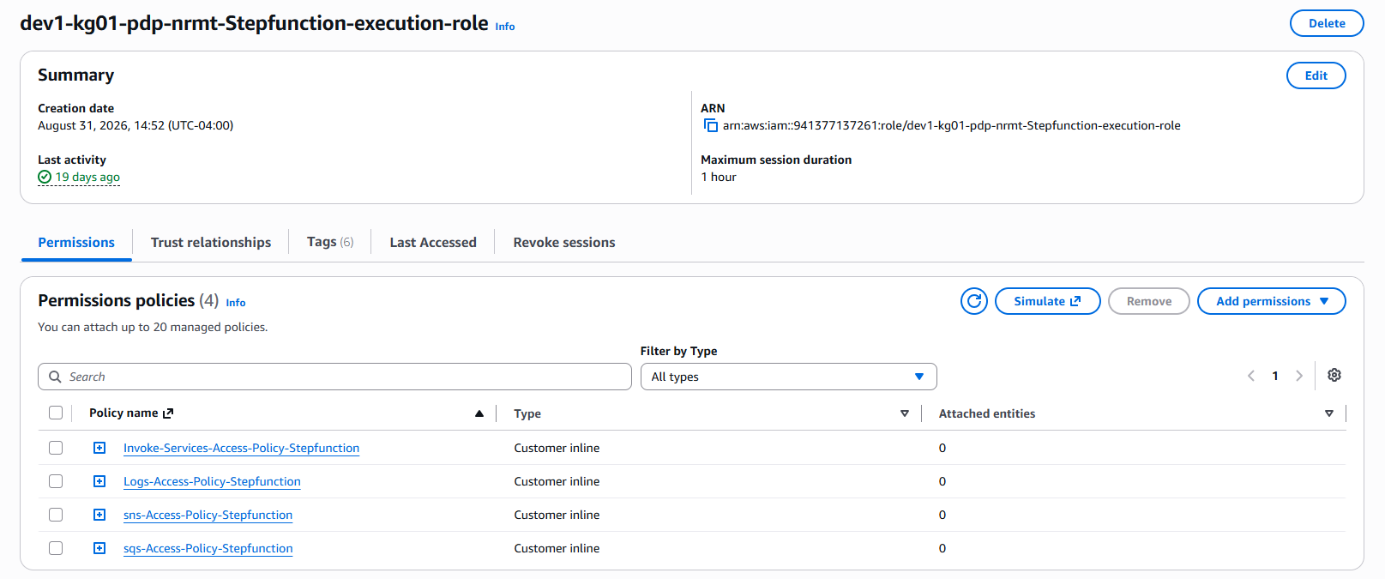

Key observations and Architecture notes.
- IAM roles are the primary security mechanism used throughout the PDP architecture.
- Every major service in the pipeline operates through an IAM role.
- The dev-kg01-pdp-nrmt-glue-execution-role provides permissions for Glue ETL jobs to access S3, Glue Catalog resources, Lake Formation-protected data, CloudWatch logging, and SMUS-related services.
- IAM roles support least-privilege access by granting only the permissions required for each component.
Architecture notes:
Glue Job -> Glue Execution Role -> Access granted to: S3, Glue Catalog, Lake Formation, CloudWatch, SMUS.

Service Interaction Summary
The four AWS services discussed in this document operate together (with other services not mentioned) to support the PDP data-product lifecycle.
- AWS Glue performs ETL processing and creates curated datasets.
- IAM Roles provide the permissions required for Glue Jobs, Lambda Functions and other services to access AWS resources.
- AWS Lake Formation governs access to Glue Catalog databases and tables, ensuring only authorized users and services can access data products.
- AWS SNS publishes workflow and publication events to downstream subscribers
- AWS Lambda automates operational activities such as data source registration, data product updates, publication, validation, and metadata management.
The simplified workflow can be represented as:
Source system -> Glue ETL Processing -> S3 Bronze / Silver / Gold Layers -> Lake Formation Governance -> SNS Notifications -> Lambda Automation -> SMUS Publication -> Data Consumers

Appendix A

Glossary of Terms
This glossary contains definitions of the acronyms and abbreviations used in this document.
Table 1: Glossary
Acronym/Abbreviation | Description
AWS | Amazon Web Services
CRA | Canada Revenue Agency
CRF | Change Request Form
ETL | Extract, Transform and Load
ITB | Information Technology Branch
JIRA | Jira issue tracking system
PDP | Program Data Provider
PROD | Production environment
SQL | Structured Query Language
SSCD | Strategic Services Compliance Data Division
TEST | Test environment
TL | Team Lead
UAT | User Acceptance Testing
pub/sub

Summary / Conclusion
PDP develops and maintains cloud-based data products that transform source system data into trusted, governed datasets for downstream consumers. Data is ingested from source systems, processed through AWS Glue ETL workflows orchestrated by EventBridge and Step Functions, and stored in Bronze, Curated, and Gold layers within Amazon S3. AWS Lake Formation governs access to the datasets through Glue Catalog resources and IAM roles. AWS Lambda functions automate data-product lifecycle activities such as registration, publication, validation, and metadata management. SNS topics are used to communicate workflow and publication events between components. The final datasets are published through SMUS, allowing consumers to discover and subscribe to authoritative data products.

