|  |  |
| --- | --- |
| File:COMSATS new logo.jpg - Wikimedia Commons  **Housing Society management System** | **Subject:**  **object oriented programming**  **submitted by:**  **Daoud Hussain**  (Sp21-bcs-102)  **Muneeb Ishaq**  (Sp21-bcs-072)  **Group name:**  **Bro-Programmers**  **submitted to:**  **mam saneeha amir**  **date of submission:**  **May 30, 2022** |

Housing Society Management System:

Introduction:

In Pakistan, Societies business booming exponentially. But, to run the business successfully, without a proper solution is close to impossible. Existing systems in the market are either too expensive or do not meet the requirements.

Online Housing Society is a console-based project used to provide guidance to the customers to choose plots according to their needs. It also helps customers to book their desired plots at reasonable rates. This console-based project also helps their customers for booking plots in installments. It is time to take advantage of the technology for a better and peaceful living.

Societies using different software for booking of the plot, Installment, Billing, and Accounting. Different system integration always remains a big challenge. Accurate data and information are key for the Societies’ business. Therefore, we would be designing one solution that would be pre-integrated for all systems. The system would be flexible to configure and accurate information would ensure via best architecture.

User can login either as an:

* + Admin
  + Customer/Member
  + Visitor

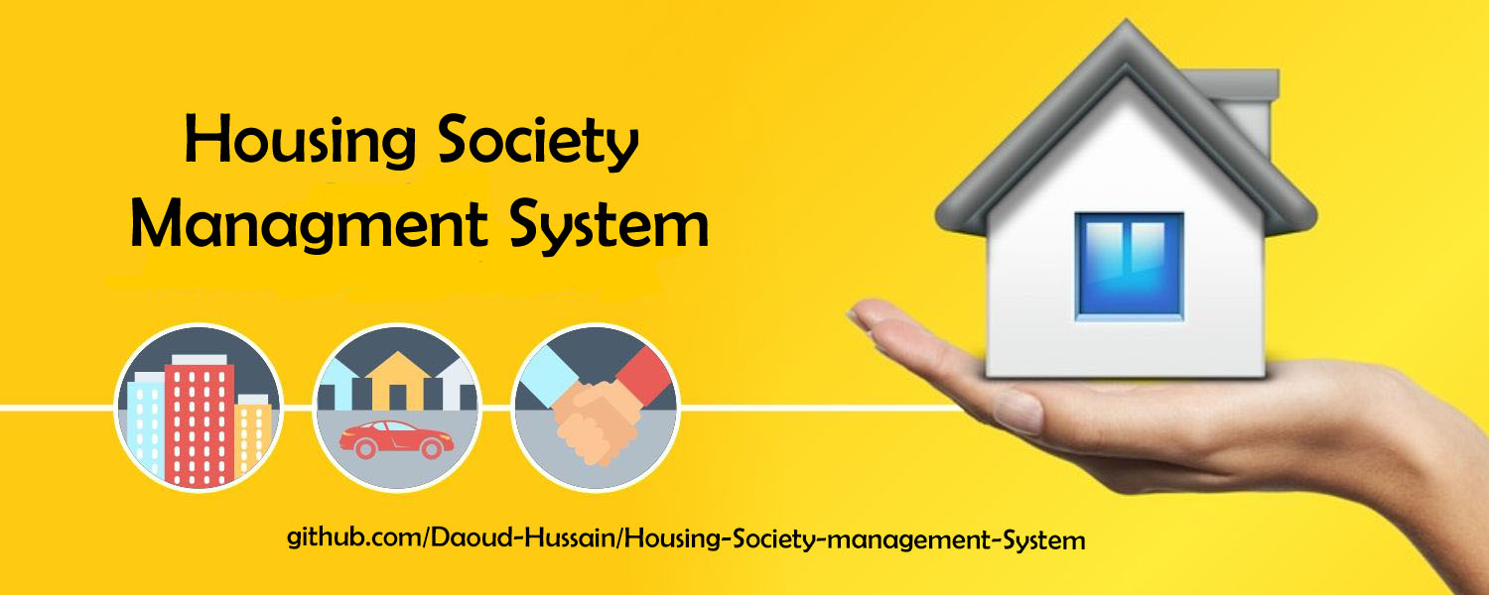

Modules:

Login / Signup

User will register and login as an admin, customer or visitor according to which all the information will be shown to him.

**Admin:**

Admin can **manage** the full system.

Admin can **create** the detail of society and detail of houses of that society.

Admin can **assign** the house to a member.

Admin can **check** the records of the members.

Admin can **manage** master data.

Admin can **update** the plots information if any plot or house get sold.

**Member/Customer:**

Customers can **search** for the property.

Customers can **sell** the property.

Customers can **buy** the property.

The customer can **maintain** his profile.

The customer can **cancel** his/her file.

Customer providing **personal** data such as

* Create Customer
* First name
* Last name
* Email Address
* Password
* Contact Info
* CNIC

**User / Visitor**

This user is a visitor, who can only **view** the system and can perform the following steps:

Users can **visit** the system.

Users can **search** for the property.

Users can also **buy** the property if he is interested in registered himself.

Common Features:

**Plot Registration:**

To register plots in society this housing society system allows users to register plots. Following are the steps

* Plots Sizes
* Rates
* Register Plots

**Search:**

People can easily search and find the plots. The customer can search the plot according to his desired requirements. Plots can be searched by using these constraints such as

* Plot Size
* Plot Type
* Plot Rates

**File Transfer:**

Members can also transfer their plots to someone but if he is not already registered then he has to first register himself. We provide this facility so if a person has an issue while paying the rest of the amount, then he can transfer his file. Then the rest of the amount will be paid by the new owner of the property.

**File Cancel:**

If a member is having some financial issues, then he can **cancel** the plot. Member will have the ease to cancel his file but his registration fee and 10% will be deducted from his paid amount.

**Accounts:**

Accounts will be managed by the admin in this functionality. All the data will be stored in files using file handling.

**Maintain Record:**

The Online Housing Society provides facilities to its customers to maintain their records. The customer’s record will be maintained properly by the admin.

The customer can update his profile.

* Update
* Delete
* Insert

**Tools and Technologies:**

Language: Java.

Editor: Sublime Text.

Paradigm: Object-Oriented Programming.

IDE’s: Eclipse, IntelliJ.

Hosted: GitHub (Private repo).