Technical Support Information
Product Function Introduction
Optic Master APP is a mobile application tool that connects and communicates with distance measurement equipment. It facilitates users to remotely control the equipment through Bluetooth connection with the equipment.
Main Function Modules
- 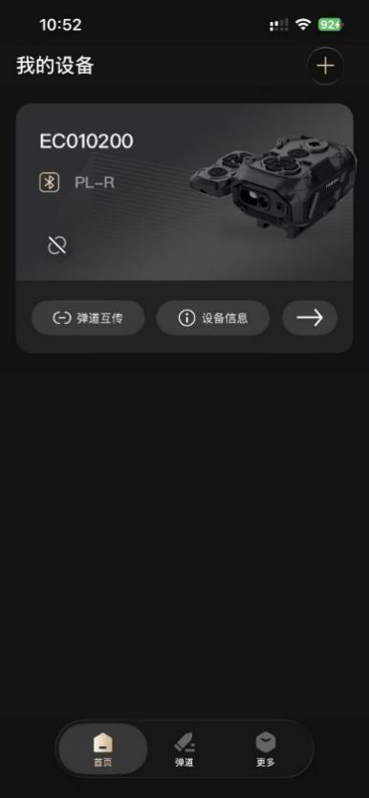
Technical Support Contact Information
If you encounter any issues during use, please feel free to contact us through the following methods:
Email: trirton@163.com
Phone: 18181449441

