AEP Summer 15: Progress report

Shared Robo-Vision

Team: Alberto Vaccari, Dapeng Lan and Yu Liu.

Introduction
RoboCup is an annual international robotics competition with the aim to promote robotics and AI research.
The AOT department of TU-Berlin has been working and participating in this competition since 2003.
After discussing with some people involved in the project, an interest in a “tool for logging matches and the behaviour of the robots” was shown.
This project was chosen as a way to improve their workflow and support their useful contribution in the field of robotics and artificial intelligence.
The main idea is to position 2 cameras overseeing the 2 sides of the football pitch, where the match will be held. Each robot will have a marker on their head to identify them, also used for tracking.
The 2 camera will be connected to a server for tracking and logging. The server will also be able to communicate with the robots through the network.
The operator will be able to see the current position of the ball and of each robot in the field, record the match and directly control a specific robot.

System Diagram
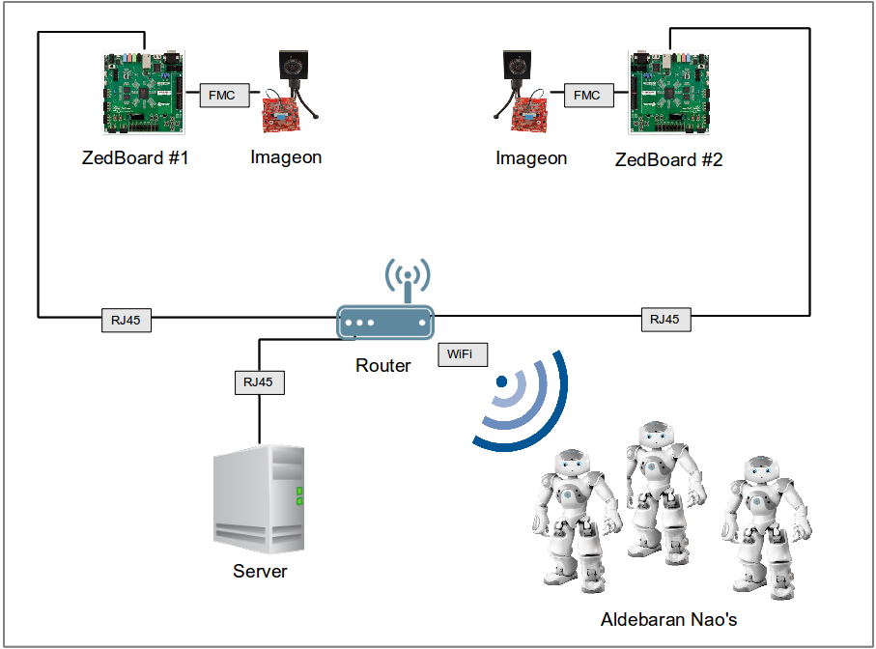

Objectives
The objectives of the project are the following:
- Transmit HD images (1920*1080) from 2 ZedBoards to a computer
- Perform some degree of image processing directly on the ZedBoards
- Track the position of the robots on the field
- Track the position of the ball on the field
- Record a match
- Replay a recorded match
- Control the movements of the robots from the server application

Roles
Alberto:
- Tracking of the robots
- Tracking of the ball
- Recording a match
- Replaying a saved match
- Communication and control of the robots
Dapeng:
- Fetching HD images from FMC-Imageon V2000C camera
- Transmission of HD images from 2 ZedBoards to the server
- Image pre-processing on the ZedBoards
Yu:
- Receiving images from the ZedBoard
- Image pre-processing on the ZedBoards

Current Status
Here is the current status of the tasks:

☑ Tracking of the robots
☑ Tracking of the ball
☑ Recording a match
☑ Replaying a saved match
☐ Communication and control of the robots
☑ Fetching HD images from FMC-Imageon V2000C camera
☐ Transmission of HD images from 2 ZedBoards to the server
☐ Image pre-processing on the ZedBoards
☑ Receiving images from the ZedBoard

Completed Partially Completed Started Not Started

Time plan
The following table shows the currently not completed tasks and their expected completion date.
Task name | Expected Completion
Communication and control of the robots | 29/06
Transmission of HD images from 2 ZedBoards to the server | 29/06
Image pre-processing on the ZedBoards | 15/07 - 20/07

