2026-2027学年第一学期
《高级语言程序设计(C++语言)》
实验报告
实验名称：C++
实验日期：2026.10.23 | 实验地点：实验室
学 号：2026302192046 | 姓 名：李明萱
学 院：人工智能学院 | 专 业：人工智能
指导老师：丁建利

一、实验目的
掌握C++分支结构；熟练运用循环结构；理解数字处理技巧；初步接触递归；熟悉结构化程序设计思想

二、实验环境
Windows 10
Visual Studio2022
C++

- 实验过程及结果
题目1.
#include<iostream>using namespace std;int main()
{
double a = 0;
double b = 0;
cout << "请输入利润" << endl;
cin >> a;
cout << "您输入的利润为:" << a << endl;
if (a > 1000000)
{
b = (a - 1000000) * 0.01 + 6000 + 6000 + 10000 + 7500 + 10000;
}
else if (a > 600000)
{
b = (a - 600000) * 0.015 + 6000 + 10000 + 7500 + 10000;
}
else if (a > 400000)
{
b = (a - 400000) * 0.03 + 10000 + 7500 + 10000;
}
else if (a > 200000)
{
b = (a - 200000) * 0.05 + 7500 + 10000;
}
else if (a > 100000)
{
b = (a - 100000) * 0.075 + 10000;
}
else
{
b = a * 0.1;
}
cout << "奖金为" << b << endl;
system("pause");
return 0;
}
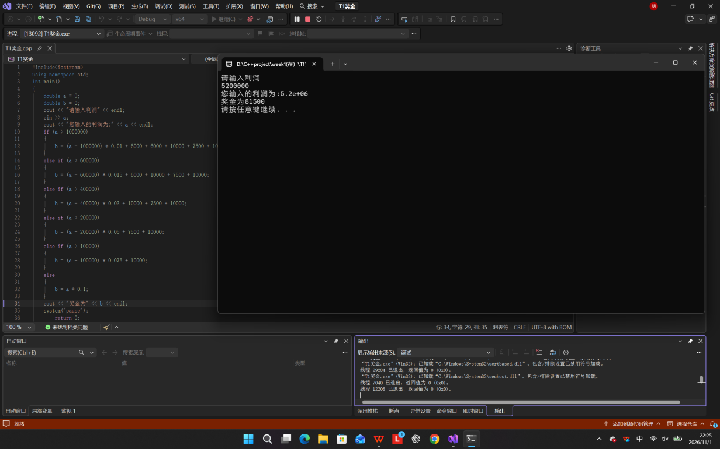

题目2
#include<iostream>using namespace std;int main()
{
int score = 0;
cout << "请给电影打分" << endl;
cin >> score;
cout << "您给出的评分是：" << score << endl;
switch (score)
{
case 10:
case 9:
cout << "经典" << endl;
break;
case 8:
case 7:
cout << "非常好" << endl;
break;
case 6:
case 5:
cout << "一般" << endl;
break;
default:
cout << "烂片" << endl;
break;
}
system("pause");
return 0;
}
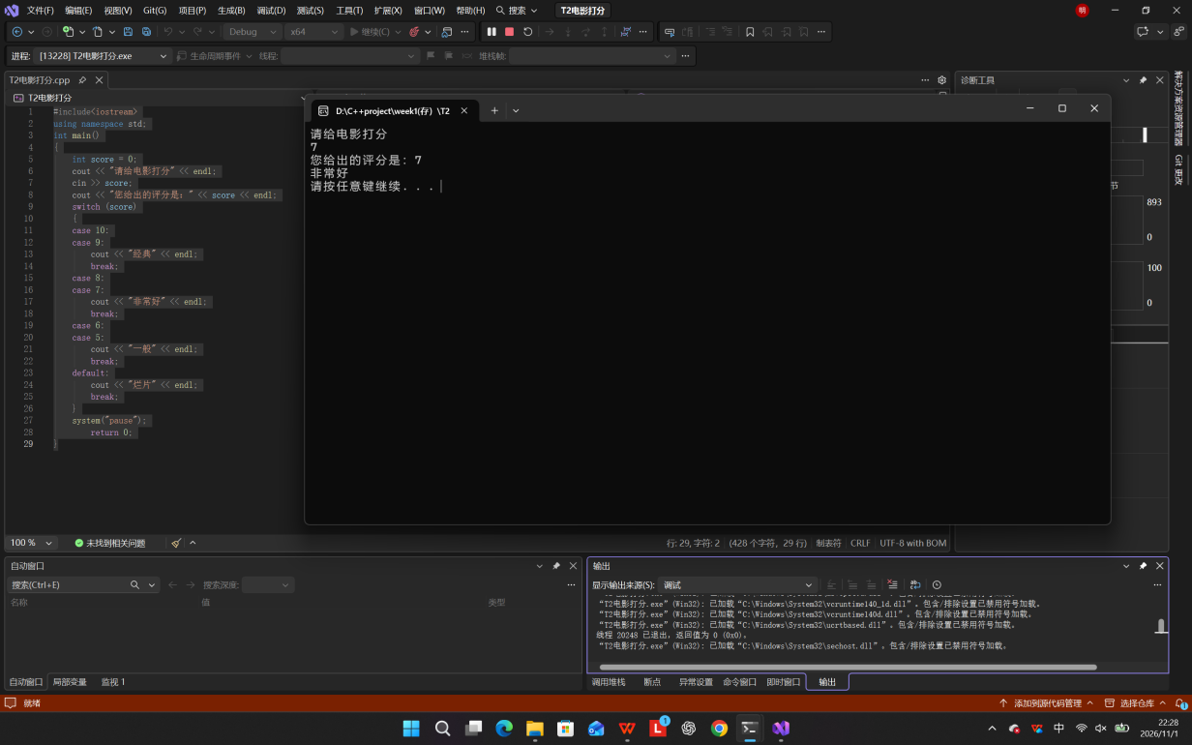

题目3
#include<iostream>using namespace std;int main()
{
int num = 0;
cout << "请输入一个数字" << endl;
cin >> num;
cout << "您输入的数字为" << num << endl;
int origin = num;
int reverse = 0;
int digit;
do {
digit = num % 10;
reverse = reverse * 10 + digit;
num /= 10;
}while(num != 0);
if (reverse == origin)
{
cout << "是回文数" << endl;
}
else
{
cout << "不是回文数" << endl;
}
return 0;

}
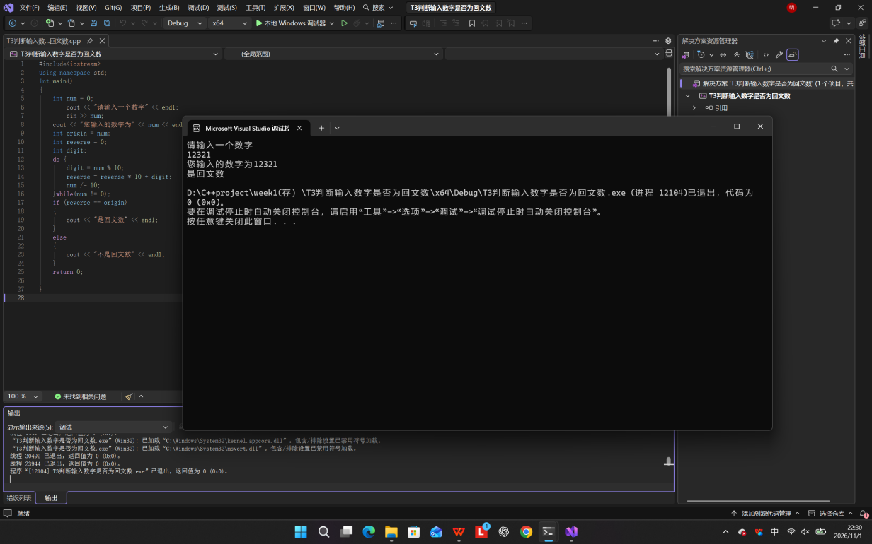

题目4
#include<iostream>using namespace std;int main()
{
int num = 100;
do {
int a = num % 10;
int b = (num / 10) % 10;
int c = num / 100;
if (a* a* a + b * b * b + c * c * c ==num)
cout << num << endl;
num++;
} while (num < 1000);
return 0;
}
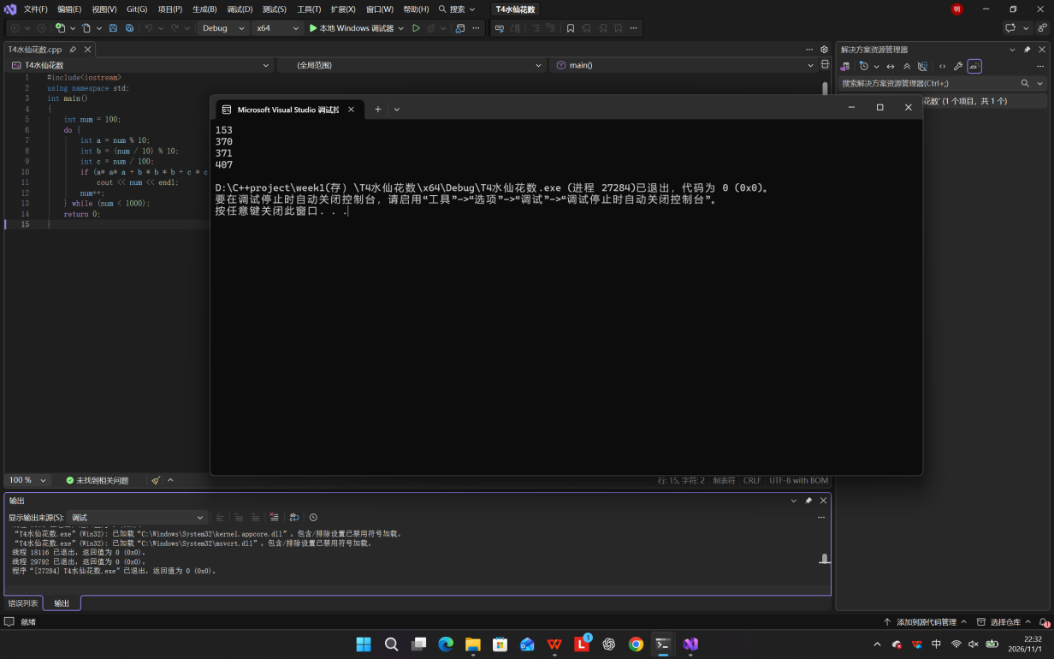

题目5
#include<iostream>using namespace std;int main()
{
cout << "输入两个正整数n和a" << endl;
int a,n;
cin >> n >> a;
long long sum = 0;
long long num = 0;
for(int i=0;i<n;i++)
{
num = num*10 + a;
sum = sum + num;
}
cout << "总和=" << sum << endl;
return 0;
}
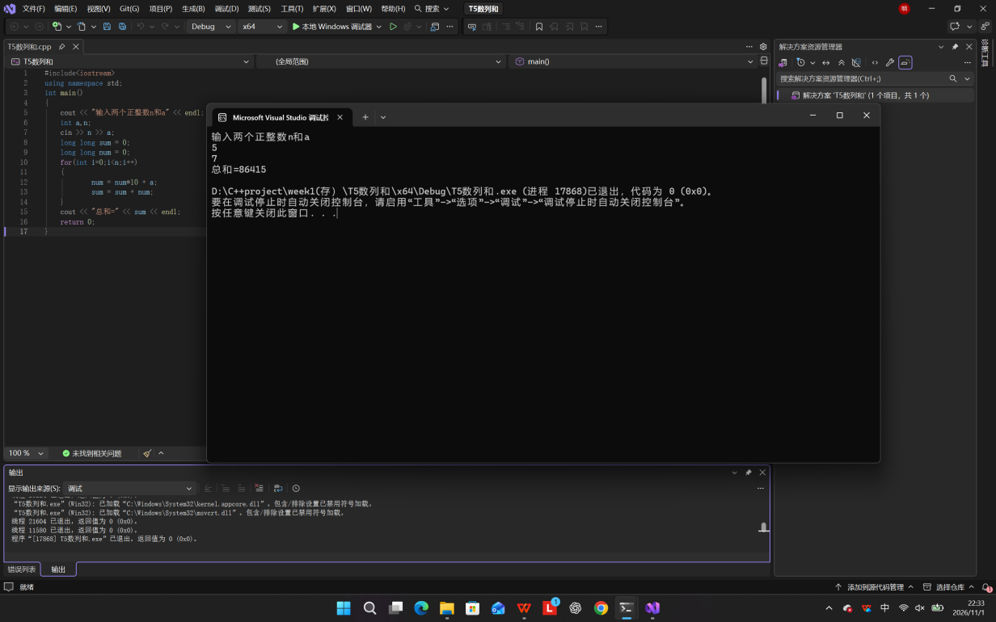

题目6
#include<iostream>using namespace std;int main()
{
for (int i = 1; i <= 9;i++)
{
for (int j=1; j <= i; j++)
{
cout << j << "*" << i << "=" << i * j << "\t";
}
cout << endl;
}
return 0;
}
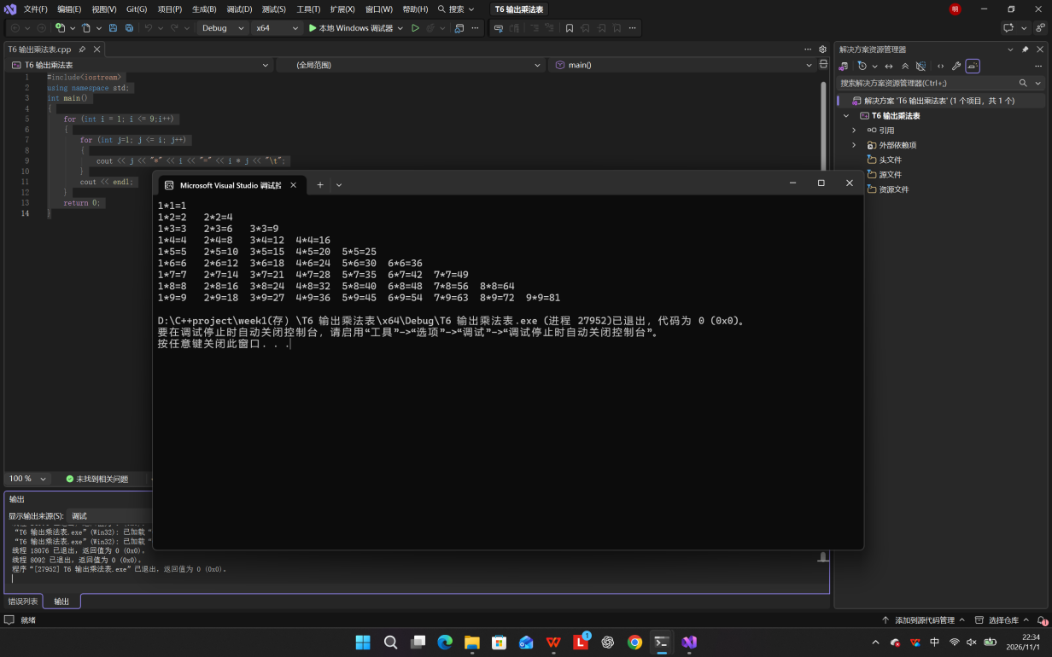

题目7
#include<iostream>using namespace std;int main()
{
int mon1 = 1, mon2 = 1;
int mon;
cout << "第1个月" << mon1 << "对" << endl;
cout << "第2个月" << mon2 << "对" << endl;
for (int i = 3;i <= 20; i++)
{
mon = mon1 + mon2;
cout<<"第"<<i<<"个月"<<mon<<"对"<<endl;
mon1 = mon2;
mon2 = mon;
}
return 0;
}
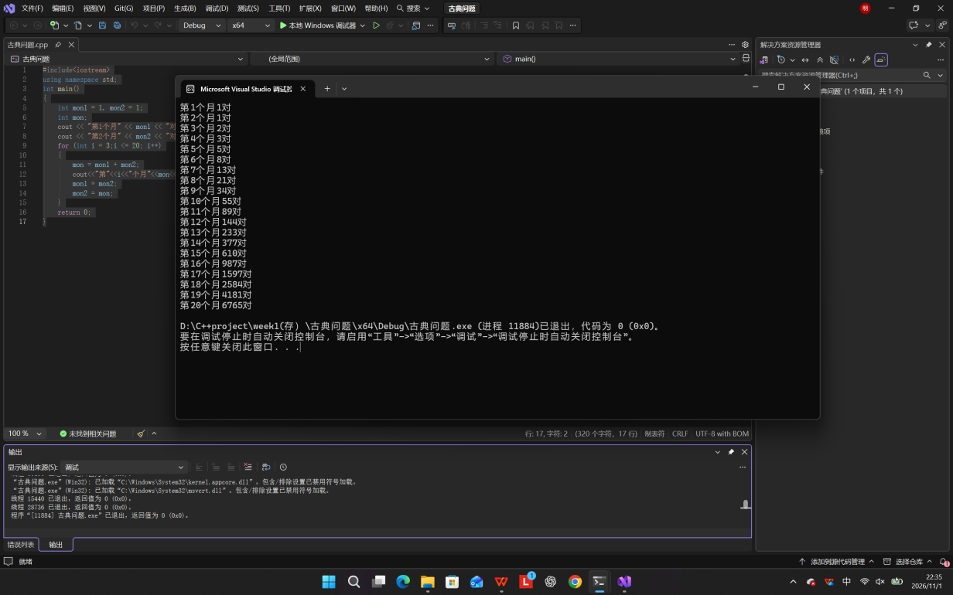

题目8
#include<iostream>using namespace std;int main()
{
int peach = 1;
for (int i = 9;i >= 1;i--)
{
peach = (peach + 1) * 2;
}
cout << "摘桃子总数" << peach << endl;
return 0;
}
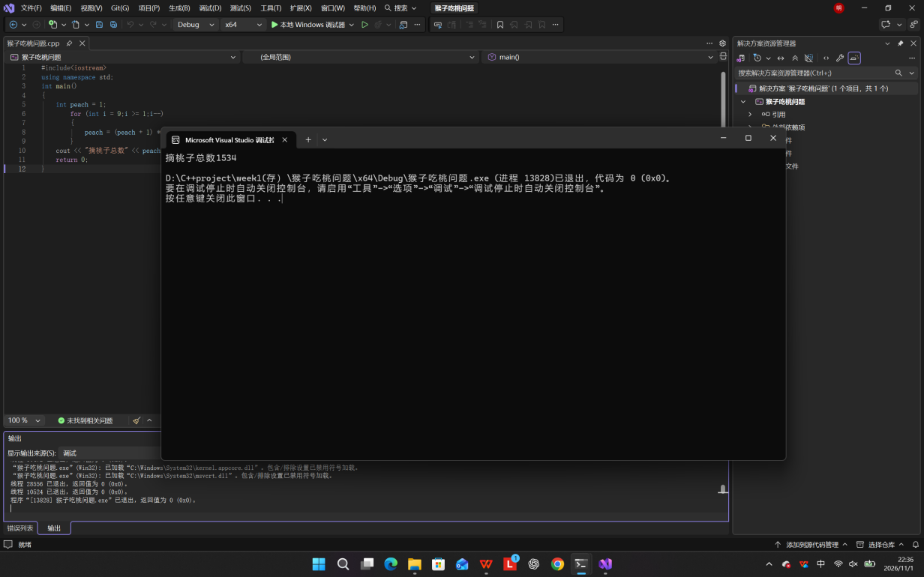
四、实验总结（本次实验的收获、体会、经验和教训）
通过本次实验，我掌握了分支与循环控制结构的编程方法，能够独立完成分段计算、数字判断、递推类题目。我体会到编程的核心是理清逻辑，区间边界、循环条件是高频易错点；调试代码的过程锻炼了我的问题排查能力，也让我明白要先构思算法再动手编码，养成分步验证的好习惯。

