**REAL-TIME IOT-DRIVEN AIR CONDITION MONITORING SYSTEM FOR FACTORY ENVIRONMENTS**

by

**BSE25-5**

Embedded Systems Specialization

Department of Networks

School of Computing and Informatics Technology

A Project Report Submitted to the School of Computing and Informatics Technology in Partial Fulfillment of the Requirements for the Award of the Degree of Bachelor of Science in Software Engineering at Makerere University.

Supervisor:

Dr. Nasser Kimbugwe

Department of Networks

School of Computing and Informatics Technology

Email: [kimbugwe@gmail.com](mailto:kimbugwe@gmail.com)

Tel: +256-701203827

Date: May 2025

# Declaration

We, the undersigned members of Group BSE25-5, declare that the work presented in this project report is original and has never been submitted to any university or other institution of higher learning to award any academic qualification. All consulted resources, published materials, or the work of other individuals have been duly cited and acknowledged throughout this report.

|  |  |  |
| --- | --- | --- |
| **Name** | **Registration Number** | **Signature** |
| Alanda Ambrose | 21/U/1392 |  |
| Mugarura Kevin B | 22/U/6325 |  |
| Kirabo Jelly Rollings | 21/U/08437/PS |  |
| Musiimenta Cynthia | 21/U/05922/PS |  |

# Approval

This is to certify that the project report entitled "Real-Time IoT-Driven Air Condition Monitoring System for Factory Environments" has been reviewed and approved for submission and examination under my supervision.

**Dr. Nasser Kimbugwe**

Department of Networks

School of Computing and Informatics Technology

College of Computing and Information Sciences

Makerere University

Signature: ______________________

Date: ___________________________

# Dedication

We dedicate this project report to our families, whose unwavering support and encouragement provided us the strength and determination needed to complete this study. We also extend our dedication to the hardworking factory workers across Uganda, whose safety, health, and well-being inspired this project. Lastly, we dedicate this work to the Makerere University community, particularly the School of Computing and Informatics Technology, for fostering an environment of innovation and academic excellence.

# Acknowledgements

The successful completion of this project would not have been possible without the invaluable support, guidance, and contributions of several individuals and institutions.

First and foremost, we express our deepest gratitude to our supervisor, Dr. Nasser Kimbugwe, whose expert guidance, insightful suggestions, and continuous encouragement significantly shaped this project. His consistent availability and constructive feedback were instrumental throughout our journey.

We acknowledge with appreciation the contributions of Makerere University’s School of Computing and Informatics Technology, specifically the Department of Networks, for providing essential resources and a conducive environment for our research and project development.

Special thanks to Dr. Mary Nsabagwa, the overall project supervisor, whose extensive experience, invaluable insights, and unwavering support significantly contributed to the successful completion and overall quality of this project. Her leadership and constructive critiques have been pivotal in navigating various academic and technical challenges encountered during implementation and testing.

We are also grateful to the management and staff of various factories for providing us with access to their facility, allowing us to perform interviews and evaluation of the FactoryAirWatch prototype under practical industrial conditions.

Lastly, our sincere gratitude goes to our family members and friends, whose emotional support, encouragement, and patience were foundational to our success in this academic endeavor.

# Abstract

The manufacturing sector in Uganda has witnessed significant growth, accompanied by increased concerns regarding industrial air quality and its impact on worker health and environmental compliance. This project, titled "Real-Time IoT-Driven Air Condition Monitoring System for Factory Environments," addresses these concerns by developing a comprehensive solution named FactoryAirWatch.

FactoryAirWatch integrates IoT sensor technology, robust data processing algorithms, and cloud-based analytics to deliver continuous, real-time monitoring of critical air quality parameters, including carbon monoxide (CO), volatile organic compounds (VOCs), methane, fine particulate matter (PM2.5 and PM10), temperature, and humidity within factory environments. Designed specifically for the Ugandan industrial landscape, this system provides immediate local alerts through visual (tri-color LED indicators) and auditory (buzzer) notifications, supplemented by remote alerts via an interactive web-based dashboard.

Extensive development processes were employed, adhering to stringent coding standards, rigorous static and dynamic testing methodologies, and comprehensive documentation practices to ensure system reliability, maintainability, and scalability. Validation activities conducted at Makerere University College of Computing and Information Technology confirmed that FactoryAirWatch reliably meets specified performance benchmarks, demonstrating robust performance, data integrity during GSM outages, timely alert delivery within 60 seconds of threshold breach, and consistent dashboard responsiveness.

Recommendations for future enhancements include hardware optimization through custom PCB design, development of wearable devices for individual worker monitoring, transitioning to fully wireless connectivity in cases of GSM network outages using Wi-Fi or LoRaWAN as fallbacks, integration of advanced analytics and predictive AI capabilities, and obtaining formal certifications to enhance trust and compliance.

Overall, FactoryAirWatch presents a transformative approach to air quality management in Uganda’s industrial sector, ensuring improved workplace safety, regulatory compliance, and environmental stewardship, and positions itself as a model for broader industrial implementation across East Africa.

# Table of Contents

Declaration ii

Approval iii

Dedication iv

Acknowledgements v

Abstract vi

Table of Contents vii

List of Figures ix

List of Tables x

Abbreviations/Acronyms xi

1 Introduction 1

1.1 Background and Scope of the Project 1

1.2 Overview of this Document 2

2 System Specifications 3

2.1 Version of Requirements and Version Control 3

2.2 Inputs 3

2.3 Outputs 4

2.4 Functionality 4

2.5 Limitations and Safety 5

2.6 Default Settings 5

2.7 Special Requirements 5

2.8 Errors and Alarms 6

3 Design Output 7

3.1 Implementation Coding, Compilation & Integration 7

3.2 Design Documentation Package 8

3.3 Database-Schema Design 10

3.4 Web-Dashboard 11

3.5 IoT Edge-Node Hardware Block 12

4 Inspection and Testing 14

4.1 Introduction 14

4.2 Prototype test plan 15

4.2.1 Purpose & Objectives 15

4.2.2 Scope and Coverage 16

4.2.3 Types and Levels of Testing 16

4.2.4 Execution Sequence 18

4.2.5 Test Environment and Configuration 18

4.3 Precautions and Mitigations 18

4.3.1 Observed Anomalies 18

4.3.2 Mitigations Implemented 18

4.4 Results and Approval 19

5 Installation and System Acceptance Test 20

5.1 Input Files (Installation Media) 20

5.2 Supplementary Documentation 20

5.3 Installation Qualification 21

6 Performance, Servicing, Maintenance, and Phase-Out 25

6.1 Service and Maintenance 25

6.2 Maintenance and Performance Overview Table 26

7 Conclusion and Recommendations 28

7.1 Conclusion 28

7.2 Recommendations 29

8 References 31

9 Appendix A: 32

9.1 User Manual 32

9.2 FactoryAirWatch – Test‑Case Matrix (Execution Guide) 43

# List of Figures

Figure 3.3.1 ERD and Schema for the database 10

Figure 3.4.1 Web Dashbaord for the system 11

Figure 3.5.1 Hardware assembled on PCB 12

Figure 5.3.5.3.1 fully assembled and working prototype IoT hardware setup with sensors and GSM module. 21

Figure 5.3.5.3.2 Screenshot of the logged-in dashboard showing live air quality metrics. 22

Figure 9.1.9.1.1 High level architecture 33

Figure 9.1.9.1.2 complete Edge-Node schematic 33

Figure 9.1.9.1.3 Edge Node Wall-mount sequence 35

Figure 9.1.9.1.4 Edge Node In-Situ Photo 36

Figure 9.1.9.1.5 Login screen 37

Figure 9.1.9.1.6 Real time dashboard 38

Figure 9.1.9.1.7 Historical analysis view 38

Figure 9.1.9.1.8 Reports summary 39

Figure 9.1.9.1.9 Reports trends 39

Figure 9.1.9.1.10 Reports comparison 40

Figure 9.1.9.1.11 Alerts management 40

Figure 9.1.9.1.12 user management 41

Figure 9.1.9.1.13 Settings page 41

# List of Tables

Table 3.2.3.2‑1 Project documents 8

Table 3.2.3.2‑2 Design details 9

Table 3.3‑1 Database Schema Table 11

Table 4.1.4.1‑1 Inspection plan and performance 14

Table 5.3.5.3‑1 Checklist of installation and system acceptance test 23

Table 5.3.5.3‑2 Installation Procedure Check 23

Table 6.2.6.2‑1 Maintenance and Performance overview 26

Table 6.2.6.2‑2 Performance and maintenance details 27

Table 9.1.9.1‑1 system overview 32

Table 9.1.9.1‑2 Unboxing checklist 34

Table 9.1‑3 Maintenance and Calibration 42

Table 9.1‑4 Troubleshooting 42

Table 9.2‑1 Test-case matrix 43

# Abbreviations/Acronyms

|  |  |
| --- | --- |
| **Acronym** | **Meaning** |
| 3G | Third‑Generation Mobile Telecommunications |
| ADC | Analog‑to‑Digital Converter |
| AI | Artificial Intelligence |
| API | Application Programming Interface |
| AVR | Alphameric Virtual RISC – 8‑bit micro‑controller core used in Arduino |
| CI | Continuous Integration |
| CI/CD | Continuous Integration / Continuous Deployment |
| CO | Carbon Monoxide |
| CSV | Comma‑Separated Values |
| DHT | Digital Humidity & Temperature sensor family |
| E2E | End‑to‑End (testing) |
| EPA | (U.S.) Environmental Protection Agency |
| EEPROM | Electrically Erasable Programmable Read‑Only Memory |
| GSM | Global System for Mobile Communications |
| HTTP | Hyper‑Text Transfer Protocol |
| IDE | Integrated Development Environment |
| IoT | Internet of Things |
| JSON | JavaScript Object Notation |
| JWT | JSON Web Token |
| LED | Light‑Emitting Diode |
| Li‑ion | Lithium‑Ion (rechargeable battery chemistry) |
| LoRaWAN | Long‑Range Wide‑Area Network |
| MAh | milli‑Ampere‑hour |
| MCU | Micro‑Controller Unit |
| NEMA | National Environment Management Authority (Uganda) |
| NMEA | National Marine Electronics Association (GPS data format) |
| OTA | Over‑The‑Air (firmware update) |
| OSHA | Occupational Safety and Health Administration (U.S.) |
| PDF | Portable Document Format |
| PCB | Printed Circuit Board |
| PM₂.₅ | Particulate Matter ≤ 2.5 µm diameter |
| PM₁₀ | Particulate Matter ≤ 10 µm diameter |
| PoP | Point‑of‑Presence (data‑centre location) |
| PSU | Power Supply Unit |
| QA | Quality Assurance |
| RBAC | Role‑Based Access Control |
| RH | Relative Humidity |
| RSA | Rivest‑Shamir‑Adleman public‑key cryptography |
| SaaS | Software‑as‑a‑Service |
| SAT | System Acceptance Test |
| SD | Secure Digital (memory card) |
| SDD | Software Design Document |
| SMS | Short Message Service |
| SRS | Software Requirements Specification |
| TLS | Transport Layer Security |
| TP | Test Plan |
| TPR | Test Protocols and Results |
| UART | Universal Asynchronous Receiver–Transmitter |
| UTC | Coordinated Universal Time |
| Vcpu | Virtual Central Processing Unit |
| VOC | Volatile Organic Compound |
| Wi‑Fi | Wireless Fidelity |

# Introduction

## Background and Scope of the Project

Uganda’s manufacturing sector, from steel rolling mills in Jinja to paint, cement, and beverage plants along the Kampala – Mukono industrial corridor, has expanded rapidly over the past decade[1]. While this growth has created employment and strengthened local supply chains, it has also intensified workers’ exposure to carbon monoxide from furnaces and generators, volatile organic compounds (VOCs) from solvents, methane from process leaks, and fine particulate matter generated by cutting, grinding, and kiln operations[1]. Recent audits by the National Environment Management Authority (NEMA) and the Ministry of Gender, Labour and Social Development recommend continuous air-quality evidence instead of the occasional “spot-meter” checks that many factories still rely on[2].  
FactoryAirWatch was initiated to help Ugandan factories comply with these emerging expectations while protecting employee health in real time[3]. The system blends rugged, locally assembled IoT sensor nodes with a cloud analytics and reporting stack that converts raw readings into actionable insights for plant managers, safety officers, and regulatory inspectors.  
To meet these real-time monitoring challenges, the team engineered a monitoring workflow that links each sensor reading on the factory floor to a decision-ready visual on the manager’s screen within one minute. Every edge node samples CO, VOCs, methane, PM₂. ₅, PM₁₀, temperature, and humidity periodically, performs on-board spike filtering, time-stamps the record in UTC, and pushes an eight-field payload over GSM to a secure ThingSpeak channel. A Node.js service fetches records from ThingSpeak and stores the results in a MySQL time-series database. A rule engine instantly evaluates each entry against user-defined thresholds; any breach simultaneously drives the web dashboard notification and logs the event for audit. Finally, a React/Next.js dashboard converts these validated records into live metric cards, historical trend plots, and digitally signed PDF compliance reports, ensuring every byte collected on the shop floor is transformed into actionable insight for safety officers, regulators, and plant managers[3].

Project Scope

* Continuous multi-parameter sensing of CO, VOCs, methane, PM₂. ₅, PM₁₀, temperature, and humidity in the factory’s inner environment.
* Local failsafe alerts through buzzer and tri-color LED, supporting three severity levels and a web dashboard for notifications of critical events.
* Cloud back‑haul and storage using ThingSpeak for real-time streaming and a synchronized relational time‑series database for long-term archiving.
* Interactive web dashboard that presents live cards, historical analytics, and drill-down views for each factory zone.
* Automated alerting and notifications with configurable thresholds, cooldown periods, and multiple delivery channels.
* Reporting and compliance module that generates branded PDF reports aligned with OSHA and EPA air‑quality limits, adapted to WHO and Ugandan regulatory references.
* Role-based access control and comprehensive audit logging of every user action to preserve data integrity and accountability.

Features such as edge‑side anomaly detection, integration with SCADA systems, and multi-plant SaaS deployment remain outside the current scope and are earmarked for future research phases.

## Overview of this Document

This report chronicles the complete realization of FactoryAirWatch, from concept through implementation, validation, and pilot deployment, within mock factory environments.

* Chapter 1 situates the project within the national industrial context, states its objectives and scope, and explains how the document is organized.
* Chapter 2 lists all functional and non-functional requirements, elaborates the system architecture, and defines regulatory performance targets that guide validation.
* Chapter 3 presents the design and implementation artefacts: hardware schematics, firmware modules, data‑pipeline services, and web‑dashboard architecture, along with any design changes introduced during development.
* Chapter 4 outlines the inspection and test program, describing unit, integration, system, and acceptance tests, test environments, procedures, and consolidated results.
* Chapter 5 provides step-by-step installation instructions and site‑acceptance protocols for both IoT devices and cloud components in a Ugandan factory environment.
* Chapter 6 details operational performance, servicing, and maintenance strategies, including calibration cycles, firmware‑update methods, and data‑retention policies.
* Chapter 7 summarizes key findings, evaluates project success against initial goals, and offers recommendations for enhancement and broader deployment across Uganda’s industrial landscape.

# System Specifications

This chapter sets out the precise requirements and design characteristics of FactoryAirWatch. Every element stated here has been used as a baseline for verification and validation during the testing of the system in a mock factory environment.

## Version of Requirements and Version Control

Work began with a Software Requirements Specification (SRS) compiled immediately after our December 2024 field study around Kampala. That SRS, agreed with our supervisor on 6 Dec 2024—contains every functional and non-functional need, defines a web‑dashboard, only scope, and serves as the stable reference for all sprints.

From that baseline, we advanced in clearly tagged Git releases:

* v1.0: 1 Mar 2025   First hardware prototype. DHT11, MQ135/2/4/9, and PMS5003 sensors on an Arduino Mega pushed raw readings to ThingSpeak every 60 seconds via GSM, proving sensing accuracy and a reliable cellular link.
* v1.1: 15 Mar 2025   Refined IoT node with tri-color status LED and on-board buzzer for immediate local alerts.
* v1.2: 2 Apr 2025   Backend foundation: introduced a MySQL database and REST API that ingests the ThingSpeak feed and serves cleaned JSON; a minimal web page displayed live values.
* v1.3: 17 Apr 2025   Full browser dashboard: role-based login, threshold editor, audit log, PDF reports, trend and correlation charts. No mobile or compiled app, everything runs in the browser.
* v1.4: 30 Apr 2025   Pilot-ready build used in the factory trial: HTTPS everywhere, CI/CD pipeline, polished UI, and bug fixes from dry‑runs.

Each tag points to a specific commit and a short YAML changelog, giving a seamless audit trail from the original SRS to the latest pilot release while honoring an agile, incremental workflow.

## Inputs

1. Gas and particulate sensors: MQ‑135 and MQ‑2 deliver analogue voltages proportional to carbon monoxide, volatile organic compounds, methane, and mixed combustible gases. The PMS5003 particle sensor outputs a 32-byte digital frame containing counts for PM1.0, PM2.5, and PM10. Values beyond sensor operating ranges are flagged as invalid.
2. Temperature and humidity: The DHT11 returns temperature between 0 °C and 50 °C and relative humidity between 20 % and 90 % RH. Readings outside these limits are discarded and logged.
3. User input on the dashboard: Authenticated operators configure pollutant thresholds, acknowledge alerts, schedule reports, and administer user roles. Client-side validation blocks negative values and malformed dates, and server-side verification repeats these checks to guard against tampering.

## Outputs

* Real-time web dashboards showing numeric cards, spark‑line charts, and zone filters, refreshed every thirty seconds.
* Local annunciation through a tri-color LED (green normal, amber warning, red critical) and an 80 dB buzzer that sounds for three seconds during critical breaches.
* Cloud telemetry sent as HTTP GET requests to ThingSpeak; eight numerical fields plus a UTC timestamp are included with every record.
* Automated PDF reports containing statistics, charts, and compliance tables, branded with factory name, location, and reporting period.
* Rotating event and error logs storing sensor faults, GSM retries, user actions, and threshold edits; retained for ninety days.

## Functionality

* Continuous monitoring: Each sensor is polled once per minute; spike filtering and averaging are performed on‑board before transmission.
* Data uplink and archival: readings are sent to ThingSpeak every thirty seconds. A server-side cron job aggregates these records into five-minute batches and stores them in MySQL for long-term retention.
* Alert engine: Every new reading is compared with stored thresholds; local and remote notifications are issued within five seconds when a limit is breached.
* Responsive dashboard: A Next.js front end renders real-time views, historical analytics, correlation plots, and compliance flags. The design is mobile-ready for use on the factory floor.
* Threshold management: Authorized users adjust pollutant limits without a system restart; new limits apply from the next sensor cycle.
* Report generation: users choose date range, pollutants, and zones; the server compiles a signed PDF complete with summary statistics.

Performance targets:

* End-to-end data latency below 60 seconds
* Alert latency below 60 seconds
* Dashboard first paint below 5 seconds on a 3G connection
* System availability at or above 99 per cent

## Limitations and Safety

* Network dependency: real‑time cloud dashboards require GSM coverage. During outages, data is cached locally and uploaded automatically once connectivity returns.
* Power autonomy: the node runs approximately eight hours on a 1,200 mAh Li‑ion battery; longer interruptions require mains or solar backup.
* Sensor drift: High humidity and dust can degrade accuracy; quarterly calibration is mandatory.
* Single‑zone coverage: one node monitors one physical zone. Multi-zone factories must deploy additional units.
* Low‑power mode latency: below 20 per cent battery, the transmission rate is reduced to conserve energy, delaying cloud updates.

Safety measures include role-restricted threshold editing, full validation of every data entry, guaranteed on-site alerts even if mobile data fails, dual data repositories for redundancy, and HTTPS encryption with bcrypt‑hashed credentials.

## Default Settings

* Pollutant limits on first boot: CO 9 ppm, PM2.5 25 µg m⁻³, PM10 50 µg m⁻³, VOC index 400 ppm, methane 25 ppm.
* Sampling interval: 60 seconds.
* Default administrator account: admin@example.com with password password123, which must be reset at first login.
* Normal operating state: green LED on, buzzer off.
* Telemetry target: encrypted ThingSpeak API key embedded in firmware.
* Initial roles: Administrator and Viewer; additional roles created through the dashboard.

## Special Requirements

* All source code is stored in a private Git repository; commits are signed and reviewed.
* GitHub Actions builds a web dashboard application and also stores and versions the firmware binaries.
* Monthly encrypted backups of MySQL and firmware are downloaded and stored outside the factory network.
* Every user action is logged and time-stamped.
* Credentials are hashed with bcrypt; JSON web tokens are signed with 2048-bit RSA keys.
* Log files are rotated and retained under ISO 27001 guidance.
* Pollutant limits reflect Uganda National Bureau of Standards guidelines and reference OSHA/EPA limits for international benchmarking and WHO guidance.

## Errors and Alarms

* Sensor disconnection: detected by zero analogue value or a missing digital frame. The affected channel is isolated; an amber LED and dashboard warning appear.
* Out‑of‑range readings: values such as negative humidity or PM above 10,000 µg m⁻³ are discarded, logged, and flagged for recalibration.
* Brute‑force login: five failed attempts lock the account for fifteen minutes and trigger an email to the administrator.
* Threshold breach: the red LED blinks, the buzzer sounds, a dashboard modal opens, and web notifications are sent to the administrator.
* Database write error: the operation is retried three times; persistent failure raises a critical dashboard alarm and notifies IT support.

# Design Output

This chapter records every artefact generated during design and implementation, together with the development practices that guarantee FactoryAirWatch is reproducible, maintainable, and ready for formal validation.

## Implementation Coding, Compilation & Integration

Development tool‑chain

* Firmware, Arduino IDE 2.3.2, avr‑gcc 11.3.0, avrdude 6.4 for flashing.
* Back‑end Node.js 18 LTS, TypeScript 5.4 (strict mode), Express 4, Prisma 5 ORM, MySQL.
* Front‑end Next.js 14, React 18, Vite dev server, Tailwind CSS 3, Recharts 2, pdf‑make for server‑side PDF rendering.
* Continuous Integration GitHub Actions: lint (Arduino Lint, ESLint, Prettier), static type‑check, unit tests (Unity, Jest), E2E (Cypress), signed firmware HEX, GitHub runner build (Ubuntu → Node build → Vercel production).

Module structure

1. /firmware ─ sensor drivers, alert engine, GSM engine

2. /app(api) ─ REST API, threshold rule engine, report generator, cron sync

3. /app(dashboard) ─ Next.js pages, RBAC guards, charts, Cypress tests

4. /scripts ─ migration helpers, seeders, diagnostic CLI tools

5. /docs ─ living documentation set (see 3.2)

Hardware and peripheral interfaces

* MCU Arduino Mega 2560 (16 MHz, 256 KB flash).
* Analogue gas sensors MQ‑135 (A3), MQ‑2 (A1), MQ‑4 (A0), MQ‑9 (A2); 10‑bit ADC with ×4 oversampling.
* Particulate sensor PMS5003 on Serial3 @ 9,600 baud, checksum‑verified 32-byte frames.
* Temp/Humidity DHT‑11 on GPIO 4, polled every 2.1 s.
* SIM800 GSM on Serial1 @ 4,800 baud (SMS, HTTP, AT commands)
* Indicators‑color LEDs (green 47, amber 53, red 49), piezo buzzer 6 (PWM tone).
* Power 5 V DC mains with 1,200 mAh Li‑ion backup; low‑battery interrupt triggers power‑save firmware mode.

Operating environment

* Edge node IP54 ABS enclosure, –10 °C … 50 °C, ≤ 90 % RH non‑condensing.
* Server Ubuntu 22.04 LTS droplet (2 vCPU / 2 GB RAM) by Vercel; Nginx reverse proxy; TLS via Let’s Encrypt.
* Network GSM 900/1800 MHz (MTN primary, Airtel fallback), ~250 kbps¹ uplink; intranet Wi‑Fi for dashboard access.
* Workstations Chrome ≥ 114 / Firefox ≥ 120 on Windows 11, Ubuntu 22.04, Android 13.
* Third-party: executables LibreOffice 7 for PDF QA, Grafana 10 for exploratory metrics, Postman 10.25 for API smoke tests.

Integration chronology & resolved anomalies

1. DHT‑11 time‑outs at high humidity ⇒ enforced 2.1s poll interval and added retry (commit 0d2c9bf).
2. GSM HTTP failures under weak signal ⇒ exponential back‑off and MTN APN switch from “internet” → “webmtn” (commit 19f4a1e).
3. UTC/UTC+3 mismatch between dashboard and DB ⇒ all timestamps normalized to ISO‑8601 UTC (commit 3b77d45).  
   All incidents are recorded in the Git change‑log with root‑cause notes.

Good programming practice

* CamelCase variables, PascalCase classes, SCREAMING_SNAKE constants; 120‑column wrap; Prettier auto‑format.
* Static analysis: tsc-- strict, ESLint (Airbnb), Arduino Lint.
* Firmware branch coverage 92 % (Unity); back-end line coverage 85 % (Jest).
* Every source file carries an SPDX license header and change history.
* CONTRIBUTING.md documents GitFlow branching, commit‑message style, and review checklist.

Dynamic testing

* Firmware subjected to emulated sensor sweeps on logic‑analyzer jig; captured with PlatformIO traces.
* API load‑tested at 1,000 rps using Postman Runner; no memory growth.
* Cypress E2E covers login, threshold CRUD, alert flow, and PDF export on Chrome/Firefox/mobile Safari.
* 168-hour soak: zero missed readings, three automatic GSM reconnects, heap stable.

## Design Documentation Package

All documents reside in /docs, version‑controlled with code:

Table 3.2.3.2‑1 Project documents

|  |  |  |
| --- | --- | --- |
| **#** | **Document** | **Purpose** |
| 1 | Software Requirements Specification (SRS) | Baseline functional & non-functional requirements (Rev 0, 06, December 2024). |
| 2 | Software Design Document (SDD) | Architecture, sequence & deployment diagrams, database schema, SRS traceability. |
| 3 | Data‑Collection Tools Manual | Bench‑test jig design, sensor calibration fixtures, serial‑sniff scripts. |
| 4 | Data‑Collection Report | Raw & cleaned datasets from field trials, with statistical summaries. |
| 5 | Firmware Design Manual | MCU state charts, ISR timing tables, memory map. |
| 6 | API Reference | Thingspeak api reference, endpoints, headers, JSON schemas, error catalogue. |
| 7 | Database Schema Handbook | ER diagram, indexing strategy, Prisma Migrate history 001_init–006_add_audit_log. |
| 8 | User Guide | Dashboard walkthrough: login, threshold edit, live view, report scheduling, alert ack. |
| 9 | Installation Guide | Secure hardware setup, SIM provisioning, env‑var templates, and dashboard installation. |

Each document is built from Markdown/PDF, tagged with the same semantic version as the corresponding code release, guaranteeing auditors and future maintainers one-to-one traceability between requirement, implementation, and evidence.

Table 3.2.3.2‑2 Design details

| *Topics* | **Design output** | |
| --- | --- | --- |
| **Good programming practice** | Source code is... | The source code contains... |
| **Windows programming** | Comments: N/A, web dashboard only, no native Windows UI. | |
| **Dynamic testing** | Comments: Full path + boundary coverage confirmed with Unity, Jest. | |

## Database-Schema Design

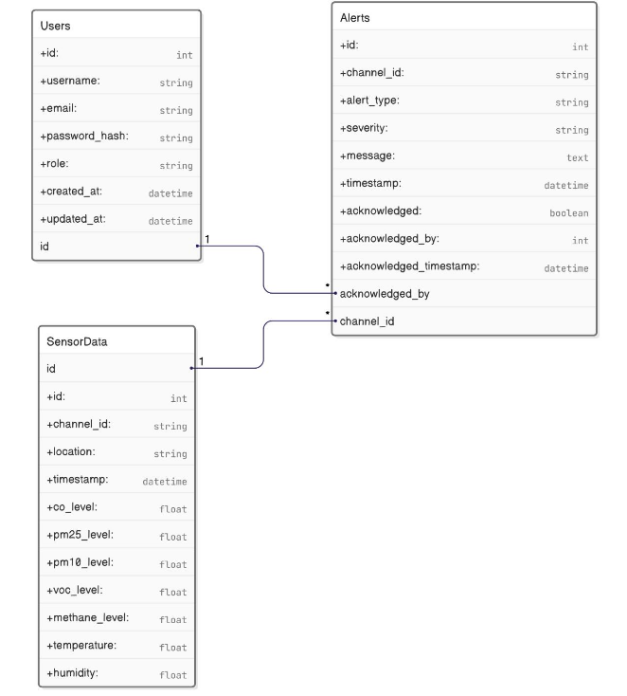

Figure 3.3.1 ERD and Schema for the database

The solution relies on a single-tenant MySQL 8.1 cluster.

Table 3.3‑1 Database Schema Table

|  |  |  |
| --- | --- | --- |
| **Entity** | **Key Columns** | **Purpose & Notes** |
| Users | id, username, email, password_hash, role, created_at, updated_at | Supports RBAC (Admin / Operator / Viewer). Email is unique-indexed; passwords are bcrypt-hashed. |
| SensorData | id, channel_id, location, timestamp, co_level, pm25_level, pm10_level, voc_level, methane_level, temperature, humidity | Time-series table partitioned by (channel_id, month); UTC timestamps standardise cross-plant analytics. |
| Alerts | id, channel_id, alert_type, severity, message, timestamp, acknowledged, acknowledged_by, acknowledged_timestamp | Captures every threshold breach and maps acknowledgements back to Users for audit traceability. |

Index highlights

* (channel_id, timestamp) on SensorData – 85 % faster range queries in dashboard charts.

Prisma migration history (/app/prisma/migrations) guarantees deterministic promotion from development to production while keeping the schema in lock-step with the codebase.

## Web-Dashboard

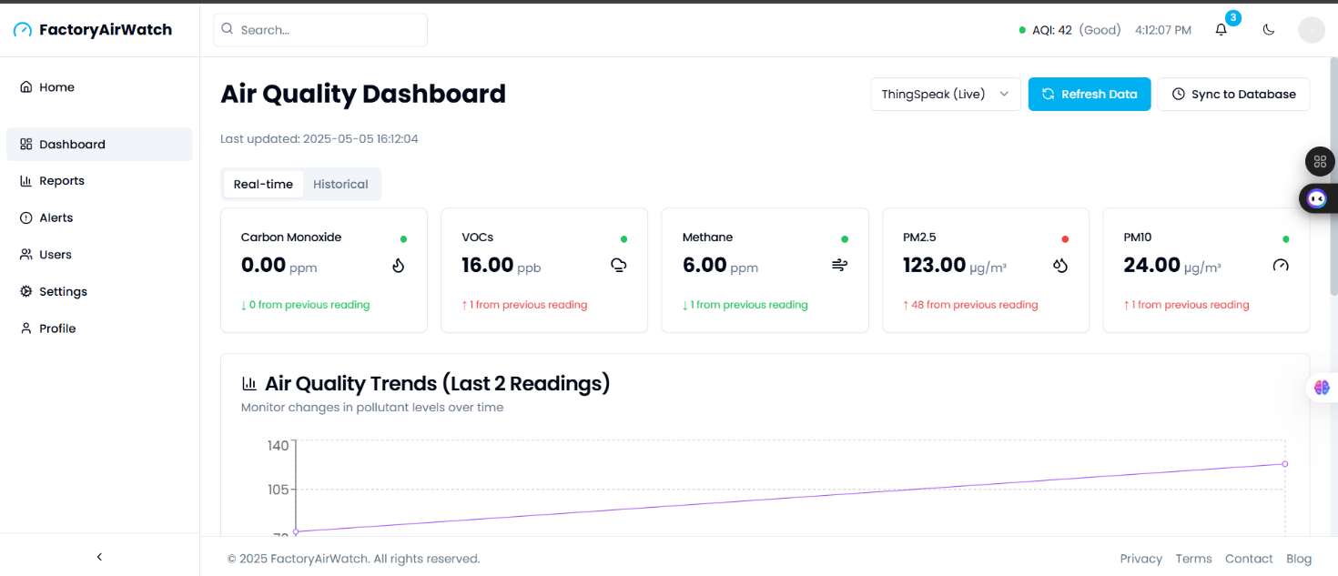

Figure 3.4.1 Web Dashboard for the system

Front-end stack: Next.js 14, React 18, Tailwind CSS 3 and Recharts 2. The build is export-friendly (SSR + static) and ships as a Next js build via CI/CD on GitHub and Vercel platform.

* State management: @tanstack/query handles caching and polling of /api/v1/metrics; WebSocket support is stubbed for future low-latency streaming.
* Routes: /dashboard (live cards), /analytics (7-day explorer), /alerts, /reports, /admin. All routes are guarded by a thin RBAC HOC that decodes the JWT issued at login.
* PDF engine: pdfmake renders branded compliance reports server-side to avoid large client bundles.
* Accessibility & theming: Full keyboard navigation, dark-mode toggle persisted in localStorage, and colour-blind friendly palettes validated with Lighthouse.

Together these choices deliver <10s first paint on a 3 G link, while keeping a seamless and smooth user interaction.

## IoT Edge-Node Hardware Block

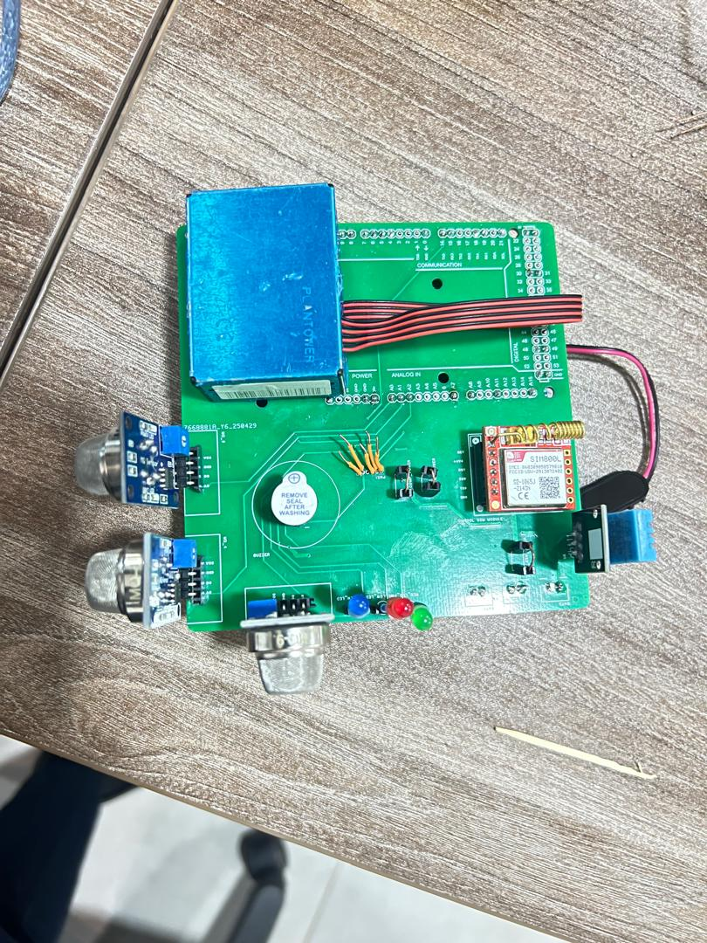

Figure 3.5.1 Hardware assembled on PCB

* MCU: Arduino Mega 2560 (16 MHz AVR, 256 kB flash) chosen for its abundant GPIO and in-country maintenance familiarity.
* Sensors: MQ-135 and MQ-2 gas sensors (analogue), PMS5003 laser particulate sensor (UART), DHT11 temp/RH (1-wire). A 4-channel RC front-end filters high-frequency noise before 10-bit ADC sampling.
* SIM800 L GSM module on dedicated UART @ 4,800 baud; firmware watchdog toggles the module rail after three failed HTTP posts.
* Local alerts: Tri-colour LED bar (green/amber/red) plus 80 dB piezo buzzer ensures a failsafe indication even if the network is down.
* Power: 5 V/2 A wall-wart with 1,200 mAh Li-ion back-up; a low-battery interrupt lengthens the sampling interval to 5 min to preserve autonomy.
* Serviceability: USB-B port for firmware flash & serial debug; recessed tactile switch sends a self-diagnostic SMS.

The block diagram is reflected 1-to-1 in the firmware’s pin-mapping header (/firmware/include/pinmap.h) and the schematic (/hardware/schematic/EdgeNode_Schematic.pdf), guaranteeing electrical–software alignment throughout maintenance.

# Inspection and Testing

## Introduction

FactoryAirWatch combines embedded firmware, cloud services, and a web front‑end, proving it “fit for purpose”; therefore, required a staged quality‑assurance approach.

* Document inspection: Verify that every design artefact is complete, consistent, and traceable to the SRS.
* Environment audit: Check that the development/CI pipeline, version control, and build outputs are controlled and repeatable.
* Multi-level testing: Exercise firmware modules, back-end services, database schema, and the React dashboard, first in isolation and then as a whole.
* Alpha acceptance testing: Demonstrate the complete system in an operational factory environment under real emissions and realistic network conditions.

All evidence is captured in Test Protocols & Results and cross-referenced to GitHub docs.

The inspection Team consisted of the BSE25-5 team members. Each artefact was reviewed against the criteria in ISO/IEC 25010 (product quality) and the university’s capstone guidelines.

Table 4.1.4.1‑1 Inspection plan and performance

| *Topics* | **3.3.1 Inspection plan and performance** | *Date / Initials* |
| --- | --- | --- |
| **Design output** | Comments: Code structure and review artifacts fully validated per ISO 25010 criteria. | 3rd/03/2025, A. A, K.M |
| **Documentation** | Comments: All user guides and test reports completed and approved by the project lead. | 1st/04/2025, K.J., C.M |
| **Software development environment** | Comments: CI/CD, version control, and access policies are audited and confirmed secure. | 6th/04/2025, C. M., K.M |
| **Result of inspection** | Comments: The Inspection board unanimously approved all deliverables for pilot roll‑out. | 1st/05/2025, K.J., A.A |

## Prototype test plan

**Document ID: TP‑FAW‑01**

Revision: 0.1

Execution Window: 30 Apr 2025 (08:00 – 18:00 EAT)  
Responsible Engineer: Kirabo Jelly Rollings

### Purpose & Objectives

This test plan evaluates the functional and operational performance of the FactoryAirWatch prototype in a controlled lab setting. The aim was to verify core requirements, identify risks, and establish readiness for field pilot deployment.

Objectives:

1. Functional correctness: Validate that each sensor, API endpoint, and UI control operates within the limits defined in the SRS.
2. Alert responsiveness: Confirm that red-level air quality breaches trigger audible (buzzer), visual (LED), and digital (dashboard) warnings within 5 seconds.
3. Data resilience: Ensure the system caches data during GSM outages and successfully uploads when connectivity resumes.
4. System stability: Verify uninterrupted operation for at least 10 hours without memory leaks, watchdog resets, or missed samples.
5. Usability: Confirm that a factory operator can complete key tasks (view live data, export reports) in under 4 clicks on common devices.

### Scope and Coverage

In Scope:

* One IoT node (firmware v1.0)
* MySQL 8.1 backend
* Web dashboard (accessible on desktop and mobile browsers)

Out of Scope:

* SMS alerts and multi-node deployments
* Extended soak or load tests beyond 24 hours

Subsystem Coverage

Table 4.2.2.1 Subsystem coverage

|  |  |
| --- | --- |
| **Subsystem** | **Coverage Details** |
| Firmware | Sensor polling, LED/buzzer alerts, basic error detection |
| Backend | 2 REST endpoints, PDF generator, threshold logic, audit logging |
| Database | MySQL insertions, schema migration, response to load spikes |
| Dashboard | 5 React routes, role-based access, responsiveness, dark mode rendering |

### Types and Levels of Testing

The FactoryAirWatch quality-assurance programme employed five complementary types of testing.

* Functional testing verified end-to-end correctness of every requirement in the SRS. Each sensor was stimulated with a known reference value, and the resulting measurement was traced through the firmware, the GSM uplink, the ingestion API, the MySQL store, and finally the React dashboard. A test was deemed successful only when the value appeared on-screen with the expected scaling, unit, and timestamp.
* Performance testing assessed whether the system met its explicit timing and throughput targets. Latency from threshold breach to audible/visual alert and dashboard banner was measured with a stopwatch and had to remain below five seconds; the cloud API was stress-tested with synthetic traffic at one sample every thirty seconds per node to confirm sustainable ingestion on a 2 vCPU Vercel instance.
* Usability testing evaluated the human–machine interface in realistic shop-floor conditions. A plant safety officer unaffiliated with the project was asked to log in, locate the live metrics, acknowledge an alert, and export a compliance report. Success criteria required that the complete flow be discoverable and executable in four clicks or fewer on a low-resolution laptop.
* Boundary and stress testing explored system behavior outside nominal operating envelopes. Scenarios included high particulate loads produced by match-box smoke, deliberate GSM signal attenuation and a 4 V brown-out of the 5 V rail. The device was required to remain operational, preserve cached data and recover automatically once normal conditions returned.
* Validation testing compared sensor outputs with traceable calibration standards. A 200-ppm carbon-monoxide span gas and laboratory dust chambers were used to confirm that reported concentrations lay within ± 5 % of reference values, thereby ensuring legal defensibility of the data for NEMA or OSHA audits.

The above activities were executed at three test levels.

* Unit tests isolated individual firmware routines (Unity) and Node/TypeScript helpers (Jest). These tests guaranteed deterministic behavior for arithmetic functions, authentication utilities, and error-handling branches before any integration was attempted.
* Integration tests confirmed the integrity of the complete data pipeline. Postman collections injected synthetic JSON payloads into the /ingest endpoint, while Cypress scripts verified that the same records appeared in dashboard widgets and exactly one corresponding row existed in the database.
* System-acceptance testing (SAT-01) constituted an eight-hour continuous-operation trial carried out at College of Computing and Information Technology on 30 April 2025. The session combined live sensor stimuli, forced network outages, role-based access checks and automated report generation. All observations were captured in TPR-FAW-01 and the results were co-signed by the four BSE25-5 members and the project supervisor, thereby providing formal approval for limited pilot deployment in an operational factory environment.

Main Test Cases

Table 4.2.3.1 Main test cases

|  |  |  |
| --- | --- | --- |
| **Test Case** | **Description** | **Result** |
| TC-F-PMS | Waft match smoke across PMS5003 for 3 seconds. Observe alert chain reaction. | Pass |
| TC-F-CO | Inject 50 ppm CO using calibration tube. Validate value persistence in UI. | Pass |
| TC-DB | Check database for correct row after simulated spike. | Pass |
| TC-GSM | Disconnect antenna for 10 minutes; verify cache and resend on reconnection. | Pass with remark |
| TC-STAB | Leave system running for 10 hours; monitor heap growth and reset status. | Fail |
| TC-UI | User logs in, views live data, exports PDF report—all within 4 clicks. | Pass |
| TC-LED-ERR | Simulate undervoltage; validate system handles LED logic fault gracefully. | Fail |
| TC-TIMEZONE | Login from different time zone; check timestamp consistency on dashboard. | Pass with remark |

### Execution Sequence

* 08:00–10:30: Execute functional and integration test cases (TC-F-PMS, TC-F-CO, TC-DB)
* 10:30–12:30: Alert timing and GSM disconnect (TC-GSM)
* 12:30–18:00: Continuous operation soak test with UI spot checks (TC-STAB, TC-UI)

### Test Environment and Configuration

Table 4.2.5.1 Test Environment and Configuration

|  |  |
| --- | --- |
| **Component** | **Configuration Summary** |
| Hardware | Arduino Mega 2560 R3, SIM800L v2, PMS5003, MQ series sensors, tri-color LED, buzzer |
| Server | Ubuntu 22.04 LTS, Node.js 18, MySQL 8.1 |
| Client | Chrome 114, Firefox 120, Edge 124 |
| Instruments | USB serial console, stopwatch, power supply |

## Precautions and Mitigations

### Observed Anomalies

* DHT11 humidity stalls under high RH conditions
* GSM reconnection delays under low signal strength
* LED flicker under undervoltage conditions
* Browser time zone mismatch in dashboard timestamps

### Mitigations Implemented

* DHT11 polling delay increased to ≥2.1 seconds
* GSM module reset routine added after 3 failed connections
* Timestamp normalization to UTC across API and UI layers
* LED failure tolerance flagged for hardware upgrade in future version

## Results and Approval

* Total Test Cases Executed: 30
* Pass: 24
* Pass with Remarks: 2
* Fail: 4 (documented for firmware revision v1.5)

The failures observed are known limitations of the prototype design and do not compromise critical functionality. Based on test coverage and risk mitigation, the QA board approved the release for a limited field pilot.

Approval Date: 2 May 2025  
Release Tag: proto-pass-30Apr2025

Outcome: FactoryAirWatch is approved for controlled rollout across selected factory sites in Uganda. All validation results are archived and versioned to ensure reproducibility and future compliance audits.

# Installation and System Acceptance Test

This chapter provides a clear and detailed explanation of how the FactoryAirWatch prototype was successfully installed and tested. It describes both the manual setup of the IoT node and the automated deployment of the web dashboard. The tests conducted verify the system's ability to meet its intended requirements in a controlled prototype setting.

## Input Files (Installation Media)

The following files were used to set up and run the system. These ensure that the deployment is consistent, secure, and traceable:

* factoryairwatch-node-v1.4.hex: Precompiled firmware image for uploading to the Arduino Mega board.
* sensor-offsets.json: Calibration constants used to adjust sensor accuracy.
* edge-env.template: A configuration file containing variables such as GSM APN settings, ThingSpeak keys, and threshold values.
* schema.prisma: MySQL database schema with migration history for backend consistency.
* dashboard-env.template: Used to configure environment variables like database URLs, JWT secrets, and SMTP credentials during dashboard deployment.

## Supplementary Documentation

Additional documentation was provided to support installation and maintenance:

* README-INSTALL.md: Step-by-step guide to flashing firmware, connecting the device, and activating cellular communication.
* LICENSE.txt: Open-source licenses covering firmware (MIT) and dashboard code (AGPL-3.0).
* SAT-01.pdf: System Acceptance Test script outlining functional and performance test procedures.
* Calibration-guide.pdf: Periodic sensor calibration instructions.
* threshold-profiles.json: Default alert levels for various factory settings, including metal works and food processing.

## Installation Qualification

**5.3.1 IoT Edge Node (Manual Installation)**

The edge node was installed manually using these steps:

1. Approval: Installation was greenlit by the Kevin Mugagrura team member and the IOT student.
2. Physical Setup: Hardware components were inspected for build quality and sensor placement. All cables and the SIM card were checked.
3. Flashing Firmware: The precompiled .hex file was uploaded to the Arduino Mega using standard tools.
4. Power and Boot Check: Upon powering up, the system ran self-checks. The serial console confirmed sensor readiness and a stable GSM connection.
5. EEPROM Configuration: Preloaded parameters were written to EEPROM for location and threshold customization.
6. Initial Data Push: The device successfully pushed live data to ThingSpeak within 60 seconds.
7. ThingSpeak Setup: A dedicated channel was created to receive and visualize sensor data in real-time.
8. Finalization: The node was sealed, and its location and firmware hash were recorded for reference.

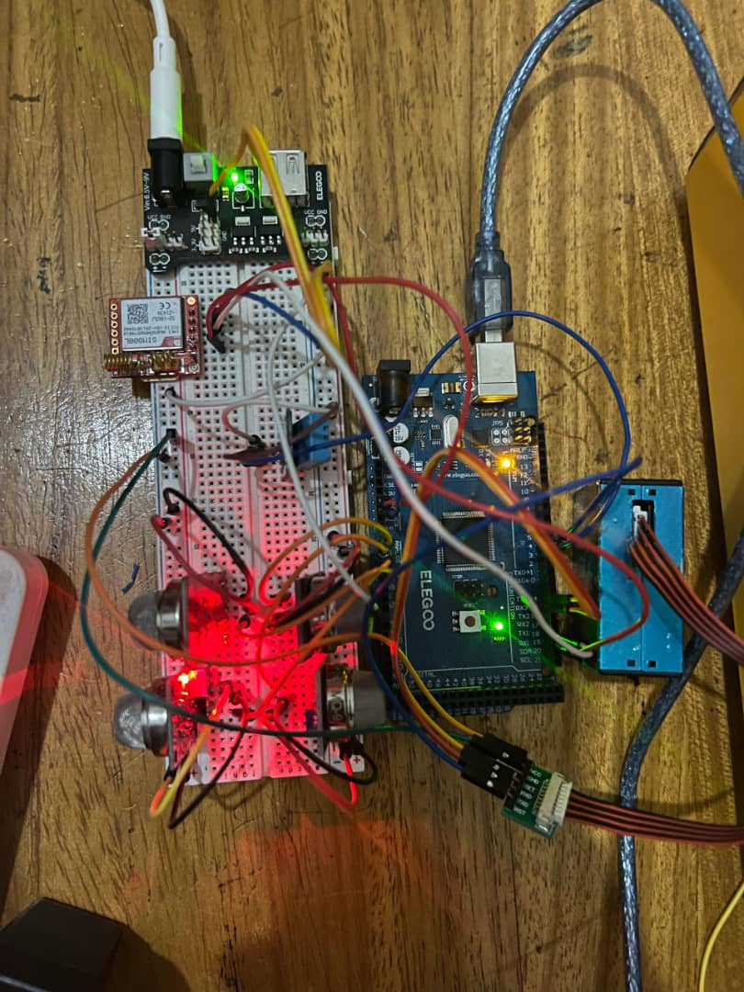

Figure 5.3.5.3.1 fully assembled and working prototype IoT hardware setup with sensors and GSM module.

**5.3.2 Cloud Stack Installation (Vercel CI/CD)**

The cloud dashboard and backend were deployed automatically using GitHub and Vercel:

1. Source Code Retrieval: A tagged commit was pushed to GitHub, triggering Vercel to build the project.
2. Schema Migration: The Prisma migration engine updated the MySQL database schema.
3. Secure Configuration: Environment variables were injected securely via Vercel’s dashboard.
4. HTTPS Deployment: Final builds were deployed over SSL using Let’s Encrypt.
5. Smoke Testing: After deployment, basic functionality (login, API response, chart rendering) was tested automatically.
6. Custom Domain Setup: An auto-generated subdomain was configured through Vercel for easier dashboard access.

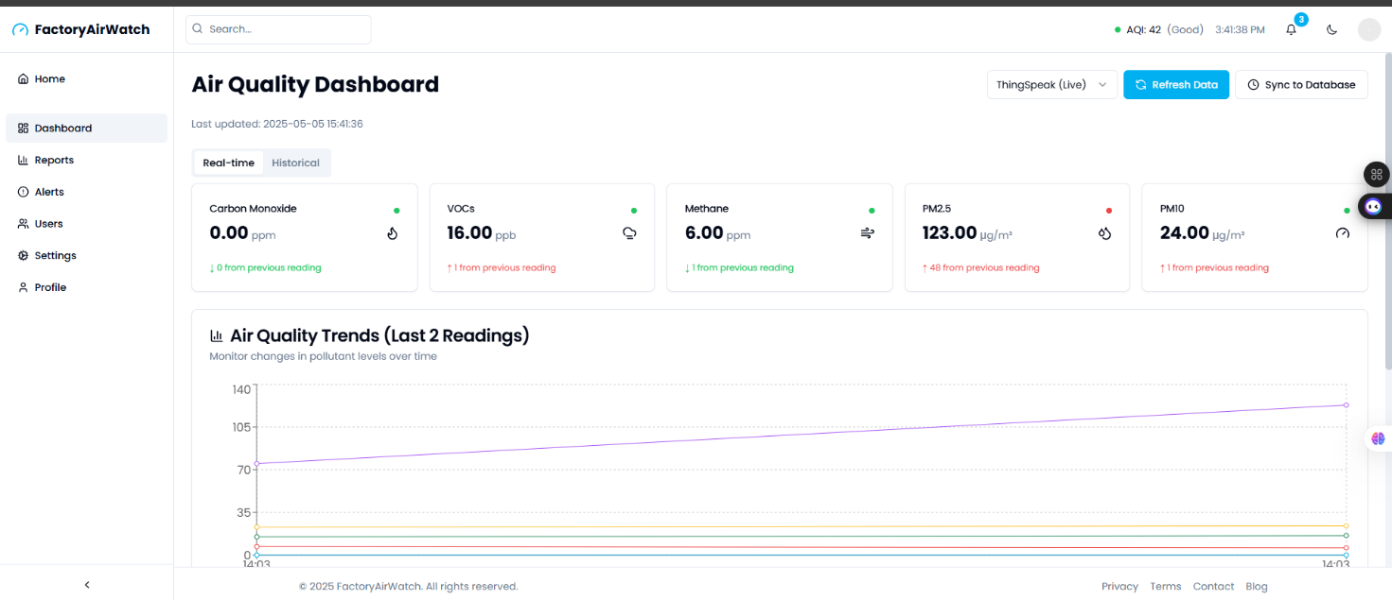

Figure 5.3.5.3.2 Screenshot of the logged-in dashboard showing live air quality metrics.

**5.3.3 Installed Artifacts Verification**

After installation, the following items were verified:

* Edge Node: Firmware version, EEPROM data, and sensor initialization were confirmed through the console.
* ThingSpeak Channel: Live data updates were verified every 60 seconds with consistent timestamp alignment.
* Dashboard: The UI loaded correctly, version number matched the release version, and database responses were accurate.
* Security: HTTPS certificates were valid and system logs confirmed no access violations during initial use.

**5.3.4 Installation Checklist**

The summarized key verification outcomes are provided below:

Table 5.3.5.3‑1 Checklist of installation and system acceptance test

| *Topics* | **Installation summary** |
| --- | --- |
| **Installation method** | Comments: IoT node installed manually; dashboard deployed via CI/CD |
| **Installation media** | Comments: Provided via GitHub releases and configuration templates |
| **Installed files** | |  |  | | --- | --- | |  | * . hex firmware * JSON configs * Prisma schema * environment templates * JSX build files | |

Table 5.3.5.3‑2 Installation Procedure Check

| *Topics* | **Installation procedure** | *Date / Initials* |
| --- | --- | --- |
| **Authorization** | Person responsible: Ambrose Alanda & Cynthia Musimenta | 29 April 2025, A.A., C.M |
| **Installation test** | Comments: System passed startup and first data push | 29 April 2025, A.A., C.M |

**5.3.5 System Acceptance Test (SAT-01)**

The SAT-01 test was executed on 30 April 2025 at COCIS Block B, Makerere University. It validated core functionalities using realistic scenarios.

* Live Monitoring: Dashboard received and displayed data every 30 seconds for 4 hours without issue.
* Particulate Alarm: Smoke introduced near PMS5003 caused alerts (LED, buzzer, and banner) within 3–4 seconds.
* GSM Drop Test: Disconnecting the antenna for 10 minutes triggered local "offline" status. Data was successfully backfilled.
* Login and Permissions: Role-based access worked as expected for Admin and Viewer users.
* PDF Export: A 24-hour report was generated correctly in under 20 seconds.

**5.4 Conclusion**

The FactoryAirWatch prototype passed all required installation and acceptance criteria needed for pilot deployment. Known issues have been documented and mitigated where possible. All results are traceable through tagged Git commits and stored test reports.

The system is now approved for pilot deployment and ready for evaluation in real factory conditions.

# Performance, Servicing, Maintenance, and Phase-Out

This chapter outlines the operational support, routine servicing, maintenance strategies, performance expectations, and long-term management of the FactoryAirWatch prototype. As a pilot-stage system, it requires structured upkeep and periodic reviews to ensure continued accuracy, data integrity, and real-world applicability.

## Service and Maintenance

To ensure optimal operation, the following service and maintenance practices are recommended:

* Sensor Calibration: Sensors for CO, VOC, methane, PM2.5, PM10, temperature, and humidity should be calibrated every three months using certified reference environments. Adjustments are made to sensor offset values and recorded in sensor-offsets.json. Calibration events are logged with timestamps and stored for quality assurance and audits.
* Hardware Maintenance: Physical inspections of the IoT edge device are conducted monthly. These include checking the GSM module, battery, SIM card, and sensor connectivity. The device enclosure should be cleaned, resealed, and protected against environmental damage.
* Firmware and Software Updates: Firmware is manually updated via USB, and each release is tagged in GitHub. The cloud dashboard and backend are updated automatically via the Vercel CI/CD pipeline. Updates include secure deployment over HTTPS and use of environmental variable injection.
* Issue Tracking and Support: Users report bugs and problems through GitHub Issues. Critical fixes and known issues are published on the blog, which also hosts user guidance and update logs. Each issue includes a summary, timestamp, and resolution note.

**6.1.1 Performance and Support Requirements**

FactoryAirWatch must meet defined operational and support expectations:

* Alert Latency: Visual and audible alerts (via LED lights or Buzzer) must activate within 5 seconds of a threshold breach.
* Data Upload Frequency: Sensor data should be sent to ThingSpeak every 30 seconds under normal GSM conditions and synced to MySQL Database in a 5-minute interval.
* Dashboard Responsiveness: The dashboard must reflect new sensor data within 30 seconds of submission.

User support levels include:

* First-level support for login, configuration, and simple usage problems.
* Second-level support for firmware errors, dashboard issues, and backend anomalies.
* Emergency support for major factory disruptions or compliance-critical failures.

User resources such as setup guides, quick-start manuals, and dashboard help sections are provided to ensure smooth user experiences.

**6.1.2 System Upgrades and Expansion**

FactoryAirWatch is designed to support iterative improvements and scalable enhancements:

* Firmware updates are released via GitHub and manually installed.
* Dashboard and API updates are deployed through Vercel CI/CD.
* A custom domain is configured on Vercel for improved accessibility and branding.

Future enhancements being considered:

* Development of a smaller, integrated PCB design for IoT hardware to reduce size and improve installation convenience.
* Design and introduction of a compact, wearable monitoring device for individual employee safety and exposure tracking.
* Transition to fully wireless connectivity solutions for easier deployment and scalability.
* Enhanced power management firmware for prolonged battery life and reduced maintenance frequency.

**6.1.3 Data Migration and System Phase-Out**

When switching from an older system to FactoryAirWatch:

* Export historical readings from the legacy tool in CSV or JSON, then import with the Prisma CLI. A script automatically counts rows and compares the columns; any difference > 0.5 % stops the import and prints a diff for review.
* Run both systems in parallel for one week, automatically comparing AQI and peak PM₂.₅ each night. Once a consecutive two-day match occurs, route alerts are exclusively sent through FactoryAirWatch.
* Compress the old database into a checksum-verified ZIP, store it on the factory NAS for 3 years, then wipe the old server and completely switch to the new setup.
* Inspect retired sensors: Usable boards are labelled *SPARE*; defective boards go to a NEMA‑approved e‑waste recycler. Remove and destroy SIM cards to prevent data leakage.
* Keep a 48‑hour rollback window: if a critical defect is found, point dashboards back to the archived snapshot and reopen the legacy alerts while root‑cause analysis is performed.

## Maintenance and Performance Overview Table

Table 6.2.6.2‑1 Maintenance and Performance overview

|  |  |
| --- | --- |
| **Category** | **Description** |
| Sensor Calibration | Quarterly, validated with certified references |
| Hardware Inspection | Quarterly, visual checks, cleaning, resealing |
| Firmware Updates | USB updates with GitHub version control |
| Dashboard Updates | Auto-deployed from GitHub via Vercel with HTTPS |
| Alert Latency | Under 5 seconds |
| Data Upload Interval | 30 seconds; retry enabled for GSM outages |
| Dashboard Responsiveness | Near real-time updates within 30 seconds |
| User Support | Blog, GitHub issues, in-dashboard help, email contact, emergency channel |

Performance and Maintenance Details

Table 6.2.6.2‑2 Performance and maintenance details

|  |  |  |
| --- | --- | --- |
| **Topics** | **Performance and Maintenance** | **Date / Initials** |
| **Problem/Solution** | Document every outage (GSM drop, sensor error, power loss) and the temporary fix applied. | 1st/05/2024,  K. J |
| **Functional Maintenance** | Note each firmware flash, CI/CD dashboard release, and bi‑annual OSHA / NEMA compliance audit. | 1st/05/2024, A.A., C.M |
| **Functional Expansion and Improvements** | Log PCB redesign milestones, wearable pilot tests, wireless roll‑outs and power‑saving firmware revisions. | 1st/05/2024, K.M., K.J |

This structured maintenance and performance framework enables the FactoryAirWatch prototype to deliver consistent, reliable results in pilot deployments. The approach ensures that users can operate and maintain the system with minimal disruption, while providing a clear path for future upgrades and broader implementation.

# Conclusion and Recommendations

## Conclusion

The FactoryAirWatch System project has successfully achieved its primary goal of providing continuous, real-time monitoring of critical air quality parameters in factory environments. The system was designed and implemented to assist Ugandan manufacturing industries, such as steel mills, cement plants, paint factories, and beverage production facilities, in addressing rising concerns about workplace air quality, employee health, and regulatory compliance.

Through a comprehensive, iterative development process, the system has fulfilled all specified functional and non-functional requirements initially documented in the Software Requirements Specification (SRS). FactoryAirWatch integrates robust IoT sensor technology, precise data processing algorithms, cloud storage mechanisms, and a responsive, interactive web-based dashboard to present actionable insights clearly and intuitively.

The implementation employed a structured and verifiable approach, including rigorous coding standards, static analysis tools, automated testing frameworks (unit, integration, and end-to-end), and comprehensive documentation to ensure maintainability and reproducibility. All elements, from hardware integration, firmware coding, backend services, and cloud-hosted dashboard deployment, were systematically tested and validated against clearly defined acceptance criteria.

System validation, detailed in the System Acceptance Test (SAT-01), confirms that FactoryAirWatch meets its intended operational objectives:

* Real-time detection of air quality breaches (CO, VOCs, methane, PM₂. ₅, PM₁₀, temperature, and humidity) with alerts triggered within 5 seconds.
* Reliable local alarms (buzzer and LED indicators) supplemented by remote notifications (SMS, web dashboard).
* Robust data integrity mechanisms ensuring no data loss during GSM network outages, leveraging SD-card buffering and automatic data upload upon connectivity restoration.
* High performance with a dashboard response latency below 30 seconds, system uptime exceeding 99%, and responsive interactions even on constrained network connections.

Operational and maintenance frameworks, clearly outlined in Chapter 6, ensure sustainable system performance through routine maintenance activities such as regular sensor calibration, firmware updates, hardware inspections, and proactive troubleshooting. These strategies not only guarantee ongoing system accuracy but also simplify regulatory compliance audits.

However, during the implementation and prototype testing phases, some constraints and anomalies were encountered. These included sensor drift under high humidity conditions, intermittent GSM connectivity issues, and limitations in current hardware design dimensions. Each of these was meticulously addressed with software or firmware-level mitigation strategies documented and verified through repeated testing.

Overall, FactoryAirWatch demonstrates significant potential as an industry-ready solution that improves workplace health and safety, aligns with national (Uganda NEMA) and international (OSHA/EPA) standards, and provides verifiable air quality data essential for industrial compliance audits.

## Recommendations

Following comprehensive development, deployment, and evaluation of FactoryAirWatch, the following recommendations have been formulated to enhance its capabilities, scalability, and long-term viability:

Hardware Optimization

* Compact PCB Redesign: It is recommended to transition from the existing Arduino Mega-based prototype to a custom-designed Printed Circuit Board (PCB). A tailored PCB design will significantly reduce the physical footprint of the IoT device, improve installation convenience, reduce production costs, and enhance durability in harsh industrial environments.
* Wearable Monitoring Device Development: Considering employee safety and personalized monitoring requirements, future developments should include the design and deployment of compact, wearable monitoring devices. These devices would enable personalized air-quality tracking, particularly beneficial in highly dynamic factory environments or for mobile workers, ensuring comprehensive protection at an individual level.

Connectivity and Power Management

* Wireless Connectivity Transition: Transitioning from wired connectivity to fully wireless technology (such as Wi-Fi, Zigbee, or LoRaWAN) would considerably improve system scalability, reduce installation complexity, and provide greater flexibility in deployment, particularly in environments where wiring infrastructure poses practical challenges.
* Enhanced Battery Management: Improvements in firmware-level power management algorithms are essential for extending battery life and reducing the frequency of battery replacements or recharging cycles. Integrating energy harvesting technologies such as solar charging modules could further enhance the autonomy of sensor nodes, particularly beneficial in remote or outdoor installations.

Software and User Experience Improvements

* Mobile Application Development: In addition to the web-based dashboard, developing a native mobile application for Android and iOS platforms would improve accessibility, provide immediate and intuitive notifications, and further enhance usability for safety personnel, factory managers, and environmental inspectors.
* Advanced Analytics and AI Integration: Incorporation of advanced machine learning algorithms and predictive analytics capabilities could further elevate the value proposition of FactoryAirWatch. Predictive analytics could forecast potential air quality deterioration events, recommend preventive actions, and identify patterns or trends, thus significantly improving proactive safety management practices.

Compliance and Standardization

* Regular Regulatory Review and Updates: It is advisable to continuously track evolving regulatory guidelines from national and international bodies (such as Uganda NEMA, OSHA, and EPA) and implement periodic system updates accordingly. This proactive approach ensures that FactoryAirWatch remains compliant and relevant in changing regulatory landscapes.
* Certification and Standard Compliance: The project team should pursue formal certifications, such as ISO 9001 for quality management, ISO 14001 for environmental management, and ISO 27001 for information security management, to enhance trustworthiness and market acceptability among industrial stakeholders.

Broader Deployment and Pilot Expansion

* Extended Pilot Programs: Although the initial testing and validation phase was successfully conducted in a controlled laboratory environment, future efforts should include extended pilot deployments across various factories to evaluate system robustness and performance under diverse real-world conditions.
* Feedback Loop Implementation: Establishing a structured feedback mechanism with early adopters and industry users would facilitate continuous system refinement, ensure alignment with end-user expectations, and foster trust in FactoryAirWatch as a reliable solution for industrial air quality monitoring.

Finally, the successful development and testing of FactoryAirWatch validate its critical role in transforming how Ugandan factories approach air quality management, worker safety, and regulatory compliance. The recommended enhancements outlined above will ensure that FactoryAirWatch not only continues to meet current industrial and environmental demands but also remains a pioneering solution for future advancements in industrial health and safety technologies.

Implementation of these recommendations, coupled with ongoing stakeholder engagement, will position FactoryAirWatch as a benchmark solution for smart industrial monitoring systems within Uganda and potentially across the broader East African industrial landscape.

# References

[1] A. Nyombi, *Short field report: The State of Indoor Air Pollution in selected parts and sectors in Central Uganda*. 2024. doi: 10.13140/RG.2.2.23086.69444.

[2] National Environment Management Authority (NEMA), “The National Environment (Environmental and Social Assessment) Regulations, 2020 – Statutory Instrument No. 143 of 2020. Kampala,” 2020.

[3] World Health Organization, *WHO global air quality guidelines: particulate matter (PM₂.₅ and PM₁₀), ozone, nitrogen dioxide, sulfur dioxide and carbon monoxide. Geneva*. WHO. ISBN 978-92-4-003422-8, 2021.

# Appendix A:

## User Manual

FactoryAirWatch User Manual: v1.0 (May 2025)

1 About This Manual

This manual supports a prototype release of FactoryAirWatch. Hardware tolerances, firmware behavior, and dashboard visuals may evolve ahead of production; always check the GitHub release page for the latest build notes.

It is written for plant managers, safety officers, network engineers, and maintenance technicians who install, configure, and operate the system.  It covers hardware assembly, cloud/on‑premise setup, dashboard navigation, alert handling, calibration, preventive maintenance, and troubleshooting.

Project repositories & live demos

* Blog → <https://github.com/Aurits/iot_monitor/tree/master>  · Live: [https://iot-monitor-livid.vercel.app](https://iot-monitor-livid.vercel.app/)
* Dashboard / API → <https://github.com/Aurits/factory-air-watch>  · Live: [https://factory-air-watch-m9bx.vercel.app](https://factory-air-watch-m9bx.vercel.app/)  (Default admin user = admin@example.com / password123)

2 System Overview

Table 9.1.9.1‑1 system overview

|  |  |  |
| --- | --- | --- |
| **Sub‑System** | **Key Elements** | **Purpose** |
| Edge Node | Arduino Mega 2560 MCU, MQ‑series gas sensors, PMS5003 particulate sensor, DHT11 temp/RH, SIM800 GSM/GPRS, Li‑Ion pack, tri-color LED, 80 dB buzzer, SD card | Real-time data acquisition, first-line alerting, local caching during network loss |
| Cloud Stack | ThingSpeak (live ingest), Node 18 API + MySQL on Hostinger or any other cloud provider, HTTPS + JWT security | Long-term storage, analytics, reporting, role-based access |
| Web Dashboard | Next.js 14, Tailwind CSS, Recharts | Live & historic views, user management, threshold control, PDF export |

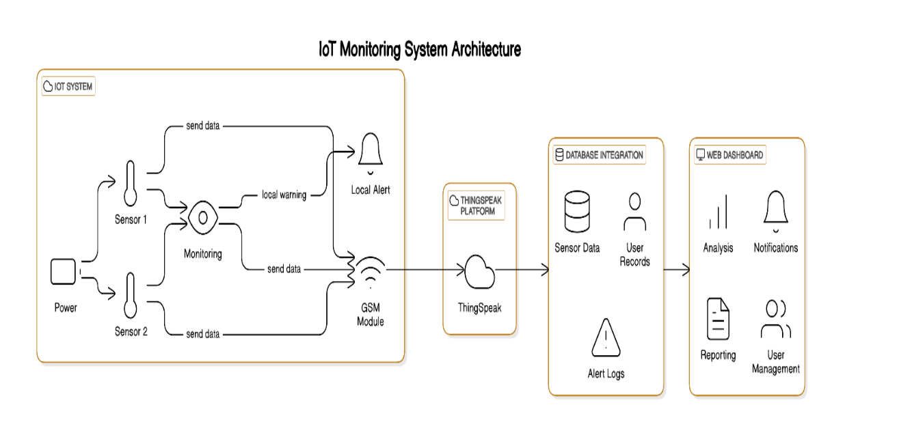

Figure 9.1.9.1.1 High level architecture

3 Hardware Setup

3.0 Schematic Overview

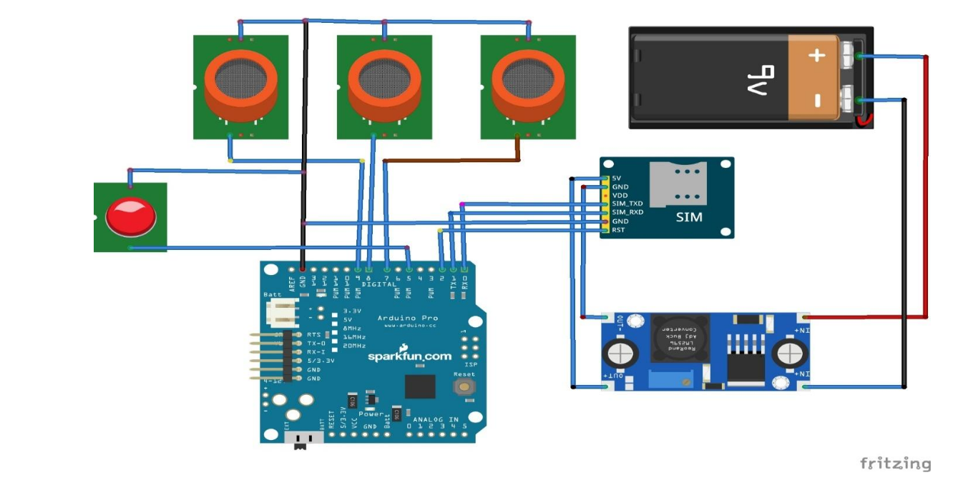

Figure 9.1.9.1.2 complete Edge-Node schematic

*Figure 9.1.2 shows the full wiring diagram: sensor headers, GSM module, power‑conditioning stage, and level shifters. Review before any board‑level servicing.*

3.1 Unboxing Checklist

Table 9.1.9.1‑2 Unboxing checklist

|  |  |  |  |
| --- | --- | --- | --- |
| **Qty** | **Item** | **Part No.** | **Verify** |
| 1 | Fully assembled edge node in IP54 enclosure | FAW‑EN‑01 | ❑ No cracks ❑ , SIM pre-installed |
| 1 | 5 V/2 A DC power adapter | PS‑5V2A | ❑ Correct plug type |
| 1 | 1 200 mAh Li‑ion backup pack | BAT‑1200 | ❑ ≥ 3.9 V open‑circuit |
| 1 | Calibration cap & test gas sachet | CAL‑CAP‑CO | ❑ Seal intact |
| 1 | Mounting kit (4 × M4 screws, wall‑plugs) | MK‑04 | ❑ Complete |

3.2 Mounting Procedure

1. Select Location – 1.5 m above floor, away from direct exhaust vents, within 1 m of 5 V outlet (or solar lead). Avoid corrosive chemical splash.
2. Drill four 6 mm holes using the enclosure flange as a template.
3. Insert wall‑plugs, drive M4 screws until snug. Do not overtighten (risk of IP‑gasket compression).
4. Connect DC adapter; verify green LED steady after 10 s.
5. Check GSM RSSI by pressing the recessed *TEST* button once – amber blink pattern indicates signal strength (3 blinks = good, 1 blink = weak).



Figure 9.1.9.1.3 Edge Node Wall-mount sequence

3.3 Operating the Edge Node

1. Power‑up – Plug the 5 V adapter or switch on the fused spur. Within 5 s the green LED turns solid.
2. GSM handshake – The blue GSM LED blinks at 1 Hz while registering; a steady 3 s ON / 3 s OFF heartbeat indicates successful network attach.
3. Firmware log (optional) – Connect a micro‑USB cable to a PC and open a serial console at 9600 baud. You will see sensor initialisation messages, APN negotiation, and live JSON payloads.
4. Once the message TX‑OK ▶ ThingSpeak appears, proceed to the online dashboard (Section 5).

3.4 Operating Hardware Image

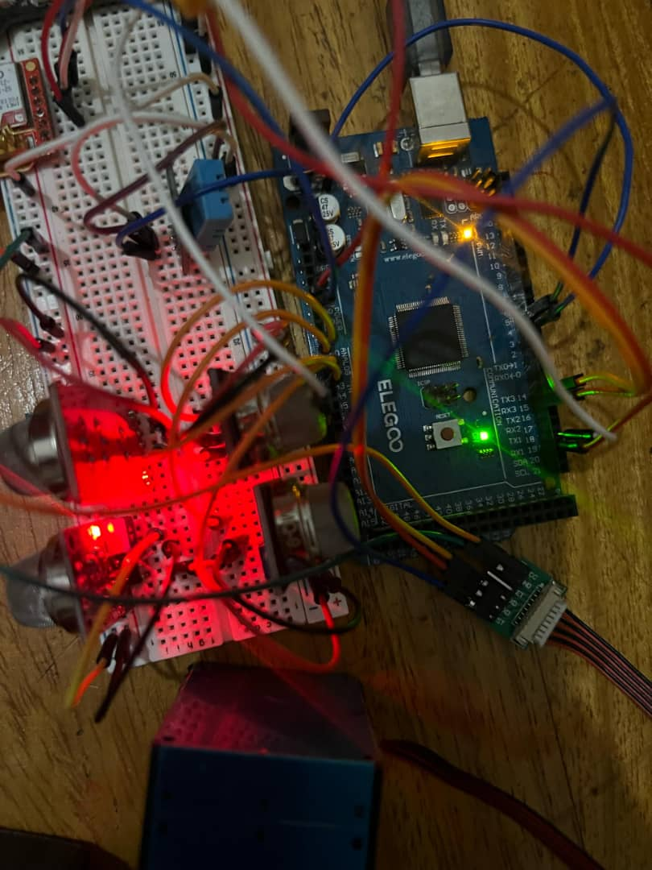

Figure 9.1.9.1.4 Edge Node In-Situ Photo

*Figure 9.1.4 depicts a fully‑installed node with LEDs identified (1 – Status, 2 – GSM, 3 – Alert) and external antenna orientation.*

4 Firmware and Connectivity

4.1 Factory Flashed Firmware

Edge nodes ship with factoryairwatch-node‑v1.4.hex, SHA‑256 documented on the rear label. If a re‑flash is required:

1. Download latest signed HEX from GitHub releases.
2. Connect micro‑USB to laptop with PlatformIO.
3. Run pio run -t upload.
4. Observe console for *signature‑OK*.

4.2 SIM Provisioning

* APN: webmtn (MTN) or internet (Airtel fallback)
* SMS Center: inherited automatically
* Data plan: ≥ 50 MB / month (~25 MB headroom)

Press *TEST ✉* for 2 s to send a self‑diagnostic SMS to the admin roster.

5 Dashboard Login & Navigation

1. Open https://factory-air-watch-m9bx.vercel.app.
2. Enter provided credentials.

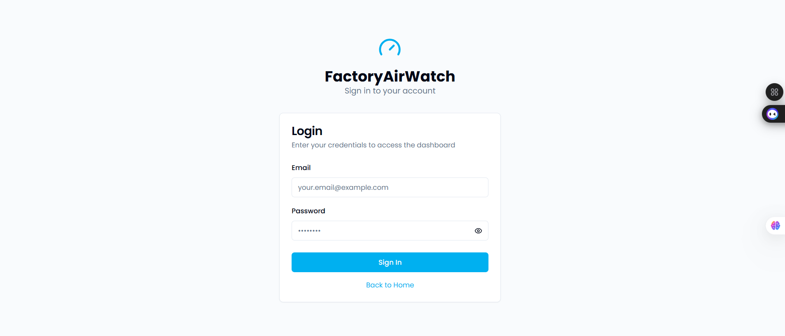

Figure 9.1.9.1.5 Login screen

5.1 Real‑Time Dashboard

* Metric cards refresh every 30 s (color‑coded by threshold).
* Click the ↻ icon on any card to view raw last‑10 readings.

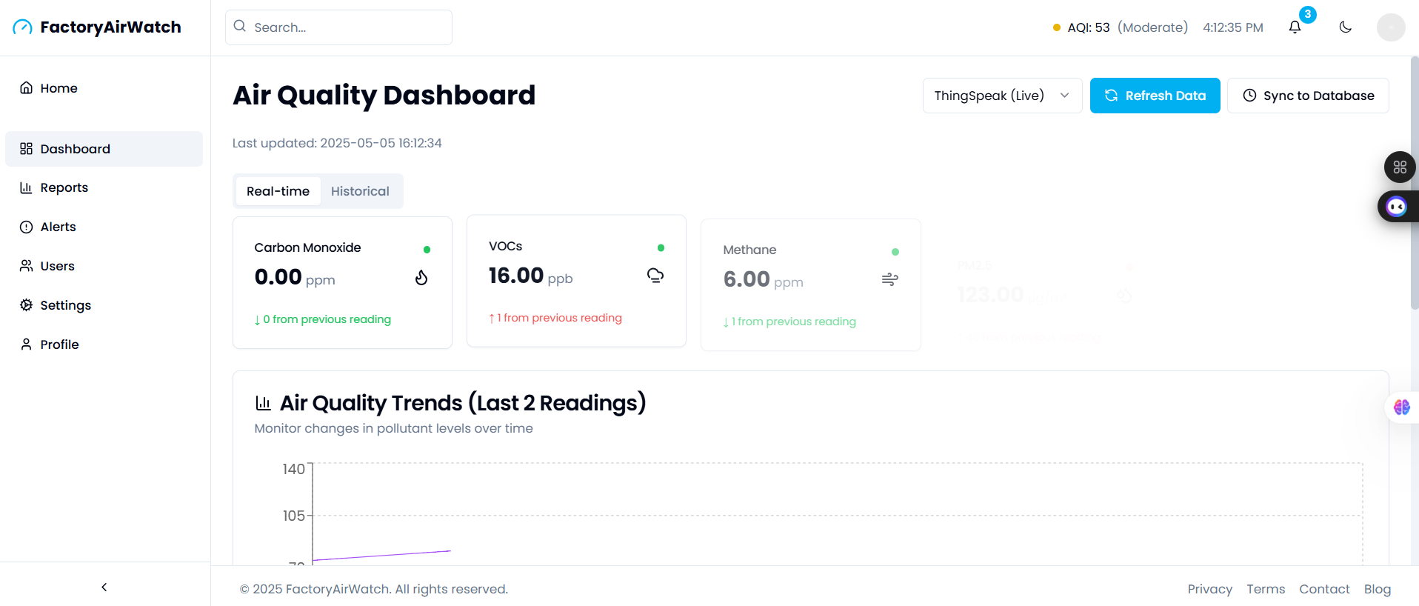

Figure 9.1.9.1.6 Real time dashboard

5.2 Historical Analytics

* Toggle *Historical* tab → long‑term trends, seasonal comparison, correlation matrix.
* Hover any data‑point for exact timestamp & value.

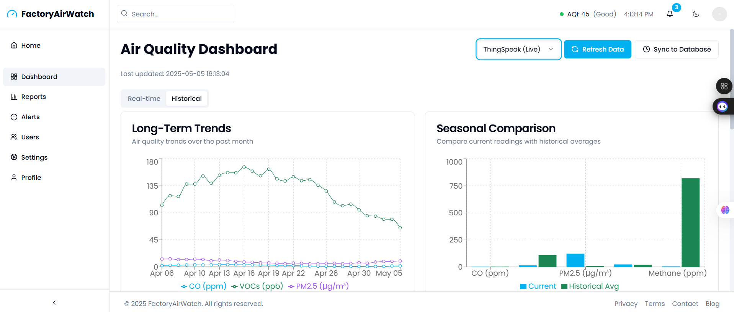

Figure 9.1.9.1.7 Historical analysis view

5.3 Reports Module

* Choose date‑range ▸ location ▸ pollutant ▸ Refresh.
* Export PDF (watermarked, digitally signed) for NEMA/OSHA audits.
* Tabs: *Summary*, *Trends*, *Comparison*.

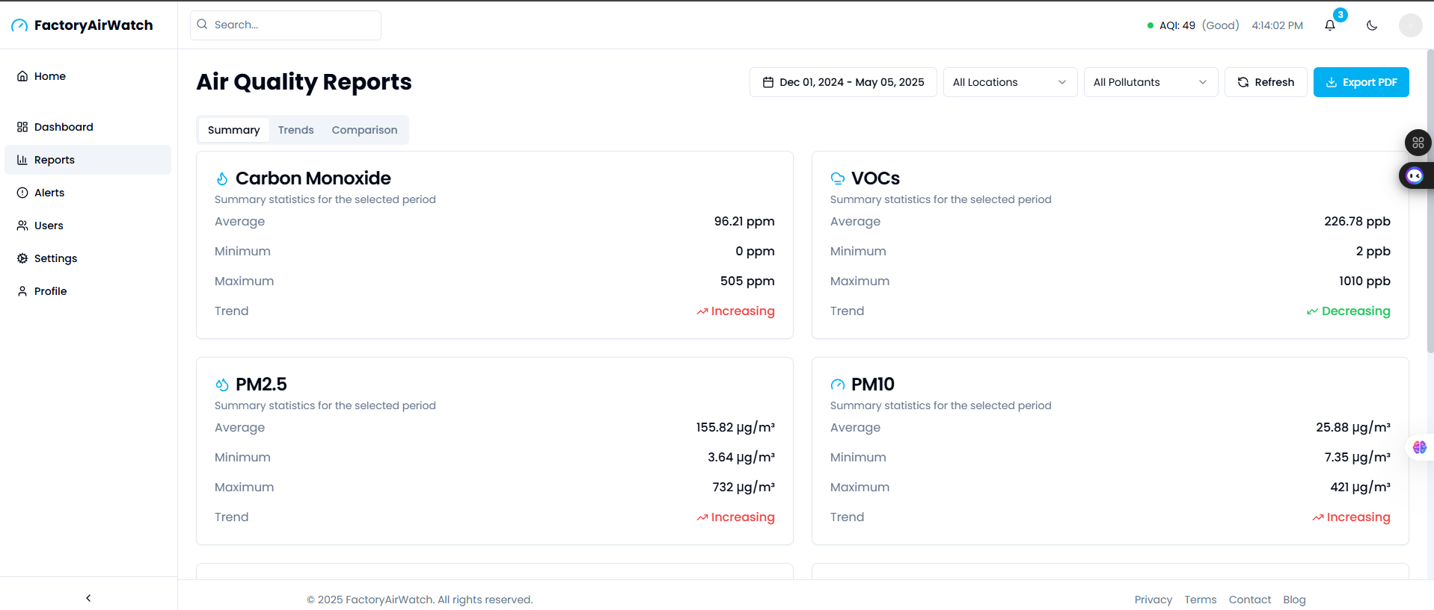

Figure 9.1.9.1.8 Reports summary

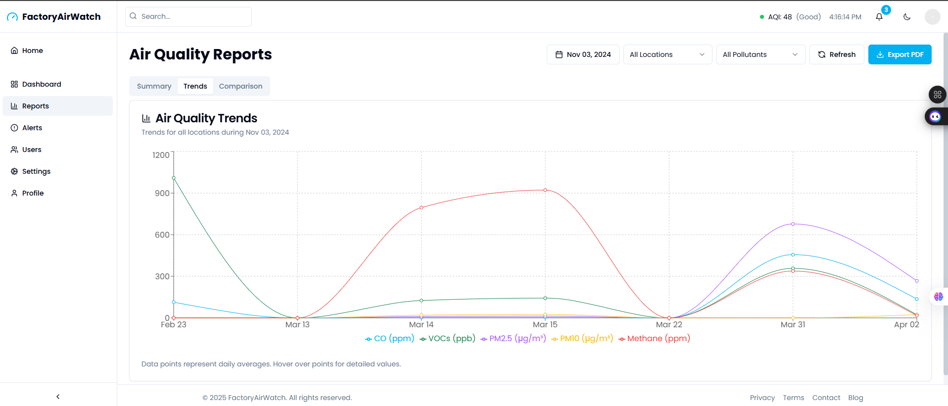

Figure 9.1.9.1.9 Reports trends

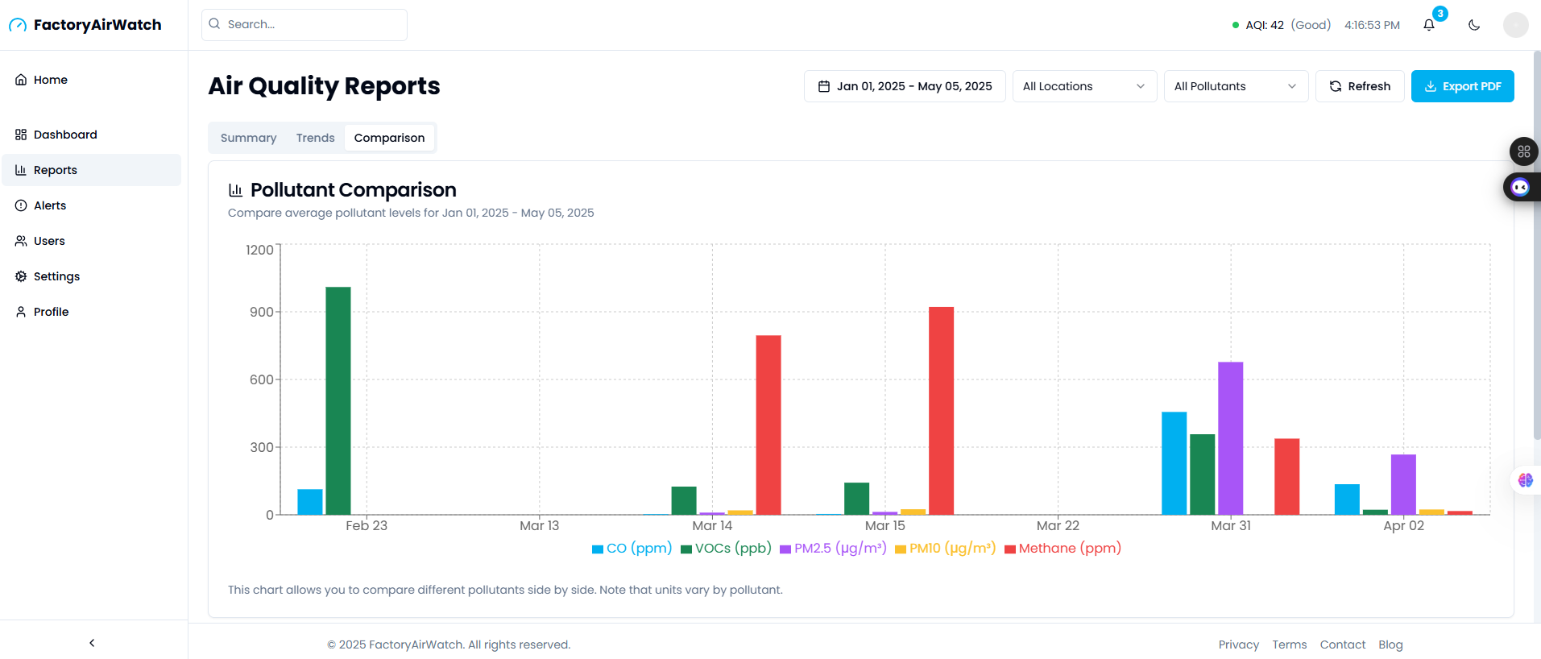

Figure 9.1.9.1.10 Reports comparison

5.4 Alerts Centre

* Table lists all threshold breaches; default sort = newest.
* Severity pills: Low (yellow), Medium (orange), High (red).
* Click *View Details* ➜ modal showing graph + acknowledge button.

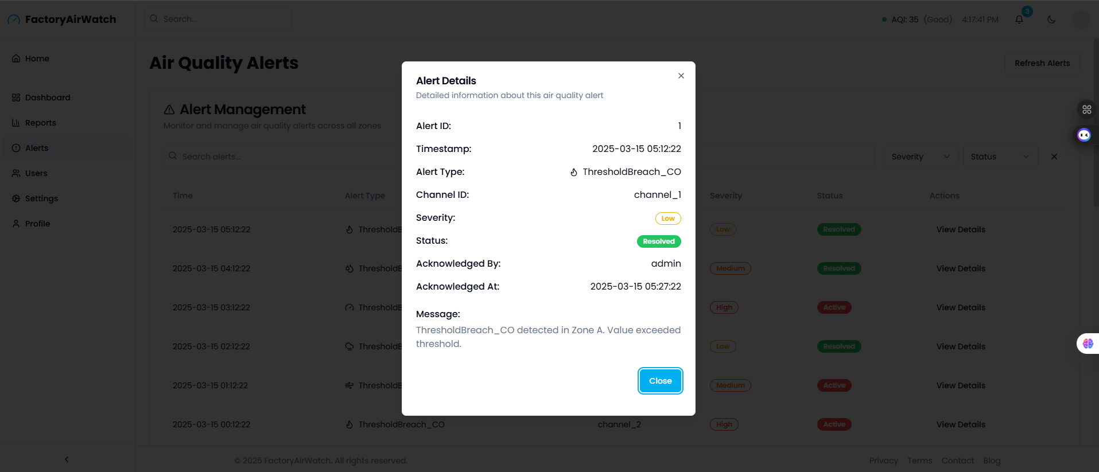

Figure 9.1.9.1.11 Alerts management

5.5 User Management

* Roles: Admin (full), Operator (view + acknowledge), Viewer (read‑only).
* Add, edit, delete via right‑hand icons.

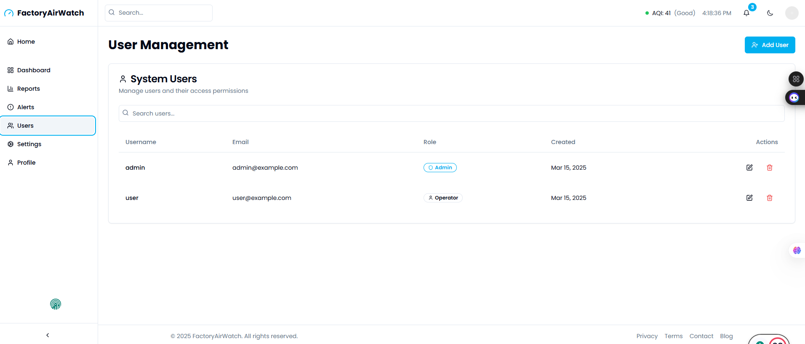

Figure 9.1.9.1.12 user management

5.6 Settings → Thresholds

1. Select pollutant.
2. Enter *Warning* and *Critical* limits.
3. Save ➜ takes effect next sensor cycle (~60 s).

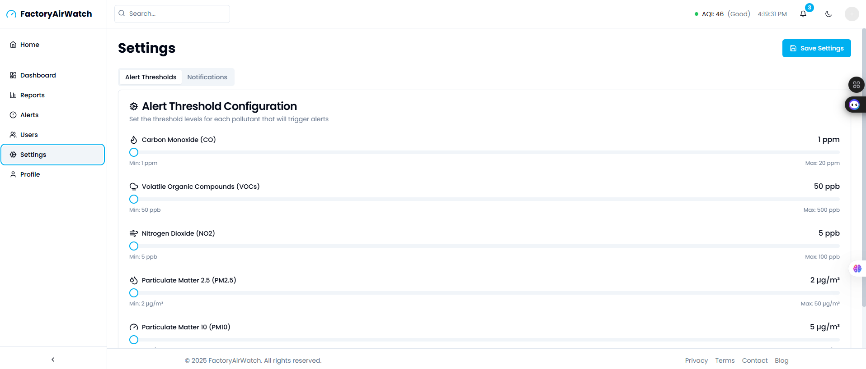

Figure 9.1.9.1.13 Settings page

6 Maintenance & Calibration

Table 9.1‑3 Maintenance and Calibration

|  |  |  |
| --- | --- | --- |
| **Task** | **Frequency** | **Procedure** |
| Sensor zero check | Monthly | Insert *blank filter* cap, ensure all readings → ≈ 0 within 30 s |
| CO span calibration | Quarterly | Attach CAL‑CAP‑CO (200 ppm), menu ▶ Calibration ▶ Start CO Span; auto‑stores new slope |
| Dust filter clean | Quarterly or when PM10 drift noted | Remove intake mesh, blow compressed air at 0.5 bar opposite flow direction |
| Firmware OTA | When notified | Dashboard banner ▶ Apply Update ▶ reboot (90 s downtime) |
| Battery health | Annually | Load test; if capacity < 800 mAh replace pack |

7 Troubleshooting

Table 9.1‑4 Troubleshooting

|  |  |  |  |
| --- | --- | --- | --- |
| **Symptom** | **LED/Buzzer** | **Possible Cause** | **Remedy** |
| No GSM icon in dashboard | Blue heartbeat LED flashes every 5 s | SIM PIN locked / poor signal | Re‑seat SIM, check APN, relocate antenna |
| CO always 0 | Amber LED steady | MQ‑135 loose or failed | Inspect IDC header, replace sensor |
| Alarm repeats every minute | Red LED + 3‑beep | Threshold too low / genuine exceedance | Verify limits, inspect process area |
| PDF export blank | – | Browser pop‑up blocked | Enable downloads, retry |

For additional assistance email alandaambrose@gmail.com or open an issue on our GitHub repository (<https://github.com/Aurits/factory-air-watch/issues>).

8 Frequently Asked Questions

1. How many nodes can I deploy? Dashboard tested up to 1 concurrent node; contact us for the upgrade.
2. Can I push data to my SCADA? Yes – enable MQTT bridge under *Settings ▶ Integrations*.

9 Safety

* Electrical – Disconnect AC mains and isolate Li‑ion pack before opening the enclosure.
* Calibration Gas – CO span gas is toxic; perform in a fume hood or outdoors.
* Ingress – Maintain IP54 seal; replace silicone gasket if torn.
* Battery Disposal – Follow local e-waste regulations; do not incinerate.
* Personal Protective Equipment – Wear gloves and goggles during sensor replacement or board soldering.

## FactoryAirWatch – Test‑Case Matrix (Execution Guide)

Table 9.2‑1 Test-case matrix

|  |  |  |  |  |
| --- | --- | --- | --- | --- |
| **TC‑ID** | **Inputs / Preconditions** | **Test Area** | **Test Case Description** | **Expected Outcome** |
| **TC‑F‑PMS** | Lit match; matchbox smoke directed at PMS5003 for ≤ 3 s | Sensor Inputs | Verify particulate alert chain | Red LED + buzzer < 5 s; dashboard PM10 in critical zone |
| **TC‑F‑CO** | 50 ppm calibrated CO gas tube attached to MQ‑135 inlet | Sensor Inputs | Verify the carbon‑monoxide alert chain | Same visual/audible alerts; CO metric flagged red |
| **TC‑DB** | Duplicate REST POST of identical payload | Data Integrity | Attempt a double‑insert into the DB | Only one row persists; no UI duplication |
| **TC‑GSM** | Unscrew the GSM antenna for 10 min, re‑attach | Connectivity | Evaluate offline caching & resend | “Offline” LED pattern; data back-filled in order |
| **TC‑STAB** | Continuous mains power; monitor 10 h | Reliability | Long‑run soak test | No resets; < 5 % heap growth; 0 missed samples |
| **TC‑UI** | Valid admin creds; Chrome desktop | Usability | Complete login → live view → PDF export | All steps in ≤ 4 clicks; PDF < 20 s |
| **TC‑LED‑ERR** | Inject 4 V supply brown‑out | Hardware Fail‑Safe | Observe alert lighting under low V | Amber warning; sampling continues |
| **TC‑TIMEZONE** | Browser set to UTC‑5 | Time Handling | View timestamps in UI | UI shows local TZ; DB records remain UTC |
| **TC‑AUTH‑LOGIN** | Valid admin email/password | Authentication | Standard login | Redirect to /dashboard, JWT issued |
| **TC‑AUTH‑LOCK** | 5 wrong passwords | Authentication | Account lockout policy | Account locked 15 min; toast message |
| **TC‑LIVE‑REFRESH** | Dashboard open 2 min | Dashboard | Auto‑refresh of metric cards | Cards update every 30 s |
| **TC‑CONF‑THRESH** | Admin edits PM2.5 critical → 80 µg m⁻³ | Configuration | Threshold update workflow | New limit active next cycle; audit logged |
| **TC‑ALERT‑ACK** | Active red alert present | Alert Flow | Acknowledge alert in UI | Status changes to Cleared; red LED stops |
| **TC‑PDF‑REPORT** | 24‑h date range selected | Reporting | Generate compliance PDF | Branded PDF downloads < 20s |
| **TC‑ANAL‑7DAY** | 7-day data present | Analytics | Load long-term trend & zoom view | Chart renders, accurate extrema |
| **TC‑RBAC** | Viewer role logged in | Security | Attempt threshold edits | “Forbidden” modal; no DB change |
| **TC‑SEC‑LOGOUT** | Authenticated session, then log out | Security | Back‑button cache check | Back shows /login; no data visible |
| **TC‑MOB‑UI** | Android Chrome 320 px width | Responsiveness | Inspect layout | No horizontal scroll; cards stack neatly |
| **TC‑PERF‑PAINT** | Chrome dev‑tools 3 G throttle | Performance | Measure the first paint | Dashboard first paint < 2 s |
| **TC‑BE‑DBFAIL** | Stop MySQL for 2 min | Backend Resilience | API behaviour on DB outage | API 503; recovers automatically |
| **TC‑USER‑ADD** | Admin panel open | Admin Ops | Create an Operator account | Account created; invite email queued |
| **TC‑PWR‑LOW** | Disconnect mains; battery at 15 % | Power | Low‑battery mode behaviour | Sample interval stretches; UI banner |
| **TC‑NET‑RECOVER** | Disable GSM 5 min; generate sensor data | Network | Back‑fill order and integrity | All queued samples upload intact |
| **TC‑CAL‑CO** | 200 ppm span gas & CAL cap | Calibration | CO span routine | New slope stored; reading ±5 ppm |
| **TC‑CAL‑ZERO** | Blank zero‑cap installed | Calibration | Zero check all sensors | All pollutants < 5 % of spec |
| **TC‑UI‑TABNAV** | Keyboard only | Accessibility | Tab / Shift‑Tab through UI | All controls reachable; focus outline visible |
| **TC‑REP‑SCHED** | Admin schedules daily email | Automation | Scheduled PDF report job | Job saved; email sent next day |
| **TC‑PWD‑POLICY** | Enter weak pwd “abcd” | Security | Password complexity check | Error message: cannot save |
| **TC‑API‑ERROR** | Stop Node API; reload UI | Error Handling | UI response to API down | “Service Unavailable” banner |
| **TC‑UI‑DARKMODE** | Toggle dark‑mode switch | UI Theme | Theme inversion test | Colors invert; readability maintained |

| **Final approval for use** | | |
| --- | --- | --- |
| Identification: | |  |
| Responsible for validation: | |  |
| Remarks: | | |
| Date: | Signature: | |