632115036 Wanatchaya Kaewwongwan

Consider the ClassyDraw classes Line, Rectangle, Ellipse, Star, and Text.

* Given the properties shared by ClassyDraw classes, what properties do these classes all share? What properties do they not share? Are there any properties shared by some classes and not others? Where should the shared and nonshared properties be implemented?

The shared properties that are essential for drawing are ForeColor and BackColor that are used by Drawable (Drawable is parent class at the top). The properties attribute are Width and Height that are used by Drawable. The nonshared properties are Font and String that are used by Text. LineThinkness and DashStyle that can be shared are used by Line. NumPoint is used by Star. Rectangle, Ellipse, and Star need Line.

* Draw an inheritance diagram showing the properties you identified. (Create parent classes as needed, and the Drawable class is a parent class at the top.)

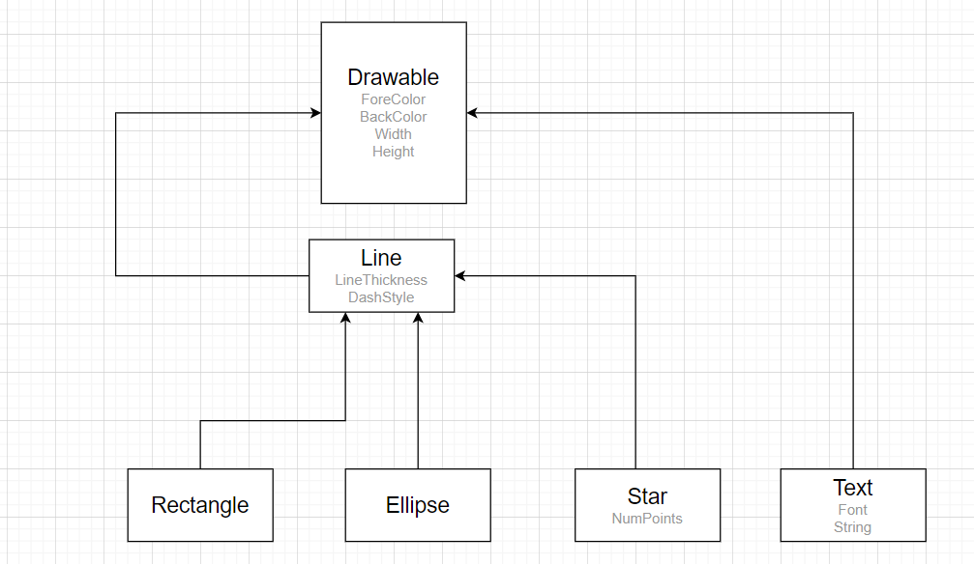

|  |  |
| --- | --- |
| Properties | Used by |
| ForeColor | Drawable |
| BackColor | Drawable |
| Width | Drawable |
| Heigth | Drawable |
| Font | Text |
| String | Text |
| NumPoint | Star |
| LineThinkness | Rectangle, Ellipse, Star |
| DashStyle | Rectangle, Ellipse, Star |