Project 1 - Martingale By: Nicholas Daponte ndaponte3@gatech.edu

Abstract—Two experiments were conducted and simulated in Py- thon on Dr. Balch’s American Roulette betting strategy in Las Ve- gas. One with an infinite bankroll and one with a more realistic
$256 bankroll. Results indicate that the expected value of win- nings is $80 within 1000 sequential bets for the infinite bankroll case and -$32 in the finite bankroll case.

1 INTRODUCTION

The purpose of this report is to summarize the results of simulating Dr. Balch’s betting strategy in Las Vegas in the American roulette wheel given his pseudo- code outlining his specific betting routine. Several experiments are prepared to test how well his strategy works through a Monte Carlo simulation. Experiments are run on different sets of episodes where the NumPy library generates ran- domized inputs and tracks the results by aggregating them. 10 episodes and 1000 episodes are conducted where an episode consists of 1000 consecutive bets on the simulator. Testing the simulator by tracking the winnings and plotting in Matplotlib will provide insight into the efficacy of Dr. Balch’s specific strategy through a statistical analysis by simulating his game in Python libraries appro- priate for this set of experiments. The second part to this report tests a second set of experiments simulating a more realistic American roulette strategy where this time there is a constraint on the bankroll to allow a more realistic simulation on running out of money. 1000 episodes are tested on this new simulation to com- pare with the results of Dr. Balch’s strategy.

2 EXPERIMENT 1 – EXPLORING DR. BALCH’S STRATEGY

Experiment 1 performs two sets of experiments to evaluate Dr. Balchs’s betting strategy on black. The first experiment runs 10 episodes and the second runs 1000 episodes. If the winnings reach $80 are above then those winnings will be filled forward for the remaining spins in that episode. Figure 1 below depicts the Py- thon script results for 10 episodes.
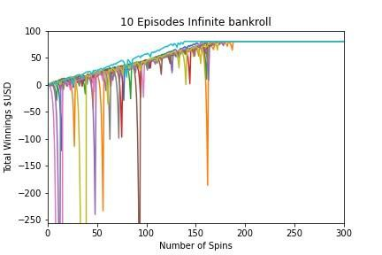

Figure 1. Python script results for simulating Dr. Balch’s American Roulette bet- ting strategy for 10 episodes.

It can be seen that the $80 threshold or above is reached for all episodes at ap- proximately 150 spins into an episode.

Similar experiments are run for 1000 episodes seen below in Figure 2 where the mean value of the winnings for each spin and its bounded standard deviations for the episodes are depicted.

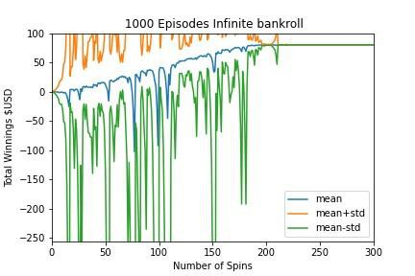
Figure 2. Python script results for simulating Dr. Balch’s American Roulette bet- ting strategy for 1000 episodes displaying the mean winnings of each spin.

It can be seen that the average winnings reach the $80 threshold or above for that particular spin in an episode at around 160 spins similar to the 10 episode results. The standard deviations stabilize at around 200 spins indicating that all episodes reach the winning threshold and are filled forward at around 200 spins.

The median is used instead of the mean for the 1000 episode experiment and is shown below in Figure 3.

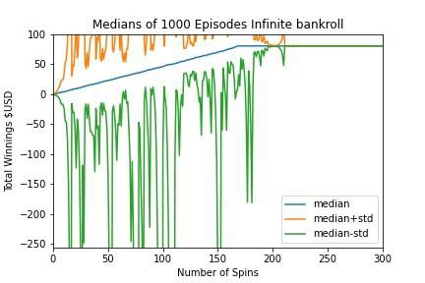

Figure 3. Python script results for simulating Dr. Balch’s American Roulette bet- ting strategy for 1000 episodes displaying the median winnings of each spin.

Q u e s t i on S e t 1

Probability of winning $80 within 1000 bets:

The estimated probability of winning $80 within 1000 bets is 100%. Over the course of 1000 episodes, every single episode resulted in a win of $80 or more. This is evident from the data showing that the number of episodes with winnings of at least $80 is exactly 1000 out of 1000. Additionally, the average winnings per episode converge to $80 after approximately 200 spins seen in Figures 1 and 2. This indicates a consistent pattern where all episodes yield winnings of $80 or
more by the final spin. Therefore, the estimated probability of winning $80 within these 1000 bets is 1, or 100%.

Q u e s t i on S e t 2

Estimated expected value of winning after 1000 bets: The estimated expected value is :
E[X] = Summation x*P [X = x]

The weight of each of the episodes is 0.001, thus the estimated expected value of winnings after 1000 consecutive bets is 100*80/1000 = 80. Shown by:

E(x) = (1/1000) * summation(i=1 to 1000) * xi

Where xi is the episode winnings at final spin(1000th spin) during the ith episode in this case all xi are 80.

Q u e s t i ons S e t 3

Standard deviation lines:

In Experiment 1, both the upper and lower standard deviation lines reach their maximum or minimum values before stabilizing, eventually converging to a value of 80. As illustrated in Figure 2, these standard deviation lines settle at 80 after about 240 spins. Before converging, they exhibit many peaks. As the num- ber of bets increase for an episode the standard deviation lines converge shown in Figure 3, the upper and lower standard deviation lines converge to 80 after
240 spins, with peaks before convergence when all episodes maintain a constant feed forward winning. As shown below in the equation, mathematically the
standard deviations will be 0 at this point.

𝜎 = √∑
(𝑥𝑖 − 𝜇)^2
𝑁

3 EXPERIMENT 2 – EXPLORING DR. BALCH’S STRATEGY

This experiment simulates the same strategy with a finite bankroll of $256 where you can only bet what money you retain in an episode.
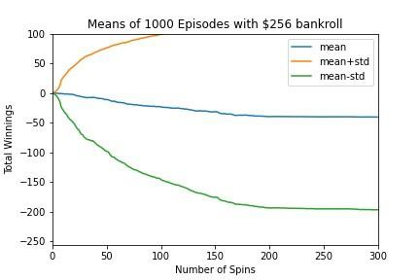

Figure 4. Mean and Standard deviation for Experiment 2 with a $256 bankroll constraint.

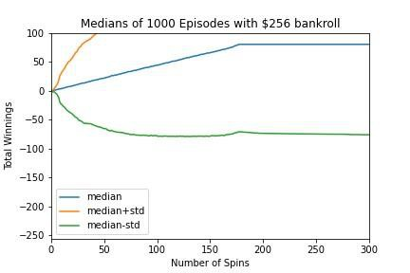

Figure 5. Median and Standard deviation for Experiment 2 with a $256 bankroll constraint.

Q u e s t i on S e t 4

Estimated probability of winning $80 within 1000 bets:

In the more realistic finite bankroll case the probability of winning the $80 is
664/1000 or 66.4% symbolizing a more realistic probability in a real world case scenario.

Q u e s t i on S e t 5

Estimated expected value of winning after 1000 bets:

The weight in each episode is 0.001 where xi is the episode winning at the final spin during the ith episode in Experiment 2. The sum of xi is -32383 thus the estimated expected value is approximately -32.383. The estimated expected value can be interpreted as the mean value of winnings after 1000 spins. Shown in Fig- ure 4, the mean value converges to around 32.383.

Q u e s t i on S e t 6

Standard deviation lines:

In Experiment 2, the upper and lower standard deviation lines reach their max- imum or minimum values before stabilizing. As the number of bets increases the episode winnings tend to be either 80 or -256 with other outcomes clustering near these values. When the winnings reach 80 or -256 , the standard deviation settles at a specific value. Figure 4 illustrates that theses standard deviation lines stabi- lize as the number of bets increase. The standard deviation will never reach 0 as the number of bets increase it is more likely that the outcome will be 90 or -256. Mathematically the mean plus the standard deviation ill not converge with the mean minus the standard deviation.

Q u e s t i on S e t 7

Benefits using the expected values instead of using result of one random episode:
Expected values in experiments provide a more comprehensive and reliable
measure by considering all possible outcomes and their probabilities rather than relying on a single random episode that may not represent typical results. This reduces the influence of outliers and random fluctuations leading to a more ro- bust and conclusive result. Expected values allow for better comparison and evaluation of different strategies or conditions under the study as they consider the average performance over many experimental trials.

3.1 Conclusion

In Experiment 1 with unlimited bankroll, it can be concluded that people will be able to earn $80 USD after 1000 successive bets using Professor Blach’s strategy based on statistical math of 100% probability. However, with the more realistic case of a finite bankroll of $256 , the expected winning is -$32 USD, indicating that a larger bankroll increases the expected winnings due to the doubling bets after losses within an episode. In summary, limited bankrolls seen in most real world cases means that the “lose-until-win” strategy will mostly fail as people
will usually not have enough funds to continue doubling their bets.

4 REFERENCES

1 . Roulette. (2024). In Wikipedia. https://en.wikipedia.org/w/index.php?title=Rou- lette&oldid=1225166628
2. Summer 2024 Student Resubmission for Course-Retake.

