Microservices Deployment Using Docker, Kubernetes, and Multi-EC2 Infrastructure
Design and Deployment of a Scalable Microservices-Based Task Management System on AWS EC2
AUPP — Cloud Computing / Distributed Systems
Student: Dapravith Rotha
Date: May 2026

1. Problem Statement
Modern cloud-native applications are expected to be horizontally scalable, fault-tolerant, and continuously deployable. Traditional monolithic applications struggle to meet these expectations: a single failure brings the whole system down, scaling means duplicating the entire codebase, and every code change requires a full re-deployment.
This project implements a microservices-based task management platform that solves those problems by splitting responsibility across four independently deployable services, each running in its own Docker container, orchestrated by Kubernetes across three AWS EC2 instances. The system demonstrates four key cloud-native concepts:
- Service decomposition — each domain (auth, students, teachers) owns its own service and its own database.
- Containerization with Docker — every service ships as an immutable image.
- Kubernetes orchestration — declarative deployments, health checks, persistent volumes, and node affinity for placement across the 3 EC2 nodes.
- Role-based authorization at the API gateway — a single edge enforces who is allowed to call what, so the downstream services stay simple.

2. Architecture
The system has four Spring Boot microservices, a MongoDB instance, and a single externally-exposed gateway. The gateway is the only service that understands JWTs; it validates the token, enforces role-based access, and rewrites the request with X-User-Email and X-User-Role headers before forwarding it to the downstream service.
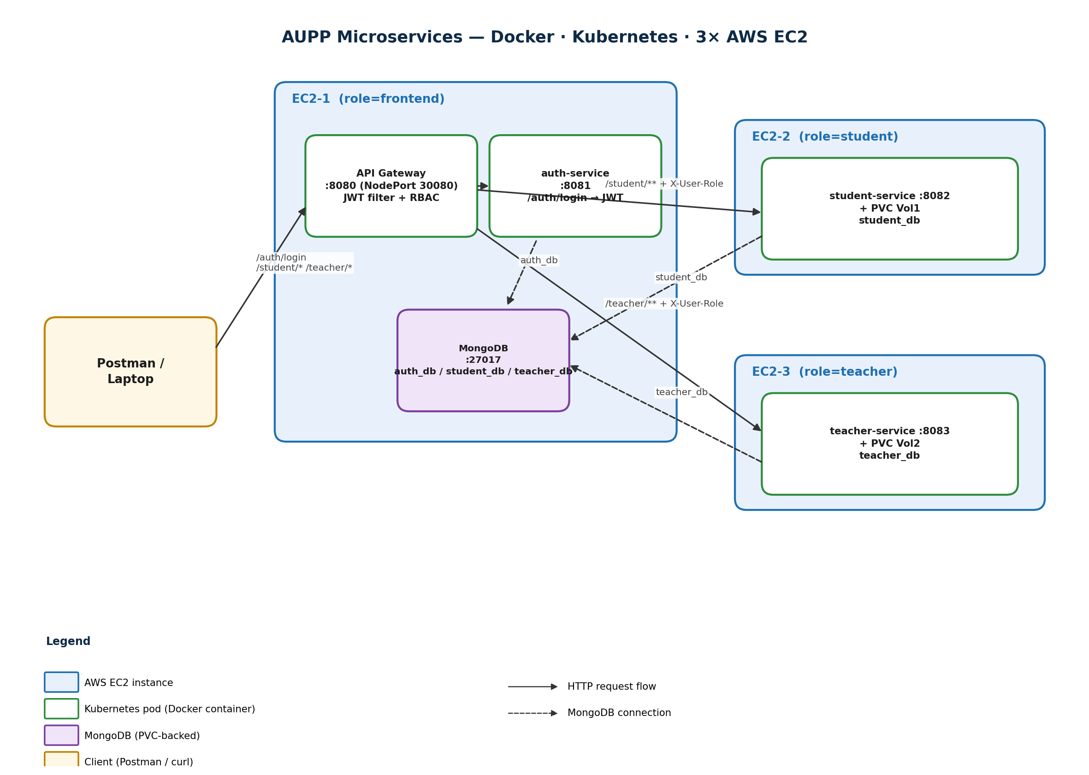
Figure A. Logical architecture across 3 AWS EC2 instances.

2.1 Component responsibilities
Service | Port | Pinned to EC2 | Responsibility
api-gateway | 8080 (NodePort 30080) | EC2-1 (role=frontend) | Edge routing, JWT validation, role-to-path enforcement.
auth-service | 8081 | EC2-1 (role=frontend) | /auth/register, /auth/login — issues JWTs containing email + role.
student-service | 8082 | EC2-2 (role=student) | Student domain CRUD. Persists to student_db.
teacher-service | 8083 | EC2-3 (role=teacher) | Teacher domain CRUD. Persists to teacher_db.
mongodb | 27017 | EC2-1 (role=frontend) | Single Mongo instance hosting auth_db, student_db, teacher_db.

2.2 Request flow
A typical authenticated request follows six steps:
- 1. Client (Postman) sends the request to the gateway’s NodePort, e.g. http://<EC2-public-IP>:30080/student/me.
- 2. The gateway’s JwtAuthFilter extracts the Bearer token from the Authorization header.
- 3. The filter verifies the HMAC-SHA256 signature using JWT_SECRET (shared with auth-service via a Kubernetes Secret) and checks the expiration.
- 4. The filter compares the JWT’s "role" claim against the path prefix: /student/** requires STUDENT, /teacher/** requires TEACHER. Mismatches return 403 Forbidden.
- 5. On success, the gateway rewrites the outbound request with X-User-Email and X-User-Role headers, then forwards it to the matching ClusterIP service.
- 6. The downstream service performs business logic, reads/writes its own MongoDB database, and returns JSON. The gateway streams the response back to the client.

2.3 Why this split is robust
- Failure isolation — if student-service crashes, the gateway, auth, and teacher continue to serve traffic.
- Independent scaling — student-service can be scaled to N replicas without touching teacher-service.
- Domain ownership — each service owns its own MongoDB database (auth_db / student_db / teacher_db). No cross-service joins.
- Single source of truth for auth — only auth-service issues tokens; only the gateway validates them.

3. Technology Stack
Layer | Choice | Why
Language / framework | Java 17, Spring Boot 3.2.5 | LTS Java, mature web/security/MongoDB starters.
API gateway | Spring Cloud Gateway 2023.0.1 | Reactive, supports global filters and dynamic routing via YAML.
JWT | jjwt 0.12.5 (HS256/512) | Self-contained, stateless, no shared session store needed.
Persistence | MongoDB 7 with Spring Data MongoDB | Document model fits flexible student/teacher records.
Containerization | Docker (multi-stage build) → eclipse-temurin:17-jre | Slim runtime images, ~280 MB each.
Orchestration | Kubernetes 1.30 (kubeadm) | Industry-standard, well-supported on EC2 with containerd.
CNI plugin | Flannel (VXLAN) | Simple, reliable pod network for small clusters.
Infrastructure | AWS EC2 (3× t3.medium, Ubuntu 22.04) | Cheap, region-flexible, full root access for kubeadm.

4. Deployment
The full step-by-step procedure is documented in DEPLOYMENT.md and automated by the scripts in infra/scripts/. The high-level sequence is:

4.1 Provision AWS resources
- Launch 3 Ubuntu 22.04 EC2 instances (t3.medium, 20 GiB gp3) in the same VPC.
- One security group with: 22/tcp from your IP, 6443/tcp and 10250/tcp within the SG, 8285/8472 UDP within the SG (Flannel), 30000–32767/tcp from your IP (NodePort range).

4.2 Bootstrap every node
sudo bash infra/scripts/bootstrap-ec2.sh
This installs containerd, Docker (for builds), kubeadm/kubelet/kubectl v1.30, and configures kernel modules and sysctl for Kubernetes networking.

4.3 Build the cluster
# On EC2-1
sudo bash infra/scripts/init-control-plane.sh
# Copy the printed `kubeadm join` command to EC2-2 and EC2-3

4.4 Pin services to nodes
EC2_1=aupp-ec2-1 EC2_2=aupp-ec2-2 EC2_3=aupp-ec2-3 \
bash infra/scripts/label-nodes.sh
Labels each node (role=frontend / student / teacher) so the Deployments land where the architecture requires.

4.5 Build images and apply manifests
REGISTRY=docker.io/<user> TAG=1.0.0 bash infra/scripts/build-and-push.sh
IMAGE_REPO=docker.io/<user> bash infra/scripts/apply-k8s.sh
apply-k8s.sh applies the manifests in dependency order: namespace → secret → MongoDB → auth + student + teacher → gateway, waiting for each rollout.

5. Evidence — Required Screenshots
The following nine screenshots demonstrate that each requirement from the assignment specification has been fulfilled. Replace each placeholder with the actual screenshot from your AWS console and Postman runs.
[ Paste SCREENSHOT 1 here ]
Figure 1. AWS EC2 console showing 3 running instances (aupp-ec2-1, aupp-ec2-2, aupp-ec2-3).
[ Paste SCREENSHOT 2 here ]
Figure 2. `docker images` on each of the 3 EC2 instances showing the four service images (api-gateway, auth-service, student-service, teacher-service).
[ Paste SCREENSHOT 3 here ]
Figure 3. `kubectl -n aupp get deploy,svc -o wide` — five Deployments and five Services across the 3 EC2 nodes.
[ Paste SCREENSHOT 4 here ]
Figure 4. `kubectl -n aupp get pods -o wide` — one pod per node (gateway/auth/mongo on EC2-1, student on EC2-2, teacher on EC2-3).
[ Paste SCREENSHOT 5 here ]
Figure 5. Postman: POST /auth/login returning a JWT (200 OK with `token` field).
[ Paste SCREENSHOT 6 here ]
Figure 6. Postman: GET /student (or /student/me) with the STUDENT JWT — 200 OK with database-backed response.
[ Paste SCREENSHOT 7 here ]
Figure 7. Postman: GET /teacher (or /teacher/me) with the TEACHER JWT — 200 OK with database-backed response.
[ Paste SCREENSHOT 8 here ]
Figure 8. Postman: GET /student with the TEACHER JWT — 403 Forbidden (role mismatch).
[ Paste SCREENSHOT 9 here ]
Figure 9. Postman: GET /teacher with the STUDENT JWT — 403 Forbidden (role mismatch).

6. API Reference (Summary)
Method | Path | Auth | Description
POST | /auth/register | public | Create a user with role STUDENT or TEACHER.
POST | /auth/login | public | Validate credentials → return signed JWT.
GET | /student | STUDENT | List students owned by the caller.
POST | /student | STUDENT | Create a student record (DB write).
GET | /student/{id} | STUDENT | Read a single record.
PUT | /student/{id} | STUDENT | Update a record (DB write).
DELETE | /student/{id} | STUDENT | Delete a record (DB write).
GET | /teacher | TEACHER | List teachers owned by the caller.
POST | /teacher | TEACHER | Create a teacher record (DB write).
GET | /teacher/{id} | TEACHER | Read a single record.
PUT | /teacher/{id} | TEACHER | Update a record (DB write).
DELETE | /teacher/{id} | TEACHER | Delete a record (DB write).

7. Conclusion
This project delivers a working microservices system that meets every requirement of the assignment brief:
- Four independently deployable Spring Boot services, each in its own Docker container.
- A Spring Cloud Gateway that authenticates JWTs and enforces role-based authorization at the edge.
- MongoDB persistence with three logical databases (auth_db, student_db, teacher_db) and PVCs for the two domain services as shown in the architecture diagram.
- A Kubernetes cluster spread across 3 AWS EC2 instances, with each service pinned to its designated node by label-based nodeSelector.
- A Postman collection with automated tests covering all four required permission combinations: student-JWT/student-API, teacher-JWT/teacher-API, student-JWT/teacher-API (403), teacher-JWT/student-API (403).
Future improvements: MongoDB replica set instead of a single instance, mutual TLS between services via a service mesh, OpenID Connect for the auth service, GitHub Actions CI building images on push, and observability via Prometheus + Grafana.

