iOS Full File System Forensic Investigation Using Autopsy
Digital Forensics Assignment 2
Group: [Enter group name or number]
Member 1: Dapunta [Enter full name and NRP]
Member 2: [Enter name and NRP, or remove if not applicable]

Case Information
Field | Recorded information
Case ID / Reference number | Assignment2_iOS_Autopsy
Report version and date | Version 1.0 | 26 October 2026
Examiner(s) | Dapunta; group details to be completed above
Requesting party (e.g., course / lecturer) | Digital Forensics course, Institut Teknologi Sepuluh Nopember; lecturer name not recorded
Case type | Mobile forensics: offline iOS file-system extraction
Date and location of examination | 25-26 October 2026, WIB (UTC+07:00). Windows examination workstation; physical location not recorded.

The examination recovered evidence addressing all eight case questions. Several results required manual decoding of exported artifacts. The reboot answer remains qualified because a reboot-detection log and acquisition boot metadata report different time values. Explicit parser errors and viewer limitations are documented separately.

Introduction
The case concerns a supplied iOS Full File System extraction associated with Patrick Bentley. The dataset was obtained from the Digital Corpora Magnet 2022 CTF scenario [1]. The outer archive contains a directory named Jess_CTF_iPhone8, an internal file-system ZIP, and acquisition-related files. The directory name was preserved; it was not used as evidence of the device owner. Acquisition metadata identifies an iPhone 8 running iOS 15.0.2 [19A404].
This examination used Autopsy to process and locate evidence, view supported SQLite and plist content, and export selected artifacts. Python and PowerShell supplied documented manual examination where content was not directly interpreted by the selected viewer. The case does not involve a new acquisition from a live handset.

Scope and Objectives
1. Determine the number of items on Patrick's shopping list.
2. Identify the latest recorded phone location, including latitude and longitude.
3. Determine the phone's last reboot information and assess timestamp limitations.
4. Identify when Patrick's Reddit account was created.
5. Identify an application that was uninstalled.
6. Recover the content of the latest retained Reddit notification.
7. Identify the alarm sound selected by Patrick.
8. Identify the GIF received through a Bumble message.
The Autopsy-specific objective was to identify and document artifacts or processing operations that were not successfully parsed and capture supporting screenshots. In scope were the supplied file-system extraction, acquisition report, selected exported artifacts, ingest logs, and supporting screenshots. Standalone iLEAPP and Plaso examinations, physical-device acquisition, physical unallocated-space recovery, and access to live accounts were outside this examination.
The assignment supplied the dataset for academic analysis. No additional authorization to access live services was assumed. The public GIPHY page was used only to identify the title corresponding to a URL already present in the evidence. Sensitive acquisition credentials and unrelated keychain contents are not reproduced.

Tools Used
Exact versions are stated only where recorded. Unrecorded versions reduce environmental reproducibility; they have not been replaced with the versions installed on a different workstation. No tool is claimed to have passed independent NIST CFTT testing for this examination.
No. | Tool | Version | Source / URL | Purpose | Validation notes
1 | Autopsy | 4.23.1 | Autopsy / Sleuth Kit [4] | Ingest, file search, SQLite/plist viewing and exports | Compared with exported artifacts, screenshots and logs
2 | WinRAR | Not recorded | rarlab.com | Archive test and extraction | Test completed with no errors; filename collision checked
3 | Python | 3.x; exact version not recorded | python.org; standard library [7] | SQLite, gzip and plist decoding; SHA-256 checks | Six reproduction scripts rerun on copies; outputs agree with findings
4 | PowerShell | Not recorded | Microsoft Windows | Hash calculation and literal log searches | Commands and corresponding screenshots retained
5 | Web browser | Not recorded | GIPHY [9] | Title lookup for an evidence URL | GIF ID matched; external title distinguished from device evidence
6 | VS Code | Not recorded | code.visualstudio.com | Read-only review of Autopsy logs | Log excerpts compared with screenshots

Description of Digital Evidence
The principal evidence is an archive-based file-system extraction. It is not a sector-by-sector disk image. The archive preserves iOS paths and application data; it does not establish access to all deleted data or all physical storage. File pairs that differ only in capitalization were encountered and preserved in a case-sensitive Windows working directory.

Evidence Inventory
Item ID | Description | Make / model / OS version | Serial no. / IMEI / image name | Source and condition | Size
E-01 | Outer downloaded ZIP | iOS scenario archive | 2022 CTF - iOS Full File System.zip | Digital Corpora; original retained in 00_Raw | Exact bytes not independently recorded
E-02 | Internal full-file-system ZIP | iPhone 8; iOS 15.0.2 | fb028ddefa8af7df5b12d3e729f075d150637a31_files_full.zip | From E-01; verified against supplied acquisition SHA-256 | 8,719,644,290 bytes per Autopsy log
E-03 | Acquisition report | Same device | Same base identifier, .pdf | Supplied acquisition metadata; historical provider record | See supplied PDF
E-04 | Selected artifact exports | Same extraction | Notes, Routined, Reboot, Reddit, notifications, alarm and Bumble | Extracted through Autopsy from LogicalFileSet2 | Per-file sizes in Appendix B
E-05 | Examination records | Windows workstation | autopsy.log.0, .1, .2; screenshots and CSVs | Autopsy output and examiner documentation | Per-file records retained

Acquisition metadata identifies file-system extraction completion around 14 February 2022, 18:36 UTC; the report logs completion at 18:36:30 UTC and lists an extraction timestamp of 18:36:27.877 UTC. These are provider-recorded times, not actions performed by the student examiner.

Integrity Verification (Hash Values)
Item ID | Algorithm | Hash at acquisition | Hash at verification | Match (Yes/No)
E-01 | SHA-256 | Provider value not available | f6bce77f357c504f9dea5bd00906d52c  9bdb02604a543ec58688ba1907a7b5f7 | Not assessable against provider; examination baseline recorded
E-02 | SHA-256 | a6d180aff36c9b37ec9a3819f3d98af4  6efc9c47b36a8a7b58cde791049b38c2 | a6d180aff36c9b37ec9a3819f3d98af4  6efc9c47b36a8a7b58cde791049b38c2 | Yes, supplied acquisition value matches verification
E-04 | SHA-256 | No individual provider baseline asserted | Per-file values in Appendix B; compared before/after reproduction | Yes for before/after checks; not an acquisition comparison

Line wrapping in the hash table is typographic; each SHA-256 digest is one continuous 64-character hexadecimal value. The outer ZIP hash was transcribed from the recorded PowerShell result. E-02 was compared with the supplied acquisition report. Matching hashes establish byte equality to the compared baseline, not the semantic truth of every application record.
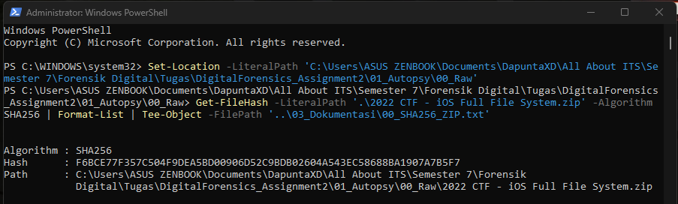
Figure 1. SHA-256 baseline for the original downloaded archive.

Chain of Custody
The following is an examination handling record, not a signed legal transfer history. The provider's original custodians and every transfer before the public dataset was obtained were not independently established. No unrecorded handover is asserted.
Date / time | Item ID | Released by | Received by | Purpose | Storage location
Before first ingest; exact download time not recorded | E-01 | Digital Corpora public dataset | Examiner | Obtain assignment dataset; record SHA-256 | 01_Autopsy/00_Raw
25 Oct 2026; before 20:53 WIB | E-02 / E-03 | No transfer; examiner derivation | Same examiner | Extract outer archive; verify internal ZIP | 01_Autopsy/01_Extracted/Jess_CTF_iPhone8
25 Oct 2026; before 22:18 WIB | E-02 working copy | No transfer | Same examiner | Re-extract with filename case preserved | C:\DF_A2\iOS_CaseSensitive
25 Oct 22:18 to 26 Oct 05:18 WIB | E-04 / E-05 | Autopsy processing | Same examiner | Ingest extracted directory | 02_Case/Assignment2_iOS_Autopsy
26 Oct 2026; artifact-specific export times not recorded | E-04 / E-05 | Autopsy export / examination | Same examiner | Manual decoding, screenshots and log review | 04_Export and 03_Dokumentasi

Forensic Process Performed
The procedure follows the collection, examination, analysis and reporting phases described in NIST SP 800-86 [2], with mobile-evidence considerations from NIST SP 800-101 Rev. 1 [3]. Preparation is recorded separately to match the supplied report template. This organization does not constitute certification of standards compliance.

1. Preparation
The examination was conducted on a Windows workstation using a local single-user Autopsy case. Evidence archives, case output, screenshots and selected exports were separated. The original handset was not available. Consequently, no hardware write blocker, Faraday enclosure, or live-device isolation step was performed by the examiner. The provider's acquisition report records its own device actions; those actions are not attributed to this examination.
Working directories were chosen to support reproducibility and preserve differing filename capitalization. The case name was Assignment2_iOS_Autopsy. The local repository root was DigitalForensics_Assignment2, with the Autopsy work beneath 01_Autopsy. Python checks used copies, and SQL connections were opened read-only.

2. Collection (Identification, Acquisition, and Preservation)
The supplied dataset was downloaded from Digital Corpora, and the outer ZIP was hashed before analysis. WinRAR extracted the outer archive into 01_Extracted. The internal ZIP was hashed separately and compared with the supplied acquisition record. WinRAR's archive test completed without errors. A successful archive test did not guarantee successful interpretation by Autopsy's separate extraction library.
The acquisition type represented by the dataset was a full-file-system extraction. The examiner did not perform a physical acquisition or collect volatile memory. An order-of-volatility acquisition sequence therefore could not be applied retrospectively to the live phone. Preservation consisted of retaining original archives, documenting hashes, processing working copies and preserving SQLite WAL/SHM companions.
The exact PowerShell hash commands and the case-sensitivity commands are reproduced in Appendix A. The original download and internal ZIP have different byte contents, so their hash values are not expected to match each other.

3. Examination

Data source selection
Logical Files was selected because the supplied material was a local archive and, later, an extracted directory tree. This imported the provided files without misrepresenting the ZIP as a raw disk image. The source could be referenced by the case rather than copied into the case directory; the working directory must remain accessible [4].
Data source option | Typical input | Decision in this examination
Disk Image or VM File | Sector image such as DD/E01, or virtual disk such as VMDK/VHD | Not supplied; renaming a ZIP would not make it a disk image
Local Disk | Directly attached storage device | The examination laptop disk was not the iPhone evidence
Logical Files | Local files and directories | Selected for the internal ZIP and extracted file tree
Unallocated Space Image File | Raw data without a file-system structure | Not the form of the provided extraction
Autopsy Logical Imager Results | Output of Autopsy Logical Imager | Not supplied
XRY Text Export | Text export from XRY | Not supplied

Logical import did not make physical unallocated space available. Examination-device file timestamps were excluded to avoid interpreting copy/extraction times as original phone times. The resulting zero date placeholders in file listings were not treated as corruption. Event times were recovered from artifact contents.

Ingest module selection
Module | Purpose and reason for selection
Recent Activity | Extract supported user and web activity. This does not guarantee coverage of every iOS app.
File Type Identification | Identify file types from content; useful for SQLite, plist and files without extensions.
Extension Mismatch Detector | Compare extension and detected type. A mismatch alone is not evidence of concealment.
Embedded File Extractor | Extract supported archives and embedded files into the ingest pipeline, especially the initial ZIP.
Picture Analyzer | Examine supported image metadata, including GPS where present.
Keyword Search | Extract/index searchable text; compressed or application-specific BLOBs may need further decoding.
Email Parser | Check supported mail stores. Enabling the module does not prove relevant email was recovered.
Encryption Detection | Flag indications of encryption; does not automatically decrypt files.

iOS Analyzer (iLEAPP) was also selected on the initial archive attempt. The log states that it skipped the source. It was not enabled on the second, extracted-folder source. Autopsy's integration documentation describes processing TAR/ZIP inputs [5]. No standalone iLEAPP report is asserted.
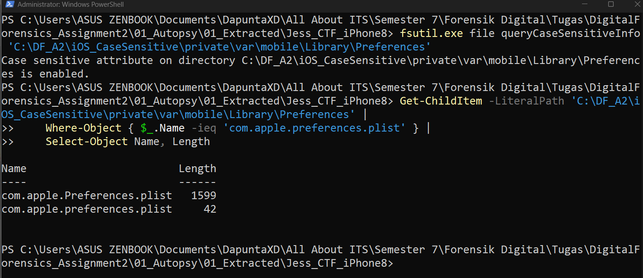
Figure 2. Verification that both differently capitalized preference files survived extraction.

Failed archive processing and recovery
The first ingest began at approximately 20:53 WIB on 25 October 2026. LogicalFileSet1 contained the internal ZIP. The iOS Analyzer logged that the source did not appear to be iOS and skipped it. The embedded extractor reported DATAERROR warnings and a SevenZipException, including ArrayIndexOutOfBoundsException and Unexpected IOException. In the supplied autopsy.log.2, 528 DATAERROR warning lines were counted; this is a count of log lines, not 528 uniquely identified failed artifacts.
Manual extraction initially encountered com.apple.preferences.plist (42 bytes) and com.apple.Preferences.plist (1,599 bytes) in the same iOS directory. These names conflict in a case-insensitive destination. The partial C:\DF_A2\iOS_Files extraction was not used as the final source. A fresh C:\DF_A2\iOS_CaseSensitive directory was configured for case-sensitive names, the ZIP was extracted again with WinRAR, and both files were verified. This resolves the observed manual extraction conflict; it does not establish the cause of the earlier SevenZipException.
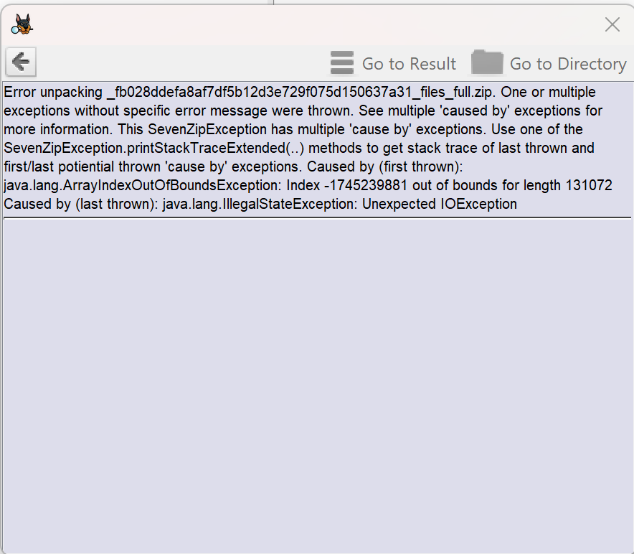
Figure 3. Autopsy error details for the initial internal ZIP extraction.

Second ingest and completion
The extracted working directory was added as LogicalFileSet2 under the same host, using Logical Files and the eight general modules above. The second ingest started on 25 October at 22:18:05 WIB. The log records all ingest tasks complete on 26 October at 05:18:27 WIB; the examiner observed completion at 05:21. These are examination dates in 2026, separate from phone events in 2022. The log reports 91,062 indexed files and 120,467 indexed chunks. Completion did not imply that every parser operation succeeded.

Search and export procedure
Tools > File Search by Attributes located candidate filenames. Keyword Search located indexed text, but hits were reviewed in context because resource files and unrelated caches also matched common words. Data Sources > LogicalFileSet2 provided source paths. The Application tab displayed supported SQLite/plist structures. Extract File(s) exported selected artifacts to purpose-specific directories in 04_Export.
For SQLite, the main database and available -wal/-shm companions were exported together [6]. Numeric export prefixes are Autopsy identifiers, not original iOS names. Reproduction scripts restored matching names only on temporary copies, connected using mode=ro and compared hashes before and after examination. PRAGMA integrity_check was used as a structural check, not proof of application-level interpretation.

4. Analysis
Analysis correlated source paths, table/field relationships, event times, log context and application identifiers. Notes content required GZIP decompression; Reddit and Bumble required NSKeyedArchiver UID resolution. Location and notification records were selected by maximum stored timestamp rather than display order. Alarm settings were cross-checked against the Autopsy viewer. Reboot and uninstall searches used literal PowerShell matching over exported logs.
Timestamp epochs were handled per field: NSDate-style numeric values used an epoch of 1 January 2001 UTC; the Bumble message creation value used Unix seconds from 1 January 1970 UTC. Text log times were left without an asserted zone where the lines did not provide one. Each finding below distinguishes the observed value from its interpretation.

5. Reporting
Findings were linked to named artifacts, table keys, screenshots and code. Explicit errors, skipped modules and unsupported viewer presentation were classified separately. Six reproduction scripts are included in Appendix C; their core outputs agree with the recorded examinations. Minor print formatting may differ from earlier script versions. The report is an examiner-authored account, not an automatically generated Autopsy report.

Findings
Finding ID | Artifact / data | Source (item and path) | Description | Significance
F-01 | Notes Grocery list | E-04; NoteStore.sqlite (P-01) | Four items | Answers question 1
F-02 | routined location | E-04; Cache.sqlite (P-02) | 38.84412765, -77.28686523 | Latest in examined table; question 2
F-03 | Reboot records | E-04 log (P-03); E-03 | 11:44:13 detection; acquisition boot 18:24:19 UTC | Qualified answer to question 3
F-04 | Reddit account | E-04; ivu21eum (P-04) | PogProgrammer; 21 Jan 21:59:38 UTC | Answers question 4
F-05 | Uninstall record | E-04; installation log (P-03) | com.tencent.xin / WeChat | Answers question 5
F-06 | Reddit notification | E-04; notifications plist (P-05) | Latest retained notice concerns Cynthia's car crash | Answers question 6
F-07 | Alarm setting | E-04; mobiletimerd plist (P-06) | system:Radar | Answers question 7
F-08 | Bumble incoming GIF | E-04; Chat.sqlite (P-07) | GIPHY ID cXCVTR1wUn1a8 | Answers question 8
F-09 | Processing limitations | E-05; Autopsy logs and screenshots | Plist/SQLite text-extraction errors; BLOB placeholders | Answers Autopsy-specific parsing objective

Artifact source paths
P-01 private/​var/​mobile/​Containers/​Shared/​AppGroup/​B7A0EA29-86E3-464A-B2A4-D4199FAD7FA5/​NoteStore.sqlite
P-02 private/​var/​mobile/​Library/​Caches/​com.apple.routined/​Cache.sqlite
P-03 private/​var/​installd/​Library/​Logs/​MobileInstallation/​mobile_installation.log.0
P-04 private/​var/​mobile/​Containers/​Shared/​AppGroup/​C0D4CE88-705C-4BBD-9900-0CC64DAF8243/​Library/​Application Support/​accounts/​ivu21eum
P-05 private/​var/​mobile/​Library/​UserNotifications/​F6C59A01-8506-44B5-866A-8CB9301E27AA/​DeliveredNotifications.plist
P-06 private/​var/​mobile/​Library/​Preferences/​com.apple.mobiletimerd.plist
P-07 private/​var/​mobile/​Containers/​Data/​Application/​F6664A1F-E4CE-412A-B6F6-825A08EDCC34/​Library/​Caches/​Chat.sqlite
Paths are relative to the extraction root. Autopsy listings prefix these with /LogicalFileSet2/iOS_CaseSensitive/. SQLite companions were collected from the same directory as the associated main database.

F-01 Shopping list
Question 1: How many items are on Patrick's shopping list? The recovered Grocery list contains four items: Energy drinks, Bread, Hand soap and Birthday card. The heading itself was not counted.
File search located NoteStore.sqlite and its WAL/SHM files. The Application viewer exposed ZICCLOUDSYNCINGOBJECT and ZICNOTEDATA. The Grocery list row had Z_PK=4 and ZNOTEDATA=1. A join on ZICCLOUDSYNCINGOBJECT.ZNOTEDATA = ZICNOTEDATA.Z_PK selected its ZDATA. The viewer presented that payload as BLOB Data not shown. The exported package was copied to a temporary directory, opened read-only, decompressed with gzip and inspected for the list text. Appendix C1 provides the full code.
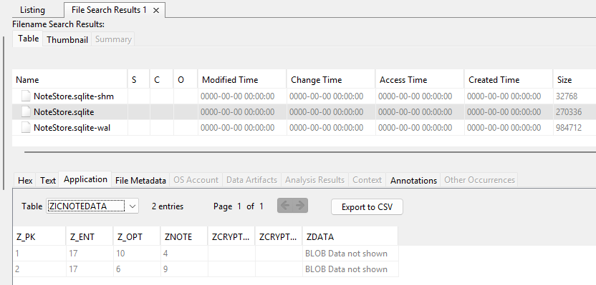
Figure 4. Notes payload is not rendered as note text in the SQLite viewer.
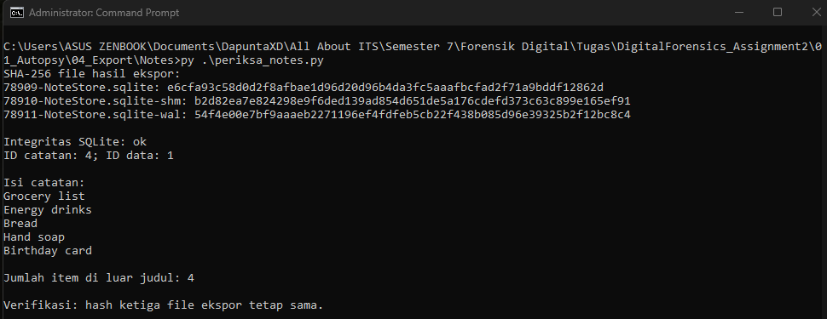
Figure 5. Decoded Grocery list and a count of four items.
Observed facts: the linked record supplies the named list and four non-empty item lines. Interpretation: those four lines answer the item-count question. The targeted text extraction is not a complete protobuf/rich-text parser and does not determine whether items were checked off. The SQLite file itself was readable; a BLOB placeholder is not a database corruption error.

F-02 Latest recorded location
Question 2: What was the phone's last known location? The latest entry in the examined routined location table is latitude 38.84412765, longitude -77.28686523, at 14 February 2022, 18:26:03.105048 UTC.
The Geolocation display initially provided no structured location artifact for the selected source. A map cursor coordinate was not treated as phone evidence. The investigation therefore followed the com.apple.routined cache directly. The ZRTCLLOCATIONMO table was readable in Autopsy. The exported database package was queried with ORDER BY ZTIMESTAMP DESC, Z_PK DESC LIMIT 1; Appendix C2 includes the code.
Field | Recovered value
Row / primary key | Z_PK = 15107
Timestamp | ZTIMESTAMP = 666555963.105048; epoch 2001 UTC
Coordinates as stored | 38.84412764999998, -77.28686522999998
Horizontal accuracy | ZHORIZONTALACCURACY = 1414.0 meters
Record type | ZTYPE = 6; enum meaning not independently assigned

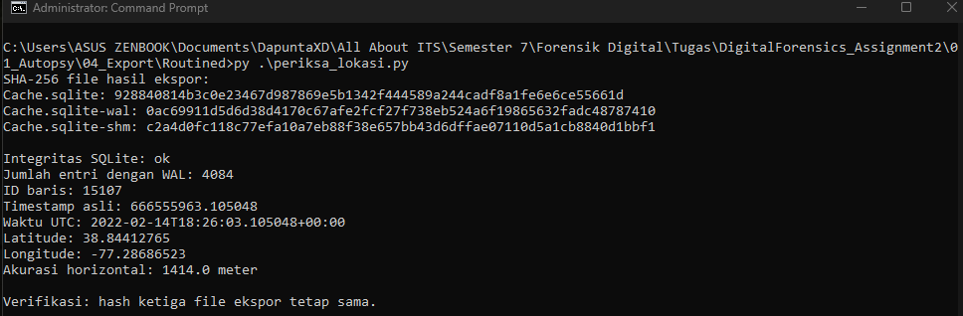
Figure 6. Latest routined entry selected from the WAL-consistent database.
The main database alone exposed 10,720 rows and a different state. With WAL, 4,084 rows were visible, consistent with Autopsy. The WAL-consistent result was used. Interpretation is limited to the newest retained entry in this table, with uncertainty of approximately 1.4 km. It does not establish a specific building or the latest location across every possible source.

F-03 Reboot information
Question 3: When was the phone last rebooted? Two distinct records were identified and must not be merged without resolving their time semantics.
Record | Observed value | Interpretation
Installation log | Mon Feb 14 11:44:13 2022 ... main: Reboot detected | Latest matching detection entry found in the searched logs; zone absent
Acquisition report | Device Boot Time 2022-02-14 13:24:19 -05:00; also 10:24:19 -08:00 | Both provider values normalize to 2022-02-14 18:24:19 UTC

Autopsy located and exported mobile installation logs. PowerShell Select-String searched both rotated exports for the literal Reboot detected. All matched dates were compared; output order was not assumed to be descending. The most recent detection entry in the searched logs was 14 February 2022 at 11:44:13. Appendix A3 reproduces the command.
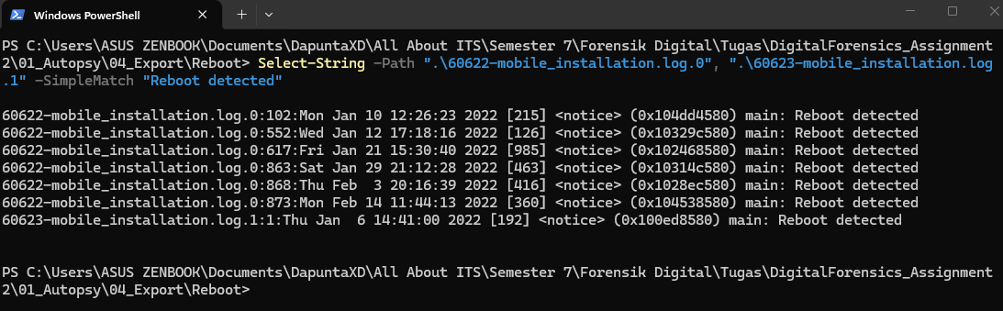
Figure 7. PowerShell search of exported installation logs, including the latest detection line.
The supplied acquisition report separately lists device boot times at two explicit offsets that both convert to 18:24:19 UTC. This is a provider-reported boot value, while the installation line records a process detecting a reboot. The exact relationship between the two was not established. Therefore, 11:44:13 is reported as the log-detected reboot time with unknown zone; 18:24:19 UTC is reported as the latest explicit boot metadata. An unqualified absolute reboot time cannot be derived from the detection line alone.

F-04 Reddit account creation
Question 4: At what time was Patrick's Reddit account created? Account PogProgrammer has a stored creation value corresponding to 21 January 2022, 21:59:38 UTC.
Searches for Reddit identified its shared AppGroup and the accounts directory. The directory contained anonymous and ivu21eum. Both files were exported, but the named account was determined from ivu21eum. Its lack of an extension did not imply an unknown format: plistlib identified a plist with NSKeyedArchiver objects.
The root UID pointed to an account object. kRedditorKey pointed to a redditor object, whose Username reference resolved to PogProgrammer. The created reference resolved to an NSDate object with NS.time=664495178.0. Adding this value to 1 January 2001 UTC produced the recovered time. The account and redditor created values matched. Appendix C3 resolves only the relevant references and does not print authentication material.
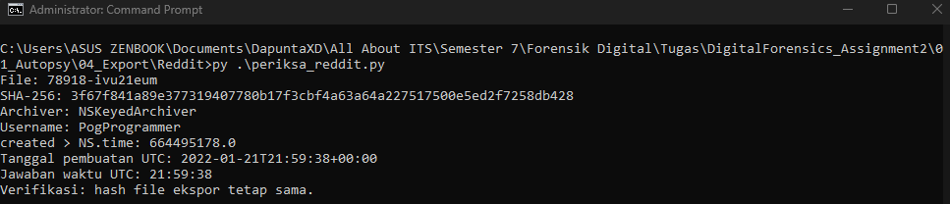
Figure 8. Reddit username and creation time recovered by resolving archived references.
Observed facts: the username and creation value occur within the same archived account structure. Interpretation: the creation field answers the account-creation question. Autopsy's PList viewer logged a UID-related parsing exception on ivu21eum. This is stronger evidence of a parser/viewer failure than the BLOB placeholders observed in Notes or Bumble.

F-05 Uninstalled application
Question 5: Which application was uninstalled? The installation log records removal of WeChat, bundle identifier com.tencent.xin.
The same exported mobile_installation.log.0 was searched for Uninstalling identifier com.tencent.xin, with three lines of preceding and ten lines of following context. The surrounding entries on 21 January 2022 around 17:11:26-17:11:27 record the uninstall request, removal of bundle and user-data containers, and extension identifiers including com.tencent.xin.WeChatNotificationServiceExtension.
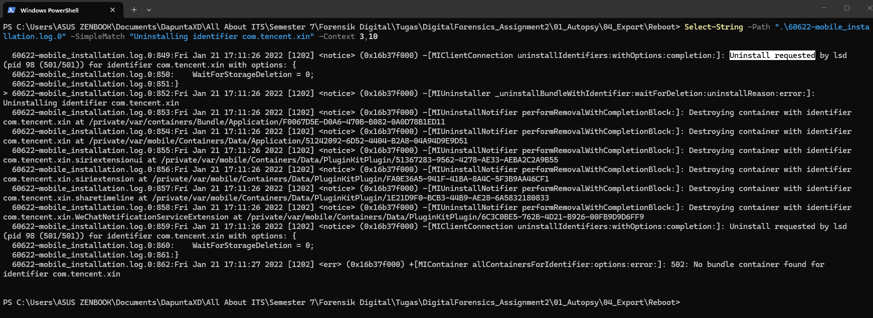
Figure 9. WeChat uninstall event with surrounding container and extension operations.
The conclusion is based on an explicit operation and correlated identifiers, not merely an absent application folder. The log does not establish why the application was removed. Its timestamp has no verified timezone in the examined lines. Appendix A4 provides the PowerShell command; no Python decoder was required for this question.

F-06 Latest Reddit notification
Question 6: What was the content of the last notification received from Reddit? The most recent retained Reddit notification contains:
“Kornbread and Jorgeous are still Making Fun of Cynthia's Car Crash...”
The ellipsis is part of the stored message. The title is r/rupaulsdragrace. The selection used AppNotificationCreationDate, corresponding to 14 February 2022, 16:59:58.381737 UTC.
UserNotifications subdirectories were UUID-named. Library.plist mapped com.reddit.Reddit to F6C59A01-8506-44B5-866A-8CB9301E27AA. The DeliveredNotifications.plist in that directory was exported. An earlier same-named candidate from another UUID contained Screen Time data and was excluded; a Reddit string in unrelated usage data was insufficient attribution.
The correct archive contains 22 records. Python resolved NSDictionary key/value UIDs and selected the maximum AppNotificationCreationDate.NS.time, 666550798.3817372. Its identifier is 77AC661A-7B6D-4B70-AD3F-C8016D3643C1. The correct exported plist has SHA-256 2cfee69ca1a5e2366b8bbb4487d5e3320028e0fecc9cbc210dd9e1a76a405531. Appendix C4 includes the mapping and selection code.
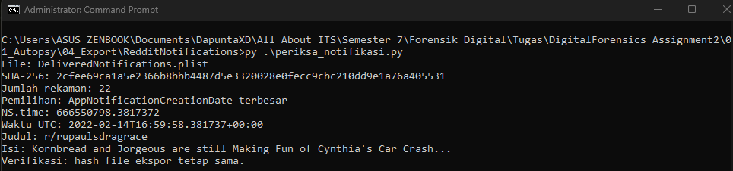
Figure 10. Latest Reddit notification selected after mapping its application UUID.
The creation field is a retained notification timestamp, not an independent measurement of packet arrival. Log errors name Library.plist and DeliveredNotifications.plist, but those names can recur in different directories. Final provenance is tied to the selected UUID and hash rather than a filename-only exception.

F-07 Alarm sound
Question 7: Which alarm sound did Patrick select? The stored tone identifier is system:Radar, corresponding to Radar.
File search located com.apple.mobiletimer.plist and com.apple.mobiletimerd.plist. The latter contains MTAlarms > MTAlarms > $MTAlarm > MTAlarmSound > $MTSound > MTSoundToneID. One alarm, titled Bed Bath and Beyond Opens, was set to 10:00. MTAlarmEnabled was False. A separate timer uses system:Default Timer; that value was not confused with the alarm setting.
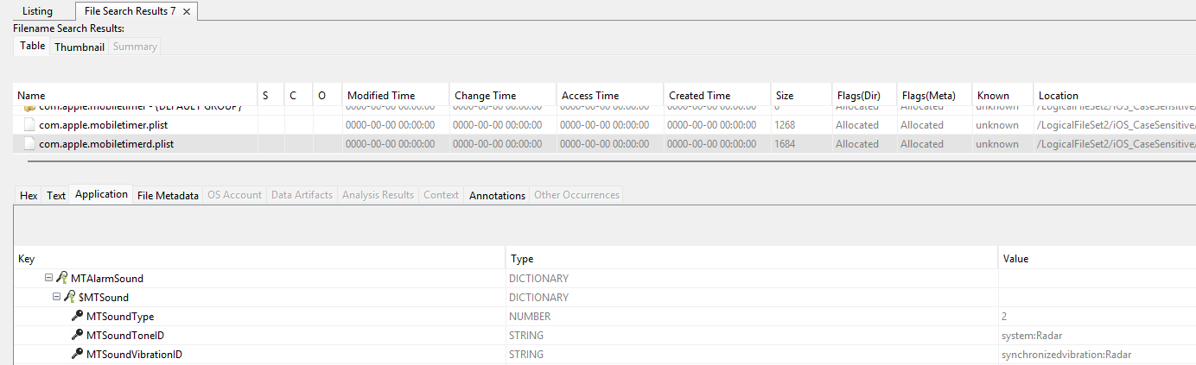
Figure 11. Radar displayed directly in Autopsy's plist viewer.
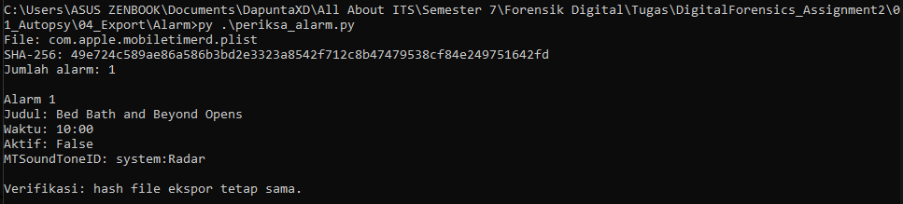
Figure 12. Independent Python inspection of the alarm setting.
Autopsy successfully displayed this setting. Python provided verification only, using Appendix C5. The selected tone persists in the preferences even though the alarm was disabled at the recorded state. This artifact is not classified as an Autopsy parsing failure.

F-08 Bumble GIF
Question 8: What is the name of the GIF sent to Patrick through Bumble? The received message contains GIPHY ID cXCVTR1wUn1a8. The corresponding public page was identified during examination as thirsty steve martin GIF.
Searches identified Bumble's container. Documents and Library/Caches were inspected. SharedUserCache.sqlite initially yielded 12 User records rather than the target message. Chat.sqlite and its companions were then exported. The Application viewer displayed 18 database2 rows, but replaced the data payload with BLOB Data not shown.
A SQL join on rowid connected database2 to secondaryIndex_isReadIndex. The plist payload was decoded and relevant UIDs resolved. Row 19, message key 4312590383, had isIncoming=1. self.messageText was https://giphy.com/embed/cXCVTR1wUn1a8. self.dateCreated=1643942797, interpreted as Unix seconds, corresponds to 4 February 2022, 02:46:37 UTC. Appendix C6 includes the code.
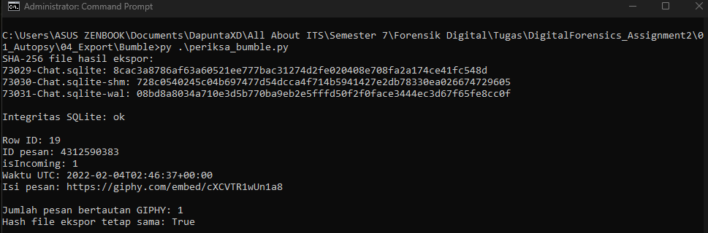
Figure 13. Incoming Bumble GIF link, message key and UTC creation time.
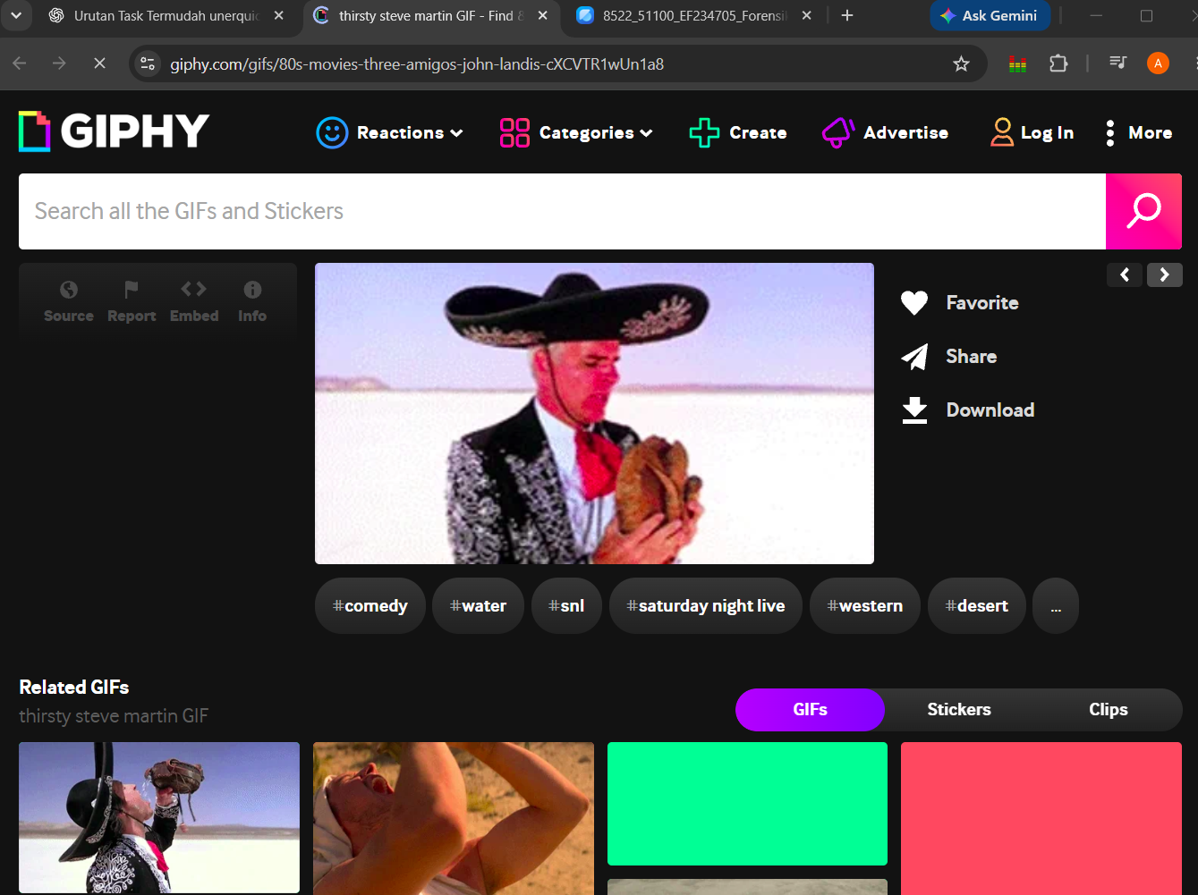
Figure 14. GIPHY page with matching ID and the title visible in the browser tab/page.
The database provides the link, direction and message time. The title comes from the external page at examination time, not a title field recovered from the database. isIncoming supports receipt by the account represented on the device. The screenshot is corroboration of that URL lookup, not proof of the title as it existed in 2022.

F-09 Artifacts not successfully interpreted by Autopsy
The examination distinguishes three categories: explicit processing errors, a module that was skipped, and data that the SQLite viewer did not decode for display. The last category is a capability limitation and is not alone evidence of corruption or a thrown parser error.
Artifact or operation | Recorded symptom | Assessment
E-02 internal ZIP / LogicalFileSet1 | SevenZipException, ArrayIndexOutOfBoundsException, Unexpected IOException; DATAERROR warnings | Archive extraction failed on first attempt; later manual extraction used
iOS Analyzer on initial source | data source does not appear to be iOS, skipping | Module skipped; does not prove dataset was not iOS
Notes ZDATA / Bumble data | BLOB Data not shown | Tables readable; application payload not decoded by selected viewer
ivu21eum and anonymous | PListViewer cannot parse root of type com.dd.plist.UID; NullPointerException | Explicit plist viewer error
Library.plist / DeliveredNotifications.plist | PListViewer UID-related exceptions | Explicit errors; exact duplicate file attribution limited by log detail
AddressBook.sqlitedb, object ID 79063 | Unable to read ABPersonFullTextSearch table | SQLite text-extraction failure on specified table
entities.db, object ID 84754 | Unable to read entity_fts table | SQLite text-extraction failure on specified table
email_footer.html, object ID 13086 | XML parse error; failed to search file | Text processing/search failure
2F36DAFFE19D35639048C279892DCE37, ID 60450 | Keyword Search StackOverflowError | Keyword analysis failure; source type and full path not established

For the table-specific failures and the hashed filename, the supplied log identifies names and object IDs but does not state the full source path. Those paths have not been invented. Additional provenance lookup is recommended before presenting them as fully located source artifacts. Notes, Bumble and Reddit source paths are identified in P-01, P-07 and P-04.
The corresponding SQLite viewer screenshot, 38_Bumble_BLOB_Autopsy.png, is retained in the examination documentation. Its placeholder behavior is corroborated by the exported database2 CSV.

F-09 Supporting parser error records
The Reddit account viewer error at 12:04:37 on 26 October 2026 reports that root has type com.dd.plist.UID, followed by an exception while parsing/displaying ivu21eum. A second similar event occurs at 12:08:24. These are viewer actions after ingest, not phone event times.
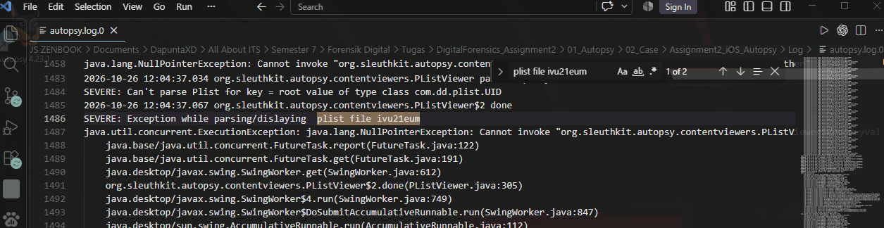
Figure 15. Autopsy PListViewer error while displaying ivu21eum.
The SQLite text extractor separately warns at 22:37:38 and 22:39:18 on 25 October that it could not read ABPersonFullTextSearch in AddressBook.sqlitedb and entity_fts in entities.db. This does not establish that all tables or the complete database were unreadable.
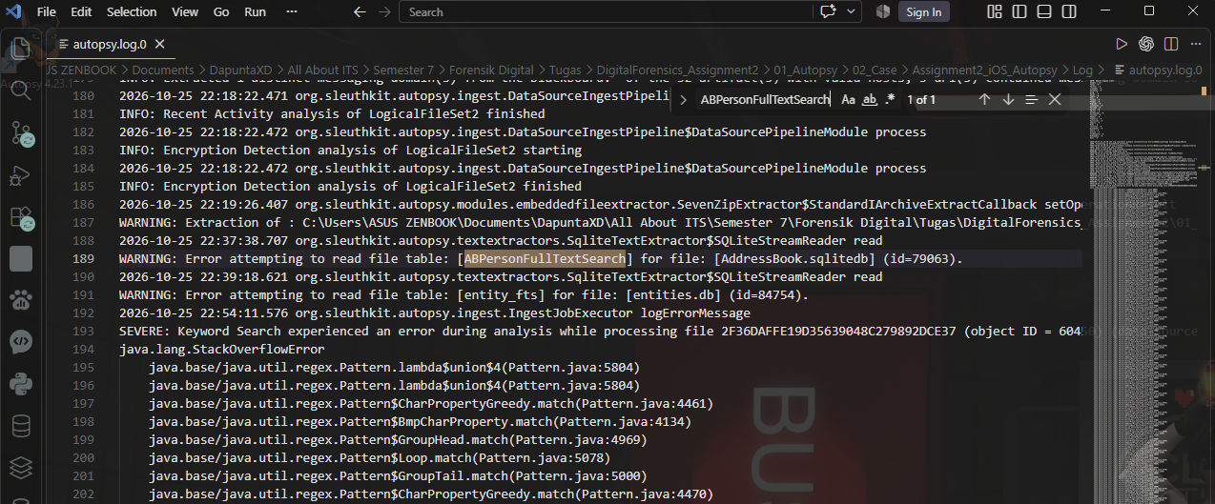
Figure 16. Specific SQLite table read warnings in the Autopsy log.
No root cause such as encryption or database corruption was assigned without supporting evidence. Additional Tika warnings refer to signature files, .strings resources and another numeric filename; the log requests further Tika details. They were retained as secondary warnings rather than given an unverified explanation.

Timeline of Events
The following phone-event timeline uses UTC only where a field's epoch or explicit offset supports conversion. Entries without verified timezone are listed separately to avoid false chronological precision. This is a manually constructed artifact timeline, not a Plaso export.
Date / time (time zone) | Event | Source artifact | Finding ID
2022-01-21 21:59:38 UTC | PogProgrammer account creation value | ivu21eum / created | F-04
2022-02-04 02:46:37 UTC | Incoming Bumble message with GIPHY URL | Chat.sqlite / key 4312590383 | F-08
2022-02-14 16:59:58.381737 UTC | Latest retained Reddit notification creation | DeliveredNotifications.plist | F-06
2022-02-14 18:24:19 UTC | Boot time reported by acquisition agent | Acquisition PDF, explicit offset values | F-03
2022-02-14 18:26:03.105048 UTC | Latest examined routined location entry | Cache.sqlite / Z_PK 15107 | F-02
2022-02-14 around 18:36 UTC | Provider file-system extraction completed | Acquisition PDF / extraction metadata | E-03

Events with unverified timezone
Date / time (time zone) | Event | Source artifact | Finding ID
2022-01-21 around 17:11:26-17:11:27; zone not verified | WeChat uninstall sequence | mobile_installation.log.0 | F-05
2022-02-14 11:44:13; zone not verified | Latest Reboot detected match in searched logs | mobile_installation.log.0 | F-03

Examination activity occurred on 25-26 October 2026 in WIB: first ingest around 20:53, second ingest at 22:18:05, completion in the log at 05:18:27 the next day, and observed completion at 05:21. These processing times are excluded from the reconstructed 2022 phone-event sequence.

Limitations and Assumptions
The investigation used an existing extraction rather than the original handset. It cannot independently certify the provider's acquisition procedure, original chain of custody or complete device coverage.
Logical-file input does not provide the physical unallocated space of the phone. No claim of complete deleted-file recovery is made.
The latest location and notification are the latest retained records in the examined structures, not proof that no later records existed elsewhere or were deleted.
The location record has horizontal accuracy of 1,414 meters. Its displayed decimal precision must not be interpreted as equivalent geographic accuracy.
Reboot detection at 11:44:13 has no verified timezone in the line and differs from explicit acquisition boot metadata at 18:24:19 UTC. The conflict remains qualified.
The selected application viewers and parsers have limited format coverage. BLOB placeholders do not prove parser exceptions; log exceptions are reported separately.
SQLite results depend on the state represented by the WAL. Main-file-only results were not substituted for the WAL-consistent state.
Python scripts target structures observed in this dataset. The Notes text extraction is not a general rich-text/protobuf decoder, and UID resolution follows only fields needed for the findings.
GIPHY title verification is external and reflects the page at examination time. The primary device evidence is the stored message URL.
Exact versions of some supporting tools, export timestamps, and physical examination location were not recorded. Group administrative details must be completed before submission.
Full source paths for several additional error examples were not established from filename/object-ID log messages alone. No blanket claim of damaged databases is made.

Conclusion
The extraction contains evidence addressing all eight questions. The shopping list contains four items. The latest examined routined record places the phone at 38.84412765, -77.28686523, with 1,414-meter horizontal accuracy. The latest searched reboot-detection log entry is 14 February 2022 at 11:44:13 without a verified zone; acquisition metadata separately reports boot at 18:24:19 UTC.
PogProgrammer's Reddit account creation value is 21 January 2022 at 21:59:38 UTC. WeChat was explicitly uninstalled. The latest retained Reddit notification contains “Kornbread and Jorgeous are still Making Fun of Cynthia's Car Crash...”. The alarm tone is Radar. The incoming Bumble message contains GIPHY ID cXCVTR1wUn1a8, whose page was identified as thirsty steve martin GIF.
Autopsy provided the case structure, ingest, artifact discovery and supported viewing. Explicit plist-viewer and SQLite text-extraction errors were demonstrated in logs. Compressed or archived BLOBs required additional decoding. The results show the practical value of preserving source context and validating application interpretation rather than treating a completed ingest as proof of complete parsing.

Recommendations
Before submission, complete group identity and tool-version details from the examination workstation. Retain original archives, acquisition records, full log copies, artifact exports and their SQLite companions. Resolve the reboot time discrepancy through additional boot or system records if an unqualified absolute reboot answer is required. Locate object IDs 79063, 84754, 13086 and 60450 in the case if those supplementary errors are to be assigned full source paths. A future standalone iLEAPP or Plaso examination should be documented as a separate task, with its own logs and limitations.

Appendices

Appendix A Command history
Commands below reproduce the recorded hashing and log-search procedure. Paths refer to the examination workstation. PowerShell commands create only the stated documentation outputs or working directory; original artifacts are not edited.

A1 Original downloaded ZIP hash
Set-Location -LiteralPath 'C:\Users\ASUS ZENBOOK\Documents\DapuntaXD\All About ITS\Semester 7\Forensik Digital\Tugas\DigitalForensics_Assignment2\01_Autopsy\00_Raw'

Get-FileHash -LiteralPath '.\2022 CTF - iOS Full File System.zip' -Algorithm SHA256 | Format-List | Tee-Object -FilePath '..\03_Dokumentasi\00_SHA256_ZIP.txt'

Get-FileHash computes the SHA-256 value. Format-List exposes the algorithm, hash and path. Tee-Object displays the output and records it in 03_Dokumentasi. The documentation folder must exist beforehand.

A2 Internal ZIP hash and case-sensitive extraction directory
Set-Location -LiteralPath 'C:\Users\ASUS ZENBOOK\Documents\DapuntaXD\All About ITS\Semester 7\Forensik Digital\Tugas\DigitalForensics_Assignment2\01_Autopsy\01_Extracted\Jess_CTF_iPhone8'

Get-FileHash -Path '.\*.zip' -Algorithm SHA256 | Format-List | Tee-Object -FilePath '..\..\03_Dokumentasi\03_SHA256_ZIP_Internal.txt'

New-Item -ItemType Directory -Path 'C:\DF_A2\iOS_CaseSensitive' -Force
fsutil.exe file setCaseSensitiveInfo 'C:\DF_A2\iOS_CaseSensitive' enable
fsutil.exe file queryCaseSensitiveInfo 'C:\DF_A2\iOS_CaseSensitive'

The case-sensitivity setting was applied before re-extraction on a supported NTFS working directory. The successful result was verified by the coexistence of the two preference filenames, rather than assumed from the command alone. WinRAR was used to extract the internal archive into this directory.

A3 Reboot detection search
Run in 04_Export/Reboot. Select-String does not automatically sort by timestamp; all returned dates must be compared.
Select-String -Path '.\60622-mobile_installation.log.0', '.\60623-mobile_installation.log.1' -SimpleMatch 'Reboot detected'

A4 Uninstall search with context
Select-String -Path '.\60622-mobile_installation.log.0' -SimpleMatch 'Uninstalling identifier com.tencent.xin' -Context 3,10

A5 Log review
The actual case log folder shown in the recorded screenshots is named Log. A filename-only match is not sufficient to resolve multiple same-named artifacts.
Select-String -Path '.\autopsy.log.0', '.\autopsy.log.1', '.\autopsy.log.2' -SimpleMatch -Pattern 'Error attempting to read file table', 'Can''t parse Plist', 'Exception while parsing/dislaying', 'Error unpacking file', 'StackOverflowError', 'XML parse error', 'skipping' -Context 1,2

Appendix B Exported artifact hash manifest
The following hashes identify the selected uploaded exports used for reproduction. They are examination baselines, not individual acquisition hashes supplied by the provider. Numeric prefixes are preserved as exported. Notification file naming is disambiguated below. Long hashes wrap across lines without adding characters.
Exported file | Bytes | SHA-256
78909-NoteStore.sqlite | 270,336 | e6cfa93c58d0d2f8afbae1d96d20d96b  4da3fc5aaafbcfad2f71a9bddf12862d
78910-NoteStore.sqlite-shm | 32,768 | b2d82ea7e824298e9f6ded139ad854d6  51de5a176cdefd373c63c899e165ef91
78911-NoteStore.sqlite-wal | 984,712 | 54f4e00e7bf9aaaeb2271196ef4fdfeb  5cb22f438b085d96e39325b2f12bc8c4
Cache.sqlite | 1,503,232 | 928840814b3c0e23467d987869e5b134  2f444589a244cadf8a1fe6e6ce55661d
Cache.sqlite-shm | 32,768 | c2a4d0fc118c77efa10a7eb88f38e657  bb43d6dffae07110d5a1cb8840d1bbf1
Cache.sqlite-wal | 3,580,312 | 0ac69911d5d6d38d4170c67afe2fcf27  f738eb524a6f19865632fadc48787410
57405-mobile_installation_helper.log.0 | 42,389 | cad6264f552a04934401d1004a1e28cc  b97edee808408408a0a3560e64da131f
60622-mobile_installation.log.0 | 237,455 | 1009cdf8da8da1ae9d934e44e155b0d4  c471912295029b14feb84403d4152130
60623-mobile_installation.log.1 | 262,187 | e9259c0437c2e43d38b10b326982bf6c  c9061262c0c538cee4baba0bf1e6e773
60633-com.apple.mobile.installation.plist | 102 | 9dc61ad5e295ebc4f7c8a9cbc8c1e46d  aec9a4ee699bb3602045d876d9682371
78917-anonymous | 1,506 | 152a4da04e0feaf4cc63c9ac54b56ca4  1909a76d4e6cd67a13babcb862c44ab0
78918-ivu21eum | 7,045 | 3f67f841a89e377319407780b17f3cbf  4a63a64a227517500e5ed2f7258db428
Library.plist | 18,357 | ce580fa23af959ee932231ea510b8658  369991d82e92e5023475c8f5e4b9e880
DeliveredNotifications.plist (Reddit; uploaded with suffix (1)) | 105,430 | 2cfee69ca1a5e2366b8bbb4487d5e332  0028e0fecc9cbc210dd9e1a76a405531
com.apple.mobiletimer.plist | 1,268 | a03775184ebf0b0bdc9e7aa7953d5ba2  cce4153b663c883cbd6e8840f0908ce8
com.apple.mobiletimerd.plist | 1,684 | 49e724c589ae86a586b3bd2e3323a854  2f712c8b47479538cf84e249751642fd
73029-Chat.sqlite | 126,976 | 8cac3a8786af63a60521ee777bac3127  4d2fe020408e708fa2a174ce41fc548d
73030-Chat.sqlite-shm | 32,768 | 728c0540245c04b697477d54dcca4f71  4b5941427e2db78330ea026674729605
73031-Chat.sqlite-wal | 123,632 | 08bd8a8034a710e3d5b770ba9eb2e5ff  fd50f2f0face3444ec3d67f65fe8cc0f
73944-SharedUserCache.sqlite | 106,496 | cfb71fe53b03fd03da1dfeb3bc1042e1  c9bb0f5755abf9150d2b7a32d89a7578
73945-SharedUserCache.sqlite-shm | 32,768 | 6f9994cbb7b6fc6af028e63fc2a7ef3b  41a50b3b105098caaabfa2fd060c90aa
73946-SharedUserCache.sqlite-wal | 57,712 | 878add3683cedf7ae26fdaab634763c3  c82b0599ac6c678838d3589991b87af1
com.apple.routined.plist | 2,619 | 7cead10ddacd8870ced11a3eb032eeec  e7b4f499f4ba4dd645ecde25ada13569

The earlier non-Reddit DeliveredNotifications.plist candidate was not used for F-06. The final local export name is DeliveredNotifications.plist; its correct hash is the Reddit value listed above. Main SQLite files, WAL and SHM are distinct files and therefore have distinct hashes.

Appendix C Reproduction scripts
These full scripts reproduce the relevant decoding operations using the Python standard library. Store each script next to its indicated exports. On Windows, run python .\periksa_notes.py (or py .\periksa_notes.py); substitute the script name for other findings. Python 3.8 or later is needed for plistlib UID support. Exact examination-workstation interpreter and SQLite-library versions were not recorded.
The code is reproduced from the supplied README. Some diagnostic labels are in Indonesian to match the examination outputs. The surrounding report provides their English interpretation. Database scripts copy files to a temporary directory, restore canonical companion names, use a read-only SQLite connection and compare source-export hashes afterward. Hash equality confirms the exports were unchanged; it does not prove that every derived interpretation is correct.

C1 Notes content
File: 04_Export/Notes/periksa_notes.py
Links the note and payload rows, decompresses GZIP and counts item lines after excluding the heading. Expected count: 4.
from pathlib import Path
import hashlib
import shutil
import sqlite3
import tempfile
import gzip
import re

files = {"78909-NoteStore.sqlite": "NoteStore.sqlite",
"78910-NoteStore.sqlite-shm": "NoteStore.sqlite-shm",
"78911-NoteStore.sqlite-wal": "NoteStore.sqlite-wal"}
dbname = "NoteStore.sqlite"

folder = Path(__file__).resolve().parent

def hashes():
return {name: hashlib.sha256((folder / name).read_bytes()).hexdigest()
for name in files}

before = hashes()
print("SHA-256 file hasil ekspor:")
for name, digest in before.items():
print(name, digest)
with tempfile.TemporaryDirectory() as temp:
work = Path(temp)
for source, target in files.items():
shutil.copy2(folder / source, work / target)
connection = sqlite3.connect((work / dbname).as_uri() + "?mode=ro", uri=True)
try:
print("Integritas SQLite:", connection.execute("PRAGMA integrity_check").fetchone()[0])
query = """SELECT o.Z_PK, d.Z_PK, d.ZDATA
FROM ZICCLOUDSYNCINGOBJECT o
JOIN ZICNOTEDATA d ON o.ZNOTEDATA = d.Z_PK
WHERE o.ZTITLE1 = ?"""
row = connection.execute(query, ("Grocery list",)).fetchone()
if row is None:
raise RuntimeError("Catatan Grocery list tidak ditemukan")
decoded = gzip.decompress(row[2])
match = re.search(rb"Grocery list[^\x00-\x08\x0b-\x1f\x7f]*", decoded)
if match is None:
raise RuntimeError("Teks daftar tidak ditemukan setelah dekompresi")
lines = [line.strip() for line in match.group().decode("utf-8").splitlines()
if line.strip()]
print("Z_PK catatan:", row[0], "Z_PK data:", row[1])
print("Judul:", lines[0])
for index, item in enumerate(lines[1:], 1):
print(f"{index}. {item}")
print("Jumlah barang:", len(lines) - 1)
finally:
connection.close()
print("Hash file ekspor tetap sama:", before == hashes())

C2 Latest location
File: 04_Export/Routined/periksa_lokasi.py
Uses the WAL-consistent table and maximum ZTIMESTAMP. Expected primary key: 15107; time: 2022-02-14 18:26:03.105048 UTC.
from pathlib import Path
import hashlib
import shutil
import sqlite3
import tempfile
from datetime import datetime, timedelta, timezone

files = {name: name for name in ("Cache.sqlite", "Cache.sqlite-shm", "Cache.sqlite-wal")}
dbname = "Cache.sqlite"

folder = Path(__file__).resolve().parent

def hashes():
return {name: hashlib.sha256((folder / name).read_bytes()).hexdigest()
for name in files}

before = hashes()
print("SHA-256 file hasil ekspor:")
for name, digest in before.items():
print(name, digest)
with tempfile.TemporaryDirectory() as temp:
work = Path(temp)
for source, target in files.items():
shutil.copy2(folder / source, work / target)
connection = sqlite3.connect((work / dbname).as_uri() + "?mode=ro", uri=True)
try:
print("Integritas SQLite:", connection.execute("PRAGMA integrity_check").fetchone()[0])
print("Jumlah lokasi:", connection.execute("SELECT COUNT(*) FROM ZRTCLLOCATIONMO").fetchone()[0])
query = """SELECT Z_PK, ZTIMESTAMP, ZLATITUDE, ZLONGITUDE,
ZHORIZONTALACCURACY, ZTYPE
FROM ZRTCLLOCATIONMO
ORDER BY ZTIMESTAMP DESC, Z_PK DESC LIMIT 1"""
row = connection.execute(query).fetchone()
print("Z_PK:", row[0], "ZTIMESTAMP:", row[1])
print("Waktu UTC:", datetime(2001, 1, 1, tzinfo=timezone.utc) + timedelta(seconds=row[1]))
print("Latitude:", row[2], "Longitude:", row[3])
print("Akurasi horizontal (meter):", row[4], "ZTYPE:", row[5])
finally:
connection.close()
print("Hash file ekspor tetap sama:", before == hashes())

C3 Reddit account
File: 04_Export/Reddit/periksa_reddit.py
Resolves the account and redditor references. Expected username: PogProgrammer; created: 2022-01-21 21:59:38 UTC.
from pathlib import Path
from datetime import datetime, timedelta, timezone
import hashlib
import plistlib

path = Path(__file__).resolve().parent / "78918-ivu21eum"
before = hashlib.sha256(path.read_bytes()).hexdigest()
archive = plistlib.loads(path.read_bytes())
objects = archive["$objects"]
def resolve(value):
return objects[value.data] if isinstance(value, plistlib.UID) else value
account = resolve(archive["$top"]["root"])
redditor = resolve(account["kRedditorKey"])
created = resolve(account["created"])["NS.time"]
print("File:", path.name)
print("SHA-256:", before)
print("Username:", resolve(redditor["Username"]))
print("NS.time:", created)
print("Created UTC:", datetime(2001, 1, 1, tzinfo=timezone.utc) + timedelta(seconds=created))
print("Tanggal akun dan redditor sama:", created == resolve(redditor["created"])["NS.time"])
print("Hash file tetap sama:", before == hashlib.sha256(path.read_bytes()).hexdigest())

C4 Reddit notification
File: 04_Export/RedditNotifications/periksa_notifikasi.py
Maps the Reddit UUID and selects the maximum notification creation date from 22 entries. Expected title: r/rupaulsdragrace.
from pathlib import Path
from datetime import datetime, timedelta, timezone
import hashlib
import plistlib

folder = Path(__file__).resolve().parent
paths = [folder / "Library.plist", folder / "DeliveredNotifications.plist"]
before = {p.name: hashlib.sha256(p.read_bytes()).hexdigest() for p in paths}
def open_archive(path):
archive = plistlib.loads(path.read_bytes())
objects = archive["$objects"]
def resolve(value):
return objects[value.data] if isinstance(value, plistlib.UID) else value
def dictionary(value):
value = resolve(value)
return {resolve(k): resolve(v) for k, v in zip(value["NS.keys"], value["NS.objects"])}
return resolve(archive["$top"]["root"]), resolve, dictionary
root, resolve, dictionary = open_archive(paths[0])
print("Folder Reddit:", dictionary(root)["com.reddit.Reddit"])
root, resolve, dictionary = open_archive(paths[1])
entries = [dictionary(item) for item in root["NS.objects"]]
latest = max(entries, key=lambda item: item["AppNotificationCreationDate"]["NS.time"])
seconds = latest["AppNotificationCreationDate"]["NS.time"]
print("Jumlah notifikasi:", len(entries))
print("Creation UTC:", datetime(2001, 1, 1, tzinfo=timezone.utc) + timedelta(seconds=seconds))
for field in ("AppNotificationTitle", "AppNotificationMessage", "AppNotificationIdentifier"):
print(field + ":", latest.get(field))
for path in paths:
print("SHA-256", path.name, before[path.name])
print("Hash file tetap sama:", before == {p.name: hashlib.sha256(p.read_bytes()).hexdigest() for p in paths})

C5 Alarm setting
File: 04_Export/Alarm/periksa_alarm.py
Reads the alarm structure, without confusing a timer tone with an alarm. Expected tone: system:Radar.
from pathlib import Path
import hashlib
import plistlib

path = Path(__file__).resolve().parent / "com.apple.mobiletimerd.plist"
before = hashlib.sha256(path.read_bytes()).hexdigest()
plist = plistlib.loads(path.read_bytes())
alarms = plist["MTAlarms"]["MTAlarms"]
print("SHA-256:", before)
print("Jumlah alarm:", len(alarms))
for item in alarms:
alarm = item["$MTAlarm"]
print("Judul:", alarm["MTAlarmTitle"])
print("Jam:", f"{alarm['MTAlarmHour']:02d}:{alarm['MTAlarmMinute']:02d}")
print("Enabled:", alarm["MTAlarmEnabled"])
print("Alarm ID:", alarm["MTAlarmID"])
print("Suara:", alarm["MTAlarmSound"]["$MTSound"]["MTSoundToneID"])
print("Hash file tetap sama:", before == hashlib.sha256(path.read_bytes()).hexdigest())

C6 Bumble message
File: 04_Export/Bumble/periksa_bumble.py
Joins message and direction records, resolves the archived text and converts Unix time. Expected row: 19; incoming: 1; GIF ID: cXCVTR1wUn1a8.
from pathlib import Path
import hashlib
import shutil
import sqlite3
import tempfile
import plistlib
from datetime import datetime, timezone

files = {"73029-Chat.sqlite": "Chat.sqlite",
"73030-Chat.sqlite-shm": "Chat.sqlite-shm",
"73031-Chat.sqlite-wal": "Chat.sqlite-wal"}
dbname = "Chat.sqlite"

folder = Path(__file__).resolve().parent

def hashes():
return {name: hashlib.sha256((folder / name).read_bytes()).hexdigest()
for name in files}

before = hashes()
print("SHA-256 file hasil ekspor:")
for name, digest in before.items():
print(name, digest)
with tempfile.TemporaryDirectory() as temp:
work = Path(temp)
for source, target in files.items():
shutil.copy2(folder / source, work / target)
connection = sqlite3.connect((work / dbname).as_uri() + "?mode=ro", uri=True)
try:
print("Integritas SQLite:", connection.execute("PRAGMA integrity_check").fetchone()[0])
query = """SELECT d.rowid, d.key, d.data, i.isIncoming
FROM database2 d JOIN secondaryIndex_isReadIndex i ON i.rowid = d.rowid
ORDER BY d.rowid"""
found = 0
for rowid, key, data, incoming in connection.execute(query):
archive = plistlib.loads(data)
objects = archive["$objects"]
message = objects[archive["$top"]["root"].data]
def value(field):
item = message.get(field)
return objects[item.data] if isinstance(item, plistlib.UID) else item
text = value("self.messageText")
if not isinstance(text, str) or "giphy.com/" not in text:
continue
found += 1
print("Row ID:", rowid, "ID pesan:", key, "isIncoming:", incoming)
print("Waktu UTC:", datetime.fromtimestamp(value("self.dateCreated"), timezone.utc).isoformat())
print("Isi pesan:", text)
print("Jumlah pesan bertautan GIPHY:", found)
finally:
connection.close()
print("Hash file ekspor tetap sama:", before == hashes())

Appendix D Supporting examination screenshots
The screenshots in the Findings section provide the main result and error evidence. The following additional screenshots document configuration and preservation steps. Original screenshot files remain supporting records; the embedded copies are scaled for the report.
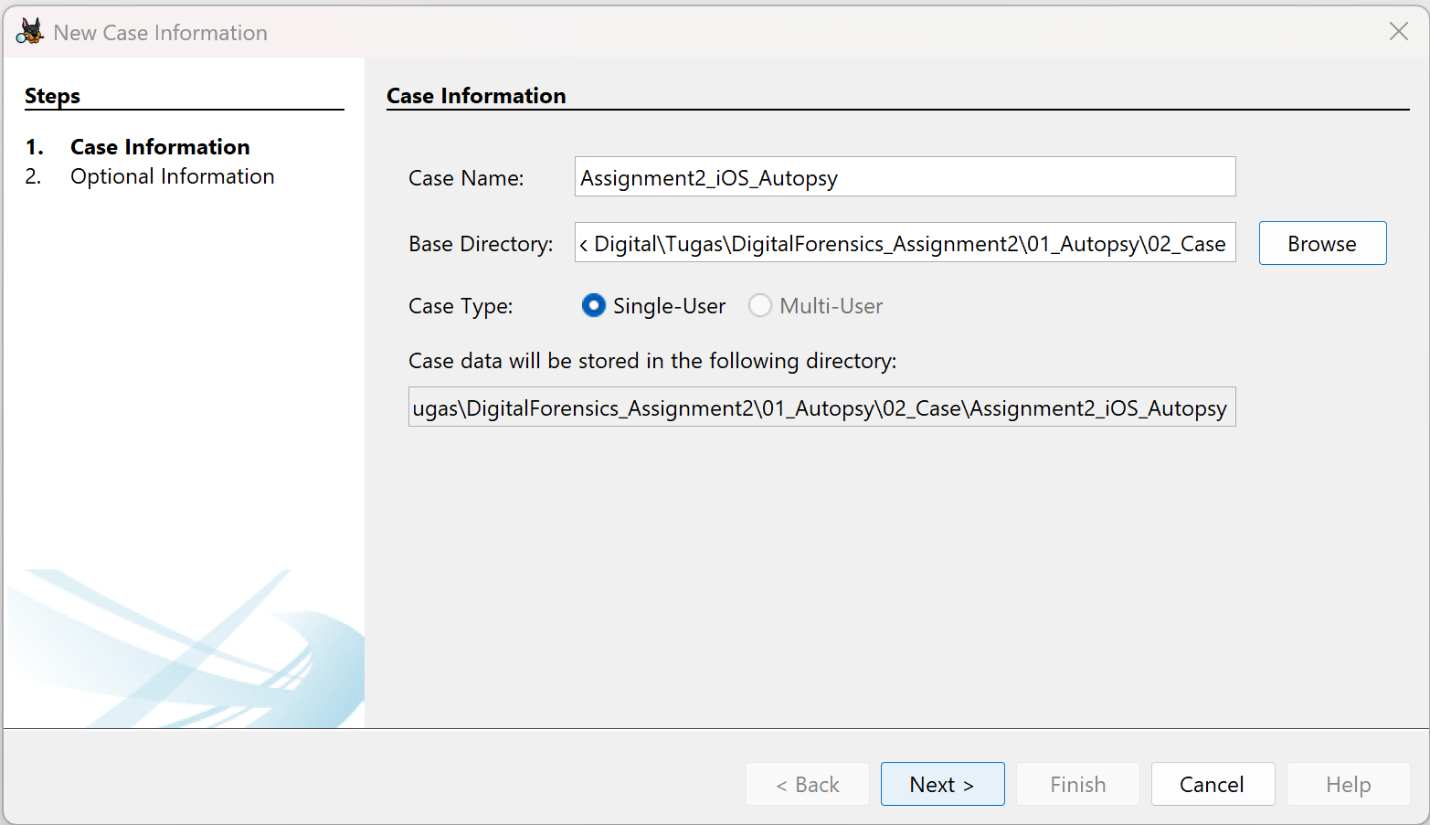
Figure 17. Creation of the local Autopsy case.
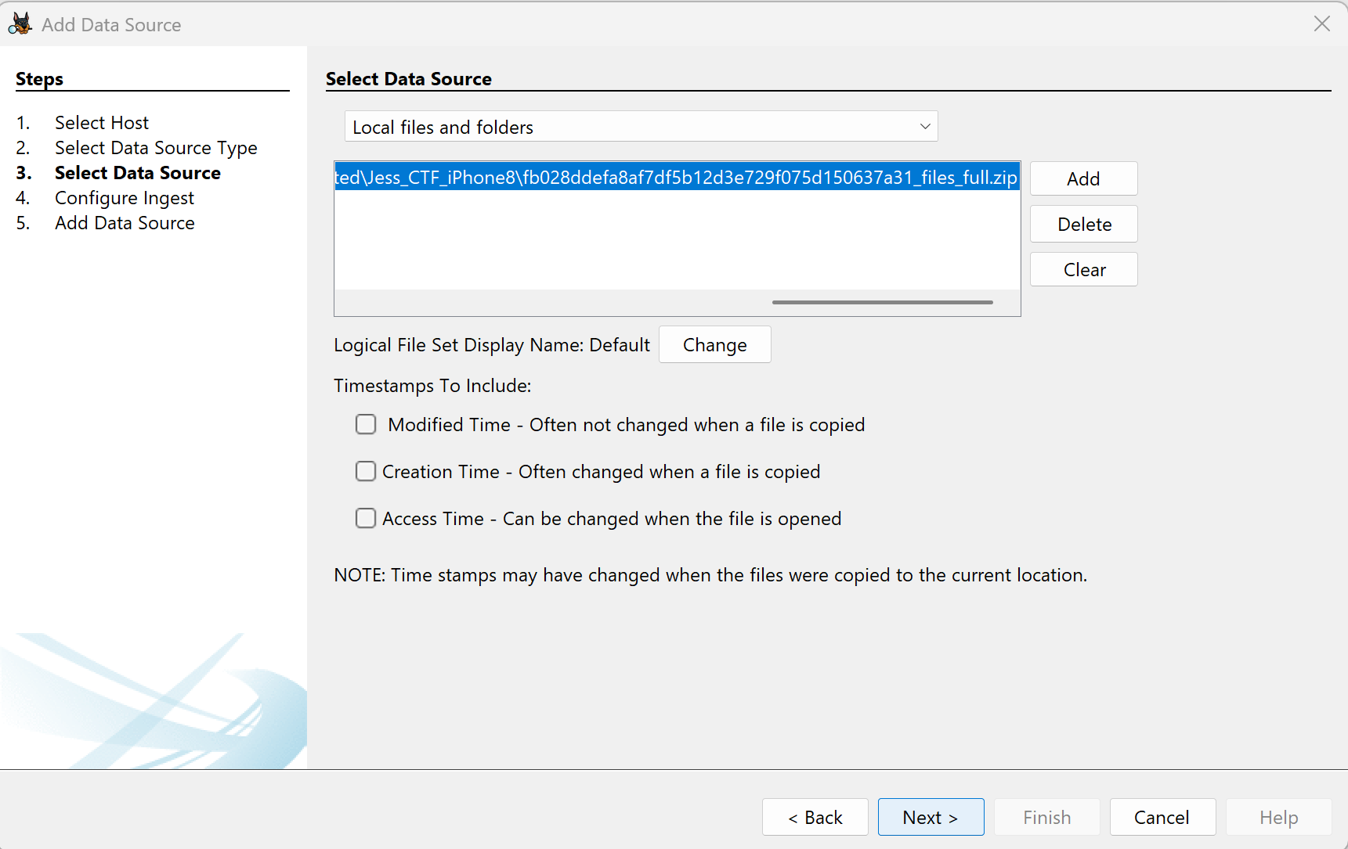
Figure 18. Logical Files input selection for the internal ZIP.

Appendix D Ingest and archive verification
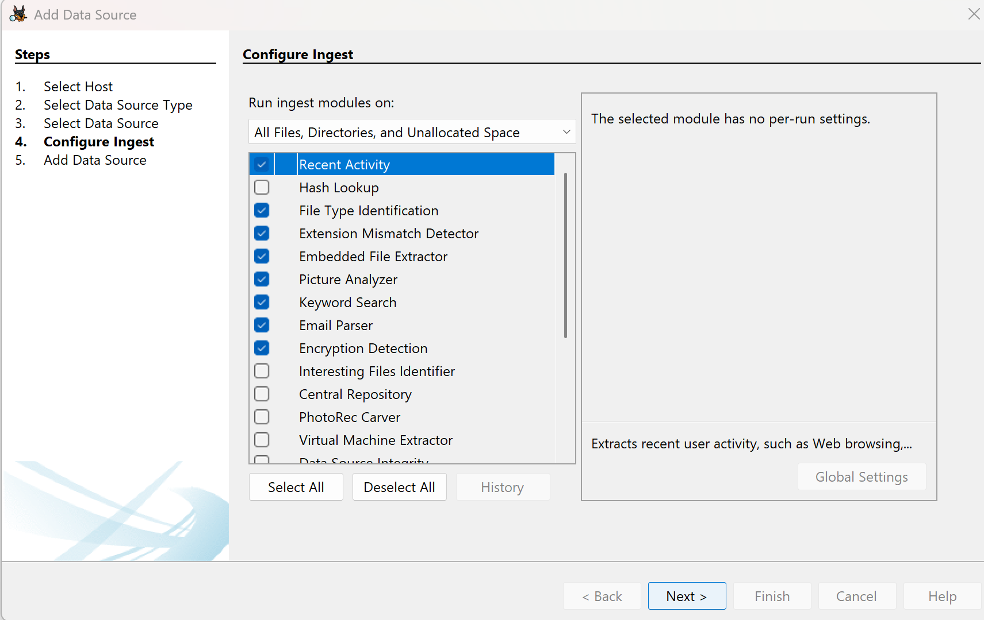
Figure 19. General ingest modules selected for the extracted-folder attempt.
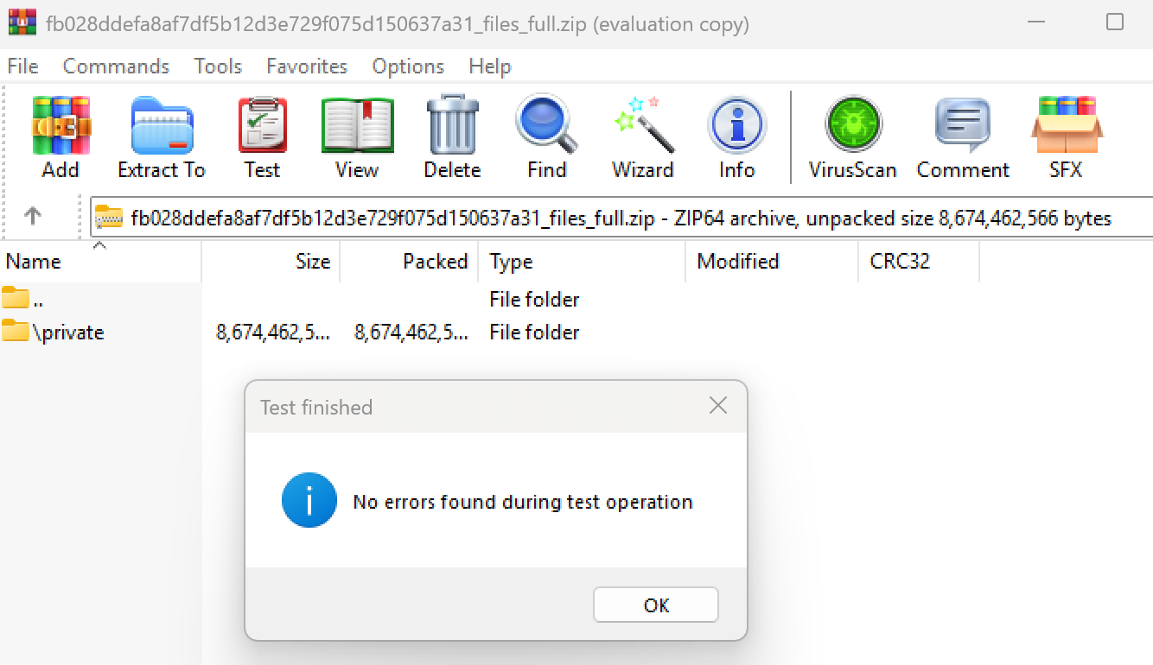
Figure 20. WinRAR archive test completed without reported errors.
A successful WinRAR archive test and an Autopsy extraction exception are different observations. They do not justify a claim that the archive was necessarily corrupt. Likewise, the case-sensitive extraction correction preserved source filenames but did not prove the internal cause of the earlier extractor exception.

References
[1] Digital Corpora. Magnet 2022 CTF iOS Full File System dataset. https://digitalcorpora.s3.amazonaws.com/corpora/scenarios/magnet/2022%20CTF%20-%20iOS%20Full%20File%20System.zip
[2] Kent, K., Chevalier, S., Grance, T., and Dang, H. (2006). Guide to Integrating Forensic Techniques into Incident Response. NIST SP 800-86. https://csrc.nist.gov/pubs/sp/800/86/final
[3] Ayers, R., Brothers, S., and Jansen, W. (2014). Guidelines on Mobile Device Forensics. NIST SP 800-101 Rev. 1. https://csrc.nist.gov/pubs/sp/800/101/r1/final
[4] Sleuth Kit Labs. Autopsy User Documentation 4.23.0. Data Sources, Ingest Modules, and Content Viewer. https://sleuthkit.org/autopsy/docs/user-docs/4.23.0/ds_page.html ; https://sleuthkit.org/autopsy/docs/user-docs/4.23.0/ingest_page.html ; https://sleuthkit.org/autopsy/docs/user-docs/4.23.0/content_viewer_page.html
[5] Sleuth Kit Labs. iOS Analyzer (iLEAPP) integration. https://sleuthkit.org/autopsy/docs/user-docs/4.23.0/ileapp_page.html
[6] SQLite. Write-Ahead Logging. https://www.sqlite.org/wal.html
[7] Python Software Foundation. plistlib and sqlite3 standard-library documentation. https://docs.python.org/3/library/plistlib.html ; https://docs.python.org/3/library/sqlite3.html
[8] Microsoft. Adjust case sensitivity. https://learn.microsoft.com/en-us/windows/wsl/case-sensitivity
[9] GIPHY. GIF ID cXCVTR1wUn1a8, identified during examination as thirsty steve martin GIF. https://giphy.com/gifs/80s-movies-three-amigos-john-landis-cXCVTR1wUn1a8
[10] Supplied acquisition report. fb028ddefa8af7df5b12d3e729f075d150637a31.pdf. Historical acquisition report generated 14 February 2022, 18:37:46 UTC.
[11] Examination records. Autopsy logs autopsy.log.0, autopsy.log.1 and autopsy.log.2; screenshots 01 and 24-40 and earlier configuration/extraction screenshots; SQLite table exports and selected artifact files. Examination dates: 25-26 October 2026.
Technical documentation for Autopsy 4.23.0 supports the 4.23 series discussion. Actual behavior on the examined 4.23.1 installation is supported by the case logs and screenshots. Case answers were derived from the artifacts; third-party CTF solution pages were not used as evidence.

