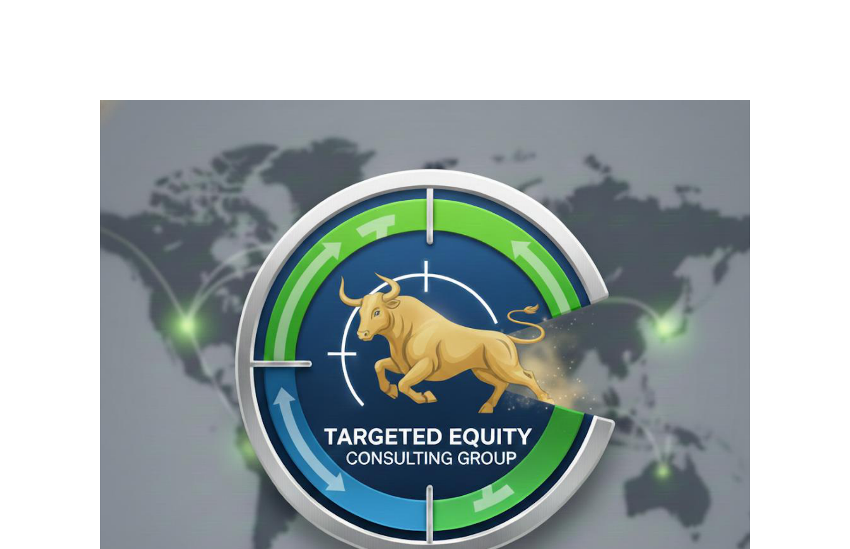

EARNINGS TRANSCRIPT ANALYSIS: AVGO
Company: Broadcom Inc.
Industry: Semiconductors
Sector: Technology
Analysis Date: 2025-12-12 16:23:05

TRANSCRIPTS ANALYZED:
1. Q4 2025 - 2025-12-11 17:00:00 (6,844 words)
2. Q3 2025 - 2025-09-04 17:00:00 (7,375 words)
3. Q2 2025 - 2025-06-05 17:00:00 (6,223 words)
4. Q1 2025 - 2025-03-06 17:00:00 (6,957 words)

Not generated (--claude-only flag used)

__________________________________________________
David Quinn
Targeted Equity Consulting Group
daquinn@targetedequityconsulting.com | 617-905-7415

