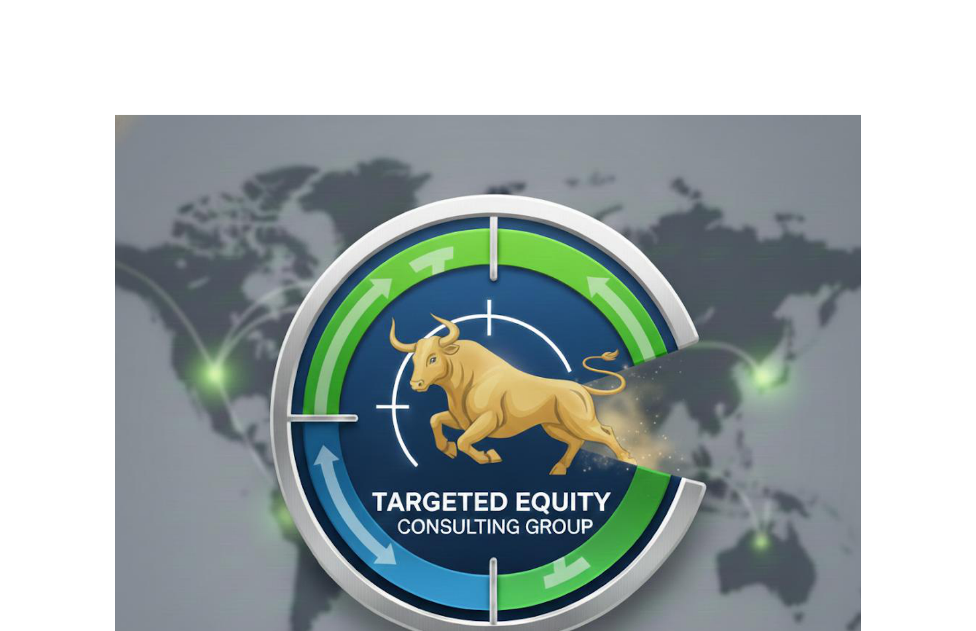

EARNINGS TRANSCRIPT ANALYSIS: AVGO
Company: Broadcom Inc.
Industry: Semiconductors
Sector: Technology
Analysis Date: 2025-12-12 16:23:05

TRANSCRIPTS ANALYZED:
1. Q4 2025 - 2025-12-11 17:00:00 (6,844 words)
2. Q3 2025 - 2025-09-04 17:00:00 (7,375 words)
3. Q2 2025 - 2025-06-05 17:00:00 (6,223 words)
4. Q1 2025 - 2025-03-06 17:00:00 (6,957 words)

# BROADCOM (AVGO) EARNINGS ANALYSIS: Q1-Q4 FY2025

1. GUIDANCE CHANGES (Critical Analysis)

Revenue Guidance Trajectory
- **Q1 2025**: No specific FY guidance given, focused on quarterly outlook
- **Q2 2025**: Sustained 60% AI growth trajectory introduced for FY2026
- **Q3 2025**: "Significantly improved" FY2026 outlook from previous 60% guidance
- **Q4 2025**: $19.1B Q1 2026 guidance (28% YoY), indicating continued acceleration

Pattern: Progressive guidance raises throughout the year, with management gaining confidence in sustained high growth rates.

Margin Guidance Evolution
- **Consistent Theme**: Gross margins under pressure from AI mix, particularly XPUs and system sales
- **Q4 Warning**: Explicit guidance that margins will compress as system sales ramp in H2 2026
- **Operating Leverage**: Management consistently emphasizes dollar growth despite margin compression

Capital Allocation Shifts
- **Dividend**: 15 consecutive annual increases, Q4 raised to $0.65/share (10% increase)
- **Debt Reduction**: Primary focus on bringing debt-to-EBITDA below 2x
- **Share Repurchases**: Opportunistic ($4.2B in Q2), but secondary to debt reduction

2. MANAGEMENT & LEADERSHIP

Leadership Continuity
- **Q3 Major Announcement**: Hock Tan committed to remain CEO through 2030 minimum
- **Stable Team**: Kirsten Spears (CFO) and Charlie Kawwas/Coaz (Semiconductor President) consistent throughout

Strategic Messaging Evolution
- **Early 2025**: Focus on 3 customers, 4 prospects for XPUs
- **Q3**: Fourth customer qualified with $10B order
- **Q4**: Fifth customer added ($1B order), total AI backlog $73B over 18 months

3. TONE ANALYSIS (Very Important)

Progressive Confidence Building
- **Q1**: Cautious optimism, introducing 2026 visibility
- **Q2**: **BULLISH** turn - "sustain trajectory into 2026"
- **Q3**: **Very BULLISH** - "significantly improved outlook", CEO extension
- **Q4**: **Measured confidence** - detailed metrics but acknowledging high expectations

Language Evolution
- **Early quarters**: "We expect", "We anticipate"
- **Later quarters**: "We are seeing", "We have visibility", "We fully expect more bookings"
- **Hedging reduced**: Less uncertainty language, more definitive statements

Q4 Reality Check
Management acknowledged struggling to "live up to recent custom silicon hype" - showing realistic self-assessment rather than over-promising.

4. POSITIVE HIGHLIGHTS

Exceptional Growth Metrics
- **AI Revenue**: $20B in FY2025 (65% growth) vs $12B in FY2024
- **Total Backlog**: Reached record $162B, with $73B AI-specific over 18 months
- **Customer Expansion**: Grew from 3 to 5 XPU customers during the year

Technology Leadership
- **Tomahawk 6**: 102.4 Tbps switch seeing "fastest deployment ever"
- **XPU Innovation**: First 2nm AI XPU with 3.5D packaging targeting 10,000 teraflops
- **Market Position**: Only provider of 102 Tbps switching capacity

Financial Strength
- **Record Results**: Multiple quarterly records for revenue, EBITDA, free cash flow
- **Operating Leverage**: Margins expanding despite gross margin pressure
- **VMware Integration**: 87% of top 10K customers adopted VCF

5. NEGATIVE HIGHLIGHTS / RED FLAGS

Margin Compression Signals
- **System Sales Impact**: Will pass through more third-party components (memory, optics, power)
- **Gross Margin Pressure**: Expected to decline as AI mix increases, particularly in H2 2026
- **Management Quote**: "Gross margins will be lower...margins will go down"

Non-AI Business Weakness
- **Persistent Softness**: Non-AI semiconductors down 7-8% YoY throughout most of year
- **U-Shaped Recovery**: Management expects slow recovery, not V-shaped
- **Limited Visibility**: Bookings up but sustainable recovery uncertain

Execution Risks
- **Supply Chain**: Acknowledged constraints in advanced packaging, silicon capacity
- **High Expectations**: Management noted difficulty living up to "custom silicon hype"
- **Customer Concentration**: Heavy dependence on small number of hyperscale customers

6. QUARTER-OVER-QUARTER CHANGES

New in Q4 (Not Previously Discussed)
- **$73B AI backlog** - First time providing 18-month forward visibility
- **Fifth customer** - Previously undisclosed XPU customer
- **System sales expansion** - Moving beyond chips to full rack systems
- **OpenAI partnership** - 10 gigawatt agreement for 2027-2029

Topics Management Avoided
- **Specific customer identification** - Refused to confirm OpenAI as 5th customer
- **Detailed 2026 guidance** - Provided Q1 only, avoided full-year numbers
- **Competitive threats** - Limited discussion of UALink, NVLink alternatives

7. INVESTMENT IMPLICATIONS

Bull Case Reinforced
- **AI Monetization Cycle**: Management sees inference driving incremental demand
- **Technology Moats**: Leading position in Ethernet switching, XPU design
- **Visibility**: 18-month backlog provides unprecedented forward clarity
- **Market Expansion**: Growing from 3 to 5+ customers validates addressable market

Bear Case Considerations
- **Margin Compression**: System sales will structurally lower gross margins
- **Customer Concentration**: Over-reliance on few hyperscale customers
- **Execution Risk**: Complex transition from chips to systems
- **Cyclical Non-AI**: 60% of semiconductor business remains weak

Key Debates
1. **Valuation vs. Growth**: Can margins support current multiples amid compression?
2. **Sustainability**: Is 60%+ AI growth sustainable beyond 2026?
3. **Competition**: Will open standards (UALink, NVLink) threaten Ethernet dominance?

What to Watch
- **Q1 2026 Results**: First test of $8.2B AI revenue guide (100% growth)
- **System Sales Metrics**: Margin impact as rack business scales
- **Customer Additions**: Progress on remaining 2-3 XPU prospects
- **Non-AI Recovery**: Signs of sustainable upturn in traditional business

8. ANALYST VIEWS EVALUATION

STRONGLY SUPPORTED Views
✅ $73B AI backlog over 18 months - Directly confirmed by management
✅ AI revenue growth 65% to $20B in FY2025 - Matches transcript data exactly
✅ Next quarter AI doubling to $8.2B - Precisely cited from guidance
✅ Expanding customer list - From 3 to 5 customers confirmed
✅ Tomahawk 6 strength - "Fastest deployment ever" supports analyst view
✅ Margin compression from XPUs - Extensively discussed by management

PARTIALLY SUPPORTED Views
⚠️ "Neutral" report characterization - Transcripts suggest more positive tone evolution
⚠️ Custom silicon hype disappointment - Management acknowledged this but emphasized solid fundamentals
⚠️ AI Monetization Supercycle timing - Management sees it happening but timing uncertain

CHALLENGED Views
❌ "Struggled to live up to hype" - While acknowledged, results were strong across metrics
❌ Focus only on weakness - Analyst underweighted significant positive developments

RATING: **STRONG SUPPORT**

The analyst's core financial metrics, business trends, and strategic insights are almost entirely validated by transcript evidence. The characterization as "neutral" appears overly conservative given management's progressive confidence building and strong execution against metrics throughout the year.

Key Update Needed
The analyst should emphasize the sustained momentum trajectory rather than focusing on short-term sentiment around hype, as management delivered on virtually all key metrics while building visibility for continued growth.

__________________________________________________
David Quinn
Targeted Equity Consulting Group
daquinn@targetedequityconsulting.com | 617-905-7415

