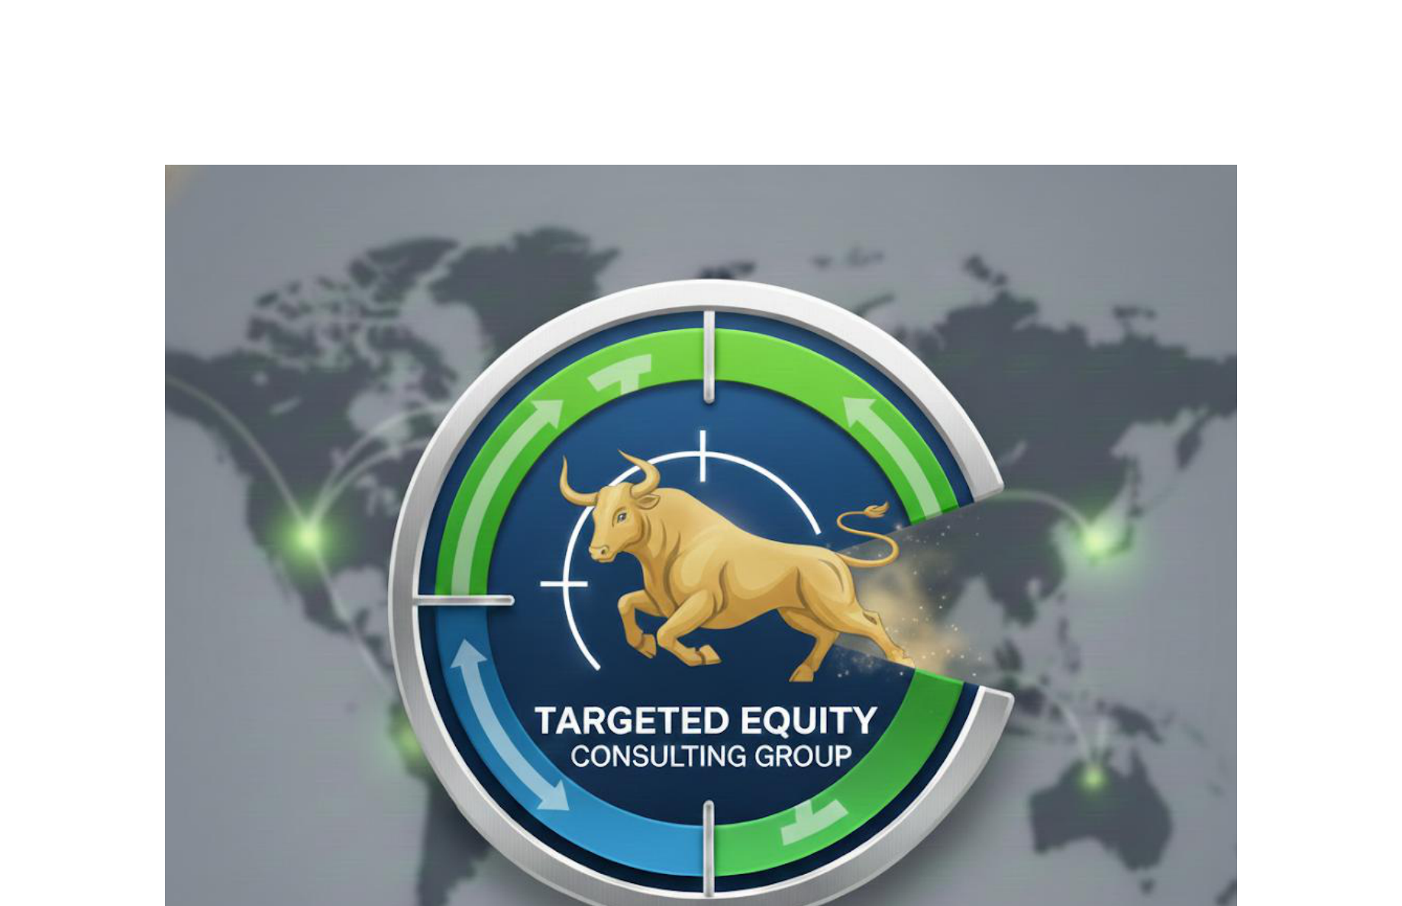

MSFT Annual Report Analysis
Generated: 2026-01-13 14:30
Reports Analyzed: FY2025 - FY2023
AI Analysis: Enabled

Executive Summary
MICROSOFT (MSFT) - INVESTMENT EXECUTIVE SUMMARY
1. The Business
Microsoft is a cloud-first technology company that generates revenue through three main segments: cloud services (Azure, Microsoft 365), productivity software (Office suite, Teams), and consumer products (Windows, Xbox, LinkedIn). Their business model has successfully transitioned from one-time software licenses to high-margin recurring cloud subscriptions, with Microsoft Cloud now generating $168.9 billion annually.
2. Business Trajectory: GETTING STRONGER
The business is clearly STRENGTHENING over the 3-year period with compelling evidence:
- Microsoft Cloud revenue grew from $137.4B to $168.9B (maintaining 23% growth rate)
- Azure accelerated from 30% to 34% growth (their crown jewel platform)
- Successful $75.4B Activision Blizzard acquisition completed in 2023, transforming gaming position
- Broad-based growth across all major segments - Search ads (20%), Dynamics 365 (19%), Xbox (16%)
- Strong margin business model with recurring subscription revenue base
3. Major Changes Over 3 Years
- Gaming Transformation: Completed largest tech acquisition ever ($75.4B Activision Blizzard) in October 2023
- AI Leadership Position: Exclusive partnership with OpenAI, integrated AI across entire product portfolio
- Infrastructure Massive Expansion: Aggressive datacenter buildout to meet cloud/AI demand
- Segment Restructuring: August 2024 reorganization to align with current business management
- Brand Evolution: Transition from "Office" to "Microsoft 365" branding across commercial products
4. Key Risks to Monitor
- Infrastructure Constraints: Growing concerns about datacenter capacity, GPU shortages, energy availability
- Margin Pressure: Management explicitly warned that AI/cloud infrastructure investments "may decrease operating margins"
- Supply Chain Concentration: Heavy dependence on "very few qualified suppliers" for critical components
- Regulatory Scrutiny: Large acquisition activity and market dominance attracting attention
- Competition: Intense rivalry in cloud (AWS, Google) and AI services markets
5. Strengths & Advantages
- Deep Competitive Moat: Exclusive OpenAI partnership creates unique AI advantage
- Recurring Revenue Model: High-margin subscription base with strong customer lock-in
- Enterprise Dominance: Unmatched position in business productivity software
- Financial Fortress: Strong cash generation ability (completed $75.4B cash acquisition)
- Diversified Portfolio: Multiple growth engines reduce single-point-of-failure risk
6. Investment Verdict
BULL CASE: Microsoft is executing a generational transition to become the dominant AI-powered cloud platform. The OpenAI partnership provides exclusive access to leading AI technology, Azure growth is accelerating (34%), and they have a diversified revenue base with strong competitive moats. The Activision acquisition adds a major new growth pillar in gaming content.
BEAR CASE: The company is making massive infrastructure investments that are pressuring margins, faces intense competition from AWS/Google in cloud, and is becoming increasingly dependent on scarce resources (GPUs, energy, datacenters). Valuation may not reflect the risk of AI investment cycle peaking or competitive response.
KEY QUESTION: What is Microsoft's actual return on AI infrastructure investments, and how sustainable is their OpenAI competitive advantage if competitors develop comparable AI capabilities or OpenAI seeks broader partnerships?

Year-over-Year Comparisons

FY2025 vs FY2024
Based on the comparison of Microsoft's FY2024 and FY2025 annual reports, here are the key changes identified:
1. Business Evolution
Strategic Changes:
- Segment reorganization: Microsoft restructured its reporting segments in August 2024, most notably bringing commercial Microsoft 365 components together in the Productivity and Business Processes segment
- Branding evolution: Transitioned from "Office" terminology to "Microsoft 365" branding (e.g., "Office Commercial" → "Microsoft 365 Commercial")
No Major New Products/Discontinuations: Both reports show similar product portfolios with continued focus on cloud and AI integration
2. Competitive Landscape Changes
Limited visibility into competitive changes as both excerpts focus more on internal operations than competitive positioning. Both reports acknowledge the "dynamic and highly competitive" nature of their markets.
3. Risk Profile Changes
NEW/Heightened Risks in FY2025:
- Infrastructure dependencies: More detailed focus on datacenter constraints (land availability, energy, networking supplies, GPUs)
- AI capacity constraints: Specific mention of GPU shortages and component supply limitations
- Supply chain concentration: Emphasis on "very few qualified suppliers" for certain components
Emerging Concerns:
- Global trade policy risks: New mention of tariffs and trade restrictions impact
- Energy and resource availability: Datacenter expansion constraints
4. Financial Trajectory
Strong Growth Trajectory:
- Microsoft Cloud: Revenue grew to $168.9B (FY25) vs $137.4B (FY24) - maintained 23% growth rate
- Azure acceleration: Growth increased from 30% (FY24) to 34% (FY25)
- Search advertising: Accelerated from 12% to 20% growth
- Windows/Devices turnaround: Improved from -15% devices decline in FY24 to +3% Windows OEM/Devices growth in FY25
5. Management Changes
Organizational Shifts:
- Segment restructuring suggests management is aligning reporting with operational reality
- Tone shift: More cautious language around infrastructure investments and margin pressure in FY25
6. Overall Assessment
GETTING STRONGER - But With Growing Pains
Positive Developments:
- Sustained high growth across core cloud businesses
- Successful integration of AI capabilities
- Recovery in Windows/Devices segment
- Strong partnership with OpenAI providing competitive moat
Growing Key Concerns:
1. Infrastructure bottlenecks: Physical constraints (land, energy, GPUs) limiting growth potential
2. Margin pressure: Explicit acknowledgment that AI/cloud investments "may decrease operating margins"
3. Supply chain vulnerabilities: Increased dependence on limited suppliers for critical components
4. Geopolitical risks: New concerns about trade restrictions and tariff impacts
Bottom Line: Microsoft is financially stronger and growing faster, but faces new operational constraints that could limit future growth. The company is in a "high-class problem" situation where demand for AI services is outpacing their ability to build infrastructure to support it. The transition from growth mode to managing capacity constraints represents a new phase of maturity for the business.

FY2024 vs FY2023
Looking at these two Microsoft annual reports (FY2023 vs FY2024), here are the key changes identified:
1. Business Evolution
Major Strategic Addition:
- Activision Blizzard Acquisition Completed: Microsoft completed the $75.4 billion acquisition of Activision Blizzard on October 13, 2023, significantly expanding their gaming portfolio and content library
Enhanced AI Focus:
- FY2024 prominently features AI as a core strategic pillar, with the mission statement emphasizing "platforms and tools, powered by AI" - this AI emphasis appears more pronounced than in FY2023
2. Competitive Landscape Changes
- The Activision Blizzard acquisition fundamentally strengthens Microsoft's position in gaming, bringing major franchises in-house
- Enhanced competitive positioning in cloud services with continued Azure growth momentum
3. Risk Profile Changes
NEW Risk Category Added:
- Cybersecurity (Item 1C): This is a new standalone section in FY2024, indicating elevated focus on cybersecurity risks as a distinct category
4. Financial Trajectory
Strong Growth Across Key Segments:
- Microsoft Cloud: Grew 23% to $137.4 billion
- Azure: 30% growth (significant acceleration)
- Xbox Content & Services: Massive 50% increase (44 points from Activision Blizzard acquisition)
- Office 365 Commercial: 16% growth
- Dynamics 365: 24% growth
Mixed Performance:
- Devices Revenue: Declined 15% (concerning trend)
- Office Consumer: Modest 4% growth
5. Management Changes
- No explicit leadership changes mentioned in the provided excerpts
- Strategic Tone Shift: Much stronger emphasis on AI integration across all business lines
6. Overall Assessment
Company is Getting STRONGER:
Positive Developments:
- Accelerating cloud growth (Azure at 30%)
- Successful integration of major acquisition (Activision Blizzard)
- Strong AI positioning and integration across product portfolio
- Robust growth in commercial segments (Office 365, Dynamics 365)
- Microsoft Cloud business now at $137.4 billion scale
Key Concerns:
- Devices segment declining (-15%) suggests hardware challenges
- Cybersecurity elevated to standalone risk indicates growing threat landscape
- Heavy dependence on acquisition for gaming growth (44 of 50 points from acquisition)
Verdict: Microsoft appears significantly stronger in FY2024, driven by cloud acceleration, successful major acquisition integration, and strategic AI positioning. The company is executing well on its cloud-first, AI-powered transformation, though traditional device business shows weakness.

Individual Report Analyses

FY2025 (Filed: 2025-07-30 00:00:00)

MD&A Analysis
Based on my analysis of this Microsoft MD&A section, here are the key findings:
1. Business Strength/Weakness Indicators
Business is getting STRONGER - Evidence shows consistent growth across all major segments:
Revenue Growth Trends:
- Microsoft Cloud: +23% to $168.9 billion (strong acceleration)
- Azure and other cloud services: +34% (impressive growth)
- Server products and cloud services: +23%
- Search and news advertising: +20%
- Dynamics 365: +19%
- Xbox content and services: +16%
- Microsoft 365 Commercial cloud: +15%
- Microsoft 365 Consumer: +11%
- LinkedIn: +9%
The growth is broad-based across all segments, indicating strong market position and customer demand.
2. Financial Health
Strong Revenue Growth: All reported segments show positive growth, with cloud services leading at 23-34% growth rates.
Margin Concerns: Management explicitly states "*The investments we are making in cloud and AI infrastructure and devices will continue to increase our operating costs and may decrease our operating margins.*" This suggests margin pressure ahead.
Cash Flow/Debt: Not detailed in this section, but the substantial infrastructure investments indicate high capital requirements.
3. Strategic Changes
Major AI Investment: Significant focus on AI infrastructure and datacenter expansion to meet growing AI services demand.
OpenAI Partnership: Maintains "*long-term strategic partnership*" with Microsoft as "*major investor*" and exclusive Azure API rights - strategic competitive moat.
Organizational Restructuring: August 2024 segment changes to "*align our segments with how we currently manage our business*" and bring Microsoft 365 commercial components together.
Infrastructure Expansion: "*continue to identify and evaluate opportunities to expand our datacenter locations and increase our server capacity*"
4. Management Commentary
Tone: Confident but realistic about challenges. Management emphasizes growth opportunities while acknowledging competitive pressures.
Forward Outlook: Cautiously optimistic. They highlight "*growing demand for AI services*" as a key driver.
Emphasis Areas:
- AI and cloud infrastructure investments
- Competitive positioning in dynamic markets
- Talent retention and acquisition
- International expansion
Key Quote: "*We must continue to evolve and adapt over an extended time in pace with this changing environment.*" - Shows awareness of need for continuous adaptation.
5. Red Flags
Margin Pressure Warning: Explicit statement about decreasing operating margins due to infrastructure investments.
Supply Chain Risks: "*some of our products contain certain components for which there are very few qualified suppliers. Extended disruptions at these suppliers could impact our ability to manufacture devices*"
Talent Competition: "*Our success is highly dependent on our ability to attract and retain qualified employees*" - indicates ongoing talent war concerns.
Competitive Pressure: "*dynamic and highly competitive*" market with "*frequent changes in both technologies and business models*"
Currency/Geopolitical Risks: Acknowledges exposure to foreign exchange fluctuations and "*global trade policies such as restrictions on international trade, including tariffs*"
Overall Assessment
Microsoft appears to be in a strong position with robust growth across all segments, particularly in high-margin cloud and AI services. However, management is transparently communicating that growth investments will pressure margins in the near term. The strategic focus on AI through the OpenAI partnership and infrastructure investments positions them well competitively, but execution and supply chain management will be critical. The tone suggests confident management that's realistic about competitive and operational challenges ahead.

FY2024 (Filed: 2024-07-30 00:00:00)

MD&A Analysis
Based on my analysis of Microsoft's MD&A section, here's what I found:
1. Business Strength/Weakness Indicators
Getting Stronger - Strong Evidence:
- Microsoft Cloud revenue up 23% to $137.4 billion - This is Microsoft's crown jewel showing robust growth
- Azure growth of 30% - Their primary cloud platform is accelerating
- Office 365 Commercial growth of 16% driving overall Office Commercial growth of 14%
- Dynamics 365 growth of 24% - Strong enterprise software momentum
- Consumer subscribers grew to 82.5 million - Expanding consumer base
Mixed Signals:
- Windows revenue up 8% (decent growth)
- LinkedIn revenue up only 9% (slowing from previous years)
- Office Consumer up only 4% (modest growth)
- Devices revenue down 15% (weakness in hardware)
2. Financial Health
Revenue Growth: While specific total revenue numbers aren't provided in this excerpt, all major segments show positive growth except Devices.
Growth Trends: The cloud businesses (Azure 30%, Dynamics 365 24%) are showing strong double-digit growth, indicating the high-margin recurring revenue model is working.
Notable: Xbox content revenue up 50%, but this is artificially boosted by the Activision acquisition (44 points of the 50% came from this deal).
*Limited financial detail in this excerpt - would need full P&L data for margin and cash flow analysis.*
3. Strategic Changes
Major M&A Activity:
- Completed $75.4 billion Activision Blizzard acquisition on October 13, 2023 - One of the largest tech acquisitions ever
- This was primarily a cash deal, indicating strong balance sheet capacity
- Activision integrated into More Personal Computing segment
Strategic Focus:
- Heavy emphasis on AI integration across platforms
- Continued cloud infrastructure investment mentioned
- Gaming expansion through Activision acquisition
4. Management Commentary
Tone: Confident and Strategic
- Opening mission statement is expansive: "empower every person and every organization on the planet"
- Strong AI emphasis: "platforms and tools, powered by AI" appears prominently
- Focus on "doing so responsibly" suggests awareness of AI concerns
- Matter-of-fact presentation of strong growth numbers
Areas of Emphasis:
1. AI integration across all products
2. Cloud-first strategy execution
3. Gaming expansion via acquisition
5. Red Flags
Minor Concerns:
- Devices revenue down 15% - Hardware struggles continue
- Xbox growth heavily acquisition-dependent - Organic gaming growth unclear
- Consumer Office growth slowing to 4% - May indicate market saturation
Positive Indicators:
- No mention of restructuring or cost-cutting
- Strong cloud growth across all segments
- Successful integration of major acquisition
Summary Assessment
Microsoft appears to be getting stronger with robust cloud growth (23% Microsoft Cloud growth), successful AI integration, and strategic expansion into gaming. The $75.4 billion Activision acquisition demonstrates strong financial capacity. Main concerns are hardware weakness and some consumer segment slowdown, but these are minor relative to the strength in high-margin cloud and enterprise services.
The company is executing well on its cloud-first, AI-powered strategy with strong financial results to back it up.

FY2023 (Filed: 2023-07-27 00:00:00)

MD&A Analysis
I notice that the text you've provided appears to be just the standard forward-looking statements disclaimer that typically appears at the beginning of a 10-K filing, rather than the actual MD&A (Management's Discussion and Analysis) section.
The text you've shared only contains:
- Legal disclaimers about forward-looking statements
- References to where the actual MD&A can be found (Part II, Item 7)
- Standard cautionary language about risks and uncertainties
To properly analyze the MD&A section, I would need:
1. The actual MD&A content which typically includes:
- Business overview and strategy
- Financial results discussion
- Year-over-year comparisons
- Segment performance analysis
- Liquidity and capital resources discussion
- Critical accounting policies
- Market conditions and outlook
2. The accompanying financial statements referenced in the MD&A
Could you please provide the actual MD&A section (usually found in Part II, Item 7 of the 10-K)? This section typically contains several pages of detailed management commentary on financial performance, business operations, and strategic initiatives - which is what I need to perform the comprehensive analysis you're requesting.
Once you share the actual MD&A content, I'll be able to provide the detailed analysis covering business strength indicators, financial health, strategic changes, management tone, and potential red flags with specific numbers and quotes.

