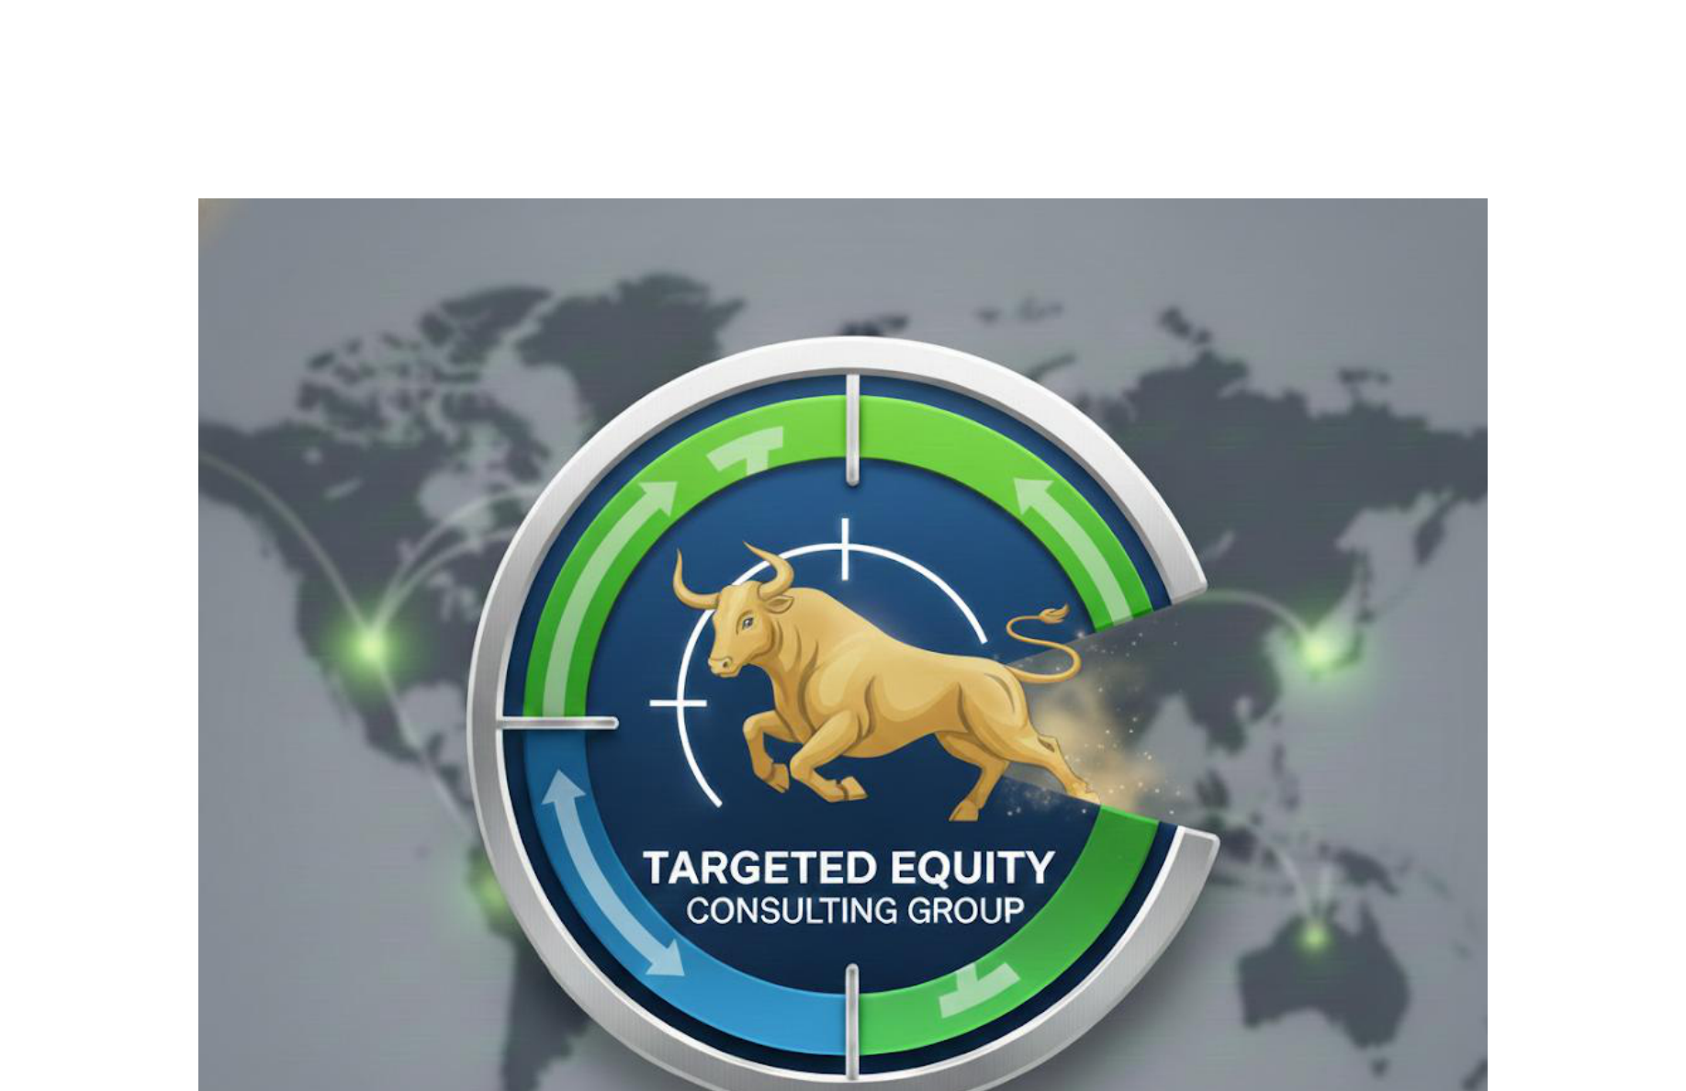

EARNINGS TRANSCRIPT ANALYSIS: AAPL
Company: Apple Inc.
Industry: Consumer Electronics
Sector: Technology
Analysis Date: 2025-12-15 17:54:51

TRANSCRIPTS ANALYZED:
1. Q4 2025 - 2025-10-30 00:00:00 (7,851 words)
2. Q3 2025 - 2025-07-31 17:00:00 (8,001 words)
3. Q2 2025 - 2025-05-01 19:13:00 (8,024 words)
4. Q1 2025 - 2025-01-30 17:00:00 (7,890 words)

Not generated (--claude-only flag used)

__________________________________________________
David Quinn
Targeted Equity Consulting Group
daquinn@targetedequityconsulting.com | 617-905-7415

