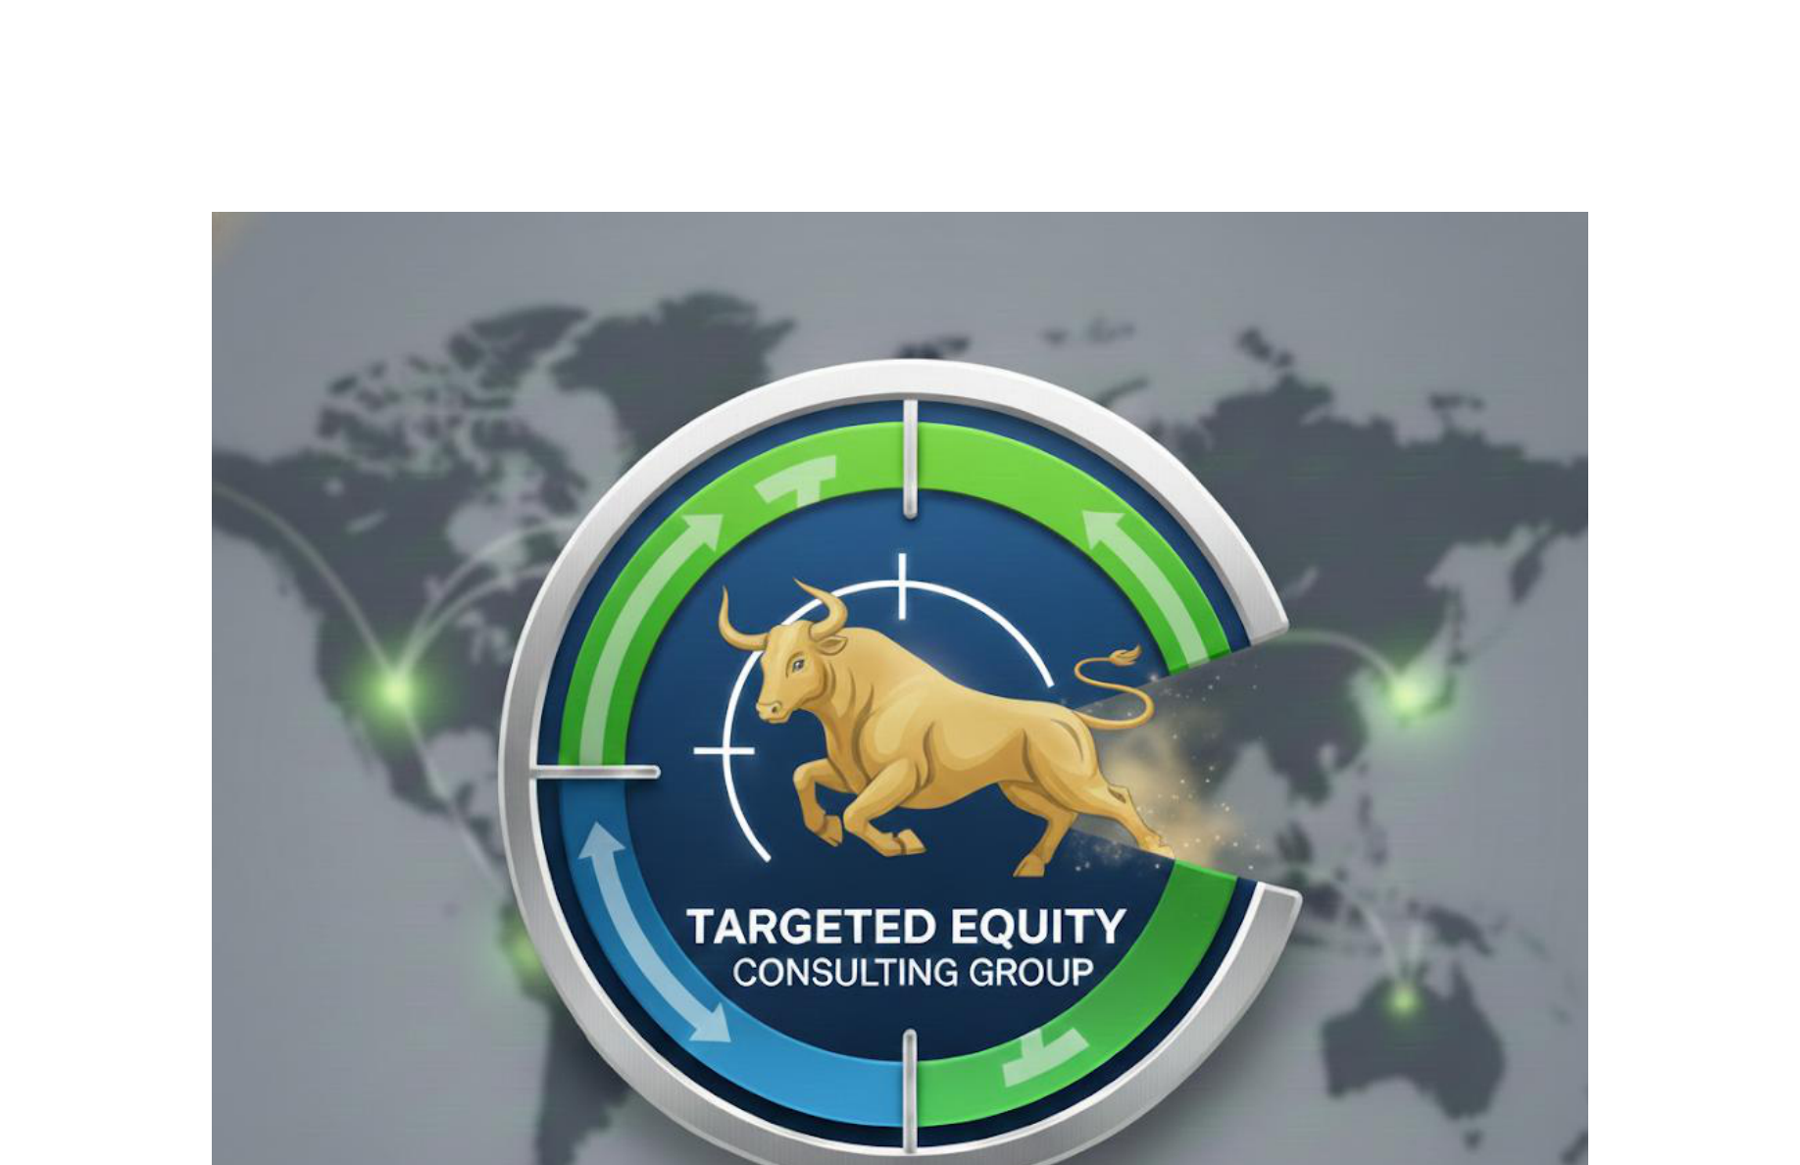

EARNINGS TRANSCRIPT ANALYSIS: AAPL
Company: Apple Inc.
Industry: Consumer Electronics
Sector: Technology
Analysis Date: 2025-12-15 17:54:51

TRANSCRIPTS ANALYZED:
1. Q4 2025 - 2025-10-30 00:00:00 (7,851 words)
2. Q3 2025 - 2025-07-31 17:00:00 (8,001 words)
3. Q2 2025 - 2025-05-01 19:13:00 (8,024 words)
4. Q1 2025 - 2025-01-30 17:00:00 (7,890 words)

CLAUDE'S ANALYSIS

# APPLE INC. (AAPL) - INVESTMENT ANALYSIS: Q4 2025 TO Q1 2025

1. GUIDANCE CHANGES (CRITICAL)

Revenue Guidance Trajectory:
- **Q1 2025**: Mid-single digits growth expected for Q2
- **Q2 2025**: Low-mid single digits growth for Q3
- **Q3 2025**: Mid-high single digits growth for Q4
- **Q4 2025**: **SIGNIFICANT ACCELERATION** - 10-12% growth expected for Q1 2026, calling it "best quarter ever"

🔺 MAJOR POSITIVE: Clear guidance acceleration from mid-single digits to double-digits represents the strongest forward guidance in this period.

Margin Guidance:
- **Stable Range**: Gross margin guidance consistently 46-48% across quarters
- **Q4 2025**: Guided 47-48% (above prior quarters), indicating improving mix/leverage

Capital Allocation:
- **Q2 2025**: Board authorized additional $100B share buyback, dividend raised 4% to $0.26
- **Consistent**: $20-25B quarterly buybacks maintained throughout period

Segment-Specific Changes:
- **Services**: Maintained double-digit growth expectations throughout
- **iPhone**: Q4 guidance calls for "best iPhone quarter ever" with double-digit growth
- **Mac**: Acknowledged difficult compares in Q4 due to prior year launches

2. MANAGEMENT & LEADERSHIP

Leadership Stability:
- **Tim Cook (CEO)** and **Kevan Parekh (CFO)** consistent throughout all calls
- **No executive changes** mentioned across the four quarters
- **Stable presentation format** with same IR director (Suhasini Chandramouli)

Strategic Messaging Evolution:
- **Q1-Q2**: Focus on AI foundation building, supply chain diversification
- **Q3-Q4**: **SHIFT TO CONFIDENCE** - Aggressive AI investment messaging, execution focus

3. TONE ANALYSIS (VERY IMPORTANT)

Overall Trajectory: **INCREASINGLY BULLISH**

Q1 2025 (Cautious Optimism):
- Measured language around AI rollout
- Hedging on China recovery
- Conservative on tariff impacts

Q2 2025 (Building Confidence):
- More assertive on AI strategy
- Increased investment messaging
- Supply chain optimization focus

Q3 2025 (Accelerating Confidence):
- "Significantly growing our investments"
- "Incredible excitement" language increases
- Revenue guidance acceleration

Q4 2025 (Peak Bullish):
- **"Extraordinary year"**, **"best ever"**, **"incredible"** used repeatedly
- **"Couldn't be more excited"** - strongest language in the series
- **"Strongest iPhone lineup ever"**
- Confident supply constraint acknowledgment (demand exceeding supply)

Hedging Language Reduction:
- Early calls: "uncertain", "monitoring", "assuming rates don't change"
- Later calls: Definitive statements, growth projections, investment commitments

4. POSITIVE HIGHLIGHTS

Major Wins:
- **Record Fiscal 2025**: $416B revenue (all-time high)
- **iPhone Records**: Q4 set September quarter record at $49B (+6% YoY)
- **Services Milestone**: Surpassed $100B annually for first time
- **AI Momentum**: Clear evidence Apple Intelligence driving iPhone upgrades in available markets
- **Supply Constraints**: Strong demand exceeding supply (positive demand signal)
- **China Recovery**: Expecting return to growth in Q1 2026
- **Emerging Markets**: India all-time records, broad emerging market strength

Guidance Beats:
- Q4 revenue guidance acceleration to double-digits
- Gross margin consistently at/above guidance ranges

5. NEGATIVE HIGHLIGHTS / RED FLAGS

Persistent Challenges:
- **China Weakness**: Down 11% in Q1, down 4% in Q4 (though improving)
- **Tariff Costs**: $800M→$1.1B→$1.4B escalating impact
- **Supply Constraints**: Production challenges on multiple iPhone models
- **AI Delays**: Personalized Siri features delayed multiple times across quarters
- **Macro Sensitivity**: Consistent hedging about macroeconomic conditions

Sequential Pressures:
- **Wearables Category**: Consistent weakness across multiple quarters
- **Foreign Exchange**: Persistent 2+ percentage point headwinds

6. QUARTER-OVER-QUARTER CHANGES

NEW This Quarter (Q4 2025):
- **Liquid Glass Design**: First unified design across all platforms
- **M5 Chip Launch**: Major silicon advancement with 3.5x faster AI performance
- **iPhone Air**: New ultra-thin form factor introduction
- **Apple Manufacturing Academy**: Detroit facility opening
- **F1 Partnership**: Major sports content deal

AVOIDING Previous Topics:
- **Reduced emphasis** on regulatory challenges (Epic, Google cases)
- **Less detailed** tariff impact discussions (more confident in mitigation)
- **Minimal mention** of supply chain diversification specifics

Strategic Pivots:
- **AI Investment**: From cautious rollout to aggressive investment
- **Geographic Strategy**: Increased confidence in China recovery
- **Supply Chain**: From defensive positioning to confident demand management

7. INVESTMENT IMPLICATIONS

BULL CASE STRENGTHENING:
1. **AI Cycle Accelerating**: Clear evidence Apple Intelligence driving upgrades
2. **Guidance Inflection**: Strongest forward guidance trajectory in the period
3. **Supply/Demand Imbalance**: Constraints indicate robust underlying demand
4. **Services Momentum**: $100B+ annual run rate with margin expansion
5. **China Recovery**: Management confident on return to growth
6. **Premium Mix**: Strong Pro model demand supporting margins

BEAR CASE DIMINISHING:
1. **Tariff Impact**: While increasing, better managed and offset by optimization
2. **Competition**: iPhone gaining share in key markets (China urban, global)
3. **AI Delays**: Core features delivered, personalized Siri delay less critical

KEY DEBATES FOR INVESTORS:

1. AI Monetization Timeline:
- Apple Intelligence driving hardware upgrades ✓
- Services monetization opportunity ahead
- Competitive positioning vs. ChatGPT/others

2. China Recovery Sustainability:
- Government subsidies providing tailwind
- Competitive pressure from local brands
- Apple Intelligence rollout timing critical

3. Margin Trajectory:
- Services mix improving margins
- Premium product mix benefits
- Tariff/input cost pressures offsetting

WHAT TO WATCH:
- **December Quarter Results**: Will validate "best ever" guidance
- **AI Feature Rollouts**: Personalized Siri launch timing and adoption
- **China Trajectory**: Subsidy impact and market share trends
- **Supply Constraint Resolution**: Production ramp success
- **Services Growth**: Sustainability above $100B annual rate

INVESTMENT RECOMMENDATION:
Increasingly Positive Trajectory - Management tone, guidance acceleration, and demand indicators suggest Apple is entering a stronger growth phase driven by AI cycle and emerging market expansion, despite persistent macro/geopolitical challenges.

CHATGPT'S ANALYSIS

Not generated (--claude-only flag used)

__________________________________________________
David Quinn
Targeted Equity Consulting Group
daquinn@targetedequityconsulting.com | 617-905-7415

