*Journal of Universal Computer Science, vol. 27, no. 1 (2021), 2987-2989 submitted: 1/1/2021, accepted: 2/2/2021, appeared: 3/3/2021 CC BY-ND 4.0*

**The Current Research Status of Solving Blockchain**

**Scalability Issue**

**Darllaine R. Lincopinis**

(Mindanao State University - Iligan Institute of Technology, Iligan City, Philippines [https://orcid.org/0000-0001-9503-8965,](https://orcid.org/0000-0001-9503-8965) darllaine.lincopinis@g.msuiit.edu.ph)

**Orven E. Llantos**

(Mindanao State University - Iligan Institute of Technology, Iligan City, Philippines [https://orcid.org/0000-0002-0787-0282,](https://orcid.org/0000-0002-0787-0282) orven.llantos@g.msuiit.edu.ph)

**Abstract:** Blockchain is an emerging technology with Big data, Artificial Intelligence, and Machine Learning. It disrupted industries such as health, education, manufacturing, and banking. However, the increasing popularity of Blockchain exposes the scalability issues of major public blockchain platforms (e.g., Bitcoin and Ethereum) and dramatically affects its development. The scalability problem manifests in terms of Low throughput, high transaction latency, and massive energy consumption. Several reviews and studies cover these factors and their potential solutions, yet these studies need to highlight more information through actual application to natural systems or projects. This study investigates all relevant papers on current research solutions for public blockchain scalability issues. The scope of this paper is to explore the implementation of different state-of-the-art scalability solutions to natural systems and projects while simultaneously highlighting the results. This study discusses the methods and techniques used and the challenges encountered that have yet to future researchers must explore.

**Keywords:** Blockchain, Scalability,Bitcoin,Ethereum,ScalabilitySolutions,Blockchainsystems,

P2P network

**DOI:** 10.3897/jucs.<SubmissionNumber>

# 1 Introduction

Blockchain technology is a ground-breaking innovation that creates a new avenue for different industries. It has the critical characteristics of decentralization, anonymity, persistence, and auditability. In the absence of centralized control, Blockchain can also prevent the possibility of interference by adopting cryptography techniques. Its concept received little attention during its initial release in 2008 by Nakamoto. However, with the emergence of the Internet of Things over the years, the popularity of Blockchain technology has captured the attention and interests of researchers as an ideal P2P technology for distributed and decentralized computation and data sharing. As it came into the limelight, especially when the hype around Bitcoin and other cryptocurrencies gained momentum [Chauhan et al., 2018], increasing transactions required more nodes to support the network. Since the whole concept of Blockchain is freedom from third-party validation, this conveys that more nodes need to store and execute computational tasks to validate every transaction. Accordingly, the average waiting time for a transaction to be validated has increased to 29 minutes [Kaur Gandhi, 2020]. It is here where Blockchain puts up with Scalability issues. Almost entirely public blockchain platforms are affected by Scalability issues since anyone is free to join and participate in the core activities of the blockchain network. Therefore, an increasing number of network validation transactions is inevitable. Public blockchains require considerable computational power, high bandwidth internet connection, and massive storage space.

Several factors contribute to the outcome of the Scalability issue in Blockchain. Transaction throughput and transaction confirmation latency are the two most discussed, and both have a lower QoS level in several popular blockchain systems. For instance, Ethereum and Bitcoin are two Blockchain platforms that process 20 and 7 transactions per second, corresponding to typical systems such as PayPal and VISA, which process 193 and 1667 transactions per second, respectively [Pawar et al., 2021]. Other interdependent factors exist, such as storage, block size, number of nodes, energy consumption, and cost.

Some studies have carefully identified the concept of Scalability trilemma [Alrehaili et al., 2021, Khan et al., 2021]. The fundamental principle of the Scalability trilemma is **scalability**, **decentralization**, and **security** (see Figure 1). The trilemma indicates that scalability, security, and decentralization cannot co-exist; therefore, Blockchain can only acquire two of these characteristics simultaneously. For instance, scaling up the Blockchain without compromising its other properties, namely decentralization, and security, unnerve challenges to the researchers.Such as, when sacrificing decentralization, a third-party authority responsible for validations must be created. The decision might improve Blockchain's scalability and performance but also lose one of its disruptive properties, making Blockchain unique from other innovations. That being so, it is indispensable to balance these three aspects.

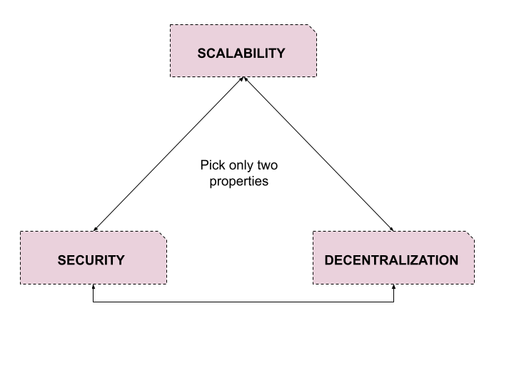

## *Figure 1: Scalability Trilemma*

It is a fact that many reviews and surveys have explored the avenue of scalability problems and covered different solutions that may be applicable. However, the question remains: Does Blockchain potentially serve other real-world applications besides cryptocurrencies? Such confusion is because of the hindrance caused by its Scalability issues.

This paper discusses several solutions to handle blockchain scalability, intending to illustrate which solutions researchers must implemented in Public Blockchain platforms. This paper explored and tracked the state-of-the-art scalability solutions by analyzing their transaction throughput and latency while scrutinizing their interdependent factors. This paper's organization started with investigating public blockchain systems by examining the implementation and techniques that aim to solve Blockchain's scalability issue. Examining specific parameters such as block size and transaction processing speed leads to establishing how these parameters contribute to the scalability problem. Also, this study discusses the implementation and results of the different state-of-the-art scalability solutions for public blockchain platforms. Ultimately, this study aims to build a thorough knowledge base in blockchain technology, specifically in solving scalability issues. The contributions of this study can be summarized as follows:

1. Provide a deeper understanding of state-of-the-art scalability solutions.
2. Construct a performance metric of listed scalability solutions.
3. Evaluate the limitations encountered with the integration of the solutions.

This paper has five sections. Section two defines blockchain technology and its types. Section three highlights the role of block size and transaction processing speed in the scalability issue. Section four covers the kinds of scalability solutions and the investigation of actual solution integration. Section five illustrates the performance analysis result of each blockchain-based solution for Scalability issues, and section five concludes the review.

**2 What is Blockchain Technology?**

The concept of centralized systems has several downsides; decisions take longer since all authorities depend on the decisions of a sole entity—a situation where Blockchain came into the limelight. Developing Blockchain relies on the foundation of distributed computing, software engineering, cryptography, and game theory [Kaur Gandhi, 2020]. It quickly integrates with applications because of its significant advantage compared to the traditional system – it does not hinge on a central entity. In effect, this advantage heavily emboldened cryptocurrency investors because users and developers control the network instead of a central authority. Another predominant property of Blockchain is its ability to avert the possibility of intrusions by adopting cryptographic techniques. In addition to being centralized and secure, the information stored on the Blockchain is also immutable. This property warrants stable ledger entry that cannot be modified.

When the notion of Blockchain came into the public eye by Nakamoto in 2008, its block size of data storage had a limit of 1 MB [Nakamoto, 2008]. Since then, it has evolved into one of the most disruptive technologies. Its idea has found takers in various applications like voting, health, prediction, food, electricity distribution, and data storage. Blockchain is composed of blocks where certain types of information are stored. A block is linked to similar blocks to form a chain where each block correlates with the previous block. There is an assurance of the association and integrity of each block in the chain by a hash function used to create a hash value of each block. The hash value is a digital fingerprint generated by the current block and the previous block's hash in the chain. Its properties are linking of each block, and when changes happen to the data present in the block, it reflected in the hash of the block and all succeeding blocks.

In addition, the partitions of the Blockchain are public, private, and consortium. The following sub-section discusses why public Blockchain is more vulnerable to scalability than private and consortium Blockchain.

### 2.1 Public blockchain

A public blockchain network allows anyone to take part and join the network by allowing members to check the transaction and confirm it, and also, they can take part on the way toward getting a consensus. It is permissionless, which means no restrictions for miners. The network typically has a reward system to urge more members to join the network [Praveen, 2017]. Examples of public blockchains are Bitcoin and Ethereum. The upper hand of a public blockchain is that it inaugurates trust in members since everybody makes the best decision to improve the network [Kaur Gandhi, 2020]. Another advantage is that it is transparent and open; even though all information inside the transactions is open for every member to see, there is still legitimacy since the transaction and information are confirmed by anyone in the network. Lastly, public Blockchain is secure, mainly when every participant actively participates in the decentralization, because the more nodes in the network, the harder it is to be attacked.

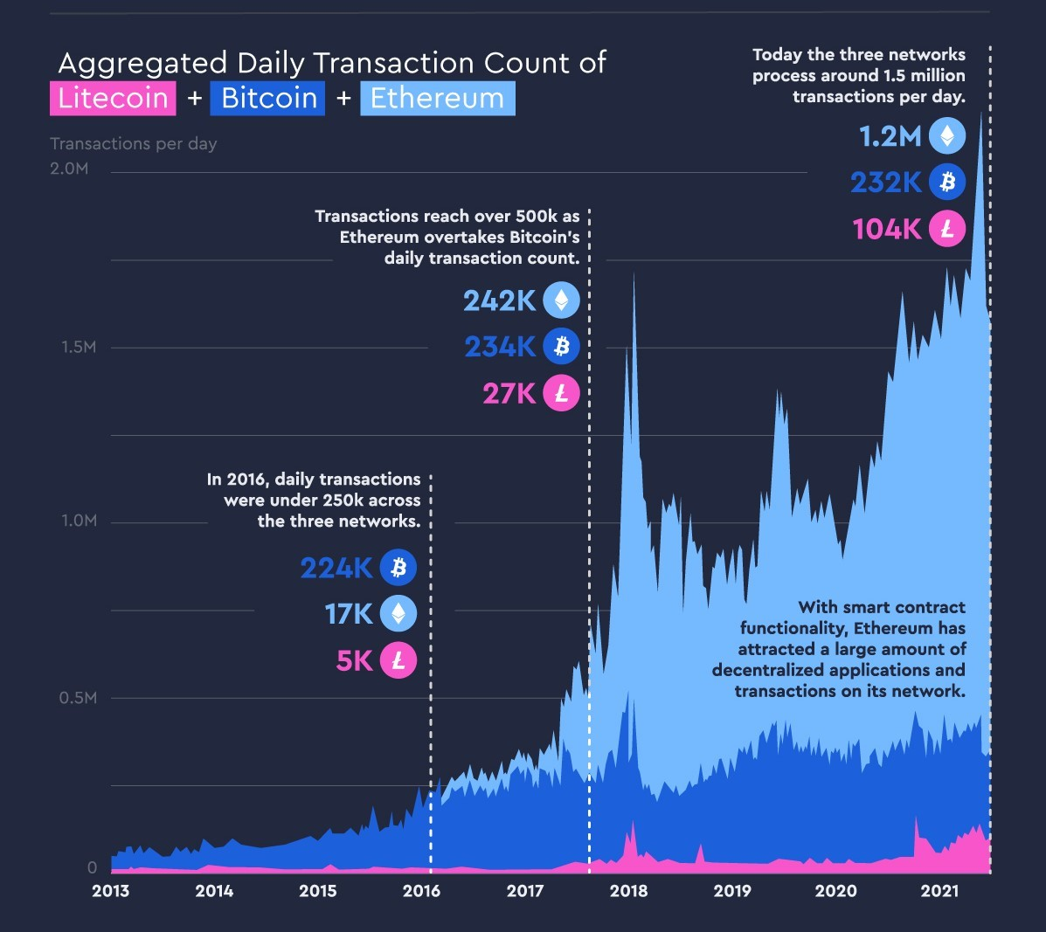

## *Figure 2: Graph denoting the transaction count of Bitcoin, Ethereum, and Litecoin over the past years. Source: visualcapitalist*

Nevertheless, being open to everybody exposes the scalability issue in the public Blockchain. Such scalability issue occurs when the number of nodes and transactions in the network to be validated increases, which is time-consuming, requiring a considerable amount of computational power, high bandwidth internet connection, and massive storage space [Khan et al., 2021].

In contrast, **the Consortium blockchain** has more than one private entity as the owner. In this type, every private entity controls the consensus removing the centralized control compared to a private blockchain. Collaborating with private entities makes detecting flaws in the Blockchain easier. However, the setup requires trust between collaborators, as one corrupt member can suffer the entire Blockchain. Consortium blockchain takes advantage of the best practices from public and private blockchains, reducing scalability issues while maintaining trust in the Blockchain through collaboration.

# 3 Role of Blockchain Parameters

Blockchain scalability is arguably the bottleneck of the cryptocurrency avenue. Questions such as why is scalability so difficult on Blockchain? What exactly does it mean when we say Blockchain can be scalable? - still rises. To answer those, there is a need to understand first the role of blockchain parameters that might cause scalability issues.

## 3.1 Block Size

A block size is the maximum limit of a block that can be filled up with transactions [Kaur Gandhi, 2020]. It has a very influential factor in averting denial-of-service attacks in the network. Since the network rejects a block when the size exceeds the limit, this raises the issues of a slow network and high processing. Also this fixed size results in a slowdown of the network, especially when the number of users in the network increases (exposure to scalability problem). To avoid this stumbling block, we can increase the block capacity by removing signature data from transactions; this process is called Segregated Witness (SegWit). The implementation of Segregated Witness in Bitcoin applications results in a significant increase in block capacity [Kaur Gandhi, 2020]. However, if signature data is dropped from transaction data, this makes the task of evidentiary evidence difficult. Who can testify to the authenticity of signature data to match it to the relevant transaction data? SegWit is just one of the suggested solutions in increasing block size capacity; this paper discusses further options in the later sections.

## 3.2 Transaction Processing Speed

Processing speed of transaction to be validated in Blockchain is measured by transaction per second (TPS) or throughput. TPS is the maximum number of transactions a blockchain can carry out in a second. However, more than measuring TPS is required - one must also consider the finality, average first block waiting time, and confirmation time. Consider the following elaboration to understand the concept of mentioned parameters. For instance, when waiting for a bus to go home. The route always has a long queue of people waiting for the bus. Minutes have passed, and a bus has arrived; however, there are too many people ahead in the queue; therefore, the bus is immediately filled. Say there is a 20 mins interval between buses, so there is a need to wait 20 mins for the next bus. Figure 3 below shows the summary of the journey and interpretation in the context of TPS, finality, waiting time, and confirmation.

The interpretation says that processing up to a thousand TPS is excellent, but if it has a longer confirmation time, more is needed. Next, if network congestion occurs,

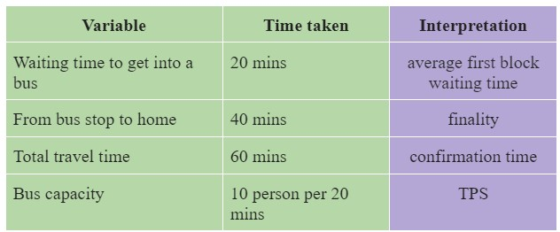

## *Figure 3: Bus concept*

TPS might not decrease, but confirmation time will degenerate because of the more extended average first block waiting time. Lastly, finality is a fixed waiting time for a block to be confirmed in the chain. The average first-block waiting time varies depending on the finality of a block. Thus, in order for the Blockchain platform to cope with tech giants such as VISA, MasterCard, and Paypal, some improvements are needed to scale up Blockchain technology.

# 4 Scalability Solutions

Scaling Blockchain is a complex topic, and different approaches have been adopted to ameliorate blockchain scalability. As mentioned, when the number of users for major blockchain platforms increases substantially, the scalability issues will intensify since it will produce transactions at a higher rate. The researchers have identified and analyzed the techniques published in recent literature to tackle the scalability issues. In general, the researchers believed that there are four directions for blockchain scalability;(1) Layer 0 (propagation protocol), (2) Layer 1 or on-chain, (3) Layer 2 or off-chain, and (4) another consensus.

## 4.1 Layer 0 (propagation protocol)

The techniques proposed in this layer are focused on solving scalability through the dissemination of information in the blockchain network through propagation protocol. [Alrehaili et al., 2021] highlighted that the nodes in this technique exchange and broadcast blocks of data/transactions inefficiently within the blockchain network, causing high confirmation time. [Alrehaili et al., 2021] listed the following studies that have been published in this layer:

1. **BloXrou** [Klarman et al., 2018] - neutral transport layer which runs underneath cryptocurrencies. The design of the network is based on increasing the block size while decreasing the interval between blocks. The advantages of this approach are that it avoids forks and enables fast propagation.
2. **KadCast** [Rohrer Tschorsch, 2019] - It is based on Kademlia Architecture, where it works similarly to the mechanism deployed for enhanced broadcasting with adjustable redundancy and overhead. It also enables fast propagation and secure transmission.

## 4.2 Layer 2 (on-chain)

The solutions proposed in the first layer require changing the structure of the actual Blockchain. To execute this, enumerated below are the leading techniques in this layer such as:

1. **Redesigning the structure of blocks** - which is done by increasing the block size and block compression process. The latter process could reduce some unessential and redundant data of a block. When this technique is integrated, each block can accommodate more transactions, which unquestionably improves the overall throughput. Bitcoin Unlimited is an example of this technique. Bitcoin Unlimited allows miners to collectively decide the block size limit according to the actual network capacity [Zhang Preneel, 2017]. However, Bitcoin Core rejects blocks that exceed 1MB; this led BU to fail for Bitcoin's original chain because miners are concerned that this would lead to divisions in the community. A good example that integrates this approach is Litecoin, a peer-to-peer decentralized and open-source protocol. In contrast to bitcoins' (10 minutes) block interval, Litecoins' is 2.5 minutes, and the throughput of Litecoin is 56 TPS.
2. **Implementing Directed Acyclic graph (DAG)** - this technique roots in the idea that the transactions in Blockchain are recorded in a linear type formation. Since Blockchain has a limited throughput with high latency, allowing a concurrent operation might enhance throughput. DAG is a finite graph commonly deployed in a computer science major. The DAG-based Blockchain considers a block as a vertex in the DAG attached to other previous vertices. Moreover, The DAG-based Blockchain permits many vertices to be attached to a preceding vertex that creates simultaneous blocks. The ideal system that implements this technique is Conflux [Li et al., 2018], a consensus protocol that represents relationships between blocks as a DAG, which is a fast, scalable, and decentralized blockchain system that optimistically processes concurrent blocks without discarding any as forks.
3. **Sharding techniques** - this is a form of database partitioning with the idea of improving performance and reducing the query response time. This technique involves breaking up a vast database into smaller and more manageable segments. When applied to Blockchain, each blockchain platform will be divided into several smaller units called a *shard*. A pool of transactions is processed in multiple shards, which reduces the load on each node and makes it possible for nodes to process a small number of transactions. With this approach, a novel shard-based blockchain consensus is proposed by [Kim, 2019] based on the cooperative game paradigm. The key idea is to split the transactions among multiple shards while processing them in parallel. Basic concepts such as *Egalitarian Bargaining Solution (EBS)* is used for tackling transaction distribution problem, the key idea of *the Proportional Bargaining Solution (PBS)* is used to foster the consensus process, and lastly, a new two-phased bargaining game model, which is designed to strategically control the shard-based consensus process[Kim, 2019]. Another adoption of sharding is the KSI cash by [Buldas et al., 202]; it is a sharded blockchain technology with unlimited scalability from the Alphabill family. Sharding is implemented in handling payment orders in KSI cash, where KSI cash blocks are sharded. In every round, each shard builds a shard block with the following authentication data (1) round number, (2) round's root hash signature, and (3) authentication path. Then after the payment order is validated and is successfully integrated into the block, the shard sends a particular proof of the

particular wallets. An ideal implementation of sharding for improving throughput is Ostraka [Manuskin et al., 2020], a blockchain node architecture that shards (parallelizes) the node themselves. The researchers concluded that Ostraka overcomes the security and performance limitations and also allows the system to achieve an order-of-magnitude improvement in throughput. However, if the target is improving latency RapidChain [Zamani et al., 2018] is a fine candidate. RapidChain is the first sharding-based public blockchain protocol that is resilient to Byzantine faults and achieves complete sharding of the communication, computation and storage overhead of processing transactions. Other state-of-the-art sharding approaches are Elastico [Luu et al., 2016], Omniledger [Kokoris-Kogias et al., 2018], and Monoxide [Wang Wang, 2019].

1. **SegWit** - is a protocol upgrade that changes the way and structure of how data is stored in the block. This is done by removing the digital signature that verifies the ownership and availability of the sender's data. Since digital signature takes up much space in a transaction, removing it would allow more transactions to be included in one block. In SegWit, the block size increases from 1MB to 4MB where the block is now divided into two parts: 1MB for the base transaction block size and 3 MB for the extended block size.

## 4.3 Layer 3 (off-chain)

The third layer of scalability solutions adds another layer to the main blockchain network with the purpose of facilitating faster transactions. This is executed by off-loading transactions from the main Blockchain to save space and reduce network congestion. This approach can also be used to diminish the storage burden of blockchain nodes while ensuring the integrity of the off-chain data. For instance, [Sun et al., 2021] proposed a Hyper-ledger fabric (HLF) solution where nodes only stores commitments of data to verify if it has been tampered with or not; the results show that TPS in Blockchain has enhanced by 9.6% compared to the plain HLF. Off-chain can also be used as a storage mechanism, as proposed by [Shahnaz et al., 2019], where the data stored on the Blockchain also has IPFS as the off-chain scaling solution used in their proposed system framework. Their study concludes that with IPFS, the data size on Blockchain decreases while transaction performs faster, and the security of the framework will not be jeopardized.

1. **Side-chaintechniques**-issimplyaseparateblockchainlinkedtothemainblockchain. This allows the assets in a specific blockchain to be moved between various subblockchain[Alrehaili et al., 2021] while guaranteeing that the assets are secure and saved. An example of side-chain implementation is the proposal of [Nartey et al., 2022], a hybrid Blockchain-IoT integration scheme that used fog computing and cloud storage to help improve the throughput of such applications. This is done by scheduling a side-chain run on a fog node where completed transactions are forwarded in the side-chain to the main Blockchain. [Thakur Breslin, 2020], on the other hand, uses offline channels in their proposal to mitigate the scalability problem, using the side-chain approach(Bitcoin Lightning network) as a basic protocol. Their research proved that reducing interaction with the Blockchain using offline channels improves scalability.
2. **Payment channels** - the idea of payment channels is to establish a temporary channel network between two parties who wants to make a transaction to reduce the volume on the main network and increase the transaction throughput of the whole.

Blockchain [Alrehaili et al., 2021]. There are several designs for payment channels, Bitcoin and Ethereum are the only one popular payment channel implementations.

Another payment channel described by [Coladangelo Sattath, 2020] is a first example of a simple hybrid classical-quantum payment system with the integration of classical Blockchain that is capable of handling stateful smart contracts and quantum lightning. The objective of this proposal is to employ smart contracts for regulating the generation of new valid quantum banknotes in order to prevent anyone from cloning banknotes. However, [Coladangelo Sattath, 2020] highlighted that quantum money is not divisible, unlike Bitcoin, since the miner must decide at the time of quantum mining if what is the denomination of the quantum money or if it remains the same for the lifetime of the quantum money. Also, hidden inflation may be a threat because a powerful adversary could create new quantum of money from thin air without others being able to notice it [Coladangelo Sattath, 2020].

1. **Cross-chain techniques** - are contemplated to be latent solutions to refine scalability in Blockchain. [Alrehaili et al., 2021] believed that once the interoperability of separated chains in these techniques is interconnected, this can result in enhancing scalability. For instance, Polkadot [Wood, 2016] has the concept of attaching various blockchains with a relay chain. The relay chain allows separated blockchains to communicate with each other, and the Polkadot acts as a mediator that connects to already functioning. The advantages of the Polkadot approach are that it increases throughput and establishes secure communication.

## 4.4 Other consensus

In solving the scalability issue of Blockchain, the relevance and potential theoretical impact of scalability trilemma is an inevitable avenue. This is often cited in research works, such as [Hafid et al., 2020] [Im, 2018]. A number of researchers believed that scalability trilemma is only an observation instead of a formal mathematical proof and believed that an algorithm might exist that can solve it. For instance, [Del Monte et al., 2020] theoretically described a new blockchain architecture that disproves the trilemma.

Their solution intends to apply a parallel version of the Algorand consensus approach [Chen Micali, 2019], distributing the storage of the state, and mainly it distributes the burden to create the next block on many parallel executing committees (involving

"almost" all nodes) .Moreover, that avoids broadcast in all cases that are critical for scalability.

As stated, Blockchain has been integrated into a number of areas. Another paper presents a scalable framework for blockchain-based Shared Manufacturing [Rožman et al., 2021] with an implementation of the concept of cross-chain networks. In cross-chain solutions, it can provide great immutability of recorded data; it also offers great modifiability within the technology. In the proposal of [Rožman et al., 2021], the main chain takes care of the storage of the crucial identification data while allowing the consumers' funds to enter the market. Side chains, on the other hand, take care of configuring the functionality by acting as a platform on which consumers can collaborate.

1. **Proof of Work(PoW)** - is an approach that can be used to verify the accuracy of a transaction on the Blockchain network. Blockchain systems with integration of PoW are capable of processing ten transactions per second compared to ordinary Blockchain systems. However, PoW integration can use much energy; it will take several minutes to verify a single transaction, and mainly, it is somewhat vulnerable to a 51% attack.
2. **Proof of Stake (PoS)** - is another blockchain consensus where the creation of the next block in the chain is selected based on how many coins or tokens the participants are currently staking. PoS delivers greater scalability and throughput compared to PoW, since transactions and blocks can be validated quicker without the need to solve complex equations. Therefore, PoS can be less energy-intensive and have greater speed and capacity.
3. **Proof of Luck and Fair share (PPLFS)** - is a framework proposed by [**?**] with a design to allow more than one miner to use the block transactions, increasing the throughput in terms of TPS. The main purpose of this proposal is to address the problems in PoW, such as the intensive wastage of energy. To do this, the following strategy is applied. (1) A 64-bit random number is generated, and simultaneously the miners generate the block hash value with a combination of the Previous block hash value, timestamp, private key, and nonce value. (2) This block hash value must be less than the 64-bit certain value, and if the condition is satisfied, then the election process has been successfully completed [**?**].
4. **Delegated Proof of stake (DPoS)** - is another consensus mechanism that is a variation of the classic PoS. It solves the scalability issue in Blockchain by sacrificing decentralization. DPoS allows miners of the network to vote and identify who then validates and produces the blocks. This validator may then distribute their block rewards to those who voted for them. However, DPoS is prone to malicious token holders, and as stated, it lacks decentralization.

# 5 Performance metric of Ideal Scalability Solutions

Herein, the factors that influence the scalability issue, such as transaction per seconds

(TPS), latency and block size are illustrated. The performance analysis shown in Table 1 is only from selected solutions discussed in the previous section that completely included their results after the final integration. From Table 1, it is observed that there is a number of proposed solutions that use the Sharding strategy, and mostly they have a high throughput except for ELASTICO. However, the solutions that use the Sharding approach are most prone to attacks such as DoS attacks; therefore, this limitation must be worked out for it to be ideal for solving blockchain scalability. In addition, comparing the block size of SegWit and Litecoin to the rest of the listed solutions, it is identified that increasing the block size does not improve the throughput. Conflux has the highest TPS for the DAG approach compared to other solutions, such as Byteball [Churyumov, 2016] and IoTA, with 20-30 tps and 500 tps, respectively. Other solutions, such as block propagation and SegWit, come last in the performance metric since some details, such as the latency and limitations in the integration, need to be clarified. Lastly, the Lightning network strategy for Offline channels is the up-to-the-mark solution that might solve the scalability issue; however, this idea is only tested on payment channels only. Future work is needed to integrate this solution into other avenues besides payment channels.

# 6 Conclusions

Until recently, blockchain technology has been creating a new avenue for different industries, and most research is focusing on how Blockchain can be integrated into these

|  |  |  |  |  |  |  |  |  |  |  |
| --- | --- | --- | --- | --- | --- | --- | --- | --- | --- | --- |
| Limitations | Onlyforpaymentchannels | Unabletoshardbandwidthandcom-  putationalresources | Notspecified | Pronetopartitioningattackandlow  responsiveness | Notspecified | Requiresatrustedsetuptogener-  ateaninitialunpredictableconfig-  uration,alsorequiresusertopartici-  pateactivelyincross-shardtransac-  tions,andmainlyvulnerabletoDoS  attacks. | Moreorphanedblockarerejected  bynetworkduetoatimelaginthe  acceptanceoftheblock. | Requirespartiestore-establishtheir  identitiesandre-buildallcommit-  tees,requiressmallcommitteesize,  allowsmaliciousnodestoprecom-  putePoWpuzzles | Notspecified | Causeshardforkandneedsmoreto  bescalable |
| Benefits | Nocostfortransitionandwaiting  timeisalmostzero | Overcomessecurityandperfor-  mancelimitationsandachieveslin-  earscalinginthenumberofnode  shards | Abletoscaleblockchainsystemlin-  earlywithoutcompromisingdecen-  tralizationandsecurity | Highthroughputwithtotalresiliency  andcommitteeresiliency | Fasterblockgenerationandhigher  throughput | Ensuressecurityandcorrectnessfor  choosinglarge,statisticallyrepresen-  tativeshardsthatprocesstransac-  tions. | Canhandlelargevolumeoftransac-  tionandsupportsfasterblockgener-  ation | Improvethethroughputandlatency  Safely | Safelyincreasetheblocksizeandto  cutdownthetimeintervalbetween  blocks,withoutincreasingtherisk  offork.Also,cryptocurrencycom-  munityisfreetoadjustitsprotocol  tobestleverage | Increaseblocksizecapacityand  transactionmalleabilityissueis  fixed |
| Block  size | 1  MB | 1  MB | 1  MB | 1  MB | Notspec-  ified | 1  MB | 4  MB | 1  MB | 1  MB | 4  MB |
| Latency | 600 | Notspeci-  fied | 13-21 | 7380 | 270-444  S | 800 | 150  s | 800 | NotSpeci-  fied | Notspeci-  fied |
| TPS | 40  million | 400000 | 11694 | 7380 | 6400 | 3500 | 56 | 40 | 33 | 7 |
| Strategyused | Lightningnet-  work | Sharding | Sharding | Sharding | DAG | Sharding | Scrypting | Sharding | Blockpropa-  gation | Segragated  digitaldesign |
| Solution | OfflineChannels | Ostraka | Monoxide | RapidChain | Conflux | OmniLedger | Litecoin | ELASTICO | BloXrou | SegWit |

*Table1:*

*Performancemetricofstate-of-the-artsolutions*

industries. However, there needs to be more focus on the disadvantaging factors of Blockchain and what are the solutions that can be implemented. This paper has discussed the state-of-the-art solutions for solving blockchain scalability issues and their performance. The paper first discussed the roles of blockchain parameters for a better understanding of blockchain scalability issues and observed that block size and throughput are the factors that caused this problem. Hence, to improve the scalability, several state-of-the-art solutions are discussed and compared in terms of performance metrics. It is observed that in order to integrate Blockchain into real-life systems, it is important to identify which solution is ideal to avoid scalability issues. The future scope of this work might focus on studying the integration of offline channels with lightning network approach to other industries aside from payment channels, and also the limitations listed in Table 1 indicate the areas as a recommendation for future work.

# References

[Chauhan et al., 2018] Chauhan, A., Malviya, O., Verma, M. & Mor, T. Blockchain and scalability.

2018 IEEE International Conference On Software Quality, Reliability And Security Companion (QRS-C). pp. 122-128 (2018)

[Kaur Gandhi, 2020] Kaur, G. & Gandhi, C. Scalability in Blockchain: Challenges and solutions. Handbook Of Research On Blockchain Technology. pp. 373-406 (2020)

[Pawar et al., 2021] Pawar, M., Patil, P. & Hiremath, P. A study on blockchain scalability. ICT Systems And Sustainability. pp. 307-316 (2021)

[Alrehaili et al., 2021] Alrehaili, A., Namoun, A. & Tufail, A. A Comparative Analysis of Scalability Issues within Blockchain-based Solutions in the Internet of Things. International Journal Of Advanced Computer Science And Applications. **12** (2021)

[Khan et al., 2021] Khan, D., Jung, L. & Hashmani, M. Systematic literature review of challenges in blockchain scalability. Applied Sciences. **11**, 9372 (2021)

[Nakamoto, 2008] Nakamoto, S. Bitcoin: A peer-to-peer electronic cash system. Decentralized Business Review. pp. 21260 (2008)

[Praveen, 2017] Praveen, J. The difference between public and private Blockchain. (IBM,2017)

[Wood, 2016] Wood, G. Polkadot: Vision for a heterogeneous multi-chain framework. White Paper. **21** pp. 2327-4662 (2016)

[Nartey et al., 2022] Nartey, C., Tchao, E., Gadze, J., Yeboah-Akowuah, B., Nunoo-Mensah, H., Welte, D. & Sikora, A. Blockchain-IoT peer device storage optimization using an advanced timevariant multi-objective particle swarm optimization algorithm. EURASIP Journal On Wireless Communications And Networking. **2022**, 1-27 (2022)

[Rohrer Tschorsch, 2019] Rohrer, E. & Tschorsch, F. Kadcast: A structured approach to broadcast in blockchain networks. Proceedings Of The 1st ACM Conference On Advances In Financial Technologies. pp. 199-213 (2019)

[Sun et al., 2021] Sun, H., Pi, B., Sun, J., Miyamae, T. & Morinaga, M. SASLedger: A Secured,

Accelerated Scalable Storage Solution for Distributed Ledger Systems. Future Internet. **13**, 310 (2021)

[Klarman et al., 2018] Klarman, U., Basu, S., Kuzmanovic, A. & Sirer, E. bloxroute: A scalable trustless blockchain distribution network whitepaper. IEEE Internet Of Things Journal. (2018)

[Thakur Breslin, 2020] Thakur, S. & Breslin, J. Scalable and secure product serialization for multi-party perishable good supply chains using Blockchain. Internet Of Things. **11** pp. 100253

(2020)

[Del Monte et al., 2020] Del Monte, G., Pennino, D. & Pizzonia, M. Scaling blockchains without giving up decentralization and security. ArXiv Preprint ArXiv:2005.06665. (2020)

[Hafid et al., 2020] Hafid, A., Hafid, A. & Samih, M. Scaling blockchains: A comprehensive survey. IEEE Access. **8** pp. 125244-125262 (2020)

[Im, 2018] Im, D. The blockchain trilemma. (2018)

[Chen Micali, 2019] Chen, J. & Micali, S. Algorand: A secure and efficient distributed ledger. Theoretical Computer Science. **777** pp. 155-183 (2019)

[Kim, 2019] Kim, S. Two-phase cooperative bargaining game approach for shard-based blockchain consensus scheme. IEEE Access. **7** pp. 127772-127780 (2019)

[Zamani et al., 2018] Zamani, M., Movahedi, M. & Raykova, M. Rapidchain: Scaling blockchain via full sharding. Proceedings Of The 2018 ACM SIGSAC Conference On Computer And Communications Security. pp. 931-948 (2018)

[Shahnaz et al., 2019] Shahnaz, A., Qamar, U. & Khalid, A. Using Blockchain for electronic health records. IEEE Access. **7** pp. 147782-147795 (2019)

[Luu et al., 2016] Luu, L., Narayanan, V., Zheng, C., Baweja, K., Gilbert, S. & Saxena, P. A secure sharding protocol for open blockchains. Proceedings Of The 2016 ACM SIGSAC Conference On Computer And Communications Security. pp. 17-30 (2016)

[Kokoris-Kogias et al., 2018] Kokoris-Kogias, E., Jovanovic, P., Gasser, L., Gailly, N., Syta,

E. & Ford, B. Omniledger: A secure, scale-out, decentralized ledger via sharding. 2018 IEEE Symposium On Security And Privacy (SP). pp. 583-598 (2018)

[Wang Wang, 2019] Wang, J. & Wang, H. Monoxide: Scale out blockchains with asynchronous consensus zones. 16th USENIX Symposium On Networked Systems Design And Implementation (NSDI 19). pp. 95-112 (2019)

[Buldas et al., 202] Buldas, A., Draheim, D., Gault, M., Laanoja, R., Nagumo, T., Saarepera, M., Shah, S., Simm, J., Steiner, J., Tammet, T. & Others An ultra-scalable blockchain platform for universal asset tokenization: design and implementation. IEEE Access. **10** pp. 77284-77322 (2022)

[Zhang Preneel, 2017] Zhang, R. & Preneel, B. On the necessity of a prescribed block validity consensus: Analyzing bitcoin unlimited mining protocol. Proceedings Of The 13th International Conference On Emerging Networking EXperiments And Technologies. pp. 108-119 (2017)

[Coladangelo Sattath, 2020] Coladangelo, A. & Sattath, O. A quantum money solution to the blockchain scalability problem. Quantum. **4** pp. 297 (2020)

[Rožman et al., 2021] Rožman, N., Diaci, J. & Corn, M. Scalable framework for blockchain-based shared manufacturing. Robotics And Computer-Integrated Manufacturing. **71** pp. 102139 (2021)

[Li et al., 2018] Li, C., Li, P., Zhou, D., Xu, W., Long, F. & Yao, A. Scaling nakamoto consensus to thousands of transactions per second. ArXiv Preprint ArXiv:1805.03870. (2018)

[Manuskin et al., 2020] Manuskin, A., Mirkin, M. & Eyal, I. Ostraka: Secure Blockchain scaling by node sharding. 2020 IEEE European Symposium On Security And Privacy Workshops (EuroSPW). pp. 397-406 (2020)

[Churyumov, 2016] Churyumov, A. Byteball: A decentralized system for storage and transfer of value. URL Https://byteball. Org/Byteball. Pdf. (2016)