[Rrgularization](https://www.youtube.com/watch v=5asL5Eq2x0A&list=RD5asL5Eq2x0A&start_radio=1)

lets start from bias-variance trade off
fit different model to the data

draw 3 graphs
- simple linear model : y=ax+b underfitting High-bias :very different from expected value and the correct value
- quatradic : y = ax+bx^2+c its ok
- n^th polynomial model : y = ax+bx^2+cx^3+dx^4+ex^5+fx^6 + .... zx^27 outfitting High-variance: sensitive to the data set, once data set changes, model changes a lot as well

So to get okay model, what we usually do: add more terms to simple linear model or remove/reduce magnitude items from n^th polynomial? we usually try to remove items.
How to do that? Ans: Regularization: add penalty tems to the n^th polynomial model

J(theta) = min[(y-y_bar)^2 + sum(theta^p))]
R(w) = (|theta1|^p1 + |theta1|^p2 + |theta1|^p3 + ... ) lambda: regularization term if lambda is vary large, theta_s turns to be zero, only theta 0

but today, we are not gonna just add R(w), we need to know why should we do this.
we see this as a optimization problem:
J(theta) = min[(y-y_bar)^2 s.t R(w)<c^2, there always is a c
beta1, beta2 two dimensional graph, betas are constrained in the gray area, level curve
to approach global minimize cost as near as possible, it is on the eage
when lambda is so big, weight coefficients go towards zero

L1 regularization is more complex (the derivative of |w| is non-
continuous at zero). But where L2 prefers weight vectors with many small weights,
L1 prefers sparse solutions with some larger weights but many more weights set to
zero. Thus L1 regularization leads to much sparser weight vectors, that is, far fewer
features.

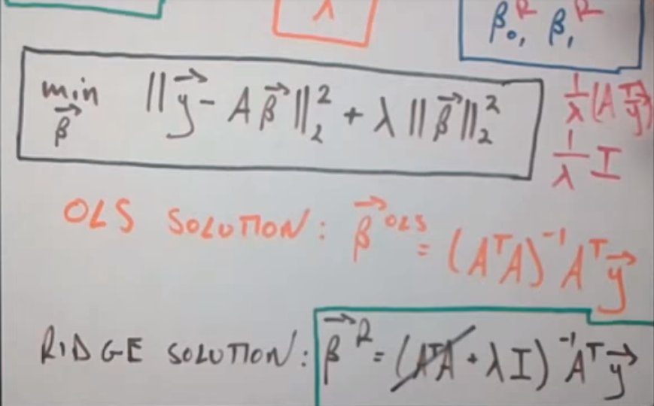
J(theta) = F(theta0, theta1, theta2 ... lambda) = min[(y-y_bar)^2 + lambda * (sum(theta^p)-c^2) take derivative try lambda, find best combination of thetas

